

Government of Sindh

Drinking Water, Sanitation and Hygiene

Sindh Strategic Sector Plan 2016 – 2026

Final Draft6.0 dated 29thDecember 2016

SINDH STRATEGIC SECTOR PLAN 2016 – 2026
Drinking Water, Sanitation and Hygiene

Government of Sindh

Local Government and Housing Town Planning Department
Planning and Development Department
Public Health Engineering and Rural Development Department
Health Department
School Education Department

Final Draft 6.0 – 29thDecember 2016

MESSAGE OF CHIEF MINISTER

The province of Sindh is home to the Indus waterway before it enters the Arabian Sea. Despite having a large riverine source of water, the province of Sindh faces many challenges in provision of potable drinking water owing to the growing urban population and presence of desert and brackish zones for its rural population. The Government of Sindh is making tireless efforts to ensure there is adequate infrastructure and capacity for supply of clean drinking water and availability of adequate sanitation to its population.

The Government of Sindh has initiated a number of projects for water and sanitation and has planned to increase investments in water and sanitation in the future.

It is a matter of great satisfaction to learn that many water and sanitation projects are under way in collaboration with national and international development partners. I assure you that the Government of Sindh shall extend all possible assistance to further enhance this collaboration so that we can achieve our ultimate goal of water and sanitation for all.

I am pleased to learn that a well-conceived and forward looking sector development plan has been formulated that provides a clear and strategic direction for the sector. Provision of clean and safely managed drinking water of acceptable quality and adequate and safely managed sanitation are not only basic necessities of life, they have an enormous impact on preventing needless mortality and nutritional deficiency because of diarrhoea. Furthermore, they also address many environmental issues.

I look forward to seeing the implementation of this sector development plan in fulfilment of the Sustainable Development Goal on water and sanitation, and welcome national and international partners to join hands with the Government of Sindh in making this a reality.

MESSAGE OF CHIEF SECRETARY

Access to safely managed drinking water and sanitation are two of the benchmarks of development in any country. Today, Pakistan in general, and Sindh province in particular, still faces many challenges of providing access to these basic services to all its citizens. There are many reasons for this, not the least of which are a burgeoning population especially in urban and peri-urban areas, multi-dimensional poverty, and low prioritisation of services in rural areas to name a few.

Today, Sindh province is undergoing a massive transition. On one hand, there is rapid urbanisation with people flocking to cities and towns, while on the other, municipal services are not able to cope with the demand especially with the mushroom growth of new housing schemes, industrial estates and commercial zones. This is further compounded by limited resources and increasing priorities each clamouring for more allocations.

Inadequate water and sanitation has adverse impacts on health and nutrition, and Sindh province today still has unacceptably high child mortality rates and high nutritional deficiency among its children. This is unacceptable.

Taking these issues into consideration, and recognising the urgency of the problems, the Government of `Sindh has developed its ten-years sector development plan for water, sanitation and hygiene, which shall usher in a new era of sectoral development based on sound evidence, clear strategic directions and multi-sectoral engagement to achieve the Sustainable Development Goal on water and sanitation.

I urge the concerned line departments to implement this plan in letter and spirit, and am confident that the new sector development plan will also provide a platform for enhanced collaboration and cooperation with national and international development partners.

ACKNOWLEDGEMENTS

This enormous task of developing a sector development plan for water, sanitation and hygiene in Sindh was made possible by the collaborative efforts of Local Government and Housing Town Planning Department, Public Health Engineering and Rural Development Department, Planning and Development Department, Health Department and Education and Literacy Department.

UNICEF supported the process from inception to completion, while Avicenna Consulting Pvt Ltd were the consultants for development of the sector plan.

The support and contributions of international, national and provincial sector partners is gratefully acknowledged.

Individuals that played a significant role in formulation of this sector plan include:

Niaz Ahmed Soomro, Special Secretary Technical LG&HTPD; Farooq Siddiqui, Director PM&EC LG&HTPD; Fahim Junejo, Project Director Saaf Surthro Sindh; Ghulam Mohammad Sheikh, Assistant Chief P&DD; Abdul Kaleem Sheikh, Assistant Chief P&DD; Nabesh Akhtar, Deputy Director, Urban Policy and Strategic Planning; M Akbar Baloch, XEN PHED; Munir Ahmed Sheikh, XEN PHED; Jamil Ahmed, Deputy Director Education; Israr Ahmed, Assistant Director, PD&R Education; Abdul Ahad Pasha, Planning Officer, P&DD; Mazhar Iqbal, Programme Policy Officer, SUN-Nutrition Section; and Ghulam Mustafa, Senior Research Officer, PCRWR.

Special thanks to Tameez Uddin Khero, Secretary PHE&RDD for his encouragement and contributions.

Profound gratitude to Irfan Alrai, WASH Specialist UNICEF, and Mubashira Iram, WASH Officer UNICEF for their continuous support, guidance, contributions and critique throughout the process.

Gratefully acknowledge the contributions and active participation of Aijaz Ali Khan, Plan Provincial Coordinator during the sector plan development process.

We acknowledge with grateful thanks the technical support by the Avicenna Consulting Pvt Ltd team, Haroon Awan, Niaz Ullah Khan and Mohammad Bashir Khan in the formulation of the WASH Sector Development Plan.

And last, but not least, this task would not have been possible without the timely administrative assistance and support of M Azeem Chana, AD LG&HTPD and Ased Khan of LG&HTPD.

CONTENTS

MESSAGE OF CHIEF MINISTER 4
MESSAGE OF CHIEF SECRETARY 5
ACKNOWLEDGEMENTS 6
LIST OF FIGURES 13
LIST OF TABLES 15
EXECUTIVE SUMMARY 17
PREAMBLE 23
INTRODUCTION 27
Population 29
Health 29
Education 29
Poverty 30
Multi-dimensional Poverty 30
Urbanisation 33
POLICY SHIFT FROM MDGS TO SDGS 36
SECTOR OVERVIEW 39
Demographics 39
Institutions 39
Drinking Water 40
Sanitation 41
LEGISLATION AND POLICIES 43
Pakistan EPA Act, 1997 43
Sindh Water Management (Amendment) Act, 2005 45
Sindh Municipal Water Act (Draft), 2012 46
Sindh Environmental Protection Act, 2014 48
Sindh Local Government Act, 2014 48
Sindh Solid Waste Management Board Act, 2014 51
Karachi Water and Sewerage Board Act, 1996 54
Pakistan Water Sector Strategy, 2002 56
National Drinking Water Policy, 2009 58
National Sanitation Policy, 2006 59
National Climate Change Policy, 2012 60
Hospital Waste Management Rules, 2005 60
Draft Sindh Drinking Water Policy, 2016 61
Draft Sindh Sanitation Policy, 2016 63
Pakistan Approaches to Total Sanitation, 2010 65
Community Led Total Sanitation 65
School Led Total Sanitation 66
Solid Waste Management 66
Inter-sectoral Nutrition Strategy Sindh 68
Draft WASH Behaviour Change and Communication Strategy, 2016 70
Legislation and Institutional Challenges 71
Strategy 73
WATER RESOURCES 75
Pakistan’s Water Resources 75
Freshwater Footprints 77
Climate Change 77
Water Resource Development in Sindh, 83
Rainwater Harvesting 85
Strategy 86
WATER SUPPLY 88
Urban Water Supply 88
Rural Water Supply 92
Water Supply Issues 96
Issues with Karachi Water Supply 96
Current Status of Water Supply Schemes 99
Reasons for Non Functional (temporarily closed) Water Supply Schemes 100
Period of construction of Water Supply Schemes 100
Recent Initiatives for Water Supply by Government of Sindh 102
Sindh Cities Improvement Programme 102
Northern Sindh Urban Services Corporation 102
Desalination Plants 102
K-IV Drinking Water Project 103
Matching Grants from Federal Government 103
Special Initiatives 103
Thar Coal 103
Other Initiatives 104
Strategy 105
WATER QUALITY 108
National Water Quality Monitoring Programme 108
Technical Assessment of Water Supply Schemes 109
Bottled Water Quality 111
Water Resources Research Institutes and Laboratories 114
Pakistan Council of Research in Water Resources 114
Pakistan Council for Scientific and Industrial Research 115
Climate Change, Alternate Energy and Water Resources Research Institute Islamabad 115
Drainage and Reclamation Institute of Pakistan 116
Arid Zone Research Institute 116
Recent Initiatives for Water Quality in Sindh 117
Water Testing Laboratories in Districts 117
Science and Technological Research Division 117
Strategy 118
SANITATION 119
Urban and Rural Sanitation 119
Sewerage and Drainage Issues 128
Wastewater 130
Storm Water Drainage 134
Recent Initiatives for Sanitation in Sindh 136
Sindh Cities Improvement Project 136
Karachi Sewerage (S-III) Project 137
Saaf Suthro Sindh Programme 138
Sindh Municipal Services Delivery Programme 138
Municipal Services Programme, Jacobabad 139
Other Initiatives 139
UN Maternal and Child Stunting Reduction Programme 139
Rural Sanitation Scale-up Strategy 140
Orangi Pilot Project 141
Strategy 142
SOLID WASTE 146
Karachi City Solid Waste 147
Hospital Waste 148
Slaughter Waste 150
Overview of solid waste management practices 152
Recent Initiatives for Solid Waste in Sindh 153
Sindh Cities Improvement Project 153
Sindh Solid Waste Management 154
Strategy 156
HEALTH, HYGIENE AND NUTRITION 159
Child Mortality 159
Diarrhoea 162
Economic Impacts of Diarrhoea 167
Hygiene 169
Nutrition and Diarrhoea 170
Health, Nutrition and Hygiene 171
Recent Initiatives for Health in Sindh 174
District Health Information System 174
Multi-Sector Nutrition Support Programme 175
Sindh Accelerated Action Plan for Reduction of Stunting and Malnutrition – Sehatmand Sindh 176
Nutrition sensitive Conditional Cash Transfers for the poor in Sindh 177
Sindh Health Sector Strategy 2012-2020 177
Strategy 179
EDUCATION 181
National Sanitation Policy 2006 181
Sindh Education Sector Plan 2014 - 2018 181
Sindh Teacher Education 183
Sindh Teacher Education Development Authority 183
Provincial Institute of Teacher Education 183
Sindh Curriculum Implementation Framework 184
Missing Facilities 185
Health and Hygiene Education 198
Menstrual Hygiene Management 199
Sindh WASH in Schools (WinS) Strategic Plan 2017-2022 201
Strategy 202
SECTOR EFFICIENCY AND CAPACITY 204
Service Efficiency 204
Specific recommendations of the Reform Led Investment Plan of KW&SB 214
Social Audit of Local Governance and Delivery of Public Services 215
Drinking Water Supply 215
Sewerage and Sanitation 215
Garbage Disposal 216
Public Opinion on Quality of Governance in Sindh 217
Citizen Report Card 217
Tube wells in Sindh 218
Sector Capacity 219
Municipal Training and Research Institute (MTRI) 219
Sindh Local Government and Rural Development Academy 219
Staffing Capacity for Solid Waste Management 221
Staffing Capacities in Local Government and Public Health Engineering 221
Strategy 223
SECTOR FINANCING 225
Sectoral Expenditure Review 225
Sectoral Development Expenditure Trends 226
Sectoral Development Allocation and Expenditure Trends 228
Estimating Cost for Sectoral Investment 231
Medium Term Budgetary Framework 231
Sustainable Development Goals 231
Developing a Costing Framework 232
Resource Mobilisation 315
Own Source Revenue (OSR) 315
Local Revenue Generation by Consumer Organisations 315
Innovation 315
Strengthening Local Government 315
Sub-National Governance Programme 316
USAID and Nutrition Support Initiative 316
World Bank Drought Emergency Programme 316
Small Dams and Water Reservoirs 316
Sustainable Development Goal for Water and Sanitation 316
Climate change 316
Achieving Equity and Universal Coverage 316
Sanitation Marketing 317
Strategy 318
SECTOR COORDINATION AND IMPLEMENTATION ARRANGEMENTS 320
Coordination 320
Improving Sector Coordination 321
Implementation Mechanism 323
Implementation Arrangements 323
Foundation 323
Features of the Implementation Framework 324
Integration 324
Integrating Structure 324
Implementation Matrix 325
Harmonisation 326
Alignment 326
Partnership 327
Need Identification and Scheme Design 328
Design Cell 328
Multi-Sectoral Nutrition Steering Committee 329
Departmental Technical Committees 329
Strategic WASH Technical Working Group 329
Sector Coordination and Monitoring Unit (SCMU) 329
District WASH Committees 330
District Coordination and Monitoring Unit 330
Rural Water Supply Schemes 331
Strategy 333
SECTOR MONITORING 334
Monitoring and Evaluation 334
Pakistan Poverty Reduction Strategy Paper Progress Report (PRSP) 334
Pakistan Social and Living Standards Measurement Survey (PSLM) 335
Multiple Indicator Cluster Survey (MICS) Balochistan 335
Pakistan Demographic and Health Survey (PDHS) 335
Joint Monitoring Programme (JMP) of WHO and UNICEF 335
Disability 337
Global Analysis and Assessment of Sanitation and Drinking-Water (GLAAS) 338
Pakistan Water Operators Network 338
School Education Management Information System (SEMIS) 339
Annual State of Education Report (ASER) 339
Pakistan Council of Research in Water Resources (PCRWR) 339
Public Health Engineering Water Testing Laboratories 339
Monitoring and Evaluation Cell - Planning and Development Department 339
Surveys and Evaluations by State and Non State Actors 340
Collation, Synthesis and Dissemination 340
Monitoring and Reporting Information Systems 341
Performance Measurement Framework 343
Strategy 355
CONSOLIDATED SECTOR DEVELOPMENT PLAN 356
Vision and Strategic Priorities 356
Strategic Objectives/Outcomes and Actions 359
Legislations, Regulations, Policies and Strategies 359
Water Resources 361
Water Supply 363
Water Quality 366
Sanitation (Sewerage and Drainage) 367
Solid Waste 371
Health, Hygiene and Nutrition 374
Education 376
Sector Efficiency and Capacity 378
Sector Financing 380
Sector Coordination 382
Sector Monitoring 383
Implementation Plan 384
Plan of Activities 412
ACRONYMS 473
OPERATIONAL DEFINITIONS 478
Annex 1 – Bottleneck Analysis – Safely Managed Water Resources 483
Annex 2 – Bottleneck Analysis – Safely Managed Sanitation Services 486
Annex 3 – Bottleneck Analysis – Institutional WASH 489
Annex 4 – Access to Improved Water by Quintiles 492
Annex 5 – Access to Piped Water by Quintiles 493
Annex 6 – Water Quality and SDG Target for Water 494
Annex 7 – Access to Improved Sanitation by Quintiles 495
Annex 8 – No Toilet (Open Defecation) by Quintiles 496
Annex 9 – Hand Washing and SDG Target for Sanitation 497
Annex 10 – Zones of Irrigation Development 498
Annex 11 – Zones of Salinity and Water Logging 499
Annex 12 – Proposed Water Reservoirs for Karachi 500
Annex 13 – Proposed Sewage Treatment Plants in Karachi 501
Annex 14 – Proposed Garbage Transfer Stations for Karachi 502
Annex 15 – Stakeholder Analysis 503
Stakeholder Interviews 503
Pakistan Council for Research in Water Resources 503
Sindh Environmental Protection Agency 504
Sindh Planning and Development and Special Initiatives Department 505
Public Health Engineering and Rural Development Department 505
Directorate of Urban Policy and Strategic Planning 506
Education Department – Reform Support Unit 507
Karachi Water Supply and Sewerage Board 507
Sindh Solid Waste Management Board 508
North Sindh Urban Services Corporation 509
Cantonment Board Malir 510
Hyderabad Water and Sanitation Agency 510
NED Engineering University of Engineering and Technology 511
Mehran University of Engineering Technology 512
National Rural Support Programme 513
Sindh Rural Support Organisation 514
Research and Development Foundation 515
HANDS 515
WaterAid Pakistan 516
Plan Pakistan 517
Asian Development Bank 518
Focus Group Discussions 519
Water 519
Sewerage/Drainage 519
Toilets 519
Solid Waste Management 520
Hand Washing 520
Governance 520
NGOs Initiatives 520
National Lady Health Workers Programme 520
School WASH 521

LIST OF FIGURES

Figure 1 - District map of Sindh 27
Figure 2 - Main supply of drinking water trends 2007-08 to 2013-14 in Sindh 40
Figure 3 - Sanitation trends 2007-08 to 2013-14 in Sindh 42
Figure 4 - Water availability (cubic metres) and population growth 76
Figure 5 - Climate Change Vulnerability Index 2015 78
Figure 6 - Decadal temperature projections of selected centres 79
Figure 7 - Decadal precipitation projections for selected centres 80
Figure 8 - Monthly Rainfall Shift 81
Figure 9 - Projected climate 2020-2030 82
Figure 10 - Sindh Irrigation System 84
Figure 11 - Sources of urban water supply in Sindh (PSLM 2014-15) 88
Figure 12 - District wise distribution of improved drinking water source in urban areas (PSLM 2014-15) 89
Figure 13 - Overall source of improved water supply by division (MICS 2014) 90
Figure 14 - Overall source of improved water supply by district (MICS 2014) 91
Figure 15 - Sources of rural water supply in Sindh (PSLM 2014-15) 92
Figure 16 - District wise distribution of improved drinking water source in rural areas (PSLM 2014-14) 93
Figure 17 - Status of improved water supply and water treatment (MICS 2014) 94
Figure 18 - Percentage households without drinking water on premises (MICS 2014) 95
Figure 19 - Existing Water Supply Network for Karachi 97
Figure 20 - Location of surveyed water supply schemes 99
Figure 21 - Water Supply Schemes by construction period 101
Figure 22 - Quality of Drinking Water at Source 110
Figure 23 - Quality of Drinking Water at Consumer's end 111
Figure 24 - Mode of urban sanitation in Sindh (PSLM 2014-15) 119
Figure 25 - District wise distribution of mode of sanitation in urban areas (PSLM 2014-15) 120
Figure 26 - Mode of rural sanitation in Sindh (PSLM 2014-15) 121
Figure 27 - District wise distribution of mode of sanitation in rural areas (PSLM 2014-15) 122
Figure 28 - District profile of improved sanitation and place for hand washing 123
Figure 29 - Equity profile of water and sanitation 124
Figure 30 - Overall status of improved sanitation (MICS 2014) 125
Figure 31 - Overall status of unimproved sanitation (MICS 2014) 126
Figure 32 - Percentage household population using improved sanitation that is not shared (MICS 2014) 127
Figure 33 - Type of Sanitation system used in Sindh 128
Figure 34 - Location of Wastewater Treatment Plants in Karachi 132
Figure 35 - Karachi Natural Nullahs and Drains 133
Figure 36 - Storm Water Drainage System Karachi 134
Figure 37 - Status of Garbage Collection in Sindh 146
Figure 38 - Existing Landfill Sites in Karachi 147
Figure 39 - Livestock slaughtered in Sindh 2011-12 150
Figure 40 - Number of recognised slaughterhouses by district 2011-12 151
Figure 41 - Decadal trends of Infant and Under 5 Mortality Rates in Sindh 159
Figure 42 - Child mortality rates and improved sanitation 161
Figure 43 - Childhood mortality rates and improved drinking water 162
Figure 44 – Diarrhoea in last 30 days in children under 5 years 163
Figure 45 - No Toilet and Diarrhoea in last 30 days in children under 5 years 164
Figure 46 – Improved Water Supply and Economic Quintiles 165
Figure 47 - Improved Sanitation and Quintiles 166
Figure 48 – No Toilet and Economic Quintiles 167
Figure 49 - Nutritional status and improved sanitation 171
Figure 50 - Top five diseases seen as outpatients in Sindh in 2015 174
Figure 51 – Improved water availability in schools in Sindh 186
Figure 52 - Improved sanitation in schools in Sindh 187
Figure 53 - Availability of drinking water in urban schools in Sindh 188
Figure 54 - Availability of drinking water in rural schools in Sindh 189
Figure 55 - Availability of student latrines in urban schools in Sindh 190
Figure 56 - Availability of student latrines in rural schools in Sindh 191
Figure 57 - Status of school facilities in government primary schools 192
Figure 58 - Status of school facilities in government middle and secondary schools 193
Figure 59 - Primary schools with drinking water by tehsil 194
Figure 60 - Middle and secondary schools with drinking water by tehsil 195
Figure 61 - Primary schools with student latrines by tehsil 196
Figure 62 - Middle and secondary schools with student latrines by tehsil 197
Figure 63 - Decadal Per Capita Sectoral Trends 204
Figure 64 - Per Capita Sectoral Spend Trends 2014-15 205
Figure 65 - Provincial trends of source of drinking water supply 206
Figure 66 - Distance to source of drinking water supply by province 206
Figure 67 - Distance to source of drinking water supply in Sindh 207
Figure 68 - Who installed water supply 207
Figure 69 - Type of toilet used by province 208
Figure 70 - Type of sanitation system used by province 208
Figure 71 - Type of overall garbage collection system from household by province 209
Figure 72 - Type of urban garbage collection system from household by province 209
Figure 73 - Tube wells in Sindh 218
Figure 74 - Current, Development and Total Pro-Poor Expenditure in Water and Sanitation 225
Figure 75 - Sectoral expenditure as percentage of total pro-poor expenditure 226
Figure 76 - Sectoral expenditure trends 227
Figure 77 - Proportionate allocation and spend by department 229
Figure 78 - Sub-sector allocation and percentage of sectoral allocation 230
Figure 79 - Sector investment scenario at current rates and with 8% inflation (safely managed water supply and sanitation) 313
Figure 80 – Sub-sector investment at current rates (safely managed water supply and sanitation) 313
Figure 81 - Sector investment scenario at current rates and with 8% inflation (improved water supply and sanitation) 314
Figure 82 – Sub-sector investment at current rates (improved water supply and sanitation) 314
Figure 83 – Implementation Mechanism 328
Figure 84 - Organogram for DCMU 330
Figure 85 - Top 10 countries with the highest numbers of people (in millions) practicing open defecation 336
Figure 86 - Disparities in rural improved sanitation coverage 337
Figure 87 - Access to improved drinking water sources and sanitation facilities – disability perspectives 338
Figure 88 - Existing monitoring and reporting systems 341

LIST OF TABLES

Table 1 - Use of Drinking Water Sources 25
Table 2 - Use of Sanitation Facilities 26
Table 3 - Multi-dimensional poverty in Pakistan - incidence, depth and severity 31
Table 4 - Non-income multi-dimensional poverty incidence 32
Table 5 - Household economic situation by quintiles 33
Table 6 - Growing population in cities 34
Table 7 - Additional Processes and Institutions affecting Water and Sanitation 52
Table 8 - Summary of legislation and regulations relating to solid waste management 67
Table 9 - Major problems with the water supply and sanitation system in Karachi 98
Table 10 - Overall status of water quality (MICS 2014) 113
Table 11 - Status of Sewerage System in Karachi 131
Table 12 - Overview of solid waste management in selected secondary cities 152
Table 13 - Nutritional status of children under five years in Sindh 170
Table 14 - Comparison of service efficiency in water and sanitation agencies 210
Table 15 - Status of efficiency of service 211
Table 16 - Staffing Capacity for solid waste management in selected secondary cities 221
Table 17 - Comparative structure in Local Government and Public Health Engineering 222
Table 18 - Sectoral development allocation and expenditure 228
Table 19 - Proportionate sectoral allocation by department 229
Table 20 – Detailed sub-sectoral financial analysis of sectoral financing in ADP 2015-16 235
Table 21 - Detailed costing for safely managed overall drinking water supply by district 241
Table 22 - Detailed costing for safely managed urban drinking water supply by district 245
Table 23 - Detailed costing for safely managed rural drinking water supply by district 247
Table 24 - Detailed costing of safely managed overall sewerage and drainage system by district 249
Table 25 - Detailed costing of safely managed urban sewerage and drainage system by district 253
Table 26 - Detailed costing of safely managed rural sewerage and drainage system by district 255
Table 27 - Detailed costing for improved overall drinking water supply by district 257
Table 28 - Detailed costing for improved urban drinking water supply by district 261
Table 29 - Detailed costing for safely managed rural drinking water supply by district 263
Table 30 - Detailed costing of improved overall sanitation system by district 265
Table 31 - Detailed costing of improved urban sanitation system by district 269
Table 32 - Detailed costing of improved rural sanitation system by district 271
Table 33 - Missing facilities (drinking water) in public sector primary schools 273
Table 34 - Missing facilities (latrines) in public sector primary schools 275
Table 35 - Missing facilities (drinking water) in public sector middle and secondary schools 277
Table 36 - Missing facilities (latrines) in public sector middle and secondary schools 279
Table 37 - Missing facilities (water and sanitation) at Basic Health Units 281
Table 38 - Indirect Cost Legislation and Policies 283
Table 39 - Indirect Costs Water Resources 285
Table 40 - Indirect Costs Water Supply 286
Table 41 - Indirect Costs Water Quality 287
Table 42 - Indirect Costs Sanitation 288
Table 43 - Indirect Costs Solid Waste 289
Table 44 - Indirect Costs Health and Hygiene 290
Table 45 - Indirect Costs Education 292
Table 46 - Indirect Costs Sector Efficiency and Capacity 293
Table 47 - Indirect Costs Sector Financing 294
Table 48 - Indirect Costs Sector Coordination 295
Table 49 - Indirect Costs Sector Monitoring 296
Table 50 - District notional estimates (safely managed water supply and sanitation) 298
Table 51 - District notional estimates (improved water supply and sanitation) 304
Table 52 - Summary Indirect Costs 310
Table 53 - Investment Overview of Sector Plan in Billion Rupees (safely managed water supply and sanitation) 311
Table 54 - Investment Overview of Sector Plan in Billion Rupees (improved water supply and sanitation) 312
Table 55 - Comparative WASH indicators in PSLM, PDHS and MICS 346
Table 56 - Proposed KW&SB, H-WASA and NSUSC Monitoring Indicators 351
Table 57 - Proposed Monitoring Indicators for District Municipal Services 353

EXECUTIVE SUMMARY

Introduction

The periodic South Asia Conference on Sanitation (SACOSAN) and biennial meeting of Sanitation and Water for All has repeatedly identified sanitation issues in Pakistan, especially for rural communities. Country participation at high-level meetings on Sanitation and Water for All in April 2014 reiterated the government’s commitment to the preparation of provincial sector plans for water and sanitation. The recent MICS 2014 indicators for WASH in Sindh have highlighted the urgency for improving WASH systems. Further, the worrisome state of nutritional deficiency demands an accelerated plan to improve WASH as poor sanitation and contaminated drinking water are important causative factors of poor nutrition and child morbidity and mortality. The LG&HTPD and PHE&RDD in collaboration with P&DD, Education and Health provided strategic guidance and facilitation for the development of a WASH Sector Development Plan 2016-2026 with support of UNICEF and technical consultants.

Demographics

Sindh is a densely populated and most urbanised province of Pakistan accounting for 24% of the country's total population. The population of Sindh increased from 41.248 million in 2010, to 45.998 million in 2015, and is expected to reach 70 million or more by 2050. About 52.5% of the population is male and 47.5% is female. Similar proportions are found in all divisions. The trend of urbanisation and a growing population will continue to increase demands for sector and sub-sector services.

Policies and Institutions

Sindh has a draft Drinking Water Policy 2016, draft Municipal Water Act 2012 and draft Sanitation Policy 2016. The National Sanitation Policy 2006 and National Drinking Water Policy 2009 guided the development of these provincial policies. The Water Sanitation and Hygiene (WASH) sector is overseen by a number of departments, including Local Government and Housing Town Planning Department (LG&HTPD), Public Health Engineering and Rural Development Department (PHE&RDD), General Services, Health, and Education for WASH in schools. These provincial departments are now working through an integrated approach to envision and design common implementation plans that are owned by multiple departments and supported by all major support organisations working in the sector. Several national and international partners collaborate with the Government and include UNICEF, WSP, WaterAid, Plan International, RSPN, etc.

Strategic Actions
Finalise the Sindh Municipal Water Act; approve drinking water and sanitation policies; formulate a legal framework and operationalise the Sindh Water Commission to govern municipal water in addition to implementing the Local Government Act 2013.

Water Resources

Pakistan is considered to be a water-stressed country (rapidly moving to water-deficit) and many of its regions are categorised as arid. Pakistan lies in an arid and semi-arid climate zone. Most of Sindh receives less than 140 millimetres of rainfall a year. (By contrast, among nations of similar area, Nigeria receives more than 1,500 millimetres, Venezuela more than 900, Turkey nearly 700.) Per capita water availability has declined rapidly since 1951 and is currently only 1050 cubic metres/capita, which puts Pakistan in the category of a high water-stress country.

Strategic Actions
Improve water resource utilisation through efficient project design and execution; strengthen municipal capacities in climate change adaptation, mitigation and resilience; develop district level preparedness for water safety and disaster risk reduction; develop and enhance rainwater harvesting interventions in areas with ample precipitation.

Drinking Water

Overall, 90.5% of household members use an improved source of drinking water, while 12.8% of household members in households using unimproved drinking water use an appropriate water treatment method. About 90% of urban and 91% of rural household members use an improved drinking water source. Piped water into dwelling is found mostly in Karachi division (65.0%), followed by Hyderabad (20.0%) and Mirpur Khas (15.1%) divisions. The rest of Sindh indicates a high use of water from a protected well with highest rates found in Larkana division (86.3%) and Sukkur division (77.3%). The results of Sindh MICS 2014 indicate that other than Karachi districts that attain about 20%-30% water treatment, all other districts rate less than 20% for water treatment, even though a large proportion of districts are using improved water for drinking. About 25.5% of the proportion of households in Sindh do not have drinking water on premises. Tharparkar has the highest percentage of households without drinking water on premises (89.7%).

Strategic Actions
Enhance coverage of Improved and safely managed water supply to meet access gap; rehabilitate and maintain dysfunctional and non-functional schemes; upgrade water supply schemes in towns; enhance community awareness about water use, safety, maintenance and preservation in all districts through an effective BCC strategy.

Water Quality

The Sindh MICS 2014 found that 3.0% of household members in Sindh drink water contaminated above WHO standards for arsenic, 5.5% for Nitrate, 4.5% for Fluoride, 2.9% for Iron, 8.9% for hard water and 23.6% for TDS. Further, 38.8% of household members drink water contaminated with E.coli, while 66.0% drink water contaminated with coliforms. This indicates a serious water quality issue in Sindh.

Strategic Actions
Conduct quarterly water quality testing at water source and distribution network; establish district level water quality testing laboratories; enhance community awareness about water quality (including adoption of treatment of safe drinking water in the household) enhanced in all districts through an effective BCC strategy.

Sanitation

According to Sindh MICS 2014, on average 54.9% use improved sanitation, while 56.1% have a place for hand washing. There is a general awareness about the need for a place for handwashing since many districts that have low rates for improved sanitation have higher rates for a place for handwashing. About 90.0% of urban, 22.1% of rural and 97.9% of households in Karachi division use flush/pour flush latrines connected to piped sewer system.About 39.9% of household population in rural areas practice open defecation, which is highest in Mirpur Khas division at 49.2%. The percentage of household population using improved sanitation that is not shared is highest in Karachi (98.0%) and least in Tando Muhammad Khan (17.7%).

Strategic Actions
Enhance improved and safely managed sanitation services coverage to reduce access gap in urban areas and rural areas, especially in those that are also nutrition-sensitive; establish wastewater treatment plants established in towns; increase proportion of treated industrial wastewater; ensure improved and systematic management of Operation and Maintenance of sewerage and drainage systems; enhance community awareness and social mobilisation regarding sanitation, nutrition and hygiene in all UCs through effective implementation of BCC strategy; and promote safe sanitation practices in high open defecation zones, nutrition-sensitive and polio priority areas.

Solid Waste

A study estimated that the Solid Waste Generation Rate (kg/C/Day) for Karachi was 0.613 kg/C/Day, while for Hyderabad, it was 0.563 kg/C/Day. Using the current estimated population of Karachi of 24 million, at least 14,712 tons per day or 5.37 million tons per year. Using an arbitrary mean Solid Waste Generation Rate of 0.330 kg/C/Day (average of urban and rural rates), the total solid waste generated per day in Sindh for a population of 44.807 million is about 14,786 tons per day, and about 5.397 million tons per year. Clearly, most of the solid waste is generated in Karachi. Only 31% of Sindh has proper disposal of waste solids (collected by any municipal institution, disposed of by solid waste management department or a private company vehicle collected from home). This ranges from 56% in urban to 4% in rural areas.

Strategic Actions
Implement integrated solid waste management implemented in districts; improve solid waste collection and disposal; improve the efficiency of solid waste disposal and recycling; enhance safe hospital high risk waste disposal; and enforce safe and hygienic Slaughterhouses.

Health, Hygiene and Nutrition

The Infant Mortality Rate (IMR) and Under 5 Mortality Rate (U5MR) remain high in Sindh. The Sindh MICS 2014 found an IMR of 82 per 1000 live births and U5MR of 104 per 1000 live births. Sindh MICS 2014 found that the lowest quintile is the most vulnerable to health risks and has the least access to improved drinking water and improved sanitation. Further, high prevalence rates of no toilet are found in the poorer quintiles compared to the richer ones. The issue of no toilet is found predominantly in the rural compared to urban areas. Recent data from Sindh MICS 2014 shows that more than four out of ten children under the age of five years in Sindh are underweight (42%) and 17% are classified as severely underweight. Almost half of children under five years (48%) are stunted or short for their age and one fourth (24%) children are severely stunted. Evidence from Sindh MICS 2014 indicates that nutritional deficiency rates show an increasing trend when use of improved sanitation decreases further suggesting that low use of improved sanitation is a risk factor for poor nutrition status

Strategic Actions
Improve and make fully functional water and sanitation services in health facilities; implement Hospital Waste Management Rules; implement multi-sector nutrition-sensitive WASH programmes in nutritionally deficient districts; integrate nutrition-sensitive WASH in health promotion in primary health care; and integrate nutrition-sensitive WASH in health advocacy and BCC campaigns and health weeks.

Education

Sindh Education Management Information System (SEMIS) found that 45% of schools had no toilet facilities and 53% had no drinking water facility; both presenting particular barriers for girls. The Sindh Education Sector Plan identified lack of basic facilities (e.g. proper classrooms, washrooms, drinking water, security, etc.), especially in rural areas as one of the top seven key issues in the provision of primary and elementary education. Of 46,039 educational institutions, only 22,724 (just under 50%) have water facilities and 24,937 (just under 55%) have latrines. Presently, there is no module on WASH in either pre-service or in-service teacher training programmes. There is need for a curriculum review to incorporate a separate section/module on nutrition-sensitive WASH. A study conducted at the national level showed WASH facilities in schools are not supportive to menstrual hygiene management (MHM); majority of the girls rely on mothers and sisters for MHM related information; and little information is provided or discussed at school level. At present, there is no menstrual hygiene education for girls in middle and high schools in Sindh.

Strategic Actions
Integrate nutrition-sensitive WASH in teacher training programme; integrate nutrition-sensitive WASH in schools’ curriculum; integrate menstrual hygiene management in health and hygiene for girls; and ensure 100% of schools with missing facilities have safely managed drinking water and latrines.

Sector Efficiency and Capacity

Over the last decade, the per capita total sectoral expenditure has increased marginally from PKR 149 in 2005-06 to PKR 164 in 2014-15, but when considered in the context of inflation, it is negligible. Further, the per capita sectoral development spend has actually decreased from PKR 137 in 2005-06 to PKR 117. This indicates diminishing prioritisation of public spending in the sector. On average, the proportion of per capita development spend to overall per capita sectoral spend between 2010-2015 is just under three-fourths (73%). The service efficiency of different water and sanitation agencies shows that KW&SB underperforms in most of the indicators only second to WASA Quetta. It has low billing and collection ratios, a high staffing ratio, and no fee for new sewerage connection. NSUSC has the lowest average unit production cost and staffing ratio. A comparison of the basic structure in Local Government and Public Health Engineering indicates that the technical capacity for water supply and sewerage and drainage lies in public health engineering, while administrative capacity lies with Local Government. This presents a major challenge to Local Government for providing O&M services as per current regulations. This anomaly needs to be corrected so that both installation and O&M of water supply and sewerage and drainage schemes rest with Public Health Engineering, while solid waste management and general sanitation services rest solely with Local Government.

Strategic Actions
Reduce systems leakages of Non Revenue Water and Unaccounted for Water; increase household water metering; improve and enhance efficient Billing and Collection; undertake systematic Human Resource Development for the sub-sectors; and develop capacities of CBOs and civil society for integrated water supply, sanitation, hygiene and solid waste management.

Sector Financing

On analysis of sectoral expenditure trends, current expenditure as a percentage of total sectoral expenditure has increased from 20.0% in 2010-11 to 28.9% in 2014-15. Conversely, development expenditure as a percentage of total sectoral expenditure has decreased from 80.0% in 2010-11 to 71.1% in 2014-15. The year on year change in development expenditure from the preceding year has vacillated from a -9.5% decrease in 2011-12, a 7.5% increase in 2012-13, followed by a -20.0% decrease in 2013-14, and then a 13.6% increase in 2014-15. These figures suggest that while there has been an overall increase in sectoral funding for water and sanitation, overall investment in the sector in relation to total pro-poor development spending has actually reduced. Further, there is diminishing prioritisation of investment in the sector compared to other sectors.

Strategic Actions
Stratify sectoral budgeting and expenditure reporting separately for each sub-sector (environment, water supply, sewerage and drainage); increase Own Source Revenue (OSR) in sub-sectors by Town Councils; increase regulated private sector participation in sub-sectors; and increase development expenditure allocation to and spending by sub-sectors.

Sector Coordination

Presently, there are two ways of managing the water supply schemes in Sindh. Generally, in urban areas, LG&HTPD manages the schemes through its staff but has poor revenue collection from the users or community based organisations (CBOs). Whereas in rural areas, the schemes are designed and executed by PHE&RDD, but on completion require to be handed over to LG&HTPD or entrusted to the local CBOs that includes operation and maintenance of the schemes. PHE&RDD does not have sufficient community mobilisation capacity, and requires additional capacity development support followed by policy reforms for appropriate well-defined community sharing and mobilisation mechanisms, and for O&M. The function of sanitation falls under the purview of LG&HTPD, which is also involved in implementing the large drainage and sanitation schemes. It is also involved in street payment and road construction in the villages. LG&HTPD has just initiated the Saaf Suthro Sindh programme through in which it shall implement the Pakistan Approaches to Total Sanitation (PATS) in selected districts in association with local community organisations in collaboration with national and international partners. There is lack of clarity about the roles and responsibilities among the stakeholders that has emerged as a result of SLGA 2014 and 18th Constitutional Amendment.

Strategic Actions
Streamline and enhance provincial level coordination and programme management for WASH by broadening the scope of the Multi-Sectoral Nutrition Steering Committee to encompass WASH, establish a Sector Coordination and Monitoring Unit in the Nutrition Unit, notify District WASH Committees, and establish a District Coordination and Monitoring Unit for WASH under the DC Office.

Sector Monitoring

Monitoring and reporting activities in the sector and sub-sector take place at various levels but are fragmented. Furthermore, there are challenges of coordination for monitoring and reporting due to complexities in the roles and responsibilities of different stakeholders in the government, cantonment boards and defence housing authorities, non-government and private sectors. Monitoring and reporting activities in the sector and sub-sector take place at various levels but are fragmented. Furthermore, there are challenges of coordination for monitoring and reporting due to complexities in the roles and responsibilities of different stakeholders in the government, cantonment boards and defence housing authorities, non-government and private sectors. There is no mechanism to collate and synthesise this information and disseminate to policy, management and operational level stakeholders. There is also no systematic approach for the monitoring and evaluation of sanitation projects.

Strategic Actions
Develop monitoring and reporting mechanisms for water and sanitation schemes; improve and establish the infrastructure for monitoring and reporting for water supply and sewerage and drainage schemes; and enhance the monitoring and reporting capacity for water and sanitation.

PREAMBLE

Water and sanitation have been and are a priority for the Government of Sindh particularly because of the arid and hot climate and brackish ground water.

In recent times, several key steps have been taken by the Government of Sindh. These include the following:

- Sindh Water Management (Amendment) Act 2005 – this Act is derived from and replaces the Sindh Water Management Ordinance, 2002, which established the Sindh Irrigation and Drainage Authority (SIDA) and repealed the Sindh Irrigation and Drainage Authority Act, 1997 and the Sindh Irrigation Water Users’ Association Ordinance, 1982
- Sindh Municipal Water Act (Draft) 2012 – this draft Act has proposed the establishment of a regulatory authority called the Sindh Municipal Water Commission. Upon establishment of the Commission, the responsibility for regulating the conservation, protection, utilisation, exploitation, development of water resources and the regulation of all municipal water services, including quality assurance of water, water services and tariff shall vest with the Commission
- Sindh Environmental Protection Act 2013 –that lays special emphasis on management of water resources
- Sindh Local Government Act 2013 – through which municipal functions include laying and maintaining intra-city network of water supply and sanitation; conservancy; garbage, sewer or storm water, solid or liquid waste, drainage, public toilets etc
- Sindh Solid Waste Management Board Act 2014 – this Act led to establishment of a Board called as the Sindh Solid Waste Management Board for the collection and disposal of solid and other waste in the Province of Sindh
- Development of a draft Sindh Policy for Drinking Water, revision of the Sindh Sanitation Policy, and a draft strategy for Behavioural Change Communication (BCC) in 2015-16

Other important events have also been taking place at the same time.

At the regional level, the periodic South Asia Conference on Sanitation (SACOSAN) has highlighted sanitation issues in Pakistan, especially for rural communities. These forums have given impetus to the formulation of national and provincial drinking water and sanitation policies and strategies, and the development of Pakistan Approaches to Total Sanitation (PATS).

The National Water Quality Monitoring Programme (NWQMP) initiated by the Pakistan Council of Research in Water Resources (PCRWR) found that of the bacterial contamination level (2002‐2006) was in the range of73%‐100% for Hyderabad, 61%‐100% for Karachi and 67%‐83% for Sukkur.

The Water Sanitation Programme (WSP), supported by the World Bank, helped establish the Pakistan Water Operators Network (P-WON), produced its first directory and facilitated development of a monitoring and reporting system for the network.

Sindh was severely affected by the massive floods in 2010-11 and this event alerted attention to the vulnerability of water supply and sanitation system to climatic events. Urgent interventions by UN Agencies, international and national non-government organisations in water and sanitation adopted the Pakistan Approach to Total Sanitation (PATS), as they launched a massive programme on rural sanitation that would reach 7 million people in the country affected by floods.

In 2012, a national sector review report on water, sanitation and hygiene was produced that emphasised the need for provinces to develop sector plans, approach the sector holistically in a sector wide approach, conduct sector capacity development needs assessment, and strengthen provincial monitoring frameworks for the sub-sectors.

Pakistan submitted its first GLAAS report in 2012 that helped stakeholders to identify information gaps in the sector, human resource capacity status and encouraging trends of provincial governments for gradually increasing allocations to the sector.

In 2012, two other national reports were produced that looked at urban water supply and sanitation, and rural water supply and sanitation. The reports reinforced issues regarding efficiency and called for better coordination, improved sector financing and establishing a regulatory body.

Pakistan participated at the fifth SACOSAN meeting in Nepal in 2013 where it reiterated previous commitments and identified research in water and sanitation as one of its emerging priorities.

In 2014, national consultations were held by the Ministry of Planning, Development and Reforms and the Pakistan Water Partnership to discuss the post-2015 development agenda on water and sanitation, having recognised that Pakistan was off-track to meet its international obligations on sanitation and access to safe drinking water was still an issue due to poor quality. The consultation made special emphasis on the need to improve by (15%) the sustainable use and development of water resources in Pakistan and reduce untreated wastewater by (2.5%), nutrient pollution by (5%) and increase wastewater reuse by (7%). The report highlighted the need to ‘Reduce, Recycle and Reuse’ wastewater to the extent possible.

An extensive international consultation was facilitated by the UN for goals and targets for the post-2015 agenda, which resulted in formulation of Sustainable Development Goals.

The status of water and sanitation in Pakistan when compared with other regional countries indicates that while Pakistan has made good progress with regards to provision of water, it lags behind with respect to improved sanitation (Tables 1 and 2).

Pakistan has a commitment for Millennium Development Goals (MDGs), and specifically MDG Goal 7 that aims to promote sustainable development with a focus on sustainable access to safe drinking water and basic sanitation. Pakistan is on track regarding improving access to safe drinking water (919% against the target of 93%) and it is off track on access to sanitation (64% against the target of 90%). The province of Sindh is lagging slightly behind both the target of improved ‘source’ of water with 90.5% coverage against the target of 93%, and on access to improved sanitation with an achievement of 64.6% against the target of 90%.

Table 1 - Use of Drinking Water Sources
Country | Improved (%) |  |  | Unimproved (%)
Country | Total Improved | Piped on Premises | Others Improved | Other Unimproved | Surface Water
Afghanistan | 55 | 12 | 43 | 39 | 6
Bangladesh | 87 | 12 | 75 | 13 | 0
India | 94 | 28 | 66 | 5 | 1
Nepal | 92 | 24 | 68 | 6 | 2
Pakistan | 91 | 39 | 52 | 7 | 2
Sri Lanka | 96 | 34 | 62 | 4 | 0

(Source: JMP Report 2015)

Table 2 - Use of Sanitation Facilities
Country | Improved (%) | Shared (%) | Unimproved (%) | Open Defecation (%)
Afghanistan | 32 | 12 | 43 | 13
Bangladesh | 61 | 28 | 10 | 1
India | 40 | 10 | 6 | 44
Nepal | 46 | 18 | 4 | 32
Pakistan | 64 | 9 | 14 | 13
Sri Lanka | 95 | 4 | 1 | 0

(Source: JMP Report 2015)

In pursuance of the goals of the Government of Sindh to provide safe and improved drinking water and improved sanitation to its population, and the recommendations ensuing from the various documents, reports, conferences and technical consultations, the Local Government and Housing Town Planning Department (LG&HTPD) in collaboration with the Planning and Development Department (P&DD), the Public Health Engineering and Rural Development Department (PHED), facilitated by UNICEF, sought to develop a sector development plan for Water, Sanitation and Hygiene (WASH) for the province of Sindh.

The process was initiated with a visioneering exercise held under the auspices of the LG&HTPD, where senior government officials from P&DD, PHE&RDD, Irrigation, School Education, and Health participated together with UNICEF and consultants who facilitated the process. This inceptive meeting provided a strategic direction to guide and steer the process of developing a sector plan.

A wide stakeholder consultation was undertaken to determine emerging priorities, develop an insight into strategy, and synthesise common themes that would guide formulation of a sector plan.

This10-years WASH sector development plan incorporates resource mapping, sector analysis, prioritisation and proposed strategic actions. It also includes an institutional framework, plan of action for sectors and sub sectors, investment and sector financing, coordination and partnership mechanism, resource mobilisation plan, and an M&E framework.

INTRODUCTION

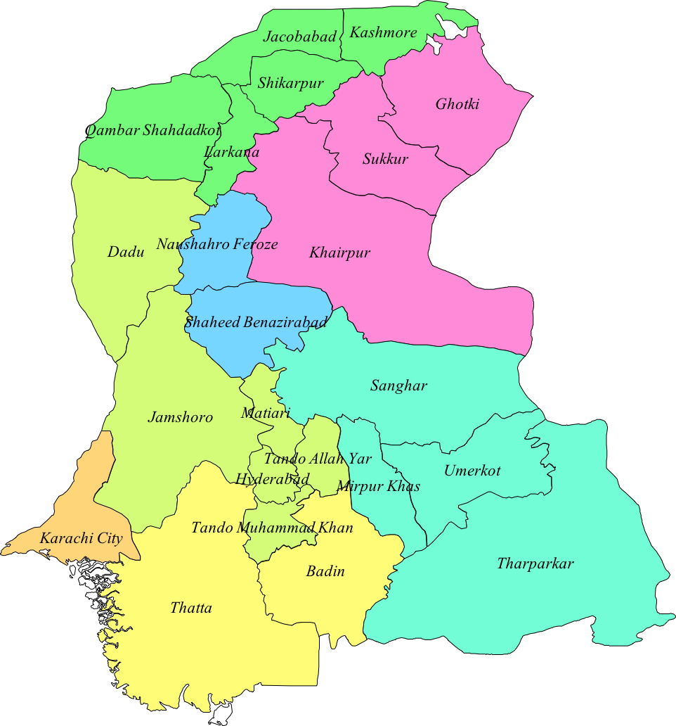

Source: FAO. (In this map, the new district of Sujawal is shown within Thatta District)

Figure 1 - District map of Sindh

The province of Sindh (Fig 1)in Pakistan is the most urbanised of the four provinces in the country. The province has a land area of140,915 sq. km and comprises of almost 16% of the country‘s land area. The province is located in the south-east of Pakistan. Sindh province is bounded by the Thar desert to its east, the Kirthar mountains in the west, and the Arabian Sea to the south. The Indus River runs through its centre across a fertile plain. The climate is mainly tropical to sub-tropical and Sindh is divided into three climatic regions - Siro (the upper region, centred on Jacobabad), Wicholo (the middle region, centred on Hyderabad), and Lar (the lower region, centred on Karachi).

Sindh receives an average annual rainfall of about seven inches, falling mainly during July and August. The southwest monsoon wind begins in mid-February and continues until the end of September, whereas the cool northerly wind blows during the winter months from October to January.

The population is mainly comprised of Sindhis, Sindhis of Pashtun origin, Sindhis of Balochi origin, Urdu-speaking Mohajirs and their descendants, Punjabis and Pashtuns.

Administratively, the province is divided into Districts, Sub-districts (Talukas) and Union Councils. The districts are further grouped into seven divisions. The administrative units in the province are as follows:

Division | Districts
Karachi | Karachi Central, Karachi East, Karachi South, Karachi West, Korangi, Malir
Banbhore | Badin, Thatta, Sujawal
Hyderabad | Dadu, Hyderabad, Jamshoro, Matiari, Tando Allah Yar, Tando Muhammad Khan
Sukkur | Ghotki, Khairpur, Sukkur
Larkana | Jacobabad, Kashmore, Larkana, Qambar Shahdadkot, Shikarpur
Mirpur Khas | Mirpur Khas, Sanghar, Tharparkar, Umerkot
Shaheed Benazir Abad | Naushahro Feroze, Shaheed Benazir Abad

- 29 Districts
- 119 Towns
- 1297 Union Councils

Furthermore, the province has the following educational and health institutions:

- Education (2009-10):
  - 45,044 primary schools
  - 2,668 middle schools
  - 1,893secondary schools
  - 225 Intermediate and Degree Colleges
- Health (2012):
  - 6 Teaching Hospitals
  - 82 Civil, Major Specialised and Taluka Hospitals
  - 108 Rural Health Centres
  - 308 Basic Health Units (BHUs)
  - 520 Dispensaries
  - 40 Mother and Child Health Centres and 186 Tuberculosis Clinics

Population

The population of the province is estimated to be 44.807 million people (about 318 persons per sq. km) in 2012 and constitutes about 24% of the population of Pakistan. About 49.5% of the population is urban and 50.5% is rural. According to the 1998 population census, the male to female population ratio is about 1.12:1, with a growth rate of 2.80%. Nearly 53.26% of Sindh’s population is under 20 years, and about 70.90% is under 30 years. This indicates that Sindh has a large youth dividend and is expected to dominate the population for another 30-35 years.

Health

Health indicators in Pakistan have shown relative improvements in the context of South Asia, but remain far from satisfactory. Pakistan ranks 147th in the Human Development Index (HDI), with a national HDI of 0.538 (Sindh’s HDI was reported as 0.507 in 2006-07 when the national HDI was 0.561), a Maternal Mortality Rate of 214, Infant Mortality Rate of 82, Under 5 Mortality Rate of 104, 42.0% children under five years with moderate and severe underweight, 48.0% children under five years with moderate and severe stunting, 15.4% children under five years with moderate and severe wasting, and skilled birth attendance at 65.7%.

Public sector current expenditure for health in Sindh has grown from PKR 18.549 billion in 2010-11, PKR 30.587 billion in 2011-12, PKR 32.366 billion in 2012-13, PKR 35.514 billion in 2013-14, to PKR 40.107 billion in 2014-15. However, development expenditure on health grew from PKR 4.388 billion in 2010-11, PKR 6.267 billion in 2011-12, PKR 11.143 billion in 2012-13, PKR 11.115 billion in 2013-14, and PKR 11.031 billion in 2014-15. Between 2012 to 2015, the development expenditure has averaged at PKR 11 billion per year with no significant change year on year during this period.

Education

Sindh has an overall literacy rate of 56% in 10+ years population, with 67% in males and 43% in females, 37% in rural and 72% in urban areas. In rural areas, 53% of males were literate as compared to 21% in females. In rural Sindh, about 37% of children aged 3-5 years are enrolled in pre-primary education, while 73% children aged 6-16 years are enrolled in school (82% in government schools and 18% in non-state schools). Of the 27% aged 6-16 years who are out of school, 52% are girls.

Overall, the situation in Sindh is worrisome, with a net enrolment rate of 48% of children aged 5-9 years (excluding Katchi class) at the primary level, with 61% in urban and 39% in rural Sindh. Overall, 7% of children aged 10-18 years old left school before completing primary level.

Currently, in children aged 6-16 years,5.9% in urban Sindh and 25.7% in rural Sindhare out of school. About 19.4% of children aged 6-16 years in rural Sindh have never attended school, while 6.3% drop out of school.

According to the ASER 2015 Report (Sindh Rural), 59.0% of primary, 68.8% of elementary and 80.0% of high schools had useable water in government schools. Further, only 46.2% of primary, 81.2% of elementary and 70.0% of high schools had useable toilet in government schools.

Poverty

During the period of 2000s to 2013-14, the annual unemployment rate has ranged from 6.8 million to 6.0 million and stabilising at about 3.6 million unemployed labour force, while per capita income growth has fallen from 7% to under 0.5%.

Although Pakistan has made significant progress in human development and poverty reduction over the past three decades, it is considered relatively slow over a long horizon. Social and economic exclusion has resulted in multiple deprivations for more than 50% of Pakistan’s population. This situation has only been worsened by the recent deluge of floods in 2010, 2011 and 2013. Inflation reduced from a high 17.03% in FY 2008-09 to 4.81% in FY 2014-15.

Multi-dimensional Poverty

It is now established that poverty is not determined by a single factor, but is the result of several factors. Poverty indicators are considered under a broad theme known as multi-dimensional poverty.

Multi-dimensional poverty in Pakistan (Table 3) has been estimated by using four main dimensions (income, education, health, housing and services) and eleven sub-dimensions (income – unidimension, years of education, read and write, immunisation, purity of water, pre-natal consultation, occupancy status, electricity connection, gas connection, telephone connection, toilet).

Table 3 - Multi-dimensional poverty in Pakistan - incidence, depth and severity
Group | % Incidence M₀ | Contribution % | % Depth  M₁ | Contribution % | % Severity  M₂ | Contribution %
Punjab | 35.56 | 22.67 | 17.42 | 22.74 | 8.54 | 22.82
Urban | 25.62 | 22.30 | 12.61 | 22.34 | 6.20 | 22.37
Rural | 42.38 | 23.22 | 20.77 | 23.33 | 10.18 | 23.44
Sindh | 38.40 | 24.48 | 18.85 | 24.61 | 9.26 | 24.75
Urban | 25.50 | 22.19 | 12.55 | 22.24 | 6.17 | 22.26
Rural | 47.29 | 25.91 | 23.17 | 26.02 | 11.35 | 26.13
Khyber Pakhtunkhwa | 38.39 | 24.48 | 18.66 | 24.36 | 9.07 | 24.24
Urban | 29.73 | 25.87 | 14.60 | 25.87 | 7.17 | 25.87
Rural | 42.54 | 23.30 | 20.63 | 23.17 | 10.01 | 23.05
Balochistan | 44.49 | 28.37 | 21.67 | 28.29 | 10.55 | 28.19
Urban | 34.05 | 29.63 | 16.68 | 29.55 | 8.18 | 29.51
Rural | 50.33 | 27.57 | 24.46 | 27.47 | 11.89 | 27.38
Pakistan | 38.31 | 100.00 | 18.73 | 100.00 | 9.16 | 100.00
Urban | 27.64 | 100.00 | 13.57 | 100.00 | 6.66 | 100.00
Rural | 44.80 | 100.00 | 21.86 | 100.00 | 10.67 | 100.00

(Source: Khan A et al. Mapping and Measuring of Multidimensional Poverty in Pakistan: Empirical Investigations, 2011)

On assessment of poverty with non-income deprivation indicators (Table 4), it was found that 57.30% of the population was in a state of multi-dimension poverty. In the case of Sindh, it was 47.63% overall, and 26.66% for urban and 67.44% for rural.

Table 4 - Non-income multi-dimensional poverty incidence
Area | % Overall M₀ | % Urban M₀ | % Rural M₀
Pakistan | 57.30 | 25.68 | 53.35
Punjab | 36.93 | 22.42 | 43.58
Sindh | 47.63 | 26.66 | 67.44
Khyber Pakhtunkhwa | 56.10 | 36.53 | 60.00
Balochistan | 78.53 | 44.83 | 88.61

(Source: Jamal H. Assessing Poverty with Non-Income Deprivation Indicators: Pakistan, 2008-09. The Pakistan Development Review 50:4 Part II (Winter 2011) pp.913–927)

Table 5 summarises key results from the recent Household Integrated Economic Survey 2010-11, in which the sample population was divided into five quintiles. The 1st quintile corresponds to the poorest 20% of the population, while the 5th quintile corresponds to the most affluent 20% of the population. There is over three times difference in average monthly income between the 1st and 5th quintiles. In the case of Sindh, it shows that the households in the 1stto 4thquintiles are in a state of deficit for the end of month household budgetary position.

A recent study by Sustainable Development Policy Institute has revealed the following in Sindh:

- After Balochistan, Sindh has the second highest incidence of poverty where 33% of households are living in poverty, with 46% in rural and 20% in urban areas
- Poor households in Sindh, on average, experience deprivation in 51% of the weighted dimensions
- After Balochistan, Sindh has the second highest Multi-dimensional Poverty Index (MPI) score of 0.17; MPI for rural Sindh is 0.25 which is two and half times higher than for urban Sindh (0.1)
- 21% of households in Sindh are severely poor (34% rural and 8% urban)

Table 5 - Household economic situation by quintiles
 |  | Quintiles
 |  | Total | 1st | 2nd | 3rd | 4th | 5th
Percentage Households |  | 100 | 15.86 | 17.63 | 19.07 | 21.52 | 25.92
Average Monthly Income per Household in Rupees |  | 21785 | 11386 | 14274 | 16841 | 20784 | 37728
Members per Household | Pakistan | 6.38 | 8.05 | 7.24 | 6.70 | 5.93 | 4.92
Members per Household | Balochistan | 7.08 | 8.09 | 7.65 | 7.19 | 6.55 | 5.64
Members per Household | Khyber Pakhtunkhwa | 7.17 | 9.33 | 8.08 | 7.42 | 6.50 | 5.09
Members per Household | Punjab | 6.16 | 7.66 | 6.89 | 6.39 | 5.69 | 5.05
Members per Household | Sindh | 6.39 | 8.43 | 7.43 | 6.90 | 6.13 | 4.50
End of Month Household Budgetary Position in Rupees Deficit (-) Surplus (+) | Pakistan | 1955.9 | 258.52 | 435.89 | 661.67 | 1444.70 | 5405.07
 | Balochistan | 752.88 | -100.24 | 169.45 | 1103.05 | 884.79 | 1855.53
 | Khyber Pakhtunkhwa | 1357.67 | 544.16 | 563.48 | 992.99 | 482.73 | 4130.98
 | Punjab | 3060.07 | 825.89 | 804.42 | 1292.04 | 2253.15 | 7610.56
 | Sindh | -266.70 | -1376.44 | -455.46 | -1155.09 | -40.39 | 883.08
Average Monthly Per Capita Expenditure Housing and Rent in Rupees (includes water and conservancy charges) | Pakistan | 421.96 | 121.6 | 186.71 | 259.95 | 381.28 | 1160.41
 | Balochistan | 274.81 | 136.3 | 183.89 | 247.38 | 340.48 | 647.61
 | Khyber Pakhtunkhwa | 273.34 | 90.9 | 139.35 | 192.94 | 299.32 | 826.88
 | Punjab | 405.39 | 122.54 | 192.29 | 262.18 | 370.88 | 994.6
 | Sindh | 582.09 | 134.56 | 208.53 | 300.18 | 466.68 | 1815.87

(Source: Computation from Household Integrated Economic Survey 2010-11)

Urbanisation

Pakistanisoneof the fastest urbanising countriesinSouthAsiaandtheshareofurban populationisincreasing significantly. The populationinruralareasdecreasedfrom61.4% in2014 to 60.8% in2015, whereasthepopulationinurbanareasincreasedfrom38.5% in 2014 to 39.2% in 2015. InPakistan, the ruralpopulationismovingtowards the cities due to reduction in the work opportunitiesinagriculturesectorbecauseofmoderntechnologyusedinthesectorandtosearchbetterworkopeningsespeciallyininformal sectorincities.Forthesereasons,smalland medium sized cities of Pakistan are growing at a higherrate.

With an increasing population, Pakistan is the fifth most populous country in the world and second largest in South Asia. Pakistan’s urbanisation is expected to reach over 50% by 2025. However, actual urbanisation is probably much higher since the definitions used in Pakistan are administrative rather than density based. By employing an amended definition, estimates of actual urbanisation at present place 50% in cities.

While increasing urbanisation is considered useful for economic growth in Pakistan, where cities produce up to 80% of GDP, rising urban poverty, quantitative shortage, inequitable coverage and poor quality of service delivery lead to further degradation of the urban environment. Three of the top fifteen cities with populations of more than 1 million in 2030 are located in Sindh (Table 6).

While underground sewerage systems have been developed and do exist in the urban areas, a high proportion of the sewers are open drains (24%). These carry untreated effluent and pose serious health and environmental hazards.

Table 6 - Growing population in cities
City with more than 1 million population | Population 2030 (‘000)
Karachi | 27,993
Lahore | 14,626
Faisalabad | 6,192
Rawalpindi | 4,149
Multan | 3,025
Hyderabad | 3,005
Gujranwala | 3,143
Peshawar | 2,778
Islamabad | 3,175
Quetta | 2,038
Sargodha | 1,074
Bahawalpur | 1,903
Sialkot | 1,087
Larkana | 1,174
Sheikhupura | 1,019

(Source: Pakistan: Framework for Economic Growth, 2011. Planning Commission, Government of Pakistan)

Solid Waste Management (SWM) is one of the rapidly growing challenges facing both urban and rural areas of Sindh. Recent estimates suggest that there is no garbage collection system in about 44% of urban areas and 97% of rural areas in Sindh. Municipal services only provide coverage of garbage collection to about a third (33%) of householdsin urban areas and to18% in rural areas.

An area of rising concern is the inadequate and unsafe disposal of hospital waste. The common finding is either of no hospital waste management system or where it does exit, incineration technology is the main mode, which has its own hazards since it produces ash and emits acidic and toxic gases. Other methods practiced include being disposed off by municipal landfills and burning waste in open air without any specific treatment.There is need for introducing non-burning technologies for safe hospital waste disposal.

POLICY SHIFT FROM MDGS TO SDGS

Member states decided on a single SDG goal for water and sanitation, that looks at the entire water cycle from the resource, to services, and back to the resource.

Goal 6: Ensure availability and sustainable management of water and sanitation for all

The decision of member states is informed by the fact that all aspects of water touch on human development, and none should be looked at in complete isolation. The six key components of this goal include:

- Drinking Water
- Sanitation and Hygiene
- Water Quality
- Water-use Efficiency
- Water Resource Management
- Eco-Systems

Two sub-components include ‘international cooperation and capacity development’, and ‘local participation’.

The indicator for SDG target 6.1 is ‘Proportion of population using safely managed drinking water services’. This represents a higher service threshold and a new ‘rung’ at the top of the drinking water service ladder used by JMP during the MDGs. The ladder aims to capture progressive improvements from no service at all (surface water) and use of unimproved water sources (no protection against contamination), to using an improved water source (helps protect against contamination) which was the old MDG standard. If you have an improved facility close to home (within 30 minutes) this is now classed as a basic level of service (accessibility, quality, quantity) but the SDGs aim higher. In order to be classed as safely managed the improved facility should firstly be located on premises (accessibility), secondly water should be available when needed (available), and thirdly it should be free from contamination (quality).

The indicator for SDG target 6.2 is ‘Proportion of population using safely managed sanitation services including a handwashing facility with soap and water’. This represents a higher service threshold and a new ‘rung’ at the top of the sanitation ladder used by Joint Monitoring Programme during the MDGs.

The purpose of the ladder is to capture progressive improvements from no service at all (open defecation) and use of unimproved latrines (fixed point defecation), to using a basic sanitation facility (which safely separates excreta from human contact). This was the old MDG standard and it is important to distinguish between facilities which are private and those which are shared with other households. In order to meet the new SDG standard, one not only needs to use an improved facility which is not shared with other households (now classed as basic) but the faecal wastes produced should either be safely disposed on site, or transported and treated offsite. This reflects a consensus that needs to address management of faecal wastes along the entire sanitation chain.

Last but not least, the proposed global SDG indicator combines use of safely managed sanitation services and the presence of handwashing facilities with soap and water. This means that there is need to monitor handwashing much more systematically in future.

This is summarised in the matrices below.

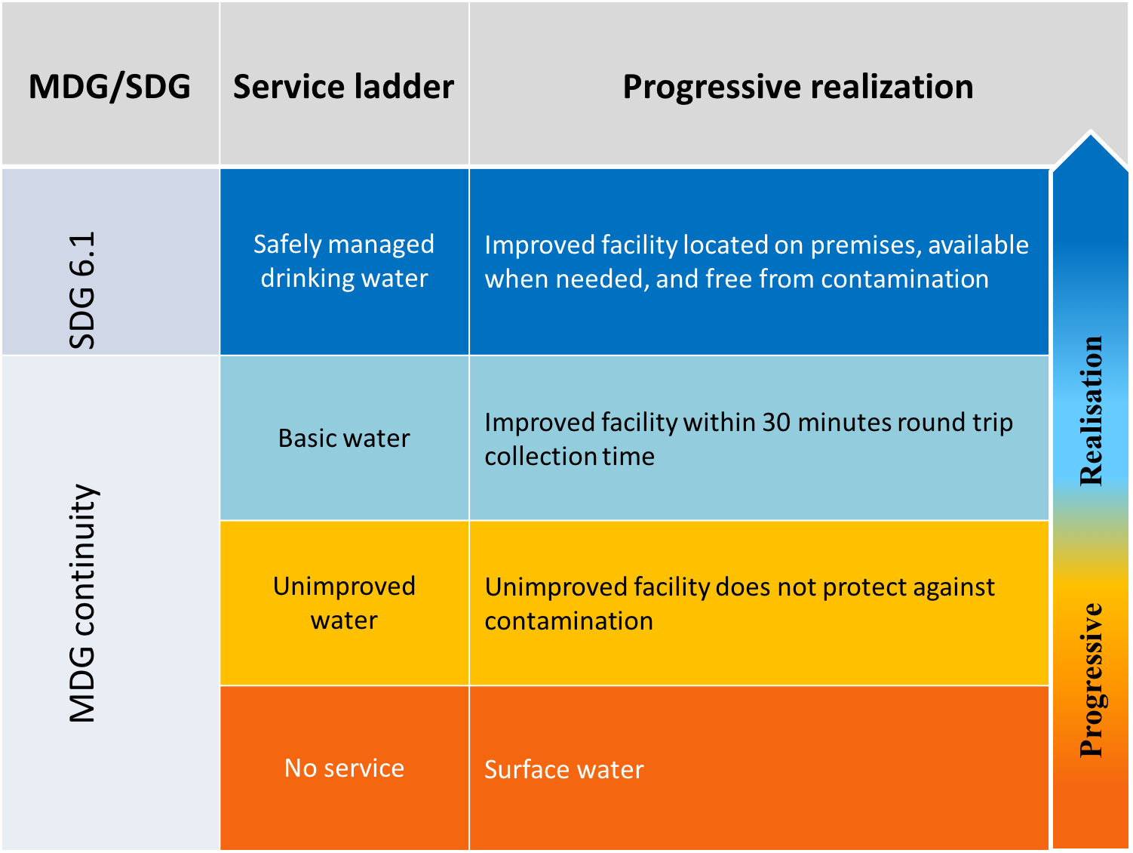

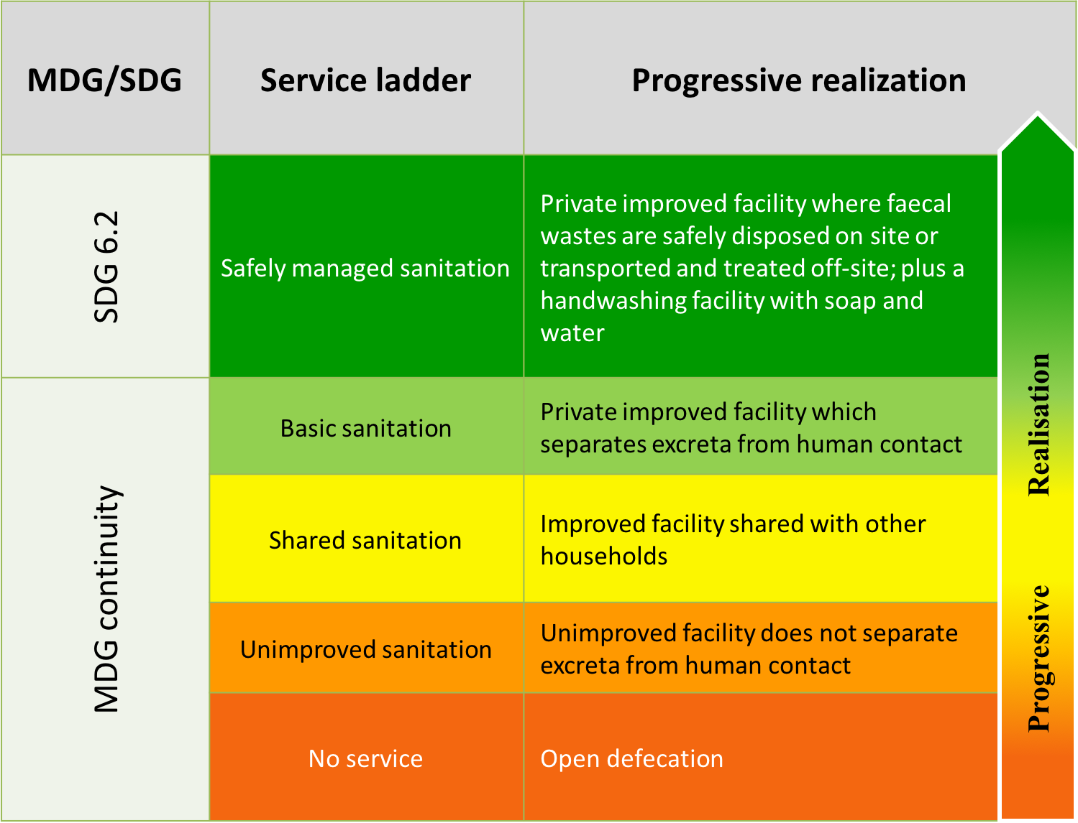

The key differences between the MDGs and SDGs are presented in the matrix below.

Aspect | MDGs | SDGs
Targets | MDG target (1990 – 2015)  Halve the proportion of people without sustainable access to safe drinking water and basic sanitation | SDG targets (2016 – 2030)  Achieve universal and equitable access to safe and affordable drinking water for all  Achieve access to adequate and equitable sanitation and hygiene for all and end open defecation paying special attention to the needs of women and girls and those in vulnerable situations
Indicators | MDG target indicators  - Proportion of population using an improved drinking water source  - Proportion of population using an improved sanitation facility | SDG targets indicators  - Percentage of the population using safely managed drinking water services  - Percentage of the population using safely managed sanitation services, including a hand-washing facility with water and soap
Definitions | MDG target indictors - definitions  - Water supply: households taking their drinking water from a household connection (piped water), a public standpipe, a borehole, a protected dug well, a protected spring, rain water collection.  - Limitations: water safety and sustainability not reflected  - Sanitation: households using toilets connected to a public sewer or a septic tank, using a pour-flush toilet, a pit latrine, a ventilated improved pit latrine. Households sharing an improved toilet NOT included.  - Limitations: open disposal of sewage, pit content not reflected | SDG target indicators – definitions  - Water Supply: Population using an improved drinking water source which is:  - Accessible: located on premises  - Available: available when needed  - Safe: free of faecal and priority chemical contamination  - Sanitation: Population using an improved sanitation facility (including a handwashing facility with water and soap) that is:  - not shared with other households  - excreta are safely disposed in situ or transported and treated off-site

The Sindh WASH Sector Development Plan is designed to be SDG compliant and aims to meet SDG targets, while recognising that some aspects like quality, safely managed, on-premises, not shared etc. may take some time to be achieved.

SECTOR OVERVIEW

Demographics

Sindh is a densely populated and most urbanised province of Pakistan accounting for 24% of the country's total population. The population of Sindh increased from 41.248 million in 2010, to 45.998 million in 2015, and is expected to reach 70 million or more by 2050. The population growth rate in 1998 was 2.80%, and the highest was for Karachi district with 3.56%. Between 1981 and 1998, the population of Karachi district almost doubled from 5.437 million to 9.856 million. Karachi City district alone had an estimated population of 16.459 million in 2012. The largest districts after Karachi district with a population over 1.5 million in 2012 are Larkana, Ghotki, Khairpur, Shaheed Benazirabad (previously Nawabshah), Dadu, Hyderabad, Badin, Thatta and Sanghar, while all the rest are under 1.5 million with Tando Mohammad Khan being the smallest district with 0.6 million. About 52.5% of the population is male and 47.5% is female. Similar proportions are found in all divisions. The trend of urbanisation and a growing population will continue to increase demands for sector and sub-sector services.

Institutions

At provincial level, the four main departments/agencies responsible for water and sanitation are Local Government and Town Planning Department (LG&TPD), Public Health Engineering and Rural Development (PHE&RDD), Karachi Water and Sewerage Board (KW&SB) and Hyderabad Water and Sanitation Authority (H-WASA). Generally, water supply schemes in urban areas are developed and maintained by the LG&TPD, while schemes for rural areas are developed by PHE&RDD and then handed over to the communities. Further, KW&SB is responsible for production, transmission and distribution of potable water to the citizens of Karachi, while the Northern Sindh Urban Services Corporation (NSUSC) develops and maintains water supply schemes for seven cities (Khairpur Mirs, Sukkur, New Sukkur, Rohri, Larkana, Shikarpur and Jacobabad). The Water and Sanitation Authority (WASA) Hyderabad has the responsibility to provide water to the urban localities of Hyderabad. Coordination mechanisms between the departments/agencies need to be improved owing to the inter-dependence between the services required. Several national and international partners collaborate with the Government and include UNICEF, Sindh Rural Support Programme (SRSP), WSP, Plan International,etc.

With regards to governance of water and sanitation, the institutional structure is as follows:

- At the provincial level – Local Government and Housing Town Planning Department (LG&HTPD), Public Health Engineering and Rural Development Department (PHE&RDD), Karachi Water and Sewerage Board (KW&SB); Karachi Development Authority; Karachi Metropolitan Corporation; Northern Sindh Urban Services Corporation (NSUSC); Hyderabad Water and Sanitation Authority (H-WASA); Community Development Programme (CDP); Special Initiatives by Planning and Development Department (P&DD)
- Local governments – Metropolitan Corporation; District Councils; Municipal Corporation; Municipal Committees and Union Administration are responsible
- Rural Water Supply Schemes – planned, designed and executed by PHE&RDD, while operation and maintenance (O&M) is the responsibility of LG&HTPD and Community Based Organisations (CBOs)

Drinking Water

Figure 2 - Main supply of drinking water trends 2007-08 to 2013-14 in Sindh
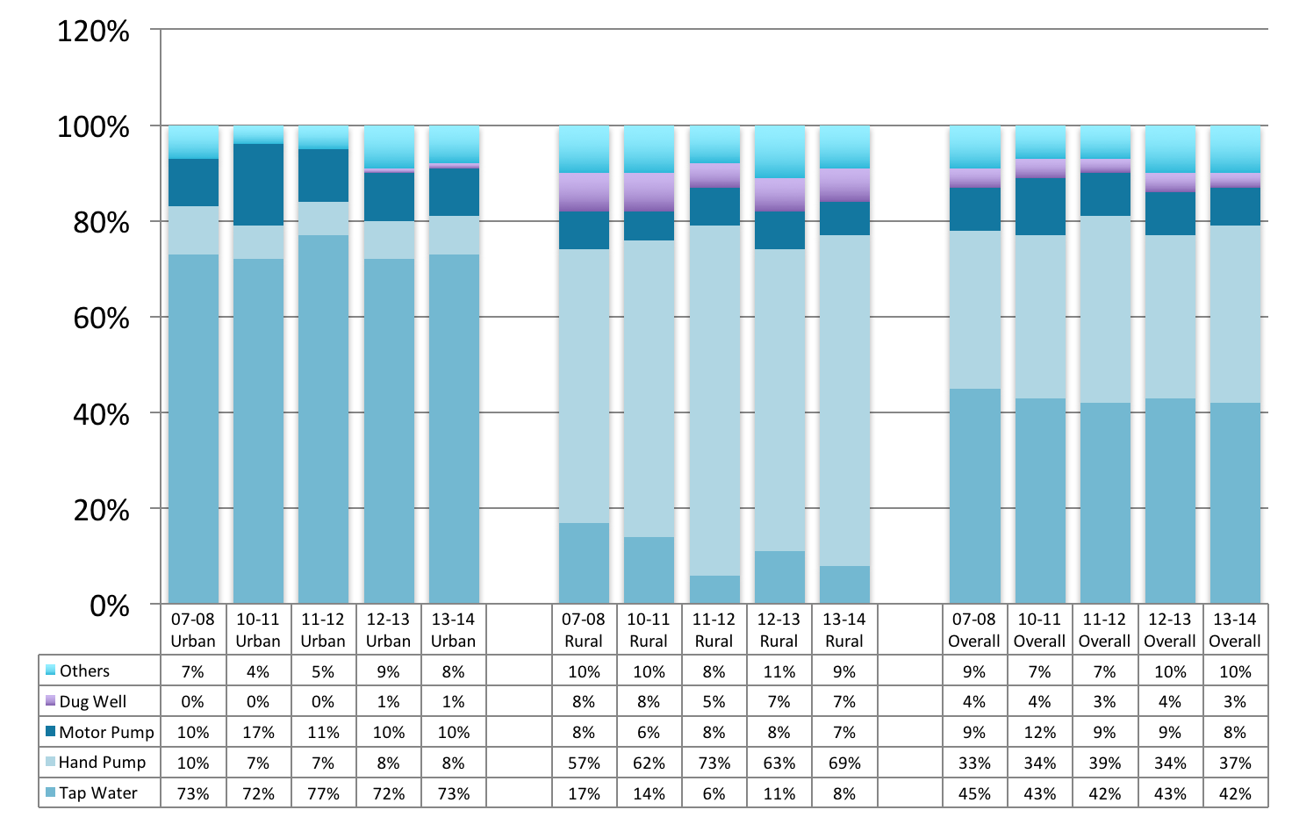
(Source: Pakistan Social and Living Standards Measurement Surveys 2007-08, 2010-11, 2011-12, 2012-13 and 2013-14)

Overall in Sindh, 42% of households are using tap water as the main supply of drinking water in 2013-14 as compared to 43% in 2010-11, followed by hand pump with 37% in 2013-14 as compared to 34% in 2010-11 and motor pump with 8% in 2013-14 as compared to 12% in 2010-11. The proportion of households using tap water as a main supply of drinking water is higher in urban areas, 73% as compared to only 8% in rural areas. Fig 2 illustrates that there is an increasing trend of ‘others’ in urban areas and hand pump being used as a main supply of drinking water in rural areas.

While comparing districts, 73% of households in Hyderabad and 86% in Karachi districts use tap water as the main supply of drinking water, followed by Jamshoro with 38%, Mirpur Khas with 35% and Sukkur with 33%. On the other hand,Dadu, Matiari, Tando Allah Yar, Tando Mohammad Khan, Jacobabad, Kashmore, Larkana, Shikarpur, Tharparkar, Khairpur and Nawabshah (Shaheed Benazirabad) have 10% or less of tap water.

The main supply of drinking water in rural areas is hand pump in 69%, followed ‘others’ by in 9%.

The Multiple Indicator Cluster Survey 2014 in Sindh reveals that overall 90.5% of household membersuse an improved source of drinking water. About 3.0% of household members use drinking water with over 10 ppb Arsenic concentration.

Both surveys do not address the issue of quality of drinking water, which is an area of critical concern.

Of those households that use an unimproved source of drinking water supply (9.5%), only 12.8% household members use an appropriate water treatment method.

Sanitation

In Sindh, about 65% households have flush toilet, with 98% in urban and 29% in rural areas. About 23% of households have non-flush toilet facilities, while 12% of households reported no toilet. In rural areas, 24% households reported having no toilet compared to 1% in urban areas.

With regards to districts, Tharparkar had the highest proportion of households with no toilet (47%), followed by Umer Kot with 35%, Badin with 32% and Thatta with 24%.

Figure 3 illustrates a rising trend of use of flush toilet in both overall and rural areas, although it seems very gradual in urban areas. Furthermore, there has been a 20% reduction in ‘No toilet’ category in rural areas and 20% reduction overall in Sindh in the last five years.

Figure 3 - Sanitation trends 2007-08 to 2013-14 in Sindh
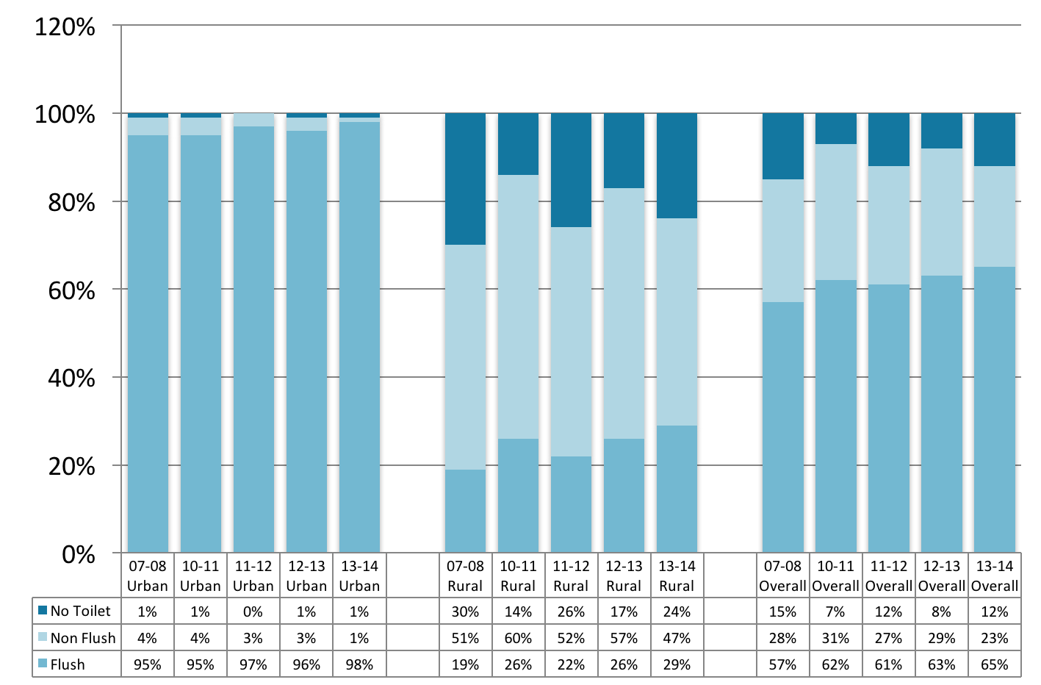
(Source: Pakistan Social and Living Standards Measurement Surveys 2007-08, 2010-11, 2011-12, 2012-13 and 2013-14)

LEGISLATION AND POLICIES

The key legislations and policies and their salient features that relate to water and sanitation are presented below.

Pakistan EPA Act, 1997

The Pakistan Environmental Protection Act 1997 was enacted on December 3, 1997. Some of its salient features are as follows:

Pakistan Environmental Protection Council

Apart from ensuring environmental protection, the council is authorised to:

- Approve comprehensive national environmental policies and ensure their implementation within the framework of a national conservation strategy as may be approved by the Federal Government from time to time
- Provide guidelines for the protection and conservation of species, habitats, and Biodiversity in general, and for the conservation of renewable and non-renewable resources
- Consider the National Environment Report and give appropriate directions thereon

The Council may, either itself or on the request of any person or organisation, direct the Federal Agency or any Government Agency to prepare, submit, promote or implement projects for the protection, conservation, rehabilitation and improvement of the environment, the prevention and control of pollution, and the sustainable development of resources, or to undertake research in any specified aspect of environment.

Pakistan Environmental Protection Agency

Among its major activities, the agency is also responsible for:

- Prepare, in coordination with the appropriate Government Agency and in consultation with the concerned sectoral Advisory Committees, national environmental policies for approval by the Council
- Prepare and publish an annual National Environment Report on the state of the environment
- Prepare or revise, and establish the National Environmental Quality Standards (NEQS) with approval of the Council
- Ensure enforcement of the National Environmental Quality Standards
- Establishing standards for the quality of the ambient air, water and land, by notification in the official Gazette, in consultation with the Provincial Agency concerned
- Establish systems and procedures for surveys, surveillance, monitoring, measurement, examination, investigation, research, inspection and audit to prevent and control pollution, and to estimate the costs of cleaning up pollution and rehabilitating the environment in various sectors
Prohibition of Certain Discharges or Emissions

Subject to the provisions of this Act and the rules and regulations made there under, no person shall discharge or emit or allow the discharge or emission of any effluent or waste or air pollutant or noise in an amount, concentration or level which is in excess of the National Environmental Quality Standards or, where applicable.

No person shall import hazardous waste into Pakistan and its territorial waters, Exclusive Economic Zone and historic waters.

Initial Environmental Examination and Environmental Impact Assessment

No proponent of a project shall commence construction or operation unless he has filed with the Federal Agency an initial environmental examination or, where the project is likely to cause an adverse environmental effect, an Environmental Impact Assessment (EIA), and has obtained from the Federal Agency approval in respect thereof.

Environmental Protection Order

Where the Federal Agency or a Provincial Agency is satisfied that the discharge or emission of any effluent, waste, air pollutant or noise, or the disposal of waste, or the handling of hazardous substances, or any other act or omission is likely to occur, or is occurring or has occurred in violation of the provisions of this Act, rules or regulations or of the conditions of a license, and is likely to cause, or is causing or has caused an adverse environmental effect, the Federal Agency or, as the case may be, the Provincial Agency may, after giving the person responsible for such discharge, emission, disposal, handling, act or omission an opportunity of being heard, by order direct such person to take such measures that the Federal Agency or Provincial Agency may consider necessary within such period as may be specified in the order.

In particular and without prejudice to the generality of the foregoing power, such measures may include:

- Immediate to stoppage, preventing, lessening or controlling the discharge, emission, disposal, handling, act or omission, or to minimise or remedy the adverse environmental effect
- Installation, replacement or alteration of any equipment or thing to eliminate or control or abate on a permanent or temporary basis, such discharge, emission, disposal, handling, act or Commission
- Action to remove or otherwise dispose of the effluent, waste, air pollutant, noise, or hazardous substances
- Action to restore the environment to the condition existing prior to such discharge, disposal, handling, act or omission, or as close to such condition as may be reasonable in the circumstances, to the satisfaction of the Federal Agency or Provincial Agency

Further sections lay out the penalties applied to the various stakeholders in case of non-compliance with the Act.

Sindh Water Management (Amendment) Act, 2005

This Act is derived from and replaces the Sindh Water Management Ordinance, 2002, which established the Sindh Irrigation and Drainage Authority (SIDA) and repealed the Sindh Irrigation and Drainage Authority Act, 1997 and the Sindh Irrigation Water Users’ Association Ordinance, 1982. The functions of SIDA shall be to:

- Operate and maintain the parts of the irrigation system such as barrages and outlets assigned to it
- Operate and maintain the parts of the drainage system assigned to it including spinal drains and inter-Area Water Board (AWB) drains
- Carry out river flood protection and maintain the infrastructure in the Province of Sindh
- Advise the Government on any matter strategic or tactical, related to its functions and tasks or to the water management system as a whole e.g. irrigation or drainage contribution rates, drought management and sea water intrusion
- Manage the transition process, to promote the formation, growth and development of the AWBs and Farmer organisations (FOs) into self-supporting and financially self-sustaining entities within a period of seven to ten years of their establishment
- Perform any other function conferred to it under this Act

Under this Act, the Government may constitute Area Water Boards (AWBs), together with their respective territorial jurisdiction, provided that the AWBs existing immediately before the commencement of this Act shall continue to function until replaced by new AWBs under this Act.

Each AWB shall establish and maintain a Water Allocation Committee (WAC). If the AWB has branch canals taking off from the main canal and conveying water to FOs, the AWB shall also establish and maintain WACs at branch level.For the purpose of a smooth interaction with the local communities in which the AWBs operate, each AWB may establish a Community Advisory Committee (CAC).

In every local area, a group of non-elected farmers may, for energising the farming community and improving service delivery, set a Water Course Association (WCA) and undertake voluntary, proactive and self-help initiatives. The WCA shall register with the respective FO.

In every local area, a group of non-elected farmers, who are interested, may undertake voluntary, proactive and self-help initiatives in connection with the drainage system and form a Drainage Beneficiaries’ Group (DBG) and register it with the FO.

The Act also proposes the establishment of a Regulatory Authority of Irrigation, Drainage and Flood Protection. The functions of the Regulatory Authority shall be to ensure compliance with the statutory provisions laid down in this Act. In addition, the Regulatory Authority shall promote effective interaction and collaboration between SIDA, AWBs, FOs and their various support bodies as well as fair dealing between FOs, WCAs, DBGs and their members. It shall, when invited to do so, arbitrate between them. Until the Regulatory Authority is established, SIDA shall perform the functions of the Regulatory Authority under this Act.

Sindh Municipal Water Act (Draft), 2012

This states that all water used, or intended to be used for drinking, domestic, recreational, horticultural, industrial or commercial purposes and such other purposes as may be prescribed shall be declared as municipal water. This categorises water into potable domestic for drinking, non-potable domestic, commercial, industrial, amenity, environmental and institutional.

The draft Act has proposed the establishment of a regulatory authority called the Sindh Municipal Water Commission. Upon establishment of the Commission, the responsibility for regulating the conservation, protection, utilisation, exploitation, development of water resources and the regulation of all municipal water services, including quality assurance of water, water services and tariff shall vest with the Commission.

The Commission shall perform the following functions:

- Manage all sources (shall be the custodian) of municipal water, on behalf of the provincial government
- Maintaining a comprehensive database of all sources of municipal water
- maintaining a comprehensive database of all the bulk and retail service providers in the province
- Setting and notification of standards of water quality and quality of services delivered for all municipal purposes
- Setting and notification of standards and norms for maintaining the quality of water taken from or discharged into any water body
- Suggesting and notifying the measures and means for the effective and sustainable use of water resources for water supply services
- Prescribing the regulations and methodologies for improving the nature, operation, sustainability, operational efficiency and economic viability of water services
- Prescribing the requirements for persons who may install and operate water services works and provide assistance and coordinate with the water utilities and water users for developing and improving the appropriation, usage and disposal of water
- Present an annual report to the Government regarding the overall management and administration of water, including recommendations on measures to be taken by the Government to enhance the quality or quantity of available water
- Develop, promote and support training and professional development of officials and other persons engaged in provision or regulation of water supply and sanitation services
- Carry out research and development, by itself or in collaboration with the specialised institutions of research and higher education, either in the public sector or in the private sector; aimed at conserving, improving and extending the water sources and water services in the province
- Advise the Government on all policy and planning matters related to municipal water

In prescribing standards, the Commission must consider:

- The need for everyone to have a reasonable quality of life
- The need for equitable access to water services
- The operational efficiency and economic viability of water services
- Any norms and standards for applicable tariffs for water services
- Any other laws or any standards set by other governmental or federal government agencies
- Any guidelines and standards prescribed under the Punjab Environmental Protection Act
- Any impact which the municipal water supply services might have on the environment
- The obligations of the Provincial Government as custodian of water resources

Water Services
Under water services, the draft Act further proposes the following:

- Water and Sanitation Master Plan:Every local government must, within one year after the commencement of this Act;

(a) As part of the city or regional master plan; or
(b) Separately, if no process for city or regional master plan has been initiated, prepare
- A draft water & sanitation master plan for its area of jurisdiction: and
- A summary of that plan
(c) The contents of the master plan and summary shall be in accordance with the rules
(d) The draft plan shall be circulated and approved by the council, after vetting by the Commission
(e) The master plan shall be published on the website as well as printed and shall be made available to the consumers at a reasonable cost
(f) The summary of the plan shall be printed in sufficient numbers and shall be distributed free of cost to all the consumers or potential consumers

- Deviation from the Master Plan:No substantial deviation from the master plan is valid unless it is embodied in a new master plan adopted in accordance with the procedure set out in the rules.

- Reporting on Implementation of Local Government Plans:
(1) A local government must report on the implementation of its plans in such manner and form as may be prescribed during each financial year
(2) The report must be:
(a) Made within four months after the end of each financial year, and
(b) Submitted to the Commission and the Department of Local Government
(3) The Local Government must publicise a summary of its report
(4) A copy of the report and of its summary must be available at the offices of the local government for inspection upon payment of such fee as may be prescribed

Sindh Environmental Protection Act, 2014

Some of the salient features of the Sindh Environmental Protection Act 2014 are as follows:

The Government of Sindh shall, by notification in the official Gazette, establish a Council to be known as the Sindh Environmental Protection Council, which shall among other provisions, approve the Sindh Environmental Quality Standards, and co-ordinate integration of the principles and concerns of sustainable development into socio-economic and development policies, plans and programmes at the provincial, district and local levels.

The Government shall by a notification in the official Gazette establish the Sindh Environmental Protection Agency to exercise the powers and perform the functions assigned to it under the provisions of this Act. The Sindh Environmental Protection Agency shall prepare and publish an Annual Environment Report on the state of the environment in the province; establish standards for the quality of the ambient air, water and land, by notification in the official Gazette in consultation with the other relevant Government Departments/ Agencies; and revise the Environmental Quality Standards with approval of the Council.

Sindh Local Government Act, 2014

The main legislation at present that governs drinking water and sanitation is the Sindh Local Government Act 2014. Some of the main provisions for water and sanitation under this Act are highlighted below.

Functions to be Performed by the Metropolitan Corporation exclusively

Planning development and maintenance of Inter-district roads, bridges, street lights and storm water drains.

Functions to be Performed by Corporations, other than Metropolitan Corporation Municipal Committees and Town Committees

A Corporation, Municipal Committee or Town Committee shall, within the limits of the funds at its disposal provide or cause to be provided, a supply of wholesome water sufficient for public and private purpose.

Private Source of water supply
All private sources of water supply within the Local Area concerned shall be subject to control, regulation and inspection by the Corporation, Municipal Committee or Town Committee.

Drainage
A Corporation, Municipal Committee or Town Committee shall, within the limits of the funds at its disposal provide adequate system of public drains in the Local Area and all such drains shall be constructed, maintained kept cleared and emptied with due regard to the health and convenience of the public.

A Corporation, Municipal Committee or Town Committee may, and if required by Government, shall, in the prescribed manner, frame and execute a water supply scheme for the construction and maintenance of such works for the provision, storage and distribution of water as may be necessary.

Where a piped water supply is provided, the Council concerned may supply water to private and public premises in such manner and on payment of such charges as the bye-laws may provide.

Private sources of water supply
- No new well, water-pump or any other sources of water for drinking purposes shall be dug, constructed, or provided except with the sanction of the Council concerned
- The Council concerned may by notice require the owner or any person having the control of any private source of water supply used for drinking-
- to keep the same in good order and to clear these from silt, refuse and decaying matter from time to time;
- to protect the same from contamination in such manner as the Council concerned may direct, and
- if the water therein is proved to the satisfaction of the Council concerned to be unfit for drinking purposes, to take such measures as may be specified in the notice to prevent the use of such water for drinking purposes.

Drainage
Every owner or occupier of any land or building within the Local Area may, with the previous permission of the Council concerned and subject to such terms and conditions, including the payment of fees, as the Council may impose, cause his drains to be emptied into public drains.

All private drains shall be subject to control, regulation and inspection by the Council concerned and the Council may, in such manner as the bye-laws may provide, require the provision, alteration, covering, clearing and closing of private drains.

Drainage Schemes
A Corporation, Municipal Committee or Town Committee may, and if so required by Government, shall prepare a drainage scheme in the prescribed manner for the construction of drains at public and private expenses, and other works for the effective drainage and disposal of sullage.

A drainage scheme prepared under clause (1) shall be submitted for approval to Government which may approve it, reject it, or approve it subject to such modifications as it may deem fit.

The drainage scheme as approved by Government shall be executed and implemented in such manner within such period and by such authority as may be specified by Government.

The Council concerned may, by notice, require the owner of any building or land within the local area -
- to construct such drains within the building or land or the street adjoining such building or land, as may be specified in the notice;
- to remove, alter, or improve any such drains; and
- to take such other steps for the effective drainage of the building or land as may be specified.

Functions of District Councils

To discharge the overall responsibility for the identification of projects and appraisal and approval of projects prepared and to be constructed by Union Councils in the following sub-section:-
- Primary, Middle and Secondary Schools
- Rural Health Centres
- Basic Health Units
- Family Welfare Clinics
- Piped Water Supply
- Potable Water Storage Tanks
- Hand Pumps
- Sanitation
- Rural Roads

Functions of Union Councils

To act as construction agency for the following sub- sectors:-
- Primary, Middle and Secondary Schools
- Rural Health Centres
- Family Welfare Clinics
- Basic Health Units
- Piped Water Supply
- Potable Water/Storage Tanks/Tube-wells, and Wells
- Hand Pumps
- Sanitation
- Rural Roads

To encourage and to facilitate the formation of associations for collective use and collection of charges for services such as electric supply and water course management, co-operative tubewell development, co-operative for input supplies and output marketing, water-course management, etc.

Provision and maintenance of wells, water pumps, tanks, ponds, and other works for the supply of water.

Adoption of measures for preventing the contamination of the sources of water supply for drinking.

Prohibition of the use of the water of wells, ponds, and other sources of water supply suspected to be dangerous to Public Health.

Regulation or prohibition of the watering of cattle, bathing or washing at or near wells, ponds or other sources of water reserved tor drinking purposes.

Regulation or prohibition of the steeping of hemp jute or other plants in or near ponds or other sources of water supply.

Taxes, Rates, Tolls and Fees to be Levied by Karachi Metropolitan Corporation

- Conservancy Tax.
- Drainage Tax.

Taxes, Rates, Tolls and Fees which may be Levied by Municipal Committees, Town Committees and Corporations excluding the Metropolitan Corporations

- Conservancy Rate.
- Rate for the execution of any work of Public Utility.
- Rate for the provision of water works or the supply of water.

Taxes, Rates, Tolls and Fees to be Levied by District Councils and Union Councils

- Drainage Rate.
- Rate for the execution of any works of Public Utility.
- Conservancy Rate.
- Rate for the provision of water works or the supply of water.

Sindh Solid Waste Management Board Act, 2014

The Sindh Solid Waste Management Board Act 2014 provides for the establishment of a Board called as the Sindh Solid Waste Management Board for the collection and disposal of solid and other waste in the Province of Sindh.

Some of the salient features and functions of the Board are as follows:

- The Board shall have the right over the solid waste related issues, assets, funds and liabilities of the Councils and shall possess sole rights on all kinds of solid waste within the limits of all Councils
- The Board shall have the authority to grant permission to individuals, institutions industries, factories, workshops, furnaces, compost making and power generation from the solid waste, for segregation of the recyclable material from the waste, collection, treatment, sale and purchase, recycling or disposal of any kinds of waste

Various legislations, rules and regulations impact on water and sanitation services in the province of Sindh. These are summarised inTable7below.

Table 7 - Additional Processes and Institutions affecting Water and Sanitation
FRESH WATER
Sindh Water Management Ordinance 2002 (No. XL) | This Ordinance establishes a framework for executing and managing schemes for irrigation, drainage and flood management. Water is defined broadly in section 2(r) as “any water standing or flowing on surface [sic] or found in the soil at any place in the province”.
Sindh Irrigation and Drainage Authority Rules 1999 | These Rules were framed under the Sindh Irrigation and Drainage Authority Act 1997. Although the 1997 Act has been repealed by the Sindh Water Management Ordinance 2002, rules framed under the 1997 Act are not specifically repealed or saved by the 2002 Ordinance. The Rules specify terms and conditions related to the supply of water, including the individual share of each canal command area, and allow the Authority to determine charges for water supply as well as “non-water services” provided (sections 8–10). Criteria according to which the aggregate water entitlement of each canal command area is determined include an “increased requirement for industrial, domestic, environmental, or health-related water usage” (section 10(2)).
Coastal Development Authority Act 1994 (No. XXVIII) | This Act establishes an Authority that is responsible for the development, improvement and beautification of the coastal areas of Thatta and Badin districts (section 7(1)). The Authority may plan and execute schemes related to a number of sectors including drinking water (section 7(2)(a)).
Port Qasim Authority Act 1973 (No. XLIII) | This federal Act establishes an Authority to oversee the planning, development and management of Port Qasim. The Authority is charged with preparing a master plan for the port area (section 10), and may call upon government agencies and local bodies to prepare and execute schemes in the port area related to matters over which these agencies ordinarily hold authority (section 11(2)). Among other activities, such schemes may provide for the utilisation of water and “other natural resources” (section 11(2)(f)), as well as environmental control and the prevention of pollution (section 11(2)(j)).
COASTAL AND MARINE
Karachi Building and Town Planning Regulations 2002 Notification No. SO(Land)HTP/KBCA-3-39/2000 | These Regulations, issued under the Sindh Buildings Control Ordinance 1979, provide exhaustive rules and procedures for construction and development activities in the city (section 1-2). They apply to all of Karachi except for cantonment areas (section 1-1.3).
URBAN AND RURAL DEVELOPMENT
Sindh Development Authorities Laws (Amendment) Ordinance 2007 | This Ordinance revives the Larkana and Sehwan development authorities.
Sindh Development Authorities Laws (Revival and Amending) Ordinance 2006 | This Ordinance revives the Lyari and Malir development authorities.
Badin Development Authority Act 1995 (No. VII) | This Act establishes the Badin Development Authority, which is responsible for public works (section 7), including the supply and distribution of potable water (section 21).
Larkana Development Authority Act 1994 (No. XXI) | This Act establishes the Larkana Development Authority, which maintains public works, conducts research and provides technical guidance for development activities, and collaborates with federal, provincial or private-sector agencies engaged in development work (section 9).
Lyari Development Authority Act 1993 (No. X of 1994 [sic]) | This law establishes the Lyari Development Authority, which maintains public works, conducts research and provides technical guidance for development activities, and collaborates with federal, provincial or private-sector agencies engaged in development work (section 8).
Malir Development Authority Act 1993 (No. XI of 1994 [sic]) | This Act establishes the Malir Development Authority, which is responsible for a wide range of development activities. These include implementing schemes for the development of urban, rural and industrial areas (section 8(1)(viii)), and the provision of “public works” (section 8(1)(ix)).
Sehwan Development Authority Act 1993 (No. V of 1994 [sic]) | This law establishes the Sehwan Development Authority, which is responsible for development activities in the taluka of Sehwan, as well as other areas of Dadu district (section 1(2)). The Authority is responsible for the “overall development, improvement and modification” of areas that lie within its jurisdiction (section 7(i)). It formulates and enforces “schemes” (section 7(ii)), builds and operates facilities for water supply, drainage, sewerage and solid waste disposal (section 7(iii)), and performs “other functions” assigned to it by the provincial government (section 7(v)). The Authority is also responsible for the production and supply of potable water to “Government agency” of (section 21).
Sindh Katchi Abadis Act 1987 (No. II) | This law establishes an Authority to develop, improve and ‘regularise’ squatter settlements, known as katchi abadis. The Authority is responsible for providing “civic amenities and civic services” to katchi abadis (section 11(2)(xiii)). This includes preparing schemes for the supply of water, gas and electricity; the construction of roads and streets; and arrangements for waste disposal (section 21).
Sindh Arid Zone Development Authority Act 1985 (No. II) | This Act provides for the establishment of an Authority to develop “arid zones” throughout the province. Such areas are defined in section 2(a) simply as those areas “declared as such” under section 3. The Authority is responsible for developing “lands” and water resources, as well as roads and public amenities (section 12(2)(iii)).
Sindh Buildings Control Ordinance 1979 (No. V) | This law provides for the regulation and control of construction activities, and the establishment of area building control authorities (section 4). Builders and property developers cannot operate without a licence (section 9). The building authority also grants licences to architects, planners, inspectors and engineers (section 8). The Karachi Building Control Authority (KBCA) was created under section 4 of this Ordinance.
Karachi Building and Town Planning Regulations 2002Notification No. SO(Land)HTP/KBCA-3-39/2000 | These Regulations, issued by the KBCA under section 21-A of the Sindh Buildings Control Ordinance 1979, provide exhaustive rules and procedures for construction and development activities in the city (section 1-2). They apply to all of Karachi except for cantonment areas (section 1-1.3).
Hyderabad Development Authority Act 1976 (No. XIII) | This Ordinance establishes the Hyderabad Development Authority, which is responsible for the “overall development, improvement and beautification” of urban areas (section 9(1)(i)) in the now-defunct Hyderabad Division.
Karachi Development Authority Order 1957 (No. 5) | This order, which establishes the Karachi Development Authority, or KDA (section 3), provides for the development and improvement of certain areas in the city. The KDA is responsible for water supply to “constituent bodies” (section 113) as well as individual consumers (section 114).
(Adapted from Environmental Law in Pakistan Governing Natural Resources and the Processes and Institutions that affect them – Sindh. Part V. IUCN, 2007)

Karachi Water and Sewerage Board Act, 1996

The Karachi Water and Sewerage Board Act 1996 provides for the establishment of a Board for supply of water and disposal of sewerage in the Karachi Division.

The main functions of the Board include the following:

(i) sanction in the manner and on payment of fees as may be prescribed by regulations:
(a) water connection
(b) water supply to tankers and
(c) sewerage connection

(ii) levy, collect or recover rates, charges of fees for water supply and sewerage service, including arrears thereof
(iii) have the power to reduce, suspend or disconnect the water supply in the event of contravention of the provisions of this Act or regulations
(iv) have the power to impose surcharge, not exceeding double the amount due, if rates, charges or fees for water supply or sewerage service or the arrears thereof are not paid within the time fixed by the Board
(v) have full financial powers within the budget grant
(vi) make regulations with the approval of the Government
(vii) undertake construction improvement, maintenance and operation of:
(a) water works including wells and recharge facilities for collecting, purifying, pumping, storing and distributing water to all types of consumers.
(b) Sewerage works for collecting, pumping, treating and disposing of sewerage and industrial waste,

(viii) Assess the position of water supply from time to time and regulate water supply.
(ix) Review the existing schemes or prepare new schemes relating to water works and sewerage work and undertake execution thereof with the approval of the Government,
(x) Regulate, control or inspect water connection, sewer lines and service lines including internal fittings.
(xi) maintain accounts and records of the Board
(xii) prepare and submit to Government schedule of water and sewerage tariff, rates, charges or fees to be levied by it,
(xiii) prepare and revise schedule of posts for the Board and submit it to the Government for approval,
(xiv) produce and supply potable water
(xv) place, maintain aqueducts, conduits, sewers etc.

Supply of water and execution of schemes

(1) The Board shall be responsible for bulk production of potable water and its distribution in accordance with the provisions of this Act.
(2) The Board shall ensure that the water supplied by it is duly filtered, treated and tested and is fit for human consumption.
(3) The Bard shall arrange retail distribution of water within its jurisdiction excluding the areas receiving water supply through constituent Bodies.
(4) The Board may, subject to availability, supply water to any person or authority in the area or areas notified under this Act.
(5) The Board shall continue to make bulk water supply to the constituent Bodies at such rates and subject to such terms and conditions as may be determined by the Board.
(6) A standing committee consisting of the Chairman or his nominee, Commissioner Karachi Division and the Managing Director shall allocate and determine quantity of water to be supplied to each constituent Body.

Provided that until such terms or conditions or quantity of water is determined, the Board shall continue the bulk water supply according to the arrangements existing immediately before the commencement of this Act.

(7) If the Board does not accept the decision of the standing committee, the Managing Director shall report the matter to Government for appropriate orders and the orders issued by Government shall be complied with by the Board.

Explanation:- The tem “Constituent Bodies” shall mean and include the Karachi Development Authority, Karachi Port Trust, Cantonment Board of Karachi, Sindh Industrial & Trading Estate, Karachi Pakistan Steel Mills Corporation Defence Service or any other body or organisation notified by Government.

(8) Until otherwise notified by Government, the Authority shall continue to execute the Hub Dam Water Supply Stage I and Phase-IV of the Greater Karachi Bulk Water Supply Stage I and Sewerage Disposal Projects.
(9) The Board or any person authorised by it shall have right to place and maintain aqueducts, conduits and lines of mains, drains, sewers or pipes, over, under, along or across any immovable property without acquiring such property, and to enter on such property for the purpose of examining, repairing, altering or removing any aqueducts, conduits or lines of mains, sewers or pipes.

Pakistan Water Sector Strategy, 2002

The National Water Policy was one of the initiatives taken by the Government of Pakistan at the beginning of the current millennium for the development of water sector in the country. The Pakistan Water Sector Strategy 2002 provided the road map for implementing the policy framed for development of the water sector. The Strategy comprises three independent documents as under:

- The ‘National Water Sector Profile’ which summarises and details all aspects of water availability and utilisation as they exist. As such it will become a standard source document for all future work in water sector
- The ‘National Water Sector Strategy’, which identifies the key issues and objectives for the water sector and proposals for planning, development and management of water resources and their use in all water sub-sectors
- The ‘Medium Term Investment Plan’ which identifies the key programmes and projects which should be undertaken up to 2011 as the initial contribution to achieve the objectives of the strategy

As in the case of the National Water Policy, the Water Sector Strategy is also mainly focused on irrigation, which is the predominant user of water. However domestic water supply having the first priority in any water allocation the Strategy has given due importance to this sub-sector in its discussions.

The following key factors have been identified by the Strategy as the driving force for development of water resources in the country:

- Population growth
- Increasing agricultural demands
- Domestic water supply needs
- Dwindling water resources; and
- Cross cutting issues

Linking the discussion on water resources and domestic water supply is the factor of additional demand of water for domestic needs by 2025. This would result in a shortfall of 11.3 million acre feet of water per annum available for irrigation if additional water resources are not developed.

Water conservation is a key component of the strategy. Most of the water saving will have to come from the irrigation sub-sector because it is by far the largest user of water.

Water quality has been identified as one of the main issues in water sector in Pakistan and its improvement a key component of the strategy. Poor water quality affects all sub-sectors as well as the quality of life of the people. Pollution of water sources is caused mainly by municipal and industrial waste water disposal and disposal of saline and chemically polluted agricultural runoff. Attacking this problem will require the cooperation of several agencies including municipal service providers and industrial sector.

Institutional and management issues also cut across the whole of the water sector. The lack of financial sustainability in water service delivery, caused by low levels of water tariff and their collection, has led to a strain on governmental resources and deteriorating infrastructure in domestic as well as irrigation sub-sectors. Failure to improve this will result in continued deterioration and poor service delivery.

The water sector strategy lays out a road map to guide the management and development of water sector and service delivery in water industry.

The Strategy divides the primary issues in the water sector into three categories, namely, Institutional and Management issues, Social and Financial Issues and Technical Issues.

The Institutional and Management issues include- inadequate coordination between various organisations of various sub-sector of water; Absence of an inter-ministerial, inter-provincial body to oversee water sector planning, management and development; changing administration under the devolution plan and uncertainty in technical capacity during transition, particularly in domestic water supply and sanitation sub-sectors; and need for improvement of water sector infrastructure and activities.

Social and Financial Issues include: Limited availability of funds for the water sector; lack of financial sustainability in water sector services due to low level of public sector funds for O&M and insufficient cost recovery; limited private sector investment or participation; and inadequate public awareness of water sector issues.

Technical Issues include: Increasing demand for water; inefficient use of water; inadequate domestic water supply and sanitation coverage and quality of service; deteriorating water quality; and deteriorating infrastructure.

The key elements of the strategy for the water sector comprise water conservation, stakeholder participation in management, improving public awareness and understanding of issues, a good quality MIS for water, improving cooperation and coordination amongst various agencies in the water sector, ensuring long terms financial sustainability of infrastructure and services through reasonable cost recovery, improvement of water quality, and involvement of the private sector.

The details of the strategy relating to domestic water supply and sanitation sub-sectors are as follows.

Overall Objectives

The main objectives of the strategy are to:

- Increase coverage of clean water supply for urban population to 96%
- Increase coverage of functional sanitation for urban population to 80%
- Achieve full compliance with EPA standards for drinking water
- Achieve full compliance with EPA standards for wastewater disposal
- Develop a water quality Information Management System

Financial Objectives

Achieve financial sustainability in all water sector developments through:
- Appropriate levels of cost recovery to make operating agencies financially viable
- Appropriate tariffs to ensure provision of adequate services to all users, including poor and disadvantaged
- Urban wastewater charges based on cost recovery and “polluter to pay‟ principle
- Private sector participation in appropriate areas of water management

Water Quality Objectives

Water quality objectives based on:

- Establishing and maintaining water quality standards for potable water
- Ensuring that wastewater effluent is treated before disposal
- Preservation of surface and groundwater resource to ensure sustainability of supply

Management Measures

- Establishing a Coordinating and Support body on a country-wide basis for urban water supply and sanitation sub-sector
- Developing a strategy and medium and long-term plan including tariff levels, improved collection methods, demand management measures, participation by the private sector, and infrastructure improvement and expansion
- Formulating appropriate institutional arrangements for smaller cities and towns in the light of Devolution Plan

Technical Measures

- Renew the existing operational assets to address the maintenance backlog
- Expand water supply and sanitation networks to increase coverage to the stated targets
- Develop additional surface and groundwater resources to meet growth in demand
- Construct new sewage disposal networks in line with EPA‟s effluent disposal regulations

National Drinking Water Policy, 2009

The policy provides a framework to the federal government, provincial governments, Azad Jammu Kashmir, Federally Administered Tribal Areas, local governments and development authorities to address the issues and challenges facing Pakistan in terms of access to safe drinking water.

The goal of the policy is to provide clean and safe drinking water to improve the quality of life of people through decreased death and illness caused by water borne diseases at an affordable cost and in an equitable, efficient and sustainable manner by 2020. The key principles of the policy include:

- Providing access to safe drinking water to every citizen of Pakistan by developing new and water supply systems in urban and rural areas especially the neglected areas by using improved technology and standardisation
- Allocate water for domestic purposes such as drinking, hygiene, sanitation etc. on priority basis
- Take measures to protect and conserve the surface and groundwater resources by developing ambient water quality standards, rain water harvesting, community management of local resources, recycling of water, etc.
- Using water treatment systems and methods to ensure provision of safe drinking water
- Involving communities especially women and children in planning, implementation, monitoring, and operation and maintenance of water supply systems
- Creating public awareness through intensive information, education and communication campaigns to promote water safety and conservation, and sage hygienic practices
- Carry out capacity development efforts to streamline and upgrade the roles and responsibilities of various agencies concerned with the water sector at the provincial and federal levels
- Promote public private partnerships for enhancing access to safe water, O & M of water supply systems, resource mobilisation and capacity development
- Carry out continuous research and development initiatives to develop new approaches and innovative ideas

National Sanitation Policy, 2006

The policy provides broad framework and guidelines to all governments to enhance and support sanitation coverage in the country through the formulation of sanitation strategies, plans and programs for improving the quality of life of people and a providing a healthy work environment.

The overall sanitation and sewerage coverage in Pakistan is very low. The urban areas fare slightly better than the rural areas. Yet data on the occurrence of cases of diarrhoea suggests that people suffer repeated and continuous exposure to polluted water. Almost 40% of all reported diseases and 30% of all deaths in the country are attributable to faecal contamination of water due to mixing up of water supply and sewerage lines.

The provision of water supply and sanitation facilities in rural areas has considerably increased in the past few years. Apart from reducing health problems this has also considerably improved the financial and economic condition of the poor. There is marked improvement in infant mortality rates due to supply of safer water. There is noticeable reduction in diseases like diarrhoea, typhoid and cholera due to successful implementation of rural water supply and sanitation schemes in Khyber Pakhtunkhwa, Punjab and Sindh. However, the coverage is still low and concerted efforts are needed throughout the country to continue improvement in coverage as well as quality of water supply and sanitation in the rural areas to promote health and hygiene.

The policy primarily focuses on the following activities/premises:

- Safe disposal of excreta by using sanitary latrines, creating a open defecation free environment, industrial and agricultural wastes, safe disposal of liquid and solid wastes, and promotion of health and hygienic practices in the country
- Develop and utilise sewage and water treatment facilities for domestic and industrial use
- Promote the concept of Community Led Total Sanitation
- Develop an institutional and financial framework for the agencies concerned in this sector, along with capacity building initiatives
- Carry out public awareness programmes
- Using appropriate, low cost, easy and cost effective technology
- Achieve sustainable development through the above initiatives
- The sanitation initiatives will be financed by the government
- For monitoring the industrial and municipal effluents, EPA will be the responsible body
- Increasing numbers and access to public toilets
- Promoting public private partnership
- Safe disposal of hospital waste by following the Hospital Waste Management Rules 2005
- Provision of incentives and rewards to tehsils/towns for the implementation of the sanitation policy

National Climate Change Policy, 2012

The Ministry of Climate Change launched Pakistan’s new climate change policy in 2012. Pakistan has been identified as one of the top 16 countries with a high climate change vulnerability index. Many sectors like water resources, agriculture and livestock, human health, forestry, biodiversity, ecosystems, are at great risk of being affected by climate change.

The new policy recommends policy measures and proposes mitigation strategies in particular for energy, transport, town planning, industries, agriculture and livestock and forestry sectors.

While mitigation for water resources is a much broader area, beyond the scope of this review, introduction of climate change mitigation strategies in town planning particularly for water, sanitation and solid waste management is particularly pertinent. Two policy measures recommended, among others, that have a direct bearing on water supply, sanitation and solid waste are:

- Make installation of wastewater treatment plants an integral part of all sewerage schemes
- Ensure separate collection, disposal and re-use of recyclable, composite and biodegradable waste, preferably at source
- Introduce local rainwater harvesting measures

Hospital Waste Management Rules, 2005

Under these Rules, every hospital is responsible for proper management of waste generated by it till its final disposal in accordance with provisions given in these Rules. The Rules require each healthcare facility to constitute a waste management team, and to prepare and implement a waste management plan. The Rules also include guidelines for waste segregation, collection, transportation, storage, and disposal. The Government of Sindh has developed its Sindh Hospital Waste Management Rules, 2014 adapted from the Hospital Waste Management Rules, 2005.

Draft Sindh Drinking Water Policy, 2016

The Vision and Mission of the draft Policy are as follows:

Vision
Our vision for the population of Sindh is to provide safely managed drinking water whose supply is adequate, well maintained and sustainable; and to enhance public awareness about health, nutrition and hygiene related to safe drinking water.

Principles
The main principles of Sindh Drinking Water Policy, adapted from the National Drinking Water Policy 2009 and aligned with the Sustainable Development Goals, are as follows:

- Access to safely managed drinking water is a fundamental right of every citizen and that it is the responsibility of the Government to ensure its provision to all citizens
- Water allocation for drinking purposes shall be given priority over other uses
- In order to ensure equitable access, special attention shall be given to removing the existing disparities in coverage of safe drinking and for addressing the needs of the poor and the vulnerable
- Recognising that inadequate and unsafe water supply and sanitation are a major cause of diarrhoea and nutritional deficiency in children, which as a consequence contribute towards child mortality, safely managed drinking water supply and sanitation shall be integrated in health, nutrition and school health programmes
- Access shall be increased to high quality nutrition-sensitive services, including access to water, sanitation facilities, and hygiene
- Key hygiene actions (safe drinking water, handwashing with soap, safe disposal of excreta, and food hygiene) shall be integrated as essential components in all nutrition programmes
- Realising the fact that access and availability of safe drinking water affects all aspects of life of citizen, a multi sectoral approach, involving different departments of the government, shall be adopted to address the issues related to safe drinking water
- Being cognisant of the fact that women are the main providers of domestic water supply and maintainers of hygienic household environment, their participation in planning, implementation, monitoring and operation & maintenance of water supply systems shall be ensured, and WASH shall be integrated in maternal and neonatal health programmes
- Responsibilities and resources shall be delegated to local authorities to enable them to discharge their assigned functions with regard to provision of safe water supply
- A supportive policy framework shall be developed that encourages alternate options through private provision, public-private partnerships, the role of NGOs and community organisations
- The execution of component-sharing model for government programmes and projects shall be promoted to ensure financial sustainability and community and private sector involvement in development and O&M
- Low cost technologies in water and sanitation, that are easy and cost-effective to maintain shall be developed and used

The Goals and Objectives of this Policy are highlighted below.

Goals and Objectives

Overall Goal:The goal of the Sindh Drinking Water Policy is to improve the quality of life of people of Sindh by reducing morbidity and mortality caused by water-borne diseases through provision of safely managed and potable drinking water to the entire population that is located on premises, available when needed, and free from contamination, affordable and of sufficient quantity, and in a way that is efficient, equitable and sustainable.

The specific objectives of the Policy are as follows:

Objectives:

- Introduce legislative measures and regulations to create an enabling framework for safely managed drinking water supply, regulation of water usage, extraction, treatment, transportation and distribution
- Ensure that all drinking water resources and supply systems are protected with community involvement
- Develop district level drinking water availability plans for urban and rural areas to ensure improved planning for equitable access
- Enhance the coverage of safely managed drinking water supply in the province to achieve that Sustainable Development Goals (SDGs) targets of universal access
- Develop criteria for installation of new drinking water supply schemes and ensure that all new schemes are safely managed, rationalised and constructed through need based criteria so that all areas and communities are served
- Develop standardised service delivery models for both urban and rural drinking water supply schemes to improve efficiency, cost-effectiveness, improve monitoring and sustainability
- Develop mechanisms for reuse, recycle and recharge of wastewater for other municipal and productive uses
- Ensure that all drinking water supply systems are designed and constructed in line with the national drinking water quality standards and all municipal discharges comply with National Environment Quality Standards (NEQS)
- Install water treatment plants at existing drinking water supply schemes where required and incorporate water treatment facilities in all new drinking water supply schemes
- Ensure development of water safety plans for all drinking water supply systems
- Develop and sustain regular drinking water quality monitoring and surveillance, and institute mechanisms for remedial action
- Increase public awareness about water borne and water-related diseases (including polio), nutrition and hygiene, and enhance the role of communities for household water treatment/storage, water safety and conservation, and safe hygiene practices
- Ensure that drinking water supply projects are nutrition sensitive and integrated in health, nutrition and school health programmes
- Institutionalise WASH in schools (infrastructure and 3 stars) and introduce curricular change to incorporate health, nutrition and hygiene and improved and safe water and sanitation practices among school children
- Institute adaptation measures and disaster risk reduction and mitigation strategies to minimise the impact of climatic events on drinking water supply systems

Draft Sindh Sanitation Policy, 2016

The Goal and Targets of the draft Policy are as follows:

Goal
The goal of the Provincial Sanitation policy is to ensure that the entire population of Sindh has access to a safely managed sanitation service and sanitary environment that is also nutrition-sensitive and hygienic. The motto of this policy is ‘Saaf Suthro Sindh’.

Targets
Its key targets are:

- Eradicate Open Defecation from Sindh Province by 2025, while 70% villages of 13 high priority districts achieve the status of open defecation free by 2020.
- 100% households in Sindh have access to and use sanitary latrines by 2025, while 70% of rural households in high priority districts will achieve this by 2020.
- Strengthen and implement liquid waste management with sewer lanes and covered/improved drains with 85% coverage of urban areas and 60% coverage in rural areas.
- Create and develop wastewater treatment mechanisms to cover 75% of urban areas and 40% in rural areas by 2025.
- More than 90% of rural households and 100% of urban households wash hands with soap at critical times by 2025.
- Implement integrated solid waste management with 100% coverage in urban areas and 60% in rural areas of Sindh by 2025.

Principles
The main principles of draft Sindh Sanitation Policy are as follows:

- The Policy aligns itself with the goals and targets of the SDGs for sanitation, which require sanitation services to be safely managed, have a private improved facility where faecal wastes are safely disposed on site or transported and treated off-site; plus a handwashing facility with soap and water
- The sanitation policy adheres itself to the pursuit of total sanitation as outlined in PATS, within the province, which refers to the complete eradication of all indiscriminate and unhygienic practices including disposal of excreta, foul water and solid waste.
- Safely managed sanitation services is a fundamental right for all persons in Sindh province, and should be ensured through enhanced access to marginalised and low resource areas with equitable distribution of resources. Recognition of inequities and rights based programming will be given key emphasis during the planning, execution and monitoring of sanitation programmes.
- The policy seeks to prioritise the areas that pose the greatest risk to human health namely hygiene awareness and excreta disposal, and then address the environmental health risks that are posed by poor drainage and solid waste disposal.
- Recognising that inadequate and unsafe water supply and sanitation are a major cause of diarrhoea and nutritional deficiency in children, which as a consequence contribute towards child mortality, safe drinking water supply and sanitation should be integrated in health, nutrition and school health programmes
- Increase access to high quality nutrition-sensitive services, including access to water, sanitation facilities, and hygiene
- Integrate key hygiene actions (safe drinking water, handwashing with soap, safe disposal of excreta, and food hygiene) as essential components in all nutrition programmes
- The policy shall promote the community led approaches to strengthen the demand for safely managed improved sanitary conditions that emerges from local communities. The multi-stakeholder partnerships and collaborations comprising of citizens, governments, civil society, non-governmental organisations (NGOs), donors, academia, media, etc. be encouraged to maximise the synergies in designing and implementation of interventions.
- Affordable (in terms of designs as well as availability of water) and cost effective technical solutions with necessary modifications and adaptations in technical standards to be consistent with cultural sensitivities of specific communities will be identified and marketed.
- Sustainability of the services shall be ensured by mobilising and engaging existing structures, where possible like LHWs, UC secretaries, NGOs and private sector in service delivery and reporting of WASH.
- The component sharing model as envisaged in the National Sanitation Policy will be institutionalised gradually in which the community is responsible to construct lane and neighbourhood level sewers (internal development) on self-help basis and the government focuses on trunks, disposal and treatment unit (external development).
- The role of women shall be an integral component of behavioural change communication strategies and project planning, implementing and monitoring through capacity development and social mobilisation of relevant stakeholders.
- An independent monitoring and evaluation system will be established and maintained to track progress under the sanitation agenda and also to operationalise incentives envisaged in this policy.

Pakistan Approaches to Total Sanitation, 2010

Pakistan Approaches to Total Sanitation (PATS) developed under the leadership of Climate Change Division of the Cabinet Secretariat, (former Ministry of Environment) has been successfully rolled out in Pakistan with the support of Provincial Governments, UNICEF and civil society partners. PATS underpins an Integrated Total Sanitation approach that seeks for sanitation demand creation, sustaining the demand through supply side interventions, promoting participatory hygiene, attaining 100% adequate drainage and wastewater treatments, linkages development with duty bearers and knowledge management and accountability. PATS extends an active social mobilisation strategy by building a cadre of human resources who inspire and empower the communities to construct technically sound and viable latrines which are connected to a secure disposal system andachieve total sanitation status, sustainably adopt hygiene practices and continuously use improved sanitation facilities.

PATS calls for humanitarian-development nexus in sanitation programmes and includes sanitation marketing strategies to achieve total sanitation in an urban or rural human settlement. Large scale sanitation programmes following PATS approach have been implemented by sanitation sector partners in the aftermath of 2010 floods, which affected the whole country. Evaluation of these programmes and subsequent sanitation programmes in response to floods in 2011 and 2012 has helped refinement of programme design under PATS, especially in harmonising humanitarian-development interventions. It is estimated that more than 8 million people have achieved ‘Open Defecation Free’ (ODF) status as a result of at scale programmes under PATS since its launch in March 2011. Another achievement of PATS approach is that all sanitation sector partners have adopted it and sanitation programmes implemented under this approach at scale are being adopted by the government in terms of funding and implementation.

Community Led Total Sanitation

Community Led Total Sanitation (CLTS) methodology is an entry point to achieve “total sanitation” and not total sanitation in itself. CLTS is an effective approach for triggering action to change defecation behaviours at the community level and to create demand for improved sanitation facilities. Sanitation, as a whole is an entry point for greater social change and community mobilisation. The steps identified under CLTS include:

Pre-triggering: selecting community and developing a better-defined sense of community

Triggering: educating the community regarding the consequences of living in a faecally contaminated environment until they come to the realisation that they are eating, washing in, and drinking each other’s faeces. Some of the triggering activities include defecation area transect, mapping of defecation areas, calculations of faeces and medical expenses, triggering disgust and ignition. The “ignition” captures the moment when the community becomes mobilised to take collective action to stop the ingestion of each other’s faeces and improve their poor sanitation.

Post-triggering: Once communities typically pledge to improve their sanitation by either becoming open-defecation free or by adopting improved sanitation technologies, there is a danger that these pledges do not come to fruition without follow-up work. Follow-up activities include immediate follow-up and encouragement, community action follow-up i.e. engaging with communities to agree furthering action plans to achieve other sanitation outcomes including external systems, participatory monitoring and indicators setting, verifying and certifying Open Defecation Free (ODF) status, celebrations and the monitoring and sustaining of ODF status

School Led Total Sanitation

A significant component of PATS is School Led Total Sanitation (SLTS). The SLTS approach is used for promotion of good health practices where children largely helped in changing perceptions at community level. The usage of a forum like the teacher-student WASH club proves highly successful in imparting hygiene communication messages at scale. Additional enabling factors such as training programmes for schoolteachers, capacity building and awareness raising of village based development organisations, coordination and support for the district level government education department play significant roles in the programme’s success. SLTS is being used as an opening intervention in PATS programme at scale in transition from humanitarian to development as it provides an opportunity to mobilise the disaster affected communities with dignity, pride and self-respect.

Solid Waste Management

Several legal rules and institutional framework deal with solid waste management in the country. These include Pakistan Environmental Protection Act (PEPA) 1997, the National Environmental Quality Standards (NEQS), Hazardous Substances Rules of 1999, Guidelines for Hospital Waste Management 1998, Hospital Waste Management Rules 2005, Hazardous Substances Rules 2003, and several other regulations, rules and standards.

Several legislations, regulations and rules are applicable to Solid Waste Management (SWM). These are summarised in Table 8.

Draft Solid Waste Management Guidelines
Draft Solid Waste Management (SWM) Guidelines were developed by the Pakistan Environmental Protection Agency in 2005 in collaboration with UNDP and JICA and provide a useful reference for municipal services.

Table 8 - Summary of legislation and regulations relating to solid waste management
Name of Regulation | Year | Major issues related to SWM
International Legislation
Basel Convention on the Control of Transboundary movements of hazardous waste and their disposal | 1994 | - Transboundary movement and management of hazardous and other wastes.  - Hazardous and other waste  - Control system
Federal Legislation
The Factories Act | 1935 | - Regulations on labour in factories  - Disposal of waste and effluents has to be arranged
Pakistan Penal Code | 1960 | - Penal Law  - Handling and negligent conduct with respect to poisonous, toxic and hazardous waste is an offence. The code is to be monitored by the provincial government
Constitution | 1973 | - Basic rights and duties of the Citizens and Government of Pakistan  - Acquiring land for public interest
Pakistan Environmental Protection Act PEPA | 1997 | - Protection, conservation, rehabilitation and improvement of environment, prevention and control of pollution  - Defines municipal waste, hazardous waste, hospital waste, industrial waste and agriculture waste, organic and inorganic matters and living organisms, buildings  - Prohibits discharge of waste in an amount of concentration that violates the National Environmental Quality Standards (NEQS)  - EPAS that are satisfied that the discharge of any waste in violation of the provisions of the Act is likely to occur or occurring are empowered to direct the responsible person to take necessary measures  - Penalties for contraventions against the provisions of the Act
Pollution Charge for Industry Rules | 1998 | - Calculation and Collection of charges
Provincial Sustainable Development Fund Rules | 1998 | - Rules on constitution and meeting of the board
Environmental tribunal Rules | 1999 | - Organisation and Procedure Rules
Review of IEE/EIA Regulations | 2000 | - Regulation on Environmental Impact Assessments  - Projects requiring an IEE/EIA  - Waste disposal projects require IEE/EIA
National Environment Quality Standards NEQS | 2000 | Quality Standards for:  - Municipal and liquid industrial effluents  - Industrial gaseous emissions  - Motor vehicle exhaust and noise
NEQS Regulations | 2000 | - Certification of Environmental Laboratories
NEQS Rules | 2001 | - Self monitoring and reporting by industrial units  - Categories of industrial units  - Monitoring report in addition to EIA approval
Environmental Sample Rules | 2001 | - Procedure of inspection and taking samples
Public Procurement Regulatory Authority Ordinance | 2002 | - Establishment of Public Procurement Regulatory Authority for regulating public procurement of goods, services and works in the public sector
Hazardous Substance Rules | 2003 | - Management of Hazardous substances  - Waste management plan pertaining to hazardous waste
Hospital Waste Management Rules | 2005 | - Management of waste generated by healthcare institutions

Name of Regulation | Year | Major issues related to SWM
Provincial and Local Legislation
Sindh Solid Waste Management Board Act | 2014 | - For collection and disposal of all solid waste, to arrange for effective delivery of sanitation services, to provide pollution free environment and to deal with other relevant matters
Sindh Solid Waste Management Policy | 2006 | - Sindh Solid Waste Management Policy is intended to support and guide the Sindh City District Government and Taluka Municipal Administrations (TMA) to frame their own solid waste management (SWM) strategies, plans and programmes and is the result of stakeholder consultations held at the Taluka and provincial levels
Sindh Hospital Waste Management Rules | 2014 | - Hospital Waste Management Plan based on internationally or nationally recognized environmental management practices, standards, which shall efficiently and effectively address the hospital waste
Sindh Local Government Act | 2014 | - Local Councils establishment and scope of services  - Solid waste management, treatment and disposal  - Industrial and hospital hazardous and toxic waste treatment and disposal
Sindh Environmental Protection Act | 2014 | - Environment control including control of air, water and soil pollution in accordance with Federal and Provincial laws and standards
Sindh Environmental Quality Standards Rules | 2014 | - The Sindh Environmental Quality Standards Rules, 2014 provide for Self-Monitoring and Reporting by Industry

Inter-sectoral Nutrition Strategy Sindh

The National Nutrition Survey 2011 indicates that Sindh is the most food deprived province of Pakistan where only 28% households are food secure (21.1% food insecure without hunger, 33.8% food insecure with moderate hunger and 16.8% food insecure with severe hunger). In order to address this serious public health issue, the Government of Sindh has launched an Inter-sectoral Nutrition Strategy for the province.

The Inter-sectoral nutrition strategy for Sindh aims to reduce chronic malnutrition in children aged 0-24 months by 10 percentage points (from an estimated 49.8% to 39.8% by the end of 2016), iron deficiencyanaemia in children from 73% to 62% and maternal anaemia from 59% to 49% by the end of2016 through sustainable, effective and inter-sectoral interventions.

The operational objectives of the strategy are:

- Improve nutritional outcomes in the Sindh province with a focus on sustainable, effective inter-sectoral interventions
- Strengthen the provincial capacity for developing, mobilizing and stewarding inter-sectoral intervention developed through public private partnership;
- Integration and mainstreaming of nutrition in agricultural education, agriculture services and community development programmes;
- Promote nutrition health of women and children through linking mother and child health with social protection, and food security interventions to produce long term sustained results;
- Promote programmatic complementarities and geographical convergence through coordinating the strategic sectoral plan
- Provide a broad Monitoring and Evaluation Framework for monitoring of nutrition sector strategy by Department of Health and partners

Specific actions pertaining to water and sanitation under the strategy include:

- Provide safe drinking water and good sanitation facilities through: Legislating “Execution, Operation & Maintenance of water and sanitation policy”; defining Role of District Councils, Municipal Committees, Union Councils and PHED”; and prepare a grand strategy that prioritise schemes in districts that are high risk for malnutrition.

- Enhance community ownership for follow up maintenance of the new schemes through reviving project implementation teams (PIT) in high risk areas (PIT consists of Community Development Officer, Assistant Community Development Officer and Hygiene Educator).

- Strengthen capacity of the service providers (Water & Sanitation) to ensure provision of safe water on WHO Standards.

- Induct environment specialist at each district level for ensuring and monitoring quality of existing and upcoming WASH facilities by following WHO standards.

- Establish intra sectoral monitoring cell to ensure that water and sanitation schemes meet the minimum WHO standards.

- Undertake social mobilisation campaign to promote health and hygiene behaviour in the community such as protection of water source, follow-up maintenance of schemes.

- Participate in integration of WASH related messages in the curriculum of outreach workers from different sectors.

- Provide technical assistance and support to Education and Literacy department for:
- inclusion of standardised messages related to environmental hygiene in their curriculum
- ensuring the availability of WASH facilities in school environment

- Introduce new WASH schemes in prioritised areas.

- Rehabilitation, improvement, extension and augmentation of WASH schemes.

- Participate actively in the forum established for generating evidence to influence policy through research.

- Participate in the inter-sectoral nutrition coordination committee.

Draft WASH Behaviour Change and Communication Strategy, 2016

A draft Behaviour Change and Communication (BCC) strategy has been developed by LG&HTPD.

Its Vision and Mission are as follows:

Vision
The Sindh BCC Strategy envisions for sustainable and safe hygiene environment by 2025 to enhance the living standards of the people of Sindh.

Mission
The Sindh BCC Strategy will strive for effective implementation relevant government development plans, processes and methods, resulting in improved hygiene in relation to water and sanitation to reduce the burden of water borne and sanitation related diseases.

Principles
The main principles of Sindh BCC strategy are the following:

- The Government owns the responsibility for ensuring safe drinking water, improved sanitation and safe hygiene by recognising these as basic human rights of the people.
- Access to clean drinking water, improved sanitation with appropriate disposal and good hygiene practices are prerequisites for healthy human life especially reductions in morbidity and mortality rate among the children.
- Water allocation and rationing for drinking and domestic purposes will be prioritised over other usages along with promoting judicious use for sanitation and hygiene purposes.
- Inclusion and equity shall be promoted by placing emphasis on eliminating the disparities in the coverage and access to safe drinking water, improved sanitation and hygiene practices for poor and vulnerable groups including women, elderly, disabled and children.
- Social mobilisation especially concerning women engagement will be promoted and enhanced in planning, implementation, monitoring and maintenances of water supply, total sanitation solutions and hygiene practices.
- Capacities and resources of the local government and newly elected councils shall be augmented in effective service delivery for safe drinking water, improved sanitation and environment friendly hygiene.
- Engagement with media and local opinion makers will be maintained and strengthened through dialogues, capacity development and awareness raising sessions.
- The transformation of poor indigenous practices contrary to healthy behaviours shall be sought through evidence based information sharing and community appreciation.

The BCC Strategy has the following Goals and Objectives

Overall Goal
Achieve Sustainable Development Goal targets for water, sanitation and hygiene, by reducing morbidity and mortality caused by faecal-oral contamination due to inadequate sanitation, poor hygiene practices and a lack of access to safe drinking water.

Objectives

Social Mobilisation
- Facilitate the creation of a sustainable environment that is open defecation and litter free ensuring appropriate liquid disposal and waste management through effective mobilisation of communities and stakeholders.
- Encourage communities and other stakeholders to construct and use the latrines at the households and important public places while ensuring safe disposal of human excreta.
- Strengthen immunity against water borne diseases including diarrhoea, stunting, wasting, etc. through promotion of good behavioural practices including hand washing, water treatments, menstrual hygiene and personal cleanliness.
- Use participatory community driven approaches for local solutions and ownerships under the umbrella of Pakistan Approach to Total Sanitation

Knowledge Management and Research
- Generate knowledge and evidence regarding consequences and impact of poor sanitation, low quality drinking water and lack of appropriate hygiene practices

Training and Capacity Building
- Enhance and develop the capacities of all key stakeholders comprising of government institutions, civil society, academia, research organisations, NGOs, media and local councils in understanding the social norms and environmental sustainability.
- Train local councils and elected representatives about social mobilisation approaches and needs for enhanced resource allocations for WASH.
- Inform stakeholders and the communities about health burden and economic losses at different levels due to poor water and sanitation services and practices.

Enabling Environment
- Mobilise support for integration of water, sanitation and hygiene aspects in different development programmes and policies including heath, environment, education, housing, urban development and town planning.

Legislation and Institutional Challenges

The Sindh Local Government Act 2014 delegates planning and management of water supply and sanitation schemes including water rates, etc. to the local government but the newly elected governments and even LG&HTPD are unclear about the distinction between the expected roles from LG&HTPD and PHE&RDD. Even with placement of Local Government in Sindh, there is lack of clarity about the utilisation and planning of funds for sanitation on the part of these local bodies elected representatives. There is need for revision in the SLGA 2013 to clearly indicate the role of PHE&RDD for rural water supply and sanitation, operation and maintenance, and to direct transfer of personnel and funds as appropriate.

It appears that there is sufficient legislation and policy pronouncement already in place, however, the motivation, coordination, resources, participation of beneficiaries and institutional capacity to effectively implement them appear to be sorely missing. Additionally, there would appear to be overlaps and lack of clarity in responsibilities for interrelated agencies and a lot of the legislation is very prescriptive and ‘over-specified’ which enforces strict bureaucratic routines and stifles the development of new ways of working.

From the foregoing, it is apparent that there exists a wide range of legislations to regulate, administer and provide guidelines for the functions and authority of institutions directly involved in the water and sanitation sector. However, the lack of an overall framework or strategy within which legislative controls are to be implemented and the absence of inter-linkages, or synergy between the various Acts and Ordinances has had little impact on management of drinking water and sanitation services. There is a pressing need for a comprehensive legislative review that underpins water supply and sanitation issues including community participation and O&M issues, so that harmonised acts for drinking water and sanitation can provide the legal and institutional framework for planning, services, sector coordination, and monitoring and evaluation, in place of the fragmented state of affairs at present.

Strategy

Legislations, Regulations, Policies and Strategies
Strategic Objectives/Outcomes | Short Term Actions  1 - 3 years | Medium Term Actions  4 - 6 years | Long Term Actions  7 - 10 years
Finalisation of drafted policies and their implementation | Approval of Draft Drinking Water Policy, Revised Draft Sanitation Policy, and Draft Behaviour Change Communication Strategy and their implementation
Sindh Local Government Act 2013provisions for WASH operationalised | Conduct a review of the SLGA and develop Rules of Business for LG&HTPD and PHE&RDD. Seek amendment in SLGA 2013 to clearly indicate role of PHE&RDD in rural water supply and sanitation, O&M, and provide administrative transfer of staff and funds
Municipal water governed by a legal framework | Enactment and promulgation of the Sindh Municipal Water Act (draft) | City and Town master plans developed and incorporate zone-wise development of water supply, sewerage and drainage, and solid waste management | Industrial wastewater management regulations put into effect in industrial zones and curbs to stop pollution enforced
Sindh Water Commission performs its functions as a regulatory body | Establishment of the Sindh Water Commission | Tariff structure revised  Minimum service delivery standards established for municipal services (water supply, sanitation, solid waste management)  Ensure that each local government has a master plan on water, sanitation and solid waste management for its area of jurisdiction  At least 25% local governments achieve minimum service delivery standards for municipal services (water, sanitation, solid waste management) | At least 50% local governments achieve minimum service delivery standards for municipal services (water supply, sanitation, solid waste management)
Legislative review to harmonise existing legislation, policies and rules | Legislative review of drinking water acts, policies, regulations and development of harmonised new acts, regulations and guidelines, including O&M  Introduce legislative change in SLGA 2014 for PHE&RDD to be responsible for O&M of water and sewerage and drainage schemes, and transfer resources and manpower to PHE&RDD for their proper maintenance  Legislative review of sanitation, sewerage and drainage acts, policies, regulations and development of harmonised new acts, regulations and guidelines, including O&M | Periodic review of new legislations, policies and regulations and their implications for WASH | Periodic review of new legislations, policies and regulations and their implications for WASH
Sectoral operating procedures (design guidelines) for planning and management developed | Development of Standard Operating Procedures (design guidelines) for water planning, management and O&M for PHE&RDD  Development of Standard Operating Procedures (design guidelines) for wastewater and solid waste planning, management and O&M for LG&HTPD
Operational guidelines for CBOs for water and sanitation developed | Development of guidelines for CBOs for project management and O&M of water supply schemes  Development of guidelines for CBOs for project management and O&M for sanitation, sewerage and drainage schemes
Municipal services duty bearers have necessary managerial and leadership skills for an integrated, safely managed and nutrition-sensitive water supply, sewerage and drainage, and solid waste management programme | Orientation and capacity building programme of 2 big cities, 119 town and 1297 union council officials on application of regulations, policies and strategies in planning, development and delivery of municipal services that are integrated, safely managed and nutrition-sensitive | At least 50% of 2 big cities, 119 town and 1297 union council officials have participated in a capacity building programme on planning for and implementing water supply, sewerage and drainage, and solid waste management that are integrated, safely managed and nutrition-sensitive | At least 90% of 2 big cities, 119 town and 1297 union council officials have participated in a capacity building programme on planning for and implementing water supply, sewerage and drainage, and solid waste management that are integrated, safely managed and nutrition-sensitive

WATER RESOURCES

Pakistan is considered to be a water-stressed country (rapidly moving to water-deficit) and many of its regions are categorised as arid. Pakistan lies in an arid and semi-arid climate zone.

Pakistan’s Water Resources

According to the AQUASTAT database on water resources, the status in Pakistan is summarised below:

- Long-term annual average precipitation – 494 mm/year
- Surface water produced internally (2014) – 47.4 km³/year
- Ground water produced internally (2014) – 55 km³/year
- Overlap between surface water and ground water (2014) – 47.4 km³/year
- Internal Renewable Water Resources (IRWR) (2014) – 55 km³/year
- Total Actual Renewable Water Resources (TARWR) (2014) – 246.8 km³/year
- Dependency Ratio – 78%
- TARWR per inhabitant in 2014 – 1306 m³/year
- Fresh water withdrawal as proportion of TARWR withdrawn (MDG Indicator in 2008) – 74.35%

The World Water Report 2013 indicated that the total freshwater withdrawal in Pakistan was 183.5 km³/year, with a Per Capita withdrawal of 993 m³/person/year. About 5% of freshwater was withdrawn for domestic use, 1% of industrial use and 94% for agricultural use. About 52 m³/person/year of freshwater is withdrawn for domestic use.

The Indus basin has a large groundwater aquifer covering a gross command area of 16.2 million Hectares (Ha).

In 2005, the total dam capacity was an estimated 23.36 km³. By 2012, there were three large hydropower dams and 50 smaller dams (no more than 15 m high), while 11 smaller dams were under construction.

The designed live storage capacity of the three large hydropower dams in the Indus basin is 22.98 km³ (Tarbela 11.96 km³, Raised Mangla 10.15 km³, which includes recent raising of 3.58 km³, and Chashma 0.87 km³). The current live storage capacity of these three large hydropower dams is 17.89 km³, representing an overall loss of storage of 22%. Pakistan can barely store 30 days of water in the Indus Basin Irrigation System (IBIS). Each km³ of storage capacity lost means 1 km³/year less water that can be supplied with a given level of reliability. There is an urgent need for storage just to replace capacity that has been lost as a result of sedimentation. Given the high silt loads from the young Himalayas, two large reservoirs are silting rapidly.

Per capita water availability has declined rapidly since 1951 and is currently only 1050 cubic meters/capita, which puts Pakistan in the category of a high water-stress country (Fig 4). About 95% of water usage is for agriculture, 1% for industrial use, and 4% for domestic and municipal use.

Figure 4 - Water availability (cubic metres) and population growth

(Source: State of the Environment Report (draft) 2005. Government of Pakistan, Ministry of Environment)

Freshwater Footprints

Freshwater footprints are reported in terms of water volumes consumed (evaporated or incorporated into a product) or polluted per unit of time. A water footprint has three components: green, blue, and grey. The “blue water” footprint refers to use of surface water and groundwater. The “green water” footprint is the volume of rainwater consumed, which is particularly relevant in agricultural production. The “grey water” footprint is a measure of freshwater pollution and is defined as the volume of freshwater required to assimilate a load of pollutants.

The water footprint of national consumption is defined as the total volume of freshwater that is used to produce the goods and services consumed by the inhabitant of the nation. It consists of two components: the internal and external water footprint of national consumption.

The internal water footprint is defined as the use of domestic water resources to produce goods and services consumed by the nation’s population. It is the sum of the water footprint within the nation minus the volume of virtual-water export to other nations related to the export of products produced with domestic water resources. The external water footprint is defined as the volume of water resources used in other nations to produce goods and services consumed by the population in the nation under consideration.

A study on national water footprints found that Pakistan had the following footprints for domestic and industrial sectors:

- Water Footprint of Domestic Water Consumption in millions of m³/year
  - Blue water footprint – 327
  - Grey water footprint – 2943
- Water Footprint of Consumption of Industrial Products in millions of m³/year:
  - Blue water footprint – 148.4 (126.9 internal; 21.5 external)
  - Grey water footprint – 2657 (2383 internal; 274 external)

By comparison, United Kingdom has a blue water footprint of 207 and grey water footprint of 242 for domestic water consumption; and an internal blue water footprint of 245.6 and grey water footprint of 117 for consumption of industrial products. This indicates the high degree of freshwater wastage in domestic and industrial sectors in Pakistan.

Climate Change

According to the World Water Development Report 2015, three years of repeated floods in 2010, 2011 and 2012 in Pakistan inflicted serious damage on the national economy, halving its potential economic growth. The economy grew on average at a rate of 2.9% per year during this period. That is less than half the rate of 6.5% that Pakistan could potentially have achieved if it had not faced economic and human losses associated with flooding. Pakistan lost a total of 3,072 lives and US$16 billion to the 2010-2012 floods. An initial estimate made by the National Disaster Management Authority of the floods’ impact shows agriculture sector losses at US$2 billion due to damages to 1.05 million acres of standing crops. Consecutive years of flooding have also pushed up the country’s inflation and unemployment rate because the flooding has disrupted supply chains, damaged major crops like sugarcane, rice and cotton, and hampered industrial production.

Pakistan lies in the zone that faces one of the highest risks of climate change in the world. Figure 5 illustrates that most of Pakistan lies in the high-extreme risk category. The negative effect of floods alone is estimated to be USD 6 billion per year. The Intergovernmental Panel on Climate Change (IPCC) has predicted that the Indus Basin is likely to face more frequent extreme events like floods and droughts of more severity and coverage. While climate change is likely to cause more floods, it is also likely to lead to a deepening water scarcity as well since the Indus system depends on glacier melt for about 45% of its flow, which is one of the highest dependency rates in the world.

Figure 5 - Climate Change Vulnerability Index 2015
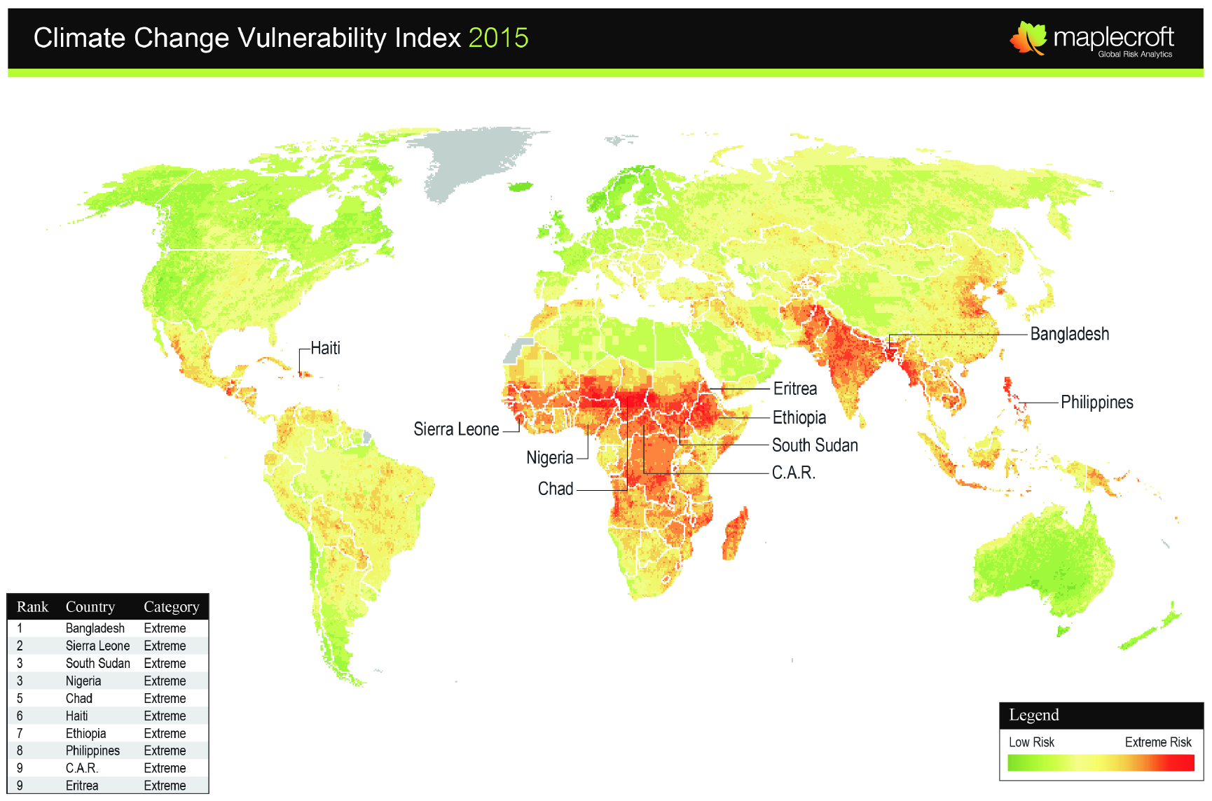

(Source: Maplecroft, 2015)

Glacial melt is expected to increase river flows and flooding for about 50 years, after which there is an expected 30%-40% decline over the next 50 years. A decline in rainfall may cause further severe water stress in arid and semi-arid areas, while rising mean temperature and depleting soil moisture would have a worsening effect on the country’s agriculture and food security. A combination of declining river flows and reduced precipitation is likely to affect coastal ecology and increase desertification.

In the period between 1995-2014, Pakistan was the 8th most affected country according to the Climate Risk Index (CRI). Its annual averages included a death toll of 487.4, 0.32 deaths per 100,000 inhabitants, US$ PPP 3.93 billion in total losses, 0.70% losses per unit GDP, and 143 total number of events in this period. In 2014, Pakistan was rated at 5th position according to the CRI with a death toll of 1,227, 0.6590 deaths per 100,000 inhabitants, US$ PPP 2.220 billion absolute losses, and 0.2511% losses per unit GDP.

Pakistan is in desperate need for more water storage capacity to counter the effects of climate change and food insecurity as it currently only has enough water stored for 30 days to meet its water requirement. Presently, Pakistan has <10% capacity for water storage (12.5 MAF of its total water resources of 145 MAF). This extra storage capacity would need to come from more dams, revitalised irrigation systems, and reducing irrigation system losses.

Figure 6 - Decadal temperature projections of selected centres
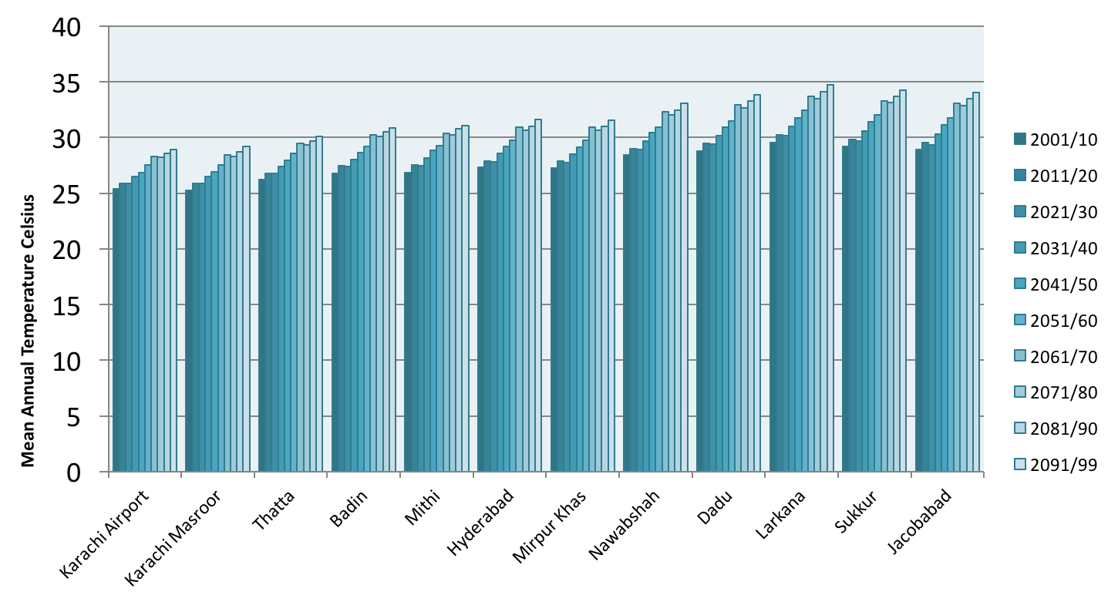
(Source: Pakistan Meteorological Department – 25 Km grid size using PRECIS Regional Climate Model)

Decadal temperature trends by the Pakistan Meteorological Department for selected cities/towns in Sindh illustrate (Fig 6) that by 2050 the average temperatures will have risen by 2.5⁰ C and in 2100 by about 5⁰ C. This is expected to have disastrous effects on water lost through evaporation, and subsequent increased groundwater mining, and reduction in agriculture yield thereby worsening food insecurity.

Decadal projections of precipitation (Fig 7) show that while there may be periods of varying rainfall, there is a general trend for mean rainfall per day to decrease over the next eighty years.

Rainfall patterns too have changed since the 2010 super floods. There has been a latitudinal redistribution of precipitation that has resulted in increased seasonal and annual precipitation and a westward shift (80-100 Km) of Monsoonal rainfall. This means that rainfall over the catchment areas of the eastern rivers has decreased (moved away). Furthermore, the probability of occurrence of heavy rainfall events leading to flash floods/floods would be high over the western rivers instead of the eastern rivers in the future. This implies that the north-west parts of the country are extremely vulnerable to floods. Fig 8 and Fig 9 illustrate the monthly rainfall shift to more precipitation in non-conventional months and drier winter periods.

Figure 7 - Decadal precipitation projections for selected centres
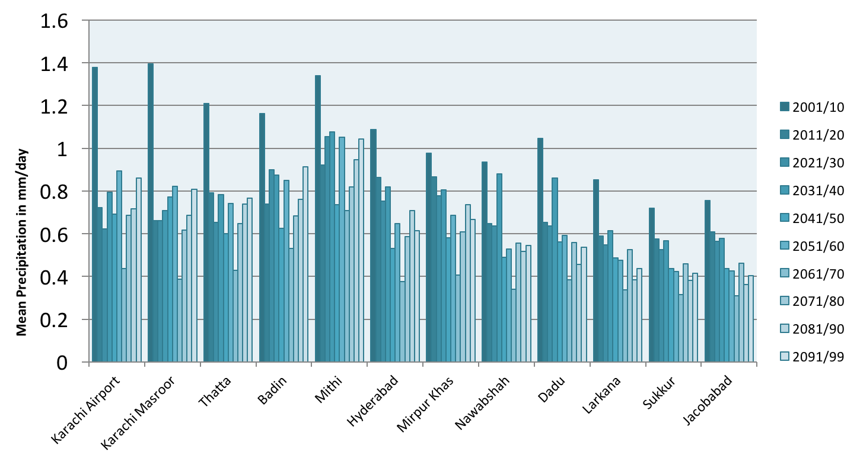

(Source: Pakistan Meteorological Department – 25 Km grid size using PRECIS Regional Climate Model)

The latitudinal redistribution of Monsoonal rainfall westward, declining decadal projection of mean annual rainfall and rising decadal project of average temperatures have major implications for water resource management and agriculture on one hand, and the safety and sustainability of water and sanitation systems in the light of climatic events like floods on the other. Climate change adaptation of water and sanitation systems would be a critical need in the future.

Figure 8 - Monthly Rainfall Shift

(Source: Pakistan Meteorological Department)

Figure 9 - Projected climate 2020-2030

(Source: Pakistan Meteorological Department)

Vulnerability to Climate Change

Analysis of the recent evidence emerging from flood affected areas regarding the health, water and sanitation repercussions are of serious concern:

- Health facilities and sanitation infrastructure was severely damaged
- Access to safe water and sanitation was severely curtailed thereby increasing the vulnerability of people to infectious and water borne diseases such as diarrhoea, typhoid, intestinal worms and hepatitis. In many cases water pipes were contaminated with sewage water and the use of toilets in most flood affected districts dropped by 50%
- The incidence of cholera, malaria and polio increased over the past one year in Pakistan

A ranking of agro-ecological zones in Pakistan according to their vulnerability to climate change shows the following:

- Balochistan is the most vulnerable region with high sensitivity and low adaptive capacity. The major threats posed by climate change in Balochistan include droughts and increase in mean temperature
- Low-intensity Punjab (mostly consisting of South Punjab) is the next most vulnerable region. The region is prone to floods as well as rise in temperature. The region has a high degree of sensitivity and low adaptive capacity
- Cotton/Wheat Sindh is the third most vulnerable region. It is vulnerable to both floods and droughts. The degree of sensitivity is high. However, the coping capacity falls in the 'medium' rank. The rain-fed (Barani) Punjab has a high degree of exposure to climate change due to its greater variability in precipitation, but relatively better adaptive capacity

In a situation where Pakistan is ploughing through a state of development deficiency, building its adaptive capacity to climate change is challenging to say the least. However, the formulation of the new National Climate Change Policy 2012 is an encouraging step. Decadal forecasts of increasing floods and droughts suggest that mitigation planning for 2030 and 2050 needs to begin now.

Water Resource Development in Sindh,

The basic lifeline of Sindh province, and indeed Pakistan, is the River Indus. It is one of the twenty-one largest rivers in the World with regard to annual flow. It is 3,180 km long and crosses China, India and Pakistan with a watershed of 1.165 million sq. km before merging into the Arabian Sea near Thatta.

The main flow of surface water is through the irrigation canal system. The water from the River Indus is diverted to the canal system through barrages, while the main canals are further divided into branch canals, distributaries, minor canals and water courses. The canal system in Sindh has three barrages, namely, Guddu Barrage, Sukkur Barrage and Kotri Barrage (Fig 10).

The total gross command area (GCA) is 14.391 million acres, with 3 Barrages, 14 main canals, 1,462 branch canals, distributaries and minors, and 42,000 water courses. More than 95% of the irrigation is from canal water. The system runs 13,234 miles in form of main canals, branch canals, distributor canals and minor canals. Approximately 80% of the area is underlain by saline groundwater. Apart from the irrigation system, Sindh has a drainage system which as such is not contiguous and integrated. There are 13 existing surface drainage systems in Sindh, which serve a total area of over 6.2 million acres (2.5 MHA) and have an aggregate length of about 2,981 miles (4,800 km). In addition, there are two sub-surface drainage systems, which serve an area of 0.10 million acres (0.04 MHA).

Figure 10 - Sindh Irrigation System
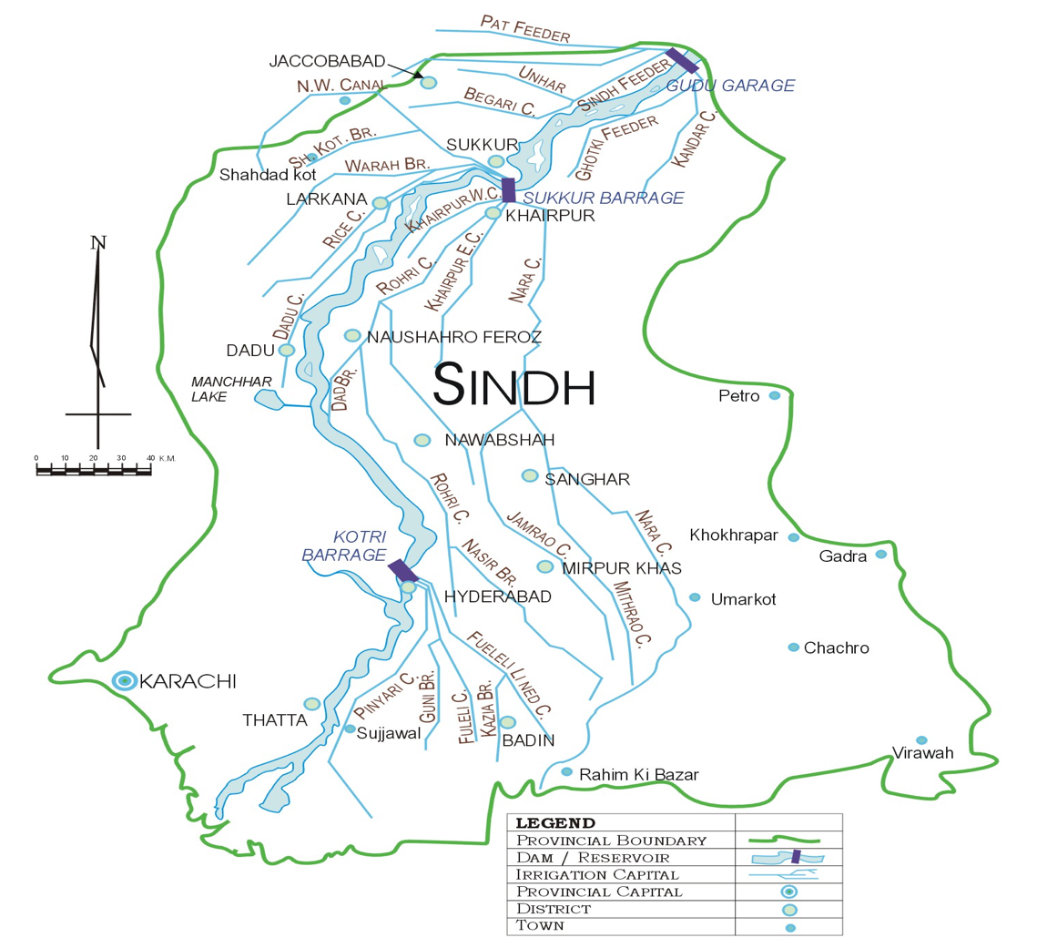

Water Resource Constraints
The climate in Sindh is arid and hot with a minimal rainfall of 140 mm annually. Approximately half of Sindh is non canal command and only rain-fed. Furthermore, there is a shortage and reduced supply of water from River Indus thereby not fulfilling the stipulations under the 1991 Water Accord between the provinces. About 85% of the Indus river flow occurs during June-September for 90-120 days. There are about 6.5 to 8.0 MAF water losses between Sukkur to Kotri Barrage. In addition, there is disposal of saline drainage water and waste into river and fresh water canals and urban waste from Hyderabad and Sukkur. Almost 80% of the irrigated land in Sindh is underlain with saline and brackish underground water not fit for agriculture and less so for drinking. Sea water intrusion has encroached up to 35 km affecting 0.6 MHA of land, which is increasing gradually.

Cropping intensity and the irrigated area have grown faster than surface irrigation supplies. In response, tube wells funded by private farmers have grown rapidly leading to unsustainable exploitation of groundwater. The irrigation infrastructure, due to high discharges from the Indus, is operating under flows that are higher than the design discharge. This reduces operational efficiency. The whole irrigation system suffers from deferred maintenance, especially distributaries and minors, and drains are neglected. Often, small channels operate without control gates and regulators.

There is no water storage facility in Sindh except the Chotiary reservoir (0.7 MAF) which runs lower than capacity. There are 10 declared wetlands of international importance (Ramsar Sites). However, there is not enough water to feed them through regular supply, seepage or rain, and this poses a major environmental threat. The River Indus below Kotri is dry. Furthermore, the urban water consumer is growing fast- Karachi alone takes 1,200 cusecs and its demand is increasing. By 2025, Sindh requires additional 25 MAF to meet agriculture and non agriculture demand. Sindh also needs water for development of Thar Coal, which is a major challenge.

The Sindh canal command is 5.1 MHA. About 1.3 MHA is cultivable waste that could be brought under irrigation if water were available. About 50% of the total Sindh Canal Command has no drainage facility. As a result, 32% of the irrigated area is saline and 43% waterlogged, with Badin and Thatta being 80% or more. The drainage effluent from Punjab and Balochistan poses a water quality threat to the River Indus from upper riparian and thereby affecting lower riparian Sindh. Furthermore, 2,135 km is flood protective embankment-bund and heavy floods can cause disasters as has been witnessed in recent years. The River Indus provides an uninterrupted supply of water to Karachi Metropolis through 100 miles of transportation. However, there is no major revenue/ recovery. The irrigation system efficiency is reduced to approximately 30%.

Distribution inequities are another major impediment to water resource management in Sindh. Poor, tail end and small farmers, women and peasants are most vulnerable. The rural and urban elites have switched from land to fish farms thereby drawing more water than is allocated. Water theft and tampering is commonplace, while use of Illegal pumping machines and cuts are common as there no checks and control.

Direct Outlets (DOs) form a serious constraint to judicious water distribution. Only the powerful and influential elite can get a DO sanctioned. Approximately 20-30% of irrigated command is served by DOs, especially in the Nara Canal. The DOs constitute a major constraint in distribution equities because from a practical standpoint, DOs do not come under rotation.

Rainwater Harvesting

PHED Karachi has completed Ten Small Dams (Retention Weirs) in rural areas of Karachi and one is still in progress with different pounding capacity to harness rain water to raise ground water for drinking water and agricultural purposes. In the recent rains in Karachi, the maximum number of these dams filled to full capacity.

Strategy

Water Resources
Strategic Objectives/Outcomes | Short Term Actions  1 - 3 years | Medium Term Actions  4 - 6 years | Long Term Actions  7 - 10 years
Improved water resource utilisation through efficient project design and execution | P&DD to issue the following Advisories/Circulars:  All future reservoirs – basic design will have outlets for drinking water depending on storage capacity  Gravity flow lines are used where feasible  Every embankment must have provision for pipe outlet for drinking water  There must be water storage provision in design for outlet in times of calamity – all field engineers would need to comply and ensure that a drinking water supply component was part of their projects and ensure that a share for drinking water is allocated  It is mandatory to include GIS mapping for every drinking water supply project  Every new drinking water supply scheme must have an outlet for distribution to local schools and health facilities - All new PHE&RDD Water Supply schemes must ensure that they provide an extension water pipe to the nearby school with its water tank
District profiles developed for water resource management and development | Conduct a study on water resource management and development in each district and map available water resources with potential for domestic and municipal use (5 districts in short-term) and upgradation  Manchar Lake should be preserved  RBOD development should be completed on priority basis | Conduct a study on water resource management and development in each district and map available water resources with potential for domestic and municipal use (10 districts in medium-term) and upgradation | Conduct a study on water resource management and development in each district and map available water resources with potential for domestic and municipal use (14 districts in long-term) and upgradation  Develop an integrated water resources management policy and implementation framework
District level preparedness for safety of water and sanitation systems and disaster risk reduction enhanced | Map out all UCs withrisk associated with disasters and safety of water and sanitation systems (5 districts)  Conduct planning for safety of water and sanitation systems and disaster risk reduction at district level (5 districts in short term) for duty bearers  Ensure water quality focus of embankments | Conduct planning for safety of water and sanitation systems and disaster risk reduction at district level (10 districts in medium term) for duty bearers  Build capacities at town and UC level for planning for safety of water and sanitation systems and disaster risk reduction at district level (60 towns and 500 UCs)  Ensure water quality focus of embankments | Conduct planning for safety of water and sanitation systems and disaster risk reduction at district level (14 districts in long term) for duty bearers  Build capacities at town and UC level planning for safety of water and sanitation systems and disaster risk reduction at district level (59 towns and 797 UCs)  Ensure water quality focus of embankments
Sectoral capacity for climate change adaptation and mitigation developed | Sub-sector climate change adaptation and mitigation strategies developed  Mapping of towns at risk of effects of climate change | Piloting of climate change adaptation and mitigation in selected towns (to be identified) | Climate change mitigation capacities developed in phased manner in towns located in zones vulnerable to climatic events (to be identified)
Municipal services duty bearers fully conversant with climate change and its mitigation strategies | Need assessment of sub-sector human resources for climate change adaptation and mitigation | Capacity building programme of city, town and union council officials in pilot areas on climate change mitigation strategies | Capacity building programme of city, town and union council officials on climate change mitigation strategies extended to other areas
Rainwater harvesting systems implemented in pilot areas | Rainwater harvesting pilot projects evaluated and plan to extend to other feasible cities developed | In participating pilot areas, rainwater harvesting provides at least 10% of water used for non-domestic municipal services and horticulture | In participating pilot areas, rainwater harvesting provides at least 30% of water used for non-domestic municipal services and horticulture

WATER SUPPLY

Urban Water Supply

Coverage

The recent PSLM 2014-15 survey shows that tap water (69%) is the prominent source of drinking water supply in households urban areas followed by motor pump (11%) (Fig 11).

Figure 11 - Sources of urban water supply in Sindh (PSLM 2014-15)
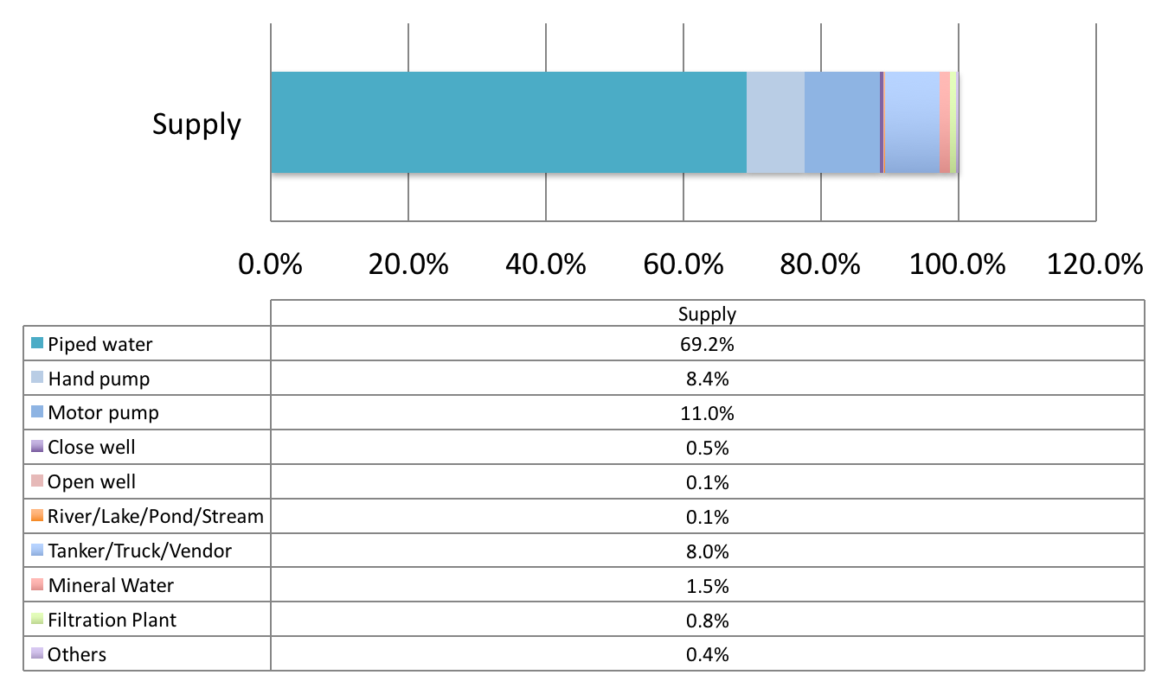

(Source: Pakistan Social and Living Standards Measurement Survey, 2014-15)

Figure12shows that Karachi, Mirpur Khasand Hyderabad had the highest percentages of tap water at 85%, 79.0% and 72% households respectively. The lowest rates for tap water were found in Naushahro Feroze (0%), Larkana (1%), Shikarpur (3%)and Jacobabad (4%). High rates of tanker/truck or vendor were found in Jacobabad (84.7%), Shahdadkot (26.9%), Karachi (9.8%) and Thatta (9.7%). The highest use of open well was found in Tharparkar (17.3%).

Figure 12 - District wise distribution of improved drinking water source in urban areas (PSLM 2014-15)
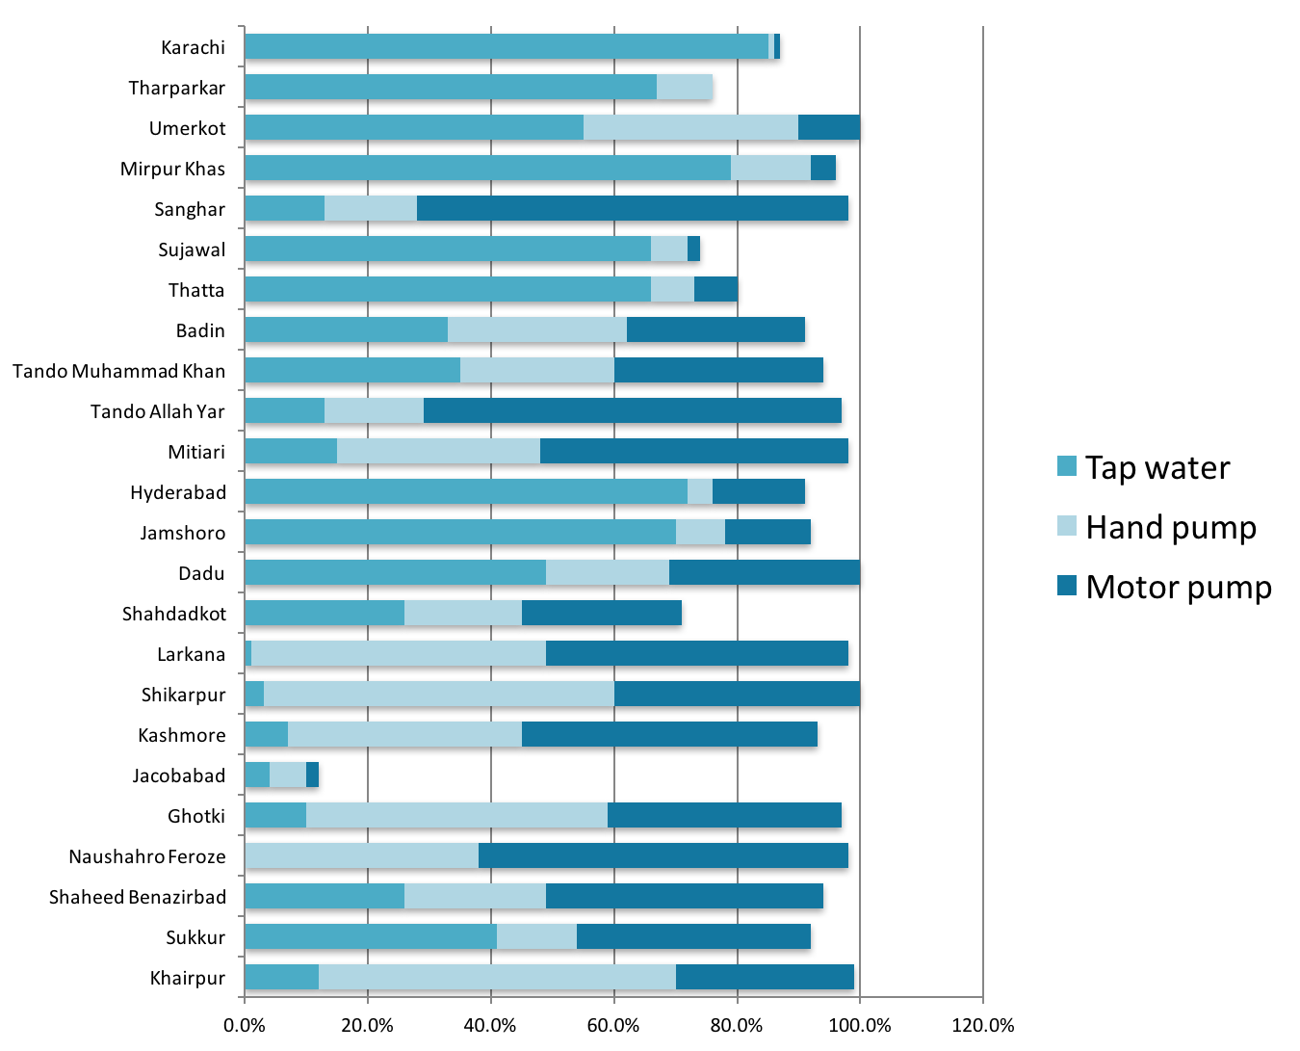

(Source: Pakistan Social and Living Standards Measurement Survey, 2014-15)

The Multiple Indicator Cluster Survey (MICS) 2014 of Sindhindicates that overall 90.5% of household members use an improved source of drinking water, while 12.8% of household members in households using unimproved drinking water use an appropriate water treatment method. About 90% of urban and 91% of rural household members use an improved drinking water source.

Figure 13 shows that piped water into dwelling is found mostly in Karachi division (65.0%), followed by Hyderabad (20.0%) and Mirpur Khas (15.1%) divisions. The rest of Sindh indicates a high use of water from a protected well with highest rates found in Larkana division (86.3%) and Sukkur division (77.3%).

Figure 14 illustrates a similar picture at district level in Karachi, Hyderabad and Mirpur Khas divisions.

Figure 13 - Overall source of improved water supply by division (MICS 2014)
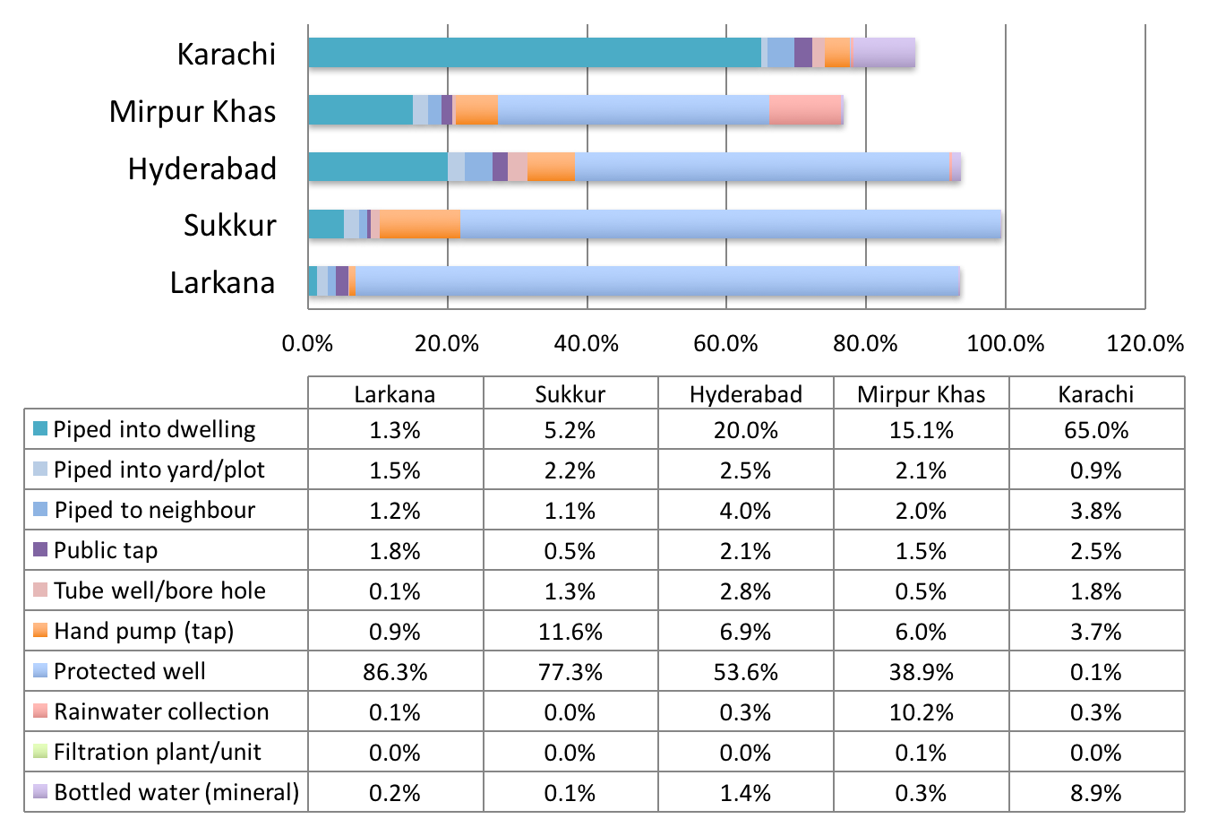
(Source: Sindh Multiple Indicator Cluster Survey, 2014)

Figure 14 - Overall source of improved water supply by district (MICS 2014)
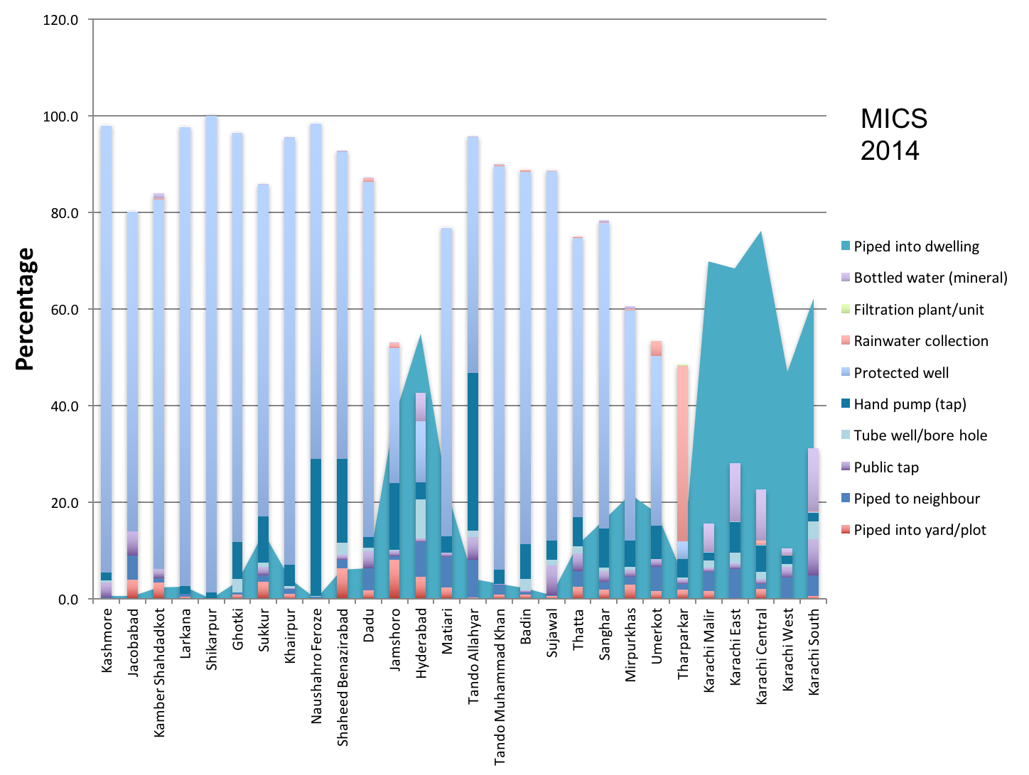
(Source: Sindh Multiple Indicator Cluster Survey, 2014)

Rural Water Supply

The PHE&RDD of the Government of Sindh is the department responsible for providing access to safe drinking water in the rural areas of the province. Presently, data regarding water supply schemes and coverage at district and provincial levels is maintained by LG&TPD and PHE&RDD.

Coverage

Figure 15 - Sources of rural water supply in Sindh (PSLM 2014-15)
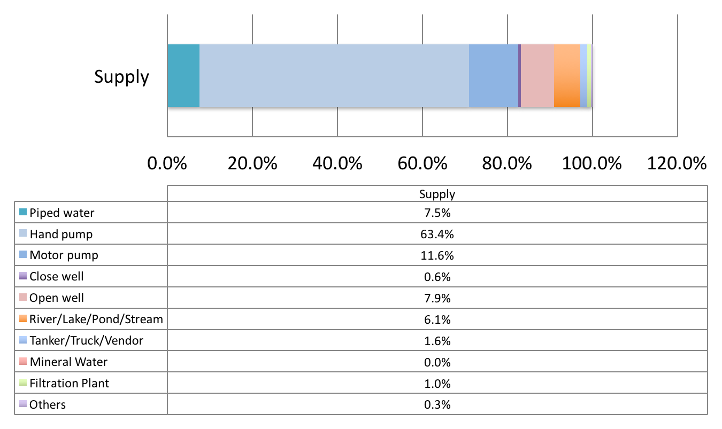

(Source: Pakistan Social and Living Standards Measurement Survey, 2014-15)

The recent PSLM 2014-15 survey shows that hand pump is the prominent source of drinking water supply in rural areas followed by motor pump (Fig 15). However, about 18% of households use ‘other’ sources of drinking water supply usually from unimproved sources (unprotected well, unprotected spring, tanker-truck, cart with small tank/drum, surface water etc).

Fig 16shows that Karachi and Jamshoro districts had the highest percentages of tap water at 54% and 38% households respectively. The lowest rates of tap water were found in Kashmore (0%), Khairpur (0.2%) and Shikarpur (0.3%). Kashmore, Jacobabad and Tando Muhammad Khan had high rates of use of hand pumps in 98%,93% and 93% respectively. The highest rate of use of motor pump was found in Dadu at 34%.

Figure 16 - District wise distribution of improved drinking water source in rural areas (PSLM 2014-14)
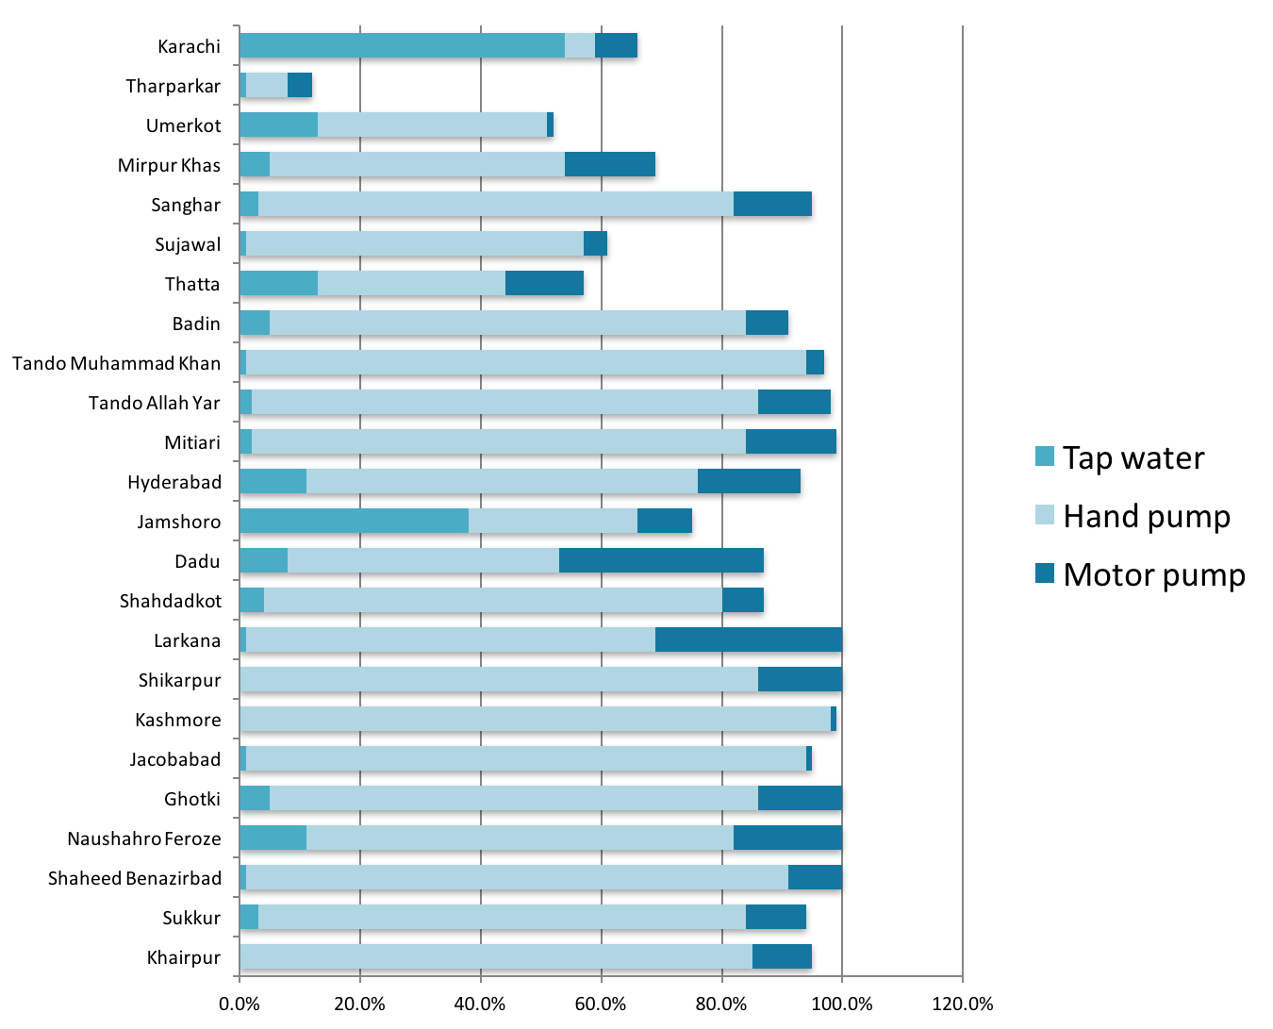

(Source: Pakistan Social and Living Standards Measurement Survey, 2014-15)

The preliminary results of Sindh MICS 2014 indicate that other than Karachi districts that attain about 20%-30% water treatment, all other districts rate less than 20% for water treatment, even though a large proportion of districts are using improved water for drinking (Fig 17).

Figure 18 illustrates the proportion of households without drinking water on premises. Tharparkar has the highest percentage of households without drinking water on premises (89.7%) with a provincial average of 25.5%.

Figure 17 - Status of improved water supply and water treatment (MICS 2014)
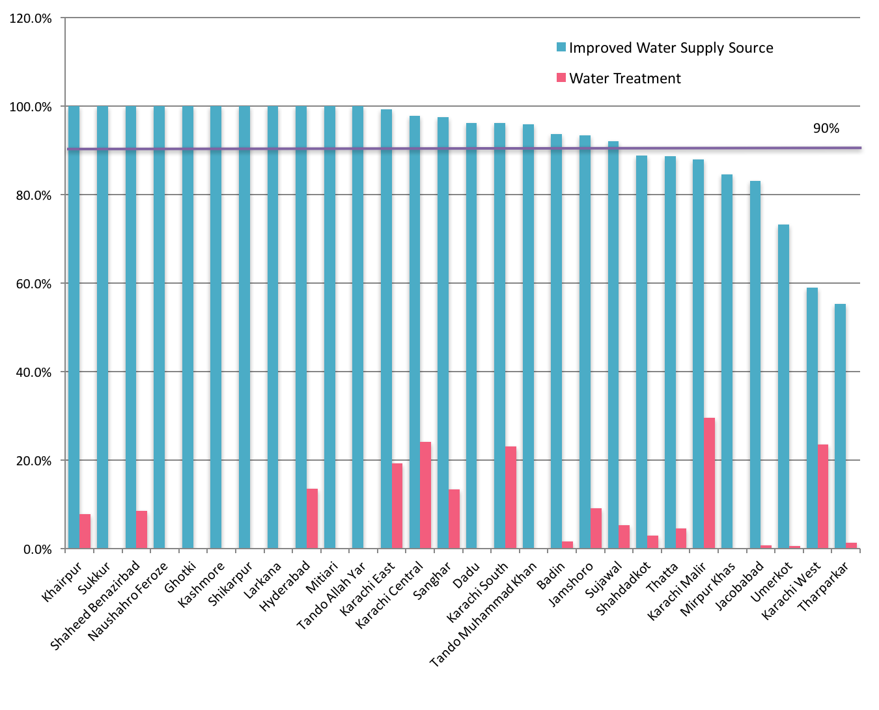
(Source: Sindh Multiple Indicator Cluster Survey, 2014)

Figure 18 - Percentage households without drinking water on premises (MICS 2014)
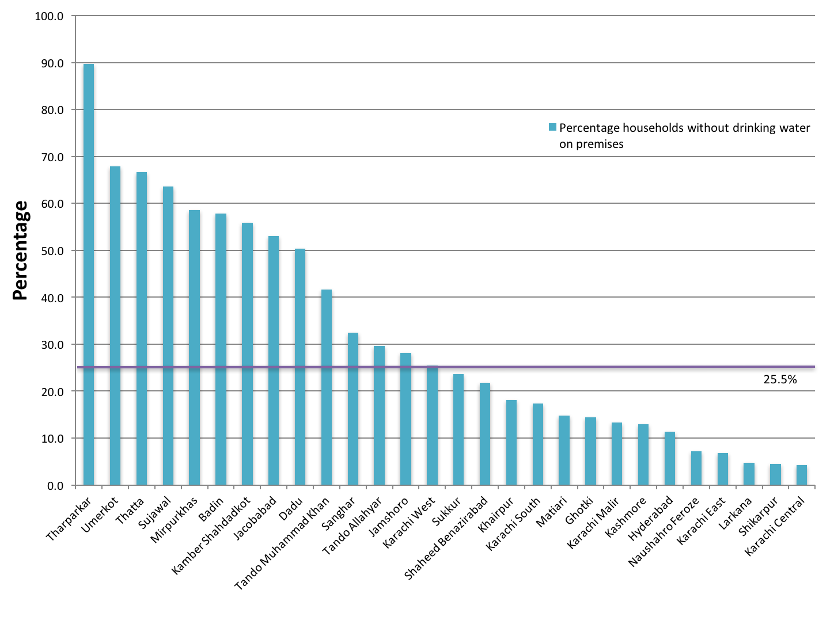
(Source: Sindh Multiple Indicator Cluster Survey, 2014)

Water Supply Issues

Work done by the Urban Unit Government of Sindh has identified the following key challenges in drinking water supply:

- Weak institutional arrangements with overlapping of roles and responsibilities
- Weak coordination mechanisms
- High proportion of non-revenue water
- Dysfunctional water supply and sanitation schemes
- Ageing infrastructure
- Water and sanitation schemes driven by political interests – they are not demand driven and not based on need assessment
- Poor water quality from polluted and contaminated sources
- Inadequate waste water treatment facilities
- High dependency on surface water which is depleting

Issues with Karachi Water Supply

Karachi faces a chronic problem of water shortage in supplies to meet the constantly growing demand. There are some major challenges in the area of management of services and the supply deficiencies in both quantity and quality of water.

The water demand amounts to approximately 752 MGD (in 2005); against this demand the capacity of the supply system is 646 MGD, giving rise to a shortfall of 106 MGD in bulk supply. But the amount of water supplied to the consumers by the service remains short by about 35% due to losses in transmission from leakages, friction and large scale unauthorised diversion or thefts. To meet the current shortages adequately and the demand up to 2020 (when the metropolitan population will increase to 27.5 million), the bulk water supply from the Indus and other sources will need to be augmented to double the quantum of the present supply.Figure 19illustrates the existing water supply network in Karachi.

About 60% of the households are connected to the supply network. Under the present conditions, water supply is irregular and inequitable. Water is supplied only for a few hours, generally four hours daily and that too at a very low pressure. Inequitable distribution marks the supply system as some areas receive more water, and some too little to meet their needs. There are some areas which are not connected to the system and get water on payment through tankers.

There is also a serious concern about water quality. The existing filtration facilities are not enough to subject all supplies to clarifier process; about 60% of water is filtered and the rest is only disinfected through chlorination. Some contamination may also occur in transmission to the end consumers.

Improvements in the system depend on public financing, for the existing tariffs only generate insufficient revenues to cover operational and maintenance costs. Enhancement of tariffs is clearly linked to the economic structure of consumer population besides improvement in service delivery. Efficiency of the delivery system is intricately tied up with the financial viability and related management issues.

Figure 19 - Existing Water Supply Network for Karachi
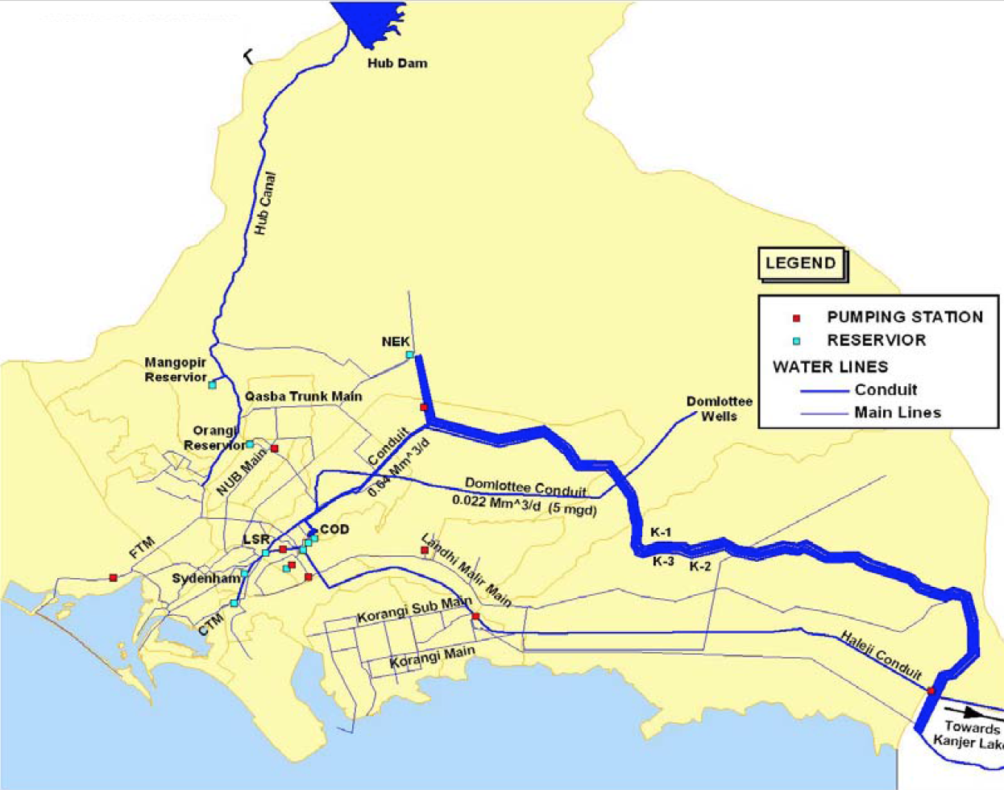
(Source: Karachi Strategic Development Plan 2020. Master Plan Group of Offices, City District Government Karachi)

Table 9 summarises key problems affecting the water supply system in Karachi.

Table 9 - Major problems with the water supply and sanitation system in Karachi
Major Problems | Symptoms | Consequences
Poor conditions of water distribution system | - An inflow of 550 MGD: Only 55 % of total water requirement | - Water demand to reach 1,400 MGD by 2020, Potential for saving 1/3rd of supplied water.
Lack of autonomy | - Intermittent water supply- available 2-4 hours per day  - High level of leakage  - Low system pressure  - Contamination: 30,000 people, mostly children, die each year in the city  - Inequitable distribution  - 8 million people (40% of city population) have access to Sewerage system | - Customers’ distrust in KW&SB and the services it provides  - Distribution System: 40-45 years  - Reluctance to pay for the services  - Insufficient revenues  - Access levels to water declined: 91 % (2007) to 89% (2013)  - Less than 10% of sewage water treated.
Weak financial capacity | - High level of receivables  - Tanker supplies  - Illegal connections  - Low tariffs  - 6.5 employees per 1000 connections | - Insufficient revenues  - Low morale of KW&SB staff  - JICA recommendations-USD 250m/Year investment for 10 years – which is 0.6 % of City GDP
Absence of measured supplies and volumetric charging system | - De-facto bankrupt utility (gap of USD 9 million / month)  - Delay in capital replacement  - Delay in system expansion  - Poor current maintenance  - Poor working environments (offices & equipment)  - Reliance on Government funding (for capital and operational expenditure)  - Collection in past 5 years: declined - 61% to 59 % | - Yearly expenditure: US$ 106 million vs US$ 60 million revenue, yearly electricity bill only US$ 66m,  - Outstanding arrears estimated at $460M: $179M (retail); $281M (bulk), Non Water Revenue estimated to 60% (or USD240 million in 2015)  - Deteriorating services  - Deteriorating assets  - Low morale of KW&SB staff  - Political interference
(Source: Adapted from The Study on Water Supply and Sewerage System in Karachi in the Islamic Republic of Pakistan. Report. Vol II, 2008. Japan International Cooperation Agency (JICA) and Karachi Water & Sewerage Board (KW&SB); and Workshop on Reform Led Investment Plan of KW&SB 2016 Karachi)

Current Status of Water Supply Schemes

Total Number and Nature of Water Supply Schemes

The Pakistan Council of Research in Water Resources conducted a Technical Assessment Survey of Water Supply Schemes to identify the problems and constraints hindering the supply of safe drinking water to thecommunities, by the water supply schemes. This involved the identification of theinstitutional, operational, technological and financial problems of the functional schemes andexploration of the reasons. In addition, the Technical Assessment Survey also investigatedand found out reasons regarding non-functional status of the water supply schemes.

Status of water supply schemes in Sindh province
- Total districts surveyed – 22
- Water supply schemes reported by province – 1300
- Total water supply schemes surveyed – 1247 (123 urban and 1124 rural)
- Total number of schemes that were functional – 529

Figure 20 - Location of surveyed water supply schemes
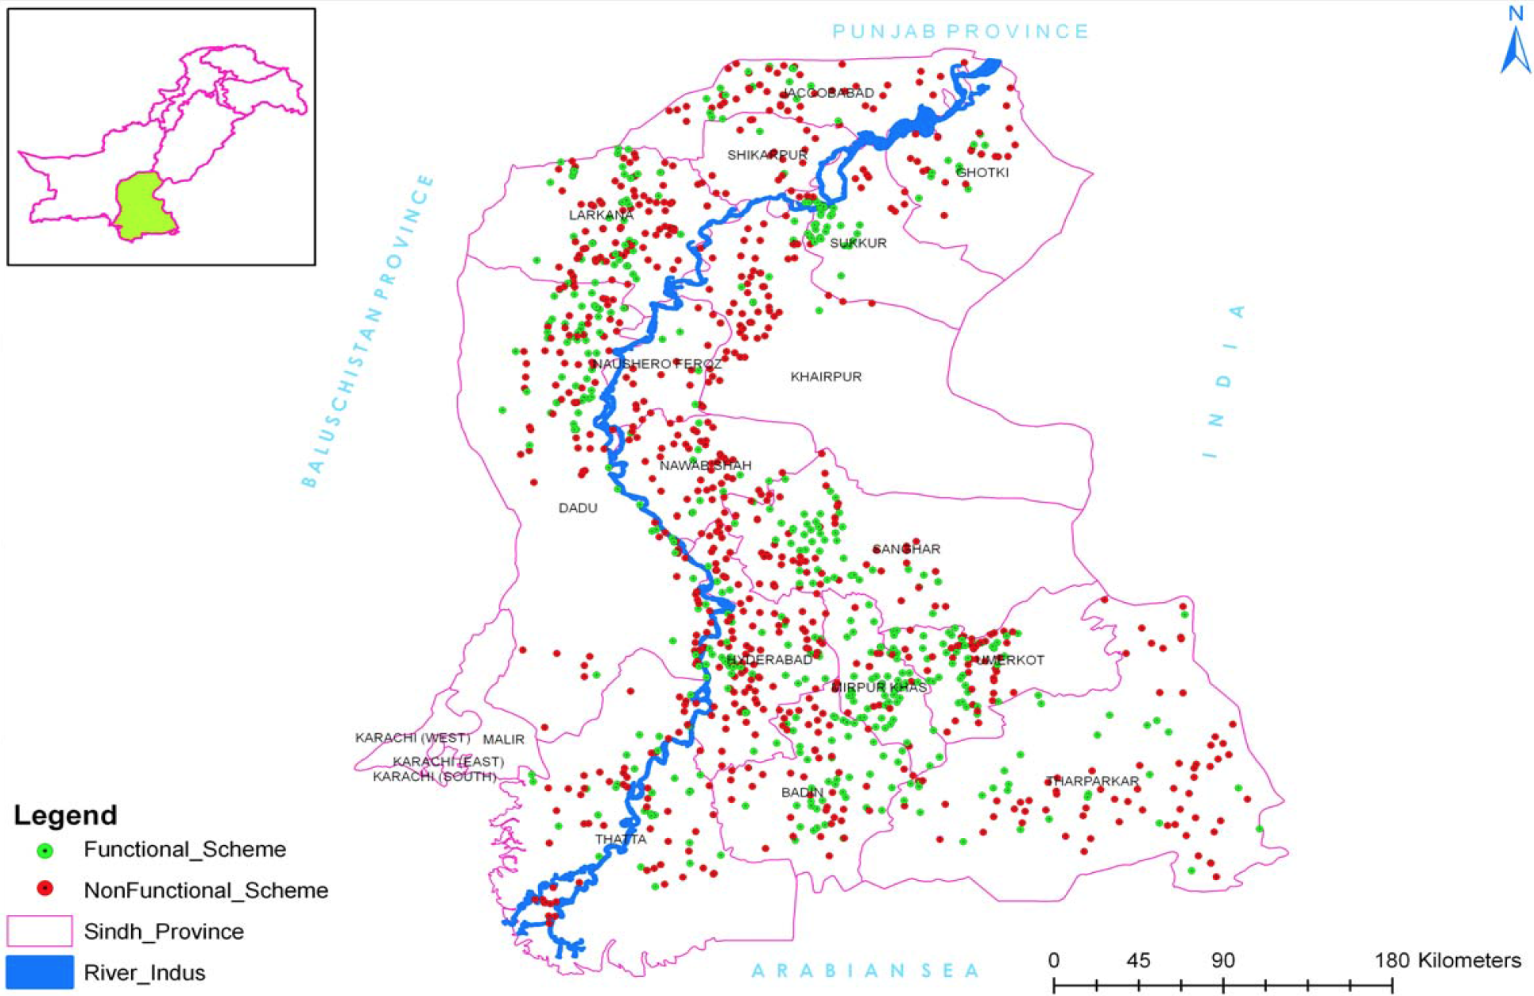

(Source: Technical Assessment Survey Report of Water Supply Schemes, Sindh 2010. Pakistan Council of Research in Water Resources)

The results showed that out of a total of 1247 water supply schemes in the province, 718 (58%) are non-functional (Fig 20). Of these non-functional schemes, 75% are temporarily closed while the remaining (25%) appear to be permanently closed.

Reasons for Non Functional (temporarily closed) Water Supply Schemes

- Lack of funds
- Missing/theft/damage of electrical and mechanical components
- Breakage in transmission/distribution network
- Shortage of water
- Lack of interest
- Community dispute/collection of O&M funds/non-payment of electricity bill
- Shortage of staff/improper design
- Low pressure
- Damage of well
- Rehabilitation of scheme
- Flood affected

Period of construction of Water Supply Schemes

The Technical Assessment Survey revealed that 107 schemes (9%) are older than 27 years. Nearly 16% of the schemes are 20 to 25 years old, 28% schemes are 15 –20 years old, whereas 47% schemes are 10 – 15 years old (Fig 21). During the 10 years’ period (1982 to 1991) that may be considered much older, a higher number of schemes were constructed in all the tehsils.

Most of the schemes have used galvanised iron pipes for the distribution system. The useful life of this material is less than 20 years, and therefore requires rehabilitation of even the functional older water supply schemes.

Figure 21 - Water Supply Schemes by construction period
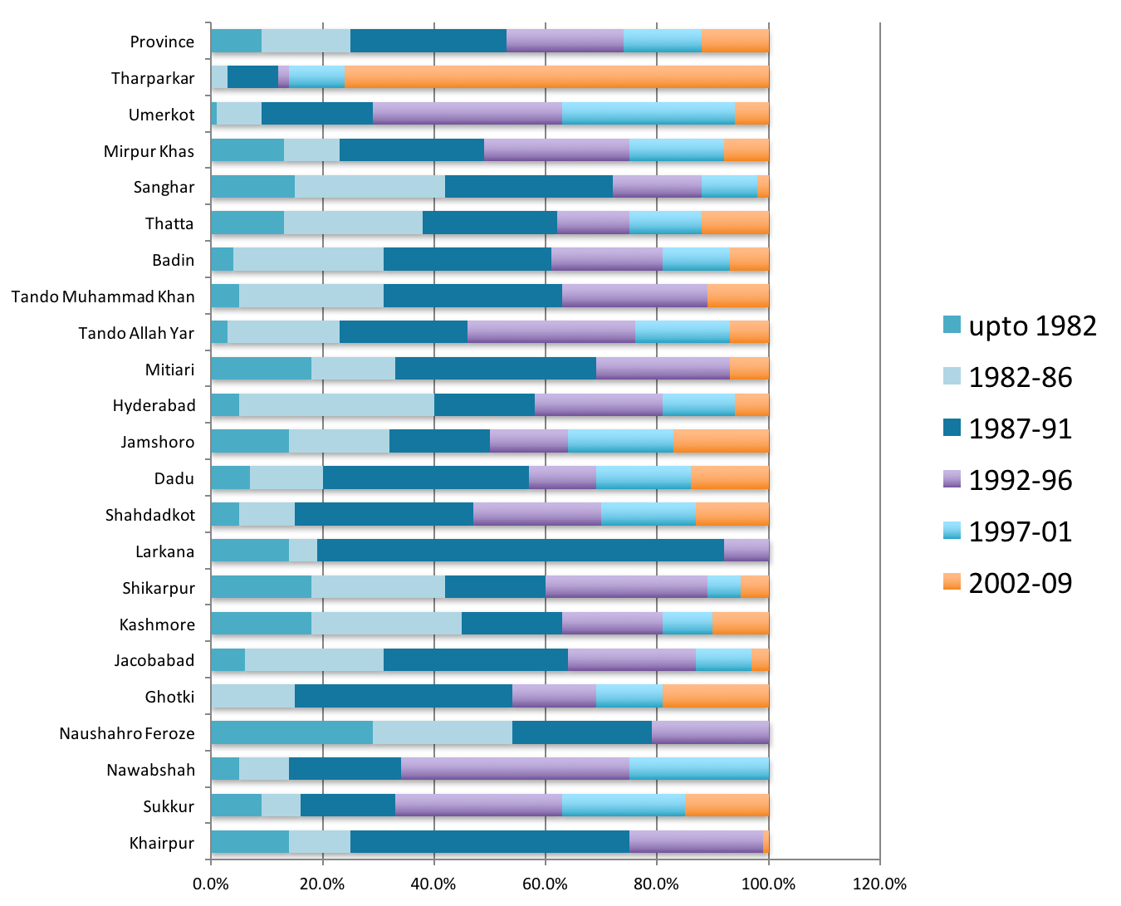
(Source: Computed from Technical Assessment Survey Report of Water Supply Schemes, Sindh 2010. Pakistan Council of Research in Water Resources)

Recent Initiatives for Water Supply by Government ofSindh

Sindh Cities Improvement Programme

Sindh Cities Improvement Investment Programme (SCIP) is an Asian Development Bank (ADB) assisted US$ 400 million infrastructure and service delivery reform programme, which aims to improve water supply, wastewater management, and solid waste management (SWM) services in 20 participating secondary cities through establishment of government-owned, professionally managed Urban Services Corporations; urban sector reforms and investment in water supply, wastewater and solid waste management infrastructure. This has been initiated as the North Sindh Urban Services Corporation (NSUSC). There are plans to establish two other similar corporations – Central Sindh Urban Services Corporation (CSUSC) and Southern Sindh Urban Services Corporation (SSUSC).

Northern Sindh Urban Services Corporation

The North Sindh Urban Services Corporationhas been established under the Companies Ordinance 1984 for the secondary cities of the Northern cluster of Sindh Province. This Urban Services Corporation aims to aggregate participating Tehsil Municipal Administration’s (TMAs) water supply, waste water and solid waste management operation in a single institution to leverage economies of scale, introduce new skills and management, and increase focus on operations, maintenance and financial management. Presently, NSUSC is being implemented in 7 cities (Sukkur/New Sukkur, Rohri, Khairpur Mirs, Shikarpur, Larkana, Jacobabad and Ghotki). In participating TMAs, the focus of water supply system includes:

- Network mapping and planning
- Source identification, development, improvement, and augmentation
- Raw water transmission, storage, and treatment
- Treatment plant rehabilitation
- Treated water storage, transmission, and distribution
- Distribution network and service connection improvement
- Leak detection and reduction; bulk and individual water metering
- Water quality monitoring
- Ground water testing
- Access current and future water demand

Desalination Plants

The Pakistan Water and Power Development Authority (WAPDA) has completed the task of installing six desalination plants along Manchar lake for providing potable water to the people residing in the areas adjacent to the lake. There are also plans underway to install desalination plants with a capacity to convert several million gallons per day (MGD) of seawater into potable water to supplement the drinking water supply needs of Karachi.

K-IV Drinking Water Project

Greater Karachi Bulk Water Supply Scheme K–IV has been envisioned at a cost of Rs. 25.522 billion with 50 % share of Government of Sindh, to address the water shortage issues of Karachi. Presently, Karachi is drawing 1200 cusecs (650 MGD) approved quota of water from Indus, which is insufficient for the ever-increasing water demand of 24 million people of Karachi. K-IV project is planned for provision of additional 1200 cusecs (650 MGD) in 3 phases from Keenjhar Lake when complete by 2025. Government of Sindh has allocated 485 cusecs (260 MGD) of additional water quota for the first phase of K-IV project, which will be completed by 2018. Additionally, the provincial government has plans to revive the Hub Dam and generate another 100 MGD of drinking water.

Matching Grants from Federal Government

Matching grants from the Federal Government includes expansion of the raw water filtration plant and supply network for supplying clean water to Hyderabad (Hyderabad Package), an urban water supply scheme in Benazirabad, and a water supply and drainage scheme in Tando Jam (Hyderabad Package) (District Hyderabad).

Special Initiatives

The Government of Sindh intends to design 2,500 Ultra Filtration (UF) and Reverse Osmosis (RO) Plants in 4 Phases through Special Initiatives till 2018.The Government completed installation of 500 plants under Phase-I all over Sindh, out of which 361 are fullyfunctional.Out of 750 plants under Phase-II, 180 Plants are installed and functional.750 RO Plants under Phase-III are approved entirely for district Tharparkar, out of which 330 plants are fullyfunctional. In addition, the Sindh Coal Authority also established 8 RO Plants for Tharparkar.

The Government is developing a database on drinking water quality in Karachi, Hyderabad and Kotri.

The Karachi Water and Sewerage Board (KWSB) successfully maintained operation of 11,000 km pipelines,1,100 million gallons of fluid, 400,000 valves and 250,000 manholes during the second year of the Government(2014-2015).

Thar Coal

As part of the Thar Coal Project under Energy, installation of RO desalination plant 25 villages Tharparkar, upgradation 2 RO plants Mithi and Islamkot, and installation 6 RO desalination plants 6 villages Tharparkar is under way.

Other Initiatives

A project is under way with the Information, Science and Technology Department for a Barani area water availability study and pilot water supply project in Malir.

The Irrigation Department is upgrading the Kinjhar Lake system for water supply to Karachi.

Construction of drains, sewerage and water supply system has been initiated in different Katchi Abadies in Shaheed Benazirabad, Khairpur, Larkana, Sukkur, Hyderababd, Mirpurkhas, Thatta and Karachi.

Water supply schemes are also being implemented through the Community Development Programme for Sustainable Development Goals in the form of Federal Government grants to Members of Provincial Assembly (MPAs), and through the Social Protection Priority Development Programmes in the form of Federal Government grants to Members of the National Assembly (MNAs).

Strategy

Water Supply
Strategic Objectives/Outcomes | Short Term Actions  1 - 3 years | Medium Term Actions  4 - 6 years | Long Term Actions  7 - 10 years
URBAN WATER SUPPLY
All cities, towns and UCs have surveys, strategies and action plans for integrated water supply, water safety, sewerage and drainage, storm water drainage and solid waste management  (common to water supply, sanitation and solid waste) | All cities have completed baseline surveys, GIS mapping and strategies, and start implementing action plans for integrated water supply, water safety, sewerage and drainage, storm water drainage and solid waste management on need basis  Develop integrated water supply, water safety, sanitation, storm water drainage and solid waste management action plans for all cities | At least 50% of UCs (500) have completed baseline surveys, GIS mapping and strategies, and start implementing action plans for integrated water supply, water safety, sewerage and drainage, storm water drainage and solid waste management on need basis  Develop integrated water supply, water safety, sanitation, storm water drainage and solid waste management action plans for 500 UCs | At least 100% UCs (797) have completed baseline surveys, GIS mapping and strategies, and start implementing action plans for integrated water supply, water safety, sewerage and drainage, storm water drainage and solid waste management on need basis  Develop integrated water supply, water safety, sanitation, storm water drainage and solid waste management action plans for 797 UCs
Improved and safely managed water supply coverage enhanced to meet access gap | Develop an SOP for all new and existing water supply schemes to provide improved and safely managed drinking water which is:  - Accessible: located on premises  - Available: available when needed  - Safe: free of faecal and priority chemical contamination  - Augmented by improved transmission and distribution networks and increased overhead reservoir capacity  Plan and implement safely managed water supply schemes to reduce access gap  - By 20% in short term  - improved availability from 4 hours to 6 hours daily  - piped drinking water that is ‘fit for drinking; in at least 25% of areas  Execution of schemes on cost sharing basis i.e. Community invests in maintenance and internal component, while Government invests for external component  Install water flow monitors at tube wells; also introduce flow monitors at valves | Plan and implement safely managed water supply schemes to reduce access gap  - By 50% in medium term  - improved availability from 6 hours to 8 hours daily  - piped drinking water that is ‘fit for drinking; in at least 50% of areas  Execution of schemes on cost sharing basis i.e. Community invests in maintenance and internal component, while Government invests for external component  Install water flow monitors at tube wells; also introduce flow monitors at valves | Plan and implement safely managed water supply schemes to reduce access gap  - By 100% in long term  - improved availability from 8 hours to 12 hours daily  - piped drinking water that is ‘fit for drinking; in at least 75% of areas  Execution of schemes on cost sharing basis i.e. Community invests in maintenance and internal component, while Government invests for external component  Install water flow monitors at tube wells; also introduce flow monitors at valves
Water supply schemes in 119 towns upgraded | Storage capacity needs of cities and towns determined  Upgrade water supply schemes in 30 towns including extra overhead storage capacity | Upgrade water supply schemes in 40 towns including extra overhead storage capacity | Upgrade water supply schemes in 49 towns including extra overhead storage capacity
RURAL WATER SUPPLY
Dysfunctional and non-functional schemes rehabilitated and maintained (538 schemes fit for repair plus 200 additional schemes) | Rehabilitate 260 dysfunctional and non-functional water supply schemes | Rehabilitate 278 dysfunctional and non-functional water supply schemes | Rehabilitate 200 newly dysfunctional and non-functional water supply schemes
Ageing water supply schemes infrastructure replaced (50 schemes per year) | Replace infrastructure of ageing water supply schemes (more than 20 years) – 150 schemes | Replace infrastructure of ageing water supply schemes (more than 20 years) – 150 schemes | Replace infrastructure of ageing water supply schemes (more than 20 years) – 200 schemes
Energy efficient water supply schemes (600) | Map areas that have persistent power shortage  Introduce solar energy supported water supply schemes  At least 180 water supply schemes converted to solar energy  All new water supply schemes are solar energy compliant where feasible | At least 180 water supply schemes converted to solar energy | At least 240 water supply schemes converted to solar energy
Community awareness about water use, safety, maintenance and preservation enhanced in all districts through an effective BCC strategy | Conduct community awareness sessions, including women and children, and disseminate key messages developed under BCC strategy by using billboards and leaflets in each district every year | Conduct community awareness sessions, including women and children, and disseminate key messages developed under BCC strategy by using billboards and leaflets in each district every year | Conduct community awareness sessions, including women and children, and disseminate key messages developed under BCC strategy by using billboards and leaflets in each district every year
Strengthen community development activities of PHE&RDD for social mobilisation and O&M (2594 social mobilisers) | Recruit 2 social mobilisers per UC and orient in water issues and maintenance | Maintain 2 social mobilisers per UC and orient in water issues and maintenance | Maintain 2 social mobilisers per UC and orient in water issues and maintenance

WATER QUALITY

National Water Quality Monitoring Programme

The National Water Quality Monitoring Programme (NWQMP) was initiated by Pakistan Council of Research in Water Resources (PCRWR) in 2002. It was the premier project of the year which generated the first detailed water quality profile of 23 major cities of the country. The NWQMP continued for five years (2002‐2006). During this phase, 357 water samples from 364 selected water sources were collected, adopting the uniform sampling criteria and analysed for 79 physico‐chemical parameters, including trace, ultra-trace elements and bacterial indicators. The analytical findings were compared to World Health Organisation (WHO) guidelines and Pakistan Standards Quality Control Authority (PSQCA) standards for drinking water.

In Sindh Province, all the 15 sources monitored in Hyderabad city were found unfit mainly dueto bacteriological contamination (93%), excessive levels of iron (47%) and turbidity (93%). Karachi, thelargest metropolitan city and capital of Sindh province revealed 93% unsafe water sources due to thepresence of bacteriological contamination (86%), Total Dissolved Solids (TDS) and fluoride (4%), sodium, chlorides, sulphate(7%), nitrate (11%) and iron (18%). Only 2 out of a total of 28 were found safe. In Sukkur, 11 out of 12sources were unfit because of bacteriological contamination (67%) and turbidity (50%), hardness,chlorides, sodium, potassium, arsenic and fluoride (8%), nitrate (25%), sulphate and TDS (17%).

The bacterial contamination level (2002‐2006) was in the range of73%‐100% for Hyderabad, 61%‐100% for Karachi and 67%‐83% for Sukkur.

Hyderabad
Water samples were collected from 15 sources covering the main localities of Hyderabad city. No source was found to be supplying safe drinking water to the citizens. The analysis of the water quality data showed that 93% of the water samples were contaminated due to Coliforms and E.coli bacterium and a high level of Turbidity. One sample (7%) was found with a high level of Calcium (Ca), 7 samples (47%) contained excess Fe contents and 13 samples (87%) contained excess Aluminium (Al).

Karachi
Water samples were collected from 28 sources that covered the major part of the metropolis. Only two sources were found to be safe. It was noticed that 86% of the water samples were contaminated with Coliforms and E.coli and 7% of the samples had high Sodium (Na), Chloride (Cl) and Sulphate (SO₄) ions more than allowed under permissible limits. Similarly, 4% of the samples were found with an excessive ionic concentration of Ca, Magnesium (Mg), hardness, Potassium (K), Fluoride (F) and TDS, and 18% were identified having high levels of Iron (Fe). About 64% of the samples had excessive aluminium while 4% of the samples had high Nickel (Ni) contents. 11% of the samples were found with high levels of Nitrate (NO₃) and one sample (4%) was found with an excessive level of Fluoride.

Sukkur
From Sukkur, 12 sources covering the entire city were selected for water sampling. The analysis of the water samples showed that only one source was supplying safe drinking water. It was found that 67% of the water samples were microbiologically contaminated and 50% of them were containing a high level of turbidity. High levels of turbidity were observed in tap and water supply distribution systems because the major source of water supplied to the city was drawn from the Indus River containing suspended colloidal material. About 25% of the samples possessed a higher concentration of Ca, and NO₃, while 17% of the samples showed excessive contents of SO₄. The analysis also showed that 80% of the samples possessed high values of hardness, Cl, Na, K, F and Arsenic (As). About 17% of the samples had high TDS and 8.3% of the samples were found with high contents of Al.

Rural Areas
In rural areas of Sindh province water quality monitoring of three districts was completed.

In Hyderabad district, 410 water samples from 20% villages of all the union councils were collected and tested. The analytical data compared with Pakistan Standards and Quality Control Authority (PSQCA) standards demonstrated that 23% water samples were contaminated with Total Coliforms, 20% with Turbidity and 48% samples had higher level of TDS. Data analysis and comparison with PSQCA water quality standards showed that 82% water sources were unsafe and only 18% were found to be safe for drinking purpose in rural areas of the district.

In Karachi district, altogether 75 water samples from 20% villages of all the union councils were collected and tested following American Public Health Association (APHA) protocols. The analytical data demonstrated that 76% water samples were contaminated with Total Coliforms and 56% samples had excessive level of TDS. An overall analytical picture showed that 95% water samples were unsafe and remaining 5% were safe for drinking purpose in rural areas of the district.

In Sukkur district, 260 water samples from 20% villages of all the union councils were collected and analysed. The analytical data demonstrated that 16% water samples were contaminated with Total Coliforms and 35% samples had excessive level of TDS. An overall analytical profile of Sukkur district showed that 48% water samples were found unsafe and remaining 52% were safe for drinking purpose in rural areas of the district.

Technical Assessment of Water Supply Schemes

The Pakistan Council of Research in Water Resources conducted a technical assessment of 1247 water supply schemes in Sindh province. The key results are presented in Figs 22 and 23.

Figure 22 - Quality of Drinking Water at Source
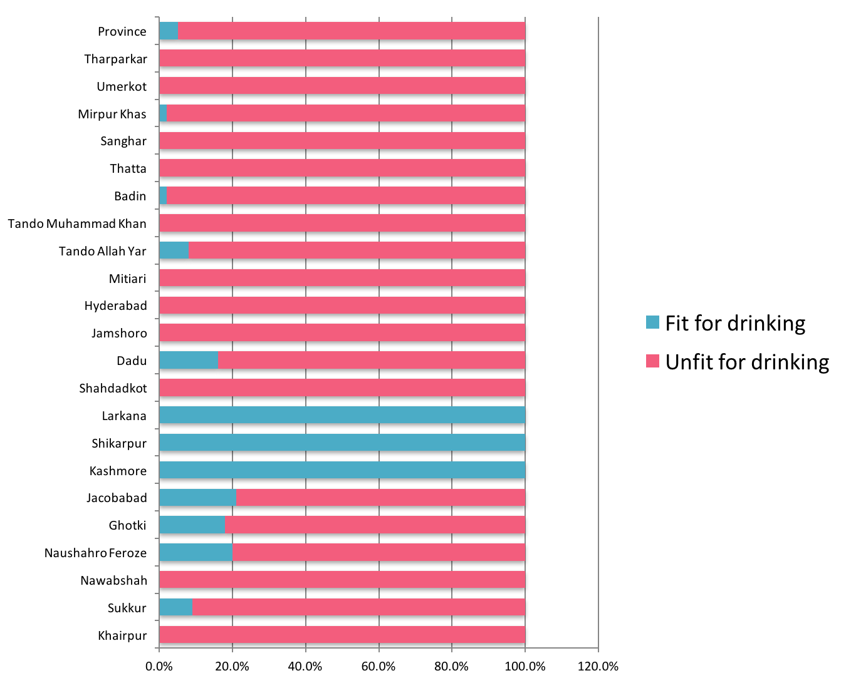
(Source: Technical Assessment Survey Report of Water Supply Schemes, Sindh 2010. Pakistan Council of Research in Water Resources)

Fig22 illustrates that only three districts (Larkana, Shikarpur and Kashmore) had a score of 100% ‘water fit for drinking’ of the samples tested. All other districts were less than 20% except for Jacobabad at 21% and Naushero Feroze at 20%. The analysis of water samples collected from the water sources of the water supply schemes indicates that 95% of the total collected samples are unsafe for drinking purpose. It has been found that water of these sources is unsafe for drinking predominantly because of microbiological contamination, though there is evidence of physical as well as chemical contamination.

Fig 23 illustrates the analysis of water samples collected from the houses of the consumers of the functional water supply schemes and reveals that 98% of the total collected samples are unsafe for drinking purposes. The causes of contamination are not indifferent from that of water at source. Microbiological contamination is again predominant at the consumers’ end, which prevails on all the functional water supply schemes, among the districts. In Larkana, 100% of the samples were fit for drinking, followed by Kashmore at 50% and Shikarpur at 25%. All other districts scored less than 10%, with Naushero Feroze at 10%.

Figure 23- Quality of Drinking Water at Consumer's end
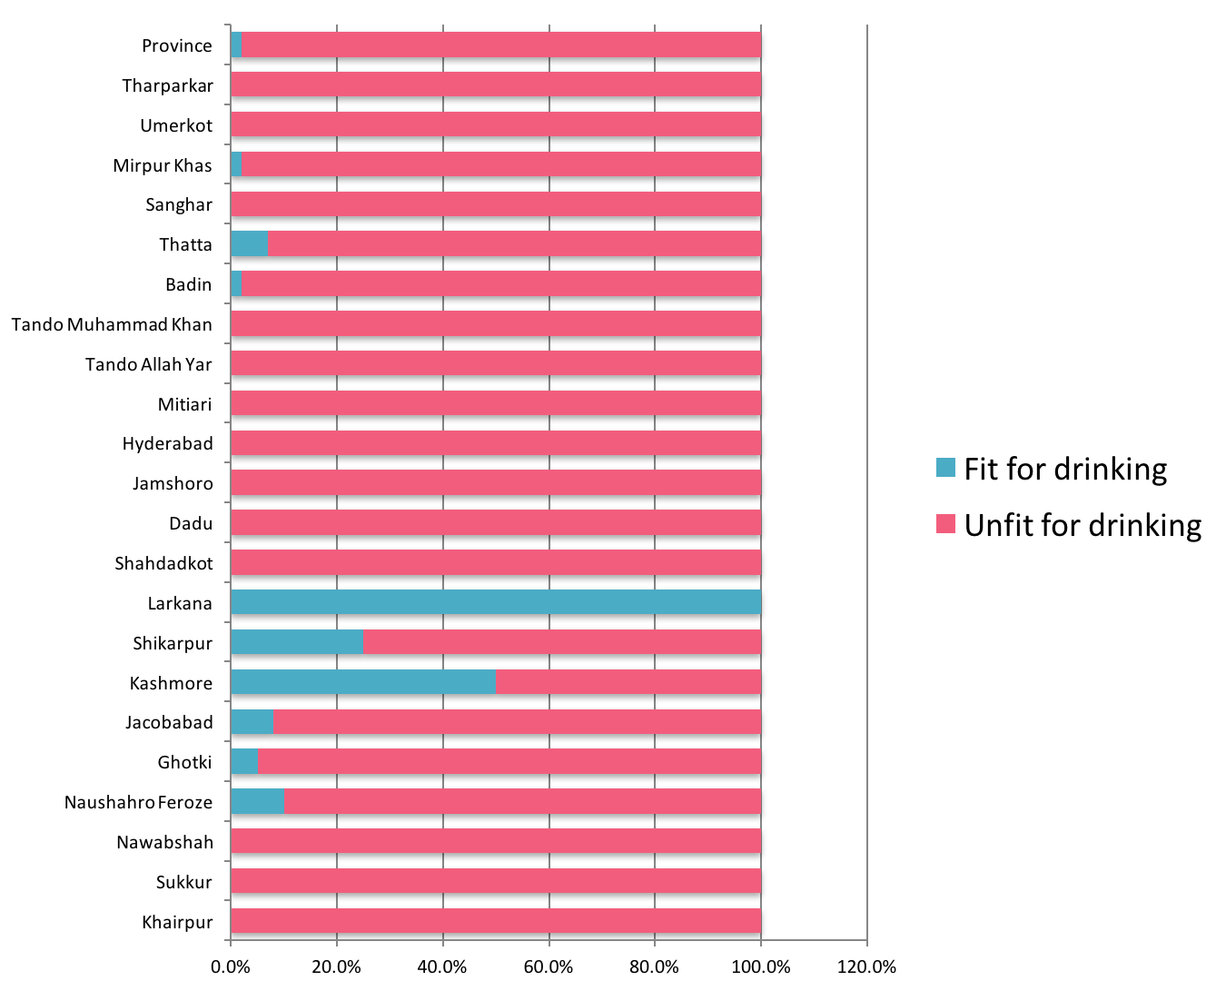
(Source: Technical Assessment Survey Report of Water Supply Schemes, Sindh 2010. Pakistan Council of Research in Water Resources)

Bottled Water Quality

The poor quality of drinking water has forced a large cross-section of citizens to buy bottled water. However, many of the mineral water companies were found selling contaminated water. To monitor and improve the quality of bottled water, the Government of Pakistan through Ministry of Science and Technology has designated the task for quarterly monitoring of bottled/mineral water brands to PCRWR. According to the monitoring report for Sindh for the quarter January to March, 2016, the following findings were noted.

Of a total of 111 brands tested by PCRWR for water quality tests in 15 cities across the country, 89 brands were safe (80%), 22 were unsafe (20%), 19 were chemically unsafe (17%), 3 were microbiologically unsafe (3%), 64 brands remained consistent in two neighbouring quarters (58%), 47 new brands were introduced (42%), and 36 brands became unavailable (32%).

For Sindh, the following results were found for various brands and the respective cities where they were manufactured.

- Hyderabad – Noble, AFRA, NG Fresh Water, Pak Life
- Jamshoro – Pearl
- Karachi – OSIO, Sunlay, Blu Plus, Al Sahar, Zindagi, Marbella, Simply Pure, Al-Habib, Livon, Aqua Water, Silver, Vinh, ORION, DAM, Aaab-e-Sehat, Aqua Arabia, Al-Masafi
- Hub (Balochistan) – Crystal Maya, Batina Pure

Arsenic
The following brands available in Sindh were found to contain high levels of Arsenic (more than the safe limit of 10 ppm) - NG Fresh Water (85 ppm), Al-Habib (62 ppm), Silver (70 ppm), ORION (68 ppm).

Potassium
Aqua Arabia (22 ppm) exceeded the safe limit of 10 ppm.

The following brands tested safe for both chemical and microbiological quality – Noble, AFRA, Pak Life, Pearl, OSIO, Sunlay, Blu Plus, Al Sahar, Zindagi, Marbella, Simply Pure, Livon, Aqua Water, Vinh, DAM, Aaab-e-Sehat, Al-Masafi, Crystal Maya, Batina Pure

Five brands were found unsafe out of 24 tested (21%).

Bacteriological contamination carries a risk of cholera, diarrhoea, dysentery, hepatitis, and typhoid, while arsenic contamination carries a risk of cancer (lungs, bladder, skin, prostrate, kidney, nose and liver), diabetes kidney disease, hypertension, heart disease, birth defects, black foot diseases. Sodium contamination carries a risk of hypertension.

Table 10 indicates that 3.0% of household members in Sindh drink water contaminated above WHO standards for arsenic, 5.5% for Nitrate, 4.5% for Fluoride, 2.9% for Iron, 8.9% for hard water and 23.6% for TDS. Further, 38.8% of household members drink water contaminated with E.coli, while 66.0% drink water contaminated with coliforms. This indicates a serious water quality issue in Sindh.

Table 10 - Overall status of water quality (MICS 2014)
 | Percentage of water quality testing sample households using improved source of drinking water | Percentage of household members with |  |  |  |  |  | Number of household members |  | Bacterial contamination
 |  | * more than 10 ppb | >10 ppm | >1.5 ppm | > 0.30 ppm | >500 ppm | above  >1000 ppm | Number of household members |  | E.coli |  |  | Total Coliform
 |  | Arsenic | Nitrate | Fluoride | Iron | Hard water | Total Dissolved Solids (TDS) | Number of household members |  | Percentage of household members with E. coli in household drinking water (>=1 cfu/ml) | Number of household members |  | Percentage of household members with other coliform risk level equal or above 1 cfu/ml | Number of household members
Total | 91.0 | 3.0 | 5.5 | 4.5 | 2.9 | 8.9 | 23.6 | 12,849 |  | 38.8 | 12,258 |  | 66.0 | 11,757
Division
Larkana | 93.3 | 0.5 | 4.6 | 2.1 | 0.2 | 16.5 | 39.3 | 1,713 |  | 28.5 | 1,617 |  | 51.6 | 1,592
Sukkur | 99.6 | 10.2 | 8.7 | 6.2 | 5.4 | 7.2 | 24.2 | 2,215 |  | 21.2 | 2,196 |  | 58.3 | 2,144
Hyderabad | 94.2 | 4.7 | 2.4 | 3.1 | 4.9 | 14.6 | 36.1 | 2,969 |  | 44.4 | 2,788 |  | 60.1 | 2,605
Mirpur Khas | 78.8 | 0.0 | 14.3 | 19.2 | 3.8 | 16.3 | 41.7 | 1,238 |  | 56.0 | 1,199 |  | 81.2 | 1,077
Karachi | 87.4 | 0.0 | 3.8 | 1.5 | 1.1 | 1.2 | 4.6 | 4,714 |  | 43.0 | 4,459 |  | 74.9 | 4,339
Area
Urban | 89.8 | 0.9 | 4.6 | 2.1 | 1.3 | 4.9 | 13.2 | 6,657 |  | 42.3 | 6,340 |  | 71.7 | 6,072
Rural | 92.4 | 5.1 | 6.4 | 7.1 | 4.6 | 13.0 | 34.5 | 6,193 |  | 35.0 | 5,918 |  | 60.0 | 5,685
Wealth index quintile
Poorest | 85.5 | 3.5 | 6.4 | 11.5 | 3.5 | 18.0 | 43.1 | 2,496 |  | 39.5 | 2,417 |  | 59.5 | 2,254
Second | 95.3 | 4.9 | 8.0 | 5.6 | 4.8 | 13.9 | 37.2 | 2,673 |  | 30.8 | 2,557 |  | 55.3 | 2,494
Middle | 87.4 | 3.4 | 6.4 | 2.2 | 3.2 | 6.9 | 20.9 | 2,694 |  | 38.3 | 2,556 |  | 73.0 | 2,443
Fourth | 89.3 | 1.0 | 2.6 | 1.8 | 2.0 | 2.0 | 6.9 | 2,521 |  | 45.6 | 2,384 |  | 73.5 | 2,353
Richest | 97.8 | 1.7 | 3.6 | 1.3 | 0.7 | 2.9 | 8.2 | 2,465 |  | 40.3 | 2,345 |  | 69.0 | 2,214
(Source: Sindh Multiple Indicator Cluster Survey, 2014)

Water Resources Research Institutes and Laboratories

Some key water institutes conduct research on water resources and quality. These institutes have a vital role in building a water quality profile in Sindh.

Pakistan Council of Research in Water Resources

The following capacity building and training was carried out by PCRWR for Sindh.

Capacity Building Training Programmes under the Project Provision of Safe Drinking Water
38th Technician Training Course for Water Supply Agencies of Northern, Areas and Sind was conducted from March 24-28, 2014 at PCRWR Headquarters Islamabad. During the course, lectures were delivered on importance of water, hazards of usage of unsafe water and its related aspects, besides laboratory demonstrations on water quality testing/monitoring and field visits.

Water Quality Testing/Treatment and Operation & Maintenance (O&M) of Water Supply Schemes
Three training programmes of 4-days each were conducted in March 2014, at PCRWR Water Quality Laboratory Karachi, to strengthen the capacity of human resource of PHED, H-WASA, Village Development Associations (VDAs), Community Based Organisations (CBOs) and other implementing partners on Water Quality Testing/Treatment and O&M of water supply schemes. These trainings were organized with financial and technical assistance of UNICEF (Sindh).

Training Programme for the Professionals of Regional Laboratories of PCRWR
The experts of National Water Quality Laboratory (NWQL) visited PCRWR Regional Laboratories (Peshawar, Abbottabad, Karachi, Hyderabad, Sukkur, Badin, Tandojam, Nawabshah, Lahore, Multan, Dera Ghazi Khan, Bahawalpur and Sahiwal) during February to March 2014 and provided onsite training, on water quality analysis, ISO-17025 management and technical requirements, to the professionals of regional laboratories. The objective of this extensive training programme was to prepare the laboratories, to achieve ISO- 17025 Accreditation.

Research and Development
Some of the research and development projects undertaken by PCRWR include the following:

Combating Drought and Desertification in the Thar Desert by Management of Water Resources
The project entails (1) Carrying out a comprehensive survey to document the existing status of water resources management and agriculture activities in the project area; (2) Conducting research for effective utilization of land and water resources by establishing a Research and Dissemination Station in Thar Desert; (3) Developing viable techniques of rainwater harvesting, saline and fresh groundwater utilization and desertification control in the area for agriculture, livestock, and human consumption; and (4) Disseminating efficient techniques for large-scale adaptation for agriculture and socio-economic development. Some of the key achievements of the project include the following:

- Catchment area around earthen pond (150 ft x 150 ft x 20 ft) constructed at Khario Nara Field Station was developed by removing obstacles to increase the efficiency of runoff and to harvest maximum rainwater during rainy season.
- Different types of vegetables like bitter gourd, lady finger, lufa gourd, bottle gourd and squash melon have been grown on pitcher irrigation system by using mix water (sweet and tube well water) on an area of 0.25 acre.
- Cluster bean grown on 20 acres.
- Grafting of 700 zizyphus, trees completed during the entire period of the project but due to unfortunate incident of fire occurred on August 4, 2014, 200 trees were burnt. Currently pruning of 50 trees is in process and after that grafting process will remain under progress in future along with applying anti-termite medicines within the roots. The plants were irrigated with ground saline water successfully
- Metrological data (temperature, wind velocity, pan evaporation, rainfall and humidity) was collected regularly.
- Monitoring activities at constructed rainwater harvesting ponds, mini dam and dug wells at community land are in progress.

Pakistan Council for Scientific and Industrial Research

The Pakistan Council for Scientific and Industrial Research (PCSIR) Laboratories Complex in Karachi is undertaking research in disposal of hazardous wastes, recycling of municipal wastewater and industrial effluents, and monitoring of water and air pollution.

Climate Change, Alternate Energy and Water Resources Research Institute Islamabad

The former Water Resources Research Institute (WRRI) established under the National Agricultural Research Centre (NARC) has been renamed the Climate Change, Alternate Energy and Water Resources Institute (CAEWRI). Its mandate includes (1) To optimise the productivity of water use under rain-fed and irrigated environment; (2) To develop sustainable balance between resource utilisation and its replenishment; (3) Climate change impact assessment on water resources and agriculture, its adaptation and mitigation; and (4) Alternate energy resources production/harvesting and management.

Drainage and Reclamation Institute of Pakistan

Drainage and Reclamation Institute of Pakistan (DRIP) in Tando Jam was established in 1975, under PCRWR with the mandate to conduct research in drainage and reclamation of waterlogged and salt affected soils, groundwater resources development and management, soil and water management and other related aspects. DRIP has successfully introduced tile drainage technology amongst the progressive farmers, for reclamation of waterlogged and salt affected soils with farmers’ participation in capital and responsibility, of the operation and maintenance expenditures. Similarly, the farmers have benefited from skimming well technology, by augmenting irrigation supplies, by pumping freshwater floating over native saline groundwater. Monitoring and evaluation of installed drainage projects has generated scientific data, for planning of future drainage projects. It has state of the art automated lysimeter research station to conduct various water management studies.

The Water Quality Laboratories of Karachi, Hyderabad, Badin and Shaheed Benazir Abad are also equipped with the state of the art facilities and are providing service to the public and private sectors, under the administrative control of DRIP.

Arid Zone Research Institute

The Arid Zone Research Institute (AZRI), Umerkot is working under the administrative control of Director General, Southern Zone Agricultural Research Centre (SARC), Karachi. Its objectives include, to:

- enhance productivity of arid and semi-arid agriculture of Thar and surrounding areas by identifying crop, livestock and socio-economic constraints
- generate baseline data on arid agriculture and develop protocol for maximum utilisation of land and the arid region of Thar and adjoining irrigated belt of lower Sindh
- develop procedures for rain water conservation for production of agricultural crops in arid zone
- conserve and promote the natural vegetation of Thar region for livestock production

Its main areas of research under land and water management include:

- Use of alternative energy sources for pumping water in agriculture (Solar, Wind and Biogas)
- Installation of drip irrigation system for cultivation of grafted ber (Zizyphus spp)
- Rain water harvesting
- Pitcher plantation
- Soil and water conservation though plantation
- Use of wind mill for pumping of ground water

Recent Initiatives for Water Quality in Sindh

Water Testing Laboratories in Districts

Pakistan Council of Research in Water Resources (PCRWR) is implementing a project called “Provision of Safe Drinking Water” in the country. The objectives of this project, which started in 2005, include the following:

- Establish 19 water quality monitoring laboratories in 19 districts in the country to provide dependable water analysis facilities for the provision of safe drinking water
- Conduct Water Quality Monitoring to identify the problems hindering in the supply of safe drinking water
- Install pilot/demonstration water conditioning and filtration plants for larger scale adoption by the federal and local Governments
- Impart training to the technical staff of all water supply schemes of four provinces, Azad Jammu and Kashmir (AJK), Federally Administered Tribal Areas (FATA) and Northern Areas
- Investigate and identify the causes of pollution in water resources and to suggest the remedial measures for water quality improvement

The following activities are planned under this project:

- Establishment of Water Quality Testing Labs in 18 districts across the country (now upgraded to 19 districts)
- Installation of Demonstration Water Conditioning and Filtration Plant in 24 districts across the country (now upgraded to 25 districts)
- Physical Survey of all Completed Water Supply Schemes (PHED/WASA)
- Training and Capacity Building of Staff associated with Water Supply Schemes
- Investigation and Identification of Causes of Pollution and Contamination of Water Supply
- Regular Monitoring and Surveillance of Water Supply Schemes/Agencies

As part of this project, PCRWR is in the process of establishing water quality testing laboratories in Sukkur and Badin in Sindh.

Science and Technological Research Division

The Federal Government has funded a scheme for ‘Demarcation of Groundwater Quality Zones in Indus Plain and Marginal Areas for Sustainable Development and Management of Groundwater (Lower Indus Plain)’, which is being undertaken by PCRWR.

Strategy

Water Quality
Strategic Objectives/Outcomes | Short Term Actions  1 - 3 years | Medium Term Actions  4 - 6 years | Long Term Actions  7 - 10 years
Quarterly water quality testing at water source | PHE&RDD conducts monthly water quality tests of town water supplies and filtration plants, and quarterly testing of at least 25% of tube wells (250) | PHE&RDD conducts monthly water quality tests of town water supplies and filtration plants, and quarterly testing of at least 50% of tube wells (500) | PHE&RDD conducts monthly water quality tests of town water supplies and filtration plants, and quarterly testing of at least 75% of tube wells (750)
Quarterly quality testing of distribution network | At least 25% coverage of distribution system every quarter (250 tube wells)  Annual monitoring of water quality in rivers and streams in collaboration with Irrigation department | At least 50% coverage of distribution system every quarter (500 tube wells)  Annual monitoring of water quality in rivers and streams in collaboration with Irrigation department | At least 75% coverage of distribution system every quarter (750 tube wells)  Annual monitoring of water quality in rivers and streams in collaboration with Irrigation department
District level water quality testing laboratories established (29 districts) | Establish water testing laboratory facilities in 5 districts | Establish water testing laboratory facilities in 10 districts | Establish water testing laboratory facilities in 14 districts
All ground and overhead reservoirs supplied with chlorination treatment | Conduct study to determine the status of ground and overhead reservoirs in cities and towns  Scheduled six monthly cleaning and maintenance of all reservoirs  Installation of chlorinators in 30% of reservoirs (or tube wells where storage capacity does not exist) and issue and orient users in standard operating procedure and safety for chlorination | Scheduled six monthly cleaning and maintenance of all reservoirs  Installation of chlorinators in 60% of reservoirs (or tube wells where storage capacity does not exist) and issue and orient users in standard operating procedure and safety for chlorination | Scheduled six monthly cleaning and maintenance of all reservoirs  Installation of chlorinators in 90% of reservoirs (or tube wells where storage capacity does not exist) and issue and orient users in standard operating procedure and safety for chlorination
Community awareness about water quality (including adoption of treatment of safe drinking water in the household) enhanced in all districts through an effective BCC strategy | Conduct community awareness sessions, including women and children, and disseminate key messages developed under BCC strategy for water quality by using billboards and leaflets in each UC every year (1297)  Promote use of low cost portable water quality testing and monitoring at village level | Conduct community awareness sessions, including women and children, and disseminate key messages developed under BCC strategy for water quality by using billboards and leaflets in each UC every year (1297)  Promote use of low cost portable water quality testing and monitoring at village level | Conduct community awareness sessions, including women and children, and disseminate key messages developed under BCC strategy for water quality by using billboards and leaflets in each UC every year (1297)  Promote use of low cost portable water quality testing and monitoring at village level

SANITATION

Urban and Rural Sanitation

Coverage

The recent PSLM 2014-15 survey shows that flush toilet is the prominent mode of sanitation in 97% of households in urban areas. No toilet was found in less than 1% of households (Fig 24).

Figure 24 - Mode of urban sanitation in Sindh (PSLM 2014-15)
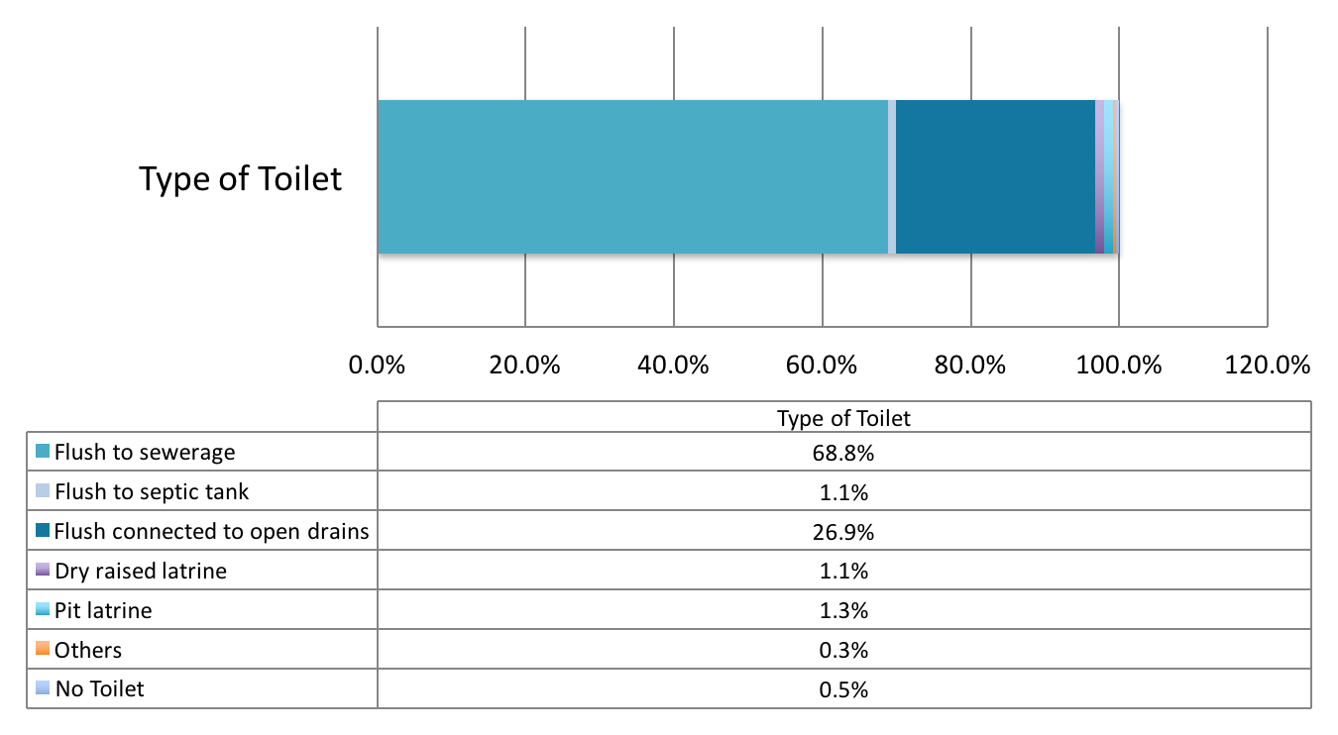

(Source: Pakistan Social and Living Standards Measurement Survey, 2014-15)

Figure 25 shows that in urban areas, Mitiari and Umerkot had the highest percentages of no toilet at 11% and 9% respectively. Jamshoro and Sujawal had the highest flush use at 100%. In over a fourth of households (26.9%), the flush toilet was connected to open drains.

In rural areas however, the rates of no toilet were thirty-one times as high at 15.7% as compared to urban areas (Fig 26). Furthermore, Fig 27shows that the highest percentages for no toilet were found in Umerkot (50%), Tharparkar (47%), Sujawal (41%), Thatta (28%) and Matiari (26%). In over a fifth of households (21.7%), the flush toilet was connected to open drains.

Figure 25 - District wise distribution of mode of sanitation in urban areas (PSLM 2014-15)
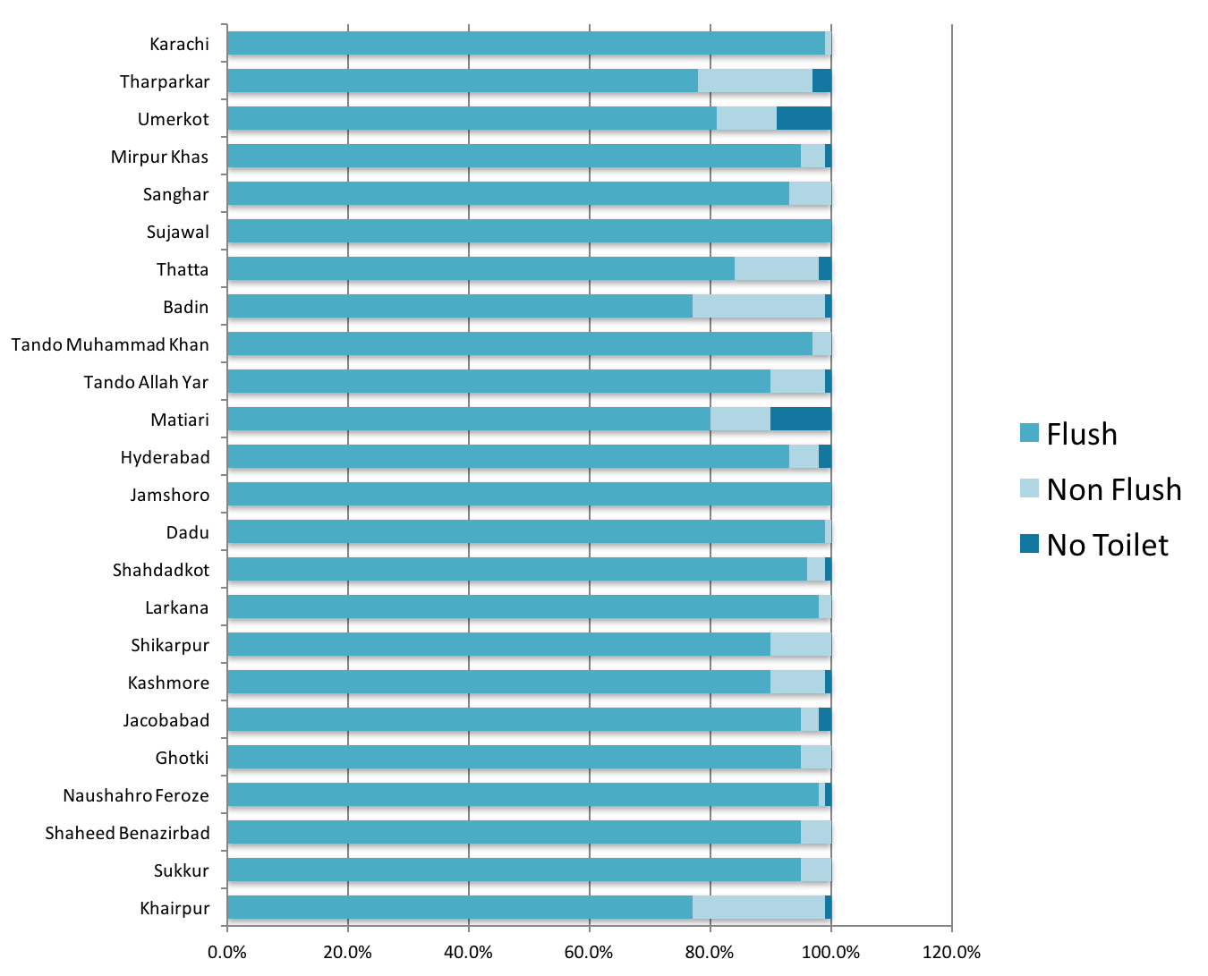

(Source: Pakistan Social and Living Standards Measurement Survey, 2014-15)

Figure 26 - Mode of rural sanitation in Sindh (PSLM 2014-15)
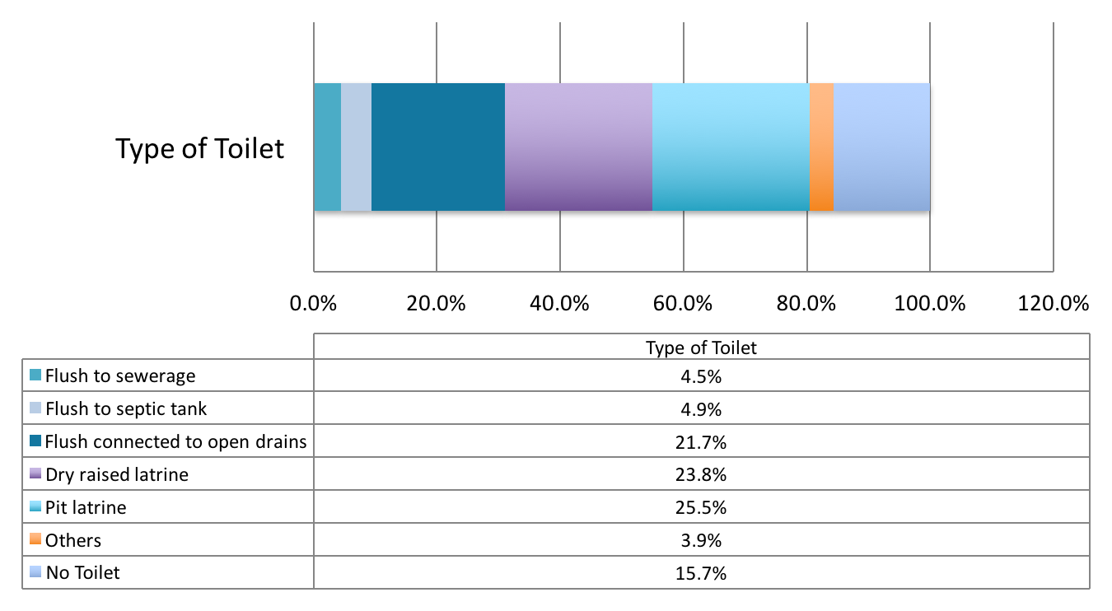

(Source: Pakistan Social and Living Standards Measurement Survey, 2014-15)

Figure 27 - District wise distribution of mode of sanitation in rural areas (PSLM 2014-15)
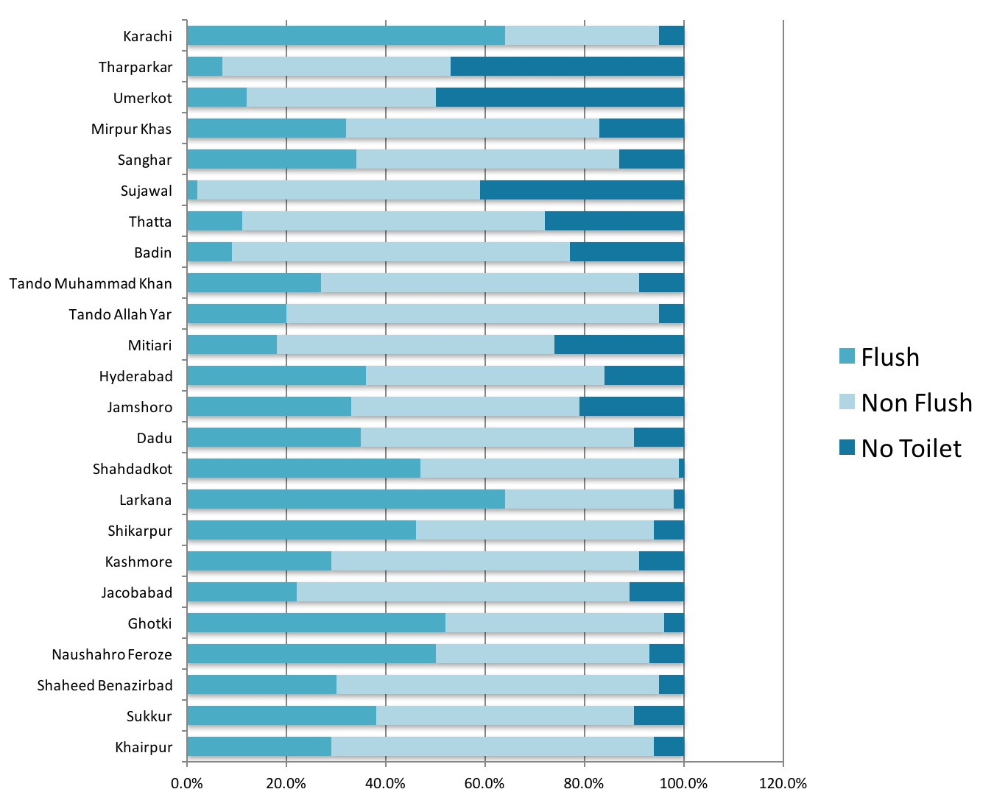

(Source: Pakistan Social and Living Standards Measurement Survey, 2014-15)

Figure 28 illustrates that on average 54.9% use improved sanitation, while 56.1% have a place for hand washing. There is a general awareness about the need for a place for handwashing since many districts that have low rates for improved sanitation have higher rates for a place for handwashing.

Figure 29indicates that the poorest and second quintiles have the lowest rates for use of improved sanitation and having a place for hand washing. However, even in the poorest category, 63.1% had soap or other cleansing agent available.

Figure 30 indicates that 90.0% of urban, 22.1% of rural and 97.9% of households in Karachi division use flush/pour flush latrines connected to piped sewer system.

Figure 31 illustrates that 39.9% of household population in rural areas practice open defecation, which is highest in Mirpur Khas division at 49.2%.

Figure 28 - District profile of improved sanitation and place for hand washing
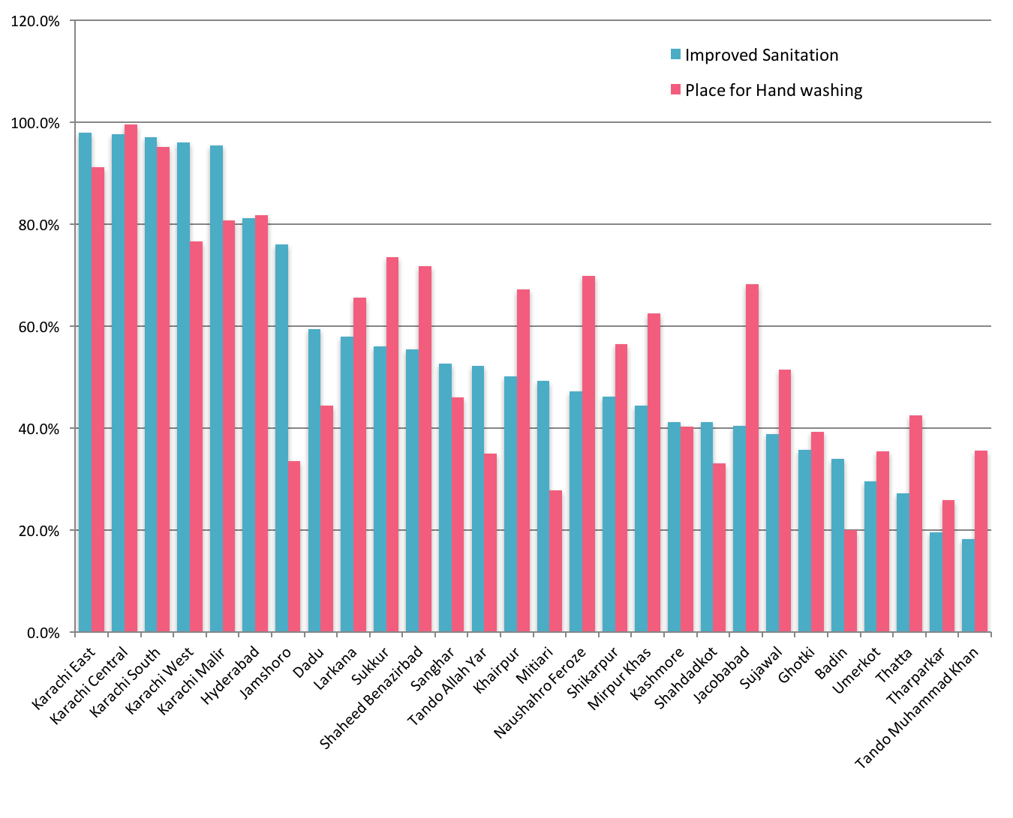

(Source: Sindh Multiple Indicator Cluster Survey 2014)

Figure 29 - Equity profile of water and sanitation
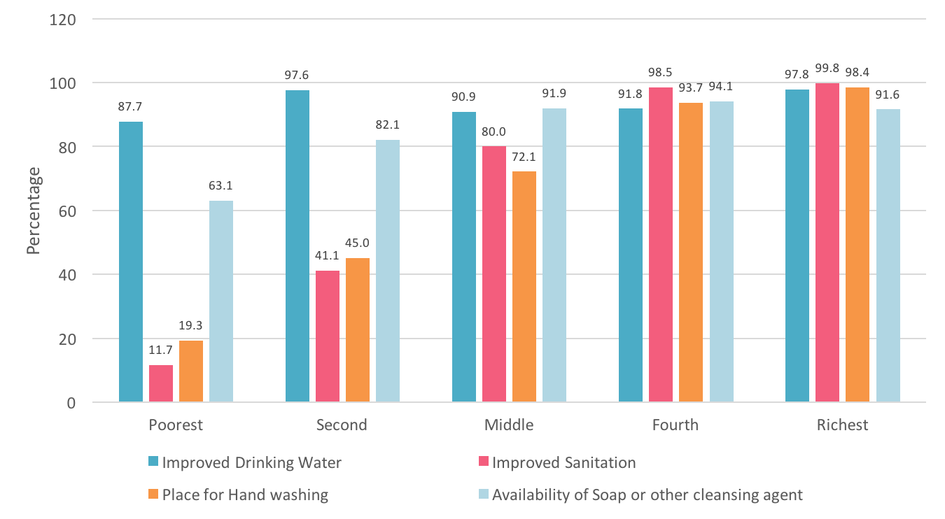

(Source: Sindh Multiple Indicator Cluster Survey 2014)

Figure 30 - Overall status of improved sanitation (MICS 2014)
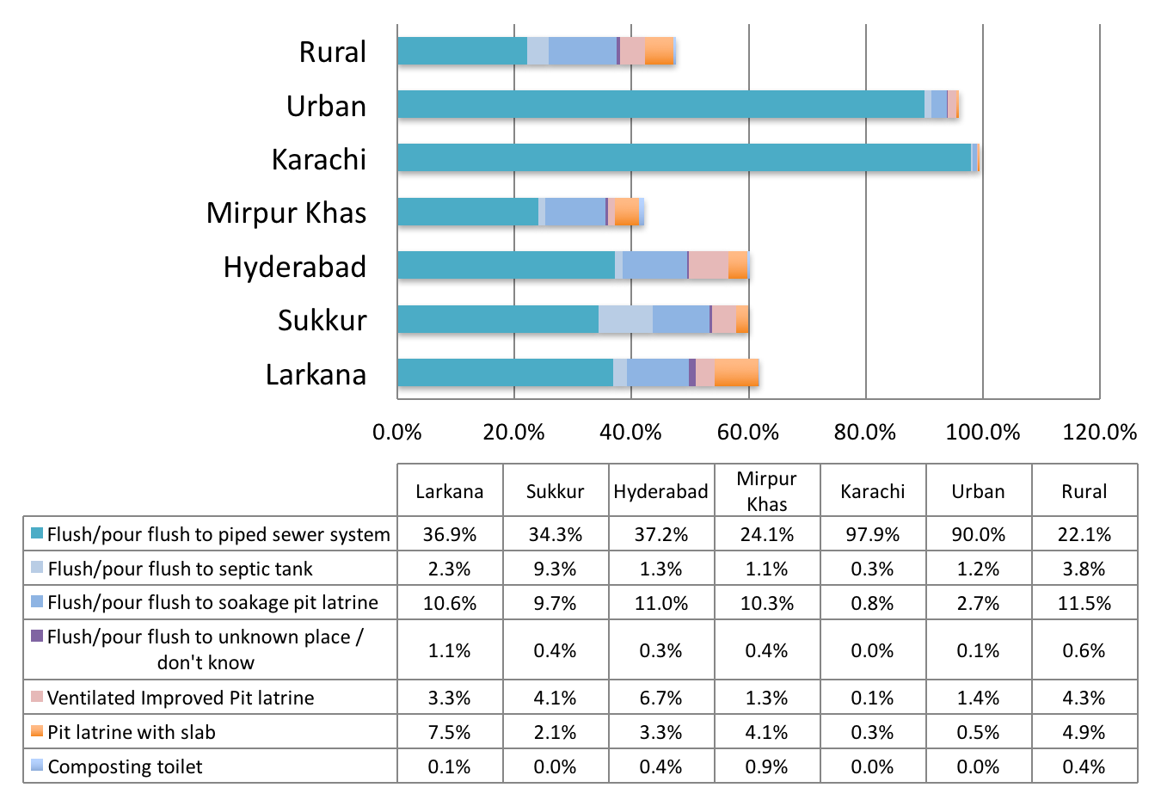
(Source: Sindh Multiple Indicator Cluster Survey 2014)

Figure 31 - Overall status of unimproved sanitation (MICS 2014)
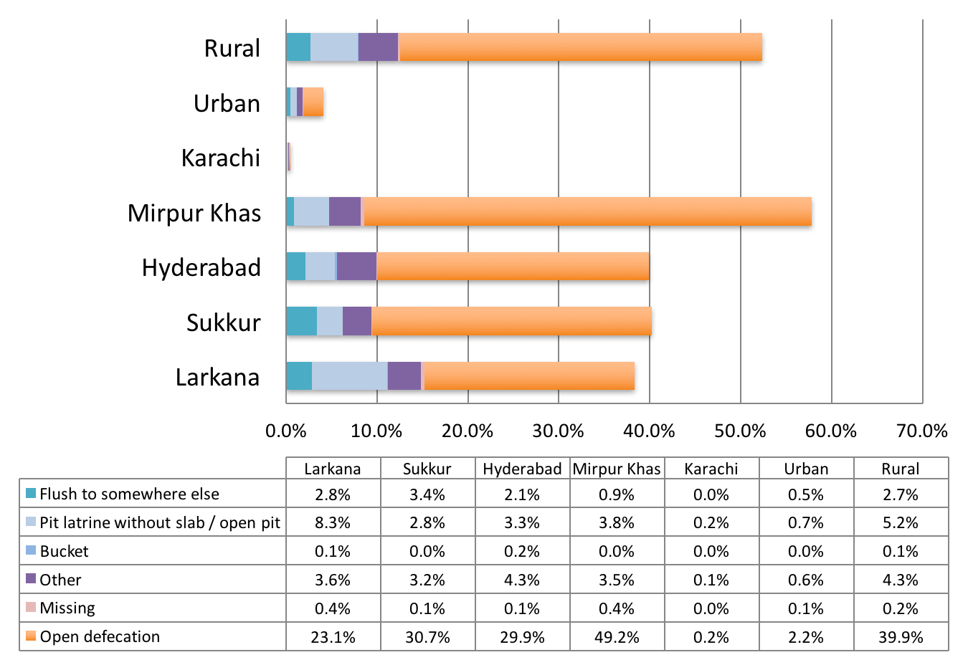
(Source: Sindh Multiple Indicator Cluster Survey 2014)

Figure 32 - Percentage household population using improved sanitation that is not shared (MICS 2014)
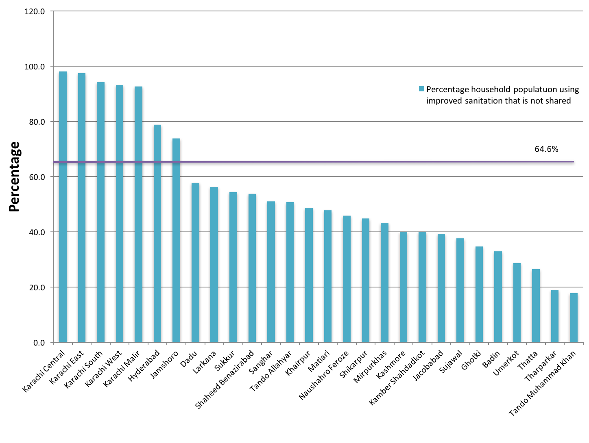
(Source: Sindh Multiple Indicator Cluster Survey 2014)

Figure 32 shows the percentage of household population using improved sanitation that is not shared, with the highest in Karachi (98.0%) and least in Tando Muhammad Khan (17.7%).

Figure33illustrates that there has been a gradual improvement in sanitation systems in the period of 2004-05 to 2013-14. Overall for Sindh, ‘No system’ has reduced from 54% to 41% and ‘underground drains’ increased from 31% to 41%. However, ‘open drains’ have increased from 15% to 17% and there has been no increase of covered drains that have remained at 1%

In urban areas, ‘underground drains’ have increased from 69% to 72%, and covered drains have decreased from 2% to 1%. In rural areas ‘no system’ has reduced only marginally from 85% to 84%. At present, only 3% of the urban areas and about four-fifths (84%) of the rural areas have no sanitation system. About one-fourth (24%) of the urban areas have open drains. Overall in Sindh, there is no sanitation system in about two-fifths of households (41%).

Figure 33 - Type of Sanitation system used in Sindh
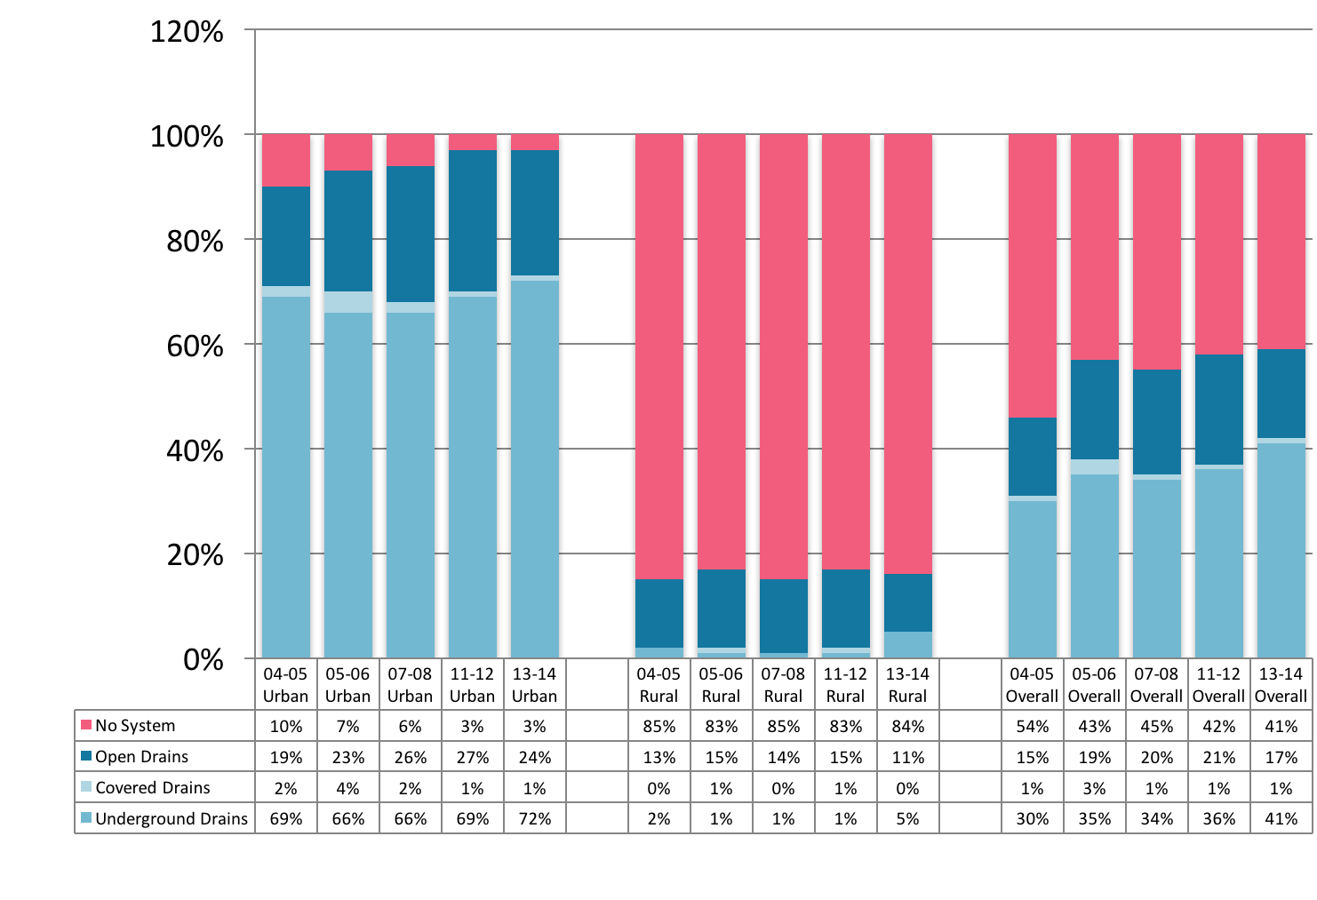

(Source: Pakistan Social and Living Standards Measurement Survey, 2004-05, 2005-06, 2007-08, 2011-12 and 2013-14)

Sewerage and Drainage Issues

Some of the key sewerage and drainage issues identified in Karachi are also to a large extent germane to urban sanitation in general. These include:

- Absence of comprehensive master plans for cities and towns – there is urgent need for master plans for sewerage implementation in line with the city planning, to implement sewerage facilities based on it and to revise the plan on regular basis taking social and physical changes into account
- Limited budget allocation for sewerage facilities – since the tariff collected in water supply and sewerage sector is very limited, the budget allocated for sewerage sector is limited, too. With the limited budget, it is almost impossible to operate and maintain existing sewerage facilities so as they function as planned and to extend or newly construct sewerage facilities to meet the future requirements
- Improper operation and maintenance of sewerage facilities – mainly due to the limited budget and personnel allocated for operation and maintenance of sewerage facilities, existing facilities are not operated properly. Improper maintenance might lead to earlier aging of facilities and non-compliance with the effluent quality standard
- Insufficient sewerage facilities – existing sewerage facilities for sewage collection and its treatment are far from sufficient in quantity to serve the rapidly increasing population. Additional sewage collection systems including branch sewers, trunk sewers and pumping stations need to be constructed to improve the living environment of the citizens. In the same manner, existing sewage treatment plants need to be extended and new plants have to be installed to treat all the generated sewage to improve water qualities of public water bodies, especially of Arabian Sea
- Insufficient information on facilities – sewers, pumping stations and sewage treatment plants consist of civil structures, mechanical and electrical equipment. For efficient and effective operation and maintenance of these facilities, it is necessary to equip their as-built drawings, list and specifications on site. However, site surveys have usually found that there was little information on these items, especially about sewers
- Inefficient record of operation and maintenance works – in the same manner, little information in written form is available on the performance of pumping and treatment facilities such as flow rates, operation hours, water qualities, facility failures and repairs and so forth
- Absence of operation and maintenance manuals – manuals for operation and maintenance of sewerage facilities are not available. It is very difficult to operate and maintain sewerage facilities in a proper way without O&M manuals

Wastewater

Disposal of wastewater is a guide to potential water contamination. About 59% of Sindh’s households have disposal of wastewater (sewerage connected with main line, sewerage connected with open drain or septic tank), ranging from 97% in urban and 16% in rural areas.

Karachi City Wastewater,

Karachi is most industrialised and urbanised city of Pakistan. More than 450 million gallons of wastewater is generated per day by different types of industrial processes and human operations. There are only three wastewater treatment plants in Karachi city working at Haroonabad (TP1), Mahmoodabad (TP2) and Mauripur (TP3), which can treat less than 30% of the total wastewater generated. Sindh Industrial Estate (SITE), Korangi Industrial Area (KIA) and Landhi Industrial Area (LIA) are important industrial sites of Karachi whose wastewater influxes indirectly into the Arabian Sea without any treatment. In addition, untreated industrial effluents and domestic wastewater from other resources is also being discharged into the Arabian Sea. Therefore, more than 70% of the wastewater goes into the Arabian Sea without any treatment.

Major rivers of Punjab discharge their wastewater load into the River Indus, which ultimately discharges its pollution load into the Arabian Sea at Keti Bunder endangering aquatic life and fish. Besides containing other toxicants, this wastewater contains large quantities of heavy/trace metals/metalloids, cyanides, phenols, oils and greases and suspended solids resulting in high values of biological and chemical oxygen demand and low dissolved oxygen threatening aquatic life and as well as fish. It is also suspected that, influx of this untreated wastewater is also making the water quality of the Arabian Sea unfit for recreation purposes at different sea spots like Paradise Point, Hawks Bay, Sand Spit, Keamari, Manora, Clifton and Sea View.

In 2007, according to KW&SB, Karachi was producing about 446 MGD of sewage per day. The three treatment plants have a collective maximum design capacity of 151 MGD of treatment of effluents. However, only about 90 MGD of total sewage is treated, while 356 MGD wastewater remains untreated. Out of this 356 MGD, about 196 MGD drains into Lyari river, 98 MGD wastewater finds its way into Malir river, which ultimately discharges into the sea, whereas 22 MGD percolates into the ground and becomes part of ground water. There is still 139 MGD of sewage water that remains unaccounted.

More recent data from KW&SB shows that of 472 MGD of sewage generated daily in Karachi, only about 50 MGD is treated, leaving 422 MGD untreated (Table 11).

Table 11 - Status of Sewerage System in Karachi
Sewerage System
Sewage generated in city (70% of water supplied) |  | 472 MGD
Optimum Design Capacity of Sewerage Treatment Plants |  | 150 MGD
Quantity of Sewage Treated |  | 50 MGD
Shortfall in Sewage Treatment Capacity |  | 322 MGD
Untreated Sewage |  | 422 MGD
Inventory of Sewerage System
Sewerage Treatment Plants |  | 3
Major Sewerage Pumping Stations |  | 6
Sewerage Lift Pumping Stations |  | 32
Sewer Cleaning Machines – Suction Machines |  | 23
Sewer Cleaning Machines – Jetting Machines |  | 23
Total Length of Sewers |  | 5670 km
Number of Manholes |  | 250,000
Sewage Treatment Plants | Optimum Design Capacity (MGD) | Actual Treatment (MGD)
Sewage Treatment Plant – TP1 | 51.00 MGD | 20 MGD
Sewage Treatment Plant – TP2 Mehmoodabad | 46.50 MGD | 0 MGD
Sewage Treatment Plant – TP3 Mauripur | 54.00 MGD | 35 MGD
Total | 151.50 MGD | 55 MGD
(Source: KW&SB, 2016)

Key issues with Sewerage and Wastewater disposal in Karachi City

The existing sewerage system serves a large part of the city. There are some areas including katchi abadis and other informal settlements which are not sewered and lack proper disposal system. The sewered areas of central and southern Karachi are connected to existing treatment plants, while other sewered areas discharge wastewater without treatment directly into nullahs, rivers or the sea.

System performance is marred by glaring deficiencies. The collection network has a low coverage and lacks major interceptors and sufficient treatment capacity. Most sewage flows into the nullahs and rivers which run as open sewers through the urban area, causing highly obnoxious, insanity conditions with serious health risks and unpleasant environment for the residents of adjoining neighbourhoods.

There are other problems in the system that are caused by poor maintenance such as low number of manholes and frequent effluent overflow onto the streets. Further, most of the network, laid 25-35 years ago, needs replacement and upgrading to carry the present sewage load which has increased much above its capacity. In addition to network improvements, major capital investments are required for building the wastewater treatment capacity and improving sanitary condition by eliminating untreated sewage (Fig 34 and 35).

Figure 34 - Location of Wastewater Treatment Plants in Karachi
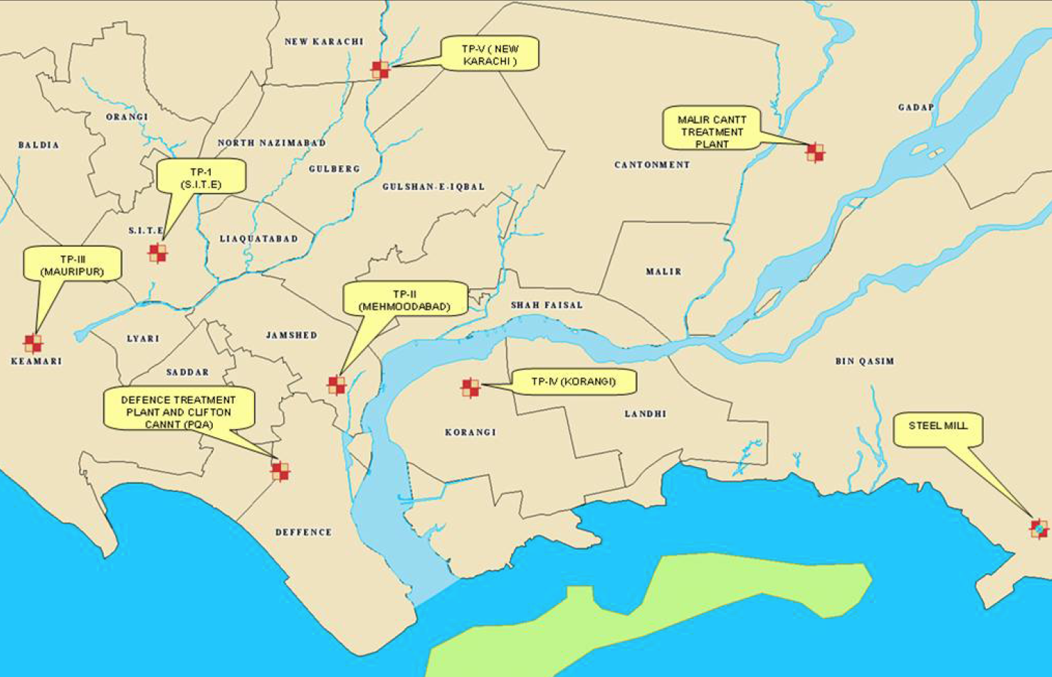
(Source: Karachi Strategic Development Plan 2020. Master Plan Group of Offices, City District Government Karachi)

Figure 35 - Karachi Natural Nullahs and Drains
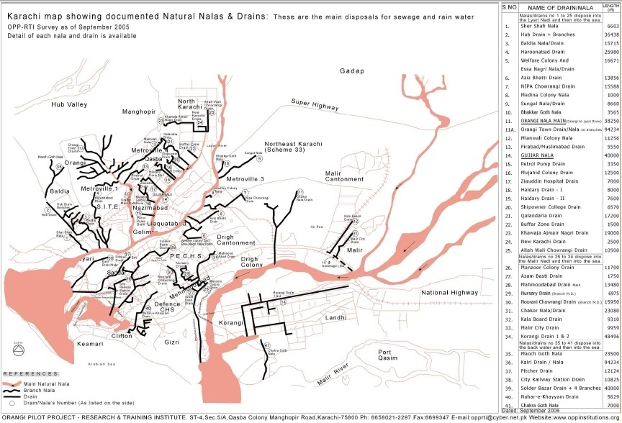
(Source: Orangi Pilot Project, Research and Training Institute, Karachi)

Sea Pollution
Due to improper handling of waste and insufficient/negligible treatment facilities available with respective organisations, marine/sea pollution is continuously increasing.The major sources of sea pollution are as follows:

- Disposal of untreated waste water generated from industrial areas located in Karachi
- Disposal of untreated waste water generated from Fertilizers discharging into river and canals
- Disposal of untreated waste water generated from different districts adjacent to River Indus
- Disposal of untreated waste water generated from KW&SB
- Disposal of untreated waste water generated from Defence Housing Authority Karachi
- Disposal of untreated waste water generated from Karachi Port Trust
- Disposal of untreated waste water generated from Cantonment Boards
- Disposal of untreated waste water generated from Right Bank Outfall Drain (RBOD) I & II
- Disposal of untreated waste water generated from Sugar mills in Sindh

Storm Water Drainage

Karachi has an annual average monsoon rainfall varying 125-250 mm whereas winter rainfall is about 25 mm. There are two main non-perennial rivers, the Malir and Lyari rivers, crossing the thickly populated city areas before falling into Arabian Sea.

The natural drainage system of Karachi consists of the Lyari and Malir rivers, and their tributaries or nullahs (Fig 36). Because of urban development and excessive occupation at the banks of the Lyari River and its tributary nullahs of Gujro and Orangi, the natural drainage has been destroyed and almost completely obliterated. As a result, the runoff of storm water is prevented from going into the natural channels, thus overflowing into the streets and parts of the residential areas. The areas worst affected are North Nazimabad, Liaquatabad, and SITE.

In the inner city, the low-lying areas of Saddar, Chundrigar Road, Bunder Road and Lyari become heavily inundated during the rainy spells mainly due to inadequate storm water drainage system. Extensive flooding occurs in parts of the Gulshan-e-Iqbal along the University Road, Societies Union area along Shahrah-e-Faisal and Tipu Sultan Road. katachi abadis of Mehmoodabad and Manzoor Colony located on the Malir River bank are also worst affected by excessive flooding and stagnant water.

Figure 36 - Storm Water Drainage System Karachi
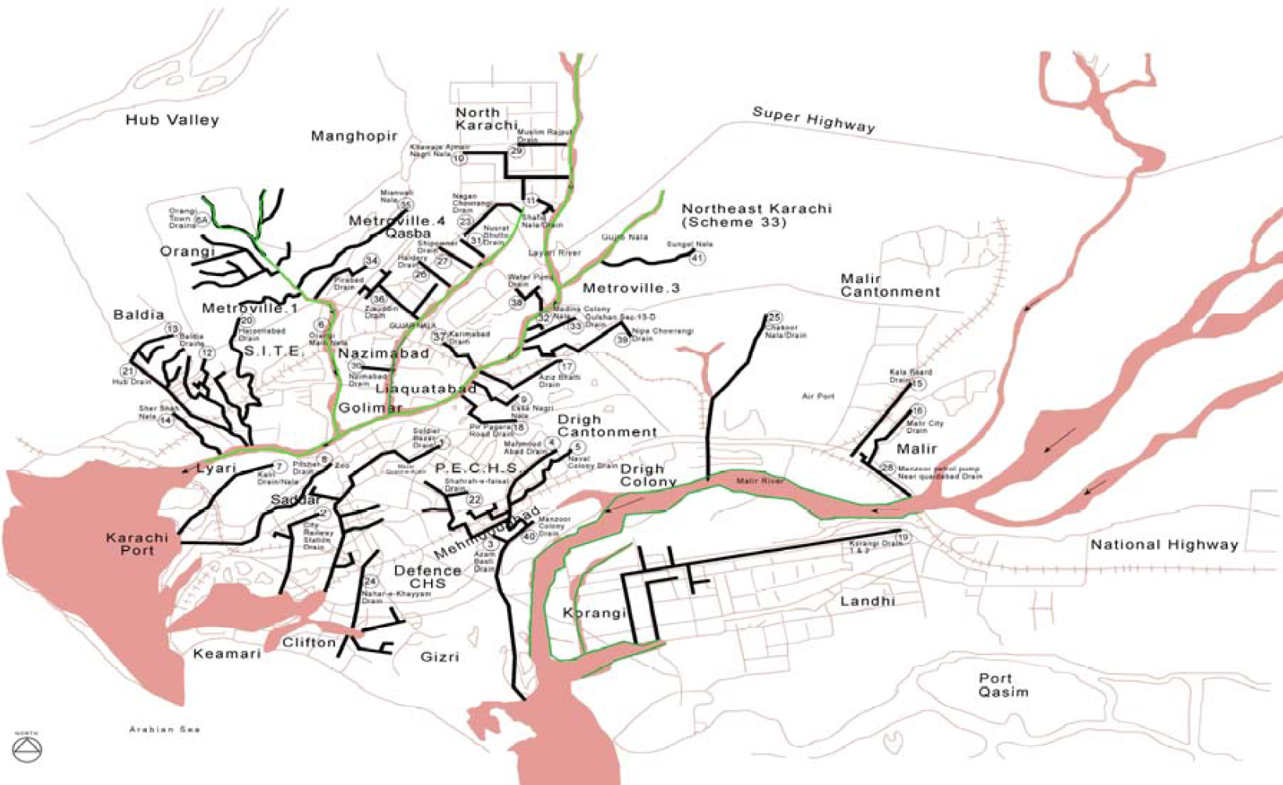
(Source: Karachi Strategic Development Plan 2020. Master Plan Group of Offices, City District Government Karachi)

Heavy rains were recorded in August,2006 resulting in high intensity uncontrolled gushing flows overtopping medians and other infrastructure features of road transportation network. Shahra-e-Faisal was among such hard hit areas wherefrom catchments of Shahra-e-Qaideen and adjoining areas of Hill Park and Shaheed-e-Millat resulted in the massive blockade of vehicular traffic which lasted well over 5 hours in complete choking conditions. The ripple effect was felt from Gulshan-e-Iqbal to areas of Korangi, Landhi and inner city areas such as Saddar. This situation occurs/results from the following reasons:

- Due to irregular and illegal land utilisation practices in the past, most of the natural drainage, nullahs and low lying areas which were left as open areas were converted into developed lands notwithstanding the requirements of providing alternate and man-made disposal channels and thus disturbing the natural flow conditions and consequently resulting in uncontrolled storm drainage pattern especially during a high intensity storm/rainfall.

- It is a general observation that due to lack of an organised solid waste disposal system in the city, a substantial percentage of solid waste is regularly disposed in the open storm drainage channels especially from adjoining localities which obviously results in complete choking or partially interrupted flow conditions in the event of storm. This practice is universally seen along the major drainage channels/nullahs such as Gujro and Orangi where the occupants of the katchi abadis due to the unavailability of any local waste collection and disposal systems invariably indulge in such practices. Almost all the residents of North Nazimabad areas will acknowledge similar practices in the localized drains mainly being used as dumpsters rather than an interconnecting interceptor drainage system. The resulting reduced and narrow channel width does not provide the adequate hydraulic radius and the flow capacities and in most cases results in localized ponding scenarios with overflows topping the streets and connecting roads.

- It is also observed that the existing interceptor drains along roads sides are also not fully functional mainly due to change in local topography and the slopes conditions. The storm sewers need major survey in terms of existing storm sewer network layout, interconnectivity, slopes, inverts and conveyance assessments.

- It is observed that all major intra-city drains overflow with storm water flowing at full capacities overtopping road medians and resulting in uncontrolled flow conditions affecting residential and commercial activities in the respective areas.

Recent Initiatives for Sanitation in Sindh

Sindh Cities Improvement Project

Under SCIP, the NSUSC is being implemented in 7 cities (Sukkur/New Sukkur, Rohri, Khairpur Mirs, Shikarpur, Larkana, Jacobabad and Ghotki). The focus on improving sanitation includes the following:

- Preparation of strategic sanitation plans
- System mapping and planning
- Leak detection and reduction; drainage and sewerage network improvements
- Rebuilding of pumping stations
- Provision of equipment
- Rehabilitation and expansion of stabilisation ponds
- Rehabilitation and construction of wastewater treatment plant

Some salient plans in progress or completed include the following:

Sukkur/New Sukkur
- Rehabilitation of 03 water treatment plants (WTP) and waste water facilities at Sukkur, Khairpur and Shikarpur Cities "Contract No. 2499-Pak/ICB/C03". Work in progress 33%
- Construction of extension of WTP at Numaish Gah of 18 MGD together with Force main to Adam Shah Reservoir including meters pressure measuring devices
- Replacement of old water mains and supply and laying of all new mains/transmission lines including district meters as part of Master Plan, supply and install appropriate leakage detection and NRW Equipment to reduce physical leakage from water supply networks
- Laying of new ring/trunk mains, including bulk meters and refurbishment of an elevated tank (OHR), and additional HSR
- Construction of water treatment plant at Sukkur Airport Road of 6 MGD together with desilting and capacity enhancement of storage lagoons and alternative supply of treated water from Numaish Gah via Adam Shah service reservoir
- 4 Additional DNI Zones – replacement of distribution network, household connections, installation of domestic and commercial meters and associated investment in transmission lines. Designed to provide 3,000 customers with 24/7 potable water supply at Sukkur
- Construction of new raw water intake on the River Indus at Sukkur
- Establishment of NRW reduction and pressure management zones with required resources at Sukkur, New Sukkur.
- Supply of sewer/drain cleaning equipment, 4 Jetting machines, 4 sucking machines for New Sukkur
- New Sukkur (1 Jetting + 1 Sucking Machine)
- Supervisory Control and Data Acquisition (SCADA) system for water supply and waste water facilities at Sukkur, New Sukkur

Rohri
- Improvement of sewerage system and waste water treatment system at in Karo Naro and improvement of Umar Kash Wah and New Yard Loco Shed (area) Sewerage Disposal Station at Rohri
- Supply of sewer/drain cleaning equipment, 4 Jetting machines, 4 sucking machines for New Sukkur, Rohri, Shikarpur and Ghotki

Khairpur Mirs
- Improvement of sewerage system Khairpur City (completed in-2010)
- Rehabilitation of 03 water treatment plants and waste water facilities - work in progress 33%
- Procurement of diesel generator sets for the disposal of wastewater (06 Shikarpur and 05 Khairpur) - Project Completed
- Rehabilitation of wastewater treatment plant at existing stabilisation Ponds at Jamali Goth, Khairpur
- Diverting wastewater of all disposal stations from Mir Wah canal to safe discharge point by providing additional force-main for disposal stations at Khairpur
- SCADA system for water supply and waste water facilities at Khairpur, Rohri, Sukkur, New Sukkur, Ghotki, Shikarpur and Jacobabad

Shikarpur
- Replacement of blocked sewers with covered drains
- Rehabilitation of 03 water treatment plants and waste water facilities - work in progress 33%
- Procurement of diesel generator sets for the disposal of wastewater (06 Shikarpur and 05 Khairpur) - project completed

Larkana
- Sanitation, drainage, sewerage strategy and prioritised works (completed-in 2012)
- Rehabilitation and Improvement of sewerage and drainage system of Larkana (based on detailed design of sewerage project consultancy of Federal Government) including 13 transformers for 13 disposal stations where new submersible pumps have been installed

Jacobabad
- Small capital works/projects for operational improvement of water supply and sewerage system of Jacobabad and Ghotki
- SCADA system for water supply and waste water facilities at Khairpur, Rohri, Sukkur, New Sukkur, Ghotki, Shikarpur and Jacobabad

Ghotki
- Small capital works/projects for operational improvement of water supply and sewerage system of Jacobabad and Ghotki
- Supply of sewer/drain cleaning equipment, 4 Jetting machines, 4 sucking machines for New Sukkur, Rohri, Shikarpur and Ghotki
- SCADA system for water supply and waste water facilities at Khairpur, Rohri, Sukkur, New Sukkur, Ghotki, Shikarpur and Jacobabad

Karachi Sewerage (S-III) Project

Karachi Sewerage Project S-III is a mega project for treated sewerage disposal for Karachi having a cost of Rs. 7.982 billion out of which Federal Government has to contribute Rs. 3.991 billion. The project is conceived to enhance the capacity of sewerage treatment of 500 MGD. The total sewerage generated in the city is 465 MGD. Rs. 1 billion has been allocated in the ADP 2015-16. This project will have immense environmental and health related benefits, in keeping with the vision of a clean, green Sindh. The project has a cost sharing mechanism between Government of Pakistan, Government of Sindh and Karachi Ports Trust.

Saaf Suthro Sindh Programme

The Saaf Suthro Sindh (SSS) Programme is an initiative of the LG&TPD, Government of Sindh, which has been conceived as an additional component of the Sindh Inter-sectoral Nutrition Support Programme (NSP).

The common objective of the SSS programme and the NSP is to improve the nutritional status of the rural communities through sanitation interventions. The SSS programme is also aligned with the Federal Government Vision 2025 and aims to achieve an open defecation free Sindh by 2025. The SSS will be implemented through the Directorate of Sanitation based in the LG&TPD which will be responsible for all sanitation related interventions in the province and also maintain integrated coordination with the Nutrition Programme for the desired results of SSS. The SSS is the first phase for achieving the 2025 objectives and will target 50% villages in 13 districts of Sindh. These districts include:

1) Jacobabad, 2) Kashmore, 3) Kambar-Shahdadkot, 4) Larkana, 5) Tharparker, 6) Badin, 7) Sanghar 8) Tando Muhammad Khan 9) Umarkot 10) Shikarpur 11) Dadu 12) Thatta; and 13) Sujawal

The SSS builds upon PATS by selecting the CLTS and Sanitation Marketing approaches as the instruments of change. The SSS model is an advanced model with additional components that have been included based on learnings from best practices. These include linkages with duty bearers, participatory health and hygiene, and development of end of pipe treatment. Behaviour change and sustainability beyond the life of the project are also an integral part of the SSS project with some linkages with schools. At the provincial level, a Directorate of Sanitation will be established at LG&TPD for implementing the programme activities while working closely with NGOs – called Implementation Partners (IPs).

Sindh Municipal Services Delivery Programme

The US Government through USAID in Pakistan has earmarked a grant of US$ 66.0 million for the development of municipal infrastructure in six selected towns in 2010 flood affected districts of the province. Under the Sindh Municipal Services Delivery Programme (SMSDP) emphasis was given to smaller towns, falling outside the purview of SCIP. Accordingly, Jacobabad, Qambar, Shahdadkot, Mehar, Khairpur Nathan Shah and Johi were selected for the USAID assisted development work under the programme. In the first phase, the construction works on Jacobabad Water Supply System are currently underway while work on Waste Water and Solid Waste Systems in Jacobabad have also been initiated.

Municipal Services Programme, Jacobabad

The main components of the SMSDP project in Jacobabad are improvement of water supply, up-gradation and rehabilitation of sanitation system, and development of solid waste collection and disposal infrastructure.

The project aims to achieve the following:

- Improved water intake – by constructing 3 new lagoons, new pump and generator rooms and 600 mm water main (running 22 km)
- Water filter plant – with Additional Clarifier and 4 Rapid Sand Filter Beds, new generator room, Alum dosing system and sodium hypochlorite disinfection
- Water distribution – with a new water transmission loop, an additional 6 overhead reservoirs, additional pumping machinery and SCADA
- Improved sewerage system – through up-gradation of pumping capacity, construction of tertiary drains, construction of new wastewater treatment plant/oxidation ponds, and provision of drain cleaning/de-silting machinery for O&M of the sewerage network
- Implementation of a solid waste management plan – with proper collection, transportation and waste management system, door-to-door collection, and machinery for collection and transportation to a landfill site

Other Initiatives

A new drainage system for Thatta City has been initiated under Special Initiatives.

Consultancy Services for establishment of four Combined Effluent Treatment Plant (CETP) for the Industrial Areas of Karachi including laying of interceptor sewers have been initiated by the Industries and Commerce Department.

Construction of drains, sewerage and water supply system has been initiated in different Katchi Abadies in Shaheed benazirabad, Khairpur, Larkana, Sukkur, Hyderababd, Mirpurkhas, Thatta and Karachi.

Drainage schemes are also being implemented through the Community Development Programme for Sustainable Development Goals in the form of Federal Government grants to Members of Provincial Assembly (MPAs), and through the Social Protection Priority Development Programmes in the form of Federal Government grants to Members of the National Assembly (MNAs).

UN Maternal and Child Stunting Reduction Programme

UNICEF has selected four implementing organisation (Plan International, HANDS, SAFWCO and NRSP) to implement WASH interventions under ‘PATS Plus Approach’ in order to achieve the ‘Open Defecation Free’ status of the rural communities in six Taluks of Districts Nausharo Feroze, Ghotki and Khairpur. WASH infrastructure with disaster risk reduction will be provided to the communities as part of incentives so that communities are mobilised to construct toilets at their household level. WASH in Schools (WinS) component will be addressed under ‘Three Star Approach’ to improve the learning environment for school children and teachers – particularly girls. WinS interventions will also ensure that school children have access to WASH facilities in their learning environment and group handwashing will be promoted through the provision of handwashing stations so that daily group handwashing becomes the regular feature for their activities.

Rural Sanitation Scale-up Strategy

The strategy to scale up rural sanitation e.g. under the ‘UN Maternal and Child Stunting Reduction Programme’ includes:

- Extensive series of activities undertaken to improve the living conditions of people and to achieve 100% ODF at Taluka level.
- Under the cascading model, social mobilisation activities will be one of the key components to achieve this goal/objective through Social Mobilisers, Community Resource Persons and Lady Health Workers.
- Overall project will be implemented by combining hardware and software components that are necessary to create a healthy environment and to develop or support safe water, sanitation and hygiene practices. It focuses on development of life-skills, a healthy and safe environment for the targeted population.
- The implementation strategy is guided by human rights based approaches particularly ensuring ‘Equity’ agenda and ‘Gender Mainstreaming’ embedded within WASH interventions exclusively. In addition, ‘Disaster Risk Reduction’ approaches will be adopted to ‘build resilience’ of rural communities during the emergency situations – particularly floods in Sindh.

As a result of project interventions in targeted areas, the initiative aims to achieve the following:

- Water Supply: people (including women and children) will have access to safe drinking water through the provision of small water supply systems (raised hand pumps with DRR) – water quality monitoring and testing will be given due consideration and project interventions will ensure to build the capacity of service providers, WASH Committees as well as communities – much focus will also be given on ‘community led water safety and security’ planning so that people have access to safe drinking water.

- Rural Sanitation under PATS Plus Approach: By the end of the project, all project areas will be declared/certified as 100% Open Defecation Free – under sanitation, a series of interventions will be undertaken like adaptation of cascading model for extensive social mobilisation and triggering communities to construct toilets through social mobilisers, community resource persons and LHWs, formation of WASH Committees, identification of local masons and entrepreneurs and ‘Behaviour Change Communication’ campaigns at community level targeting the key segments. Standardised capacity building planning and trainings shall be delivered by implementing partners to all local activists (including social organisers, community resource persons, WASH Committees, local masons and entrepreneurs). These trainings will ensure to roll out cascading model and achieve the quality results.

- Health and Hygiene: Health and hygiene related key messages and sessions will be delivered to the community so that key social norms are created particularly, handwashing with soap during critical times and proper use of toilet and water safety practices through educating them on household water treatment options.

- WASH in Schools: School children in target areas will have access to WASH facilities in their schools. WASH clubs will be institutionalised after providing improved WASH facilities in schools which would help in mobilising households to move up the sanitation ladder and adopt improved practices e.g. treatment of water by boiling before use at household level, construction of latrines and consuming a balanced diet. Children at school are direct recipients of improved WASH services at school which help in improving enrolment and retention rates, especially among girls at the age of puberty. In addition, under ‘Three Star Approach’, group handwashing will be promoted through the provision of handwashing stations so that daily group handwashing becomes the regular feature for their activities. This activity will be organised as part of the routine of institutionalized WASH clubs. Evidence from previous programmes of UNICEF has shown the link between group hand washing at school by children and promotion of hand washing practices at household level by them after school. This activity will follow the three star approach guidelines which will help in engaging children and school authorities to help their school graduate from one star to two and then three stars using a prescribed methodology. School children would directly benefit from this activity but promotion of hand washing with soap at household level by them will also benefit the target group and help in community mobilization efforts through other activities. Menstruation Hygiene Management will be addressed as a cross cutting theme and will be the key component of WinS interventions.

- WASH in Health Facilities: Catchment populations in target areas will have access to WASH facilities in health centres. Improved WASH facilities would be provided in healthcare facilities/and CMAM sites, adopting construction manuals and standards, for reducing vulnerability of WASH related infections in pregnant/lactating women and children visiting the healthcare facilities. Improved WASH activities at healthcare facilities will also help in improving health seeking behaviour, reporting cases of diarrhoea and promoting good practices e.g. use of latrines with more dignity and privacy, especially important for women. WASH facilities are a pre-requisite to inculcate improved behaviour in healthcare facilities.

Orangi Pilot Project

In the urban areas, the Orangi Pilot Project–Research and Training Institute (OPP-RTI) has demonstrated strategies for community participation, engagement with local governments, and engagement with utilities. It also conducts documentation and analysis of the sector. Direct assistance to communities in Orangi town in north-western Karachi and the demonstration effect of OPP-RTI’s work benefited over 108,000 households (more than 865,000 people) in nearly 7,600 lanes, representing almost 90% of the entire settlement of Orangi. Collectively, communities invested nearly US$1.7 million of their own money in their community’s sewerage system.

Strategy

Sanitation (Sewerage and Drainage)
Strategic Objectives/Outcomes | Short Term Actions  1 - 3 years | Medium Term Actions  4 - 6 years | Long Term Actions  7 - 10 years
URBAN SANITATION
All cities, towns and UCs have surveys, strategies and action plans for integrated water supply, water safety, sewerage and drainage, storm water drainage and solid waste management  (common to water supply, sanitation and solid waste) | All cities have completed surveys, GIS mapping and strategies, and start implementing action plans for integrated water supply, water safety, sewerage and drainage, storm water drainage and solid waste management  Develop integrated water supply, water safety, sanitation, storm water drainage and solid waste management action plans for all cities | At least 50% of UCs (500) have completed surveys, GIS mapping and strategies, and start implementing action plans for integrated water supply, water safety, sewerage and drainage, storm water drainage and solid waste management  Develop integrated water supply, water safety, sanitation, storm water drainage and solid waste management action plans for 500 UCs | At least 100% UCs (608) have completed surveys, GIS mapping and strategies, and start implementing action plans for integrated water supply, water safety, sewerage and drainage, storm water drainage and solid waste management  Develop integrated water supply, water safety, sanitation, storm water drainage and solid waste management action plans for 608 UCs
Improved and safely managed sanitation services coverage enhanced to reduce access gap in urban areas and rural areas, especially in those that are also nutrition-sensitive | Develop an SOP for all new sanitation schemes to meet criteria for 'safely managed’ which include:  - not shared with other households  - excreta are safely disposed in situ or transported and treated off-site  - guidelines for integration in interventions in nutrition-sensitive areas  Plan and implement safely managed sanitation schemes to reduce access gap  - By 20% in short term  - reduce proportion of households connected to open drains from 27% to 24%  Execution of schemes on cost sharing basis i.e. Community invests in maintenance and internal component, while Government invests for external component | Plan and implement safely managed sanitation schemes to reduce access gap  - By 50% in medium term  - reduce proportion of households connected to open drains from 24% to 20%  Execution of schemes on cost sharing basis i.e. Community invests in maintenance and internal component, while Government invests for external component | Plan and implement safely managed sanitation schemes to reduce access gap  - By 100% in long term  - reduce proportion of households connected to open drains from 20% to 15%  Execution of schemes on cost sharing basis i.e. Community invests in maintenance and internal component, while Government invests for external component
Wastewater treatment plants established in 119 towns (12 per year) | Establish wastewater treatment plants in 36 towns | Establish wastewater treatment plants in 36 towns | Establish wastewater treatment plants in 47 towns
Water supply and sanitation schemes linked with wastewater treatment | At least 25% of new schemes have in-built wastewater treatment facility  Incorporate wastewater treatment options (like oxidation ponds, wetlands, sewerage treatment units, community septic tanks) in rural sanitation schemes | At least 50% of new schemes have in-built wastewater treatment facility  Incorporate wastewater treatment options (like oxidation ponds, wetlands, sewerage treatment units, community septic tanks) in rural sanitation schemes | At least 75% of new schemes have in-built wastewater treatment facility  Incorporate wastewater treatment options (like oxidation ponds, wetlands, sewerage treatment units, community septic tanks) in rural sanitation schemes
Monitor contamination levels of industrial effluent | LG&HTPD, PHE&RDD, Irrigation department, PCSIR and Sindh Environment Protection Agency map major industrial wastewater flows and conduct periodic wastewater testing and public reporting of industrial effluent quality  Environment protection regulations enforced | Hazard and risk GIS mapping of contaminated rivers and water bodies done  Conduct periodic wastewater testing and public reporting of industrial effluent quality  Environment protection regulations enforced | Conduct periodic wastewater testing and public reporting of industrial effluent quality  Environment protection regulations enforced
Increased proportion of treated industrial wastewater | Set up Combined Effluent Treatment Plant (CETP) for cluster of industries where feasible  Identify industries with high volume of untreated effluent and prioritise for enforcement of regulations | At least 5% of industrial wastewater treated | At least 10% of industrial wastewater treated
Optimal sewage flow capacity maintained | Sewage flows determined for all cities and towns, and six monthly de-silting and cleaning of 30% drains and sewers with safe sludge disposal in towns and zones in cities | Six monthly de-silting and cleaning of 60% drains and sewers with safe sludge disposal in towns and zones in cities | Six monthly de-silting and cleaning of 90% drains and sewers with safe sludge disposal in towns and zones in cities
Optimal status of sewer maintenance equipment (sucking machine, jetting machine, sucking/jetting machine) | Status of equipment availability and functionality determined for each town and city zone  At least 30% of towns and city zones equipped with sewer maintenance equipment | At least 60% of towns and city zones equipped with sewer maintenance equipment | At least 90% of towns and city zones equipped with sewer maintenance equipment
Adequate and functional collector and branch sewers | Status of collector and branch sewers in each city and town determined  Phased replacement or laying of new lines instituted | Phased replacement of 25% non-functional collector and branch sewers or laying of new lines instituted | Phased replacement of 50% non-functional collector and branch sewers or laying of new lines instituted
Optimal functionality of pumping stations | Status of pumping stations in each city and town determined  Phased rehabilitation plan instituted for at least 30% dysfunctional pumping stations | Phased rehabilitation plan instituted for at least 60% dysfunctional pumping stations | Phased rehabilitation plan instituted for at least 90% dysfunctional pumping stations
Systematic management of Operation and Maintenance of sewerage and drainage systems | Develop O&M manual for sewerage and drainage including sewer desilting safety measures  Train LG&HTPD and PHE&RDD staff in use of O&M manual | Refresher training to LG&HTPD and PHE&RDD staff on use of O&M manual | Refresher training to LG&HTPD and PHE&RDD staff on use of O&M manual
RURAL SANITATION
Implement rural sanitation scale-up strategy in nutrition and WASH programmes | Ensure provision of small water supply systems, implement PATS Plus Approach, disseminate health and hygiene related key messages on handwashing with soap during critical times and proper use of toilet and water safety practices through educating them on household water treatment options, establish WASH clubs in schools, promote handwashing through provision of handwashing stations, and establish WASH in Health Facilities (13 priority districts) | Ensure provision of small water supply systems, implement PATS Plus Approach, disseminate health and hygiene related key messages on handwashing with soap during critical times and proper use of toilet and water safety practices through educating them on household water treatment options, establish WASH clubs in schools, promote handwashing through provision of handwashing stations, and establish WASH in Health Facilities (13 ongoing + 6 other districts) | Ensure provision of small water supply systems, implement PATS Plus Approach, disseminate health and hygiene related key messages on handwashing with soap during critical times and proper use of toilet and water safety practices through educating them on household water treatment options, establish WASH clubs in schools, promote handwashing through provision of handwashing stations, and establish WASH in Health Facilities (19 ongoing + 10 other districts)
Community awareness and social mobilisation regarding sanitation, nutrition and hygiene enhanced in all UCs through effective implementation of BCC strategy | Conduct community awareness sessions, including women and children, and disseminate key messages developed under BCC strategy by using billboards and leaflets in each UC every year (1297 UCs) | Conduct community awareness sessions, including women and children, and disseminate key messages developed under BCC strategy by using billboards and leaflets in each UC every year (1297 UCs) | Conduct community awareness sessions, including women and children, and disseminate key messages developed under BCC strategy by using billboards and leaflets in each UC every year (1297 UCs)
2 Community Resource Persons (preferably one male and one female) deployed for BCC for each UC (2594 Community Resource Persons) | Deploy and orient 2594 Community Resource Persons in 1297 UCs | Maintain 2594 Community Resource Persons in 1297 UCs | Maintain 2594 Community Resource Persons in 1297 UCs
Safe sanitation practices promoted in high open defecation zones, nutrition-sensitive and polio priority areas | Develop provincial and district level road maps on PATS/ODF for identified villages in 13 priority districts  Incentivising the ODF villages by laying of water supply scheme, sewerage system, waste water treatment, etcin 13 priority districts  Execution of schemes on cost sharing basis i.e. Community invests in internal component, while Government invests for external componentin 13 priority districts  Collaborate with international partners and NGOs for integrating WASH component in interventions in nutrition-sensitive areas, and strengthening the supply side interventions especially sanitation marketing (training of masons, entrepreneurs and small businesses) in 13 priority districts | Develop provincial and district level road maps on PATS/ODF for identified villages in 6 additional districts  Incentivising the ODF villages by laying of water supply scheme, sewerage system, waste water treatment, etcin 6 additional districts  Execution of schemes on cost sharing basis i.e. Community invests in internal component, while Government invests for external componentin 6 additional districts  Collaborate with international partners and NGOs for integrating WASH component in interventions in nutrition-sensitive areas, and strengthening the supply side interventions especially sanitation marketing (training of masons, entrepreneurs and small businesses) in 6additional districts | Develop provincial and district level road maps on PATS/ODF for identified villages in 10 additional districts  Incentivising the ODF villages by laying of water supply scheme, sewerage system, waste water treatment, etcin 10 additional districts  Execution of schemes on cost sharing basis i.e. Community invests in internal component, while Government invests for external componentin 10 additional districts  Collaborate with international partners and NGOs for integrating WASH component in interventions in nutrition-sensitive areas, and strengthening the supply side interventions especially sanitation marketing (training of masons, entrepreneurs and small businesses) in 10 additional districts

SOLID WASTE

The Ministry of Environment undertook a study during 1996 on “Data Collection for Preparation of National Study on Privatisation of Solid Waste Management in Eight Selected Cities of Pakistan”. The study revealed that the rate of waste generation on average from all type of municipal controlled areas varies from 0.283 kg/capita/day to 0.613 kg/capita/day or from 1.896 kg/house/day to 4.29 kg/house/day in all selected cities. The projected population of the country for the year 2014 was 197.77 million on the basis of current annual growth rate of 2.6% resulting in an estimated projection of solid waste of 71,018 tons per day/ 25.921 million tons per year.

The study estimated that the Solid Waste Generation Rate (kg/C/Day) for Karachi was 0.613 kg/C/Day, while for Hyderabad, it was 0.563 kg/C/Day. Using the current estimated population of Karachi of 24 million, at least 14,712 tons per day or 5.37 million tons per year. Using an arbitrary mean Solid Waste Generation Rate of 0.330 kg/C/Day (average of urban and rural rates), the total solid waste generated per day in Sindh for a population of 44.807 million is about 14,786 tons per day, and about 5.397 million tons per year. Clearly, most of the solid waste is generated in Karachi.

Figure 37 - Status of Garbage Collection in Sindh
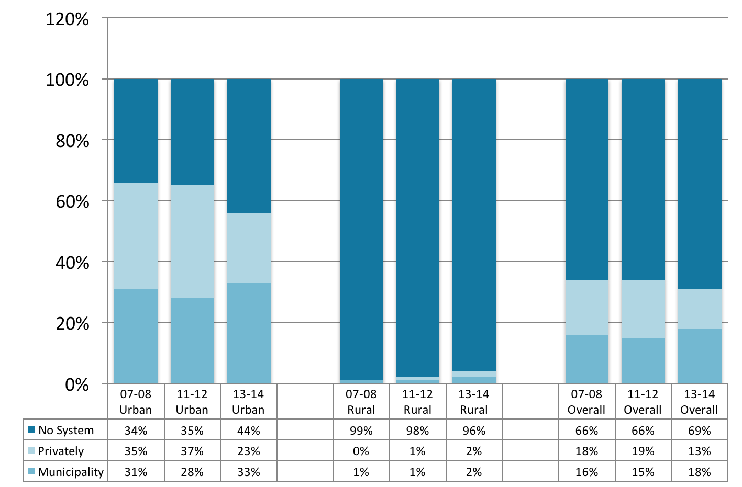
(Source: Pakistan Social and Living Standards Measurement Survey, 2007-08, 2011-12 and 2013-14)
Only 31% of Sindh has proper disposal of waste solids (collected by any municipal institution, disposed of by solid waste management department or a private company vehicle collected from home) (Fig 37). This ranges from 56% in urban to 4% in rural areas.

Karachi City Solid Waste

The performance of solid waste management system has always been a major cause of concern, as this municipal service was traditionally wanting in such basic aspects as primary collection of garbage and safe transfer to the landfill sites.

Approximately 9,000 tons of solid waste were being generated each day in 2005. Households, trade and industrial establishments, construction activity and a variety of institutions contribute in waste generation. The amount of solid wastes is expected to substantially increase with the rapid growth of population and economic activity. By the year 2020, the solid waste generation may approach 16,000 to 18,000 tons each day. The quality of civic life is closely related and affected by the sanitary conditions in the residential neighbourhoods and other areas, where efficient collection of garbage is the key to clean and healthy environment.

Figure 38 - Existing Landfill Sites in Karachi
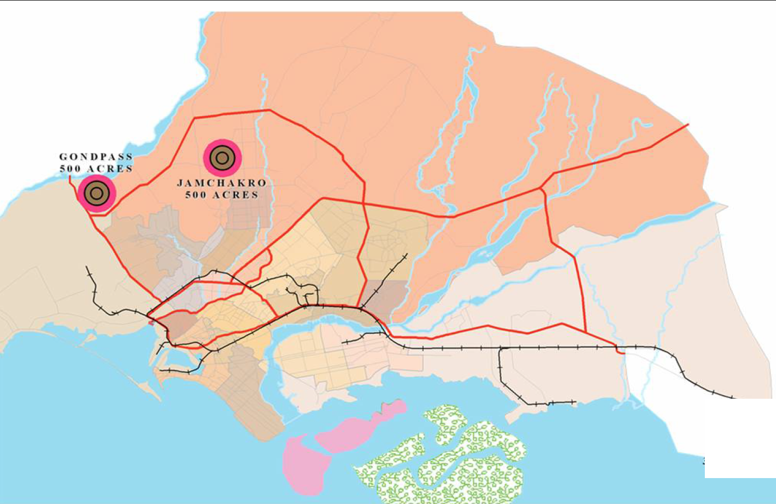
(Source: Karachi Strategic Development Plan 2020. Master Plan Group of Offices, City District Government Karachi)

it is estimated that of the total household solid waste generated daily within the City District Karachi, around 4,500 tons is lifted and ofthis, not more than 2,000 tons makes it to one of the twodesignated city "landfill" sites - actually open dumping sites. Theremainder is either recovered for recycling (an estimated 1,500tons per day) or is disposed of by burning or by illegal dumpinginto open drains or onto roadsides or open land (an estimated 1,400 tons). It is estimated that some 55,000 families dependon the informal solid waste recycling industry for their livelihoodand with more than 1,000 operating units that the industry isworth some Rs 1.2 Billion per annum.

It is important to effectively organise primary collection of garbage i.e. from the households (within the Union Councils) and locations of origin/generations such as markets, industrial areas, hospitals and recreational places. The city conspicuously lacks garbage transfer stations which need to be developed for better handling of the garbage and transfer to sanitary landfills (Fig 38).

Poor planning, inappropriate technology and poor management are obviously the main areas of concern needing serious efforts on the part of the local government and other agencies towards efficient management and modern technological development of this sector.

Hospital Waste

Various studies have reported the waste generation in urban centres of Pakistan, however, there is paucity of data on the situation in Sindh. In Pakistan, however, all hospital waste including hazardous waste is considered to be a part of municipal solid waste.

There is little data on the true estimate of hospital waste being generated in Karachi City. There are no discrete criteria for the categorisation of hospital / clinical / healthcare unit / biohazard waste. Furthermore, the segregation practice is not discretely observed. It is commonly observed that segregation practices are limited or restricted to the boundaries of the source only and are mostly applied where there are source segregation practices at source. Outside the point of generation of source in more than 95% cases the waste is a commingled waste i.e. mixed with municipal solid waste (MSW). Therefore, in order to estimate the realistic quantities of hospital waste being generated in Karachi, comprehensive studies should be undertaken to characterise the type, composition and quantities of hospital waste generated.

Only 140 health care units (HCUs) in Karachi City dispose of their waste through incineration plants run by City District Government (CDG). The remaining HCUs dispose of their waste along with the municipal waste. This poses a health hazard. The reasons of health hazards are:

- Non-registration of HCUs either with Health Department, Government of Sindh or with City Government and
- Non-presence of Environment Protection Agency of Sindh at grass root level

The CDG installed two incineration plants at Mewa Shah in 1996. Each has a capacity of 1000 kg/hour. Incineration takes place at 800 ⁰C in 10 minutes. At present 140 hospitals/clinics are incinerating their waste through these incinerators.

A studywas undertaken to evaluate the current practices of segregation approaches, storage arrangements, collection and disposal systems in eight teaching hospitals of Karachi. Out of the eight hospitals visited, two (25%) were segregating sharps, pathological waste, chemical, infectious, pharmaceutical and pressurised containers at source. For handling potentially dangerous waste, two (25%) hospitals provided essential protective gears to its waste handlers. Only one (12.5%) hospital arranged training sessions for its waste handling staff regularly. Five (62.5%) hospitals had storage areas but mostly they were not protected from access of scavengers. Five (62.5%) hospitals disposed of their hazardous waste by burning in incinerators, two (25%) disposed of by municipal landfills and one (12.5%) was burning waste in open air without any specific treatment. No record of waste was generally maintained. Only two (25%) hospitals had well documented guidelines for waste management and a proper waste management team.

A similar study was conducted at Shaheed Mohtarma Benazir Bhutto Medical University (SMBBMU) Hospital Larkana.to assess the hospital waste management system at different medical wards and to determine the total daily waste generation rates. The study found that the average generation rate of hospital and infectious waste was about 1.072 and 0.453 kg/bed/day respectively. It also observed that the existing hospital waste management system was lower than prescribed standards. The poor waste management system in the hospital was mainly due to ineffective segregation, collection, storage and dumping of waste. In addition, lack of training and protective equipment for sanitary staff, scarcity of funds and inadequate policy of waste treatment were also the main causes of inappropriate waste management.

The Government of Sindh has developed its Hospital Waste Management Rules 2014. However, its wide scale adoption remains a challenge. In 2015, on the directives of Minister Environment, notices for personal hearings under Section 21 (1) of Sindh Environmental Protection Act 2014 were issued to 30 hospitals in the province for non-compliance of the directives requiring them to submit a comprehensive Hospital Waste Management Plan.

Slaughter Waste

According to Livestock Census 2006, 49% of total cattle population of Pakistan resides in Punjab, 23% in Sindh, 20% in Khyber Pakhtunkhwa and 8% in Balochistan. There is a growing demand for both domestic consumption and meat exports. In 2003, the demand for beef in Pakistan was 1.21 million tons, while the supply was 1.05 million tons with a gap of 0.16 million tons. Similarly, for mutton, the demand was 0.80 million tons, while the supply was 0.70 million tons with a gap of 0.10 million tons. By 2020, the demand for beef and mutton would have risen to 3.74 and 2.50 million tons respectively, but the gap would also have increased to 2.31 and 1.47 million tons respectively.

There is paucity of data on slaughter waste. However, there is data available on livestock slaughtered which gives an idea of the scale of disposal required (Fig 39). About 80%-87% of goats, sheep, buffaloes and cattle slaughtered in Sindh take place in Karachi (over 2.4 million livestock are slaughtered annually in Karachi). There are 85 recognised slaughterhouses in Sindh. Current practices suggest that slaughter waste is mixed with and disposed in municipal solid waste. The number of recognised slaughterhouses by Government of Sindh are shown by district in Fig 40.

Figure 39 - Livestock slaughtered in Sindh 2011-12
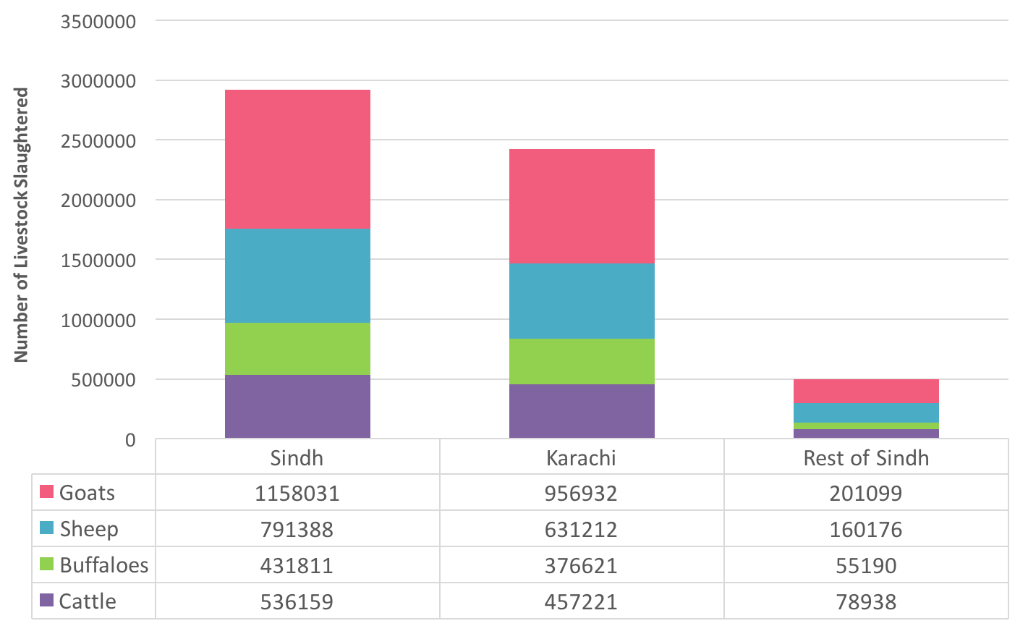
(Source: Directorate of Animal Husbandry Sindh, Hyderabad – in Development Statistics of Sindh 2013, Sindh Bureau of Statistics)

Figure 40 - Number of recognised slaughterhouses by district 2011-12
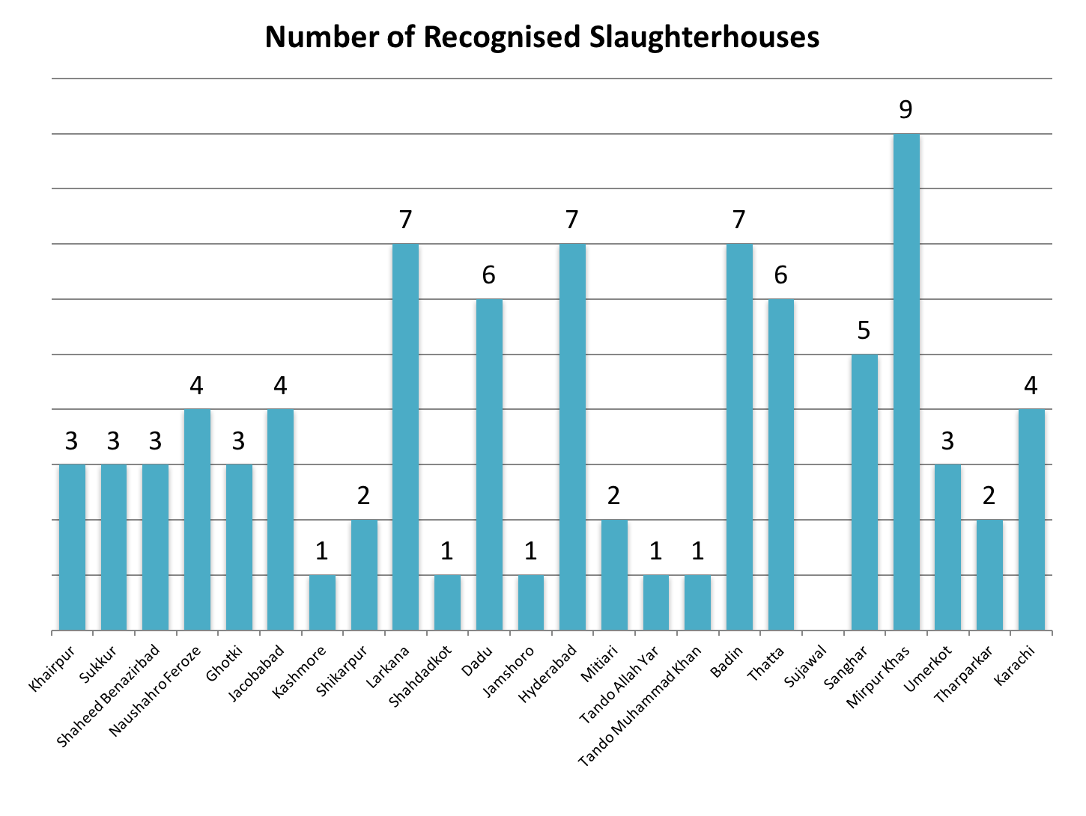
(Source: Directorate of Animal Husbandry Sindh, Hyderabad – in Development Statistics of Sindh 2013, Sindh Bureau of Statistics)

Overview of solid waste management practices

Table 12 illustrates the practices in selected secondary cities as part of data obtained for the Sindh Environment Management Programme. It shows less than satisfactory solid waste management, outmoded collection and disposal methods, lack of adequate equipment and infrastructure and low operating efficiency.

Table 12 - Overview of solid waste management in selected secondary cities
 | Mirpur Khas | Umerkot | Johi | Larkana | Shikarpur | Sukkur
Urban population (2006) | 231,276 | 55,615 | 29,296 | 38,996 | 164,727 | 240,776
Collection vehicles
Tractor trolleys | 6 | 4 | 2 | 8 | 5 | 7
Dumper trucks |  |  |  | 2 |  | 5
Container carriers |  |  |  |  |  | 1
Mechanical loaders | 2 |  |  | 2 | 1 | 1
Donkey carts | 9 | 1 |  | 20 | 10 | 11
Hand carts | 70 | 21 | 10 | 40 | 24 | 150
Primary-secondary transfer | Open heaps | Open heaps | Open heaps | Open heaps | Open heaps | Open heaps
Disposal methods | Open dumping | Open dumping | Open dumping | Open dumping | Open dumping | Open dumping
Hospital wastes | Collected with municipal wastes | Burnt at site | Negligible (on site in disposal) | Open dumping | Collected with municipal wastes | Collected with municipal wastes
Dead animals | Collected with municipal wastes | Collected with municipal wastes | Collected with municipal wastes | Collected with municipal wastes | Collected with municipal wastes | Collected with municipal wastes
Annual expenditure (Rs) | 16,686,000 | 9,224,700 | 3,185,000 | 3,070,000 | 13,517,000 | 29,732,000
Collection cost/ton (Rs) | 952 | 1487 | 550 | 766 | 823 | 1037
Cost per inhabitant per year (Rs) | 72 | 166 | 51 | 79 | 82 | 123
Collection efficiency (%) | 48 | 80 | 73 | 62.5 | 65 | 72
Staff per 1000 population | 1.5 | 2.59 | 1.06 | 0.97 | 0.92 | 1.79
Contracts awarded to private sector |  |  | 1 | 1
(Source: Urban Municipal Services Sindh Secondary Cities Urban Sector Assessment Prepared under ADB PPTA 4534 – Sindh Basic Urban Services Project, 2007)

Recent Initiatives for Solid Waste in Sindh

Sindh Cities Improvement Project

Under SCIP, the NSUSC is being implemented in 7 cities (Sukkur/New Sukkur, Rohri, Khairpur Mirs, Shikarpur, Larkana, Jacobabad and Ghotki). This includes investments in primary and secondary storage and collection, waste reduction, recycling / reuse and recovery (including incineration where appropriate), treatment, and final sanitary disposal. The Solid Waste Management (SWM) also includes:

- Construction of landfill facilities
- Procurement of specialised solid waste collection and disposal equipment
- Provision of improved communal bins for waste storage

Some salient plans in progress or completed include the following:

Sukkur/New Sukkur
- Skip platforms for solid waste collection (project completed in 2011)
- Additional SWM secondary collection equipment and skips and system, and replacement of old TMA system including new solid waste management secondary collection equipment (including road mechanical sweepers and small skid loaders for all T1 and T2 Towns. 3.5 cm Skips (68 Nos), Side Loading Trucks (13 Nos), Skid Loader (2 Nos))

Rohri
- Site investigation for SWM landfill sites (in progress since July 2011- due to land issues)
- Skip platforms for solid waste collection (project completed in 2011)

Khairpur Mirs
- Site investigation for SWM landfill sites (in progress since July 2011- due to land issues)
- Skip platforms for solid waste collection (project completed in 2011)
- Construction of three sanitary landfill sites, disposal works, landfill equipment landfill in Rohri, Sukkur, Khairpur and Shikarpur
- Additional SWM secondary collection equipment and skips and system, and replacement of old TMA system including new solid waste management secondary collection equipment (including road mechanical sweepers and small skid loaders for all T1 and T2 Towns

Shikarpur
- Site investigation for SWM landfill sites (in progress since July 2011- due to land issues)
- Skip platforms for solid waste collection (project completed in 2011)
- Construction of three sanitary landfill sites, disposal works, landfill equipment landfill in Rohri, Sukkur, Khairpur and Shikarpur
- Additional SWM secondary collection equipment and skips and system, and replacement of old TMA system including new solid waste management secondary collection equipment (including road mechanical sweepers and small skid loaders for all T1 and T2 Towns

Larkana
- Skip platforms for solid waste collection (project completed in 2011)
- Construction of three sanitary landfill sites, disposal works, landfill equipment landfill in Rohri, Sukkur, Khairpur and Shikarpur
- Additional SWM secondary collection equipment and skips and system, and replacement of old TMA system including new solid waste management secondary collection equipment (including road mechanical sweepers and small skid loaders for all T1 and T2 Towns

Ghotki
- Construction of three sanitary landfill sites, disposal works, landfill equipment landfill in Rohri, Sukkur, Khairpur and Shikarpur
- Additional SWM secondary collection equipment and skips and system, and replacement of old TMA system including new solid waste management secondary collection equipment (including road mechanical sweepers and small skid loaders for all T1 and T2 Towns

Sindh Solid Waste Management

Government of Sindh has established the Sindh Solid Waste Management Board to support local councils in managing municipal solid waste, medical hazardous waste and industrial hazardous waste in all cities of the province.

Sindh Government has assigned very high priority to this sector as it has a direct impact on the health of the people and environment of cities. In its Phase I, Integrated Solid Waste Management Projects are being started in 06 districts of Karachi, Hyderabad, ShaheedBenazirabad and Larkana districts. These projects are being undertaken on fast track basis and will be on ground from October 2015 onwards. In Phase II, 10 districts of Sindh will be taken up and in Phase III all remaining districts will be completed.

Sindh Solid Waste Management Board is introducing Integrated Municipal Solid Waste Management Projects whereby the present method of manual sweeping and collection and transportation of garbage will be replaced by a modern, scientific and environment friendly system of mechanical sweepers, door to door collection of garbage, complete ban on burning of garbage, and transportation of waste from community dustbins to Garbage Transfer Stations and then to Sanitary Engineered Landfill sites.

These initiatives include the following under Services, General Administration and Coordination Department:

- Establishment of six garbage transfer stations with Material Recovery (MR) and Refused Derived Fuel (RDF) facility in Karachi
- Development of new sanitary engineered landfill site in Karachi
- Development of sanitary engineered existing 2 landfill sites and their scientific improvement in Karachi
- Integrated solid waste Management Project Nawabshah Municipal Committee, Shaheed Benazirabad District. (Phase I) (Front end Collection System and two Garbage Transfer Stations)
- Integrated Municipal Solid Waste Management Project Nawabshah Municipal Committee, Shaheed Benazirabad District (Phase-II) – landfill site and material recovery facility
- Integrated Municipal Solid Waste Management Project Municipal Corporation, Larkana (Phase-I)
- Integrated Municipal Solid Waste Management Project Municipal Corporation, Larkana (Phase-II) – landfill site and material recovery facility

Strategy

Solid Waste
Strategic Objectives/Outcomes | Short Term Actions  1 - 3 years | Medium Term Actions  4 - 6 years | Long Term Actions  7 - 10 years
All cities, towns and UCs have surveys, strategies and action plans for integrated water supply, water safety, sewerage and drainage, storm water drainage and solid waste management  (common to water supply, sanitation and solid waste) | All cities have completed surveys, GIS mapping and strategies, and start implementing action plans for integrated water supply, water safety, sewerage and drainage, storm water drainage and solid waste management  Develop integrated water supply, water safety, sanitation, storm water drainage and solid waste management action plans for all cities  Conduct waste characterisation studies (including hospital waste) for mega cities | At least 50% of UCs (500) have completed surveys, GIS mapping and strategies, and start implementing action plans for integrated water supply, water safety, sewerage and drainage, storm water drainage and solid waste management  Develop integrated water supply, water safety, sanitation, storm water drainage and solid waste management action plans for 500 UCs  Conduct waste characterisation studies (including hospital waste) for intermediate cities | At least 100% UCs (608) have completed surveys, GIS mapping and strategies, and start implementing action plans for integrated water supply, water safety, sewerage and drainage, storm water drainage and solid waste management  Develop integrated water supply, water safety, sanitation, storm water drainage and solid waste management action plans for 608 UCs
Integrated solid waste management implemented in 29 districts (5 in short term, 10 in medium term, and 13 in long term) | Develop integrated solid waste management in 5 districts (Karachi, Hyderabad, Shaheed Benazirabad and Larkana) | Develop integrated solid waste management in 10 districts | Develop integrated solid waste management in 14 districts
Town and UC level profiles developed for wastewater and solid waste in 119 towns and 1297 UCs | Conduct a study on wastewater and solid waste in 119 towns to develop town  level profiles (including infrastructure, equipment and staffing) | Conduct a study on wastewater and solid waste in 1297 UCs to develop UC level profiles (including infrastructure, equipment and staffing)  Periodic updating of town and UC level profiles | Periodic updating of town and UC level profiles
Solid waste collection and disposal | At least 70% of solid waste generated is collected and disposed of per day  At least 30 town councils providing door to door collection service  Village based solid waste management piloted in selected villages | At least 80% of solid waste generated is collected and disposed of per day  At least 60 town councils providing door to door collection service  Village based solid waste management scaled up to 10% villages in Sindh | At least 90% of solid waste generated is collected and disposed of per day  At least 100 town councils providing door to door collection service  Village based solid waste management scaled up to 30% villages in Sindh
Effective solid waste management | Develop a minimum standards list of staffing, hardware and equipment for solid waste management and upgrade in 30 town councils (10 per year) | Upgrade the hardware and equipment for solid waste management in 30town councils (10 per year) | Upgrade the hardware and equipment for solid waste management in 40town councils (10 per year)
Efficient Solid waste disposal and recycling | At least 30% town councilshave established transfer stations to reduce disposal time  Recycle at least 10% of solid waste by systematic separation  Sanitary landfill options identified for towns where feasible | At least 60% town councilshave established transfer stations to reduce disposal time  Recycle at least 15% of solid waste by systematic separation  At least 20 towns served by sanitary landfill sites | At least 90% town councilshave established transfer stations to reduce disposal time  Recycle at least 20% of solid waste by systematic separation  At least 40 towns served by sanitary landfill sites
Waste to Energy | Formalise contracts with companies for waste to energy options | At least each mega city has a WTE option in place | At least each intermediate city has a WTE in place
Safe hospital high risk waste disposal | Health department establishes hospital waste management committees in each hospital in line with the Environmental and Medical Waste Management Guidelines  Health department in collaboration with LG&HTPD orients each hospital waste management committee on Environmental and Medical Waste Management Guidelines, municipal solid waste and high risk waste and their separate disposal  Each mega city and intermediate city has a centralised and functional high risk hospital waste disposal facility  At least 50% of hospital high risk waste disposed of safely | Each town has a centralised and functional high risk hospital waste disposal facility  At least 60% of hospital high risk waste disposed of safely | At least 90% of hospital high risk waste disposed of safely
Safe and hygienic Slaughterhouses | Update status of all slaughterhouses (recognised and unrecognised) in each district and prioritise those for rehabilitation, solid waste and wastewater management  Develop slaughterhouse safety and hygiene practice guidelines and orient 100% slaughterhouse staff in recognised slaughterhouses in safe handling and disposal of carcass, entrails, hides, and wastewater  At least 30% of municipal services dispose of slaughterhouse solid waste safely | Provide refresher training on slaughterhouse safety and hygiene practice guidelines to 100% slaughterhouse staff in recognised slaughterhouses in safe handling and disposal of carcass, entrails, hides, and wastewater  At least 60% of municipal services dispose of slaughterhouse solid waste safely | Provide refresher training on slaughterhouse safety and hygiene practice guidelines to 100% slaughterhouse staff in recognised slaughterhouses in safe handling and disposal of carcass, entrails, hides, and wastewater  At least 90% of municipal services dispose of slaughterhouse solid waste safely
Efficient and effective management of Industrial Solid Waste | Determine the current status of industrial solid waste production and disposal | Develop strategies and actions for efficient and effective management of industrial solid waste

HEALTH,HYGIENE AND NUTRITION

Child Mortality

The Infant Mortality Rate (IMR) and Under 5 Mortality Rate (U5MR) remain high in Sindh. The Sindh MICS 2014 found an IMR of 82 per 1000 live births and U5MR of 104 per 1000 live births. In recent years, the people of Sindh have experienced major emergencies as a result of two successive years (2010 and 2011) of record breaking rains and floods. Children may have been disproportionately affected. Decadal trends show that while there have been improvements in child mortality rates, they are still way above previous Millennium Development Goals (MDG) targets (Fig 41).

Figure 41 - Decadal trends of Infant and Under 5 Mortality Rates in Sindh
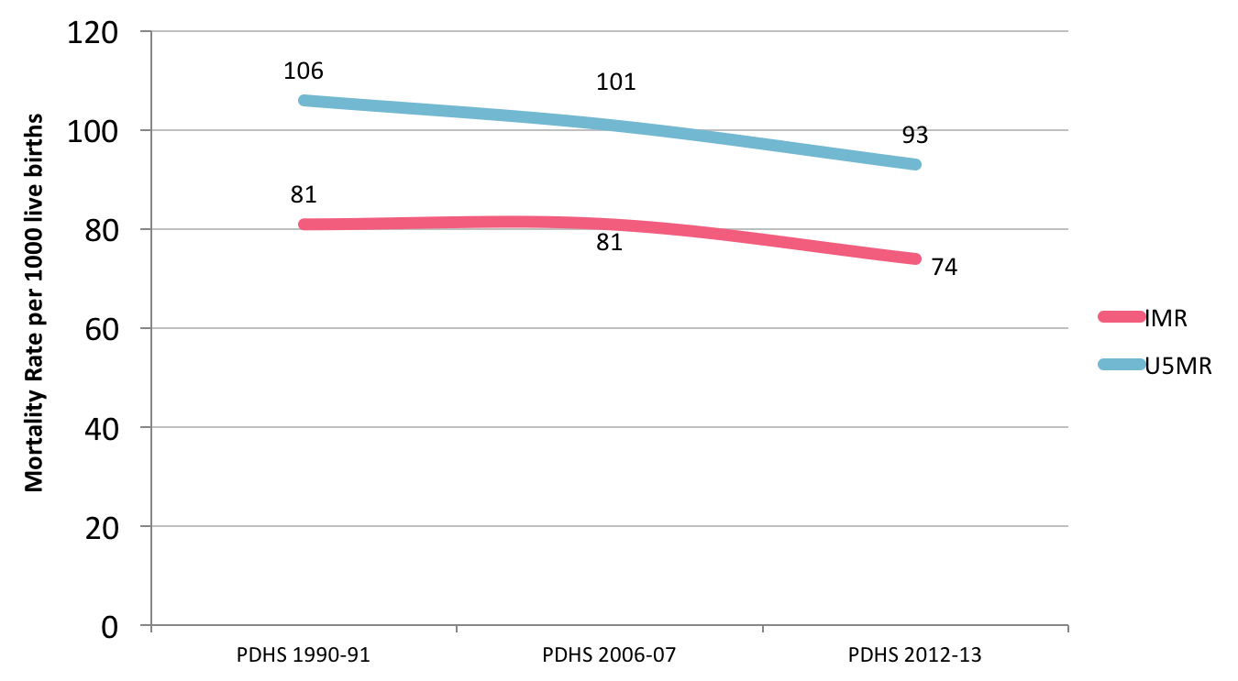

(Source: Pakistan Demographic and Health Surveys 1990-91, 2006-07, and 2012-13)

Evidence suggests that pneumonia, diarrhoea and malaria cause about 50% of all deaths in children in Pakistan. Diarrhoea alone accounts for almost 19%-23% of all child deaths. In Pakistan, 53,000 children die every year from diarrhoea. WHO and UNICEF estimate that in Pakistan, the rates of child mortality due to diarrhoea are in the range of 100 - <500 per 100,000 children. PSLM 2014-15 found that overall 6% of children under five had diarrhoea in the past 30 days preceding the survey, with urban at 8% and rural at 5%. The prevalence of diarrhoea was highest in Naushahro Feroze (12%), Hyderabad (10%) and Sanghar (10%), and lowest in Kashmore, Shahdadkot and Dadu (each at 2%). About 96% of children under five years with diarrhoea received treatment from a practitioner.

Sindh MICS 2014 found 69.2% of children under 5 years who had diarrhoea in the last 2 weeks sought advice or treatment from a health facility or provider; 11.6% of children under 5 years with diarrhoea in the last 2 weeks received oral rehydration solution (ORS) and zinc; and 41% of children under 5 years with diarrhoea in the last 2 weeks received ORT (ORS packet, pre-packaged ORS fluid, recommended homemade fluid or increased fluids) and continued feeding during the episode of diarrhoea.

PDHS 2012-13 found that of children under 5 years, 21.9% in urban and 23.9% in rural Sindh suffered from diarrhoea in the two weeks preceding the survey. The survey also found that overall in Pakistan, children aged 6-11 months (35.3%) were the most vulnerable and were three times more likely to have had diarrhoea than children aged 48-59 months (12%). In Pakistan, 10.8% of all deaths in children under 5 years of age and 17.7% of all child deaths were due to diarrhoea. In Sindh, 10.1% of all deaths in children under 5 years of age were due to diarrhoea, and this was the fifth most important cause after birth asphyxia (21.5%), sepsis (16.1%), pneumonia (13.7%) and prematurity (10.3%).

Figure 42illustrates that as the rates of improved sanitation decrease, the rates of IMR and U5MR increase. This trend however is visible when IMR and U5MR rates are compared to improved drinking water suggesting that low rates of improved sanitation are a risk factor for child mortality (Fig 43).

Figure 42 - Child mortality rates and improved sanitation
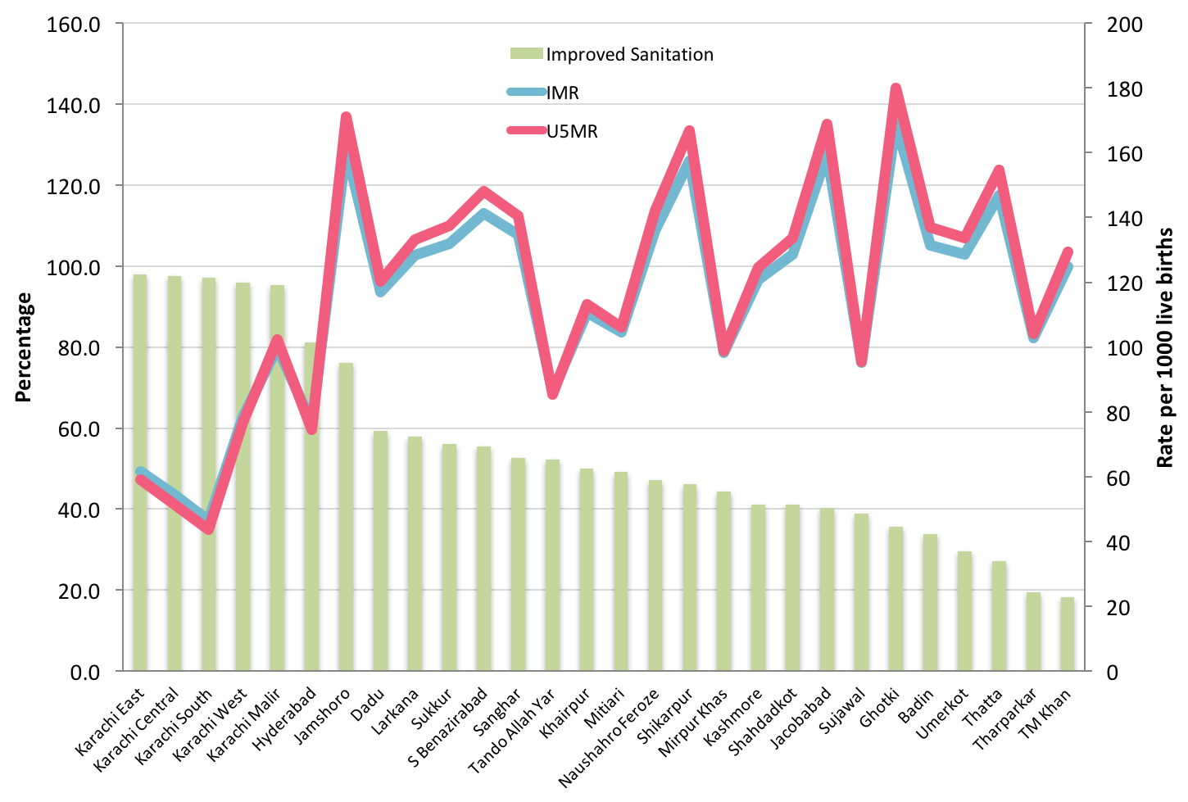

(Source: Sindh Multiple Indicator Cluster Survey 2014)

Figure 43 - Childhood mortality rates and improved drinking water
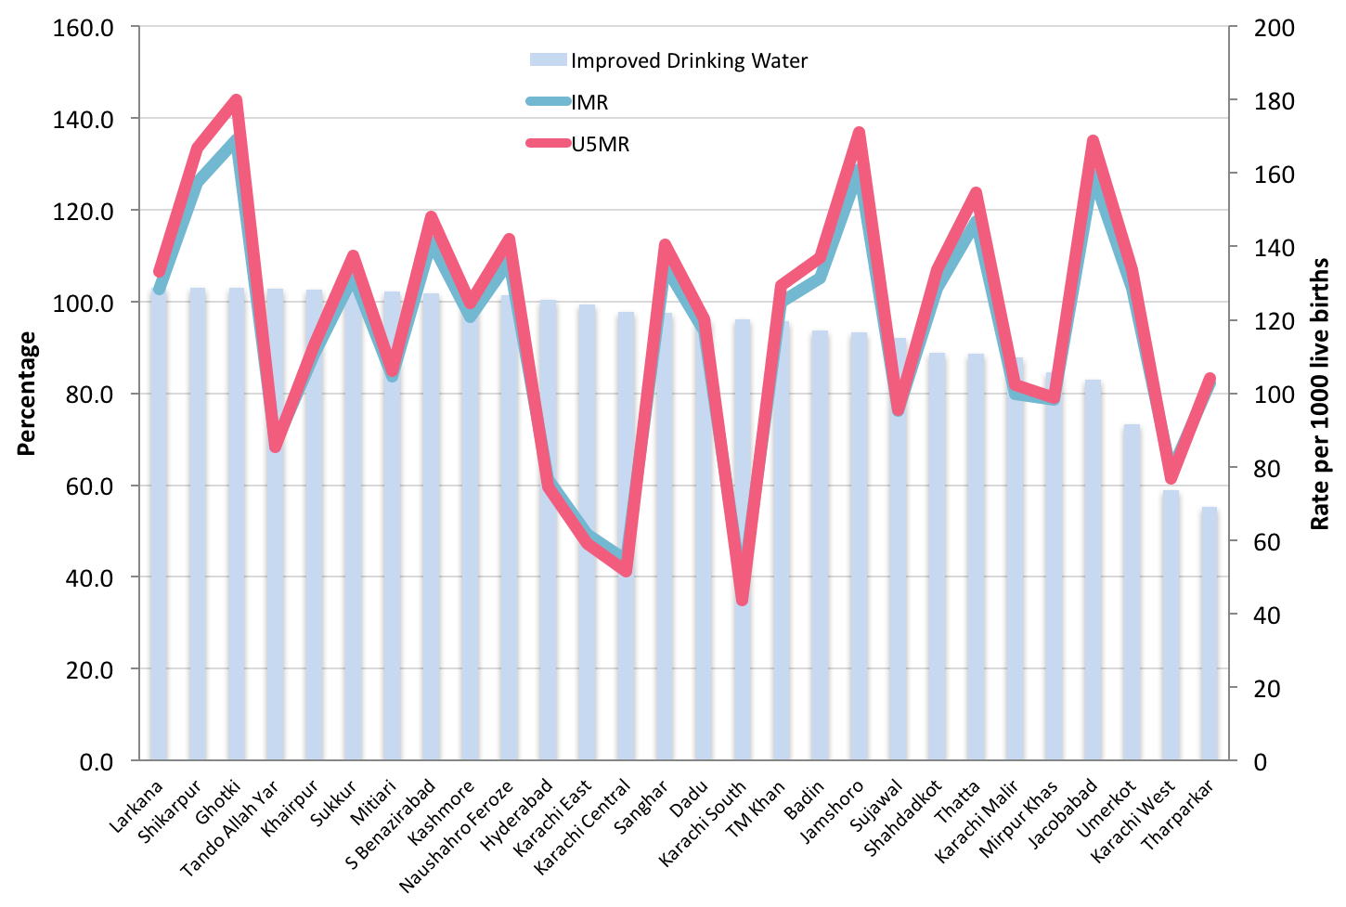

(Source: Sindh Multiple Indicator Cluster Survey 2014)

Diarrhoea

On a review of the status of diarrhoea in the last 30 days in children under 5 years, generally the prevalence of diarrhoea is more in urban areas than rural areas (Fig 44). Of particular note are urban diarrhoea rates in Naushahro Feroze (24%), Sanghar (20%), and Tando Muhammad Khan (14%). Hyderabad has similar rates for urban (10%) and rural (11%). A high rural rate is also seen for Sukkur (11%).

When rural diarrhoea rates for each district are overlain with no toilet rates, the data suggests that in most districts there may be other factors like water quality that may be responsible for diarrhoea in children under 5 years (Fig 45). The trends in Sukkur and Naushahro Feroze are suggestive of an association between no toilet and diarrhoea. Similar trends are also observed for Shaheed Benazirabad, Ghotki, Shikarpur, Larkana, Shahdadkot, Tando Allah Yar and Karachi.

Figure 44 – Diarrhoea in last 30 days in children under 5 years
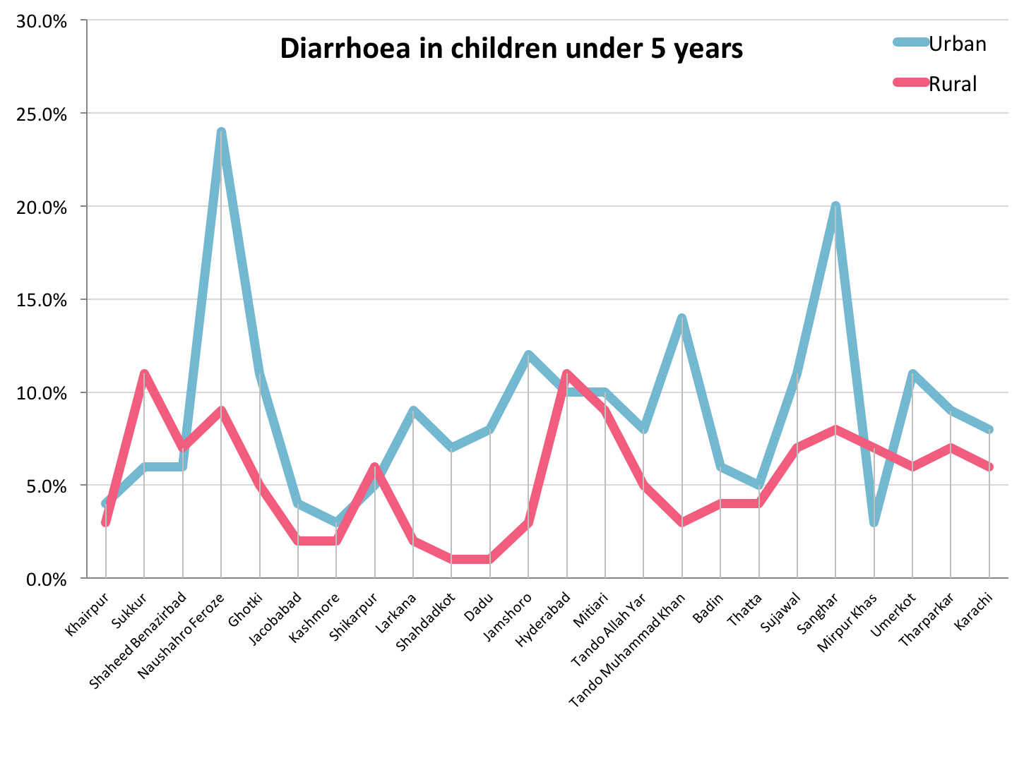

(Source: Pakistan Social and Living Standards Measurement Survey, 2014-15)

Figure 45 - No Toilet and Diarrhoea in last 30 days in children under 5 years
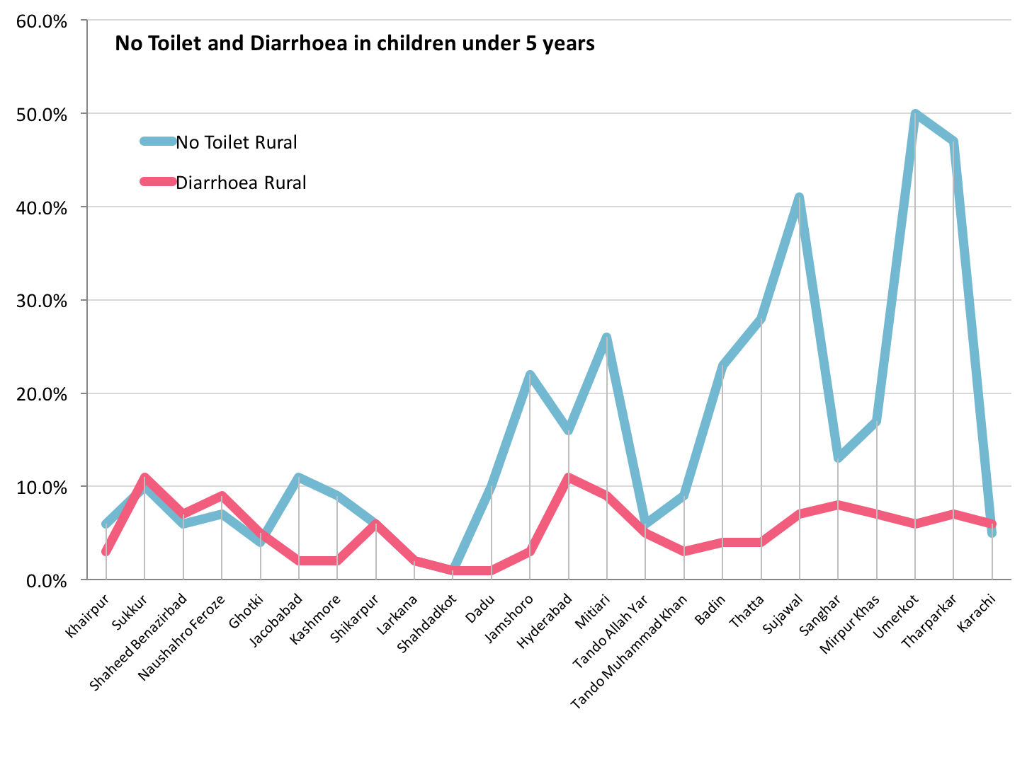

(Source: Pakistan Social and Living Standards Measurement Survey, 2014-15)

Economic Quintiles
Figures46and 47show that the lowest quintile is the most vulnerable to health risks and has the least access to improved drinking water and improved sanitation. Interestingly, in the higher quintiles, the rate of improved water supply actually decreases due to use of other sources of water supply like tanker. Furthermore, Fig 48illustrates the high prevalence rates of no toilet in the poorer quintiles compared to the richer ones. The issue of no toilet is found predominantly in the rural compared to urban areas.

Figure 46–Improved Water Supply and Economic Quintiles
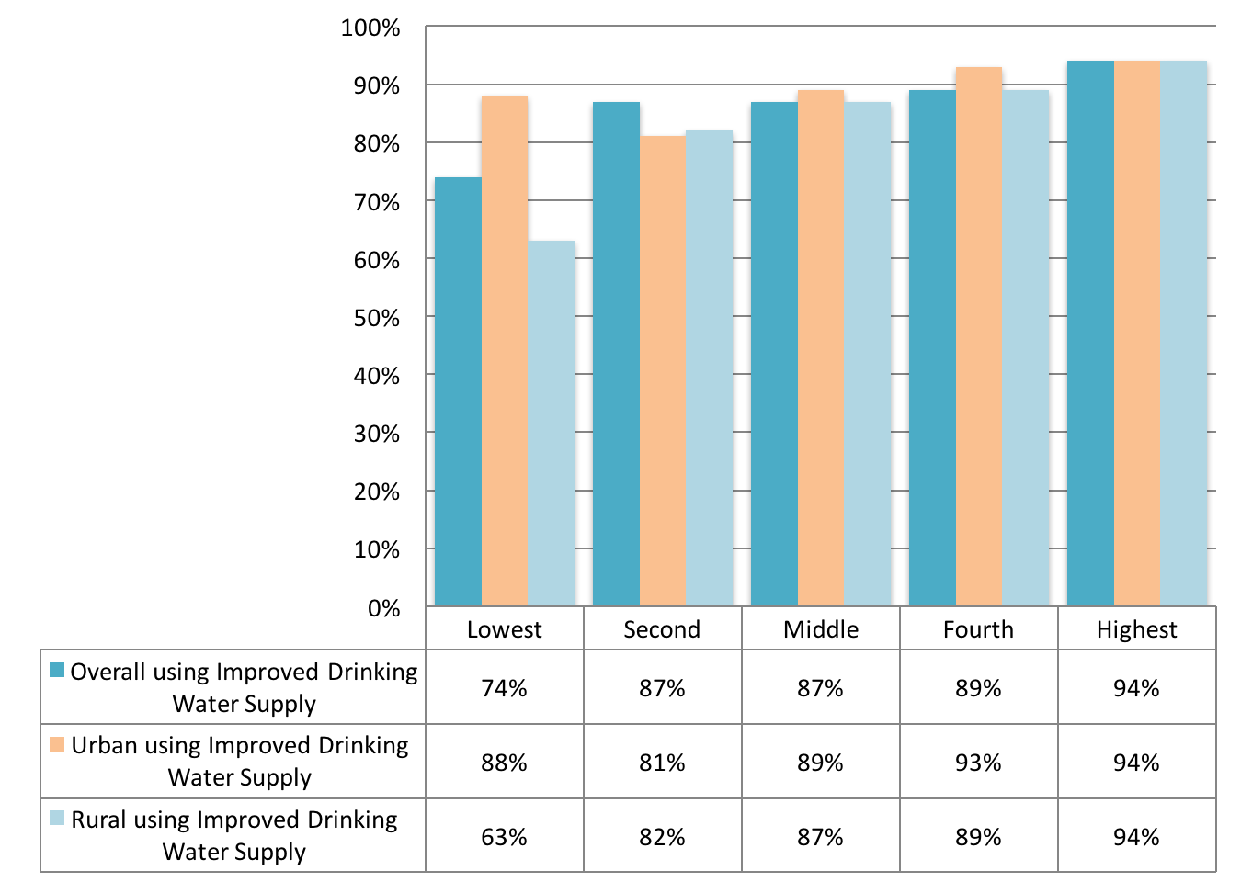

(Source: Pakistan Social and Living Standards Measurement Survey, 2014-15)

Figure 47 - Improved Sanitation and Quintiles
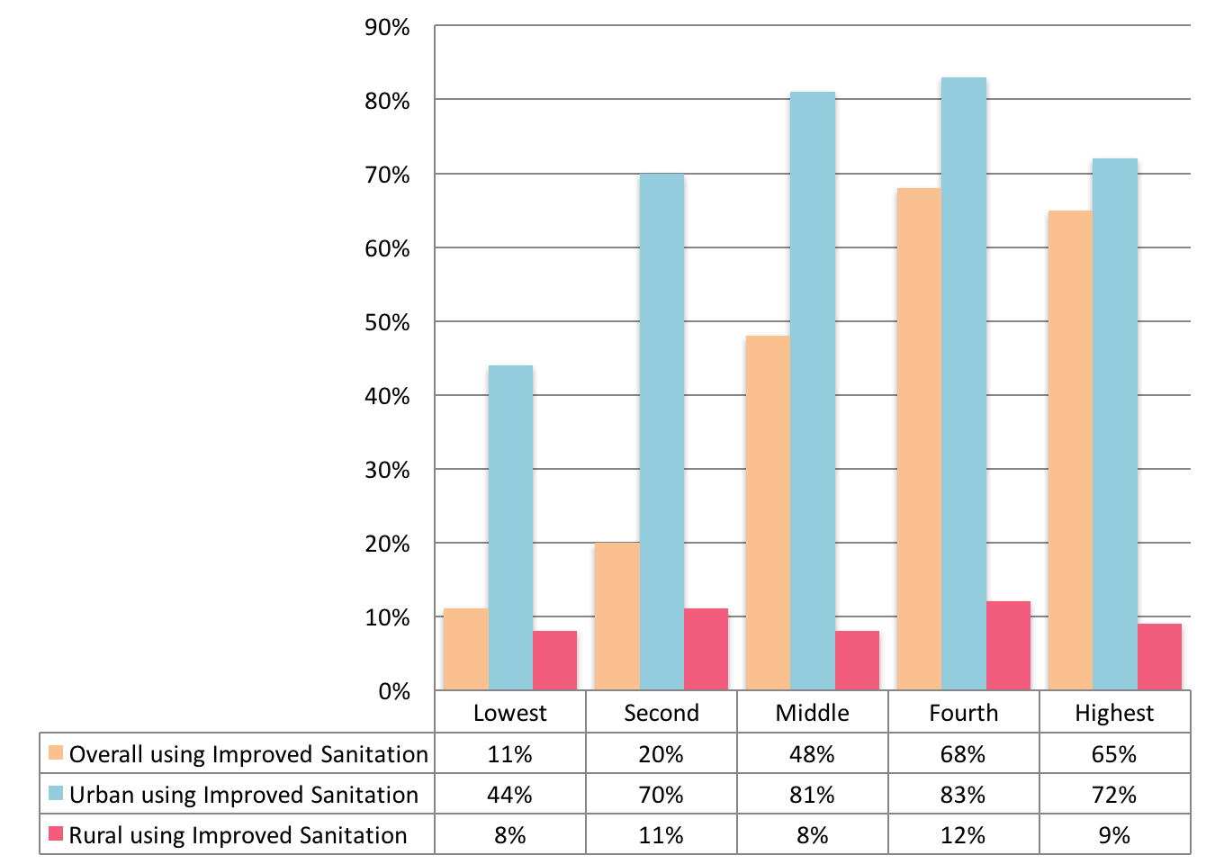

(Source: Pakistan Social and Living Standards Measurement Survey, 2014-15)

Figure 48–No Toilet and Economic Quintiles
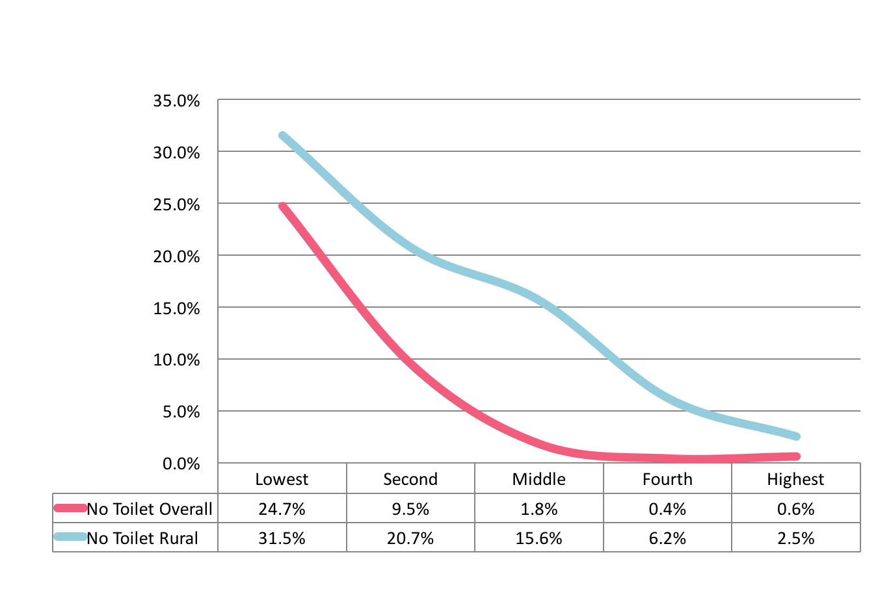

(Source: Pakistan Social and Living Standards Measurement Survey, 2014-15)

Economic Impacts of Diarrhoea

The cost of diarrhoeal health impacts is determined using the human capital approach since both diarrheal and typhoid mortality predominantly affects children. The cost of morbidity includes the cost of illness (medical treatment, medicines, and value of lost time). About 50% of these costs are associated with the value of time lost to illness (including care giving), and another 50% are from cost of treatment and medicines.

2.5 million DALYs are lost annually from diarrhoeal mortality and morbidity associated with inadequate water, sanitation and hygiene. The annual economic loss was estimated at PKR 114 billion by the World Bank in 2006.

A study on cost and impact analysis of water supply and environmental sanitation in Pakistan revealed that if water supply facilities are available to 90% of households and latrine facilities available to at least 60% of households in villages, the Benefit to Costs ratio is 2.7 at 6% discount rate and 1.75 at 12% discount rate.

Recent data from the Economics of Sanitation Initiative supported by WSP suggests that the economic impact of poor sanitation and water in Pakistan may be as high as 3.94% of GDP.

A report from the World Bank on water and sanitation to reduce child mortality found that 25 deaths or more per 1000 children born could be prevented by investing in water and sanitation infrastructure. This difference accounts for about 40% of the gap between current child mortality rates and the 2015 target set in the Millennium Development Goals. For Pakistan, the cost per Life Year Saved relative to GDP per capita (in 2007) is about 20%, which is highly cost-effective.

The report also found that the average cost per life-year saved ranges between 65% and 80% of developing countries’ annual gross domestic product per capita. The results suggest that investment in water and sanitation is a highly cost-effective policy option, even when only the mortality benefits are taken into consideration. Taking into account the additional expected benefits, such as reduced morbidity, time spending, and environmental hazards, would further increase the benefit-cost ratio.

The WHO estimates that the return on US$1 investment is in the range US$5 to US$36, with a global average of US$8. Using meta-analysis, a reduction in diarrhoea frequency include:

- Improved hygiene - 37% reduction
- Improved sanitation - 32% reduction
- Improved water supply - 25% reduction
- Improved water quality - 31% reduction
- Multiple - 33% reduction

Economic benefits that arise from water and sanitation improvements include:

- Direct economic benefits of avoiding diarrhoeal disease - less expenditure on treatment of diarrheal disease and related health seeking costs
- Indirect economic benefits related to health improvement - value of avoided days lost at work or school, impact on school attendance of girls, avoided time lost of caretaker of sick children, and economic contribution of a saved life due to diarrheal disease
- Non-health benefits related to water and sanitation improvement - time savings related to water collection or accessing sanitary facilities; benefits to agriculture and industry of improved water supply; more efficient management of water resources

A per capita annual economic benefit of at least US$15 is achieved, if universal coverage for combined water and sanitation interventions is done.

Hygiene

Data from the Sindh MICS 2014found the following:

- 43.7% of children age 0-2 years had their last stools disposed of safely
- 66.5% of households had a specific place for hand washing where water and soap or other cleansing agent were present
- 82% of households had soap or other cleansing agent available

Personal hygiene and household sanitation
A baseline cross-sectional household survey was conducted of eight key family practices in Sindh in 5 districts, which were selected using criteria for representing different socio-cultural and geographical strata in the province of Sindh. These included: Malir, Hyderabad, Tando Allah Yar, Naushahro Feroze and Jacobabad, which represented 58% rural and 42% urban areas.

The survey found that about 94% mothers reported that water was always available. The main source of water for 62% of the population was a hand pump, particularly in rural areas. Similarly, the majority of the study population in rural areas did not have modern flush system for safe disposal of faeces. Around 52% mothers reported rinsing off neonatal faeces while 20% threw it away. Most of the responding mothers mentioned that they used soap for hand washing after using the toilet (81%) and after attending a child who had defecated (76%). Data collectors observed thathousestheyvisited were generally clean. 72%, had water containers covered (88%), soap was present in bathroom/toilet and a dust bin was present in the house (42%).Only 25% mothers reported to use dustbin for collecting garbage while rest would throw it in the street.

Furthermore, assessment of hygiene and sanitation practices revealed that despite wide spread availability of water and toilet facilities, caregivers still throw faeces of neonates outside home. Majority of study respondents reported to throw household garbage in the street/yard. The study found wide variability in the availability of toilet facilities between study districts, and urban and rural areas indicating inequity and geographical disparity. Practice of hand washing with soap after using a toilet or attending a child for defecation has been reported as adequate while only few reported washing hands with soap before and after eating and cooking, which might have increased the risk of transmitting infection to the newborn.

Nutrition and Diarrhoea

Recent data from Sindh MICS 2014 (Table 13) shows that more than four out of ten children under the age of five years in Sindh are underweight (42%) and 17% are classified as severely underweight. Almost half of children under five years (48%) are stunted or short for their age and one fourth (24%) children are severely stunted. The results also show that 15% of the children are wasted or thin for their height and only 1% of children are overweight or too heavy for their height.

Table 13 - Nutritional status of children under five years in Sindh
Description | Indicator | Value in %
Underweight Prevalence
Percentage of children under age 5 who fall below  (a) minus two standard deviations (moderate and severe)  (b) minus three standard deviations (severe)  of the median weight for age of the WHO standard | (a) Moderate and severe | 42.0
 | (b) Severe | 17.0
Stunting Prevalence
Percentage of children under age 5 who fall below  (a) minus two standard deviations (moderate and severe)  (b) minus three standard deviations (severe)  of the median height for age of the WHO standard | (a) Moderate and severe | 48.0
 | (b) Severe | 24.4
Wasting Prevalence
Percentage of children under age 5 who fall below  (a) minus two standard deviations (moderate and severe)  (b) minus three standard deviations (severe)  of the median weight for height of the WHO standard | (a) Moderate and severe | 15.4
 | (b) Severe | 3.6
(Source: Sindh MICS 2014)

Evidence from studies around the world have demonstrated unequivocally the link between inadequate sanitation, diarrhoea and nutritional deficiency. The key findings include:

- Improvements in sanitation were associated with increases in height ranging from 0.8 cm to 1.9 cm
- Odds of stunting at 24 months of age increase by a factor of 1.05 with each episode of diarrhoea
- Hand washingreduced the risk of diarrhoea by 30%
- WASH interventionsreduced the frequency by diarrhoea by almost a third– hygiene (37%); sanitation (32%); water supply (23%); water quality (31%); and multiple (33%)

Evidence from Sindh MICS 2014 indicates that nutritional deficiency rates show an increasing trend when use of improved sanitation decreases further suggesting that low use of improved sanitation is a risk factor for poor nutrition status (Fig 49).

Figure 49 - Nutritional status and improved sanitation
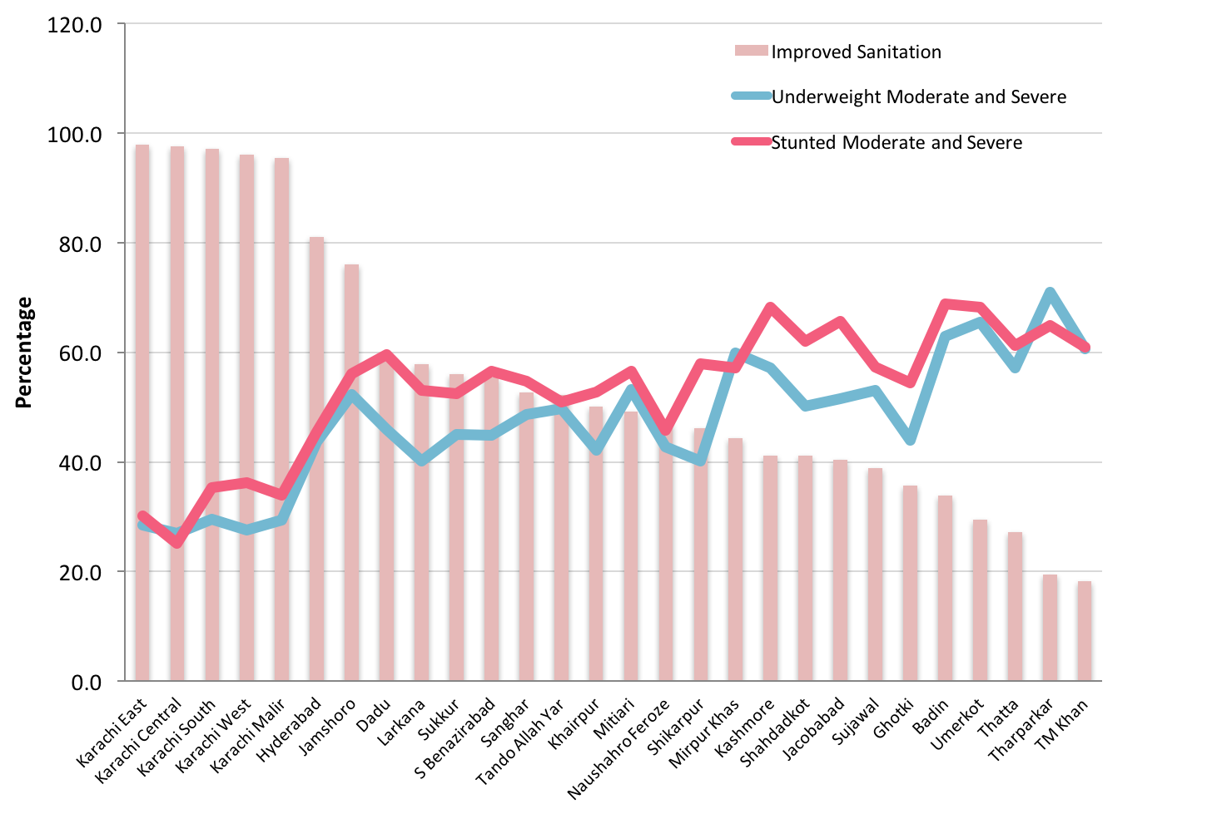

(Source: Sindh Multiple Indicator Cluster Survey 2014)

Health, Nutrition and Hygiene

Health, nutrition and hygiene modules with special emphasis on water and sanitation would need to be developed for incorporation in training programmes for LG&HTPD and PHE&RDD. Similar modules would need to be developed for integration into training curricula of Lady Health Workers for health promotion in communities. All new drinking water supply schemes would need to incorporate a mandatory nutrition-sensitive health, nutrition and hygiene component as part of the community participation process.

Drinking water supply and sanitation schemes would need to be made nutrition-sensitive and where feasible an integrated multi-sectoral approach adopted with health, nutrition and education programmes. This may include the adopting an integrated nutrition-sensitive WASH and Nutrition approach, which includes among others:

- Handwashing with soap at critical times
- Safe disposal of infant and animal faeces
- Safe water treatment and storage
- Exclusive breastfeeding
- Complementary feeding
- Prevent stunting and maternal and child anaemia in the first 1,000 days and improve infant and young child feeding
- Referring malnourished children to health care facilities
- Rehabilitating drinking water supplies
- Promoting point-of-use water treatment
- Conducting nutrition (cooking) and food hygiene demonstrations

Communities would need to be encouraged to adopt essential food safety actions that include:

- Keep food preparation areas clean, including hands, surfaces, and utensils
- Separate raw and cooked food
- Cook food thoroughly
- Keep foods at safe temperatures
- Use safe water and raw materials

Essential Nutrition Actions would need to be adopted within integrated nutrition-sensitive WASH programmes and include the following:

- Promotion of optimal breastfeeding during the first six months
- Promotion of optimal complementary feeding starting at six months with continued breastfeeding to 2 years old and beyond
- Promotion of optimal nutrition for women
- Promotion of optimal nutritional care of sick and severely malnourished children
- Promotion of adequate intake of iron and folic acid and prevention and control of anaemia for women and children
- Promotion of adequate intake of iodine by all members of the household
- Prevention of vitamin A deficiency in women and children

Public awareness campaigns on water and health and nutrition issues would need to be promoted with the help of non-governmental agencies, educational institutions and mass media. Standardised messages and effective materials would need to be developed for use within health, nutrition and WASH programmes.

Recent Initiatives for Health in Sindh

District Health Information System

The District Health Information System (DHIS) is an improvement to the earlier Health Management Information System and now collects and reports health data from all districts. In Sindh, by 2012 DHIS had been implemented in 21 districts. By 2012, the overall reporting compliance in Sindh was 79%. District data for 2012 shows that the commonest single cause for admission to secondary hospitals in Sindh was diarrhoea/dysentery accounting for 27.5% of all admissions to secondary hospitals. DHIS 2015 data for Sindh shows that the top five diseases include acute respiratory infections, diarrhoea/dysentery, fever due to other causes, suspected malaria and scabies. Diarrhoea/dysentery alone accounts for about 8.1%, which is the single largest category after acute respiratory infections (Fig 50).

Figure 50 - Top five diseases seen as outpatients in Sindh in 2015
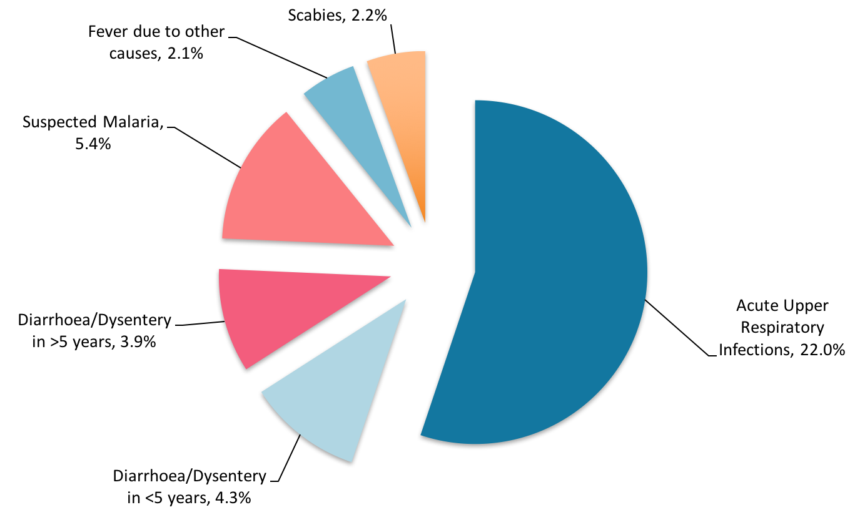

(Source: District Health Information System, Annual Report 2015. PPHI, Sindh)

Multi-Sector Nutrition Support Programme

In order to address the issue nutritional deficiency, the Government of Sindh has planned a nutrition specific intervention called the Nutrition Support Programme (NSP). The overall goal of the project, costing Rs. 4.118 billion is to improve the nutritional status of male and female children under five years and that of pregnant and lactating women in nine selected districts (Jacobabad, Kashmore-Kandhkot, Larkana, Qambar-Shahdadkot, Badin, Tando Muhammad Khan, Sanghar, Umerkot and Tharparkar). The project will be implemented with the support of the People’s Primary Healthcare Initiative (PPHI) Sindh through the use of their staff and primary health care facilities. The key role in implementing the project will belong to the Lady Health Workers (LHWs) and Community Midwives (CMWs) who will mainly focus on community awareness, screening and referrals.

The Sindh Department of Health/World Bank-funded PC-1 is approved for 9 of Sindh’s 23 districts for nutrition programming and will be integrated within the primary health care activities. Non-governmental organisation (NGO) partners will implement activities in non-LHW covered areas. The World Bank is also implementing a WASH project coordinated with the Sindh Nutrition Cell in addition to its support to the public sector’s Integrated Management of Childhood Illnesses (IMNCI), Mother Newborn and Child Health (MNCH) Programme, and Expanded Programme of Immunisation (EPI) in Thatta-Sujawal districts.

Currently, USAID’s flagship Maternal and Child Health Programme focuses on 15 districts of Sindh with an aim to improving reproductive, maternal, newborn, and child health through enhanced service delivery at 1,500 fully functional, standardised 24/7 MNCH Centres. Merlin is implementing a European Union-funded Women’s and Infant Nutrition Program (EU WINS) (2013 -2016) project in Thatta, with Action against Hunger (ACF) working in Dadu, and Save the Children working in Shikarpur districts. The Pakistan Emergency Food Security Alliance (PEFSA) is a consortium of NGOs, funded by the European Community Humanitarian aid Office (ECHO), which is implementing a WASH/Nutrition programme and, UNICEF plans to layer additional elements of WASH or infant and young child feeding activities in order to have a full slate of stunting reduction activities. This type of layering could allow for consolidation of funding from a variety of sources to achieve a common impact. Currently, the Sindh Nutrition Cell, Micronutrient Initiative, UNICEF, and WFP are collaborating on fortification initiatives, such as universal salt iodization and wheat flour fortification.

A multi-sector project has been launched (the partners include UNICEF Nutrition, UNICEF WASH and The World Bank) whose purpose is to contribute towards a reduction in stunting rates by focusing on the 1,000 days critical window, through a multi-sectoral approach in targeted districts of Sindh. The project aims to support the scale up of evidence-based nutrition-specific interventions and nutrition-sensitive interventions, with emphasis on greater equity for greater impact. UNICEF has initiated its first phase of the project in collaboration with Plan International in Taluka Moro (District Nausharo Feroze), Taluka Mirpur Mathelo (District Ghotki), and Taluka Kotdiji (District Khairpur).

Nutrition-specific interventions will aim to improve outcomes in the following focus areas:

- Infant and young child feeding and care (IYCF) in the first two years of life
- Micronutrient nutrition and anaemia control in young children
- Early detection and treatment of severe wasting in young children
- Women’s nutrition with a focus on pre pregnant, pregnant and lactating mothers
- Cross-cutting communication elements – which will include harmonised training for NGO implementing partners and LHWs consisting of health, WASH and nutrition elements to be developed and implemented during the first year of the programme

Nutrition-sensitive interventions will aim to improve outcomes in Water, Sanitation and Hygiene (WASH). With WASH, the main focus will be on reducing the incidence and severity of infection in children while controlling environmental enteropathy and its potential negative impact on children’s linear growth. This will encompass efforts to maintain an adequate water supply, both in terms of quality and quantity, sufficient means of sanitation (encouraging community-based approaches for ‘total sanitation’ that seek to eliminate the practice of open defecation), capacity development of service providers and improved hygienic practices (hand washing with soap).

Sindh Accelerated Action Plan for Reduction of Stunting and Malnutrition – Sehatmand Sindh

In view of the urgency to address malnutrition as a top priority in Sindh, an Accelerated Action Plan (AAP) namely Sehatmand Sindh” has been prepared for the reduction of stunting and malnourishment by 2021 with a ten years aim to reduce stunting from 48% to 30% in first five years (by 2021) and 15% by 2026 in Sindh by increasing and expanding coverage of multi-sectoral interventions, that are known to reduce stunting in first five years of children’s lives.

A number of interventions are proposed under various sectors, some of which will have direct and immediate impact on prevention of stunting - health, sanitation, hygiene, social protection and Social & Behavioral Change Communication (SBCC) - while a couple of sectors like agriculture and education that will manifest their impact on stunting rates in longer term period interventions. The strategic focus of all interventions will be on all such segments of the population that are nutritionally vulnerable and on whom stunting prevention strategies could be most responsive. These include: the first 1,000 days of child’s life, children of 24-59 months and the women of reproductive age with particular attention to adolescent girls.

The key areas proposed here include: Expanding Coverage of nutrition specific services through strengthening facility based care, revitalising the LHW programme, leveraging NGOs and various health department programmes; dovetailing nutrition services with the Costed Implementation Plan for family planning; agriculture for nutrition, improved sanitation and hygiene with focus on making districts open defecation free and hand washing practices; social protection support to poorest pregnant women for seeking health care and improving nutrition related behavior; and engaging education sector for improving nutrition knowledge, skills and behaviors among children and adolescent girls. All these areas will be supported by intensive SBCC, engaging civil society organizations and enhanced monitoring and supervision mechanisms including a third party evaluation at mid-term and end of five years.

Nutrition sensitive Conditional Cash Transfers for the poor in Sindh

Social protection through Conditional Cash Transfers (CCT) is one of the important interventions for prevention of stunting.CCT is one of the mechanisms included in the Sehatmand Sindh programme. The Government of Sindhshall fund the CCT using the same mechanism and channel as being envisaged for other sectors whereby the development partner will support the proposed plan by matching the commitment of government.

The CCT interventions are proposed to be implemented in a phased manner. To begin with a pilot shall be undertaken in two districts (Tharparkar and Umerkot) where most of the NSP (Nutrition Support Programme) interventions are already being rolled out including community based nutrition service contracts with NGOs to those villages that are not covered through LHWs. The one-year pilot shall help in streamlining the process, develop registration and disbursement mechanisms and test the feasibility of attaching the nutrition services conditionality to cash transfers. The marketing and education material prepared for the pilot could also be tested for its effectiveness and acceptability. Once the pilot is evaluated, the lessons would be applied andthe CCT intervention then rolled out to Phase 1 districts.

Sindh Health Sector Strategy 2012-2020

The Health Sector Strategy has a special focus area on Nutrition and stresses on need for mainstreaming of key evidence based nutrition interventions through health sector and coordination with other department on nutrition as part of a larger provincial inter-sectoral strategy on nutrition inclusive of micro-nutrient supplementation, community based awareness and counselling, and inter-sectoral measures such as birth spacing, water and sanitation and food security programmes.

Under Strategy 1.6a: Intersectoral district based pilots on nutrition and social development through collaboration with BISP, water and sanitation, education and other sectors:

- Strategic Action 1.6.1a Inter-sectoral pilots on nutrition- Inter-sectoral pilots on nutrition Pilots in catchment area of FLCF
  - Links for inter-sectoral action on under-nutrition with other departments such as water and sanitation, food, education, PDMA etc. Poverty reduction projects in conjunction with BISP, Bait-ul-Mal and NGOs

Under Strategy 3.2: Mainstreaming of evidence based action for under-nutrition in health packages and establishing linkages with other sectors for integrated pilots:

- Strategic Action - 3.2.3 Inter-sectoral action- Inter-sectoral pilots at district level for multi -pronged enhancement of nutrition with related departments such as food, water and sanitation, education, BISP etc

Under Key Performance Indicators – Targets for 2020

1.6 a Intersectoral district based pilots on nutrition and social development through collaboration with BISP, water and sanitation,education and other sectors
Indicator | Target
1.6.1: 1 pilot in place in each district by 2018 | 22 districts

Strategy

Health and Hygiene
Strategic Objectives/Outcomes | Short Term Actions  1 - 3 years | Medium Term Actions  4 - 6 years | Long Term Actions  7 - 10 years
Fully functional and safely managed water and sanitation services in health facilities DHQs, THQs/CHs, RHCs, CDs, MCHs at communal and facility level  For Basic Health Units with missing facilities for water and sanitation (about 20% of BHUs), provide extension of water distribution pipe from water supply scheme, water tank and 2 latrines per BHU | Health Department and PHE&RDD to jointly conduct a situation analysis and update the status of missing facilities for safely managed water and sanitation in all health facilities and develop a Joint Action Plan (JAP) to address these  Provision of missing WASH facilities (latrines, hand washing spots, filter tap for drinking water purposes, supply of soap and water treatment technology at health facility) in targeted health facilities based on Joint Action Plan (JAP)in 13 priority districts  Provide water distribution point to local health facility in all new water supply schemes in 13 priority districts | Provide water distribution point to local health facility in all new water supply schemes  Provision of missing WASH facilities (latrines, hand washing spots, filter tap for drinking water purposes, supply of soap and water treatment technology at health facility) in targeted health facilities based on Joint Action Plan (JAP) in 6 additional districts | Provide water distribution point to local health facility in all new water supply schemes  Provision of missing WASH facilities (latrines, hand washing spots, filter tap for drinking water purposes, supply of soap and water treatment technology at health facility) in targeted health facilities based on Joint Action Plan (JAP) in 10 additional districts
Hospital Waste Management Rules implemented in 88 hospitals as initial priority. | Implement Hospital Waste Management Rules in 27 hospitals | Implement Hospital Waste Management Rules in additional 27 hospitals | Implement Hospital Waste Management Rules in additional 34 hospitals  Hospital Waste Management Rules to be implemented in all health facilities.
Multi-sector nutrition-sensitive WASH programme implemented in nutritionally deficient districts | Multi-sector nutrition-sensitive WASH programme implemented in 3 nutritionally deficient districts | Multi-sector nutrition-sensitive WASH programme implemented in 10 nutritionally deficient districts | Surveillance and consolidation of multi-sector nutrition-sensitive WASH programme implemented in 13 nutritionally deficient districts
Nutrition-sensitive WASH integrated in health promotion in primary health care | Nutrition-sensitive WASH health education module added to curriculum of LHWs/CMWs/LHVs with supporting training material as part of multi-sector nutrition-sensitive WASH interventions  Master trainers, district trainers and facility trainers oriented in key nutrition-sensitive WASH messages and LHWs/CMWs/LHVs provided training on nutrition-sensitive WASH health promotion and hygiene as part of on-going training by health department  At least 100% of LHWs/CMWs/LHVs trained in nutrition-sensitive WASH health promotion and hygiene as part of on-going training by health department | At least 60% of LHWs/CMWs/LHVs receive refresher training in nutrition-sensitive WASH health promotion and hygiene as part of on-going training by health department | At least 100% of LHWs/CMWs/LHVs receive refresher training in nutrition-sensitive WASH health promotion and hygiene as part of on-going training by health department
Nutrition-sensitive WASH integrated in health advocacy and BCC campaigns and health weeks | Nutrition-sensitive WASH component of health promotion and hygiene integrated in mother and child health weeks as part of on-going campaign by health department across the province  Advocacy and BCC campaign held at health facility, district and provincial levels as part of on-going health campaigns  Key messages to advertised in electronic and print media as part of on-going health campaigns | Continue Nutrition-sensitive WASH component of health promotion and hygiene disseminated in mother and child health weeks as part of on-going campaign by health department across the province  Advocacy and BCC campaign held at health facility, district and provincial levels as part of on-going health campaigns  Key messages to advertised in electronic and print media as part of on-going health campaigns | Continue Nutrition-sensitive WASH component of health promotion and hygiene disseminated in mother and child health weeks as part of on-going campaign by health department  Advocacy and BCC campaign held at health facility, district and provincial levels as part of on-going health campaigns  Key messages to advertised in electronic and print media as part of on-going health campaigns
IEC materials with key nutrition-sensitive hygiene messages distributed at health facility level | Development of nutrition-sensitive IEC materials for primary, secondary and tertiary health facilities; CBOs and faith based facilities  Availability at and dissemination of IEC materials for 50% primary, secondary and tertiary health facilities; CBOs and faith based facilities | Availability at and dissemination of nutrition-sensitive IEC materials for 75% primary, secondary and tertiary health facilities; CBOs and faith based facilities | Availability at and dissemination of nutrition-sensitive IEC materials for 100% primary, secondary and tertiary health facilities; CBOs and faith based facilities
WASH services at health facilities monitored regularly by Health Department | Regular monitoring and supervision conducted by health facility in-charges, DHOs and respective stakeholders | Regular monitoring and supervision conducted by health facility in-charges, DHOs and respective stakeholders | Regular monitoring and supervision conducted by health facility in-charges, DHOs and respective stakeholders

EDUCATION

National Sanitation Policy 2006

The National Sanitation Policy 2006 of Pakistan recommends a sanitation training/awareness raising programme at all educational and teachers training institutes. The National Education Policy 2009 lays emphasis on a school health programme along with health education.

With the support of United Nations Programme for Pakistan, the school health initiative has been piloted in selected districts of four provinces, and school health education materials have been developed. The materials include the importance of hand washing and clean drinking water. However, these training materials have not been institutionalised in pre-service and in-service teachers training curriculum as envisaged in both national policies.

Sindh Education Sector Plan 2014 - 2018

The Sindh Education Sector Plan (SESP) 2014-18 developed by the Education and Literacy Department, Government of Sindh has the following components:

- Increasing Equitable Access to Early Childhood Education, Primary, Middle/Elementary and Secondary education
- Improving the Curriculum and Learning Outcomes
- Improving Teacher Quality
- Strengthening Governance and Service Delivery
- Improving Resource Allocation
- Adult Literacy and Non-formal Basic Education
- Cross-cutting areas (ICT, Education in Emergencies, Gender Equity, Social Cohesion and Public-Private Partnerships for Education)

In 2011-12, Sindh Education Management Information System (SEMIS) found that 45% of schools had no toilet facilities and 53% had no drinking water facility; both presenting particular barriers for girls.

The SESP identified lack of basic facilities (e.g. proper classrooms, washrooms, drinking water, security, etc.), especially in rural areas as one of the top seven key issues in the provision of primary and elementary education.

SEMIS 2011-12 identified the following missing facilities with respect to toilets and drinking water.

Missing Facilities (identified by SEMIS in 2011-12)
- Out of 43,089 primary and 2,554 elementary schools, 17,299 primary and 586 elementary schools are without toilet; and 20,346 primary and 945 elementary schools are without drinking water
- There are 175 secondary and higher secondary schools without toilet; and 294 without drinking water

The SESP has the following objectives, strategies and targets with respect to toilets and drinking water.

Objective | Strategy | Targets/Outcomes
Increase Access at Primary Level | - Provision of basic facilities in schools  - Basic facilities will be provided on a priority basis, i.e. toilets will be given preference over boundary walls | - 6,920 schools with toilet facilities (40%)  - 20,346 with drinking water (100%)
Ensure balanced and standardised infrastructure facilities in the province and build capacity at all levels through dissemination of standards | - Develop infrastructure standards  - Well-defined budget allocations for school facilities  - Capacity building for the approved standards | Activities  - Prepare proposal for well-defined budget allocations and secure approval (55-75% for classroom development; 25-45% for other facilities such as boundary walls and school gate, drinking and domestic water facilities, separate toilets for girls and boys, provision of alternate sources of electricity where required)

Design parameters
- Toilet facilities
  - 25:1 for girls
  - 40:1 for boys
- Water facilities
  - For domestic use: 45-100 litres per head
  - Separate drinking water system 4-6 litres per head

Sindh Teacher Education

Sindh Teacher Education Development Authority

The Sindh Teacher Education Development Authority (STEDA) has been established to oversee and regulate the teacher training activities and to maintain the standards of the trainings and the training providers. The Education Department, through STEDA, has introduced higher professional qualification for teachers (4 year B.Ed. Honours)

Provincial Institute of Teacher Education

The Provincial Institute of Teacher Education (PITE) is the main structurethat assists the Education and Literacy Department and STEDA in formulation of policy and teacher development. Its main functions include:

- Undertake qualitative and quantitative research in Teacher Education
- Design and experiment research based innovative approaches and programmes in teacher education
- Develop leadership qualities in management of Teacher Education Institutes (TEIs) through professional development courses
- Assist STEDA in quality assurance in Teacher Education Programmes
- Develop strong coordination and linkage with the partners at district, provincial, national and international level for the development of the teacher education

Since its establishment, some of the major achievements of PITE Sindh include:

- Training of 30000 teachers across Sindh province
- Training of 2000 Education Officers
- Development of several Modules and manuals of the Training
- Participation in the process of National Curriculum 2006
- Participation in the National Education Policy 2009
- Collaborated with national and international development partners in the implementation of variety of interventions in Sindh province
- Supported Reforms Support Unit (RSU) in the implementation of Teacher Education Development Policy 2009: Pilot of Continuing Professional Development framework in Sindh province in year 2010 and 2011
- Supported RSU in the implementation of Education Management Reforms Policy 2009: Pilot of Sindh Education Sector Management Course in year 2011 and 2012

PITE Sindh has six major components. These include:

- Initial Teacher Education (ITE)
- Continuing Professional Development (CPD)
- Educational Leadership Development Centre (ELDC)
- Human Resource Development Centre (HRDC)
- Quality Assurance and Support Centre (QASC)
- Educational Technology Resource Centre (ETRC)

Sindh Curriculum Implementation Framework

The Sindh Curriculum Implementation Framework (CIF) has the following institutional arrangements.

Institution | Role
Education and Literacy Department (ELD) | Shall be responsible for the overall realisation of curriculum implementation with its true spirit and shall coordinate with its allied departments and agencies established for curriculum development, implementation, monitoring and evaluation. It shall delegate certain aspects of the curriculum implementation to its departments and agencies established for that purpose.
Bureau of Curriculum and Extension Wing (BCEW) | - Devise school education standards in line with guidelines provided by the Education and Literacy Department  - Commission evidenced-based research to inform policy, curriculum design, development and review, textbook and learning material development, and assessment of and /or for learning  - Develop, implement and evaluate curriculum by working closely with Sindh Textbook Board, Directorates of School Education and other related line departments  - Review textbooks and learning material for alignment with the school education standards and curriculum goals  - Develop training packages for Training of Trainers (TOTs) / Master Trainers  - Conduct training of TOTs / Master Trainers
Provincial Education Assessment Centre (PEACe) | - Develop assessment framework that are student learning outcomes (SLO) based to align existing system (internal & external) with the curriculum standards  - Conduct students’ achievement tests at grade 3, 5 and 8  - Promote continuous assessment of students learning across all school levels.
Boards of Intermediate and Secondary Education (BISE) | Shall conduct annual examination of students at Secondary and Higher Secondary levels.
Sindh Textbook Board (STBB) | Shall continue to arrange for the production and publication of textbooks and learning material for all stages and types of school education. It shall further be strengthened as an effective regulating and monitoring authority to improve efficiency in managing authorship, production, copyrights, printing, and distribution of textbooks and learning materials in a timely manner.
Sindh Teacher Education Development Authority (STEDA) | Shall certify and accredit teacher education programmes and ensure the quality of both pre and in-service teacher education programmes to prepare professionally competent teachers to teach curriculum effectively. It shall also be responsible for teacher licensing for promoting culture of professionalism among teachers.
Provincial Institute of Teacher Education (PITE) | Shall implement pre-service teacher education and continuous professional development programmes based on school education standards and curriculum for developing professionally competent teachers, teacher educators, and head teachers. PITE shall be responsible for academic supervision of teacher education programmes, whereas all constituent teacher education institutes as well as PITE shall work under the administrative control of Education and Literacy Department.
Directorates of School Education (DSE) | Shall monitor, through their District Education Officers, implementation of curriculum and gather relevant information on the attainment of school education standards and report to the Education and Literacy Department in a timely manner.
Public Private Partnership | Mutual collaboration between the government and the private sector that could help reduce public spending, improve access, quality, equity and relevance in education.
(Source: Sindh Curriculum Implementation Framework, 2014. Sindh Education Sector Support Programme (SESSP), Reform Support Unit. Education and Literacy Department, Government of Sindh)

Missing Facilities

The Sindh Education Management Information System (SEMIS) of Education and Literacy Department indicates that there are the following schools in Sindh:

- 42,900 primary schools – of which 9,532 are boys, 6,264 are girls and 27,104 are mixed
- 2,429elementary and middle schools – of which 577 are boys, 695 are girls 1,157 are mixed
- 2,065 higher secondary and secondary schools – of which 716 are boys, 633 are girls and 716 are mixed

The Annual Status of Education Report (ASER) for 2015 presents the scorecard for rural Sindh as follows:

- 42,297 children aged 3-16 years in 25 districts surveyed
- 727 schools in 703 villages surveyed
- A total of 13,984 households visited
- The current state of enrolment is:
  - Children 3-5 years – 37% enrolled (of which 70% are in government schools and 30% in non-state schools)
  - Children 6-16 years – 73% enrolled (of which 82% are in government schools and 18% in non-state schools). Of the 33% who are out of school, 52% are girls and 48% boys
- Of all rural government primary schools – only 59% have usable water and 48% have usable toilets

The recent Pakistan Education Statistics Report 2014-15 indicates that only 47.0% of primary, 60.3% of middle, 86.4% of secondary schools have availability of water (Fig 51). The report further indicates (Fig 52) that:

- 50.7%, 69.6% and 93.7% of boys primary, middle and upper secondary have improved sanitation facilities
- 54.0%, 69.3% and 95.7% of girls primary, middle and upper secondary have improved sanitation facilities

Figures 53 and 54illustrate the status of availability of drinking water in urban and rural schools, while Figs 55 and 56 illustrate the status of availability of student latrine facilities in urban and rural schools.

Figure 51 – Improved water availability in schools in Sindh
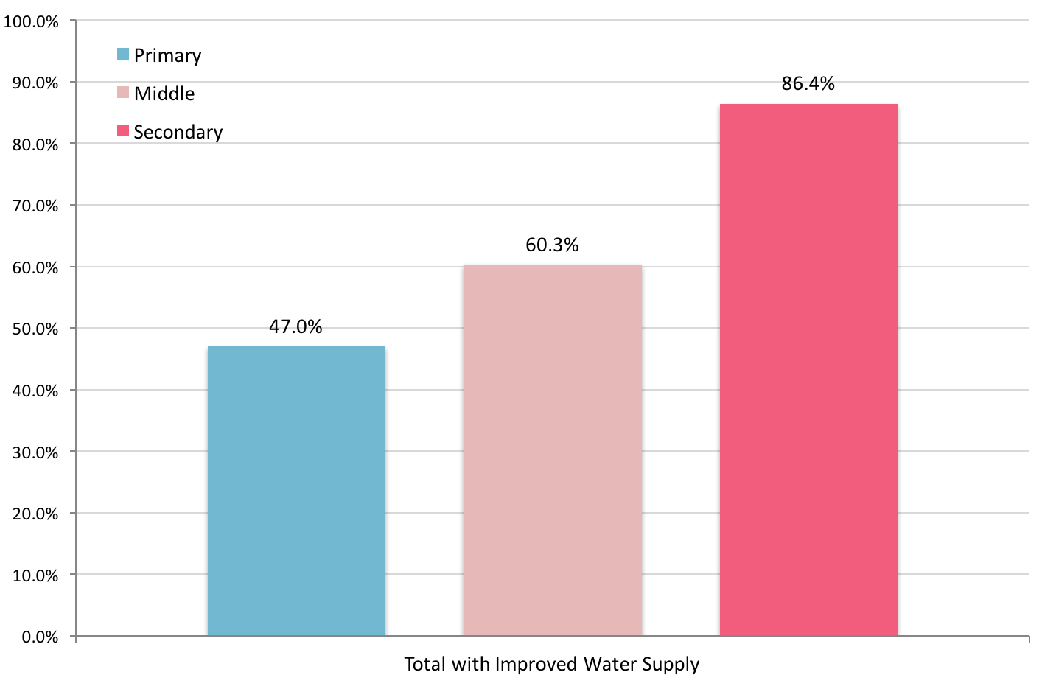

(Source: Pakistan Education Statistics 2014-15. National Education Management Information System Academy of Educational Planning and Management, Ministry of Federal Education and Professional Training, Government of Pakistan, February 2016)

Figure 52 - Improved sanitation in schools in Sindh
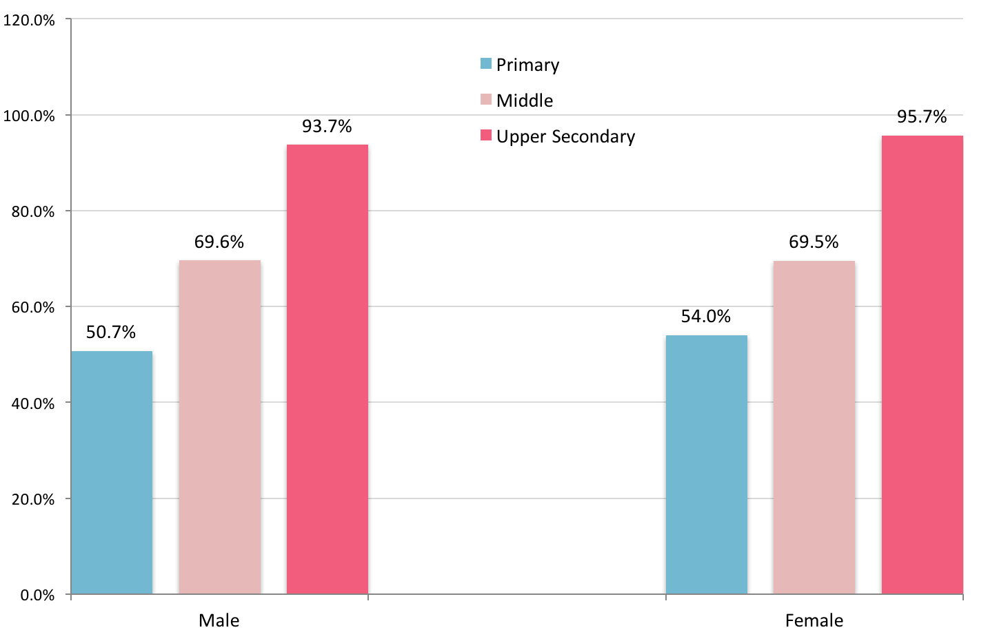

(Source: Pakistan Education Statistics 2014-15. National Education Management Information System Academy of Educational Planning and Management, Ministry of Federal Education and Professional Training, Government of Pakistan, February 2016)

Figure 53 - Availability of drinking water in urban schools in Sindh
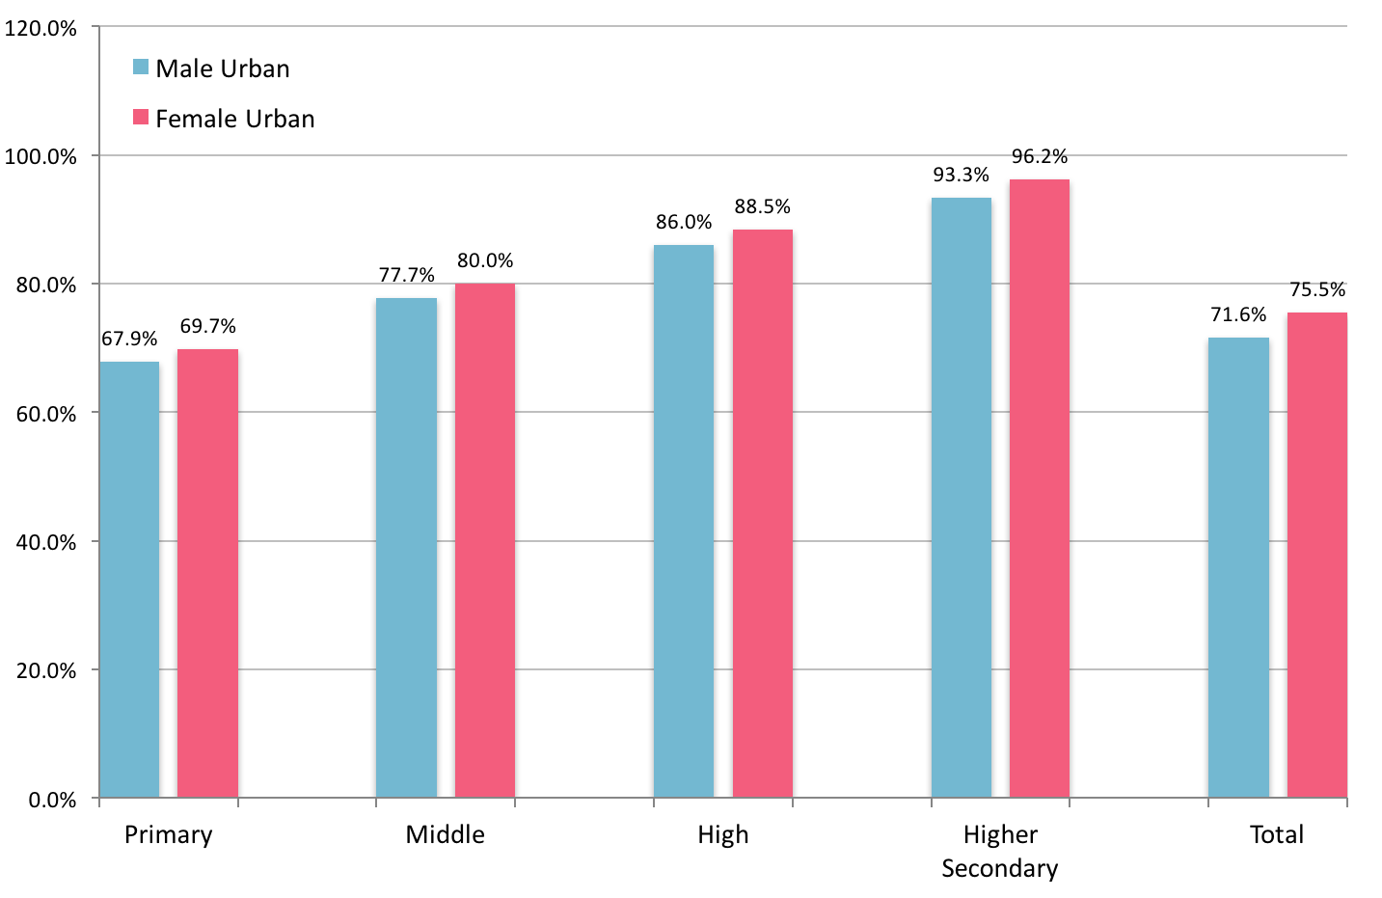
(Source: Pakistan Education Statistics 2014-15. National Education Management Information System Academy of Educational Planning and Management, Ministry of Federal Education and Professional Training, Government of Pakistan, February 2016)

Figure 54 - Availability of drinking water in rural schools in Sindh
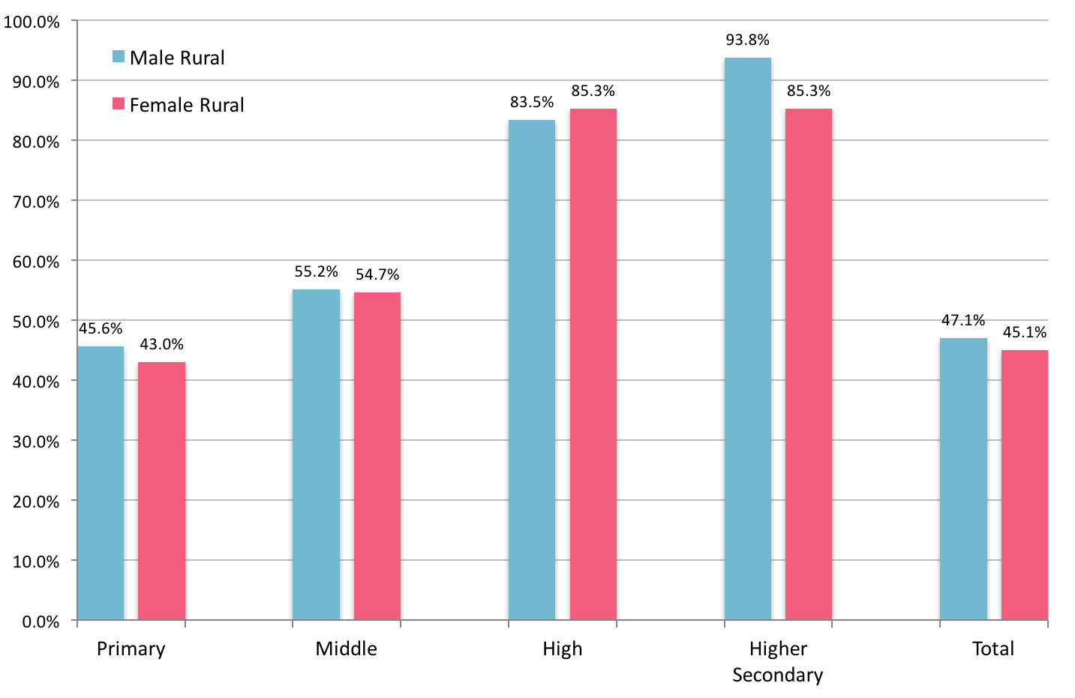

(Source: Pakistan Education Statistics 2014-15. National Education Management Information System Academy of Educational Planning and Management, Ministry of Federal Education and Professional Training, Government of Pakistan, February 2016)

Figure 55 - Availability of student latrines in urban schools in Sindh
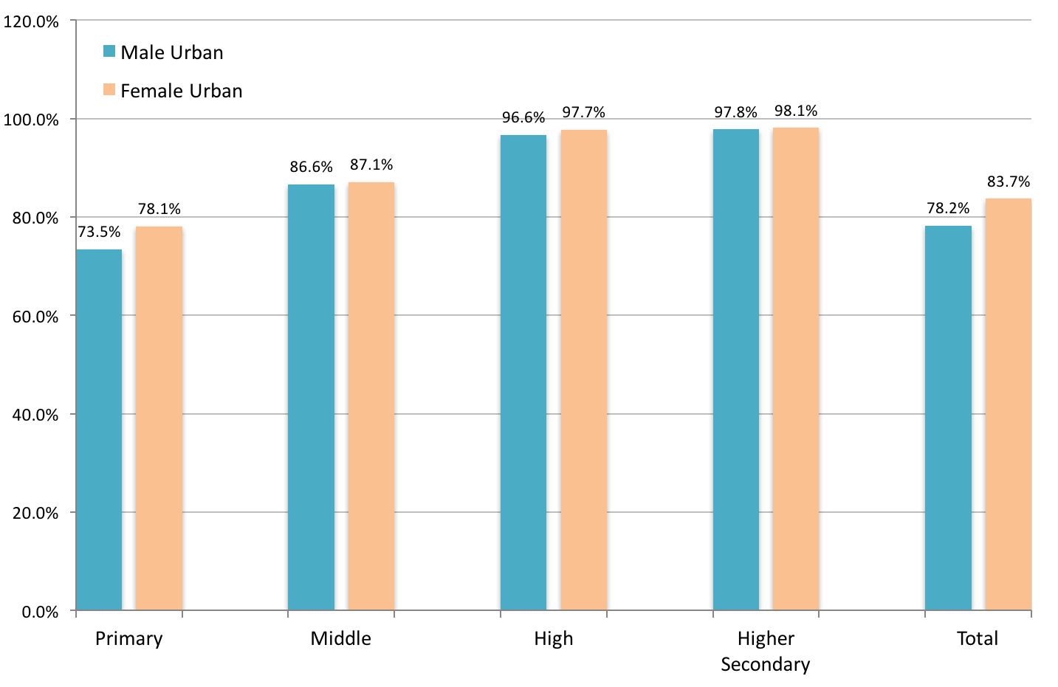

(Source: Pakistan Education Statistics 2014-15. National Education Management Information System Academy of Educational Planning and Management, Ministry of Federal Education and Professional Training, Government of Pakistan, February 2016)

Figure 56 - Availability of student latrines in rural schools in Sindh
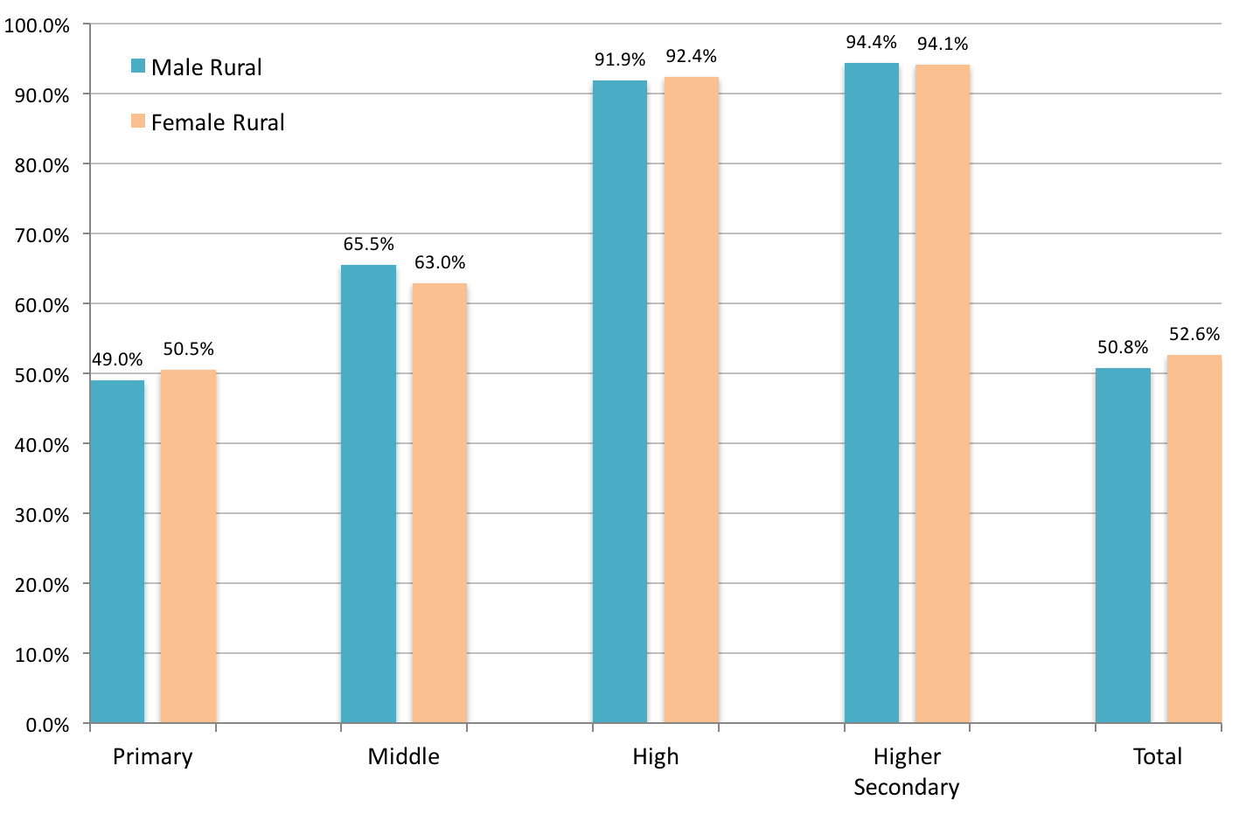

(Source: Pakistan Education Statistics 2014-15. National Education Management Information System Academy of Educational Planning and Management, Ministry of Federal Education and Professional Training, Government of Pakistan, February 2016)

The Pakistan Education Atlas 2015 was launched recently and is a joint project between National Education Management Information System (NEMIS), Academy of Educational Planning and Management (AEPAM), Ministry of Education, Trainings and Standards in Higher Education, Government of Pakistan and Vulnerability Analysis and Mapping (VAM) Unit, United Nations World Food Programme (WFP) Pakistan in collaboration with UNESCO and UNICEF.

The atlas shows that in government primary schools in Sindh, (Fig 57). Kashmore (25%), Sujawal (28%) and Thatta (31%) stand out with very low scores for availability of student latrines, while Matiari (29%), Sujawal (14%) and Thatta (18%)have very low scores for availability of drinking water.

In contrast, in government middle and secondary schools in Sindh, (Fig 58). Jacobabad, Sujawal and Tharparkar score 41% or less for drinking water supply, whileJacobabad and Tharparkar score less than 60% for student latrines.

Figure 57 - Status of school facilities in government primary schools
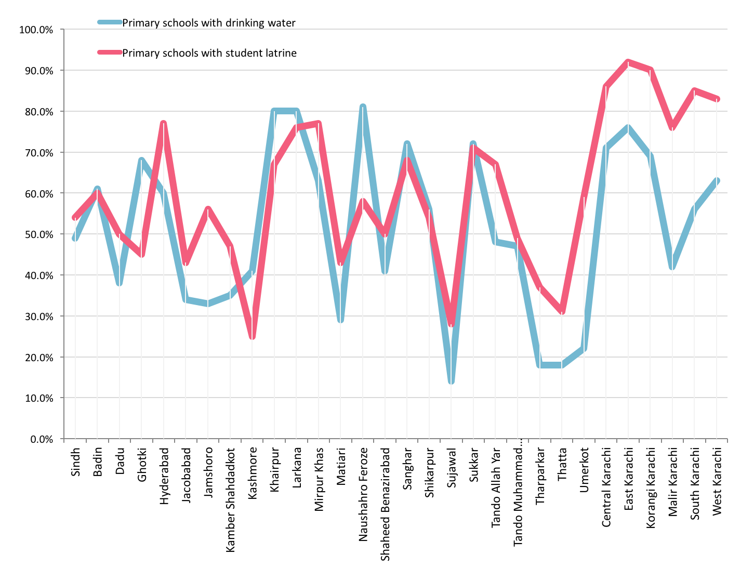

(Source: Pakistan Education Atlas 2015. National Education Management Information System (NEMIS), Academy of Educational Planning and Management (AEPAM), Government of Pakistan and Vulnerability Analysis and Mapping (VAM) Unit, United Nations World Food Programme (WFP) Pakistan)

Figure 58 - Status of school facilities in government middle and secondary schools
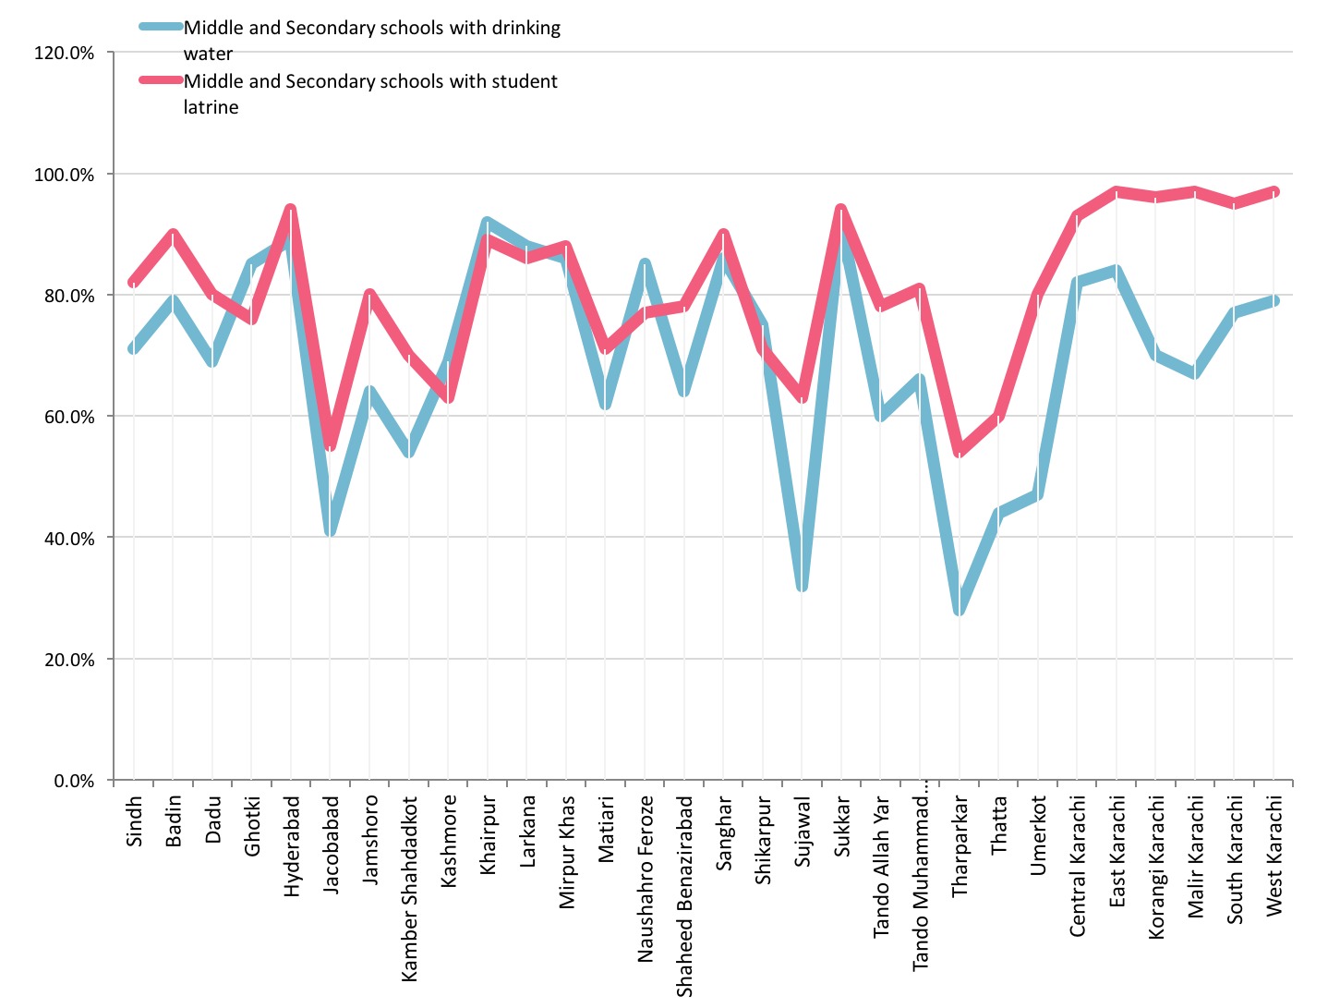

(Source: Pakistan Education Atlas 2015. National Education Management Information System (NEMIS), Academy of Educational Planning and Management (AEPAM), Government of Pakistan and Vulnerability Analysis and Mapping (VAM) Unit, United Nations World Food Programme (WFP) Pakistan)

Synopsis of missing facilities for WASH in schools
Currently, the situation of water facilities in schools is worrisome and is summarised below:

- Out of 41,724primary schools, 19,599 have water facilities and 21,438 have latrines
- Out of 2,316 middle schools, 1,397 have water facilities and 1,612 have latrines
- Out of 1,706 high schools, 1,455 have water facilities and 1,607 have latrines
- Out of 283 higher secondary schools, 273 have water facilities and 280 have latrines

This implies that of 46,039 educational institutions, only 22,724(just under 50%) have water facilities and 24,937 (just under 55%) have latrines.

Figure 59 - Primary schools with drinking water by tehsil
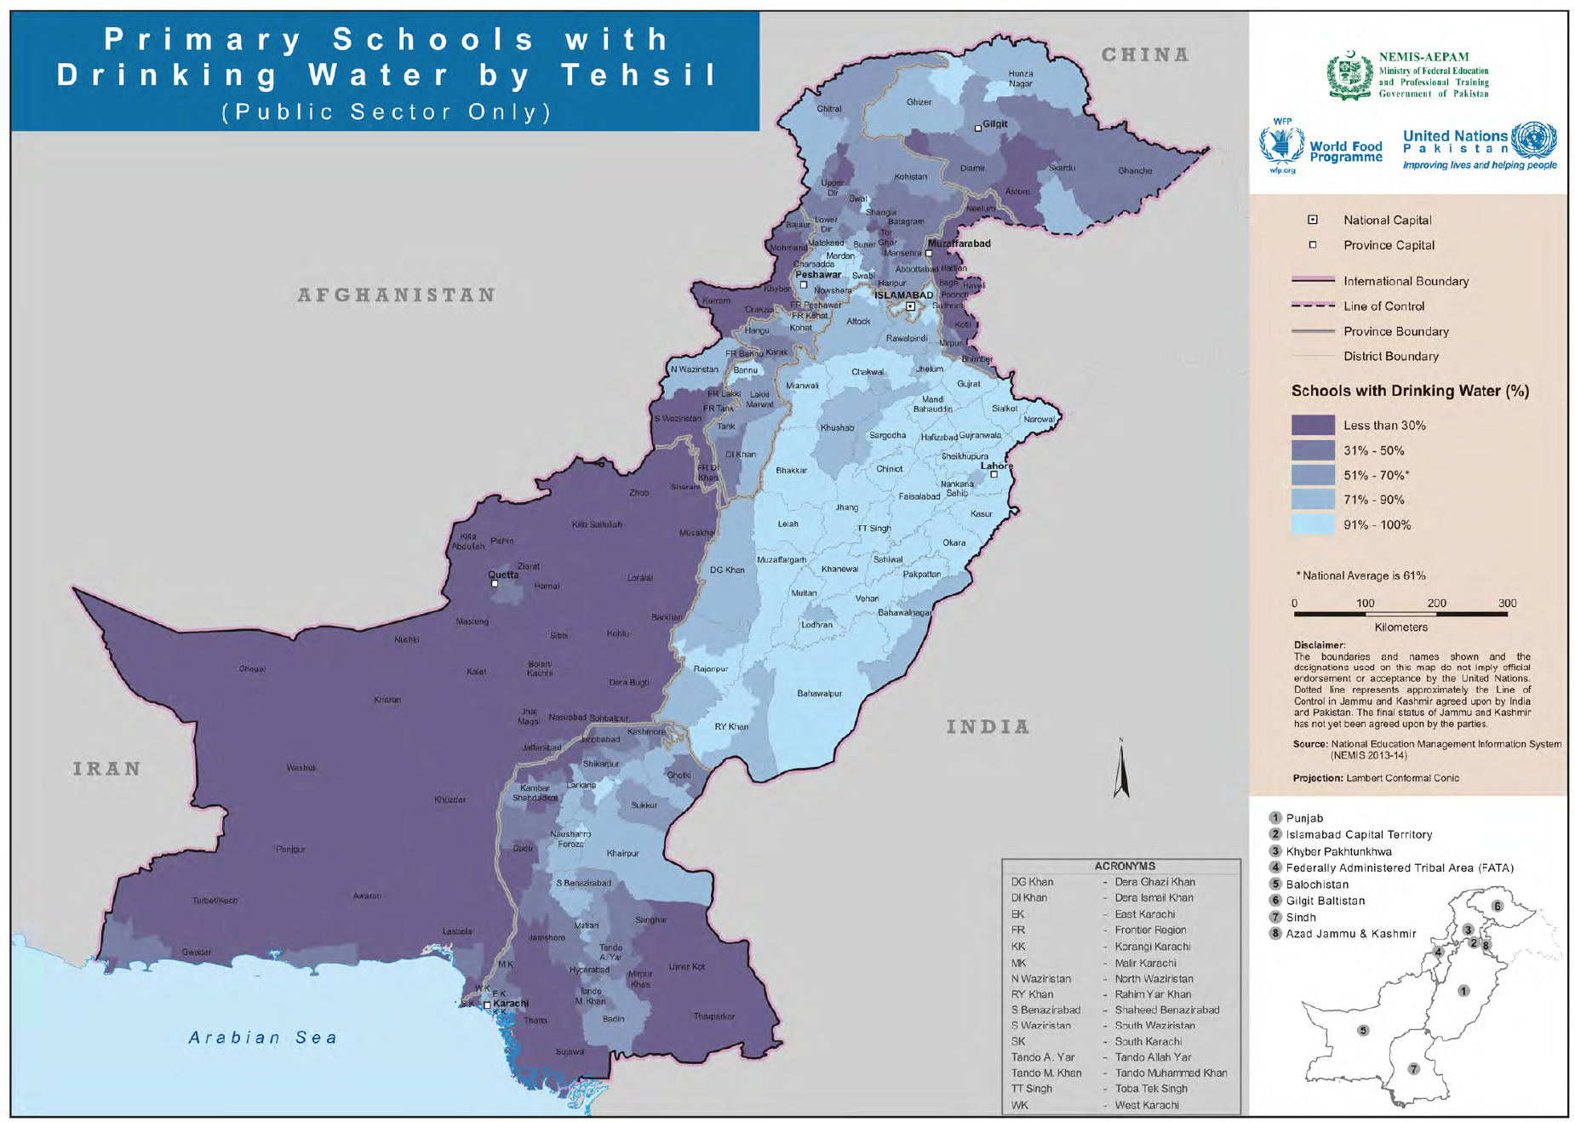

(Source: Pakistan Education Atlas 2015. National Education Management Information System (NEMIS), Academy of Educational Planning and Management (AEPAM), Government of Pakistan and Vulnerability Analysis and Mapping (VAM) Unit, United Nations World Food Programme (WFP) Pakistan)

Figure59illustrates the status of availability of drinking water in primary schools by tehsil.

Figure 60 - Middle and secondary schools with drinking water by tehsil
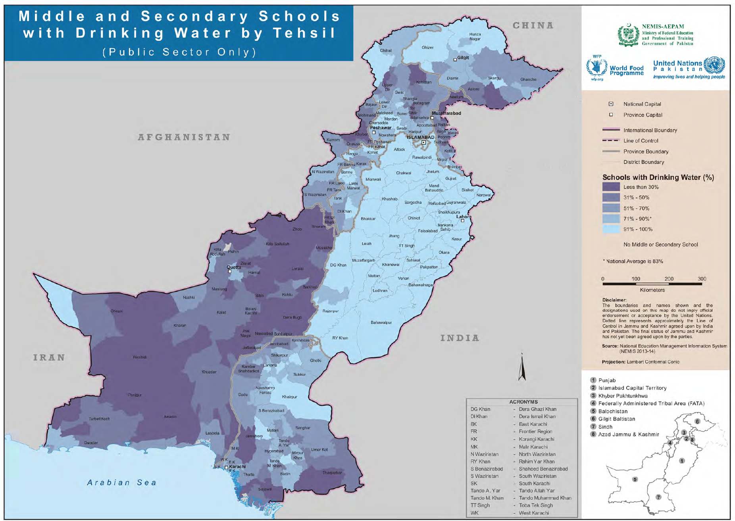

(Source: Pakistan Education Atlas 2015. National Education Management Information System (NEMIS), Academy of Educational Planning and Management (AEPAM), Government of Pakistan and Vulnerability Analysis and Mapping (VAM) Unit, United Nations World Food Programme (WFP) Pakistan)

Figure60illustrates the status of availability of drinking water in middle and secondary schools by tehsil.

Figure 61 - Primary schools with student latrines by tehsil
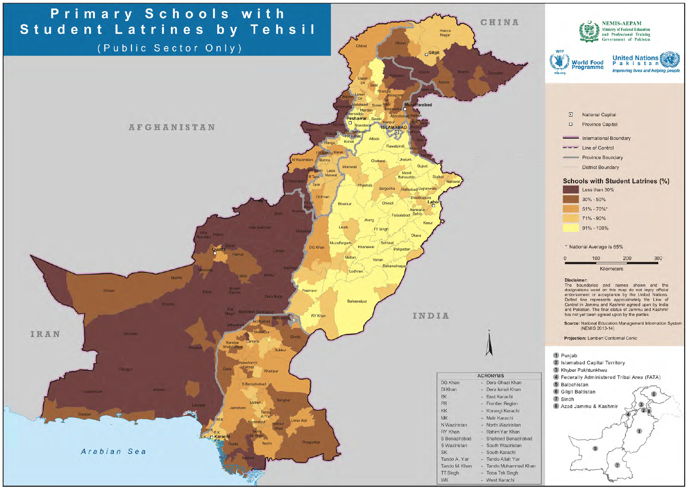

(Source: Pakistan Education Atlas 2015. National Education Management Information System (NEMIS), Academy of Educational Planning and Management (AEPAM), Government of Pakistan and Vulnerability Analysis and Mapping (VAM) Unit, United Nations World Food Programme (WFP) Pakistan)

Figure61 illustrates the status of availability of student latrines in primary schools by tehsil.

Figure 62 - Middle and secondary schools with student latrines by tehsil
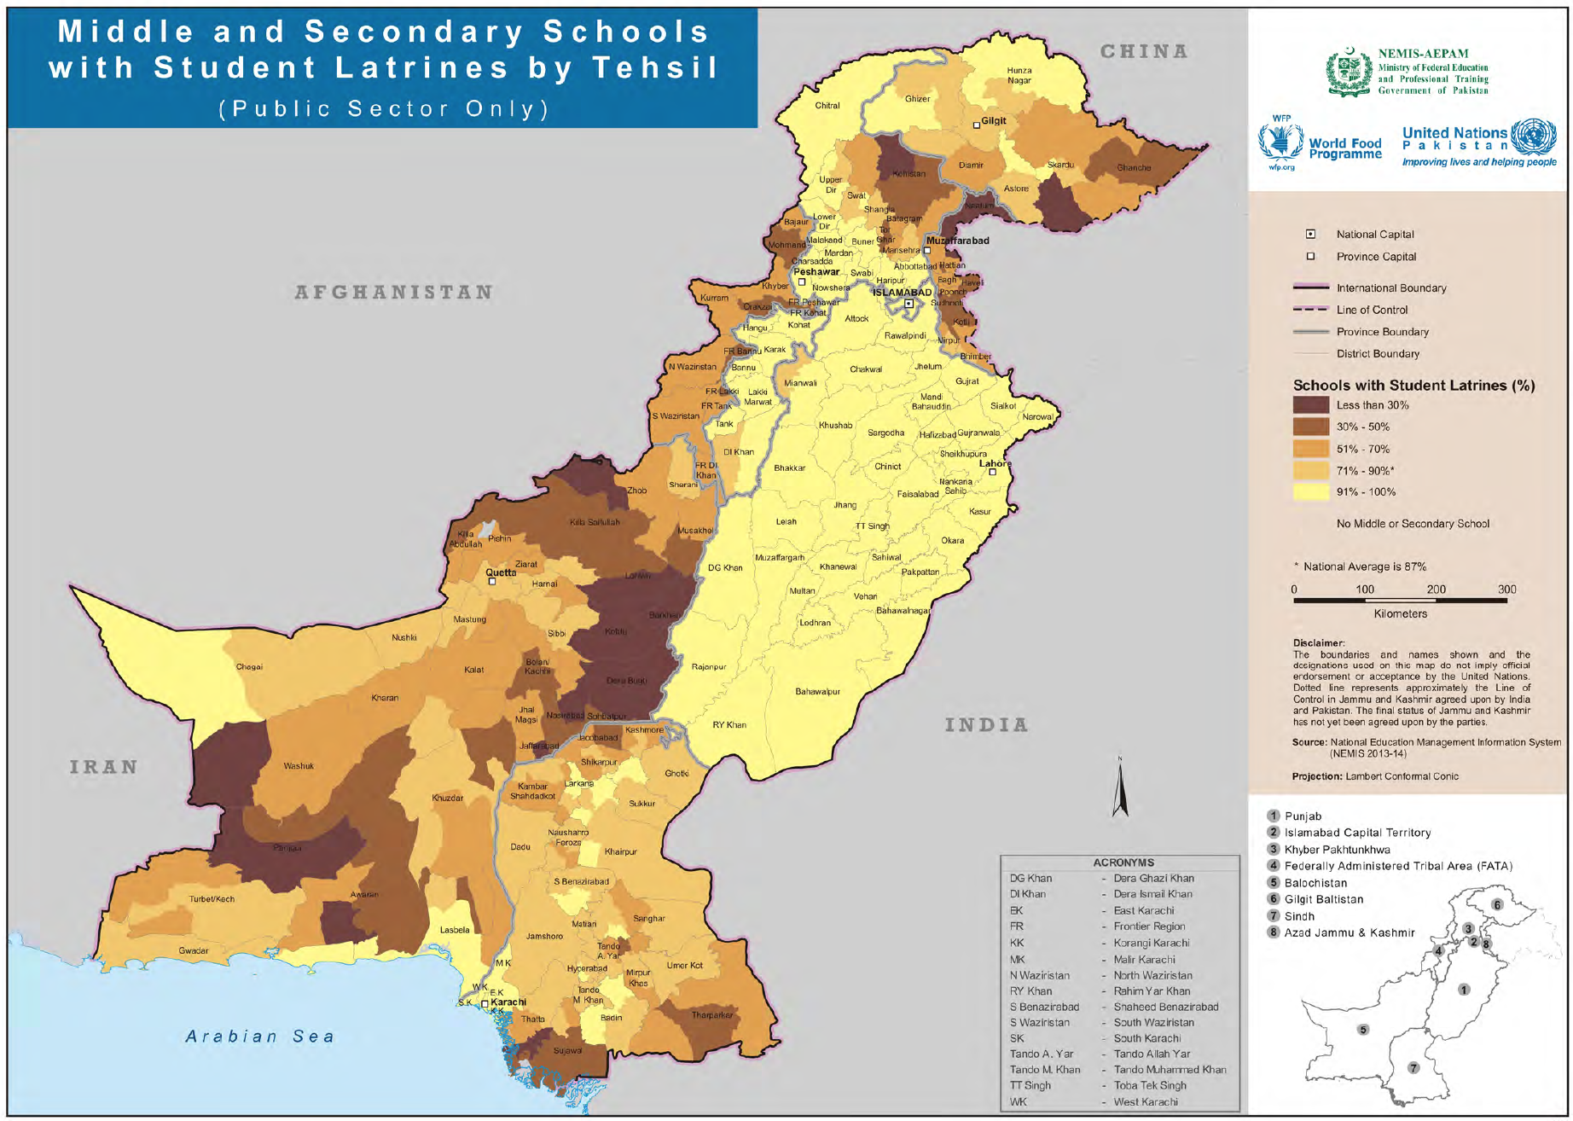

(Source: Pakistan Education Atlas 2015. National Education Management Information System (NEMIS), Academy of Educational Planning and Management (AEPAM), Government of Pakistan and Vulnerability Analysis and Mapping (VAM) Unit, United Nations World Food Programme (WFP) Pakistan)

Figure62 illustrates the status of availability of student latrines in middle and secondary schools by tehsil.

Health and Hygiene Education

The Sindh Education Sector Plan 2014-18 states that ‘Utilities management is not given due attention. Drinking water standpoints are rarely available or are either not functional or of low quality; toilets are not built as per quotas (25:1 for girls and 40:1 for boys) and design standards; awareness campaign drives to motivate children for proper use of facilities are very limited; and the promotion of good health and hygiene practices is almost negligible’. The sector plan has therefore identified health and hygiene as vital components under its strategic objective to ‘Develop a contextually relevant and broad-based curriculum’.

One of the areas that can have a sustained impact on long term sustainability of improved hygiene and sanitation practices is by institutionalising and integrating teacher training in nutrition-sensitive WASH as part of Sindh Teacher Education Development.

There is no health screening of school children at present.

Presently, there is no module on WASH in either pre-service or in-service teacher training programmes. There is need for a curriculum review to incorporate a separate section/module on nutrition-sensitive WASH.

The Bureau of Curriculum and Extension Wing prepares and reviews the schools’ curriculum. There is currently very little on WASH. There is need for a curriculum review to incorporate a separate section/module on nutrition-sensitive WASH.

Menstrual Hygiene Management

A study conducted at the national level showed WASH facilities in schools are not supportive to menstrual hygiene management (MHM); majority of the girls rely on mothers and sisters for MHM related information; and little information is provided or discussed at school level. Most girls reported using reusable torn cloth during menstruation, but reported difficulties in washing and drying the cloth due to lack of privacy.

Trends of MHM in Azad Jammu Kashmir showed the following:

- About 50% of schoolgirls dropped out of school during menstruation
- About 43% of schoolgirls said that there was no availability of protective material during their monthly periods
- About 72% of schoolgirls did not use any pads during their monthly periods
- About 70% of schoolgirls had some knowledge about menstrual periods
- About 50% responded that they had financial problems in buying protective material

In the earthquake affected areas, there was limited but good availability of low cost sanitary pads production. In addition, there was limited but good MHM Information Education and Communication (IEC) material available.

The study in Azad Jammu Kashmir found the following problems associated with Menstruation, which further resulted in limited coping strategies:

- Shame during menses
- Information on menstruation is provided by close family members, if at all
- Teachers’ unwillingness to discuss menstrual hygiene
- Staying out of school for 3 -4 days: ridicule by boys, lack of facilities = poor school performance
- Lack of designated washrooms with water and disposal facilities in schools
- Changing, cleaning and drying of re-useable menstrual clothes
- Unable to afford conventional sanitary pads

The menstrual hygiene management study and action research conducted in 2013 helped girls in Punjab and Khyber Pakhtunkhwa to access improved and customised WASH services. Through this pilot project, UNICEF developed monitoring tools to assist duty bearers to enforce the construction and maintenance of appropriate menstrual hygiene management facilities in schools. UNICEF has prepared a booklet on Menstrual Hygiene Management for Adolescent Girls.

The Integrated Rural Support Programme (IRSP) Pakistan in collaboration with Fresh Water Action Network South Asia (FANSA) conducted a situation analysis on MHM in several districts in the country, which included Haripur, Swabi, Charsadda and Mardan in Khyber Pakhtunkhwa; Faisalabad, Sargodha, Lahore and Multan in Punjab; and Khairpur, Mirpur Khas and Sukkur in Sindh. Some of the key findings from this study were as follows:

- About two-thirds (65.6%) of the girls/women used a cotton cloth during menses, and only 16.8% used a sanitary pad
- About a third (30%) did not wash their hands after changing the cloth
- About half (49.3%) reused the cloth
- About a fifth (19.3%) reused the cloth for 2 months, while a fourth (25%) reused it for 3 months or more
- Just under a third (28.7%) burnt the cloth after washing, while about half (47.5%) threw it in the rubbish after washing it

The School of Nursing and Community Development Department of The Aga Khan University conducted a community-based studyin Hyderabad also conducted by the School of Nursing and Community Development Department of The Aga Khan University, the findings showed that majority of women used some kind of material to absorb menses (98.5%). Most used a washed plain cloth (70.4%). However, unsanitary practices (e.g. unclean cloth) were used by 16.3%, and of those who washed the cloth, a large proportion (19.3%) did not dry the cloth in the sun, as is the best practice. The frequency of change of the menstrual material averaged 2.5 changes on the first day of menstruation to 0.6 change of material per day on the last days. Despite availability of bathing facilities for nearly all women, only 64% reported bathing during menstruation.

The School of Nursing and Community Development Department of The Aga Khan University conducted a cross-sectional study to explore the menstrual practices among 1275 female adolescents of urban Karachi. Findings from the study showed that 50% of the girls lacked an understanding of the origin of menstrual blood and those with a prior knowledge of menarche had gained it primarily through conversations with their mothers. Many reported having fear at the first experience of bleeding. Nearly 50% of the participants reported that they did not take baths during menstruation. Further analysis showed that factors of using unhygienic material, using washcloths, and not drying under sun were found to be statistically significant among those going and not going to schools. The study concluded that there are unhygienic practices and misconceptions among girls that require action by health care professionals.

The Government of Pakistan initiated a dialogue related to Menstrual Hygiene Management (MHM) in selected schools, primarily to understand the scope of education impacts and challenges across cultural backgrounds.

While the issue of MHM relates more to reproductive health, it is an important hygiene and solid waste issue especially at schools and in communities. MHM needs to be integrated in health education and reproductive health programmes and communities sensitised about sanitary waste disposal of pads and cloths used during the menstrual periods. Furthermore, dissemination of information about preparation of low cost home-made sanitary pads needs to be disseminated through hygiene education for girls.

At present, there is no menstrual hygiene education for girls in middle and high schools in Sindh.

Sindh WASH in Schools (WinS) Strategic Plan 2017-2022

In view of the serious issue of missing facilities that not only had an impact on children’s health but also on enrolment and retention in schools, Department of Education, Sindh, Ministry of Federal Education and Professional Training (MoFEPT) Islamabad and UNICEF collaborated to develop a strategic plan to address WASH in schools.

The objectives and targets of the strategic plan include creating awareness, providing latrines where not already available and provision of drinking water by 2022.

The strategies to achieve the objectives and targets are (I) preparation of WASH policy and planning guidelines (II) creating awareness amongst children and teachers and community about health, hygiene and sanitation (III) construction of latrines (IV) provision of drinking water in schools where not already available (V) ensure operation and maintenance (VI) address cross cutting issues, such as latrines for persons with disabilities and Menstrual Hygiene Management (MHM) facilities.

The estimated cost for the strategic plan comes out to be around PKR 24.6 billion. The major cost is on construction of latrines i.e. PKR 16.94 billion followed by drinking water i.e. PKR 7 billion and crosscutting issues i.e. PKR 700 million.

The plan includes an effective system and mechanism, supervision and evaluation. The strategies for M&E include on site supervision and monitoring by Joint monitoring teams; generation and sharing of periodic progress reports; and district, provincial and national level implementation review workshop. The proposed evaluation includes the baseline, interim and summative evaluation. Besides it has also been proposed to develop and integrate wash indicators in SEMIS.

Strategy

Education
Strategic Objectives/Outcomes | Short Term Actions  1 - 3 years | Medium Term Actions  4 - 6 years | Long Term Actions  7 - 10 years
Nutrition-sensitive WASH integrated in teacher training programme | Collaborate with Sindh Teacher Education Development Authority, Board of Curriculum & Extension Wing, Provincial Institute of Teacher Education, Sindh Textbook Board and incorporate nutrition-sensitive WASH hygiene promotion in pre-service and in-service teacher training programme and CPD training of teacher educators  Nutrition-sensitive WASH hygiene promotion cascaded through Teacher Educators as part of on-going education programme | Nutrition-sensitive WASH hygiene promotion cascaded through Teacher Educators as part of on-going education programme | Nutrition-sensitive WASH hygiene promotion cascaded through Teacher Educators as part of on-going education programme
Nutrition-sensitive WASH integrated in schools’ curriculum | Collaborate with Sindh Teacher Education Development Authority, Board of Curriculum & Extension Wing, Provincial Institute of Teacher Education, Sindh Textbook Board for inclusion of topics on nutrition-sensitive water, sanitation and hygiene in curriculum for classes 1 to 12  WASH in Schools policy guidelines developed to ensure operation and maintenance of WASH infrastructure in schools  Implement WASH in Schools policy guidelines in 30% schools | Implement WASH in Schools policy guidelines in additional 30% schools | Implement WASH in Schools policy guidelines in 100% schools
Menstrual hygiene management integrated in health and hygiene for girls | Nutrition-sensitive WASH hygiene promotion module incorporates menstrual hygiene management for girls  Impart menstrual hygiene management education in nutrition-sensitive WASH hygiene promotion to at least 25% of girls middle and high schools as part of on-going school health education and WinS | Impart menstrual hygiene management education in nutrition-sensitive WASH hygiene promotion to at least 50% of girls middle and high schools as part of on-going school health education and WinS | Impart menstrual hygiene management education in nutrition-sensitive WASH hygiene promotion to at least 75% of girls middle and high schools as part of on-going school health education and WinS
100% of schools with missing facilities have safely managed drinking water and latrines (30% in short term, 30% in medium term, 40% in long term) (extension of water distribution pipe from water supply scheme, water tank and 2 latrines per school) in line with SESP and Sindh WinS strategic plan 2017-2022 | Water Supply  More than 68% of primary, 76% of middle and 91% of high schools with missing facilities have safely managed drinking water in line with SESP and Sindh WinS strategic plan 2017-2022  Create linkages with PCRWR and PHE&RDD for water quality testing and reporting in at least 10% schools  Sanitation  More than 71% of primary, 82% of middle and 97% of high schools with missing facilities have safely managed latrines and include proper design of wastewater in schools in line with SESP and Sindh WinS strategic plan 2017-2022 | Water Supply  More than 89% of primary, 92% of middle and 97% of high schools with missing facilities have safely managed drinking water in line with SESP and Sindh WinS strategic plan 2017-2022  Create linkages with PCRWR and PHE&RDD for water quality testing and reporting in 10% ongoing and 20% additional schools  Sanitation  More than 90% of primary, 94% of middle and 99% of high schools with missing facilities have safely managed latrines and include proper design of wastewater in schools in line with SESP and Sindh WinS strategic plan 2017-2022 | Water Supply  100% of primary, 100% of middle and 100% of high schools with missing facilities have safely managed drinking water in line with SESP and Sindh WinS strategic plan 2017-2022  Create linkages with PCRWR and PHE&RDD for water quality testing and reporting in 30% ongoing and 30% additional schools  Sanitation  100% of primary, 100% of middle and 100% of high schools with missing facilities have safely managed latrines and include proper design of wastewater in schools in line with SESP and Sindh WinS strategic plan 2017-2022

SECTOR EFFICIENCY AND CAPACITY

Service Efficiency

Over the last decade, the per capita total sectoral expenditure has increased marginally from PKR 149 in 2005-06 to PKR 164 in 2014-15, but when considered in the context of inflation, it is negligible (Fig 63). Further, the per capita sectoral development spend has actually decreased from PKR 137 in 2005-06 to PKR 117. This indicates diminishing prioritisation of public spending in the sector. On average, the proportion of per capita development spend to overall per capita sectoral spend between 2010-2015 is just under three-fourths (73%).

In 2014-15, the total per capita sectoral expenditure was PKR 867 in Balochistan, compared to PKR 260 in Punjab, PKR 313 in Khyber Pakhtunkhwa, and PKR 164 in Sindh. This indicates that Sindh has the lowest per capita sectoral spend of the provinces. Figure64illustrates the wide difference in per capita sectoral spending in water and sanitation compared to other provinces in 2014-15.

Figure 63 - Decadal Per Capita Sectoral Trends
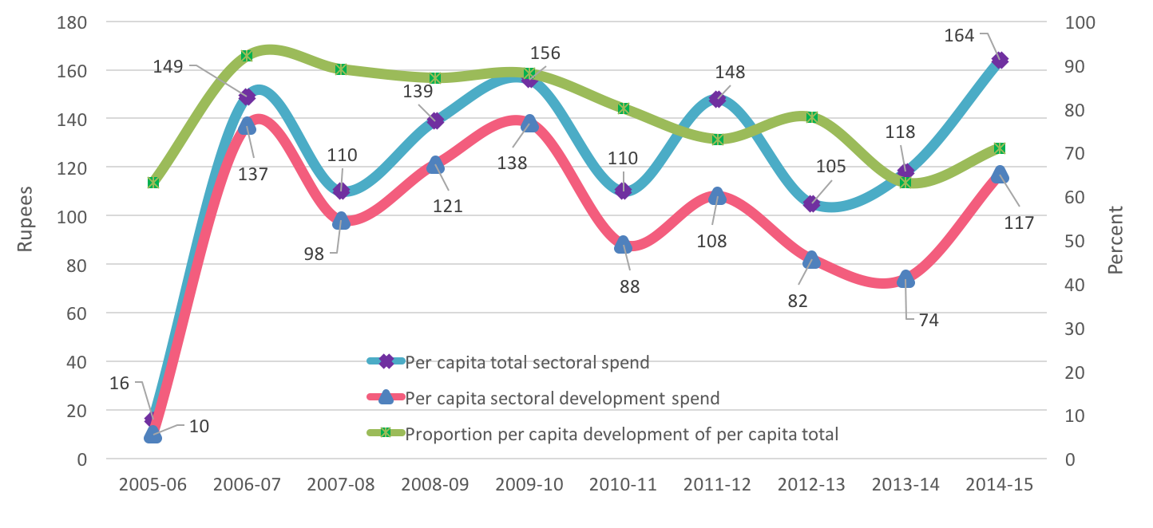
(Source: Computation based on population projections for 2015 and PRSP expenditures - Annual PRSP Budgetary Expenditures for FY 2005-06 to 2014-15, Ministry of Finance, Government of Pakistan. Population estimates obtained from Development Statistics of Sindh 2013)

Figure 64 - Per Capita Sectoral Spend Trends 2014-15
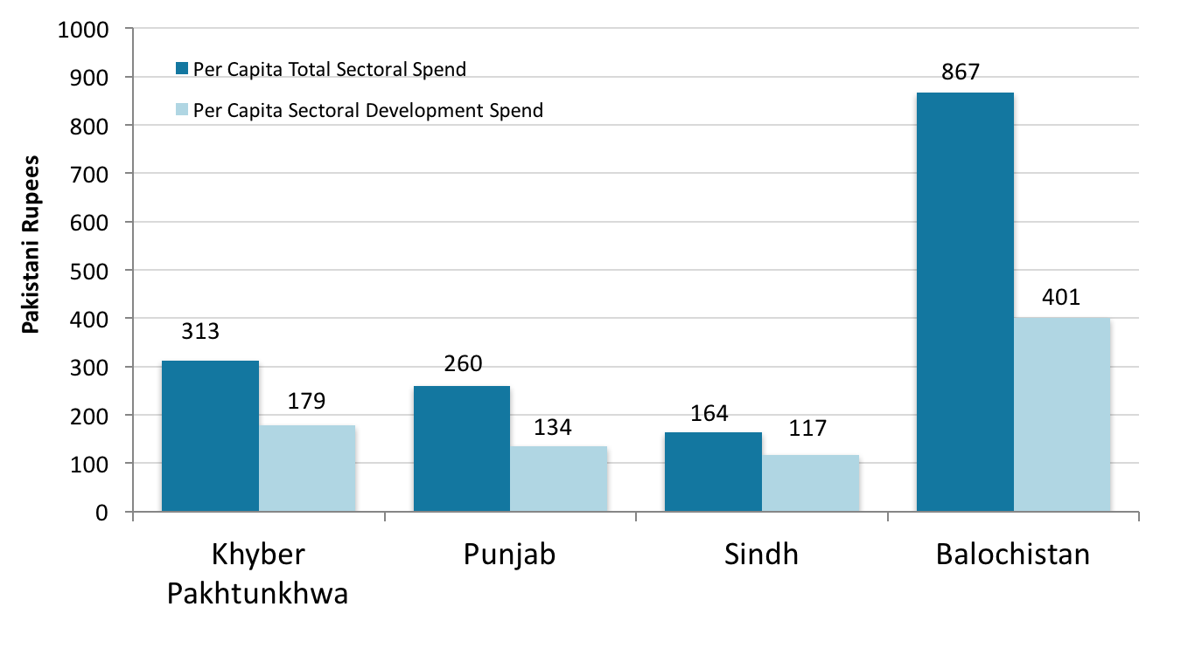
(Source: Computation based on population projections for 2015 and PRSP expenditures - Annual PRSP Budgetary Expenditures for FY 2014-15 (Provisional), Ministry of Finance, Government of Pakistan)

There are provincial differences in the access to and quality of improved drinking water supply sources, sanitation systems and garbage collection systems. The provincial trends are illustrated as follows:

- Fig 65 for sources of drinking water supply in which Sindh and Punjab are progressing at the same pace with 90% or more with access to improved water supply
- Fig 66 and Fig 67for distance to source of drinking water supply in which Sindh is second to Punjab with 79% inside the house
- Fig 68 shows who installed the water supply – it is important to note that 72% of hand pumps and 79% of motor pumps have been installed by the households themselves, while 96% of open wells were installed by NGOs. This raises serious concerns about the quality of installation and risk of using unsafe water supply
- Fig 69 for type of toilet used which shows that Sindh still has about 7% population with no toilet
- Fig 70 for type of sanitation system used which shows that in Sindh, 58% of the population uses unsafe sanitation systems (17% use open drains and 41% have no system)
- Fig 71for type of garbage collection system from household which shows that 69% of households do not have any garbage collection system
- Fig 72 for type of urban garbage collection system from household which shows that 56% of households have a garbage collection system while 44% do not

Figure 65 - Provincial trends of source of drinking water supply
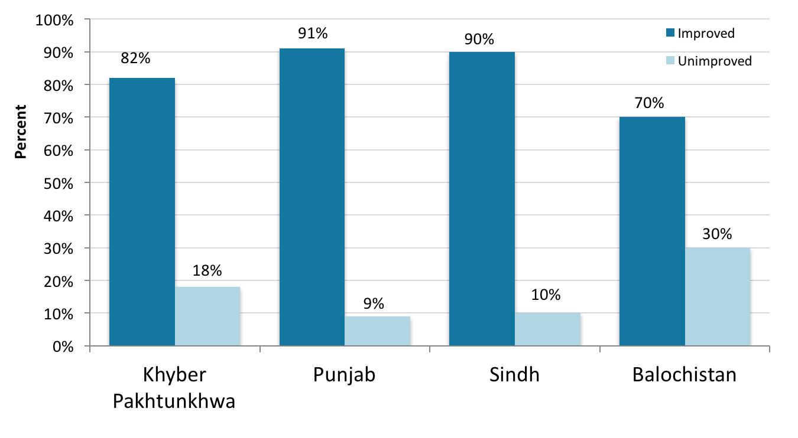
(Source: PSLM 2014-15)

Figure 66 - Distance to source of drinking water supply by province
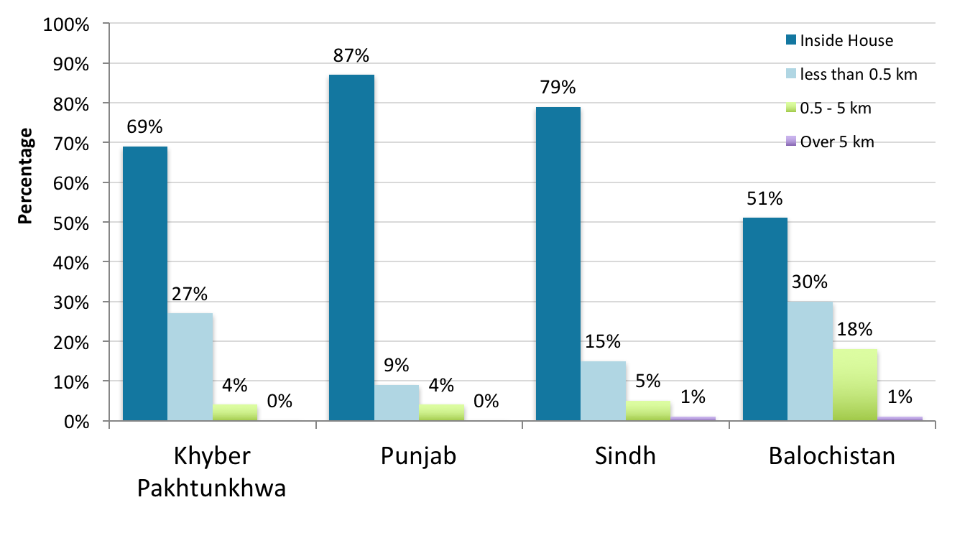
(Source: PSLM 2013-14)

Figure 67 - Distance to source of drinking water supply in Sindh
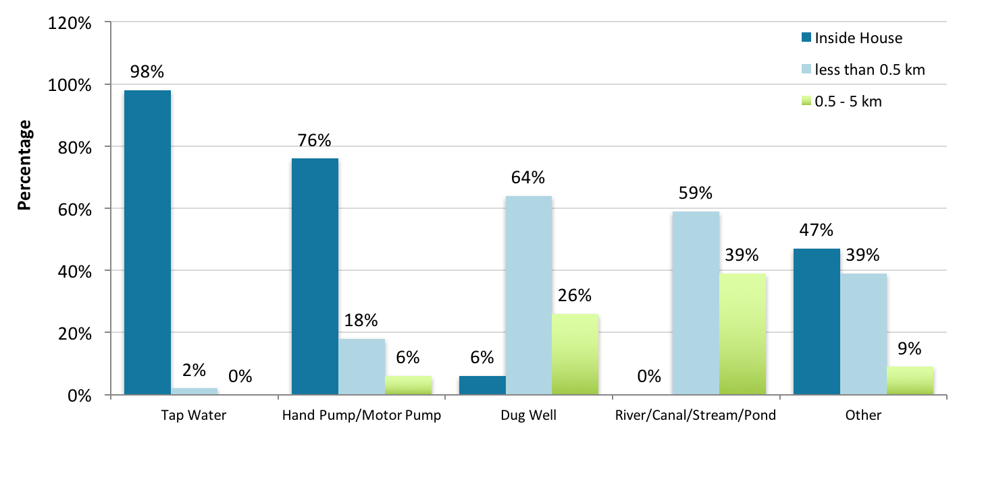
(Source: PSLM 2013-14)

Figure 68 - Who installed water supply
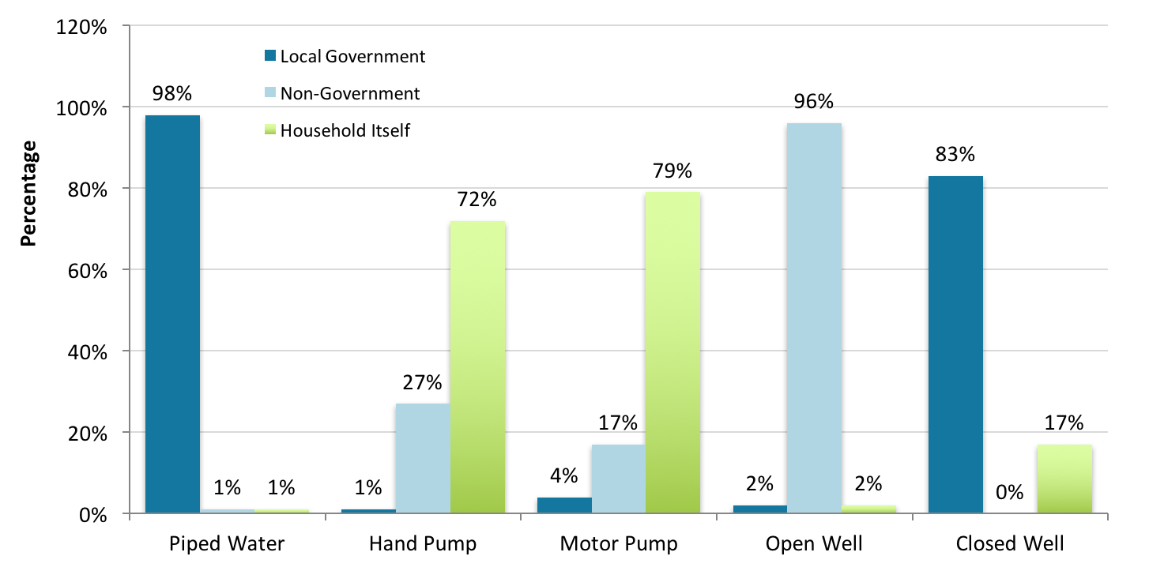
(Source: PSLM 2013-14)

Figure 69 - Type of toilet used by province
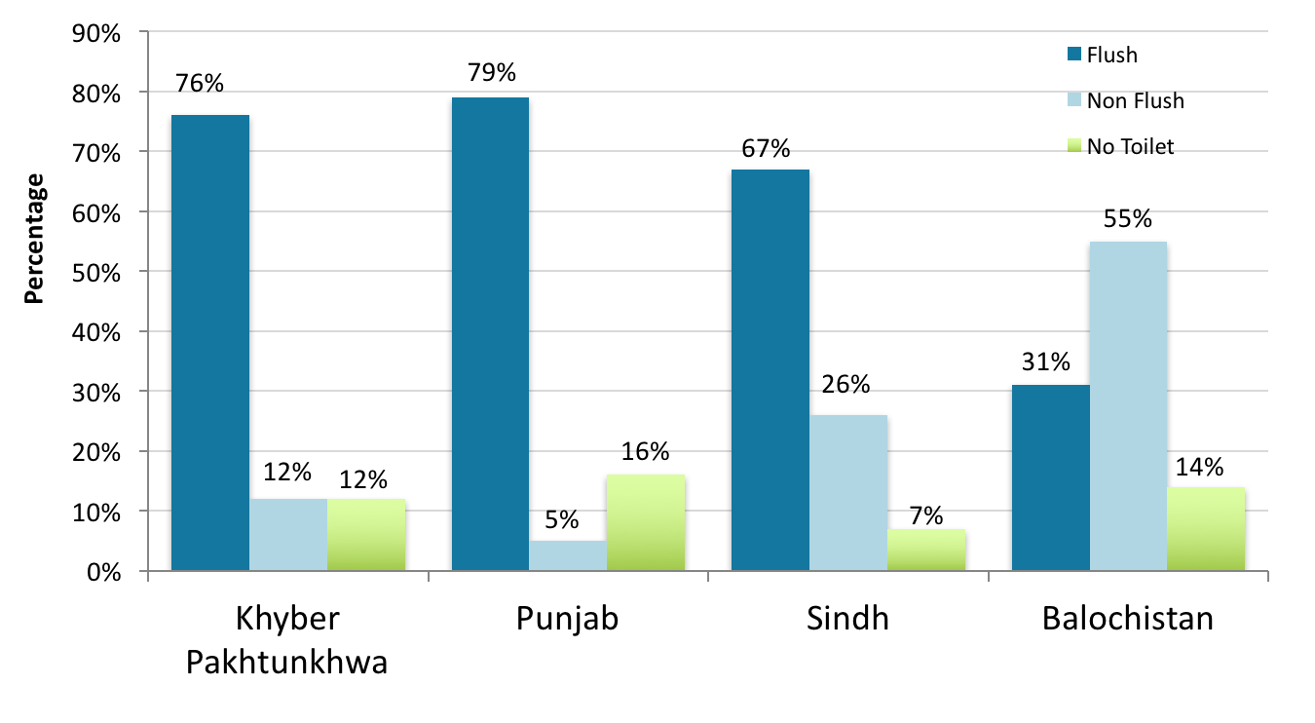
(Source: PSLM 2014-15)

Figure 70 - Type of sanitation system used by province
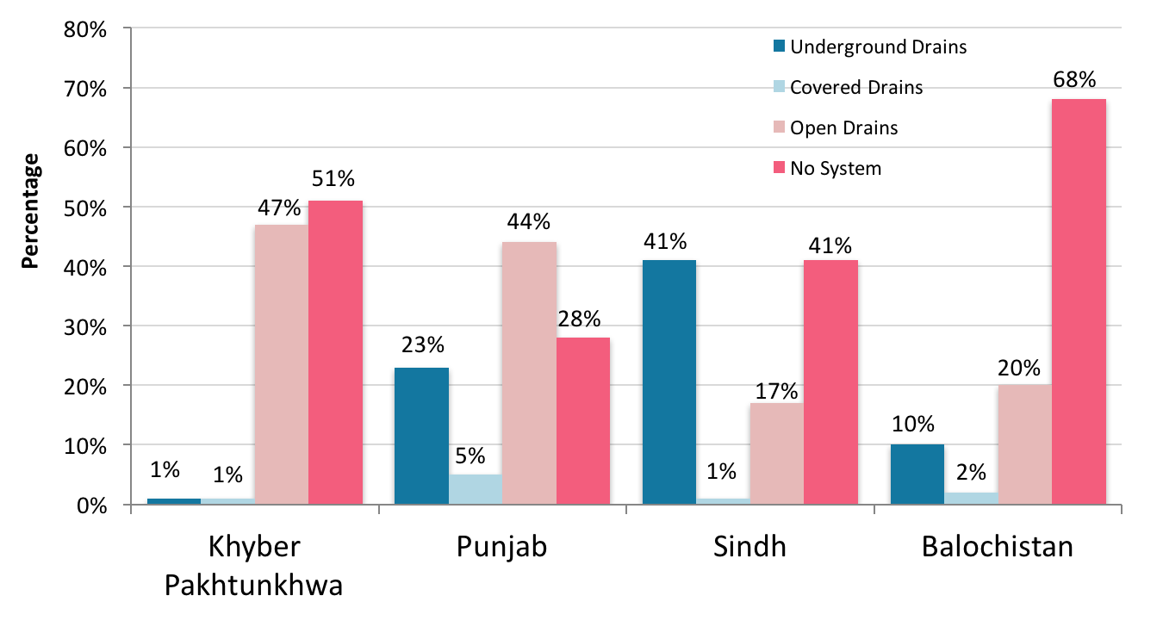
(Source: PSLM 2013-14)

Figure 71 - Type of overall garbage collection system from household by province
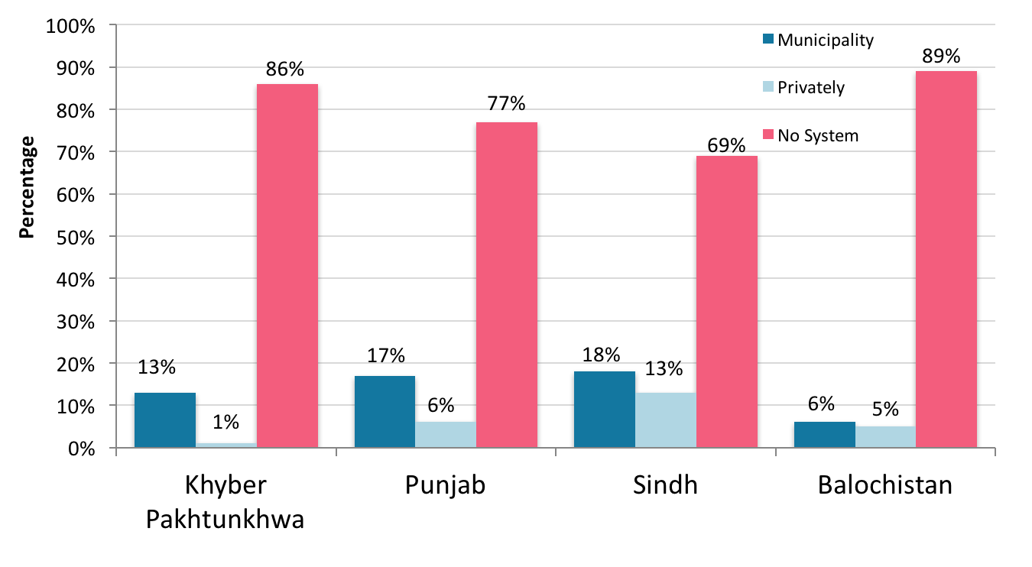
(Source: PSLM 2013-14)

Figure 72 - Type of urban garbage collection system from household by province
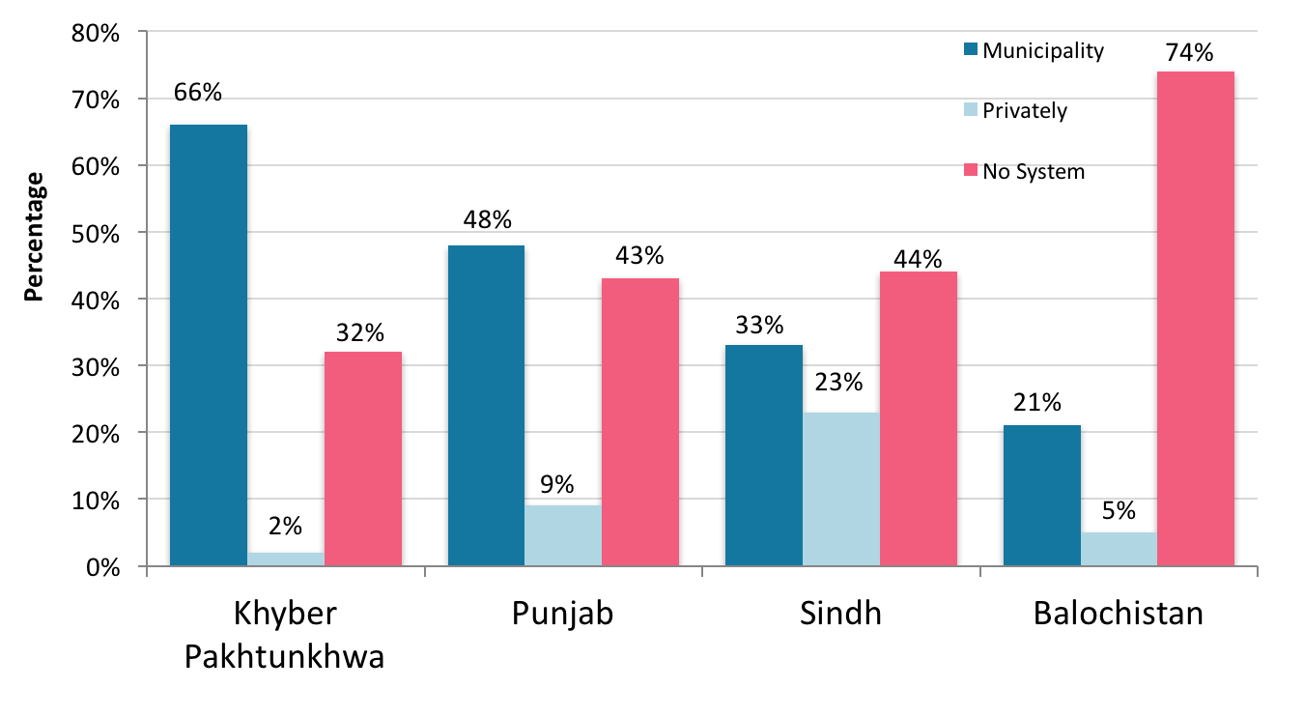
(Source: PSLM 2013-14)

Table 14 highlights the service efficiency of different water and sanitation agencies. It shows that KW&SB underperforms in most of the indicators only second to WASA Quetta. It has low billing and collection ratios, a high staffing ratio, and no fee for new sewerage connection. NSUSC has the lowest average unit production cost and staffing ratio.Table 15provides further insights to service efficiency.

Table 14 - Comparison of service efficiency in water and sanitation agencies
 | Khyber Pakhtunkhwa  WASA Peshawar | Punjab  WASA Lahore | Sindh  Karachi Water and Sewerage Board | North Sindh Urban Services Corporation Sukkur | Balochistan WASA Quetta
SERVICE
Water coverage | 100% | 89% | 90% | 40% | 70%
Sewerage coverage | 100% | 88% | 80% | 85% | 12.5%
Water availability | 9 hr/d per consumer | 14-18 hr/d per consumer | 5 hr/d per consumer | 8 hr/d per consumer | 1 hr/d per consumer
Per capita consumption | 312 litres per day | 327 litres per day | 135 litres per day | 77 litres per day | 59 litres per day
EFFICIENCY
Average unit production cost | PKR 7.90/m³ | PKR 6.73/m³ | PKR 7.69/m³ | PKR 0.08/m³ | PKR 0.75/m³
Billing efficiency | 100% | 98% | 70% | 80% | 60%
Collection efficiency | 93% | 80% | 43% | 60% | 21%
Staffing ratio (staff/1000 water and sewerage connections) | 7 | 4 | 7 | 3 | 24
ANNUAL O&M COST
Salary | N/A | 33% | 65% | 41% | 47%
Power | N/A | 46% | 7% | 30% | 39%
Others | N/A | 21% | 28% | 29% | 14%
CONSUMER SERVICE
Average water bill/month per connection | PKR 219 | PKR 287 | PKR 449 | PKR 30 | PKR 125
New connection fee water supply residential | PKR 2,300 – 5,750 | PKR 6,400 | PKR 3,207 (average) | PKR 365 | PKR 1,000
New connection fee sewerage residential | PKR 1,500 – 4,600 | PKR 400 | NIL | NIL | Nil
(Source: Pakistan Water and Sanitation Operators Directory, 2012. Pakistan Water Operators Network)

Table 15 - Status of efficiency of service
 | KW&SB  (Q1 2012 data) | NSUSC Sukkur  (Q1 2012 data)
SERVICE COVERAGE
Water Coverage % | 80.01 | 85.67
Sewerage Coverage % | 80.00 | 95.35
CONSUMPTION AND PRODUCTION
Water Production L/capita/day | 197.35 | N/A
Water Consumption L/capita/day | 137.98 | ?
NON REVENUE WATER
Non Revenue Water % | 30.08 | ?
Unaccounted For Water % | 30.08 | ?
METERING PRACTICES
Metering Level % | 0.21 | N/A
Metered Water Sold % | N/A | N/A
NETWORK PERFORMANCE
Pipe Breaks-Burst/km | 0.51 | 2.81
Sewer System Blockages/km | 38.46 | 31.79
Pipe Leakages/km | 1.53 | 16.71
Replacement of Manhole Covers % | 7.2 | 94.35
Cleaning/Desiltation of Manholes % | 36 | 88.81
Cleaning/Desiltation of Sewers % | 10 | N/A
Storm Water Drain Used as Sullage Carrier % | N/A | 100
Sewer Collapse/Crown Failure % | N/A | 75
COST AND STAFFING
Unit Operating Cost – Water Consumption Rs/m³ water consumed | 10.05 | 516.66
Unit Operating Cost – Water Production Rs/m³ water produced | 7.02 | ?
W&WW Staff Per 1000 W&WW Connections | 9.56 | 6.53
Water Staff Per 1000 Water Connections | 14.51 | N/A
Waste Water Staff Per 1000 Waste Water Connection | 4.07 | N/A
Salary Cost as % of Total Operating Cost | 37 | 82.48
Electricity Cost as % of Total Operating Cost | 45.06 | 8.76
Maintenance Cost as % of Total Operating Cost | 8.89 | 2.19
Contracted Out Cost as % of Total Operating Cost | 9.05 | 6.57

N/A – Data Not Available
? - Unclear
(Source: Pakistan Water Operators Network)

Table 15 continued.
 | KW&SB  (Q1 2012 data) | NSUSC  (Q1 2012 data)
QUALITY OF SERVICE
Continuity of Service per day | 5 | 9
Chemical Unfit Source(s) % | 1.15 | 100
Biologically Unfit Source(s) % | 2.07 | 100
Chemically Unfit at Taps % | 2 | 100
Biologically Unfit at Taps % | 2.53 | 100
Water Quality – % of Required Residual Chlorine Test | 100 | 100
Water Quality – Samples Passing On Residual Chlorine % | 78.75 | 100
Complaints About W&WW Services % of total connections | 17.29 | 1.77
Waste Water Treatment – Primary Level % | 61.1 | 0
Waste Water Treatment – Secondary Level % | 0 | 0
BILLING AND COLLECTION
Average Revenue Water and Waste Water Rs/m³ water sold | 6.16 | 176.21
Collection Period days | 1910.39 | N/A
Billing Efficiency % | 94.88 | ?
Collection Efficiency (Physical) % | 26.42 | 86.41
Collection Efficiency (Financial) % | 61.5 | 400
FINANCIAL PERFORMANCE
Operational Cost Coverage (ratio) | 0.61 | 0.34
Working Ratio | 1.63 | 2.93
Debt Servicing % | N/A | N/A

N/A – Data Not Available
? - Unclear
(Source: Pakistan Water Operators Network)

Table 15 presents the status of efficiency of KW&SB and NSUSC Sukkur in 2012. Some of the highlights are indicated below.

Service Coverage
Both show good coverage of 80% and above.

Consumption and Production
The production in KW&SB is 197.35 L/capita/day, while the consumption is 137 L/capita/day. There is an apparent good correlation between production and capacity with 70% consumption being matched by production.

Water consumption rates in litres per person per day are shown below for selected countries :

- Germany – 193 L/capita/day
- Brazil – 187 L/capita/day
- Philippines – 164 L/capita/day
- United Kingdom – 149 L/capita/day
- India – 135 L/capita/day
- China – 86 L/capita/day

This shows that the median consumption rate is about 156 L/capita/day, and when about 20% is added for NRW/UAW, the figure comes to about 187 L/capita/day. This is equivalent to about 40 gallons per person per day.

The water needs per person per day are estimated to be about 120 L/capita/day as shown below:

- Drinking – 5 litres
- Food preparation – 10 litres
- Bathing – 25 litres
- Sanitation – 45 litres
- Laundry – 35 litres

This is about 26 gallons per person day.

From the available data, the production and consumption rates at KW&SB seems to be at optimal level.

Non Revenue Water
Non Revenue Water and Unaccounted for Wateris still high at 30%and KW&SB should strive to bring these close to 10% or lower.

Metering Practices
Metering practices are dismal with KW&SBat less than 1%.

Network Performance
Cleaning and de-silting of drains and sewers varies from KW&SB and NSUSC. Higher cleaning rates of about 88.81% are noted in NSUSC compared to 36% at KW&SB for cleaning/desilting of manholes. However, factors like gravity, pumping house functionality, and overall O&M probably determine need and frequency for cleaning. Both KW&SB and NSUSC show high rates of sewer system blockages/km of over 30%.

Cost and Staffing
The Water and Waste Water staff per 1000 connections ranges from 9.56 atKW&SB to 6.53 at NSUSC. The desired rate should be closer to 2-3 staff per 1000 connections. A higher rate indicates lesser efficiency. Further, KW&SB has a much higher proportion of electricity to total operating costs (45%) compared to 8.76% at NSUSC. Most of the operating cost at NSUSC is salary cost (82.48%).

Quality of Service
The quality of water shows that ‘chemically unfit at source’ and ‘biologically unfit at source’ at KW&SB is generally 1.15% and 2.07% respectively. However, ‘chemically unfit at taps’ and ‘biologically unfit at taps’ at KW&SB is 2% and 2.53% respectively. The data for NSUSC is unclear.

Billing and Collection
The collection period at KW&SB is a staggering 1910.3 days. On the positive side, it has a high billing efficiency at 94.88%, but falls short again in its collection efficiency (physical) of 26.42%. NSUSC has a highcollection efficiency (physical) of 86.41% and also a high collection efficiency (financial) of over 400%.

Financial Performance
The operating cost coverage ratio is better at KW&SB with 0.63, and also a better working ratio of 1.63. Optimal financial performance requires for the operating cost coverage ratio to be more than 1.0 and working ratio to be less than 1.0.

Specific recommendations of the Reform Led Investment Plan of KW&SB

Tackle inefficiency by promoting institutional reforms:

- Enhance governance and insulate the utility from political interference while maintaining public accountability: i.e. Corporatize KW&SB
- Strengthen KW&SB Board of Directors
- Institutional restructuring of KW&SB
- Amend KW&SB Act to revisit board composition and role and responsibilities of the utility management
- Enhance civil society and citizen engagement with specific focus on gender and marginalised segments
- Introduce a new KW&SB Brand responding to customers
- Reaching out to Urban Poor

Improve the Financial with careful attention to poor households.

- Develop and implement WSS financial viability plan for revenue mobilization, recovering arrears (incrementally) and collecting current bill (100%), introducing domestic metering in pilot areas with volumetric tariff and rationalizing tariff (Target: recovering 100% OpEx)
- Outsourcing of billing and collection to private sector on pilot basis in selected towns/districts.
- Improve water availability by reducing losses
- Develop and implement a performance improvement plan for KW&SB (Target: Universal access, Reliability: 8hours/day)
- Establish pro-poor service unit in KW&SB for improving service delivery in low income and informal settlement

Social Audit of Local Governance and Delivery of Public Services

A Social Audit of Local Governance and Delivery of Public Services conducted by United Nations Development Programme (UNDP) in 2011 – 2012 indicated the following findings in the different provinces:

Drinking Water Supply
- A higher proportion of respondents in Punjab (39%) indicated that they do not have access to government drinking water compared to any other province. Punjab is followed by Balochistan, where 30% of households do not have access to government water services. The situation is far better in Sindh and Khyber Pakhtunkhwa, where 89% and 85% of respondents respectively indicated that they do have access to government water services. The better situation in Sindh may be due to high urbanisation in the province with a large population of the province residing in Hyderabad and Karachi. However, the rural marginalised community of Sindh reported clean drinking water as a major problem of their area
- Residents in Sindh are most satisfied with government water services, with three-fifths (60.4%) of respondents indicating that they are satisfied. This is only slightly higher than the satisfaction in Punjab (55.2%), which is in turn significantly higher than the satisfaction in Khyber Pakhtunkhwa where only 44.8% of respondents indicated they were satisfied with water supply. The situation in Balochistan with respect to this question is by far the worst, with less than one-third (31.6%) of respondents indicating they were satisfied with government water supply. There is, therefore, a clear ranking in the satisfaction with water among provinces, with Sindh displaying the highest satisfaction followed by Punjab, Khyber Pakhtunkhwa and Balochistan. The high percentage of dissatisfied households in Balochistan, with government water services, is corroborated by the findings of focus group discussions conducted with different groups in Balochistan. According to the rural marginalised community of Balochistan, there has not been any change for the better in the present system, rather the situation has grown from bad to worse – “Drinking water is the biggest issue of our area but nothing has been done in this regard”

Sewerage and Sanitation
- Availability of adequate sewerage and sanitation in the country, particularly in urban and peri-urban areas, is a key indicator of development and affects living standards of citizens. In Pakistan, sewerage and sanitation has been on the agenda of local governments since 1960’s with this service being implemented at the tehsil and/or union council levels through various local government systems. Indeed, its importance in maintaining hygiene standards of settlements, preventing outbreaks of epidemics and its impact in the health of communities make this public service an essential element of measuring the state-citizen relationship
- Punjab and Khyber Pakhtunkhwa have similarly high levels of sanitation service availability at 85.5% and 82.1%. Sindh has lower access to sanitation than Khyber Pakhtunkhwa and Punjab, at 73.5%. Access in Sindh is still higher than Balochistan, however, which lags behind all the other three provinces with only 54.5% of respondents indicating that they have access to sanitation services
- Households in Sindh (31.3%) and Punjab (30.6%) are more likely to be satisfied with sanitation compared to those in Khyber Pakhtunkhwa and Balochistan. Among Khyber Pakhtunkhwa and Balochistan, there is also a significant difference in satisfaction with only 11.4% of households in Balochistan expressing satisfaction with sanitation compared to 21.6% in Khyber Pakhtunkhwa. This suggests that the government is failing to satisfy citizen’s demand for sanitation in all four provinces, but more so in Khyber Pakhtunkhwa and Balochistan, and especially so in Balochistan where only 1 out of 9 households are satisfied with sanitation compared to 2 out of 9 for Khyber Pakhtunkhwa and almost 3 out of 9 for Sindh and Punjab

Garbage Disposal
- Khyber Pakhtunkhwa (30.7%) and Punjab (33.1%) have similarly low levels of access to garbage disposal services, with one-third or less of respondents indicating that they do not have access. Surprisingly, Balochistan has higher levels of access to garbage disposal services with 44.4% of respondents indicating so. Sindh has higher access compared to all three other provinces, with a majority (61.3%) of respondents indicating that they have access to garbage disposal services. Hence the garbage disposal service is much more likely to be available in Sindh than other provinces
- Residents in Balochistan are least satisfied with garbage disposal with only 13% of respondents who have access to garbage disposal indicating they were satisfied. Satisfaction levels were also low, but higher than Balochistan, in Khyber Pakhtunkhwa where a little more than a fifth (21.1%) of respondents indicated they were satisfied. The situation is comparatively better in Punjab (40.1%) and Sindh (37.0%) compared with Khyber Pakhtunkhwa and Balochistan

Public Opinion on Quality of Governance in Sindh

A survey on Public Opinion on Quality of Governance in Pakistan was undertaken by the Pakistan Institute of Legislative Development And Transparency (PILDAT) in 2014-15. The key findings with regards to water and sanitation in Sindh included the following:

- Provincial Government performance with regards to access to safe drinking water supply – 1% indicated very good, 17% good, 38% bad, and 39% very bad
- Provincial Government performance with regards to Sanitation (Sewerage, Solid Waste Collection and Disposal) – 2% indicated very good, 21% good, 33% bad, and 38% very bad

These findings suggest that 82% of the population is not satisfied with drinking water services, while 77% are dissatisfied with sanitation services.

A survey on Assessment of the Quality of Governance in Sindh was undertaken by the Pakistan Institute of Legislative Development And Transparency (PILDAT) in 2014-15. There was extreme dissatisfaction of the public with the Government's performance. Public approval fell from 28% in 2013-2014 to 18% in 2014-2015. This is reflective of the acute water shortage problem that people of Karachi have been facing this year. According to statistical reports at KW&SB's official website, the present supply of water to Karachi from Indus and Hub sources is approximately 650 million gallons per day (MGD) and the demand for 20 million population is estimated to be 1080 MGD (54 gallons per capita per day). The current shortfall is calculated to be 430 MGD. By the end of the year 2020, the population of Karachi is expected to be around 23 million and the demand of 49 water would be 1242 MGD (54 GPCD). And the short fall of water will be of 600 MGD (2700 ml/day.

According to PILDAT's Public Opinion Poll on Quality of Governance, the Approval Rating for the provision of sewerage and solid waste collection in Sindh was 24% in 2013-2014. In 2014-2015, this figure further declined to 23%,suggesting an increasing dissatisfaction of the public regarding the Government's performance in improving sanitationin the Province.

Citizen Report Card

A project designed to test the feasibility of using a Citizens Report Card was undertaken in collaboration with KW&SB and supported by WSP to gain insights about perceptions and attitudes of citizens towards services, and identify local issues pertaining to water and sanitation in Karachi.
A quantitative survey of 4500 households was conducted in 9 towns of Karachi covering the north, south, central, north east, and south west areas of the city representing low, middle and high income groups.

Eight themes were analysed:

- Availability, access and use of services
- Reliability of services
- Perceptions on water quality
- Costs incurred by customers
- Interactions with KW&SB
- Transparency in service provision
- Satisfaction with services
- Priority areas for improvement

Key findings revealed that KW&SB’s services were found satisfactory and above average by 6.5% of users, and that both users and utility staff want improvement in systems and services. The project has built in a strong demand side advocacy component and a supply side willingness to reform.

Tube wells in Sindh

Figure 73 illustrates the exponential increase of tube wells in Sindh from 2011-12 to 2013-14. While over 90% of tube wells are for agricultural purposes, it indicates an increasing trend of groundwater mining and thereby reducing valuable freshwater resources. There is need to enhance efficient use of surface water and reduce groundwater abstraction.

Figure 73 - Tube wells in Sindh
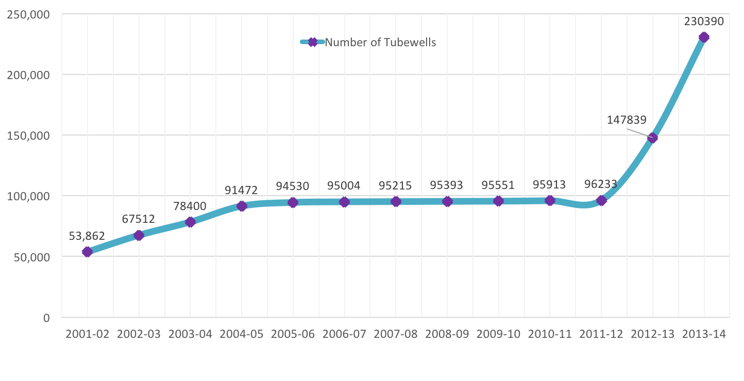
(Source: Agricultural Statistics of Pakistan 2013-14. Government of Pakistan)

Sector Capacity

Municipal Training and Research Institute (MTRI)
Municipal Training and Research Institute (MTRI) was an attached department of Ministry of Local Government and Rural Development to impart training and orientation facilities to elected representatives i.e. Nazims/Naib Nazims, Members/ Councillors, Officers and staff of Local Government Institutions viz District Governments, TMAs and Union Councils as well as the representatives of NGOs. MTRI was established in the year 1986. However, it became functional during the year 1988-89. The Mission Statement of MTRI is to strengthen a sound Local Government System consisting of trained professionals in the country who are responsive to public needs at the grassroots.

Municipal Training and Research Institute (MTRI), Karachi being a local Government Institute at the apex level provides a comprehensive training forum to the participants from all over Pakistan and other regional countries to exchange views and share their experiences and knowledge on the problems and constraints being faced by them in the field of Local Government, Management of Local Affairs and Sustainable Local Development. The training also aims to raise their knowledge and skill and to equip them with modern techniques for making positive contribution to the development process carried out in their respective localities.

Sindh Local Government and Rural Development Academy
Sindh Local Government and Rural Development Academy was originally established as village aid training institute in 1953 at Sakrand. In 1956, it was shifted to Tandojam in the present campus. In the first phase, the institute was confined to the level of imparting pre-service and in-service trainings to the newly recruited male and female village workers under the Village-Aid Programme in the subjects of agriculture, animal husbandry, horticulture, poultry, carpeting, smiting, home economics, community development, first aid and child card. During the above period, eight long term courses, each of one year duration, were conducted at the institute and 522 male and female workers were trained in 1960. The second phase started after the wind up of the Village Aid Programme and introduction of Basic Democracies system in the country in July 1960.

The institute was renamed Basic Democracies Training Institute Southern Zone. The institute catered for the training needs of offices/officials and the elected representatives of various tiers of Basic Democracies in Karachi, Hyderabad, Khairpur, Multan, Bahalwalpur, Quetta and Kalat division of the then province of West Pakistan. In all, 93 courses of two or three weeks and three to six months duration were conducted and 3188 participants were trained in the subjects of Public Administration, Office Procedure, Basic Democracies Order 1959, Municipal Administration Ordinance 1960 and rules framed thereunder, Accounts, Budget, Taxation, Conciliation Courts Ordinance, etc. 1970. Subsequent to Basic Democracies system, the nomenclature of the institute was changed as Sindh Local Government Training Institute, with the object of catering the training needs of the officers/officials of local councils, constituted under Sindh Peoples Local Government Ordinance 1979. During this phase, 74 training courses were conducted and 4858 participants were trained.

In July 1983, the institute was raised to the status of academy and renamed as the Sindh Local Government and Rural Development Academy. In 2006, the Academy was renamed and upgraded as Sindh Civil Services and Local Government Academy Tandojam. Presently, the Academy has an enhanced scope in its activities and a well-articulated methodology of training in the field of rural development to the functionaries of various departments at Taluka, district and division level and elected representatives of local councils and village leaders are being sponsored to acquaint them with the nature and scope of the problem of rural development. The functionaries are being kept abreast of the latest knowledge and skills to improve their efficiency. The Academy is also conducting different training programmes in the disciplines of local government system, financial management and public administration for the employees and elected representatives of local councils.

The Academy has four facilities namely, Local Government, Rural Development. Financial Management and Public Administration and each faculty is headed by one post of Chief Instructor (BS-18) and three posts of posts of Senior Instructors BS-17.

The main objective of these courses is to acquaint local council employees at various level and elected representatives about the working of local government system and to create in them professional skills and to enhance their capability and aptitudes for better management of local councils.

Achievements
- The Academy has imparted trainings to trained 13,096 participants through 317 courses from 1982 to September-2015, conducted and organised different in-campus and off-campus Trainings / Workshops / Seminars and Conferences
- Apart from above according to NRB instructions, 426 notified trainers were trained by the Master Trainers at this Academy from 15th April to 6th July- 2001
- Through these trainers, 21,637 Councillors including Nazims and Naib Nazims of entire Sindh were also trained before taking their oath i.e. 14th August- 2001
- 844 Chief Municipal Officers of Municipal Committees, Town Officers of Town Committees and Secretaries, Union Councils were trained in collaboration with UNDP, on “Water Sanitation and Hygienic” and “Local Government Budgeting for WASH” in this Academy in 2015
- 4,000 Elected Members of Local Government were trained through a one day Seminar / Workshop in 2005, under the directives of the Chief Minister at 14 District Headquarters
- 300 Mukhtiarkars, Supervising Tapedars and Tapedars of five districts i.e. Thatta, Umerkot, Sanghar, Mirpurkhas and Badin were trained in-collaboration with the Board of Revenue Sindh
- Provided managerial support to WPSS for imparting trainings to 3635 Women Councilors of Sindh at Taluka level
- 1,289 Nazims/Naib Nazims/Women Councilors/ Potential Local Women Leaders and Secretaries of Union Councils were trained in eight district of Sindh in collaboration with Gender Based Governance System Project

Staffing Capacity for Solid Waste Management

Table 16 indicates the staffing capacity for solid waste management in selected secondary cities in Sindh. This needs to be viewed together with Table 12 in the Chapter on Solid Waste.

Table 16 - Staffing Capacity for solid waste management in selected secondary cities
 | Mirpur Khas | Umerkot | Johi | Larkana | Shikarpur | Sukkur
Chief Officer | 1 | 1 | 1 | 1 | 1 | 1
Chief Sanitary Inspector | 1 |  |  | 1 | 1 | 1
Sanitary Inspectors | 8 | 3 | 1 | 11 | 2 | 7
Supervisors |  | 4 | 5
Drivers | 6 | 4 |  | 13 | 5 | 14
Sanitary Jamadars | 8 |  |  | 23 | 8 | 17
Collectors | 18 | 12 | 3 | 40 | 18 | 28
Sanitary Workers | 305 | 120 | 21 | 290 | 118 | 364
(Source: Capacity Building for Environmental Management in Sindh, 2006. Asian Development Bank TA 4432-PAK)

There is insufficient data regarding other cities at present and warrants further study.

Staffing Capacities in Local Government and Public Health Engineering

A comparison of the basic structure in Local Government and Public Health Engineering is shown in Table 17. It illustrates that the technical capacity for water supply and sewerage and drainage lies in public health engineering, while administrative capacity lies with Local Government. This presents a major challenge to Local Government for providing O&M services as per current regulations. This anomaly needs to be corrected so that both installation and O&M of water supply and sewerage and drainage schemes rest with Public Health Engineering, while solid waste management and general sanitation services rest solely with Local Government.

The Government of Sindh has recently issued a notification directing O&M functions to be executed by PHE&RDD and financing for this is being provided.

Table 17 - Comparative structure in Local Government and Public Health Engineering
Local Government | Public Health Engineering
LG&HTPD Secretariat - Karachi | PHED Secretariat – Karachi
Sindh Civil Services and Local Government Academy - Tandojam
MTRI - Karachi
Provincial Local Government Commission (IM&EC) - Karachi | Chief Engineer – Hyderabad. The Chief Engineer is supported by a Director (Technical), 2 Superintending Engineers, 1 Research Officer, 2 Design Officers, 1 Executive Engineer, 1 Senior Geophysicist, 1 Junior Geophysicist, 1 Chief Head Draughtsman and 1 Hydro-geologist
Rural Development Department Secretariat - Karachi | Chief Engineer – Sukkur. The Chief Engineer is supported by a Director (Technical), 2 Superintending Engineers, 2 Design Officers, 1 Executive Engineer, 1 Senior Geophysicist, 1 Junior Geophysicist, 1 Chief Head Draughtsman and 1 Hydro-geologist
Director General Rural Development Department - Hyderabad | Research Laboratory - Hyderabad
Field Office Local Government – one each in 23 districts. A Field Office is staffed by a Local Government Support Officer assisted by 3-9 Development Officers | Superintending Engineer – one each in 4 divisions
Field Office (SAP) – one each in 15 districts. A Field Office (SAP) usually has 3-9 District Officers | Executive Engineer – one each in 25 districts. One Executive Engineer is supported by 3-4 Assistant Engineers and 1 Sub-Engineer
Directorates of Local Government – one each in 5 divisions
Divisional Office of Director RDD
Field Office (SAP) of Executive Engineer
Administration cadres BPS 16-20 – 238 nos | Administration cadres BPS 16-20 – 24 nos
Technical cadres BPS 16-20 – 12 nos | Technical cadres BPS 16-20 – 187 nos
Other cadres BPS 14 and below – 1090 nos | Other cadres BPS 14 and below – 3075 nos
(Source: Government of Sindh, Annual Budget 2015-16)

Strategy

SectorEfficiency and Capacity
Strategic Objectives/Outcomes | Short Term Actions  1 - 3 years | Medium Term Actions  4 - 6 years | Long Term Actions  7 - 10 years
Reduced systems leakages of Non Revenue Water and Unaccounted for Water | Map out points of system leakages area by area and take remedial measures for Distribution Network Improvements (DNI)  Reduce NRW losses from 60% to 30% in Karachi  Reduce NRW and UAW to 20% or less  Outsource at least 25% of revenue collection | Reduce NRW and UAW to 20% or less in Karachi and other cities of Sindh | Reduce NRW and UAW to 10% or less in Karachi and other cities of Sindh
Increased household water metering | Introduce water metering in phases  All new connections to be metered  At least 100% of high income areas have metering in place  All commercial and business premises have water metering | At least 10% of medium income areas have metering in place | At least 20% of medium income areas have metering in place
Efficient Billing and Collection | Collection period reduced to less than 30 days  Billing efficiency increased to 50%  Financial collection efficiency increased to 50%  Outsource billing and collection | Collection period reduced to less than 15 days  Billing efficiency increased to 75%  Financial collection efficiency increased to 75% | Collection period maintained at less than 15 days  Billing efficiency increased to 90% and above  Financial collection efficiency increased to 90% and above
A functional Biometric tracking system in all cities and towns | All mega cities have an installed and functional biometric tracking system for staff, equipment/vehicles  At least 50% of intermediate cities have an installed and functional biometric tracking system for staff, equipment/vehicles  At least 30% of towns have an installed and functional biometric tracking system for staff, equipment/vehicles | At least 75% of intermediate cities have an installed and functional biometric tracking system for staff, equipment/vehicles  At least 60% of towns have an installed and functional biometric tracking system for staff, equipment/vehicles | At least 90% of towns have an installed and functional biometric tracking system for staff, equipment/vehicles
Human Resource Development for the sub-sectors | Conduct a human resource capacity, infrastructure and training capacity, and training needs assessment in the sub-sectors and develop a human resource development plan  Strengthen infrastructure and training capacities at Local Government Training Institutes
Technical training / workshops conducted for town level Local Government staff | Conduct 238 technical training / workshops per year for Local Government on SWM, DRR, Record Keeping, Management and Community Mobilisation – 2 training workshops per town per year | Conduct 238 technical training / workshops per year for Local Government on SWM, DRR, Record Keeping, Management and Community Mobilisation – 2 training workshops per town per year | Conduct 238 technical training / workshops per year for Local Government on SWM, DRR, Record Keeping, Management and Community Mobilisation – 2 training workshops per town per year
Capacities developed of CBOs and civil society in solid waste management (LG&HTPD) | Conduct 238 capacity development workshops per year of CBOs and civil society in solid waste management (LG&HTPD) (2 workshops per town per year) | Conduct 238 capacity development workshops per year of CBOs and civil society in solid waste management (LG&HTPD) (2 workshops per town per year) | Conduct 238 capacity development workshops per year of CBOs and civil society in solid waste management (LG&HTPD) (2 workshops per town per year)
Technical training / workshops conducted for district PHED staff | Conduct 145 technical training / workshops per year for district PHED staff on O&M, DRR, Record – 5 training workshops per district per year | Conduct 145 technical training / workshops per year for district PHED staff on O&M, DRR, Record – 5 training workshops per district per year | Conduct 145 technical training / workshops per year for district PHED staff on O&M, DRR, Record – 5 training workshops per district per year
Capacities developed of CBOs and civil society in O&M of water supply schemes (PHE&RDD) (5 workshops per district per year) | Conduct 145 capacity development workshops per year of CBOs and civil society in O&M of water supply and drainage schemes (PHE&RDD) (5 workshops per district per year) | Conduct 145 capacity development workshops per year of CBOs and civil society in O&M of water supply and drainage schemes (PHE&RDD) (5 workshops per district per year) | Conduct 145 capacity development workshops per year of CBOs and civil society in O&M of water supply and drainage schemes (PHE&RDD) (5 workshops per district per year)

SECTOR FINANCING

Sectoral Expenditure Review

The Government of Sindh has had vacillating investments in water supply and sanitation in the last five financial year periods. There was a spike in sectoral spend in 2011-12 following the 2010 floods. Figure74 illustrates the sectoral investment trends from PKR 4.6 billion in 2010-11 to PKR 7.5 billion in 2014-15. Pro-poor sectoral current expenditure has also increased over three-fold during this period from PKR 921 million to 2.1 billion, a significant proportion of which is due to salaries and utilities.

Overall, the increase in pro-poor sectoral development expenditure has been modest from PKR 3.6 billion in 2010-11 to PKR 5.3 in 2014-15.

Figure 74 - Current, Development and Total Pro-Poor Expenditure in Water and Sanitation
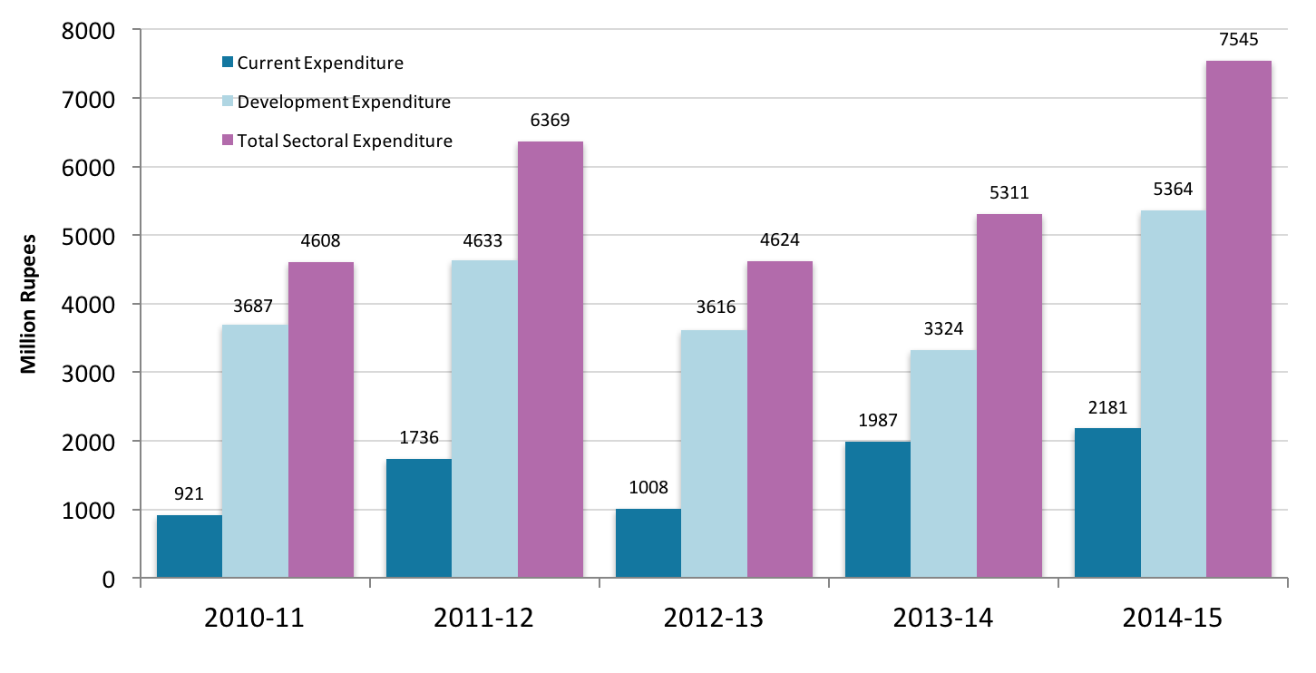
(Source: PRSP Annual Progress Reports, Ministry of Finance, Government of Pakistan –2010-11, 2011-12, 2012-13, 2013-14 and 2014-15)

Sectoral Development Expenditure Trends

The overall pro-poor sectoral expenditure in water supply and sanitation averages around 1.9% of total pro-poor expenditure between 2010-11 to 2014-15 (Fig 75). Current expenditure during this period averages at about 0.7% of total pro-poor current expenditure, while development expenditure averages at 4.4% total pro-poor development expenditure. There has been a gradual but definite reduction in development expenditure in proportion to overall total pro-poor expenditure from 6.5% in 2010-11 to 3.7% in 2014-15.

Figure 75 - Sectoral expenditure as percentage of total pro-poor expenditure
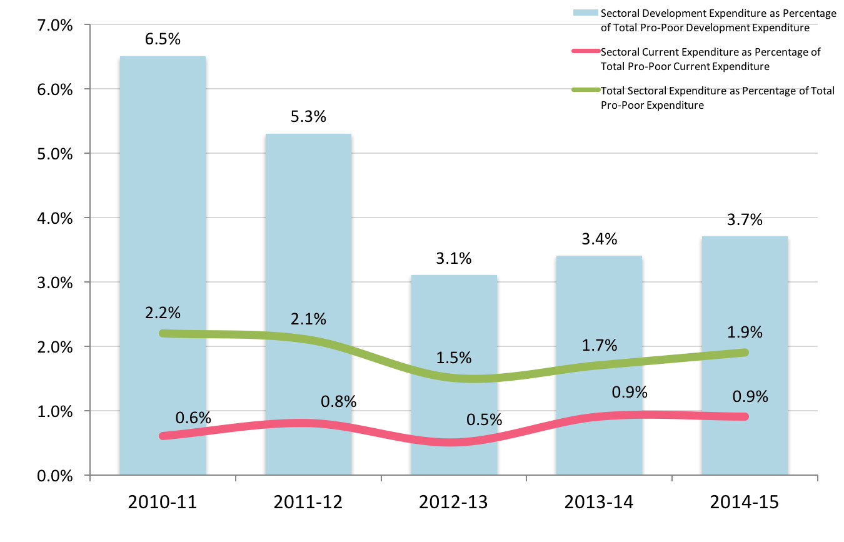
(Source: PRSP Annual Progress Reports, Ministry of Finance, Government of Pakistan –2010-11, 2011-12, 2012-13, 2013-14 and 2014-15)

On analysis of sectoral expenditure trends, current expenditure as a percentage of total sectoral expenditure has increased from 20.0% in 2010-11 to 28.9% in 2014-15 (Fig 76). Conversely, development expenditure as a percentage of total sectoral expenditure has decreased from 80.0% in 2010-11 to 71.1% in 2014-15. The year on year change in development expenditure from the preceding year has vacillated from a -9.5% decrease in 2011-12, a 7.5% increase in 2012-13, followed by a -20.0% decrease in 2013-14, and then a 13.6% increase in 2014-15.

These figures suggest that while there has been an overall increase in sectoral funding for water and sanitation, overall investment in the sector in relation to total pro-poor development spending has actually reduced. Further, there is diminishing prioritisation of investment in the sector compared to other sectors.

Figure 76 - Sectoral expenditure trends
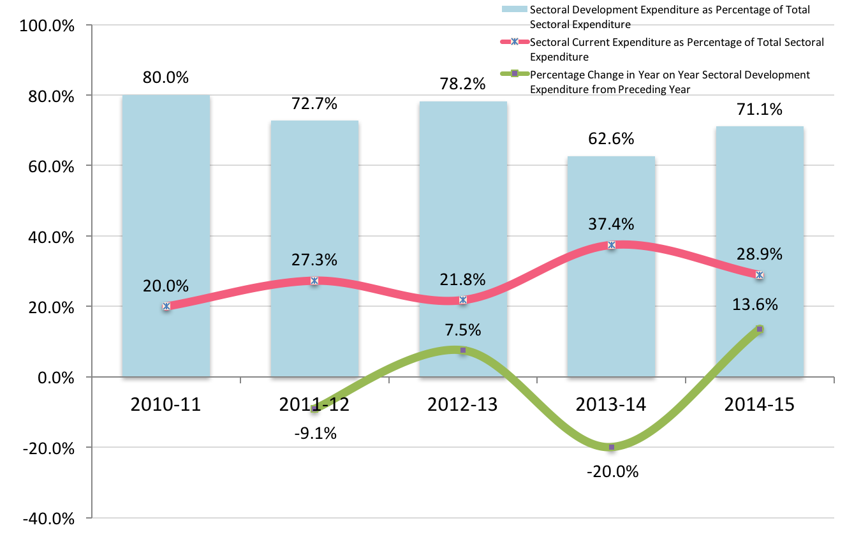
(Source: PRSP Annual Progress Reports, Ministry of Finance, Government of Pakistan –2010-11, 2011-12, 2012-13, 2013-14 and 2014-15)

Sectoral Development Allocation and Expenditure Trends

Table 18 indicates the various departments under which sectoral spending takes place. The majority of schemes are under PHED followed by LG&HTPD. However, in terms of financial outlay, the largest schemes are found under Federal Matching Grants and Special Initiatives. Overall, there is 28.9% utilisation of cost of ongoing scheme, while ADP allocations for new schemes are about 25% of the cost of the scheme. The total estimated cost of ongoing schemes is Rs 101,599.479 million, while the estimated cost of new schemes is Rs 14,968.25. The total ADP allocation for ongoing and new schemes for 2015-16 is Rs 22,129.253.

Furthermore, about 69% of the ADP allocation is for ongoing schemes, while 31% is for new schemes. There is need to further increase allocation for ongoing schemes to minimise cost-overruns and limit new schemes until ongoing ones are completed. Table 19and Fig 77 indicates the proportionate allocation and spend by department, while Fig 78 illustrates the sub-sectoral allocation in the ADP 2015-16.

Table 18 - Sectoral development allocation and expenditure
 | Number of ongoing schemes | Estimated cost of ongoing schemes | Actual expenditure up to June 2015 | ADP allocation 2015-16 ongoing schemes | Number of new schemes | Estimated cost of new schemes | ADP allocation 2015-16 new schemes | Total number of ongoing and new schemes 2015-16 | Total allocation ongoing plus new schemes 2015-16 | Percent utilisation in ongoing schemes | Percent allocation of new scheme cost
LG&HTPD | 42 | 16063.821 | 3638.065 | 5020.977 | 21 | 3761.549 | 940.387 | 63 | 5961.364 | 22.6% | 25.0%
PHED | 146 | 22814.074 | 7262.076 | 2409.341 | 59 | 1962.637 | 490.659 | 205 | 2900.000 | 31.8% | 25.0%
RDD | 5 | 177.992 | 32.032 | 67.250 | 1 | 25.000 | 6.250 | 6 | 73.500 | 18.0% | 25.0%
Federal Matching | 6 | 36278.120 | 6588.971 | 4381.708 | 0 | 0 | 0 | 6 | 4281.708 | 18.2% | 0.0%
P&DD | 2 | 7926.000 | 587.250 | 1169.000 | 0 | 0 | 0 | 2 | 1169.000 | 7.4% | 0.0%
Special Initiatives | 6 | 12589.154 | 9750.420 | 1853.000 | 2 | 3400.000 | 850.000 | 8 | 2703.000 | 77.5% | 25.0%
Services | 0 | 0 | 0 | 0 | 7 | 5819.064 | 3016.764 | 7 | 3016.764 | 0.0% | 51.8%
Thar Coal | 3 | 2191.416 | 2014.098 | 186.889 | 0 | 0 | 0 | 3 | 186.889 | 91.9% | 0.0%
Industries and Commerce | 1 | 20.000 | 0.000 | 20.000 | 0 | 0 | 0 | 1 | 20.000 | 0.0% | 0.0%
Information, Science and technology | 1 | 59.000 | 0.800 | 58.200 | 0 | 0 | 0 | 1 | 58.200 | 1.4% | 0.0%
Irrigation | 1 | 3422.782 | 2665.000 | 68.000 | 0 | 0 | 0 | 1 | 68.000 | 77.9% | 0.0%
Katchi Abadis | 1 | 57.120 | 0.000 | 57.120 | 0 | 0 | 0 | 1 | 57.120 | 0.0% | 0.0%
Community Develop Programme SDGs | 0 | 0 | 0 | 0 | 215 | 0 | 1119.641 | 215 | 1119.641
Priority DevelopmentProgramme | 0 | 0 | 0 | 0 | 121 | 0 | 514.067 | 121 | 514.067
Total | 214 | 101599.479 | 32538.712 | 15291.485 | 426 | 14968.25 | 6937.768 | 640 | 22129.253 | 28.9%
(Source: Government of Sindh, Annual Budget 2015-16) Rupees Million

Table 19 - Proportionate sectoral allocation by department
 | ADP 2015-16 | Percentage
LG | 5961.364 | 26.9%
PHED | 2900.000 | 13.1%
RDD | 73.500 | 0.3%
Matching grants | 4281.708 | 19.3%
P&DD | 1169.000 | 5.3%
Special Initiatives | 2703.000 | 12.2%
Services General Administration and Coordination | 3016.764 | 13.6%
Thar Coal | 186.889 | 0.8%
Industries and Commerce | 20.000 | 0.1%
Information Science and Technology | 58.200 | 0.3%
Irrigation | 68.000 | 0.3%
Katchi Abadis | 57.120 | 0.3%
Community Development Programme for SDGs DC-MPAs | 1119.641 | 5.1%
Social Protection Priority Development Programmes MNAs | 514.067 | 2.3%
Total | 22129.253 | 100.0%
(Source: Government of Sindh, Annual Budget 2015-16) Rupees Million

Figure 77 - Proportionate allocation and spend by department
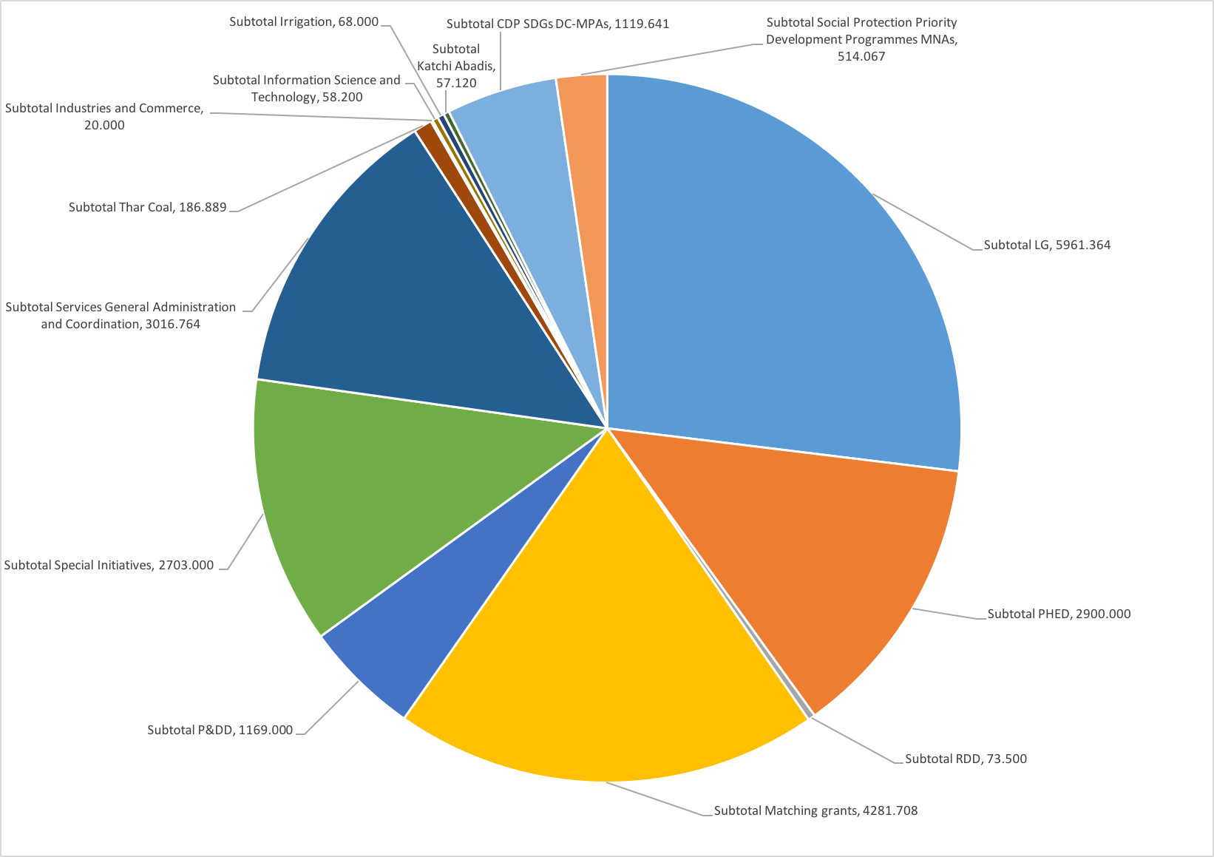
(Source: Government of Sindh, Annual Budget 2015-16) Rupees Million

Figure 78 - Sub-sector allocation and percentage of sectoral allocation
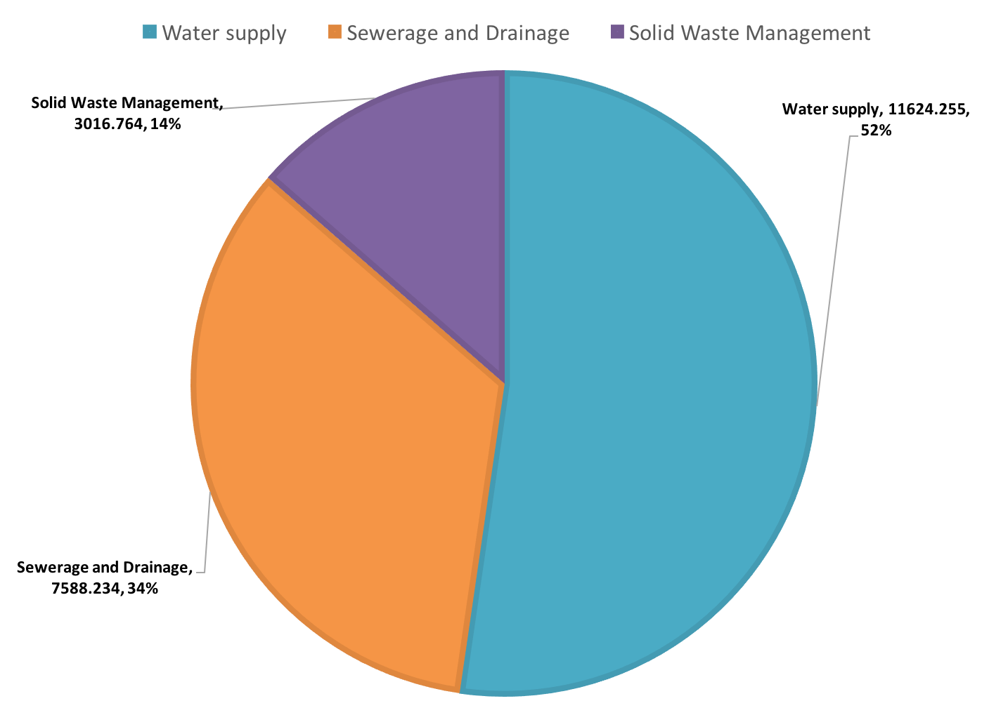
(Source: Government of Sindh, Annual Budget 2015-16) Rupees Million

Estimating Cost for Sectoral Investment

Medium Term Budgetary Framework

Medium Implementation of Medium Term Budgetary Framework (MTBF) is at the heart of Public Financial Management Reform initiatives in Balochistan. One of the aims of MTBF is to establish a link between outcomes, outputs and costs. Contrary to annual budgeting, MTBF is a multi-year approach to budgeting which links the spending plans of the government to its policy objectives set out in a fiscal framework. Multi- year horizon provides the line departments the requisite space and flexibility to formulate, plan and implement the policies focusing solely on service delivery and outputs. Given the fact that public policy decisions normally take more than one year for their implementation, it is important to keep the multi-year horizon in determining the resource allocation amongst the different functions of the Government.

The aim of this sector development plan is to align with MTBF processes and:

- ensure systematic use of rolling multi-year perspective to formulate annual budgets
- link resources with Medium Term Fiscal Framework and fiscal/policy indicators
- facilitate strategic prioritisation of expenditures which synchronise with the departmental priorities

Sustainable Development Goals

The Sustainable Development Goal (SDG) for water and sanitation (Goal 6) is “Ensure availability and sustainable management of water and sanitation for all”. This shall serve as the overarching guide for setting targets for the Balochistan WASH sector development plan.

The SDG targets are as follows:

- 6.1 by 2030, achieve universal and equitable access to safe and affordable drinking water for all
- 6.2 by 2030, achieve access to adequate and equitable sanitation and hygiene for all, and end open defecation, paying special attention to the needs of women and girls and those in vulnerable situations
- 6.3 by 2030, improve water quality by reducing pollution, eliminating dumping and minimizing release of hazardous chemicals and materials, halving the proportion of untreated wastewater, and increasing recycling and safe reuse by x% globally
- 6.4 by 2030, substantially increase water-use efficiency across all sectors and ensure sustainable withdrawals and supply of freshwater to address water scarcity, and substantially reduce the number of people suffering from water scarcity
- 6.5 by 2030 implement integrated water resources management at all levels, including through transboundary cooperation as appropriate
- 6.6 by 2020 protect and restore water-related ecosystems, including mountains, forests, wetlands, rivers, aquifers and lakes
- 6.a by 2030, expand international cooperation and capacity-building support to developing countries in water and sanitation related activities and programmes, including water harvesting, desalination, water efficiency, wastewater treatment, recycling and reuse technologies
- 6.b support and strengthen the participation of local communities for improving water and sanitation management

Developing a Costing Framework

The policy targets for drinking water supply and sanitation are aligned with the proposed SDG targets for drinking water and sanitation and are as follows:

- provision of safely managed drinking water to the entire population by 2026
- entire population has universal access to sustainable and safely managed sanitation by 2026

For the purposes of estimating sectoral investment, the following assumptions have been used

- Align with Sustainable Development Goal 6 of achieving 100% population coverage
- Use a target of 100% coverage for drinking water supply – with improved water supply source
- Use a target of 100% for sanitation system
- Population projections used for 2026
- Status of access to water supply is obtained from PSLM 2014-15
- Status of sewerage system is derived from PSLM 2014-15
- Unit rates for water supply schemes are obtained from PHE&RDD
- Unit rates for sewerage and drainage schemes are obtained from LG&HTPD and PHE&RDD
- Latrine construction is presumed to be the responsibility of the citizens, and therefore sanitation costs refer to sewerage and drainage.

Table 20presents a detailed sub-sector financial analysis of the ADP 2015-16. It indicates that 52.3% of the ADP allocation is for drinking water supply, 34.1% for sanitation and 13.6% for solid waste management.

Table 21 presents costing for safely managed overall drinking water supply by district with unit costing per UC (excluding indirect costs), per household and per capita at current rates and at 8% inflation. Improved water here includes piped, hand pump and motorised pump.

Table 22 presents costing for safely managed urban drinking water supply by district at current rates and at 8% inflation. Improved water here includes piped, hand pump and motorised pump.

Table 23 presents costing for safely managed rural drinking water supply by district at current rates and at 8% inflation. Improved water here includes piped, hand pump and motorised pump.

Table 24 presents costing for safely managed overall sewerage and drainage by district with unit costing per UC (excluding indirect costs), per household and per capita at current rates and at 8% inflation. Improved sanitation (sewerage and drainage) here includes flush to sewer and flush to septic tank. It does not include flush to open sewer.

Table 25 presents costing for safely managed urban sewerage and drainage by district at current rates and at 8% inflation. Improved sanitation (sewerage and drainage) here includes flush to sewer and flush to septic tank. It does not include flush to open sewer.

Table 26 presents costing for safely managed rural sewerage and drainage by district at current rates and at 8% inflation. Improved sanitation (sewerage and drainage) here includes flush to sewer and flush to septic tank. It does not include flush to open sewer.

Table 27 presents costing for improved overall drinking water supply by district with unit costing per UC (excluding indirect costs), per household and per capita at current rates and at 8% inflation. Improved water here includes piped, hand pump and motorised pump.

Table 28 presents costing for improved urban drinking water supply by district at current rates and at 8% inflation. Improved water here includes piped, hand pump and motorised pump.

Table 29 presents costing for improved rural drinking water supply by district at current rates and at 8% inflation. Improved water here includes piped, hand pump and motorised pump.

Table 30 presents costing for improved overall sewerage and drainage by district with unit costing per UC (excluding indirect costs), per household and per capita at current rates and at 8% inflation. Improved sanitation (sewerage and drainage) here includes flush to sewer and flush to septic tank. It does not include flush to open sewer.

Table 31 presents costing for improved urban sewerage and drainage by district at current rates and at 8% inflation. Improved sanitation (sewerage and drainage) here includes flush to sewer and flush to septic tank. It does not include flush to open sewer.

Table 32 presents costing for improved rural sewerage and drainage by district at current rates and at 8% inflation. Improved sanitation (sewerage and drainage) here includes flush to sewer and flush to septic tank. It does not include flush to open sewer.

Tables 33-36 present costing of missing facilities (drinking water and latrines) in public sector primary and middle/secondary schools.

Table 37 presents the costing requirement for water and sanitation at Basic Health Units.

Tables 38-49 present the indirect costs for the sector, while Tables50and 51present notional costs per district for safely managed and improved water supply and sanitation options respectively. However, Tables50 and 51 should not be taken as ‘all encompassing’ as several activities which have been costed at provincial level would need to be further costed at district level at the time of operationalization. It does however, provide a useful guideline for programme planning.

Table 52 presents a summary of indirect costs.

Table 53 presents the investment overview for the sector development plan at current rates and at 8% inflation for the safely managed water supply and sanitation option, while Table 54 presents the investment overview for the sector development plan at current rates and 8% inflation for the improved water supply and sanitation option.

Figure 79 illustrates the additional investment required over and above current investment trends both at current rates and at 8% inflation for the safely managed water supply and sanitation option, while Fig 80 illustrates the sub-sector investment requirements for the safely managed water supply and sanitation option. Figure 81 illustrates the additional investment required over and above current investment trends both at current rates and at 8% inflation for the improved water supply and sanitation option, while Fig 82 illustrates the sub-sector investment requirements for the improved water supply and sanitation option.

The investment plan proposes an additional PKR 214 billion in the short term, PKR 343 billion in the medium term, and PKR 587 billion in the long term, over current investment trends under the safely managed water supply and sanitation option; while an additional PKR 24 billion would be required in the short term, PKR 58 billion in the medium term, and PKR 111 billion in the long term, over current investment trends under the improved water supply and sanitation option.

Table 20 – Detailed sub-sectoral financial analysis of sectoral financing in ADP 2015-16
 |  | Number of ongoing schemes | Estimated Cost ongoing schemes | Actual Expenditure up to June 2015 | ADP allocation 2015-16 ongoing schemes | Number of new schemes | Estimated cost new schemes | ADP allocation 2015-16 new schemes | Total number of ongoing plus new schemes 2015-16 | Total allocation ongong plus new schemes 2015-16 | Percent utilisation ongoing | Percent allocation of new scheme cost
Local Government
LG Water Supply | Water Supply | 15 | 11143.815 | 1077.164 | 3343.336 | 5 | 1077.913 | 269.479 | 20 | 3612.815 | 9.7% | 25.0%
LG Sanitation | Drainage | 27 | 4920.006 | 2560.901 | 1677.641 | 16 | 2683.636 | 670.908 | 43 | 2348.549 | 52.1% | 25.0%
Subtotal LG |  | 42 | 16063.821 | 3638.065 | 5020.977 | 21 | 3761.549 | 940.387 | 63 | 5961.364 | 22.6% | 25.0%
PHED
PHED Water Supply | Water Supply | 66 | 9286.084 | 3715.124 | 963.652 | 27 | 1154.694 | 288.673 | 93 | 1252.325 | 40.0% | 25.0%
PHED Drainage | Drainage | 73 | 8884.863 | 3306.966 | 1029.931 | 32 | 807.943 | 201.986 | 105 | 1231.917 | 37.2% | 25.0%
Rehab non-functional schemes | Water Supply |  | 4590.000 | 202.617 | 400.000 | 0 | 0 | 0 | 0 | 400.000 | 4.4% | 0.0%
Additional schemes from 2014-15 | Water Supply | 7 | 53.127 | 37.369 | 15.758 | 0 | 0 | 0 | 7 | 15.758 | 70.3% | 0.0%
Subtotal PHED |  | 146 | 22814.074 | 7262.076 | 2409.341 | 59 | 1962.637 | 490.659 | 205 | 2900.000 | 31.8% | 25.0%
RDD
RDD Water Supply | Water Supply | 4 | 162.992 | 32.032 | 63.500 | 0 | 0.000 | 0.000 | 4 | 63.500 | 19.7% | 0.0%
RDD Drainage | Drainage | 1 | 15.000 | 0.000 | 3.750 | 1 | 25.000 | 6.250 | 2 | 10.000 | 0.0% | 25.0%
Subtotal RDD |  | 5 | 177.992 | 32.032 | 67.250 | 1 | 25.000 | 6.250 | 6 | 73.500 | 18.0% | 25.0%
Matching Grants
S-III GoS | Drainage | 1 | 3991.000 | 1970.000 | 1000.000 |  |  |  | 1 | 1000.000 | 49.4%
S-III GoP ECNEC | Drainage |  | 3991.000 | 829.000 | 100.000 |  |  |  | 0 | 100.000 | 0.0%
STPs Hyderabad Package GoP ECNEC | Drainage | 1 | 915.300 | 496.150 | 124.955 |  |  |  | 1 | 124.955 | 54.2%
K-IV GoS | Water supply | 1 | 12775.500 | 0.000 | 2500.000 |  |  |  | 1 | 2500.000 | 0.0%
K-IV GoP ECNEC | Water supply |  | 12755.000 | 2080.000 | 500.000 |  |  |  | 0 | 500.000 | 16.3%
Water filtration plant Hyderabad Package GoP CDWP | Water supply | 1 | 935.000 | 665.044 | 100.000 |  |  |  | 1 | 100.000 | 71.1%
Urban water supply Benazirabad GoP ECNEC | Water supply | 1 | 783.500 | 463.710 | 10.000 |  |  |  | 1 | 10.000 | 59.2%
Water supply and drainage Tando Jam Hyderabad Package GoP CDWP | Water supply | 1 | 131.820 | 85.067 | 46.753 |  |  |  | 1 | 46.753 | 64.5%
Subtotal Matching grants |  | 6 | 36278.120 | 6588.971 | 4381.708 | 0 | 0 | 0 | 6 | 4381.708 | 18.2% | 0.0%
P&DD
SCIP | FPA 3876.790 | 1 | 7000.000 | 525.000 | 969.000 |  |  |  | 1 | 969.000 | 7.5%
SMSDP | FPA 2250.000 | 1 | 926.000 | 62.250 | 200.000 |  |  |  | 1 | 200.000 | 6.7%
Subtotal P&DD |  | 2 | 7926.000 | 587.250 | 1169.000 | 0 | 0 | 0 | 2 | 1169.000 | 7.4% | 0.0%
Special Initiatives
Sindh DW hubs phase II for 750 units | Water supply | 1 | 4000.000 | 3841.650 | 158.350 |  |  |  | 1 | 158.350 | 96.0% | 0.0%
Sindh solar power generation water filtration plants Phase I and II | Water supply | 1 | 2135.000 | 1560.000 | 575.000 |  |  |  | 1 | 575.000 | 73.1% | 0.0%
CDWA O&M | Water supply | 1 | 971.540 | 276.487 | 12.000 |  |  |  | 1 | 12.000 | 28.5% | 0.0%
PPIU CDWA | Water supply | 1 | 36.614 | 22.283 | 8.331 |  |  |  | 1 | 8.331 | 60.9% | 0.0%
Tharparkar DW hubs Phase III 750 units | Water supply | 1 | 5254.000 | 4040.000 | 1000.000 |  |  |  | 1 | 1000.000 | 76.9% | 0.0%
New drainage system Thatta City | Drainage | 1 | 192.000 | 10.000 | 99.319 |  |  |  | 1 | 99.319 | 5.2% | 0.0%
Sindh DW hubs Phase IV 500 units | Water supply |  |  |  |  | 1 | 3000.000 | 750.000 | 1 | 750.000 |  | 25.0%
PMU DW hubs | Water supply |  |  |  |  | 1 | 400.000 | 100.000 | 1 | 100.000 |  | 25.0%
Subtotal Special Initiatives |  | 6 | 12589.154 | 9750.420 | 1853.000 | 2 | 3400.000 | 850.000 | 8 | 2703.000 | 77.5% | 25.0%
Services General Administration and Coordination
Karachi | Solid waste |  |  |  |  | 3 | 3940.000 | 2327.500 | 3 | 2327.500 |  | 59.1%
Shaheed Benazirabad | Solid waste |  |  |  |  | 2 | 692.664 | 392.664 | 2 | 392.664 |  | 56.7%
Larkana | Solid waste |  |  |  |  | 2 | 1186.400 | 296.600 | 2 | 296.600 |  | 25.0%
Subtotal Services General Administration and Coordination |  |  | 0 | 0 | 0 | 7 | 5819.064 | 3016.764 | 7 | 3016.764 | 0.0% | 51.8%
Energy - Thar Coal
Installation of RO desalination plant 25 villages Tharparkar | Water supply | 1 | 942.000 | 880.103 | 61.897 |  |  |  | 1 | 61.897 | 93.4%
Upgradation 2 RO plants Mithi and Islamkot | Water supply | 1 | 934.820 | 943.391 | 1.000 |  |  |  | 1 | 1.000 | 100.9%
Installation 6 RO desalination plants 6 villages Tharparkar | Water supply | 1 | 314.596 | 190.604 | 123.992 |  |  |  | 1 | 123.992 | 60.6%
Subtotal Thar Coal |  | 3 | 2191.416 | 2014.098 | 186.889 | 0 | 0 | 0 | 3 | 186.889 | 91.9% | 0.0%
Industries and Commerce
Consultancy Services for Establishment of Four Combined Effluent Treatment Plant (CETP) for Industrial Areas of Karachi including laying of interceptor sewers | Waste water | 1 | 20.000 | 0.000 | 20.000 | 0 | 0 | 0 | 1 | 20.000 | 0.0%
Subtotal Industries and Commerce |  | 1 | 20.000 | 0.000 | 20.000 | 0 | 0 | 0 | 1 | 20.000 | 0.0%
Information Science and Technology
Barani area water availability study pilot water supply project Malir | Water supply | 1 | 59.000 | 0.800 | 58.200 |  |  |  | 1 | 58.200 | 1.4%
Subtotal Information Science and Technology |  | 1 | 59.000 | 0.800 | 58.200 |  |  |  | 1 | 58.200 | 1.4%
Irrigation
Water supply Karachi upgrading Kinjhar Lake system | Water supply | 1 | 3422.782 | 2665.000 | 68.000 | 0 | 0 | 0 | 1 | 68.000 | 77.9%
Subtotal Irrigation |  | 1 | 3422.782 | 2665.000 | 68.000 | 0 | 0 | 0 | 1 | 68.000 | 77.9% | 0.0%
Katchi Abadis
Water supply, sewerage and drainage in different Katchi Abadies in SBA, Khairpur, Larkana, Sukkur, Hyderababd, Mirpurkhas, Thatta & Karachi |  | 1 | 57.120 | 0.000 | 57.120 |  |  |  | 1 | 57.120 | 0.0%
Subtotal Katchi Abadis |  | 1 | 57.120 | 0.000 | 57.120 |  |  |  | 1 | 57.120 | 0.0% | 0.0%
Community Development Programme for SDGs
CDP SDGs DC-MPAs Water supply | Water Supply |  |  |  |  | 30 |  | 177.444 | 30 | 177.444
CDP SDGs DC-MPAs Drainage | Drainage |  |  |  |  | 185 |  | 942.197 | 185 | 942.197
Subtotal CDP SDGs DC-MPAs |  |  |  |  |  | 215 |  | 1119.641 | 215 | 1119.641
Social Protection Priority Development Programmes
Social Protection Priority Development Programmes MNAs | Water supply |  |  |  |  | 6 |  | 28.890 | 6 | 28.890
Social Protection Priority Development Programmes MNAs | Drainage |  |  |  |  | 115 |  | 485.177 | 115 | 485.177
Subtotal Social Protection Priority Development Programmes MNAs |  |  |  |  |  | 121 |  | 514.067 | 121 | 514.067
 |  | 214 | 101599.479 | 32538.712 | 15291.485 | 426 | 14968.250 | 6937.768 | 640.000 | 22229.253

Table 21 - Detailed costing for safely managed overall drinking water supply by district
District | % piped water supply on premises | Number of HH 1998 | No UCs | Total est pop all UCs 2026 | Total est No of HH all UCs 2026 | Mean pop per UC 2026 | Mean No of HH per UC 2026 | Population with access to Piped Water Supply PSLM 2014-15 | Access population gap to meet by 2026
 | a | A | B | C | D | E | F | G | H
 |  |  |  |  | [C/A] | [C/B] | [D/B] | [C*a] | [C-G]
Badin | 0.115 | 214,348 | 49 | 2,075,398 | 391,584 | 42,355 | 7,992 | 238,671 | 1,836,727
Sujawal | 0.100 | 109,852 | 29 | 996,762 | 207,117 | 34,371 | 7,142 | 100,075 | 896,687
Thatta | 0.229 | 110,612 | 34 | 1,102,581 | 208,696 | 32,429 | 6,138 | 252,712 | 849,869
Dadu | 0.156 | 203,217 | 55 | 2,317,005 | 421,274 | 42,127 | 7,660 | 361,684 | 1,955,321
Hyderabad | 0.603 | 425,512 | 116 | 2,623,925 | 437,321 | 22,620 | 3,770 | 1,581,964 | 1,041,961
Jamshoro | 0.456 | 101,402 | 30 | 1,218,663 | 221,575 | 40,622 | 7,386 | 555,954 | 662,709
Matiari | 0.047 | 74,362 | 25 | 902,260 | 150,377 | 36,090 | 6,015 | 42,587 | 859,673
Tando Allah Yar | 0.046 | 99,120 | 30 | 819,938 | 136,656 | 27,331 | 4,555 | 37,553 | 782,385
Tando M Khan | 0.058 | 91,733 | 31 | 772,086 | 128,681 | 24,906 | 4,151 | 44,858 | 727,228
Karachi Central | 0.819 | 337,122 | 42 | 6,119,496 | 905,653 | 145,702 | 21,563 | 5,011,867 | 1,107,629
Karachi East | 0.819 | 215,339 | 26 | 3,702,357 | 578,493 | 142,398 | 22,250 | 3,032,230 | 670,127
Karachi South | 0.819 | 237,165 | 30 | 4,218,944 | 637,126 | 140,631 | 21,238 | 3,455,315 | 763,629
Karachi West | 0.819 | 225,872 | 30 | 4,208,477 | 608,132 | 140,283 | 20,271 | 3,446,743 | 761,734
Korangi | 0.819 | 213,437 | 28 | 4,122,657 | 573,384 | 147,238 | 20,478 | 3,376,456 | 746,201
Malir | 0.819 | 116,573 | 25 | 2,054,672 | 313,165 | 82,187 | 12,527 | 1,682,776 | 371,896
Jacobabad | 0.014 | 121,127 | 42 | 1,305,942 | 233,204 | 31,094 | 5,552 | 18,414 | 1,287,528
Kashmore | 0.018 | 131,473 | 44 | 1,203,411 | 214,895 | 27,350 | 4,884 | 21,541 | 1,181,870
Larkana | 0.009 | 166,450 | 43 | 2,383,207 | 403,933 | 55,423 | 9,394 | 20,496 | 2,362,711
Q Shahdadkot | 0.093 | 162,483 | 43 | 2,196,695 | 372,321 | 51,086 | 8,659 | 203,634 | 1,993,061
Shikarpur | 0.009 | 150,108 | 52 | 1,686,491 | 285,846 | 32,433 | 5,497 | 15,853 | 1,670,638

Mirpur Khas | 0.270 | 148,659 |  | 41 | 1,929,655 | 316,337 | 47,065 | 7,716 | 520,428 | 1,409,227
Sanghar | 0.066 | 246,091 |  | 69 | 2,846,978 | 490,858 | 41,261 | 7,114 | 186,477 | 2,660,501
Tharparkar | 0.054 | 163,692 | 46 |  | 2,167,030 | 386,970 | 47,109 | 8,412 | 117,886 | 2,049,144
Umerkot | 0.222 | 121,572 | 34 |  | 1,641,132 | 303,913 | 48,269 | 8,939 | 364,003 | 1,277,129
Ghotki | 0.051 | 153,217 | 75 |  | 2,382,961 | 471,873 | 31,773 | 6,292 | 122,246 | 2,260,715
Khairpur | 0.032 | 254,828 | 76 |  | 3,269,872 | 536,045 | 43,025 | 7,053 | 104,636 | 3,165,236
Sukkur | 0.241 | 137,632 | 43 |  | 1,996,271 | 302,465 | 46,425 | 7,034 | 480,502 | 1,515,769
N Feroze | 0.106 | 187,512 | 51 |  | 1,700,898 | 293,258 | 33,351 | 5,750 | 180,295 | 1,520,603
S Benazirabad | 0.061 | 178,589 | 58 |  | 1,733,906 | 288,984 | 29,895 | 4,982 | 106,115 | 1,627,791
Sindh | 0.356 | 5,099,099 | 1297 |  | 65,699,670 | 10,820,136 |  |  | 25,683,972 | 40,015,698
District | % piped water supply on premises | Number of HH 1998 | No UCs |  | Total est pop all UCs 2026 | Total est No of HH all UCs 2026 | Mean pop per UC 2026 | Mean No of HH per UC 2026 | Population with access to Piped Water Supply PSLM 2014-15 | Access population gap to meet by 2026

Table 21 continued

District | Unit cost of WSS per 1000 pop at present rates | Total Cost to meet gap at current rates | Mean cost per UC at current rates | Mean cost per HH at current rates | Mean cost per capita at current rates | Mean Annual Cost to meet gap at current rates | Total Cost to meet gap with 8% inflation | Mean cost per UC at 8% inflation | Mean cost per HH at 8% inflation | Mean cost per capita at 8% inflation | Mean Annual Cost to meet gap at 8% inflation
 | I | J | K | L | M | N | O | P | Q | R | S
 | 15,000,000 | [(H/1000)*I] | [J/B] | [J/(H/A)] | [J/H] | [J/10] | [J*1.08^10] | [O/B] | [O/(H/A)] | [O/H] | [O/10]
Badin | 15,000,000 | 27,550,908,450 | 562,263,438 | 3,215,220,000 | 15,000 | 2,755,090,845 | 59,480,344,950 | 1,213,884,591 | 6,941,418,830 | 32,384 | 5,948,034,495
Sujawal | 15,000,000 | 13,450,306,428 | 463,803,670 | 1,647,780,000 | 15,000 | 1,345,030,643 | 29,038,202,768 | 1,001,317,337 | 3,557,433,432 | 32,384 | 2,903,820,277
Thatta | 15,000,000 | 12,748,041,522 | 374,942,398 | 1,659,180,000 | 15,000 | 1,274,804,152 | 27,522,065,508 | 809,472,515 | 3,582,045,177 | 32,384 | 2,752,206,551
Dadu | 15,000,000 | 29,329,807,793 | 533,269,233 | 3,048,255,000 | 15,000 | 2,932,980,779 | 63,320,855,208 | 1,151,288,277 | 6,580,953,918 | 32,384 | 6,332,085,521
Hyderabad | 15,000,000 | 15,629,409,263 | 134,736,287 | 6,382,680,000 | 15,000 | 1,562,940,926 | 33,742,722,349 | 290,885,537 | 13,779,727,402 | 32,384 | 3,374,272,235
Jamshoro | 15,000,000 | 9,940,634,091 | 331,354,470 | 1,521,030,000 | 15,000 | 994,063,409 | 21,461,083,428 | 715,369,448 | 3,283,789,689 | 32,384 | 2,146,108,343
Matiari | 15,000,000 | 12,895,099,920 | 515,803,997 | 1,115,430,000 | 15,000 | 1,289,509,992 | 27,839,553,560 | 1,113,582,142 | 2,408,129,710 | 32,384 | 2,783,955,356
Tando A Yar | 15,000,000 | 11,735,772,594 | 391,192,420 | 1,486,800,000 | 15,000 | 1,173,577,259 | 25,336,652,815 | 844,555,094 | 3,209,889,686 | 32,384 | 2,533,665,282
Tando M Khan | 15,000,000 | 10,908,417,051 | 351,884,421 | 1,375,995,000 | 15,000 | 1,090,841,705 | 23,550,454,252 | 759,692,073 | 2,970,670,002 | 32,384 | 2,355,045,425
Karachi Central | 15,000,000 | 16,614,431,640 | 395,581,706 | 5,056,830,000 | 15,000 | 1,661,443,164 | 35,869,311,783 | 854,031,233 | 10,917,316,694 | 32,384 | 3,586,931,178
Karachi East | 15,000,000 | 10,051,899,255 | 386,611,510 | 3,230,085,000 | 15,000 | 1,005,189,926 | 21,701,296,572 | 834,665,253 | 6,973,511,250 | 32,384 | 2,170,129,657
Karachi South | 15,000,000 | 11,454,432,960 | 381,814,432 | 3,557,475,000 | 15,000 | 1,145,443,296 | 24,729,261,647 | 824,308,722 | 7,680,321,705 | 32,384 | 2,472,926,165
Karachi West | 15,000,000 | 11,426,015,055 | 380,867,169 | 3,388,080,000 | 15,000 | 1,142,601,506 | 24,667,909,521 | 822,263,651 | 7,314,610,605 | 32,384 | 2,466,790,952
Korangi | 15,000,000 | 11,193,013,755 | 399,750,491 | 3,201,555,000 | 15,000 | 1,119,301,376 | 24,164,877,190 | 863,031,328 | 6,911,917,120 | 32,384 | 2,416,487,719
Malir | 15,000,000 | 5,578,434,480 | 223,137,379 | 1,748,595,000 | 15,000 | 557,843,448 | 12,043,421,645 | 481,736,866 | 3,775,085,456 | 32,384 | 1,204,342,164
Jacobabad | 15,000,000 | 19,312,923,267 | 459,831,506 | 1,816,905,000 | 15,000 | 1,931,292,327 | 41,695,152,812 | 992,741,734 | 3,922,561,622 | 32,384 | 4,169,515,281
Kashmore | 15,000,000 | 17,728,049,147 | 402,910,208 | 1,972,095,000 | 15,000 | 1,772,804,915 | 38,273,528,455 | 869,852,919 | 4,257,605,192 | 32,384 | 3,827,352,846
Larkana | 15,000,000 | 35,440,671,297 | 824,201,658 | 2,496,750,000 | 15,000 | 3,544,067,130 | 76,513,751,183 | 1,779,389,562 | 5,390,295,987 | 32,384 | 7,651,375,118
Q Shahdadkot | 15,000,000 | 29,895,920,603 | 695,253,968 | 2,437,245,000 | 15,000 | 2,989,592,060 | 64,543,050,305 | 1,501,001,170 | 5,261,829,155 | 32,384 | 6,454,305,031
Shikarpur | 15,000,000 | 25,059,569,769 | 481,914,803 | 2,251,620,000 | 15,000 | 2,505,956,977 | 54,101,731,595 | 1,040,417,915 | 4,861,078,702 | 32,384 | 5,410,173,160
Mirpur Khas | 15,000,000 | 21,138,405,698 | 515,570,871 | 2,229,885,000 | 15,000 | 2,113,840,570 | 45,636,232,463 | 1,113,078,841 | 4,814,154,468 | 32,384 | 4,563,623,246
Sanghar | 15,000,000 | 39,907,514,115 | 578,369,770 | 3,691,365,000 | 15,000 | 3,990,751,412 | 86,157,329,802 | 1,248,656,954 | 7,969,380,173 | 32,384 | 8,615,732,980
Tharparkar | 15,000,000 | 30,737,153,520 | 668,198,990 | 2,455,380,000 | 15,000 | 3,073,715,352 | 66,359,209,079 | 1,442,591,502 | 5,300,981,260 | 32,384 | 6,635,920,908
Umerkot | 15,000,000 | 19,156,933,836 | 563,439,230 | 1,823,580,000 | 15,000 | 1,915,693,384 | 41,358,383,330 | 1,216,423,039 | 3,936,972,447 | 32,384 | 4,135,838,333
Ghotki | 15,000,000 | 33,910,726,511 | 452,143,020 | 2,298,255,000 | 15,000 | 3,391,072,651 | 73,210,715,139 | 976,142,869 | 4,961,760,170 | 32,384 | 7,321,071,514
Khairpur | 15,000,000 | 47,478,541,440 | 624,717,651 | 3,822,420,000 | 15,000 | 4,747,854,144 | 102,502,609,949 | 1,348,718,552 | 8,252,318,088 | 32,384 | 10,250,260,995
Sukkur | 15,000,000 | 22,736,528,555 | 528,756,478 | 2,064,480,000 | 15,000 | 2,273,652,855 | 49,086,459,848 | 1,141,545,578 | 4,457,057,478 | 32,384 | 4,908,645,985
N Feroze | 15,000,000 | 22,809,042,180 | 447,236,121 | 2,812,680,000 | 15,000 | 2,280,904,218 | 49,243,011,326 | 965,549,242 | 6,072,365,161 | 32,384 | 4,924,301,133
S Benazirabad | 15,000,000 | 24,416,864,292 | 420,980,419 | 2,678,835,000 | 15,000 | 2,441,686,429 | 52,714,178,675 | 908,865,150 | 5,783,403,845 | 32,384 | 5,271,417,868
Sindh | 15,000,000 | 600,235,468,484 | 465,190,956 | 2,637,465,000 | 15,000 | 60,023,546,848 | 1,295,863,357,159 | 1,004,312,382 | 5,694,089,118 | 32,384 | 129,586,335,716
District | Unit cost of WSS per 1000 pop at present rates | Total Cost to meet gap at current rates | Mean cost per UC at current rates | Mean cost per HH at current rates | Mean cost per capita at current rates | Mean Annual Cost to meet gap at current rates | Total Cost to meet gap with 8% inflation | Mean cost per UC at 8% inflation | Mean cost per HH at 8% inflation | Mean cost per capita at 8% inflation | Mean Annual Cost to meet gap at 8% inflation

Table 22 - Detailed costing for safely managed urban drinking water supply by district
District | % piped water supply urban  (fraction) | Total est pop all UCs 2026 | % Urban population  (fraction) | Total est pop urban | Access to piped Water Supply PSLM 2014-15 | Pop gap to meet access by 2026 | Unit cost of WSS per 1000 pop at present rates | Total Cost to meet gap at current rates | Mean cost per capita at current rates | Mean Annual Cost to meet gap at current rates | Total Cost to meet gap with 8% inflation | Mean cost per capita at 8% inflation | Mean Annual Cost to meet gap at 8% inflation
 | a | A | B | C | D | E | F | G | H | I | J | K | L
 |  |  |  | [A*B] | [C*a] | [C-D] | 15,000,000 | [(E/1000)*F] | [G/E] | [G/10] | [G*1.08^10] | [J/E] | [J/10]
Badin | 0.325 | 2,075,398 | 0.164 | 339,810 | 110,506 | 229,304 | 15,000,000 | 3,439,555,644 | 15,000 | 343,955,564 | 7,425,742,659 | 32,384 | 742,574,266
Sujawal | 0.621 | 996,762 | 0.112 | 111,945 | 69,496 | 42,450 | 15,000,000 | 636,745,536 | 15,000 | 63,674,554 | 1,374,685,855 | 32,384 | 137,468,586
Thatta | 0.710 | 1,102,581 | 0.112 | 123,830 | 87,919 | 35,911 | 15,000,000 | 538,659,855 | 15,000 | 53,865,986 | 1,162,926,226 | 32,384 | 116,292,623
Dadu | 0.484 | 2,317,005 | 0.214 | 495,227 | 239,442 | 255,785 | 15,000,000 | 3,836,773,026 | 15,000 | 383,677,303 | 8,283,305,196 | 32,384 | 828,330,520
Hyderabad | 0.707 | 2,623,925 | 0.508 | 1,332,831 | 941,645 | 391,186 | 15,000,000 | 5,867,786,305 | 15,000 | 586,778,631 | 12,668,110,533 | 32,384 | 1,266,811,053
Jamshoro | 0.666 | 1,218,663 | 0.508 | 619,023 | 412,022 | 207,001 | 15,000,000 | 3,105,021,850 | 15,000 | 310,502,185 | 6,703,509,289 | 32,384 | 670,350,929
Matiari | 0.141 | 902,260 | 0.508 | 458,306 | 64,529 | 393,776 | 15,000,000 | 5,906,643,218 | 15,000 | 590,664,322 | 12,751,999,694 | 32,384 | 1,275,199,969
Tando A Yar | 0.139 | 819,938 | 0.508 | 416,490 | 57,892 | 358,598 | 15,000,000 | 5,378,967,644 | 15,000 | 537,896,764 | 11,612,787,707 | 32,384 | 1,161,278,771
Tando M Khan | 0.324 | 772,086 | 0.508 | 392,183 | 126,989 | 265,194 | 15,000,000 | 3,977,916,020 | 15,000 | 397,791,602 | 8,588,022,333 | 32,384 | 858,802,233
Karachi Central | 0.835 | 6,119,496 | 1.000 | 6,119,496 | 5,109,167 | 1,010,329 | 15,000,000 | 15,154,931,844 | 15,000 | 1,515,493,184 | 32,718,361,190 | 32,384 | 3,271,836,119
Karachi East | 0.835 | 3,702,357 | 1.000 | 3,702,357 | 3,091,098 | 611,259 | 15,000,000 | 9,168,887,111 | 15,000 | 916,888,711 | 19,794,939,580 | 32,384 | 1,979,493,958
Karachi South | 0.835 | 4,218,944 | 1.000 | 4,218,944 | 3,522,396 | 696,548 | 15,000,000 | 10,448,214,816 | 15,000 | 1,044,821,482 | 22,556,912,143 | 32,384 | 2,255,691,214
Karachi West | 0.835 | 4,208,477 | 0.907 | 3,817,089 | 3,186,887 | 630,201 | 15,000,000 | 9,453,020,014 | 15,000 | 945,302,001 | 20,408,361,209 | 32,384 | 2,040,836,121
Korangi | 0.835 | 4,122,657 | 1.000 | 4,122,657 | 3,442,006 | 680,651 | 15,000,000 | 10,209,760,061 | 15,000 | 1,020,976,006 | 22,042,106,211 | 32,384 | 2,204,210,621
Malir | 0.835 | 2,054,672 | 0.907 | 1,863,588 | 1,555,909 | 307,678 | 15,000,000 | 4,615,174,454 | 15,000 | 461,517,445 | 9,963,815,495 | 32,384 | 996,381,549
Jacobabad | 0.033 | 1,305,942 | 0.243 | 317,785 | 10,487 | 307,298 | 15,000,000 | 4,609,476,145 | 15,000 | 460,947,614 | 9,951,513,273 | 32,384 | 995,151,327
Kashmore | 0.058 | 1,203,411 | 0.243 | 292,836 | 16,984 | 275,851 | 15,000,000 | 4,137,767,537 | 15,000 | 413,776,754 | 8,933,129,769 | 32,384 | 893,312,977
Larkana | 0.014 | 2,383,207 | 0.289 | 688,867 | 9,437 | 679,429 | 15,000,000 | 10,191,439,684 | 15,000 | 1,019,143,968 | 22,002,553,891 | 32,384 | 2,200,255,389
Q Shahdadkot | 0.249 | 2,196,695 | 0.289 | 634,955 | 157,850 | 477,106 | 15,000,000 | 7,156,582,660 | 15,000 | 715,658,266 | 15,450,525,199 | 32,384 | 1,545,052,520
Shikarpur | 0.023 | 1,686,491 | 0.241 | 406,291 | 9,345 | 396,946 | 15,000,000 | 5,954,194,805 | 15,000 | 595,419,480 | 12,854,660,003 | 32,384 | 1,285,466,000
Mirpur Khas | 0.793 | 1,929,655 | 0.331 | 638,959 | 506,822 | 132,137 | 15,000,000 | 1,982,049,606 | 15,000 | 198,204,961 | 4,279,096,440 | 32,384 | 427,909,644
Sanghar | 0.149 | 2,846,978 | 0.228 | 648,555 | 96,894 | 551,660 | 15,000,000 | 8,274,907,125 | 15,000 | 827,490,712 | 17,864,903,841 | 32,384 | 1,786,490,384
Tharparkar | 0.647 | 2,167,030 | 0.044 | 94,837 | 61,341 | 33,496 | 15,000,000 | 502,447,481 | 15,000 | 50,244,748 | 1,084,746,426 | 32,384 | 108,474,643
Umerkot | 0.547 | 1,641,132 | 0.169 | 277,235 | 151,537 | 125,698 | 15,000,000 | 1,885,475,020 | 15,000 | 188,547,502 | 4,070,599,152 | 32,384 | 407,059,915
Ghotki | 0.064 | 2,382,961 | 0.163 | 388,152 | 24,725 | 363,427 | 15,000,000 | 5,451,406,527 | 15,000 | 545,140,653 | 11,769,177,821 | 32,384 | 1,176,917,782
Khairpur | 0.104 | 3,269,872 | 0.236 | 771,495 | 80,158 | 691,337 | 15,000,000 | 10,370,054,517 | 15,000 | 1,037,005,452 | 22,388,169,920 | 32,384 | 2,238,816,992
Sukkur | 0.397 | 1,996,271 | 0.509 | 1,015,724 | 403,141 | 612,583 | 15,000,000 | 9,188,745,273 | 15,000 | 918,874,527 | 19,837,811,863 | 32,384 | 1,983,781,186
N Feroze | 0.000 | 1,700,898 | 0.177 | 301,722 | - | 301,722 | 15,000,000 | 4,525,826,939 | 15,000 | 452,582,694 | 9,770,920,913 | 32,384 | 977,092,091
S Benazirabad | 0.205 | 1,733,906 | 0.264 | 457,738 | 93,791 | 363,948 | 15,000,000 | 5,459,215,172 | 15,000 | 545,921,517 | 11,786,036,100 | 32,384 | 1,178,603,610
Sindh | 0.635 | 65,699,670 | 0.427 | 35,068,927 | 23,640,417 | 11,428,510 | 15,000,000 | 171,427,645,888 | 15,000 | 17,142,764,589 | 370,099,429,931 | 32,384 | 37,009,942,993
District | % piped water supply urban  (fraction) | Total est pop all UCs 2026 | % Urban population  (fraction) | Total est pop urban | Access to piped Water Supply PSLM 2014-15 | Pop gap to meet access by 2026 | Unit cost of WSS per 1000 pop at present rates | Total Cost to meet gap at current rates | Mean cost per capita at current rates | Mean Annual Cost to meet gap at current rates | Total Cost to meet gap with 8% inflation | Mean cost per capita at 8% inflation | Mean Annual Cost to meet gap at 8% inflation

Table 23 - Detailed costing for safely managed rural drinking water supply by district
District | % piped water supply rural on premises  (fraction) | Total est pop all UCs 2026 | % Rural population  (fraction) | Total est pop rural | Access to piped Water Supply PSLM 2014-15 | Pop gap to meet access by 2026 | Unit cost of WSS per 1000 pop at present rates | Total Cost to meet gap at current rates | Mean cost per capita at current rates | Mean Annual Cost to meet gap at current rates | Total Cost to meet gap with 8% inflation | Mean cost per capita at 8% inflation | Mean Annual Cost to meet gap at 8% inflation
 | a | A | B | C | D | E | F | G | H | I | J | K | L
 |  |  |  | [A*B] | [C*a] | [C-D] | 15,000,000 | [(E/1000)*F] | [G/E] | [G/10] | [G*1.08^10] | [J/E] | [J/10]
Badin | 0.055 | 2,075,398 | 0.836 | 1,735,588 | 94,937 | 1,640,651 | 15,000,000 | 24,609,771,694 | 15,000 | 2,460,977,169 | 53,130,651,287 | 32,384 | 5,313,065,129
Sujawal | 0.013 | 996,762 | 0.888 | 884,817 | 11,591 | 873,225 | 15,000,000 | 13,098,382,275 | 15,000 | 1,309,838,227 | 28,278,424,917 | 32,384 | 2,827,842,492
Thatta | 0.158 | 1,102,581 | 0.888 | 978,751 | 154,447 | 824,304 | 15,000,000 | 12,364,563,256 | 15,000 | 1,236,456,326 | 26,694,164,693 | 32,384 | 2,669,416,469
Dadu | 0.088 | 2,317,005 | 0.786 | 1,821,778 | 159,952 | 1,661,826 | 15,000,000 | 24,927,385,117 | 15,000 | 2,492,738,512 | 53,816,354,846 | 32,384 | 5,381,635,485
Hyderabad | 0.106 | 2,623,925 | 0.492 | 1,291,094 | 136,727 | 1,154,368 | 15,000,000 | 17,315,513,799 | 15,000 | 1,731,551,380 | 37,382,895,581 | 32,384 | 3,738,289,558
Jamshoro | 0.388 | 1,218,663 | 0.492 | 599,640 | 232,420 | 367,219 | 15,000,000 | 5,508,288,495 | 15,000 | 550,828,849 | 11,891,981,723 | 32,384 | 1,189,198,172
Matiari | 0.015 | 902,260 | 0.492 | 443,954 | 6,793 | 437,162 | 15,000,000 | 6,557,427,726 | 15,000 | 655,742,773 | 14,156,994,635 | 32,384 | 1,415,699,463
Tando Allah Yar | 0.019 | 819,938 | 0.492 | 403,448 | 7,666 | 395,783 | 15,000,000 | 5,936,738,124 | 15,000 | 593,673,812 | 12,816,972,338 | 32,384 | 1,281,697,234
Tando M Khan | 0.005 | 772,086 | 0.492 | 379,903 | 1,975 | 377,927 | 15,000,000 | 5,668,906,901 | 15,000 | 566,890,690 | 12,238,744,815 | 32,384 | 1,223,874,481
Karachi Central | 0.000 | 6,119,496 | 0.000 | - | - | - | 15,000,000 | - | #DIV/0! | - | - | #DIV/0! | -
Karachi East | 0.000 | 3,702,357 | 0.000 | - | - | - | 15,000,000 | - | #DIV/0! | - | - | #DIV/0! | -
Karachi South | 0.000 | 4,218,944 | 0.000 | - | - | - | 15,000,000 | - | #DIV/0! | - | - | #DIV/0! | -
Karachi West | 0.575 | 4,208,477 | 0.093 | 391,388 | 225,048 | 166,340 | 15,000,000 | 2,495,100,801 | 15,000 | 249,510,080 | 5,386,735,491 | 32,384 | 538,673,549
Korangi | 0.000 | 4,122,657 | 0.000 | - | - | - | 15,000,000 | - | #DIV/0! | - | - | #DIV/0! | -
Malir | 0.575 | 2,054,672 | 0.093 | 191,084 | 109,874 | 81,211 | 15,000,000 | 1,218,163,662 | 15,000 | 121,816,366 | 2,629,923,981 | 32,384 | 262,992,398
Jacobabad | 0.008 | 1,305,942 | 0.757 | 988,157 | 7,510 | 980,647 | 15,000,000 | 14,709,700,258 | 15,000 | 1,470,970,026 | 31,757,139,590 | 32,384 | 3,175,713,959
Kashmore | 0.000 | 1,203,411 | 0.757 | 910,575 | - | 910,575 | 15,000,000 | 13,658,630,459 | 15,000 | 1,365,863,046 | 29,487,958,727 | 32,384 | 2,948,795,873
Larkana | 0.005 | 2,383,207 | 0.711 | 1,694,340 | 7,794 | 1,686,546 | 15,000,000 | 25,298,193,717 | 15,000 | 2,529,819,372 | 54,616,902,801 | 32,384 | 5,461,690,280
Q Shahdadkot | 0.047 | 2,196,695 | 0.711 | 1,561,740 | 72,933 | 1,488,806 | 15,000,000 | 22,332,094,971 | 15,000 | 2,233,209,497 | 48,213,318,074 | 32,384 | 4,821,331,807
Shikarpur | 0.004 | 1,686,491 | 0.759 | 1,280,200 | 5,633 | 1,274,567 | 15,000,000 | 19,118,506,596 | 15,000 | 1,911,850,660 | 41,275,421,801 | 32,384 | 4,127,542,180
Mirpur Khas | 0.057 | 1,929,655 | 0.669 | 1,290,696 | 73,441 | 1,217,256 | 15,000,000 | 18,258,836,491 | 15,000 | 1,825,883,649 | 39,419,458,522 | 32,384 | 3,941,945,852
Sanghar | 0.038 | 2,846,978 | 0.772 | 2,198,423 | 84,419 | 2,114,004 | 15,000,000 | 31,710,060,271 | 15,000 | 3,171,006,027 | 68,459,641,784 | 32,384 | 6,845,964,178
Tharparkar | 0.012 | 2,167,030 | 0.956 | 2,072,193 | 24,866 | 2,047,326 | 15,000,000 | 30,709,897,309 | 15,000 | 3,070,989,731 | 66,300,364,964 | 32,384 | 6,630,036,496
Umerkot | 0.134 | 1,641,132 | 0.831 | 1,363,897 | 182,217 | 1,181,680 | 15,000,000 | 17,725,205,824 | 15,000 | 1,772,520,582 | 38,267,389,934 | 32,384 | 3,826,738,993
Ghotki | 0.048 | 2,382,961 | 0.837 | 1,994,809 | 96,150 | 1,898,659 | 15,000,000 | 28,479,882,235 | 15,000 | 2,847,988,224 | 61,485,929,677 | 32,384 | 6,148,592,968
Khairpur | 0.001 | 3,269,872 | 0.764 | 2,498,377 | 3,248 | 2,495,129 | 15,000,000 | 37,426,931,661 | 15,000 | 3,742,693,166 | 80,801,938,335 | 32,384 | 8,080,193,834
Sukkur | 0.025 | 1,996,271 | 0.491 | 980,547 | 24,514 | 956,034 | 15,000,000 | 14,340,502,935 | 15,000 | 1,434,050,294 | 30,960,070,260 | 32,384 | 3,096,007,026
N Feroze | 0.134 | 1,700,898 | 0.823 | 1,399,176 | 186,790 | 1,212,386 | 15,000,000 | 18,185,792,712 | 15,000 | 1,818,579,271 | 39,261,762,481 | 32,384 | 3,926,176,248
S Benazirabad | 0.006 | 1,733,906 | 0.736 | 1,276,168 | 7,402 | 1,268,766 | 15,000,000 | 19,031,489,739 | 15,000 | 1,903,148,974 | 41,087,558,933 | 32,384 | 4,108,755,893
Sindh | 0.073 | 65,699,670 | 0.573 | 30,630,743 | 1,918,346 | 28,712,398 | 15,000,000 | 430,685,967,028 | 15,000 | 43,068,596,703 | 929,818,700,192 | 32,384 | 92,981,870,019
District | % piped water supply rural on premises  (fraction) | Total est pop all UCs 2026 | % Rural population  (fraction) | Total est pop rural | Access to piped Water Supply PSLM 2014-15 | Pop gap to meet access by 2026 | Unit cost of WSS per 1000 pop at present rates | Total Cost to meet gap at current rates | Mean cost per capita at current rates | Mean Annual Cost to meet gap at current rates | Total Cost to meet gap with 8% inflation | Mean cost per capita at 8% inflation | Mean Annual Cost to meet gap at 8% inflation

Table 24 - Detailed costing of safely managed overall sewerage and drainage system by district
District | % pop connected to sewerage and drainage* system (fraction) | HH size 1998 | No UCs | Total est pop all UCs 2026 | Total est No of HH all UCs 2026 | Mean pop per UC 2026 | Mean No of HH per UC 2026 | Access to sewerage and drainage system PSLM 2014-15 | Access pop gap to meet by 2026
 | a | A | B | C | D | E | F | G | H
 |  |  |  |  | [C/A] | [C/B] | [D/B] | [C*a] | [C-G]
Badin | 0.058 | 214,348 | 49 | 2,075,398 | 391,584 | 42,355 | 7,992 | 119,335 | 1,956,063
Sujawal | 0.013 | 109,852 | 29 | 996,762 | 207,117 | 34,371 | 7,142 | 12,759 | 984,003
Thatta | 0.080 | 110,612 | 34 | 1,102,581 | 208,696 | 32,429 | 6,138 | 88,537 | 1,014,044
Dadu | 0.010 | 203,217 | 55 | 2,317,005 | 421,274 | 42,127 | 7,660 | 22,012 | 2,294,993
Hyderabad | 0.213 | 425,512 | 116 | 2,623,925 | 437,321 | 22,620 | 3,770 | 557,584 | 2,066,341
Jamshoro | 0.072 | 101,402 | 30 | 1,218,663 | 221,575 | 40,622 | 7,386 | 88,231 | 1,130,432
Matiari | 0.024 | 74,362 | 25 | 902,260 | 150,377 | 36,090 | 6,015 | 21,474 | 880,786
Tando Allah Yar | 0.045 | 99,120 | 30 | 819,938 | 136,656 | 27,331 | 4,555 | 36,815 | 783,123
Tando M Khan | 0.130 | 91,733 | 31 | 772,086 | 128,681 | 24,906 | 4,151 | 100,062 | 672,024
Karachi Central | 0.967 | 337,122 | 42 | 6,119,496 | 905,653 | 145,702 | 21,563 | 5,918,777 | 200,719
Karachi East | 0.967 | 215,339 | 26 | 3,702,357 | 578,493 | 142,398 | 22,250 | 3,580,920 | 121,437
Karachi South | 0.967 | 237,165 | 30 | 4,218,944 | 637,126 | 140,631 | 21,238 | 4,080,563 | 138,381
Karachi West | 0.967 | 225,872 | 30 | 4,208,477 | 608,132 | 140,283 | 20,271 | 4,070,439 | 138,038
Korangi | 0.967 | 213,437 | 28 | 4,122,657 | 573,384 | 147,238 | 20,478 | 3,987,434 | 135,223
Malir | 0.967 | 116,573 | 25 | 2,054,672 | 313,165 | 82,187 | 12,527 | 1,987,279 | 67,393
Jacobabad | 0.063 | 121,127 | 42 | 1,305,942 | 233,204 | 31,094 | 5,552 | 82,405 | 1,223,537
Kashmore | 0.172 | 131,473 | 44 | 1,203,411 | 214,895 | 27,350 | 4,884 | 206,626 | 996,785
Larkana | 0.018 | 166,450 | 43 | 2,383,207 | 403,933 | 55,423 | 9,394 | 43,851 | 2,339,356
Q Shahdadkot | 0.110 | 162,483 | 43 | 2,196,695 | 372,321 | 51,086 | 8,659 | 242,515 | 1,954,180
Shikarpur | 0.028 | 150,108 | 52 | 1,686,491 | 285,846 | 32,433 | 5,497 | 47,222 | 1,639,269
Mirpur Khas | 0.292 | 148,659 | 41 | 1,929,655 | 316,337 | 47,065 | 7,716 | 562,494 | 1,367,161
Sanghar | 0.100 | 246,091 | 69 | 2,846,978 | 490,858 | 41,261 | 7,114 | 285,267 | 2,561,711
Tharparkar | 0.016 | 163,692 | 46 | 2,167,030 | 386,970 | 47,109 | 8,412 | 34,672 | 2,132,358
Umerkot | 0.051 | 121,572 | 34 | 1,641,132 | 303,913 | 48,269 | 8,939 | 83,205 | 1,557,927
Ghotki | 0.160 | 153,217 | 75 | 2,382,961 | 471,873 | 31,773 | 6,292 | 380,797 | 2,002,164
Khairpur | 0.090 | 254,828 | 76 | 3,269,872 | 536,045 | 43,025 | 7,053 | 294,942 | 2,974,930
Sukkur | 0.112 | 137,632 | 43 | 1,996,271 | 302,465 | 46,425 | 7,034 | 222,784 | 1,773,487
N Feroze | 0.010 | 187,512 | 51 | 1,700,898 | 293,258 | 33,351 | 5,750 | 16,669 | 1,684,229
S Benazirabad | 0.074 | 178,589 | 58 | 1,733,906 | 288,984 | 29,895 | 4,982 | 128,136 | 1,605,770
Sindh | 0.367 | 5,099,099 | 1297 | 65,699,670 | 10,820,136 |  |  | 27,303,806 | 38,395,864
District | % pop connected to sewerage and drainage* system (fraction) | HH size 1998 | No UCs | Total est pop all UCs 2026 | Total est No of HH all UCs 2026 | Mean pop per UC 2026 | Mean No of HH per UC 2026 | Access to sewerage and drainage system PSLM 2014-15 | Access pop gap to meet by 2026
*Sewerage and Drainage – includes flush to sewer and flush to septic tank (does not include flush to open drain)

Table 24 continued

District | Unit cost of sanitation scheme per 1000 pop at present rates | Total Cost to meet gap at current rates | Mean cost per UC at current rates | Mean cost per HH at current rates | Mean cost per capita at current rates | Mean Annual Cost to meet gap at current rates | Total Cost to meet gap with 8% inflation | Mean cost per UC at 8% inflation | Mean cost per HH at 8% inflation | Mean cost per capita at 8% inflation | Mean Annual Cost to meet gap at 8% inflation
 | I | J | K | L | M | N | O | P | Q | R | S
 | 15,000,000 | [(H/1000)*I] | [J/B] | [J/(H/A)] | [J/H] | [J/10] | [J*1.08^10] | [O/B] | [O/(H/A)] | [O/H] | [O/10]
Badin | 15,000,000 | 29,340,939,225 | 598,794,678 | 3,215,220,000 | 15,000 | 2,934,093,923 | 63,344,887,136 | 1,292,752,799 | 6,941,418,830 | 32,384 | 6,334,488,714
Sujawal | 15,000,000 | 14,760,051,696 | 508,967,300 | 1,647,780,000 | 15,000 | 1,476,005,170 | 31,865,844,568 | 1,098,822,226 | 3,557,433,432 | 32,384 | 3,186,584,457
Thatta | 15,000,000 | 15,210,656,186 | 447,372,241 | 1,659,180,000 | 15,000 | 1,521,065,619 | 32,838,665,864 | 965,843,114 | 3,582,045,177 | 32,384 | 3,283,866,586
Dadu | 15,000,000 | 34,424,901,788 | 625,907,305 | 3,048,255,000 | 15,000 | 3,442,490,179 | 74,320,780,998 | 1,351,286,927 | 6,580,953,918 | 32,384 | 7,432,078,100
Hyderabad | 15,000,000 | 30,995,114,063 | 267,199,259 | 6,382,680,000 | 15,000 | 3,099,511,406 | 66,916,126,543 | 576,863,160 | 13,779,727,402 | 32,384 | 6,691,612,654
Jamshoro | 15,000,000 | 16,956,476,982 | 565,215,899 | 1,521,030,000 | 15,000 | 1,695,647,698 | 36,607,762,022 | 1,220,258,734 | 3,283,789,689 | 32,384 | 3,660,776,202
Matiari | 15,000,000 | 13,211,793,180 | 528,471,727 | 1,115,430,000 | 15,000 | 1,321,179,318 | 28,523,270,555 | 1,140,930,822 | 2,408,129,710 | 32,384 | 2,852,327,056
Tando Allah Yar | 15,000,000 | 11,746,841,757 | 391,561,392 | 1,486,800,000 | 15,000 | 1,174,684,176 | 25,360,550,308 | 845,351,677 | 3,209,889,686 | 32,384 | 2,536,055,031
Tando M Khan | 15,000,000 | 10,080,354,816 | 325,172,736 | 1,375,995,000 | 15,000 | 1,008,035,482 | 21,762,729,994 | 702,023,548 | 2,970,670,002 | 32,384 | 2,176,272,999
Karachi Central | 15,000,000 | 3,010,792,032 | 71,685,525 | 5,056,830,000 | 15,000 | 301,079,203 | 6,500,074,179 | 154,763,671 | 10,917,316,694 | 32,384 | 650,007,418
Karachi East | 15,000,000 | 1,821,559,644 | 70,059,986 | 3,230,085,000 | 15,000 | 182,155,964 | 3,932,610,649 | 151,254,256 | 6,973,511,250 | 32,384 | 393,261,065
Karachi South | 15,000,000 | 2,075,720,448 | 69,190,682 | 3,557,475,000 | 15,000 | 207,572,045 | 4,481,324,763 | 149,377,492 | 7,680,321,705 | 32,384 | 448,132,476
Karachi West | 15,000,000 | 2,070,570,684 | 69,019,023 | 3,388,080,000 | 15,000 | 207,057,068 | 4,470,206,808 | 149,006,894 | 7,314,610,605 | 32,384 | 447,020,681
Korangi | 15,000,000 | 2,028,347,244 | 72,440,973 | 3,201,555,000 | 15,000 | 202,834,724 | 4,379,049,568 | 156,394,627 | 6,911,917,120 | 32,384 | 437,904,957
Malir | 15,000,000 | 1,010,898,624 | 40,435,945 | 1,748,595,000 | 15,000 | 101,089,862 | 2,182,454,309 | 87,298,172 | 3,775,085,456 | 32,384 | 218,245,431
Jacobabad | 15,000,000 | 18,353,055,897 | 436,977,521 | 1,816,905,000 | 15,000 | 1,835,305,590 | 39,622,871,152 | 943,401,694 | 3,922,561,622 | 32,384 | 3,962,287,115
Kashmore | 15,000,000 | 14,951,779,970 | 339,813,181 | 1,972,095,000 | 15,000 | 1,495,177,997 | 32,279,771,530 | 733,631,171 | 4,257,605,192 | 32,384 | 3,227,977,153
Larkana | 15,000,000 | 35,090,339,868 | 816,054,416 | 2,496,750,000 | 15,000 | 3,509,033,987 | 75,757,411,904 | 1,761,800,277 | 5,390,295,987 | 32,384 | 7,575,741,190
Q Shahdadkot | 15,000,000 | 29,312,698,080 | 681,690,653 | 2,437,245,000 | 15,000 | 2,931,269,808 | 63,283,916,622 | 1,471,718,991 | 5,261,829,155 | 32,384 | 6,328,391,662
Shikarpur | 15,000,000 | 24,589,038,780 | 472,866,130 | 2,251,620,000 | 15,000 | 2,458,903,878 | 53,085,890,481 | 1,020,882,509 | 4,861,078,702 | 32,384 | 5,308,589,048
Mirpur Khas | 15,000,000 | 20,507,408,513 | 500,180,695 | 2,229,885,000 | 15,000 | 2,050,740,851 | 44,273,956,867 | 1,079,852,607 | 4,814,154,468 | 32,384 | 4,427,395,687
Sanghar | 15,000,000 | 38,425,662,066 | 556,893,653 | 3,691,365,000 | 15,000 | 3,842,566,207 | 82,958,122,371 | 1,202,291,629 | 7,969,380,173 | 32,384 | 8,295,812,237
Tharparkar | 15,000,000 | 31,985,362,800 | 695,333,974 | 2,455,380,000 | 15,000 | 3,198,536,280 | 69,053,999,296 | 1,501,173,898 | 5,300,981,260 | 32,384 | 6,905,399,930
Umerkot | 15,000,000 | 23,368,899,114 | 687,320,562 | 1,823,580,000 | 15,000 | 2,336,889,911 | 50,451,700,456 | 1,483,873,543 | 3,936,972,447 | 32,384 | 5,045,170,046
Ghotki | 15,000,000 | 30,032,457,483 | 400,432,766 | 2,298,255,000 | 15,000 | 3,003,245,748 | 64,837,823,190 | 864,504,309 | 4,961,760,170 | 32,384 | 6,483,782,319
Khairpur | 15,000,000 | 44,623,943,184 | 587,157,147 | 3,822,420,000 | 15,000 | 4,462,394,318 | 96,339,746,417 | 1,267,628,242 | 8,252,318,088 | 32,384 | 9,633,974,642
Sukkur | 15,000,000 | 26,602,307,346 | 618,658,310 | 2,064,480,000 | 15,000 | 2,660,230,735 | 57,432,386,314 | 1,335,636,891 | 4,457,057,478 | 32,384 | 5,743,238,631
N Feroze | 15,000,000 | 25,263,437,994 | 495,361,529 | 2,812,680,000 | 15,000 | 2,526,343,799 | 54,541,867,802 | 1,069,448,388 | 6,072,365,161 | 32,384 | 5,454,186,780
S Benazirabad | 15,000,000 | 24,086,555,199 | 415,285,434 | 2,678,835,000 | 15,000 | 2,408,655,520 | 52,001,066,117 | 896,570,105 | 5,783,403,845 | 32,384 | 5,200,106,612
Sindh | 15,000,000 | 575,937,964,661 | 426,052,436 | 2,637,465,000 | 15,000 | 57,593,796,466 | 1,243,406,868,784 | 919,815,254 | 5,694,089,118 | 32,384 | 124,340,686,878
District | Unit cost of sanitation scheme per 1000 pop at present rates | Total Cost to meet gap at current rates | Mean cost per UC at current rates | Mean cost per HH at current rates | Mean cost per capita at current rates | Mean Annual Cost to meet gap at current rates | Total Cost to meet gap with 8% inflation | Mean cost per UC at 8% inflation | Mean cost per HH at 8% inflation | Mean cost per capita at 8% inflation | Mean Annual Cost to meet gap at 8% inflation
*Sewerage and Drainage – includes flush to sewer and flush to septic tank (does not include flush to open drain)

Table 25 - Detailed costing of safely managed urban sewerage and drainage system by district
District | % pop connected to sewerage and drainage* system (fraction) | Total est pop all UCs 2026 | % Urban population (fraction) | Total est pop urban | Access to sewerage and drainage system PSLM 2014-15 Urban | Pop gap to meet access by 2026 | Unit cost of WSS per 1000 pop at present rates | Total Cost to meet gap at current rates | Mean cost per capita at current rates | Mean Annual Cost to meet gap at current rates | Total Cost to meet gap with 8% inflation | Mean cost per capita at 8% inflation | Mean Annual Cost to meet gap at 8% inflation
 | a | A | B | C | D | E | F | G | H | I | J | K | L
 |  |  |  | [A*B] | [a*C] | [C-D] | 15,000,000 | [(E/1000)*F] | [G/E] | [G/10] | [G*1.08^10] | [J/E] | [J/10]
Badin | 0.083 | 2,075,398 | 0.164 | 339,810 | 28,068 | 311,742 | 15,000,000 | 4,676,123,811 | 15,000 | 467,612,381 | 10,095,400,586 | 32,384 | 1,009,540,059
Sujawal | 0.056 | 996,762 | 0.112 | 111,945 | 6,258 | 105,688 | 15,000,000 | 1,585,315,034 | 15,000 | 158,531,503 | 3,422,576,256 | 32,384 | 342,257,626
Thatta | 0.605 | 1,102,581 | 0.112 | 123,830 | 74,954 | 48,876 | 15,000,000 | 733,134,637 | 15,000 | 73,313,464 | 1,582,782,695 | 32,384 | 158,278,269
Dadu | 0.011 | 2,317,005 | 0.214 | 495,227 | 5,398 | 489,829 | 15,000,000 | 7,347,438,917 | 15,000 | 734,743,892 | 15,862,569,543 | 32,384 | 1,586,256,954
Hyderabad | 0.210 | 2,623,925 | 0.508 | 1,332,831 | 279,894 | 1,052,936 | 15,000,000 | 15,794,041,503 | 15,000 | 1,579,404,150 | 34,098,151,008 | 32,384 | 3,409,815,101
Jamshoro | 0.191 | 1,218,663 | 0.508 | 619,023 | 118,481 | 500,542 | 15,000,000 | 7,508,135,969 | 15,000 | 750,813,597 | 16,209,502,426 | 32,384 | 1,620,950,243
Matiari | 0.014 | 902,260 | 0.508 | 458,306 | 6,462 | 451,844 | 15,000,000 | 6,777,653,106 | 15,000 | 677,765,311 | 14,632,444,713 | 32,384 | 1,463,244,471
Tando Allah Yar | 0.047 | 819,938 | 0.508 | 416,490 | 19,408 | 397,082 | 15,000,000 | 5,956,222,709 | 15,000 | 595,622,271 | 12,859,038,095 | 32,384 | 1,285,903,810
Tando M Khan | 0.088 | 772,086 | 0.508 | 392,183 | 34,316 | 357,867 | 15,000,000 | 5,368,010,009 | 15,000 | 536,801,001 | 11,589,130,994 | 32,384 | 1,158,913,099
Karachi Central | 0.993 | 6,119,496 | 1.000 | 6,119,496 | 6,073,600 | 45,896 | 15,000,000 | 688,443,300 | 15,000 | 68,844,330 | 1,486,297,450 | 32,384 | 148,629,745
Karachi East | 0.993 | 3,702,357 | 1.000 | 3,702,357 | 3,674,589 | 27,768 | 15,000,000 | 416,515,162 | 15,000 | 41,651,516 | 899,224,996 | 32,384 | 89,922,500
Karachi South | 0.993 | 4,218,944 | 1.000 | 4,218,944 | 4,187,302 | 31,642 | 15,000,000 | 474,631,200 | 15,000 | 47,463,120 | 1,024,693,162 | 32,384 | 102,469,316
Karachi West | 0.993 | 4,208,477 | 0.907 | 3,817,089 | 3,788,460 | 28,628 | 15,000,000 | 429,422,472 | 15,000 | 42,942,247 | 927,090,909 | 32,384 | 92,709,091
Korangi | 0.993 | 4,122,657 | 1.000 | 4,122,657 | 4,091,737 | 30,920 | 15,000,000 | 463,798,912 | 15,000 | 46,379,891 | 1,001,307,066 | 32,384 | 100,130,707
Malir | 0.993 | 2,054,672 | 0.907 | 1,863,588 | 1,849,611 | 13,977 | 15,000,000 | 209,653,594 | 15,000 | 20,965,359 | 452,626,385 | 32,384 | 45,262,639
Jacobabad | 0.058 | 1,305,942 | 0.243 | 317,785 | 18,400 | 299,386 | 15,000,000 | 4,490,783,326 | 15,000 | 449,078,333 | 9,695,264,379 | 32,384 | 969,526,438
Kashmore | 0.168 | 1,203,411 | 0.243 | 292,836 | 49,255 | 243,581 | 15,000,000 | 3,653,710,231 | 15,000 | 365,371,023 | 7,888,086,350 | 32,384 | 788,808,635
Larkana | 0.024 | 2,383,207 | 0.289 | 688,867 | 16,533 | 672,334 | 15,000,000 | 10,085,009,765 | 15,000 | 1,008,500,977 | 21,772,779,680 | 32,384 | 2,177,277,968
Q Shahdadkot | 0.038 | 2,196,695 | 0.289 | 634,955 | 24,382 | 610,573 | 15,000,000 | 9,158,597,133 | 15,000 | 915,859,713 | 19,772,724,290 | 32,384 | 1,977,272,429
Shikarpur | 0.062 | 1,686,491 | 0.241 | 406,291 | 25,190 | 381,101 | 15,000,000 | 5,716,514,562 | 15,000 | 571,651,456 | 12,341,526,185 | 32,384 | 1,234,152,618
Mirpur Khas | 0.445 | 1,929,655 | 0.331 | 638,959 | 284,400 | 354,558 | 15,000,000 | 5,318,371,984 | 15,000 | 531,837,198 | 11,481,966,222 | 32,384 | 1,148,196,622
Sanghar | 0.125 | 2,846,978 | 0.228 | 648,555 | 81,004 | 567,550 | 15,000,000 | 8,513,250,911 | 15,000 | 851,325,091 | 18,379,470,199 | 32,384 | 1,837,947,020
Tharparkar | 0.053 | 2,167,030 | 0.044 | 94,837 | 5,017 | 89,820 | 15,000,000 | 1,347,304,669 | 15,000 | 134,730,467 | 2,908,729,730 | 32,384 | 290,872,973
Umerkot | 0.101 | 1,641,132 | 0.169 | 277,235 | 28,112 | 249,123 | 15,000,000 | 3,736,850,138 | 15,000 | 373,685,014 | 8,067,579,174 | 32,384 | 806,757,917
Ghotki | 0.103 | 2,382,961 | 0.163 | 388,152 | 40,019 | 348,134 | 15,000,000 | 5,222,008,452 | 15,000 | 522,200,845 | 11,273,924,583 | 32,384 | 1,127,392,458
Khairpur | 0.081 | 3,269,872 | 0.236 | 771,495 | 62,105 | 709,390 | 15,000,000 | 10,640,849,379 | 15,000 | 1,064,084,938 | 22,972,795,717 | 32,384 | 2,297,279,572
Sukkur | 0.066 | 1,996,271 | 0.509 | 1,015,724 | 67,342 | 948,381 | 15,000,000 | 14,225,719,551 | 15,000 | 1,422,571,955 | 30,712,261,544 | 32,384 | 3,071,226,154
N Feroze | 0.047 | 1,700,898 | 0.177 | 301,722 | 14,302 | 287,420 | 15,000,000 | 4,311,302,742 | 15,000 | 431,130,274 | 9,307,779,261 | 32,384 | 930,777,926
S Benazirabad | 0.254 | 1,733,906 | 0.264 | 457,738 | 116,266 | 341,473 | 15,000,000 | 5,122,090,955 | 15,000 | 512,209,095 | 11,058,210,201 | 32,384 | 1,105,821,020
Sindh | 0.637 | 65,699,670 | 0.427 | 35,068,927 | 25,070,866 | 9,998,060 | 15,000,000 | 149,970,904,134 | 15,000 | 14,997,090,413 | 323,775,933,799 | 32,384 | 32,377,593,380
District | % pop connected to sewerage and drainage* system (fraction) | Total est pop all UCs 2026 | % Urban population (fraction) | Total est pop urban | Access to sewerage and drainage system PSLM 2014-15 Urban | Pop gap to meet access by 2026 | Unit cost of WSS per 1000 pop at present rates | Total Cost to meet gap at current rates | Mean cost per capita at current rates | Mean Annual Cost to meet gap at current rates | Total Cost to meet gap with 8% inflation | Mean cost per capita at 8% inflation | Mean Annual Cost to meet gap at 8% inflation
*Sewerage and Drainage – includes flush to sewer and flush to septic tank (does not include flush to open drain)

Table 26 - Detailed costing of safely managed rural sewerage and drainage system by district
District | % pop connected to sewerage and drainage* system (fraction) | Total est pop all UCs 2026 | % Rural population (fraction) | Total est pop rural | Access to sewerage and drainage system PSLM 2014-15 Rural | Pop gap to meet access by 2026 | Unit cost of WSS per 1000 pop at present rates | Total Cost to meet gap at current rates | Mean cost per capita at current rates | Mean Annual Cost to meet gap at current rates | Total Cost to meet gap with 8% inflation | Mean cost per capita at 8% inflation | Mean Annual Cost to meet gap at 8% inflation
 | a | A | B | C | D | E | F | G | H | I | J | K | L
 |  |  |  | [A*B] | [a*C] | [C-D] | 15,000,000 | [(E/1000)*F] | [G/E] | [G/10] | [G*1.08^10] | [J/E] | [J/10]
Badin | 0.050 | 2,075,398 | 0.836 | 1,735,588 | 87,474 | 1,648,114 | 15,000,000 | 24,721,717,127 | 15,000 | 2,472,171,713 | 53,372,333,081 | 32,384 | 5,337,233,308
Sujawal | 0.006 | 996,762 | 0.888 | 884,817 | 4,955 | 879,862 | 15,000,000 | 13,197,924,140 | 15,000 | 1,319,792,414 | 28,493,328,338 | 32,384 | 2,849,332,834
Thatta | 0.002 | 1,102,581 | 0.888 | 978,751 | 2,349 | 976,402 | 15,000,000 | 14,646,032,182 | 15,000 | 1,464,603,218 | 31,619,684,989 | 32,384 | 3,161,968,499
Dadu | 0.009 | 2,317,005 | 0.786 | 1,821,778 | 16,760 | 1,805,017 | 15,000,000 | 27,075,261,099 | 15,000 | 2,707,526,110 | 58,453,457,994 | 32,384 | 5,845,345,799
Hyderabad | 0.224 | 2,623,925 | 0.492 | 1,291,094 | 289,076 | 1,002,018 | 15,000,000 | 15,030,276,545 | 15,000 | 1,503,027,655 | 32,449,239,750 | 32,384 | 3,244,923,975
Jamshoro | 0.033 | 1,218,663 | 0.492 | 599,640 | 20,028 | 579,612 | 15,000,000 | 8,694,173,186 | 15,000 | 869,417,319 | 18,770,067,821 | 32,384 | 1,877,006,782
Matiari | 0.027 | 902,260 | 0.492 | 443,954 | 12,031 | 431,923 | 15,000,000 | 6,478,847,806 | 15,000 | 647,884,781 | 13,987,346,481 | 32,384 | 1,398,734,648
Tando Allah Yar | 0.044 | 819,938 | 0.492 | 403,448 | 17,913 | 385,535 | 15,000,000 | 5,783,024,415 | 15,000 | 578,302,442 | 12,485,115,970 | 32,384 | 1,248,511,597
Tando M Khan | 0.138 | 772,086 | 0.492 | 379,903 | 52,427 | 327,476 | 15,000,000 | 4,912,140,881 | 15,000 | 491,214,088 | 10,604,943,738 | 32,384 | 1,060,494,374
Karachi Central | 0.000 | 6,119,496 | 0.000 | - | - | - | 15,000,000 | - | #DIV/0! | - | - | #DIV/0! | -
Karachi East | 0.000 | 3,702,357 | 0.000 | - | - | - | 15,000,000 | - | #DIV/0! | - | - | #DIV/0! | -
Karachi South | 0.000 | 4,218,944 | 0.000 | - | - | - | 15,000,000 | - | #DIV/0! | - | - | #DIV/0! | -
Karachi West | 0.581 | 4,208,477 | 0.093 | 391,388 | 227,475 | 163,913 | 15,000,000 | 2,458,701,684 | 15,000 | 245,870,168 | 5,308,152,526 | 32,384 | 530,815,253
Korangi | 0.000 | 4,122,657 | 0.000 | - | - | - | 15,000,000 | - | #DIV/0! | - | - | #DIV/0! | -
Malir | 0.581 | 2,054,672 | 0.093 | 191,084 | 111,058 | 80,026 | 15,000,000 | 1,200,392,804 | 15,000 | 120,039,280 | 2,591,558,031 | 32,384 | 259,155,803
Jacobabad | 0.065 | 1,305,942 | 0.757 | 988,157 | 64,033 | 924,124 | 15,000,000 | 13,861,861,831 | 15,000 | 1,386,186,183 | 29,926,720,017 | 32,384 | 2,992,672,002
Kashmore | 0.173 | 1,203,411 | 0.757 | 910,575 | 157,803 | 752,773 | 15,000,000 | 11,291,589,801 | 15,000 | 1,129,158,980 | 24,377,695,480 | 32,384 | 2,437,769,548
Larkana | 0.014 | 2,383,207 | 0.711 | 1,694,340 | 23,721 | 1,670,619 | 15,000,000 | 25,059,291,747 | 15,000 | 2,505,929,175 | 54,101,131,366 | 32,384 | 5,410,113,137
Q Shahdadkot | 0.132 | 2,196,695 | 0.711 | 1,561,740 | 205,525 | 1,356,215 | 15,000,000 | 20,343,219,629 | 15,000 | 2,034,321,963 | 43,919,485,383 | 32,384 | 4,391,948,538
Shikarpur | 0.015 | 1,686,491 | 0.759 | 1,280,200 | 19,715 | 1,260,485 | 15,000,000 | 18,907,273,599 | 15,000 | 1,890,727,360 | 40,819,385,602 | 32,384 | 4,081,938,560
Mirpur Khas | 0.229 | 1,929,655 | 0.669 | 1,290,696 | 295,569 | 995,127 | 15,000,000 | 14,926,903,759 | 15,000 | 1,492,690,376 | 32,226,065,657 | 32,384 | 3,222,606,566
Sanghar | 0.092 | 2,846,978 | 0.772 | 2,198,423 | 202,914 | 1,995,509 | 15,000,000 | 29,932,634,888 | 15,000 | 2,993,263,489 | 64,622,313,694 | 32,384 | 6,462,231,369
Tharparkar | 0.013 | 2,167,030 | 0.956 | 2,072,193 | 27,767 | 2,044,425 | 15,000,000 | 30,666,381,260 | 15,000 | 3,066,638,126 | 66,206,417,078 | 32,384 | 6,620,641,708
Umerkot | 0.037 | 1,641,132 | 0.831 | 1,363,897 | 50,328 | 1,313,569 | 15,000,000 | 19,703,538,468 | 15,000 | 1,970,353,847 | 42,538,461,733 | 32,384 | 4,253,846,173
Ghotki | 0.174 | 2,382,961 | 0.837 | 1,994,809 | 347,296 | 1,647,512 | 15,000,000 | 24,712,686,213 | 15,000 | 2,471,268,621 | 53,352,836,016 | 32,384 | 5,335,283,602
Khairpur | 0.094 | 3,269,872 | 0.764 | 2,498,377 | 235,847 | 2,262,530 | 15,000,000 | 33,937,948,646 | 15,000 | 3,393,794,865 | 73,269,485,688 | 32,384 | 7,326,948,569
Sukkur | 0.174 | 1,996,271 | 0.491 | 980,547 | 170,615 | 809,932 | 15,000,000 | 12,148,979,923 | 15,000 | 1,214,897,992 | 26,228,736,446 | 32,384 | 2,622,873,645
N Feroze | 0.000 | 1,700,898 | 0.823 | 1,399,176 | - | 1,399,176 | 15,000,000 | 20,987,643,061 | 15,000 | 2,098,764,306 | 45,310,747,238 | 32,384 | 4,531,074,724
S Benazirabad | 0.004 | 1,733,906 | 0.736 | 1,276,168 | 5,615 | 1,270,553 | 15,000,000 | 19,058,289,262 | 15,000 | 1,905,828,926 | 41,145,417,093 | 32,384 | 4,114,541,709
Sindh | 0.094 | 65,699,670 | 0.573 | 30,630,743 | 2,648,294 | 27,982,449 | 15,000,000 | 419,736,733,955 | 15,000 | 41,973,673,396 | 906,180,127,210 | 32,384 | 90,618,012,721
District | % pop connected to sewerage and drainage* system (fraction) | Total est pop all UCs 2026 | % Rural population (fraction) | Total est pop rural | Access to sewerage and drainage system PSLM 2014-15 Rural | Pop gap to meet access by 2026 | Unit cost of WSS per 1000 pop at present rates | Total Cost to meet gap at current rates | Mean cost per capita at current rates | Mean Annual Cost to meet gap at current rates | Total Cost to meet gap with 8% inflation | Mean cost per capita at 8% inflation | Mean Annual Cost to meet gap at 8% inflation

*Sewerage and Drainage – includes flush to sewer and flush to septic tank (does not include flush to open drain)

Table 27 - Detailed costing for improved overall drinking water supply by district
District | % improved water supply | Number of HH 1998 | No UCs | Total est pop all UCs 2026 | Total est No of HH all UCs 2026 | Mean pop per UC 2026 | Mean No of HH per UC 2026 | Population with access to Improved Water Supply PSLM 2014-15 | Access population gap to meet by 2026
 | a | A | B | C | D | E | F | G | H
 |  |  |  |  | [C/A] | [C/B] | [D/B] | [C*a] | [C-G]
Badin | 0.913 | 214,348 | 49 | 2,075,398 | 391,584 | 42,355 | 7,992 | 1,895,669 | 179,729
Sujawal | 0.640 | 109,852 | 29 | 996,762 | 207,117 | 34,371 | 7,142 | 638,027 | 358,735
Thatta | 0.650 | 110,612 | 34 | 1,102,581 | 208,696 | 32,429 | 6,138 | 717,008 | 385,573
Dadu | 0.921 | 203,217 | 55 | 2,317,005 | 421,274 | 42,127 | 7,660 | 2,132,803 | 184,202
Hyderabad | 0.906 | 425,512 | 116 | 2,623,925 | 437,321 | 22,620 | 3,770 | 2,376,226 | 247,699
Jamshoro | 0.782 | 101,402 | 30 | 1,218,663 | 221,575 | 40,622 | 7,386 | 952,507 | 266,156
Matiari | 0.988 | 74,362 | 25 | 902,260 | 150,377 | 36,090 | 6,015 | 891,433 | 10,827
Tando Allah Yar | 0.985 | 99,120 | 30 | 819,938 | 136,656 | 27,331 | 4,555 | 807,885 | 12,053
Tando M Khan | 0.965 | 91,733 | 31 | 772,086 | 128,681 | 24,906 | 4,151 | 745,063 | 27,023
Karachi Central | 0.856 | 337,122 | 42 | 6,119,496 | 905,653 | 145,702 | 21,563 | 5,235,229 | 884,267
Karachi East | 0.856 | 215,339 | 26 | 3,702,357 | 578,493 | 142,398 | 22,250 | 3,167,366 | 534,991
Karachi South | 0.856 | 237,165 | 30 | 4,218,944 | 637,126 | 140,631 | 21,238 | 3,609,307 | 609,637
Karachi West | 0.856 | 225,872 | 30 | 4,208,477 | 608,132 | 140,283 | 20,271 | 3,600,352 | 608,125
Korangi | 0.856 | 213,437 | 28 | 4,122,657 | 573,384 | 147,238 | 20,478 | 3,526,933 | 595,724
Malir | 0.856 | 116,573 | 25 | 2,054,672 | 313,165 | 82,187 | 12,527 | 1,757,772 | 296,900
Jacobabad | 0.740 | 121,127 | 42 | 1,305,942 | 233,204 | 31,094 | 5,552 | 966,658 | 339,284
Kashmore | 0.980 | 131,473 | 44 | 1,203,411 | 214,895 | 27,350 | 4,884 | 1,179,583 | 23,828
Larkana | 0.996 | 166,450 | 43 | 2,383,207 | 403,933 | 55,423 | 9,394 | 2,373,912 | 9,295
Q Shahdadkot | 0.835 | 162,483 | 43 | 2,196,695 | 372,321 | 51,086 | 8,659 | 1,833,142 | 363,553
Shikarpur | 1.000 | 150,108 | 52 | 1,686,491 | 285,846 | 32,433 | 5,497 | 1,686,491 | -

Mirpur Khas | 0.772 | 148,659 |  | 41 | 1,929,655 | 316,337 | 47,065 | 7,716 | 1,489,501 | 440,154
Sanghar | 0.958 | 246,091 |  | 69 | 2,846,978 | 490,858 | 41,261 | 7,114 | 2,728,544 | 118,434
Tharparkar | 0.172 | 163,692 | 46 |  | 2,167,030 | 386,970 | 47,109 | 8,412 | 372,946 | 1,794,084
Umerkot | 0.628 | 121,572 | 34 |  | 1,641,132 | 303,913 | 48,269 | 8,939 | 1,030,467 | 610,665
Ghotki | 0.995 | 153,217 | 75 |  | 2,382,961 | 471,873 | 31,773 | 6,292 | 2,371,523 | 11,438
Khairpur | 0.974 | 254,828 | 76 |  | 3,269,872 | 536,045 | 43,025 | 7,053 | 3,184,855 | 85,017
Sukkur | 0.931 | 137,632 | 43 |  | 1,996,271 | 302,465 | 46,425 | 7,034 | 1,858,528 | 137,743
N Feroze | 0.986 | 187,512 | 51 |  | 1,700,898 | 293,258 | 33,351 | 5,750 | 1,676,745 | 24,153
S Benazirabad | 0.976 | 178,589 | 58 |  | 1,733,906 | 288,984 | 29,895 | 4,982 | 1,692,292 | 41,614
Sindh | 0.866 | 5,099,099 | 1297 |  | 65,699,670 | 10,820,136 |  |  | 56,498,769 | 9,200,901
District | % improved water supply | Number of HH 1998 | No UCs |  | Total est pop all UCs 2026 | Total est No of HH all UCs 2026 | Mean pop per UC 2026 | Mean No of HH per UC 2026 | Population with access to Improved Water Supply PSLM 2014-15 | Access population gap to meet by 2026

Table 27 continued

District | Unit cost of WSS per 1000 pop at present rates | Total Cost to meet gap at current rates | Mean cost per UC at current rates | Mean cost per HH at current rates | Mean cost per capita at current rates | Mean Annual Cost to meet gap at current rates | Total Cost to meet gap with 8% inflation | Mean cost per UC at 8% inflation | Mean cost per HH at 8% inflation | Mean cost per capita at 8% inflation | Mean Annual Cost to meet gap at 8% inflation
 | I | J | K | L | M | N | O | P | Q | R | S
 | 10,000,000 | [(H/1000)*I] | [J/B] | [J/(H/A)] | [J/H] | [J/10] | [J*1.08^10] | [O/B] | [O/(H/A)] | [O/H] | [O/10]
Badin | 10,000,000 | 1,797,294,668 | 36,679,483 | 2,143,480,000 | 10,000 | 179,729,467 | 3,880,224,386 | 79,188,253 | 4,627,612,553 | 21,589 | 388,022,439
Sujawal | 10,000,000 | 3,587,346,438 | 123,701,601 | 1,098,520,000 | 10,000 | 358,734,644 | 7,744,811,899 | 267,062,479 | 2,371,622,288 | 21,589 | 774,481,190
Thatta | 10,000,000 | 3,855,725,757 | 113,403,699 | 1,106,120,000 | 10,000 | 385,572,576 | 8,324,222,719 | 244,830,080 | 2,388,030,118 | 21,589 | 832,422,272
Dadu | 10,000,000 | 1,842,018,975 | 33,491,254 | 2,032,170,000 | 10,000 | 184,201,898 | 3,976,780,811 | 72,305,106 | 4,387,302,612 | 21,589 | 397,678,081
Hyderabad | 10,000,000 | 2,476,985,200 | 21,353,321 | 4,255,120,000 | 10,000 | 247,698,520 | 5,347,625,266 | 46,100,218 | 9,186,484,934 | 21,589 | 534,762,527
Jamshoro | 10,000,000 | 2,661,559,992 | 88,718,666 | 1,014,020,000 | 10,000 | 266,155,999 | 5,746,108,398 | 191,536,947 | 2,189,193,126 | 21,589 | 574,610,840
Matiari | 10,000,000 | 108,271,200 | 4,330,848 | 743,620,000 | 10,000 | 10,827,120 | 233,749,400 | 9,349,976 | 1,605,419,806 | 21,589 | 23,374,940
Tando A Yar | 10,000,000 | 120,530,886 | 4,017,696 | 991,200,000 | 10,000 | 12,053,089 | 260,217,143 | 8,673,905 | 2,139,926,457 | 21,589 | 26,021,714
Tando M Khan | 10,000,000 | 270,230,100 | 8,717,100 | 917,330,000 | 10,000 | 27,023,010 | 583,406,518 | 18,819,565 | 1,980,446,668 | 21,589 | 58,340,652
Karachi Central | 10,000,000 | 8,842,671,720 | 210,539,803 | 3,371,220,000 | 10,000 | 884,267,172 | 19,090,665,019 | 454,539,643 | 7,278,211,129 | 21,589 | 1,909,066,502
Karachi East | 10,000,000 | 5,349,905,865 | 205,765,610 | 2,153,390,000 | 10,000 | 534,990,587 | 11,550,045,505 | 444,232,519 | 4,649,007,500 | 21,589 | 1,155,004,551
Karachi South | 10,000,000 | 6,096,374,080 | 203,212,469 | 2,371,650,000 | 10,000 | 609,637,408 | 13,161,614,394 | 438,720,480 | 5,120,214,470 | 21,589 | 1,316,161,439
Karachi West | 10,000,000 | 6,081,249,265 | 202,708,309 | 2,258,720,000 | 10,000 | 608,124,927 | 13,128,961,053 | 437,632,035 | 4,876,407,070 | 21,589 | 1,312,896,105
Korangi | 10,000,000 | 5,957,239,365 | 212,758,549 | 2,134,370,000 | 10,000 | 595,723,937 | 12,861,232,980 | 459,329,749 | 4,607,944,746 | 21,589 | 1,286,123,298
Malir | 10,000,000 | 2,969,001,040 | 118,760,042 | 1,165,730,000 | 10,000 | 296,900,104 | 6,409,850,562 | 256,394,022 | 2,516,723,637 | 21,589 | 640,985,056
Jacobabad | 10,000,000 | 3,392,837,316 | 80,781,841 | 1,211,270,000 | 10,000 | 339,283,732 | 7,324,881,293 | 174,401,936 | 2,615,041,081 | 21,589 | 732,488,129
Kashmore | 10,000,000 | 238,275,378 | 5,415,349 | 1,314,730,000 | 10,000 | 23,827,538 | 514,418,670 | 11,691,333 | 2,838,403,462 | 21,589 | 51,441,867
Larkana | 10,000,000 | 92,945,073 | 2,161,513 | 1,664,500,000 | 10,000 | 9,294,507 | 200,661,441 | 4,666,545 | 3,593,530,658 | 21,589 | 20,066,144
Q Shahdadkot | 10,000,000 | 3,635,530,225 | 84,547,215 | 1,624,830,000 | 10,000 | 363,553,023 | 7,848,837,081 | 182,531,095 | 3,507,886,103 | 21,589 | 784,883,708
Shikarpur | 10,000,000 | - | - | #DIV/0! | #DIV/0! | - | - | - | #DIV/0! | #DIV/0! | -
Mirpur Khas | 10,000,000 | 4,401,543,055 | 107,354,709 | 1,486,590,000 | 10,000 | 440,154,306 | 9,502,601,328 | 231,770,764 | 3,209,436,312 | 21,589 | 950,260,133
Sanghar | 10,000,000 | 1,184,342,848 | 17,164,389 | 2,460,910,000 | 10,000 | 118,434,285 | 2,556,907,380 | 37,056,629 | 5,312,920,115 | 21,589 | 255,690,738
Tharparkar | 10,000,000 | 17,940,841,370 | 390,018,291 | 1,636,920,000 | 10,000 | 1,794,084,137 | 38,732,930,906 | 842,020,237 | 3,533,987,507 | 21,589 | 3,873,293,091
Umerkot | 10,000,000 | 6,106,652,172 | 179,607,417 | 1,215,720,000 | 10,000 | 610,665,217 | 13,183,804,024 | 387,758,942 | 2,624,648,298 | 21,589 | 1,318,380,402
Ghotki | 10,000,000 | 114,382,128 | 1,525,095 | 1,532,170,000 | 10,000 | 11,438,213 | 246,942,435 | 3,292,566 | 3,307,840,113 | 21,589 | 24,694,244
Khairpur | 10,000,000 | 850,166,720 | 11,186,404 | 2,548,280,000 | 10,000 | 85,016,672 | 1,835,446,184 | 24,150,608 | 5,501,545,392 | 21,589 | 183,544,618
Sukkur | 10,000,000 | 1,377,426,990 | 32,033,186 | 1,376,320,000 | 10,000 | 137,742,699 | 2,973,761,561 | 69,157,246 | 2,971,371,652 | 21,589 | 297,376,156
N Feroze | 10,000,000 | 241,527,516 | 4,735,834 | 1,875,120,000 | 10,000 | 24,152,752 | 521,439,792 | 10,224,310 | 4,048,243,441 | 21,589 | 52,143,979
S Benazirabad | 10,000,000 | 416,137,440 | 7,174,783 | 1,785,890,000 | 10,000 | 41,613,744 | 898,409,522 | 15,489,819 | 3,855,602,563 | 21,589 | 89,840,952
Sindh | 10,000,000 | 92,009,012,782 | 86,616,016 | #DIV/0! | 10,000 | 9,200,901,278 | 198,640,557,669 | 186,997,483 | #DIV/0! | 21,589 | 19,864,055,767
District | Unit cost of WSS per 1000 pop at present rates | Total Cost to meet gap at current rates | Mean cost per UC at current rates | Mean cost per HH at current rates | Mean cost per capita at current rates | Mean Annual Cost to meet gap at current rates | Total Cost to meet gap with 8% inflation | Mean cost per UC at 8% inflation | Mean cost per HH at 8% inflation | Mean cost per capita at 8% inflation | Mean Annual Cost to meet gap at 8% inflation

Table 28 - Detailed costing for improved urban drinking water supply by district
District | % improved water supply urban  (fraction) | Total est pop all UCs 2026 | % Urban population  (fraction) | Total est pop urban | Access to improved Water Supply PSLM 2014-15 | Pop gap to meet access by 2026 | Unit cost of WSS per 1000 pop at present rates | Total Cost to meet gap at current rates | Mean cost per capita at current rates | Mean Annual Cost to meet gap at current rates | Total Cost to meet gap with 8% inflation | Mean cost per capita at 8% inflation | Mean Annual Cost to meet gap at 8% inflation
 | a | A | B | C | D | E | F | G | H | I | J | K | L
 |  |  |  | [A*B] | [C*a] | [C-D] | 10,000,000 | [(E/1000)*F] | [G/E] | [G/10] | [G*1.08^10] | [J/E] | [J/10]
Badin | 0.928 | 2,075,398 | 0.164 | 339,810 | 315,446 | 24,364 | 10,000,000 | 243,643,687 | 10,000 | 24,364,369 | 526,008,446 | 21,589 | 52,600,845
Sujawal | 0.738 | 996,762 | 0.112 | 111,945 | 82,582 | 29,363 | 10,000,000 | 293,632,831 | 10,000 | 29,363,283 | 633,931,259 | 21,589 | 63,393,126
Thatta | 0.847 | 1,102,581 | 0.112 | 123,830 | 104,822 | 19,008 | 10,000,000 | 190,078,822 | 10,000 | 19,007,882 | 410,365,921 | 21,589 | 41,036,592
Dadu | 1.000 | 2,317,005 | 0.214 | 495,227 | 495,227 | - | 10,000,000 | - | #DIV/0! | - | - | #DIV/0! | -
Hyderabad | 0.901 | 2,623,925 | 0.508 | 1,332,831 | 1,200,480 | 132,350 | 10,000,000 | 1,323,500,693 | 10,000 | 132,350,069 | 2,857,338,730 | 21,589 | 285,733,873
Jamshoro | 0.911 | 1,218,663 | 0.508 | 619,023 | 563,683 | 55,341 | 10,000,000 | 553,407,004 | 10,000 | 55,340,700 | 1,194,764,215 | 21,589 | 119,476,422
Matiari | 0.989 | 902,260 | 0.508 | 458,306 | 453,127 | 5,179 | 10,000,000 | 51,788,538 | 10,000 | 5,178,854 | 111,807,570 | 21,589 | 11,180,757
Tando A Yar | 0.975 | 819,938 | 0.508 | 416,490 | 406,119 | 10,371 | 10,000,000 | 103,705,996 | 10,000 | 10,370,600 | 223,893,468 | 21,589 | 22,389,347
Tando M Khan | 0.934 | 772,086 | 0.508 | 392,183 | 366,456 | 25,727 | 10,000,000 | 257,272,297 | 10,000 | 25,727,230 | 555,431,593 | 21,589 | 55,543,159
Karachi Central | 0.863 | 6,119,496 | 1.000 | 6,119,496 | 5,278,677 | 840,819 | 10,000,000 | 8,408,187,504 | 10,000 | 840,818,750 | 18,152,646,184 | 21,589 | 1,815,264,618
Karachi East | 0.863 | 3,702,357 | 1.000 | 3,702,357 | 3,193,653 | 508,704 | 10,000,000 | 5,087,038,518 | 10,000 | 508,703,852 | 10,982,534,619 | 21,589 | 1,098,253,462
Karachi South | 0.863 | 4,218,944 | 1.000 | 4,218,944 | 3,639,261 | 579,683 | 10,000,000 | 5,796,829,056 | 10,000 | 579,682,906 | 12,514,919,154 | 21,589 | 1,251,491,915
Karachi West | 0.863 | 4,208,477 | 0.907 | 3,817,089 | 3,292,621 | 524,468 | 10,000,000 | 5,244,679,790 | 10,000 | 524,467,979 | 11,322,870,301 | 21,589 | 1,132,287,030
Korangi | 0.863 | 4,122,657 | 1.000 | 4,122,657 | 3,556,204 | 566,453 | 10,000,000 | 5,664,530,718 | 10,000 | 566,453,072 | 12,229,296,965 | 21,589 | 1,222,929,696
Malir | 0.863 | 2,054,672 | 0.907 | 1,863,588 | 1,607,531 | 256,057 | 10,000,000 | 2,560,569,230 | 10,000 | 256,056,923 | 5,528,076,919 | 21,589 | 552,807,692
Jacobabad | 0.119 | 1,305,942 | 0.243 | 317,785 | 37,785 | 280,001 | 10,000,000 | 2,800,006,502 | 10,000 | 280,000,650 | 6,045,004,030 | 21,589 | 604,500,403
Kashmore | 0.952 | 1,203,411 | 0.243 | 292,836 | 278,780 | 14,056 | 10,000,000 | 140,561,105 | 10,000 | 14,056,111 | 303,460,884 | 21,589 | 30,346,088
Larkana | 0.991 | 2,383,207 | 0.289 | 688,867 | 682,805 | 6,062 | 10,000,000 | 60,620,277 | 10,000 | 6,062,028 | 130,874,632 | 21,589 | 13,087,463
Q Shahdadkot | 0.719 | 2,196,695 | 0.289 | 634,955 | 456,215 | 178,740 | 10,000,000 | 1,787,399,537 | 10,000 | 178,739,954 | 3,858,861,542 | 21,589 | 385,886,154
Shikarpur | 1.000 | 1,686,491 | 0.241 | 406,291 | 406,332 | -41 | 10,000,000 | -406,291 | 10,000 | -40,629 | -877,152 | 21,589 | -87,715
Mirpur Khas | 0.966 | 1,929,655 | 0.331 | 638,959 | 617,234 | 21,725 | 10,000,000 | 217,245,927 | 10,000 | 21,724,593 | 469,017,663 | 21,589 | 46,901,766
Sanghar | 0.971 | 2,846,978 | 0.228 | 648,555 | 629,617 | 18,938 | 10,000,000 | 189,377,920 | 10,000 | 18,937,792 | 408,852,725 | 21,589 | 40,885,273
Tharparkar | 0.790 | 2,167,030 | 0.044 | 94,837 | 74,893 | 19,944 | 10,000,000 | 199,442,630 | 10,000 | 19,944,263 | 430,581,679 | 21,589 | 43,058,168
Umerkot | 0.989 | 1,641,132 | 0.169 | 277,235 | 274,102 | 3,133 | 10,000,000 | 31,327,551 | 10,000 | 3,132,755 | 67,633,834 | 21,589 | 6,763,383
Ghotki | 0.976 | 2,382,961 | 0.163 | 388,152 | 378,837 | 9,316 | 10,000,000 | 93,156,578 | 10,000 | 9,315,658 | 201,118,066 | 21,589 | 20,111,807
Khairpur | 1.000 | 3,269,872 | 0.236 | 771,495 | 771,495 | - | 10,000,000 | - | #DIV/0! | - | - | #DIV/0! | -
Sukkur | 0.925 | 1,996,271 | 0.509 | 1,015,724 | 939,240 | 76,484 | 10,000,000 | 764,840,014 | 10,000 | 76,484,001 | 1,651,232,226 | 21,589 | 165,123,223
N Feroze | 0.931 | 1,700,898 | 0.177 | 301,722 | 280,903 | 20,819 | 10,000,000 | 208,188,039 | 10,000 | 20,818,804 | 449,462,362 | 21,589 | 44,946,236
S Benazirabad | 0.942 | 1,733,906 | 0.264 | 457,738 | 431,006 | 26,732 | 10,000,000 | 267,319,135 | 10,000 | 26,731,913 | 577,121,962 | 21,589 | 57,712,196
Sindh | 0.883 | 65,699,670 | 0.427 | 35,068,927 | 30,815,132 | 4,253,794 | 10,000,000 | 42,537,943,612 | 10,000 | 4,253,794,361 | 91,836,229,796 | 21,589 | 9,183,622,980
District | % improved water supply urban  (fraction) | Total est pop all UCs 2026 | % Urban population  (fraction) | Total est pop urban | Access to improved Water Supply PSLM 2014-15 | Pop gap to meet access by 2026 | Unit cost of WSS per 1000 pop at present rates | Total Cost to meet gap at current rates | Mean cost per capita at current rates | Mean Annual Cost to meet gap at current rates | Total Cost to meet gap with 8% inflation | Mean cost per capita at 8% inflation | Mean Annual Cost to meet gap at 8% inflation

Table 29 - Detailed costing for safely managed rural drinking water supply by district
District | % improved water supply rural on premises  (fraction) | Total est pop all UCs 2026 | % Rural population  (fraction) | Total est pop rural | Access to improved Water Supply PSLM 2014-15 | Pop gap to meet access by 2026 | Unit cost of WSS per 1000 pop at present rates | Total Cost to meet gap at current rates | Mean cost per capita at current rates | Mean Annual Cost to meet gap at current rates | Total Cost to meet gap with 8% inflation | Mean cost per capita at 8% inflation | Mean Annual Cost to meet gap at 8% inflation
 | a | A | B | C | D | E | F | G | H | I | J | K | L
 |  |  |  | [A*B] | [C*a] | [C-D] | 10,000,000 | [(E/1000)*F] | [G/E] | [G/10] | [G*1.08^10] | [J/E] | [J/10]
Badin | 0.909 | 2,075,398 | 0.836 | 1,735,588 | 1,577,823 | 157,765 | 10,000,000 | 1,577,649,598 | 10,000 | 157,764,960 | 3,406,027,153 | 21,589 | 340,602,715
Sujawal | 0.624 | 996,762 | 0.888 | 884,817 | 551,949 | 332,868 | 10,000,000 | 3,328,679,982 | 10,000 | 332,867,998 | 7,186,370,422 | 21,589 | 718,637,042
Thatta | 0.621 | 1,102,581 | 0.888 | 978,751 | 608,000 | 370,751 | 10,000,000 | 3,707,509,350 | 10,000 | 370,750,935 | 8,004,234,612 | 21,589 | 800,423,461
Dadu | 0.904 | 2,317,005 | 0.786 | 1,821,778 | 1,646,705 | 175,073 | 10,000,000 | 1,750,728,429 | 10,000 | 175,072,843 | 3,779,691,369 | 21,589 | 377,969,137
Hyderabad | 0.928 | 2,623,925 | 0.492 | 1,291,094 | 1,198,265 | 92,830 | 10,000,000 | 928,296,941 | 10,000 | 92,829,694 | 2,004,123,470 | 21,589 | 200,412,347
Jamshoro | 0.739 | 1,218,663 | 0.492 | 599,640 | 443,313 | 156,326 | 10,000,000 | 1,563,260,190 | 10,000 | 156,326,019 | 3,374,961,501 | 21,589 | 337,496,150
Matiari | 0.988 | 902,260 | 0.492 | 443,954 | 438,583 | 5,372 | 10,000,000 | 53,718,476 | 10,000 | 5,371,848 | 115,974,161 | 21,589 | 11,597,416
Tando Allah Yar | 0.988 | 819,938 | 0.492 | 403,448 | 398,728 | 4,720 | 10,000,000 | 47,203,422 | 10,000 | 4,720,342 | 101,908,649 | 21,589 | 10,190,865
Tando M Khan | 0.971 | 772,086 | 0.492 | 379,903 | 368,923 | 10,979 | 10,000,000 | 109,791,857 | 10,000 | 10,979,186 | 237,032,385 | 21,589 | 23,703,239
Karachi Central | 0.746 | 6,119,496 | 0.000 | - | - | - | 10,000,000 | - | #DIV/0! | - | - | #DIV/0! | -
Karachi East | 0.746 | 3,702,357 | 0.000 | - | - | - | 10,000,000 | - | #DIV/0! | - | - | #DIV/0! | -
Karachi South | 0.746 | 4,218,944 | 0.000 | - | - | - | 10,000,000 | - | #DIV/0! | - | - | #DIV/0! | -
Karachi West | 0.746 | 4,208,477 | 0.093 | 391,388 | 292,132 | 99,256 | 10,000,000 | 992,560,883 | 10,000 | 99,256,088 | 2,142,864,503 | 21,589 | 214,286,450
Korangi | 0.746 | 4,122,657 | 0.000 | - | - | - | 10,000,000 | - | #DIV/0! | - | - | #DIV/0! | -
Malir | 0.746 | 2,054,672 | 0.093 | 191,084 | 142,625 | 48,459 | 10,000,000 | 484,590,282 | 10,000 | 48,459,028 | 1,046,194,073 | 21,589 | 104,619,407
Jacobabad | 0.953 | 1,305,942 | 0.757 | 988,157 | 941,219 | 46,937 | 10,000,000 | 469,374,420 | 10,000 | 46,937,442 | 1,013,344,169 | 21,589 | 101,334,417
Kashmore | 0.993 | 1,203,411 | 0.757 | 910,575 | 904,019 | 6,556 | 10,000,000 | 65,561,426 | 10,000 | 6,556,143 | 141,542,202 | 21,589 | 14,154,220
Larkana | 1.000 | 2,383,207 | 0.711 | 1,694,340 | 1,694,340 | - | 10,000,000 | - | #DIV/0! | - | - | #DIV/0! | -
Q Shahdadkot | 0.869 | 2,196,695 | 0.711 | 1,561,740 | 1,356,683 | 205,056 | 10,000,000 | 2,050,564,054 | 10,000 | 205,056,405 | 4,427,013,996 | 21,589 | 442,701,400
Shikarpur | 1.000 | 1,686,491 | 0.759 | 1,280,200 | 1,280,200 | - | 10,000,000 | - | #DIV/0! | - | - | #DIV/0! | -
Mirpur Khas | 0.693 | 1,929,655 | 0.669 | 1,290,696 | 894,453 | 396,244 | 10,000,000 | 3,962,437,920 | 10,000 | 396,243,792 | 8,554,606,275 | 21,589 | 855,460,627
Sanghar | 0.955 | 2,846,978 | 0.772 | 2,198,423 | 2,098,395 | 100,028 | 10,000,000 | 1,000,282,683 | 10,000 | 100,028,268 | 2,159,535,289 | 21,589 | 215,953,529
Tharparkar | 0.128 | 2,167,030 | 0.956 | 2,072,193 | 264,826 | 1,807,367 | 10,000,000 | 18,073,665,609 | 10,000 | 1,807,366,561 | 39,019,688,476 | 21,589 | 3,901,968,848
Umerkot | 0.530 | 1,641,132 | 0.831 | 1,363,897 | 722,729 | 641,168 | 10,000,000 | 6,411,679,946 | 10,000 | 641,167,995 | 13,842,336,110 | 21,589 | 1,384,233,611
Ghotki | 1.000 | 2,382,961 | 0.837 | 1,994,809 | 1,994,609 | 199 | 10,000,000 | 1,994,809 | 10,000 | 199,481 | 4,306,642 | 21,589 | 430,664
Khairpur | 0.963 | 3,269,872 | 0.764 | 2,498,377 | 2,405,687 | 92,690 | 10,000,000 | 926,897,743 | 10,000 | 92,689,774 | 2,001,102,708 | 21,589 | 200,110,271
Sukkur | 0.940 | 1,996,271 | 0.491 | 980,547 | 921,518 | 59,029 | 10,000,000 | 590,289,420 | 10,000 | 59,028,942 | 1,274,390,584 | 21,589 | 127,439,058
N Feroze | 1.000 | 1,700,898 | 0.823 | 1,399,176 | 1,399,316 | -140 | 10,000,000 | -1,399,176 | 10,000 | -139,918 | -3,020,716 | 21,589 | -302,072
S Benazirabad | 0.989 | 1,733,906 | 0.736 | 1,276,168 | 1,262,513 | 13,655 | 10,000,000 | 136,549,950 | 10,000 | 13,654,995 | 294,801,100 | 21,589 | 29,480,110
Sindh | 0.849 | 65,699,670 | 0.573 | 30,630,743 | 25,807,555 | 4,823,189 | 10,000,000 | 48,231,888,216 | 10,000 | 4,823,188,822 | 104,129,029,134 | 21,589 | 10,412,902,913
District | % improved water supply rural  (fraction) | Total est pop all UCs 2026 | % Rural population  (fraction) | Total est pop rural | Access to improved Water Supply PSLM 2014-15 | Pop gap to meet access by 2026 | Unit cost of WSS per 1000 pop at present rates | Total Cost to meet gap at current rates | Mean cost per capita at current rates | Mean Annual Cost to meet gap at current rates | Total Cost to meet gap with 8% inflation | Mean cost per capita at 8% inflation | Mean Annual Cost to meet gap at 8% inflation

Table 30 - Detailed costing of improved overall sanitation system by district
District | % pop connected to improved sanitation* system (fraction) | HH size 1998 | No UCs | Total est pop all UCs 2026 | Total est No of HH all UCs 2026 | Mean pop per UC 2026 | Mean No of HH per UC 2026 | Access to improved sanitation system PSLM 2014-15 | Access pop gap to meet by 2026
 | a | A | B | C | D | E | F | G | H
 |  |  |  |  | [C/A] | [C/B] | [D/B] | [C*a] | [C-G]
Badin | 0.245 | 214,348 | 49 | 2,075,398 | 391,584 | 42,355 | 7,992 | 507,435 | 1,567,963
Sujawal | 0.166 | 109,852 | 29 | 996,762 | 207,117 | 34,371 | 7,142 | 164,964 | 831,798
Thatta | 0.223 | 110,612 | 34 | 1,102,581 | 208,696 | 32,429 | 6,138 | 245,986 | 856,595
Dadu | 0.480 | 203,217 | 55 | 2,317,005 | 421,274 | 42,127 | 7,660 | 1,111,004 | 1,206,001
Hyderabad | 0.823 | 425,512 | 116 | 2,623,925 | 437,321 | 22,620 | 3,770 | 2,159,753 | 464,172
Jamshoro | 0.494 | 101,402 | 30 | 1,218,663 | 221,575 | 40,622 | 7,386 | 601,654 | 617,009
Matiari | 0.333 | 74,362 | 25 | 902,260 | 150,377 | 36,090 | 6,015 | 300,813 | 601,447
Tando Allah Yar | 0.355 | 99,120 | 30 | 819,938 | 136,656 | 27,331 | 4,555 | 290,832 | 529,106
Tando M Khan | 0.370 | 91,733 | 31 | 772,086 | 128,681 | 24,906 | 4,151 | 285,517 | 486,569
Karachi Central | 0.971 | 337,122 | 42 | 6,119,496 | 905,653 | 145,702 | 21,563 | 5,938,971 | 180,525
Karachi East | 0.971 | 215,339 | 26 | 3,702,357 | 578,493 | 142,398 | 22,250 | 3,593,137 | 109,220
Karachi South | 0.971 | 237,165 | 30 | 4,218,944 | 637,126 | 140,631 | 21,238 | 4,094,485 | 124,459
Karachi West | 0.971 | 225,872 | 30 | 4,208,477 | 608,132 | 140,283 | 20,271 | 4,084,327 | 124,150
Korangi | 0.971 | 213,437 | 28 | 4,122,657 | 573,384 | 147,238 | 20,478 | 4,001,039 | 121,618
Malir | 0.971 | 116,573 | 25 | 2,054,672 | 313,165 | 82,187 | 12,527 | 1,994,059 | 60,613
Jacobabad | 0.426 | 121,127 | 42 | 1,305,942 | 233,204 | 31,094 | 5,552 | 555,809 | 750,133
Kashmore | 0.474 | 131,473 | 44 | 1,203,411 | 214,895 | 27,350 | 4,884 | 570,778 | 632,633
Larkana | 0.796 | 166,450 | 43 | 2,383,207 | 403,933 | 55,423 | 9,394 | 1,897,986 | 485,221
Q Shahdadkot | 0.584 | 162,483 | 43 | 2,196,695 | 372,321 | 51,086 | 8,659 | 1,283,749 | 912,946
Shikarpur | 0.583 | 150,108 | 52 | 1,686,491 | 285,846 | 32,433 | 5,497 | 982,887 | 703,604
Mirpur Khas | 0.508 | 148,659 | 41 | 1,929,655 | 316,337 | 47,065 | 7,716 | 980,651 | 949,004
Sanghar | 0.487 | 246,091 | 69 | 2,846,978 | 490,858 | 41,261 | 7,114 | 1,387,048 | 1,459,930
Tharparkar | 0.111 | 163,692 | 46 | 2,167,030 | 386,970 | 47,109 | 8,412 | 240,324 | 1,926,706
Umerkot | 0.267 | 121,572 | 34 | 1,641,132 | 303,913 | 48,269 | 8,939 | 437,690 | 1,203,442
Ghotki | 0.610 | 153,217 | 75 | 2,382,961 | 471,873 | 31,773 | 6,292 | 1,453,368 | 929,593
Khairpur | 0.470 | 254,828 | 76 | 3,269,872 | 536,045 | 43,025 | 7,053 | 1,535,859 | 1,734,013
Sukkur | 0.713 | 137,632 | 43 | 1,996,271 | 302,465 | 46,425 | 7,034 | 1,422,942 | 573,329
N Feroze | 0.618 | 187,512 | 51 | 1,700,898 | 293,258 | 33,351 | 5,750 | 1,050,645 | 650,253
S Benazirabad | 0.485 | 178,589 | 58 | 1,733,906 | 288,984 | 29,895 | 4,982 | 840,771 | 893,135
Sindh | 0.648 | 5,099,099 | 1297 | 65,699,670 | 10,820,136 |  |  | 44,014,481 | 21,685,189
District | % pop connected to improved sanitation* system (fraction) | HH size 1998 | No UCs | Total est pop all UCs 2026 | Total est No of HH all UCs 2026 | Mean pop per UC 2026 | Mean No of HH per UC 2026 | Access to improved sanitation system PSLM 2014-15 | Access pop gap to meet by 2026
*Improved sanitation – includes flush to sewer, flush to septic tank and flush to open drain

Table 30 continued

District | Unit cost of sanitation scheme per 1000 pop at present rates | Total Cost to meet gap at current rates | Mean cost per UC at current rates | Mean cost per HH at current rates | Mean cost per capita at current rates | Mean Annual Cost to meet gap at current rates | Total Cost to meet gap with 8% inflation | Mean cost per UC at 8% inflation | Mean cost per HH at 8% inflation | Mean cost per capita at 8% inflation | Mean Annual Cost to meet gap at 8% inflation
 | I | J | K | L | M | N | O | P | Q | R | S
 | 10,000,000 | [(H/1000)*I] | [J/B] | [J/(H/A)] | [J/H] | [J/10] | [J*1.08^10] | [O/B] | [O/(H/A)] | [O/H] | [O/10]
Badin | 10,000,000 | 15,679,631,890 | 319,992,488 | 2,143,480,000 | 10,000 | 1,567,963,189 | 33,851,149,235 | 690,839,780 | 4,627,612,553 | 21,589 | 3,385,114,924
Sujawal | 10,000,000 | 8,317,978,890 | 286,826,858 | 1,098,520,000 | 10,000 | 831,797,889 | 17,957,892,552 | 619,237,674 | 2,371,622,288 | 21,589 | 1,795,789,255
Thatta | 10,000,000 | 8,565,951,789 | 251,939,759 | 1,106,120,000 | 10,000 | 856,595,179 | 18,493,247,443 | 543,919,042 | 2,388,030,118 | 21,589 | 1,849,324,744
Dadu | 10,000,000 | 12,060,011,025 | 219,272,928 | 2,032,170,000 | 10,000 | 1,206,001,103 | 26,036,659,269 | 473,393,805 | 4,387,302,612 | 21,589 | 2,603,665,927
Hyderabad | 10,000,000 | 4,641,723,325 | 40,014,856 | 4,255,120,000 | 10,000 | 464,172,333 | 10,021,132,517 | 86,389,073 | 9,186,484,934 | 21,589 | 1,002,113,252
Jamshoro | 10,000,000 | 6,170,090,769 | 205,669,692 | 1,014,020,000 | 10,000 | 617,009,077 | 13,320,763,197 | 444,025,440 | 2,189,193,126 | 21,589 | 1,332,076,320
Matiari | 10,000,000 | 6,014,465,160 | 240,578,606 | 743,620,000 | 10,000 | 601,446,516 | 12,984,779,179 | 519,391,167 | 1,605,419,806 | 21,589 | 1,298,477,918
Tando Allah Yar | 10,000,000 | 5,291,059,914 | 176,368,664 | 991,200,000 | 10,000 | 529,105,991 | 11,423,001,510 | 380,766,717 | 2,139,926,457 | 21,589 | 1,142,300,151
Tando M Khan | 10,000,000 | 4,865,685,972 | 156,957,612 | 917,330,000 | 10,000 | 486,568,597 | 10,504,651,074 | 338,859,712 | 1,980,446,668 | 21,589 | 1,050,465,107
Karachi Central | 10,000,000 | 1,805,251,320 | 42,982,174 | 3,371,220,000 | 10,000 | 180,525,132 | 3,897,402,201 | 92,795,291 | 7,278,211,129 | 21,589 | 389,740,220
Karachi East | 10,000,000 | 1,092,195,315 | 42,007,512 | 2,153,390,000 | 10,000 | 109,219,532 | 2,357,967,767 | 90,691,068 | 4,649,007,500 | 21,589 | 235,796,777
Karachi South | 10,000,000 | 1,244,588,480 | 41,486,283 | 2,371,650,000 | 10,000 | 124,458,848 | 2,686,973,181 | 89,565,773 | 5,120,214,470 | 21,589 | 268,697,318
Karachi West | 10,000,000 | 1,241,500,715 | 41,383,357 | 2,258,720,000 | 10,000 | 124,150,072 | 2,680,306,928 | 89,343,564 | 4,876,407,070 | 21,589 | 268,030,693
Korangi | 10,000,000 | 1,216,183,815 | 43,435,136 | 2,134,370,000 | 10,000 | 121,618,382 | 2,625,649,639 | 93,773,201 | 4,607,944,746 | 21,589 | 262,564,964
Malir | 10,000,000 | 606,128,240 | 24,245,130 | 1,165,730,000 | 10,000 | 60,612,824 | 1,308,585,409 | 52,343,416 | 2,516,723,637 | 21,589 | 130,858,541
Jacobabad | 10,000,000 | 7,501,330,848 | 178,603,115 | 1,211,270,000 | 10,000 | 750,133,085 | 16,194,810,681 | 385,590,730 | 2,615,041,081 | 21,589 | 1,619,481,068
Kashmore | 10,000,000 | 6,326,331,627 | 143,780,264 | 1,314,730,000 | 10,000 | 632,633,163 | 13,658,075,491 | 310,410,807 | 2,838,403,462 | 21,589 | 1,365,807,549
Larkana | 10,000,000 | 4,852,209,452 | 112,842,080 | 1,664,500,000 | 10,000 | 485,220,945 | 10,475,556,278 | 243,617,588 | 3,593,530,658 | 21,589 | 1,047,555,628
Q Shahdadkot | 10,000,000 | 9,129,464,420 | 212,313,126 | 1,624,830,000 | 10,000 | 912,946,442 | 19,709,828,948 | 458,368,115 | 3,507,886,103 | 21,589 | 1,970,982,895
Shikarpur | 10,000,000 | 7,036,040,452 | 135,308,470 | 1,501,080,000 | 10,000 | 703,604,045 | 15,190,283,614 | 292,120,839 | 3,240,719,135 | 21,589 | 1,519,028,361
Mirpur Khas | 10,000,000 | 9,490,043,290 | 231,464,470 | 1,486,590,000 | 10,000 | 949,004,329 | 20,488,291,684 | 499,714,431 | 3,209,436,312 | 21,589 | 2,048,829,168
Sanghar | 10,000,000 | 14,599,303,184 | 211,584,104 | 2,460,910,000 | 10,000 | 1,459,930,318 | 31,518,800,587 | 456,794,211 | 5,312,920,115 | 21,589 | 3,151,880,059
Tharparkar | 10,000,000 | 19,267,063,730 | 418,849,212 | 1,636,920,000 | 10,000 | 1,926,706,373 | 41,596,145,511 | 904,264,033 | 3,533,987,507 | 21,589 | 4,159,614,551
Umerkot | 10,000,000 | 12,034,420,956 | 353,953,558 | 1,215,720,000 | 10,000 | 1,203,442,096 | 25,981,412,230 | 764,159,183 | 2,624,648,298 | 21,589 | 2,598,141,223
Ghotki | 10,000,000 | 9,295,930,861 | 123,945,745 | 1,532,170,000 | 10,000 | 929,593,086 | 20,069,217,509 | 267,589,567 | 3,307,840,113 | 21,589 | 2,006,921,751
Khairpur | 10,000,000 | 17,340,131,216 | 228,159,621 | 2,548,280,000 | 10,000 | 1,734,013,122 | 37,436,042,738 | 492,579,510 | 5,501,545,392 | 21,589 | 3,743,604,274
Sukkur | 10,000,000 | 5,733,290,312 | 133,332,333 | 1,376,320,000 | 10,000 | 573,329,031 | 12,377,743,771 | 287,854,506 | 2,971,371,652 | 21,589 | 1,237,774,377
N Feroze | 10,000,000 | 6,502,533,054 | 127,500,648 | 1,875,120,000 | 10,000 | 650,253,305 | 14,038,481,156 | 275,264,336 | 4,048,243,441 | 21,589 | 1,403,848,116
S Benazirabad | 10,000,000 | 8,931,349,806 | 153,988,790 | 1,785,890,000 | 10,000 | 893,134,981 | 19,282,114,356 | 332,450,248 | 3,855,602,563 | 21,589 | 1,928,211,436
Sindh | 10,000,000 | 216,851,889,827 | 168,923,676 | 1,758,310,000 | 10,000 | 21,685,188,983 | 468,166,965,653 | 364,693,546 | 3,796,059,412 | 21,589 | 46,816,696,565
District | Unit cost of sanitation scheme per 1000 pop at present rates | Total Cost to meet gap at current rates | Mean cost per UC at current rates | Mean cost per HH at current rates | Mean cost per capita at current rates | Mean Annual Cost to meet gap at current rates | Total Cost to meet gap with 8% inflation | Mean cost per UC at 8% inflation | Mean cost per HH at 8% inflation | Mean cost per capita at 8% inflation | Mean Annual Cost to meet gap at 8% inflation
*Improved sanitation – includes flush to sewer, flush to septic tank and flush to drain covered with slab

Table 31 - Detailed costing of improved urban sanitation system by district
District | % pop connected to improved sanitation* system (fraction) | Total est pop all UCs 2026 | % Urban population (fraction) | Total est pop urban | Access to improved sanitation system PSLM 2014-15 Urban | Pop gap to meet access by 2026 | Unit cost of WSS per 1000 pop at present rates | Total Cost to meet gap at current rates | Mean cost per capita at current rates | Mean Annual Cost to meet gap at current rates | Total Cost to meet gap with 8% inflation | Mean cost per capita at 8% inflation | Mean Annual Cost to meet gap at 8% inflation
 | a | A | B | C | D | E | F | G | H | I | J | K | L
 |  |  |  | [A*B] | [a*C] | [C-D] | 10,000,000 | [(E/1000)*F] | [G/E] | [G/10] | [G*1.08^10] | [J/E] | [J/10]
Badin | 0.765 | 2,075,398 | 0.164 | 339,810 | 259,853 | 79,957 | 10,000,000 | 799,572,657 | 10,000 | 79,957,266 | 1,726,217,395 | 21,589 | 172,621,740
Sujawal | 1.000 | 996,762 | 0.112 | 111,945 | 111,945 | - | 10,000,000 | - | #DIV/0! | - | - | #DIV/0! | -
Thatta | 0.877 | 1,102,581 | 0.112 | 123,830 | 108,599 | 15,231 | 10,000,000 | 152,310,718 | 10,000 | 15,231,072 | 328,827,416 | 21,589 | 32,882,742
Dadu | 0.990 | 2,317,005 | 0.214 | 495,227 | 490,374 | 4,853 | 10,000,000 | 48,532,269 | 10,000 | 4,853,227 | 104,777,529 | 21,589 | 10,477,753
Hyderabad | 0.915 | 2,623,925 | 0.508 | 1,332,831 | 1,218,873 | 113,957 | 10,000,000 | 1,139,570,083 | 10,000 | 113,957,008 | 2,460,246,339 | 21,589 | 246,024,634
Jamshoro | 0.994 | 1,218,663 | 0.508 | 619,023 | 615,557 | 3,467 | 10,000,000 | 34,665,316 | 10,000 | 3,466,532 | 74,839,817 | 21,589 | 7,483,982
Matiari | 0.780 | 902,260 | 0.508 | 458,306 | 357,570 | 100,736 | 10,000,000 | 1,007,355,819 | 10,000 | 100,735,582 | 2,174,805,658 | 21,589 | 217,480,566
Tando Allah Yar | 0.903 | 819,938 | 0.508 | 416,490 | 376,174 | 40,316 | 10,000,000 | 403,162,267 | 10,000 | 40,316,227 | 870,397,096 | 21,589 | 87,039,710
Tando M Khan | 0.971 | 772,086 | 0.508 | 392,183 | 380,810 | 11,373 | 10,000,000 | 113,733,180 | 10,000 | 11,373,318 | 245,541,406 | 21,589 | 24,554,141
Karachi Central | 0.993 | 6,119,496 | 1.000 | 6,119,496 | 6,073,600 | 45,896 | 10,000,000 | 458,962,200 | 10,000 | 45,896,220 | 990,864,966 | 21,589 | 99,086,497
Karachi East | 0.993 | 3,702,357 | 1.000 | 3,702,357 | 3,674,589 | 27,768 | 10,000,000 | 277,676,775 | 10,000 | 27,767,677 | 599,483,331 | 21,589 | 59,948,333
Karachi South | 0.993 | 4,218,944 | 1.000 | 4,218,944 | 4,187,302 | 31,642 | 10,000,000 | 316,420,800 | 10,000 | 31,642,080 | 683,128,775 | 21,589 | 68,312,877
Karachi West | 0.993 | 4,208,477 | 0.907 | 3,817,089 | 3,788,460 | 28,628 | 10,000,000 | 286,281,648 | 10,000 | 28,628,165 | 618,060,606 | 21,589 | 61,806,061
Korangi | 0.993 | 4,122,657 | 1.000 | 4,122,657 | 4,091,737 | 30,920 | 10,000,000 | 309,199,275 | 10,000 | 30,919,927 | 667,538,044 | 21,589 | 66,753,804
Malir | 0.993 | 2,054,672 | 0.907 | 1,863,588 | 1,849,611 | 13,977 | 10,000,000 | 139,769,063 | 10,000 | 13,976,906 | 301,750,924 | 21,589 | 30,175,092
Jacobabad | 0.956 | 1,305,942 | 0.243 | 317,785 | 303,898 | 13,887 | 10,000,000 | 138,872,187 | 10,000 | 13,887,219 | 299,814,636 | 21,589 | 29,981,464
Kashmore | 0.883 | 1,203,411 | 0.243 | 292,836 | 258,486 | 34,350 | 10,000,000 | 343,496,201 | 10,000 | 34,349,620 | 741,582,535 | 21,589 | 74,158,253
Larkana | 0.978 | 2,383,207 | 0.289 | 688,867 | 673,367 | 15,500 | 10,000,000 | 154,995,027 | 10,000 | 15,499,503 | 334,622,639 | 21,589 | 33,462,264
Q Shahdadkot | 0.968 | 2,196,695 | 0.289 | 634,955 | 614,764 | 20,192 | 10,000,000 | 201,915,827 | 10,000 | 20,191,583 | 435,921,126 | 21,589 | 43,592,113
Shikarpur | 0.912 | 1,686,491 | 0.241 | 406,291 | 370,537 | 35,754 | 10,000,000 | 357,536,092 | 10,000 | 35,753,609 | 771,893,606 | 21,589 | 77,189,361
Mirpur Khas | 0.943 | 1,929,655 | 0.331 | 638,959 | 602,282 | 36,676 | 10,000,000 | 366,762,242 | 10,000 | 36,676,224 | 791,812,172 | 21,589 | 79,181,217
Sanghar | 0.936 | 2,846,978 | 0.228 | 648,555 | 607,242 | 41,313 | 10,000,000 | 413,129,229 | 10,000 | 41,312,923 | 891,915,021 | 21,589 | 89,191,502
Tharparkar | 0.786 | 2,167,030 | 0.044 | 94,837 | 74,533 | 20,305 | 10,000,000 | 203,046,443 | 10,000 | 20,304,644 | 438,362,042 | 21,589 | 43,836,204
Umerkot | 0.808 | 1,641,132 | 0.169 | 277,235 | 224,089 | 53,146 | 10,000,000 | 531,459,434 | 10,000 | 53,145,943 | 1,147,381,058 | 21,589 | 114,738,106
Ghotki | 0.946 | 2,382,961 | 0.163 | 388,152 | 367,347 | 20,805 | 10,000,000 | 208,049,692 | 10,000 | 20,804,969 | 449,163,681 | 21,589 | 44,916,368
Khairpur | 0.775 | 3,269,872 | 0.236 | 771,495 | 598,063 | 173,432 | 10,000,000 | 1,734,321,508 | 10,000 | 173,432,151 | 3,744,270,058 | 21,589 | 374,427,006
Sukkur | 0.949 | 1,996,271 | 0.509 | 1,015,724 | 964,023 | 51,700 | 10,000,000 | 517,003,409 | 10,000 | 51,700,341 | 1,116,171,584 | 21,589 | 111,617,158
N Feroze | 0.988 | 1,700,898 | 0.177 | 301,722 | 298,161 | 3,560 | 10,000,000 | 35,603,172 | 10,000 | 3,560,317 | 76,864,578 | 21,589 | 7,686,458
S Benazirabad | 0.953 | 1,733,906 | 0.264 | 457,738 | 436,133 | 21,605 | 10,000,000 | 216,052,451 | 10,000 | 21,605,245 | 466,441,038 | 21,589 | 46,644,104
Sindh | 0.960 | 65,699,670 | 0.427 | 35,068,927 | 33,977,981 | 1,090,945 | 10,000,000 | 10,909,454,985 | 10,000 | 1,090,945,499 | 23,552,695,075 | 21,589 | 2,355,269,507
District | % pop connected to improved sanitation* system (fraction) | Total est pop all UCs 2026 | % Urban population (fraction) | Total est pop urban | Access to improved sanitation system PSLM 2014-15 Urban | Pop gap to meet access by 2026 | Unit cost of WSS per 1000 pop at present rates | Total Cost to meet gap at current rates | Mean cost per capita at current rates | Mean Annual Cost to meet gap at current rates | Total Cost to meet gap with 8% inflation | Mean cost per capita at 8% inflation | Mean Annual Cost to meet gap at 8% inflation
*Improved sanitation – includes flush to sewer, flush to septic tank and flush to drain covered with slab

Table 32 - Detailed costing of improved rural sanitation system by district
District | % pop connected to improved sanitation* system (fraction) | Total est pop all UCs 2026 | % Rural population (fraction) | Total est pop rural | Access to improved sanitation system PSLM 2014-15 Rural | Pop gap to meet access by 2026 | Unit cost of WSS per 1000 pop at present rates | Total Cost to meet gap at current rates | Mean cost per capita at current rates | Mean Annual Cost to meet gap at current rates | Total Cost to meet gap with 8% inflation | Mean cost per capita at 8% inflation | Mean Annual Cost to meet gap at 8% inflation
 | a | A | B | C | D | E | F | G | H | I | J | K | L
 |  |  |  | [A*B] | [a*C] | [C-D] | 10,000,000 | [(E/1000)*F] | [G/E] | [G/10] | [G*1.08^10] | [J/E] | [J/10]
Badin | 0.096 | 2,075,398 | 0.836 | 1,735,588 | 165,922 | 1,569,666 | 10,000,000 | 15,696,658,923 | 10,000 | 1,569,665,892 | 33,887,909,322 | 21,589 | 3,388,790,932
Sujawal | 0.026 | 996,762 | 0.888 | 884,817 | 22,651 | 862,165 | 10,000,000 | 8,621,652,777 | 10,000 | 862,165,278 | 18,613,501,698 | 21,589 | 1,861,350,170
Thatta | 0.126 | 1,102,581 | 0.888 | 978,751 | 123,323 | 855,429 | 10,000,000 | 8,554,285,036 | 10,000 | 855,428,504 | 18,468,059,797 | 21,589 | 1,846,805,980
Dadu | 0.373 | 2,317,005 | 0.786 | 1,821,778 | 679,341 | 1,142,437 | 10,000,000 | 11,424,368,345 | 10,000 | 1,142,436,835 | 24,664,354,399 | 21,589 | 2,466,435,440
Hyderabad | 0.384 | 2,623,925 | 0.492 | 1,291,094 | 495,780 | 795,314 | 10,000,000 | 7,953,142,080 | 10,000 | 795,314,208 | 17,170,237,242 | 21,589 | 1,717,023,724
Jamshoro | 0.330 | 1,218,663 | 0.492 | 599,640 | 197,701 | 401,938 | 10,000,000 | 4,019,383,603 | 10,000 | 401,938,360 | 8,677,547,735 | 21,589 | 867,754,773
Matiari | 0.181 | 902,260 | 0.492 | 443,954 | 80,400 | 363,554 | 10,000,000 | 3,635,542,172 | 10,000 | 363,554,217 | 7,848,862,873 | 21,589 | 784,886,287
Tando Allah Yar | 0.196 | 819,938 | 0.492 | 403,448 | 79,197 | 324,251 | 10,000,000 | 3,242,512,015 | 10,000 | 324,251,202 | 7,000,340,243 | 21,589 | 700,034,024
Tando M Khan | 0.250 | 772,086 | 0.492 | 379,903 | 94,938 | 284,965 | 10,000,000 | 2,849,649,555 | 10,000 | 284,964,956 | 6,152,179,658 | 21,589 | 615,217,966
Karachi Central | 0.634 | 6,119,496 | 0.000 | - | - | - | 10,000,000 | - | #DIV/0! | - | - | #DIV/0! | -
Karachi East | 0.634 | 3,702,357 | 0.000 | - | - | - | 10,000,000 | - | #DIV/0! | - | - | #DIV/0! | -
Karachi South | 0.634 | 4,218,944 | 0.000 | - | - | - | 10,000,000 | - | #DIV/0! | - | - | #DIV/0! | -
Karachi West | 0.634 | 4,208,477 | 0.093 | 391,388 | 248,140 | 143,248 | 10,000,000 | 1,432,481,401 | 10,000 | 143,248,140 | 3,092,619,905 | 21,589 | 309,261,991
Korangi | 0.634 | 4,122,657 | 0.000 | - | - | - | 10,000,000 | - | #DIV/0! | - | - | #DIV/0! | -
Malir | 0.634 | 2,054,672 | 0.093 | 191,084 | 121,148 | 69,937 | 10,000,000 | 699,369,255 | 10,000 | 69,936,926 | 1,509,885,768 | 21,589 | 150,988,577
Jacobabad | 0.244 | 1,305,942 | 0.757 | 988,157 | 241,209 | 746,948 | 10,000,000 | 7,469,476,303 | 10,000 | 746,947,630 | 16,126,039,108 | 21,589 | 1,612,603,911
Kashmore | 0.291 | 1,203,411 | 0.757 | 910,575 | 265,160 | 645,416 | 10,000,000 | 6,454,158,180 | 10,000 | 645,415,818 | 13,934,043,431 | 21,589 | 1,393,404,343
Larkana | 0.653 | 2,383,207 | 0.711 | 1,694,340 | 1,106,065 | 588,275 | 10,000,000 | 5,882,749,219 | 10,000 | 588,274,922 | 12,700,414,341 | 21,589 | 1,270,041,434
Q Shahdadkot | 0.471 | 2,196,695 | 0.711 | 1,561,740 | 736,048 | 825,692 | 10,000,000 | 8,256,917,103 | 10,000 | 825,691,710 | 17,826,064,734 | 21,589 | 1,782,606,473
Shikarpur | 0.460 | 1,686,491 | 0.759 | 1,280,200 | 589,276 | 690,924 | 10,000,000 | 6,909,239,326 | 10,000 | 690,923,933 | 14,916,529,494 | 21,589 | 1,491,652,949
Mirpur Khas | 0.332 | 1,929,655 | 0.669 | 1,290,696 | 427,866 | 862,831 | 10,000,000 | 8,628,305,372 | 10,000 | 862,830,537 | 18,627,864,152 | 21,589 | 1,862,786,415
Sanghar | 0.342 | 2,846,978 | 0.772 | 2,198,423 | 752,301 | 1,446,123 | 10,000,000 | 14,461,229,649 | 10,000 | 1,446,122,965 | 31,220,710,181 | 21,589 | 3,122,071,018
Tharparkar | 0.063 | 2,167,030 | 0.956 | 2,072,193 | 129,719 | 1,942,474 | 10,000,000 | 19,424,735,315 | 10,000 | 1,942,473,532 | 41,936,546,638 | 21,589 | 4,193,654,664
Umerkot | 0.120 | 1,641,132 | 0.831 | 1,363,897 | 163,258 | 1,200,639 | 10,000,000 | 12,006,385,570 | 10,000 | 1,200,638,557 | 25,920,885,934 | 21,589 | 2,592,088,593
Ghotki | 0.525 | 2,382,961 | 0.837 | 1,994,809 | 1,047,275 | 947,534 | 10,000,000 | 9,475,340,801 | 10,000 | 947,534,080 | 20,456,550,113 | 21,589 | 2,045,655,011
Khairpur | 0.339 | 3,269,872 | 0.764 | 2,498,377 | 847,699 | 1,650,677 | 10,000,000 | 16,506,774,640 | 10,000 | 1,650,677,464 | 35,636,888,394 | 21,589 | 3,563,688,839
Sukkur | 0.386 | 1,996,271 | 0.491 | 980,547 | 378,785 | 601,762 | 10,000,000 | 6,017,618,223 | 10,000 | 601,761,822 | 12,991,586,406 | 21,589 | 1,299,158,641
N Feroze | 0.522 | 1,700,898 | 0.823 | 1,399,176 | 729,670 | 669,506 | 10,000,000 | 6,695,058,136 | 10,000 | 669,505,814 | 14,454,128,369 | 21,589 | 1,445,412,837
S Benazirabad | 0.304 | 1,733,906 | 0.736 | 1,276,168 | 388,465 | 887,702 | 10,000,000 | 8,877,022,908 | 10,000 | 887,702,291 | 19,164,826,657 | 21,589 | 1,916,482,666
Sindh | 0.332 | 65,699,670 | 0.573 | 30,630,743 | 10,111,338 | 20,519,406 | 10,000,000 | 205,194,055,908 | 10,000 | 20,519,405,591 | 442,998,576,592 | 21,589 | 44,299,857,659
District | % pop connected to improved sanitation* system (fraction) | Total est pop all UCs 2026 | % Rural population (fraction) | Total est pop rural | Access to improved sanitation system PSLM 2014-15 Rural | Pop gap to meet access by 2026 | Unit cost of WSS per 1000 pop at present rates | Total Cost to meet gap at current rates | Mean cost per capita at current rates | Mean Annual Cost to meet gap at current rates | Total Cost to meet gap with 8% inflation | Mean cost per capita at 8% inflation | Mean Annual Cost to meet gap at 8% inflation

*Improved sanitation – includes flush to sewer, flush to septic tank and flush to drain covered with slab

Table 33 - Missing facilities (drinking water) in public sector primary schools
District | Total schools | Schools with DW | % | Gap | Cost @ 150,000 per school
Badin | 2886 | 1762 | 61% | 1124 | 168,600,000
Sujawal | 1610 | 225 | 14% | 1385 | 207,750,000
Thatta | 1441 | 259 | 18% | 1182 | 177,300,000
Dadu | 1965 | 751 | 38% | 1214 | 182,100,000
Hyderabad | 779 | 464 | 60% | 315 | 47,250,000
Jamshoro | 745 | 249 | 33% | 496 | 74,400,000
Matiari | 1976 | 572 | 29% | 1404 | 210,600,000
Tando A Yar | 747 | 357 | 48% | 390 | 58,500,000
Tando M Khan | 976 | 454 | 47% | 522 | 78,300,000
Karachi Central | 390 | 275 | 71% | 115 | 17,250,000
Karachi East | 219 | 166 | 76% | 53 | 7,950,000
Karachi South | 393 | 222 | 56% | 171 | 25,650,000
Karachi West | 324 | 204 | 63% | 120 | 18,000,000
Korangi | 470 | 322 | 69% | 148 | 22,200,000
Malir | 512 | 216 | 42% | 296 | 44,400,000
Jacobabad | 1368 | 466 | 34% | 902 | 135,300,000
Kashmore | 1393 | 568 | 41% | 825 | 123,750,000
Larkana | 1048 | 840 | 80% | 208 | 31,200,000
Q Shahdadkot | 1519 | 529 | 35% | 990 | 148,500,000
Shikarpur | 1199 | 675 | 56% | 524 | 78,600,000
Mirpur Khas | 857 | 538 | 63% | 319 | 47,850,000
Sanghar | 2471 | 1776 | 72% | 695 | 104,250,000
Tharparkar | 3751 | 663 | 18% | 3088 | 463,200,000
Umerkot | 2150 | 476 | 22% | 1674 | 251,100,000
Ghotki | 1875 | 1284 | 68% | 591 | 88,650,000
Khairpur | 3140 | 2497 | 80% | 643 | 96,450,000
Sukkur | 1123 | 813 | 72% | 310 | 46,500,000
N Feroze | 2178 | 1765 | 81% | 413 | 61,950,000
S Benazirabad | 2837 | 1172 | 41% | 1665 | 249,750,000
Sindh | 42342 | 20560 | 49% | 21782 | 3,267,300,000
District | Total schools | Schools with DW | % | Gap | Cost @ 150,000 per school

Computed from the following source:
- Pakistan Education Atlas 2015. National Education Management Information System (NEMIS), Academy of Educational Planning and Management (AEPAM), Government of Pakistan and Vulnerability Analysis and Mapping (VAM) Unit, United Nations World Food Programme (WFP) Pakistan

Table 34 - Missing facilities (latrines) in public sector primary schools
District | Total schools | Schools with Latrines | % | Gap | Cost @ 150,000 per school
Badin | 2886 | 1743 | 60% | 1143 | 171,450,000
Sujawal | 1610 | 444 | 28% | 1166 | 174,900,000
Thatta | 1441 | 451 | 31% | 990 | 148,500,000
Dadu | 1965 | 979 | 50% | 986 | 147,900,000
Hyderabad | 779 | 603 | 77% | 176 | 26,400,000
Jamshoro | 745 | 418 | 56% | 327 | 49,050,000
Matiari | 1976 | 856 | 43% | 1120 | 168,000,000
Tando A Yar | 747 | 500 | 67% | 247 | 37,050,000
Tando M Khan | 976 | 475 | 49% | 501 | 75,150,000
Karachi Central | 390 | 335 | 86% | 55 | 8,250,000
Karachi East | 219 | 202 | 92% | 17 | 2,550,000
Karachi South | 393 | 333 | 85% | 60 | 9,000,000
Karachi West | 324 | 269 | 83% | 55 | 8,250,000
Korangi | 470 | 423 | 90% | 47 | 7,050,000
Malir | 512 | 390 | 76% | 122 | 18,300,000
Jacobabad | 1368 | 582 | 43% | 786 | 117,900,000
Kashmore | 1393 | 345 | 25% | 1048 | 157,200,000
Larkana | 1048 | 797 | 76% | 251 | 37,650,000
Q Shahdadkot | 1519 | 709 | 47% | 810 | 121,500,000
Shikarpur | 1199 | 652 | 54% | 547 | 82,050,000
Mirpur Khas | 857 | 658 | 77% | 199 | 29,850,000
Sanghar | 2471 | 1680 | 68% | 791 | 118,650,000
Tharparkar | 3751 | 1386 | 37% | 2365 | 354,750,000
Umerkot | 2150 | 1276 | 59% | 874 | 131,100,000
Ghotki | 1875 | 843 | 45% | 1032 | 154,800,000
Khairpur | 3140 | 2113 | 67% | 1027 | 154,050,000
Sukkur | 1123 | 793 | 71% | 330 | 49,500,000
N Feroze | 2178 | 1257 | 58% | 921 | 138,150,000
S Benazirabad | 2837 | 1421 | 50% | 1416 | 212,400,000
Sindh | 42342 | 22933 | 54% | 19409 | 2,911,350,000
District | Total schools | Schools with Latrines | % | Gap | Cost @ 150,000 per school

Computed from the following source:
- Pakistan Education Atlas 2015. National Education Management Information System (NEMIS), Academy of Educational Planning and Management (AEPAM), Government of Pakistan and Vulnerability Analysis and Mapping (VAM) Unit, United Nations World Food Programme (WFP) Pakistan

Table 35 - Missing facilities (drinking water) in public sector middle and secondary schools
District | Total schools | Schools with DW | % | Gap | Cost @ 150,000 per school
Badin | 178 | 141 | 79% | 37 | 5,550,000
Sujawal | 56 | 18 | 32% | 38 | 5,700,000
Thatta | 97 | 43 | 44% | 54 | 8,100,000
Dadu | 140 | 96 | 69% | 44 | 6,600,000
Hyderabad | 164 | 146 | 89% | 18 | 2,700,000
Jamshoro | 74 | 47 | 64% | 27 | 4,050,000
Matiari | 191 | 119 | 62% | 72 | 10,800,000
Tando A Yar | 89 | 53 | 60% | 36 | 5,400,000
Tando M Khan | 67 | 44 | 66% | 23 | 3,450,000
Karachi Central | 254 | 209 | 82% | 45 | 6,750,000
Karachi East | 119 | 100 | 84% | 19 | 2,850,000
Karachi South | 180 | 138 | 77% | 42 | 6,300,000
Karachi West | 98 | 77 | 79% | 21 | 3,150,000
Korangi | 207 | 145 | 70% | 62 | 9,300,000
Malir | 135 | 91 | 67% | 44 | 6,600,000
Jacobabad | 101 | 41 | 41% | 60 | 9,000,000
Kashmore | 102 | 70 | 69% | 32 | 4,800,000
Larkana | 142 | 125 | 88% | 17 | 2,550,000
Q Shahdadkot | 112 | 61 | 54% | 51 | 7,650,000
Shikarpur | 128 | 96 | 75% | 32 | 4,800,000
Mirpur Khas | 69 | 59 | 86% | 10 | 1,500,000
Sanghar | 206 | 177 | 86% | 29 | 4,350,000
Tharparkar | 294 | 81 | 28% | 213 | 31,950,000
Umerkot | 150 | 70 | 47% | 80 | 12,000,000
Ghotki | 123 | 104 | 85% | 19 | 2,850,000
Khairpur | 330 | 305 | 92% | 25 | 3,750,000
Sukkur | 153 | 141 | 92% | 12 | 1,800,000
N Feroze | 238 | 202 | 85% | 36 | 5,400,000
S Benazirabad | 185 | 118 | 64% | 67 | 10,050,000
Sindh | 4382 | 3117 | 71% | 1265 | 189,750,000
District | Total schools | Schools with DW | % | Gap | Cost @ 150,000 per school

Computed from the following source:
- Pakistan Education Atlas 2015. National Education Management Information System (NEMIS), Academy of Educational Planning and Management (AEPAM), Government of Pakistan and Vulnerability Analysis and Mapping (VAM) Unit, United Nations World Food Programme (WFP) Pakistan

Table 36 - Missing facilities (latrines) in public sector middle and secondary schools
District | Total schools | Schools with Latrines | % | Gap | Cost @ 150,000 per school
Badin | 178 | 161 | 90% | 17 | 2,550,000
Sujawal | 56 | 35 | 63% | 21 | 3,150,000
Thatta | 97 | 58 | 60% | 39 | 5,850,000
Dadu | 140 | 112 | 80% | 28 | 4,200,000
Hyderabad | 164 | 154 | 94% | 10 | 1,500,000
Jamshoro | 74 | 59 | 80% | 15 | 2,250,000
Matiari | 191 | 136 | 71% | 55 | 8,250,000
Tando A Yar | 89 | 69 | 78% | 20 | 3,000,000
Tando M Khan | 67 | 54 | 81% | 13 | 1,950,000
Karachi Central | 254 | 235 | 93% | 19 | 2,850,000
Karachi East | 119 | 115 | 97% | 4 | 600,000
Karachi South | 180 | 171 | 95% | 9 | 1,350,000
Karachi West | 98 | 95 | 97% | 3 | 450,000
Korangi | 207 | 198 | 96% | 9 | 1,350,000
Malir | 135 | 131 | 97% | 4 | 600,000
Jacobabad | 101 | 56 | 55% | 45 | 6,750,000
Kashmore | 102 | 64 | 63% | 38 | 5,700,000
Larkana | 142 | 122 | 86% | 20 | 3,000,000
Q Shahdadkot | 112 | 78 | 70% | 34 | 5,100,000
Shikarpur | 128 | 91 | 71% | 37 | 5,550,000
Mirpur Khas | 69 | 61 | 88% | 8 | 1,200,000
Sanghar | 206 | 186 | 90% | 20 | 3,000,000
Tharparkar | 294 | 158 | 54% | 136 | 20,400,000
Umerkot | 150 | 120 | 80% | 30 | 4,500,000
Ghotki | 123 | 93 | 76% | 30 | 4,500,000
Khairpur | 330 | 294 | 89% | 36 | 5,400,000
Sukkur | 153 | 144 | 94% | 9 | 1,350,000
N Feroze | 238 | 184 | 77% | 54 | 8,100,000
S Benazirabad | 185 | 145 | 78% | 40 | 6,000,000
Sindh | 4382 | 3579 | 82% | 803 | 120,450,000
District | Total schools | Schools with Latrines | % | Gap | Cost @ 150,000 per school

Computed from the following source:
- Pakistan Education Atlas 2015. National Education Management Information System (NEMIS), Academy of Educational Planning and Management (AEPAM), Government of Pakistan and Vulnerability Analysis and Mapping (VAM) Unit, United Nations World Food Programme (WFP) Pakistan

Table 37 - Missing facilities (water and sanitation) at Basic Health Units
 | Number of BHUs requiring Water Supply and Tank (20% of BHUs) | Cost @ PKR 150,000 per BHU for Water Supply and Tank | Number of BHUs requiring Sanitation Facilities (20% of BHUs) | Cost @ PKR 150,000 per BHU for Sanitation Facilities | Total cost
Badin | 7 | 1,050,000 | 7 | 1,050,000 | 2,100,000
Sujawal | 6 | 900,000 | 6 | 900,000 | 1,800,000
Thatta | 4 | 600,000 | 4 | 600,000 | 1,200,000
Dadu | 9 | 1,350,000 | 9 | 1,350,000 | 2,700,000
Hyderabad | 4 | 600,000 | 4 | 600,000 | 1,200,000
Jamshoro | 4 | 600,000 | 4 | 600,000 | 1,200,000
Matiari | 4 | 600,000 | 4 | 600,000 | 1,200,000
Tando A Yar | 3 | 450,000 | 3 | 450,000 | 900,000
Tando M Khan | 3 | 450,000 | 3 | 450,000 | 900,000
Karachi | 7 | 1,050,000 | 7 | 1,050,000 | 2,100,000
Jacobabad | 5 | 750,000 | 5 | 750,000 | 1,500,000
Kashmore | 4 | 600,000 | 4 | 600,000 | 1,200,000
Larkana | 6 | 900,000 | 6 | 900,000 | 1,800,000
Q Shahdadkot | 6 | 900,000 | 6 | 900,000 | 1,800,000
Shikarpur | 7 | 1,050,000 | 7 | 1,050,000 | 2,100,000
Mirpur Khas | 8 | 1,200,000 | 8 | 1,200,000 | 2,400,000
Sanghar | 12 | 1,800,000 | 12 | 1,800,000 | 3,600,000
Tharparkar | 7 | 1,050,000 | 7 | 1,050,000 | 2,100,000
Umerkot | 6 | 900,000 | 6 | 900,000 | 1,800,000
Ghotki | 7 | 1,050,000 | 7 | 1,050,000 | 2,100,000
Khairpur | 16 | 2,400,000 | 16 | 2,400,000 | 4,800,000
Sukkur | 5 | 750,000 | 5 | 750,000 | 1,500,000
N Feroze | 9 | 1,350,000 | 9 | 1,350,000 | 2,700,000
S Benazirabad | 7 | 1,050,000 | 7 | 1,050,000 | 2,100,000
Sindh | 156 | 23,400,000 | 156 | 23,400,000 | 46,800,000
 | Number of BHUs requiring Water Supply and Tank (20% of BHUs) | Cost @ PKR 150,000 per BHU for Water Supply and Tank | Number of BHUs requiring Sanitation Facilities (20% of BHUs) | Cost @ PKR 150,000 per BHU for Sanitation Facilities | Total cost

Computed from the following source:
- Health Profile of Sindh 2015. (District-wise). Bureau of Statistics, Planning and Development Department, Government of Sindh
- PPHI Sindh data

Table 38 - Indirect Cost Legislation and Policies
Thematic Area | Strategic Actions | Unit cost | Units | Short Term | Medium Term | Long Term | Total
 |  |  |  | 2016-19 | 2019-22 | 2022-26 | Total
Legislation and Policies
 | Conduct a review of the SLGA and develop Rules of Business for LG&HTPD and PHE&RDD | 5,000,000 |  | 5,000,000 |  |  | 5,000,000
 | Legislative review of drinking water acts, policies, regulations and development of harmonised new acts, regulations and guidelines | 10,000,000 |  | 10,000,000 |  |  | 10,000,000
 | Legislative review of sanitation, sewerage and drainage acts, policies, regulations and development of harmonised new acts, regulations and guidelines | 10,000,000 |  | 10,000,000 |  |  | 10,000,000
 | Development Standard Operating Procedures for water planning, management and O&M for PHE&RDD | 5,000,000 |  | 5,000,000 |  |  | 5,000,000
 | Development of Standard Operating Procedures for wastewater and solid waste planning, management and O&M for LG&HTPD | 5,000,000 |  | 5,000,000 |  |  | 5,000,000
 | Development of guidelines for CBOs for project management and O&M of water supply schemes | 1,000,000 |  | 1,000,000 |  |  | 1,000,000
 | Development of guidelines for CBOs for project management and O&M for sanitation, sewerage and drainage schemes | 1,000,000 |  | 1,000,000 |  |  | 1,000,000
 | Orientation and capacity building programme of 2 big cities, 119 town and 1297 union council officials on application of regulations, policies and strategies in planning, development and delivery of municipal services that are integrated, safely managed and nutrition-sensitive | 20,000,000 |  | 5,000,000 | 5,000,000 | 10,000,000 | 20,000,000
Subtotal Legislation and Policies |  |  |  | 42,000,000 | 5,000,000 | 10,000,000 | 57,000,000

Table 39 - Indirect Costs Water Resources
Thematic Area | Strategic Actions | Unit cost | Units | Short Term | Medium Term | Long Term | Total
 |  |  |  | 2016-19 | 2019-22 | 2022-26 | Total
Water Resources
 | Conduct a study on water resource management and development in each district (5 districts in short term, 10 districts in medium term, and 14 districts in long term) | 5,000,000 | 29 | 25,000,000 | 50,000,000 | 70000000 | 145,000,000
 | Water safety planning at district level including disaster risk reduction (5 districts in short term, 10 districts in medium term, and 14 districts in long term) | 2,000,000 | 29 | 10,000,000 | 20,000,000 | 26000000 | 56,000,000
 | Sub-sector climate change adaptation and mitigation strategies developed with piloting in selected districts |  |  | 10,000,000 | 15,000,000 | 25000000 | 50,000,000
 | Need assessment and capacity building programme of city, town and union council officials in pilot areas on climate change mitigation strategies | 20,000,000 |  | 5,000,000 | 5,000,000 | 10,000,000 | 20,000,000
 | Pilot rainwater harvesting | To be determined
Subtotal Water Resources |  |  |  | 50,000,000 | 90,000,000 | 131,000,000 | 271,000,000

Table 40 - Indirect Costs Water Supply
Thematic Area | Strategic Actions | Unit cost | Units | Short Term | Medium Term | Long Term | Total
 |  |  |  | 2016-19 | 2019-22 | 2022-26 | Total
Water Supply
 | Rehabilitate 74 non-functional water supply schemes per year (total 538 schemes plus additional 200 schemes in long term) | 1,000,000 | 740 | 222,000,000 | 222,000,000 | 296,000,000 | 740,000,000
 | Replace ageing water supply schemes (50 schemes per year) | 5,000,000 | 500 | 750,000,000 | 750,000,000 | 1,000,000,000 | 2,500,000,000
 | Upgrade 119 township schemes (12 per year) | 100,000,000 | 119 | 3,600,000,000 | 3,600,000,000 | 4,800,000,000 | 12,000,000,000
 | Water supply schemes converted to solar energy (60 units per year) | 5,000,000 | 600 | 900,000,000 | 900,000,000 | 1,200,000,000 | 3,000,000,000
 | Community awareness, leaflets, billboards for water use | 1,000,000 | 29 | 87,000,000 | 87,000,000 | 116,000,000 | 290,000,000
 | Recruitment of 2594 Social Mobilisers – 2 per UC | 600,000 | 2594 | 4,669,200,000 | 4,669,200,000 | 6,225,600,000 | 15,564,000,000
 | Travel cost of Social Mobilisers | 120,000 | 2594 | 933,840,000 | 933,840,000 | 1,245,120,000 | 3,112,800,000
Subtotal Water Supply |  |  |  | 11,162,040,000 | 11,162,040,000 | 14,882,720,000 | 37,206,800,000

Table 41 - Indirect Costs Water Quality
Thematic Area | Strategic Actions | Unit cost | Units | Short Term | Medium Term | Long Term | Total
 |  |  |  | 2016-19 | 2019-22 | 2022-26 | Total
Water Quality
 | District level water testing laboratory facilities (5 in short term, 10 in medium term, 14 in long term) | 20,000,000 | 29 | 100,000,000 | 200,000,000 | 280,000,000 | 580,000,000
 | Study to determine status of ground and overhead reservoirs in cities and towns | 20,000,000 |  | 10,000,000 | 10,000,000 |  | 20,000,000
Subtotal Water Quality |  |  |  | 110,000,000 | 210,000,000 | 280,000,000 | 600,000,000

Table 42 - Indirect Costs Sanitation
Thematic Area | Strategic Actions | Unit cost | Units | Short Term | Medium Term | Long Term | Total
 |  |  |  | 2016-19 | 2019-22 | 2022-26 | Total
Sanitation
 | Establish wastewater treatment plants in 119 towns (12 per year) | 15,000,000 | 119 | 540,000,000 | 540,000,000 | 705,000,000 | 1,785,000,000
 | Community awareness, leaflets, billboards for safe sanitation and hygiene (1297 Ucs in 29 districts) | 1,000,000 | 29 | 87,000,000 | 87,000,000 | 116,000,000 | 290,000,000
 | Recruitment of 2594 Social Mobilisers – 2 per UC | 600,000 | 2594 | 4,669,200,000 | 4,669,200,000 | 6,225,600,000 | 15,564,000,000
 | Travel cost of Social Mobilisers | 120,000 | 2594 | 933,840,000 | 933,840,000 | 1,245,120,000 | 3,112,800,000
Subtotal Sanitation |  |  |  | 6,230,040,000 | 6,230,040,000 | 8,291,720,000 | 20,751,800,000

Table 43 - Indirect Costs Solid Waste
Thematic Area | Strategic Actions | Unit cost | Units | Short Term | Medium Term | Long Term | Total
 |  |  |  | 2016-19 | 2019-22 | 2022-26 | Total
Solid Waste
 | Study to develop profile on wastewater and solid waste in 119 towns and 1297 Ucs (5 districts in short term, 10 districts in medium term, and 14 districts in long term) | 5,000,000 | 29 | 25,000,000 | 50,000,000 | 70,000,000 | 145,000,000
 | Study on status of slaughterhouses and slaughter waste | 5,000,000 |  | 5,000,000 |  |  | 5,000,000
 | Develop slaughterhouse safety and hygiene practice guidelines and orient 100% slaughterhouse staff in recognised slaughterhouses in safe handling and disposal of carcass, entrails, hides, and wastewater | 10,000,000 |  | 10,000,000 | 5,000,000 | 5,000,000 | 20,000,000
 | Study on status of industrial solid waste | 10,000,000 |  |  | 10,000,000 |  | 10,000,000
Subtotal Solid Waste |  |  |  | 40,000,000 | 65,000,000 | 75,000,000 | 180,000,000

Table 44 - Indirect Costs Health and Hygiene
Thematic Area | Strategic Actions | Unit cost | Units | Short Term | Medium Term | Long Term | Total
 |  |  |  | 2016-19 | 2019-22 | 2022-26 | Total
Health and Hygiene
 | Conduct a situation analysis of WASH services in all health facilities | 10,000,000 |  | 10,000,000 |  |  | 10,000,000
 | Address missing facilities for water supply in Basic Health Units (extension of water distribution pipe from water supply scheme, water tank per BHU) - missing WASH facilities in other health facilities to be costed after situation analysis and development of JAP | 150,000 | 156 | 23,400,000 |  |  | 23,400,000
 | Address missing facilities for sanitation in Basic Health Units (2 latrines per BHU) - missing WASH facilities in other health facilities to be costed after situation analysis and development of JAP | 150,000 | 156 | 23,400,000 |  |  | 23,400,000
 | Implement Hospital Waste Management Rules in 88 hospitals (9 hospitals per year) | 20,000,000 | 88 | 540,000,000 | 540,000,000 | 680,000,000 | 1,760,000,000
 | Develop WASH health education module and add to curriculum of LHWs/CMWs/LHVs with supporting training material | 2,000,000 |  | 2,000,000 |  |  | 2,000,000
 | Develop WASH IEC and health promotion and hygiene education material for health facilities, health campaigns, advocacy and BCC campaigns, and media | 5,000,000 |  | 5,000,000 | 1,000,000 | 1,000,000 | 7,000,000
Subtotal Health and Hygiene |  |  |  | 603,800,000 | 541,000,000 | 681,000,000 | 1,825,800,000

Table 45 - Indirect Costs Education
Thematic Area | Strategic Actions | Unit cost | Units | Short Term | Medium Term | Long Term | Total
 |  |  |  | 2016-19 | 2019-22 | 2022-26
Education
Supplement to WinS strategic plan 2017-2022 | Address missing facilities for water supply in primary schools (30% in short term, 30% in medium term, 40% in long term) extension of water distribution pipe from water supply scheme, water tank) | 150,000 | 21,782 | 980,190,000 | 980,190,000 | 1,306,920,000 | 3,267,300,000
Supplement to WinS strategic plan 2017-2022 | Address missing facilities for water supply in middle and high schools (30% in short term, 30% in medium term, 40% in long term) extension of water distribution pipe from water supply scheme, water tank) | 150,000 | 1,265 | 56,925,000 | 56,925,000 | 75,900,000 | 189,750,000
Supplement to WinS strategic plan 2017-2022 | Address missing facilities for sanitation in primary schools (30% in short term, 30% in medium term, 40% in long term) (2 latrines per school) | 150,000 | 19,409 | 873,405,000 | 873,405,000 | 1,164,540,000 | 2,911,350,000
Supplement to WinS strategic plan 2017-2022 | Address missing facilities for sanitation in middle and high schools (30% in short term, 30% in medium term, 40% in long term) (2 latrines per school) | 150,000 | 843 | 37,935,000 | 37,935,000 | 50,580,000 | 126,450,000
Subtotal Education |  |  |  | 1,948,455,000 | 1,948,455,000 | 2,597,940,000 | 6,494,850,000

Table 46 - Indirect Costs Sector Efficiency and Capacity
Thematic Area | Strategic Actions | Unit cost | Units | Short Term | Medium Term | Long Term | Total
 |  |  |  | 2016-19 | 2019-22 | 2022-26 | Total
Sector Efficiency and Capacity
 | Conduct a human resource capacity, infrastructure and training capacity, and training needs assessment in the sub-sectors and develop a human resource development plan |  |  | 10,000,000 |  |  | 10,000,000
 | Local Government Technical training /workshops for each LG staff - O&M, DRR, Record Keeping, Management and Community Mobilisation – 2 training workshops per town per year (29 districts) | 5,000,000 | 29 | 435,000,000 | 435,000,000 | 580,000,000 | 1,450,000,000
 | Capacity development of CBOs and civil society in O&M of sanitation schemes (LG) 2 workshops per town per year (29 districts) | 5,000,000 | 29 | 435,000,000 | 435,000,000 | 580,000,000 | 1,450,000,000
 | PHED Technical training /workshops for each district PHED staff - O&M, DRR, Record – 5 training workshops per district per year | 5,000,000 | 29 | 435,000,000 | 435,000,000 | 580,000,000 | 1,450,000,000
 | Capacity development of CBOs and civil society in O&M of water supply schemes (PHED) (5 workshops per district per year) | 5,000,000 | 29 | 435,000,000 | 435,000,000 | 580,000,000 | 1,450,000,000
Subtotal Sector Efficiency and Capacity |  |  |  | 1,750,000,000 | 1,740,000,000 | 2,320,000,000 | 5,810,000,000

Table 47 - Indirect Costs Sector Financing
Thematic Area | Strategic Actions | Unit cost | Units | Short Term | Medium Term | Long Term | Total
 |  |  |  | 2016-19 | 2019-22 | 2022-26 | Total
Sector Financing
 | Conduct a financial budgeting and expenditure review of sectoral budgets and expenditures | 10,000,000 |  | 10,000,000 |  |  | 10,000,000
Subtotal Sector Financing |  |  |  | 10,000,000 |  |  | 10,000,000

Table 48 - Indirect Costs Sector Coordination
Thematic Area | Strategic Actions | Unit cost | Units | Short Term | Medium Term | Long Term | Total
 |  |  |  | 2016-19 | 2019-22 | 2022-26 | Total
Sector Coordination
 | Establish a Programme Management Unit |  |  | 116,000,000 | 114,000,000 | 157,000,000 | 387,000,000
Subtotal Sector Coordination |  |  |  | 116,000,000 | 114,000,000 | 157,000,000 | 387,000,000

Table 49 - Indirect Costs Sector Monitoring
Thematic Area | Strategic Actions | Unit cost | Units | Short Term | Medium Term | Long Term | Total
 |  |  |  | 2016-19 | 2019-22 | 2022-26 | Total
Sector Monitoring
 | Establish district monitoring unit - office costs - 1 office per district based at DC Office | 2,400,000 | 29 | 208,800,000 | 208,800,000 | 278,400,000 | 696,000,000
 | Procure computers and accessories for MIS – 5 sets per district for water supply schemes | 375,000 | 29 | 10,875,000 |  |  | 10,875,000
 | Computerised MIS for water supply schemes – 29 districts | 250,000 | 29 | 7,250,000 |  |  | 7,250,000
 | Procure computers and accessories for MIS – 5 sets per district for sanitation, sewerage and drainage schemes | 375,000 | 29 | 10,875,000 |  |  | 10,875,000
 | Computerised MIS for sanitation, sewerage and drainage schemes – 29 districts | 250,000 | 29 | 7,250,000 |  |  | 7,250,000
 | District M&E Manager | 1,200,000 | 29 | 104,400,000 | 104,400,000 | 139,200,000 | 348,000,000
 | Water and Sanitation Reporting Officers – 2 per district | 1,440,000 | 29 | 125,280,000 | 125,280,000 | 167,040,000 | 417,600,000
 | Drivers - 1 per district | 240,000 | 29 | 20,880,000 | 20,880,000 | 27,840,000 | 69,600,000
 | Travel and maintenance of vehicles for Water and Sanitation Reporting Officers | 600,000 | 29 | 52,200,000 | 52,200,000 | 69,600,000 | 174,000,000
 | Vehicles for Water and Sanitation Reporting Officers (1 per district) | 2,500,000 | 29 | 72,500,000 |  |  | 72,500,000
Subtotal Sector Monitoring |  |  |  | 620,310,000 | 511,560,000 | 682,080,000 | 1,813,950,000

Table 50 - District notional estimates (safely managed water supply and sanitation)
District |  | Urban Water and Sanitation Costs |  | O&M Costs Urban Water and Sanitation | Rural Water and Sanitation Costs |  | O&M Costs Rural Water and Sanitation | Primary Schools Water and Sanitation Costs
 | Number of UCs | Urban safely managed Water | Urban safely managed Sanitation | O&M 10% Urban | Rural safely managed Water | Rural safely managed Sanitation | O&M 10% Rural | Primary Schools Water | Primary Schools Sanitation
Badin | 49 | 3,439,555,644 | 4,676,123,811 | 811,567,945 | 24,609,771,694 | 24,721,717,127 | 4,933,148,882 | 168,600,000 | 171,450,000
Sujawal | 29 | 636,745,536 | 1,585,315,034 | 222,206,057 | 13,098,382,275 | 13,197,924,140 | 2,629,630,641 | 207,750,000 | 174,900,000
Thatta | 34 | 538,659,855 | 733,134,637 | 127,179,449 | 12,364,563,256 | 14,646,032,182 | 2,701,059,544 | 177,300,000 | 148,500,000
Dadu | 55 | 3,836,773,026 | 7,347,438,917 | 1,118,421,194 | 24,927,385,117 | 27,075,261,099 | 5,200,264,622 | 182,100,000 | 147,900,000
Hyderabad | 116 | 5,867,786,305 | 15,794,041,503 | 2,166,182,781 | 17,315,513,799 | 15,030,276,545 | 3,234,579,034 | 47,250,000 | 26,400,000
Jamshoro | 30 | 3,105,021,850 | 7,508,135,969 | 1,061,315,782 | 5,508,288,495 | 8,694,173,186 | 1,420,246,168 | 74,400,000 | 49,050,000
Matiari | 25 | 5,906,643,218 | 6,777,653,106 | 1,268,429,632 | 6,557,427,726 | 6,478,847,806 | 1,303,627,553 | 210,600,000 | 168,000,000
Tando Allah Yar | 30 | 5,378,967,644 | 5,956,222,709 | 1,133,519,035 | 5,936,738,124 | 5,783,024,415 | 1,171,976,254 | 58,500,000 | 37,050,000
Tando M Khan | 31 | 3,977,916,020 | 5,368,010,009 | 934,592,603 | 5,668,906,901 | 4,912,140,881 | 1,058,104,778 | 78,300,000 | 75,150,000
Karachi Central | 42 | 15,154,931,844 | 688,443,300 | 1,584,337,514 | - | - | - | 17,250,000 | 8,250,000
Karachi East | 26 | 9,168,887,111 | 416,515,162 | 958,540,227 | - | - | - | 7,950,000 | 2,550,000
Karachi South | 30 | 10,448,214,816 | 474,631,200 | 1,092,284,602 | - | - | - | 25,650,000 | 9,000,000
Karachi West | 30 | 9,453,020,014 | 429,422,472 | 988,244,249 | 2,495,100,801 | 2,458,701,684 | 495,380,249 | 18,000,000 | 8,250,000
Korangi | 28 | 10,209,760,061 | 463,798,912 | 1,067,355,897 | - | - | - | 22,200,000 | 7,050,000
Malir | 25 | 4,615,174,454 | 209,653,594 | 482,482,805 | 1,218,163,662 | 1,200,392,804 | 241,855,647 | 44,400,000 | 18,300,000
Jacobabad | 42 | 4,609,476,145 | 4,490,783,326 | 910,025,947 | 14,709,700,258 | 13,861,861,831 | 2,857,156,209 | 135,300,000 | 117,900,000
Kashmore | 44 | 4,137,767,537 | 3,653,710,231 | 779,147,777 | 13,658,630,459 | 11,291,589,801 | 2,495,022,026 | 123,750,000 | 157,200,000
Larkana | 43 | 10,191,439,684 | 10,085,009,765 | 2,027,644,945 | 25,298,193,717 | 25,059,291,747 | 5,035,748,546 | 31,200,000 | 37,650,000
Q Shahdadkot | 43 | 7,156,582,660 | 9,158,597,133 | 1,631,517,979 | 22,332,094,971 | 20,343,219,629 | 4,267,531,460 | 148,500,000 | 121,500,000
Shikarpur | 52 | 5,954,194,805 | 5,716,514,562 | 1,167,070,937 | 19,118,506,596 | 18,907,273,599 | 3,802,578,019 | 78,600,000 | 82,050,000
Mirpur Khas | 41 | 1,982,049,606 | 5,318,371,984 | 730,042,159 | 18,258,836,491 | 14,926,903,759 | 3,318,574,025 | 47,850,000 | 29,850,000
Sanghar | 69 | 8,274,907,125 | 8,513,250,911 | 1,678,815,804 | 31,710,060,271 | 29,932,634,888 | 6,164,269,516 | 104,250,000 | 118,650,000
Tharparkar | 46 | 502,447,481 | 1,347,304,669 | 184,975,215 | 30,709,897,309 | 30,666,381,260 | 6,137,627,857 | 463,200,000 | 354,750,000
Umerkot | 34 | 1,885,475,020 | 3,736,850,138 | 562,232,516 | 17,725,205,824 | 19,703,538,468 | 3,742,874,429 | 251,100,000 | 131,100,000
Ghotki | 75 | 5,451,406,527 | 5,222,008,452 | 1,067,341,498 | 28,479,882,235 | 24,712,686,213 | 5,319,256,845 | 88,650,000 | 154,800,000
Khairpur | 76 | 10,370,054,517 | 10,640,849,379 | 2,101,090,390 | 37,426,931,661 | 33,937,948,646 | 7,136,488,031 | 96,450,000 | 154,050,000
Sukkur | 43 | 9,188,745,273 | 14,225,719,551 | 2,341,446,482 | 14,340,502,935 | 12,148,979,923 | 2,648,948,286 | 46,500,000 | 49,500,000
N Feroze | 51 | 4,525,826,939 | 4,311,302,742 | 883,712,968 | 18,185,792,712 | 20,987,643,061 | 3,917,343,577 | 61,950,000 | 138,150,000
S Benazirabad | 58 | 5,459,215,172 | 5,122,090,955 | 1,058,130,613 | 19,031,489,739 | 19,058,289,262 | 3,808,977,900 | 249,750,000 | 212,400,000
Sindh | 1297 | 171,427,645,888 | 149,970,904,134 | 32,139,855,002 | 430,685,967,028 | 419,736,733,955 | 85,042,270,098 | 3,267,300,000 | 2,911,350,000
 | Number of UCs | Urban safely managed Water | Urban safely managed Sanitation | O&M 10% Urban | Rural safely managed Water | Rural safely managed Sanitation | O&M 10% Rural | Primary Schools Water | Primary Schools Sanitation

Table 50 continued
District | Middle and High Schools Water and Sanitation Costs |  | BHUs Water and Sanitation Costs | Social Mobilisation Costs Water Supply | Community Mobilisation Costs Sanitation | Community awareness and communication | CBOs Capacity Development Costs Water Supply | CBOs Capacity Development Costs Sanitation
 | Middle and High Schools Water | Middle and High Schools Sanitation | Missing Facilities WASH in BHUs | Social Mobilisation Water | Community Mobilisation Sanitation | Community awareness for water and sanitation | Capacity development CBOs in water supply | Capacity development of CBOs in sanitation
Badin | 5,550,000 | 2,550,000 | 2,100,000 | 705,600,000 | 705,600,000 | 20,000,000 | 50,000,000 | 50,000,000
Sujawal | 5,700,000 | 3,150,000 | 1,800,000 | 417,600,000 | 417,600,000 | 20,000,000 | 50,000,000 | 50,000,000
Thatta | 8,100,000 | 5,850,000 | 1,200,000 | 489,600,000 | 489,600,000 | 20,000,000 | 50,000,000 | 50,000,000
Dadu | 6,600,000 | 4,200,000 | 2,700,000 | 792,000,000 | 792,000,000 | 20,000,000 | 50,000,000 | 50,000,000
Hyderabad | 2,700,000 | 1,500,000 | 1,200,000 | 1,670,400,000 | 1,670,400,000 | 20,000,000 | 50,000,000 | 50,000,000
Jamshoro | 4,050,000 | 2,250,000 | 1,200,000 | 432,000,000 | 432,000,000 | 20,000,000 | 50,000,000 | 50,000,000
Matiari | 10,800,000 | 8,250,000 | 1,200,000 | 360,000,000 | 360,000,000 | 20,000,000 | 50,000,000 | 50,000,000
Tando Allah Yar | 5,400,000 | 3,000,000 | 900,000 | 432,000,000 | 432,000,000 | 20,000,000 | 50,000,000 | 50,000,000
Tando M Khan | 3,450,000 | 1,950,000 | 900,000 | 446,400,000 | 446,400,000 | 20,000,000 | 50,000,000 | 50,000,000
Karachi Central | 6,750,000 | 2,850,000 | 2,100,000 | 604,800,000 | 604,800,000 | 20,000,000 | 50,000,000 | 50,000,000
Karachi East | 2,850,000 | 600,000 |  | 374,400,000 | 374,400,000 | 20,000,000 | 50,000,000 | 50,000,000
Karachi South | 6,300,000 | 1,350,000 |  | 432,000,000 | 432,000,000 | 20,000,000 | 50,000,000 | 50,000,000
Karachi West | 3,150,000 | 450,000 |  | 432,000,000 | 432,000,000 | 20,000,000 | 50,000,000 | 50,000,000
Korangi | 9,300,000 | 1,350,000 |  | 403,200,000 | 403,200,000 | 20,000,000 | 50,000,000 | 50,000,000
Malir | 6,600,000 | 600,000 |  | 360,000,000 | 360,000,000 | 20,000,000 | 50,000,000 | 50,000,000
Jacobabad | 9,000,000 | 6,750,000 | 1,500,000 | 604,800,000 | 604,800,000 | 20,000,000 | 50,000,000 | 50,000,000
Kashmore | 4,800,000 | 5,700,000 | 1,200,000 | 633,600,000 | 633,600,000 | 20,000,000 | 50,000,000 | 50,000,000
Larkana | 2,550,000 | 3,000,000 | 1,800,000 | 619,200,000 | 619,200,000 | 20,000,000 | 50,000,000 | 50,000,000
Q Shahdadkot | 7,650,000 | 5,100,000 | 1,800,000 | 619,200,000 | 619,200,000 | 20,000,000 | 50,000,000 | 50,000,000
Shikarpur | 4,800,000 | 5,550,000 | 2,100,000 | 748,800,000 | 748,800,000 | 20,000,000 | 50,000,000 | 50,000,000
Mirpur Khas | 1,500,000 | 1,200,000 | 2,400,000 | 590,400,000 | 590,400,000 | 20,000,000 | 50,000,000 | 50,000,000
Sanghar | 4,350,000 | 3,000,000 | 3,600,000 | 993,600,000 | 993,600,000 | 20,000,000 | 50,000,000 | 50,000,000
Tharparkar | 31,950,000 | 20,400,000 | 2,100,000 | 662,400,000 | 662,400,000 | 20,000,000 | 50,000,000 | 50,000,000
Umerkot | 12,000,000 | 4,500,000 | 1,800,000 | 489,600,000 | 489,600,000 | 20,000,000 | 50,000,000 | 50,000,000
Ghotki | 2,850,000 | 4,500,000 | 2,100,000 | 1,080,000,000 | 1,080,000,000 | 20,000,000 | 50,000,000 | 50,000,000
Khairpur | 3,750,000 | 5,400,000 | 4,800,000 | 1,094,400,000 | 1,094,400,000 | 20,000,000 | 50,000,000 | 50,000,000
Sukkur | 1,800,000 | 1,350,000 | 1,500,000 | 619,200,000 | 619,200,000 | 20,000,000 | 50,000,000 | 50,000,000
N Feroze | 5,400,000 | 8,100,000 | 2,700,000 | 734,400,000 | 734,400,000 | 20,000,000 | 50,000,000 | 50,000,000
S Benazirabad | 10,050,000 | 6,000,000 | 2,100,000 | 835,200,000 | 835,200,000 | 20,000,000 | 50,000,000 | 50,000,000
Sindh | 189,750,000 | 120,450,000 | 46,800,000 | 18,676,800,000 | 18,676,800,000 | 580,000,000 | 1,450,000,000 | 1,450,000,000
 | Middle and High Schools Water | Middle and High Schools Sanitation | Missing Facilities WASH in BHUs | Social Mobilisation Water | Community Mobilisation Sanitation | Community awareness for water and sanitation | Capacity development CBOs in water supply | Capacity development of CBOs in sanitation

Table 50 continued
District | LG staff capacity building | PHED staff capacity building | Water and sanitation MIS | Monitoring and Evaluation Costs |  |  | Total Notional Costs for District | Estimated Short Term Costs | Estimated Medium Term Costs | Estimated Long Term Costs | Average Total Cost Per UC
 | Capacity develop LG staff | Capacity develop PHED staff | MIS | District M&E Manager | District M&E staff, office costs and travel | District level vehicles | Total notional costs for district | Estimated Short Term Costs | Estimated Medium Term Costs | Estimated Long Term Costs | Average Total Cost Per UC
Badin | 50,000,000 | 50,000,000 | 625,000 | 625,000 | 12,000,000 | 46,800,000 | 2,500,000 | 65,235,885,103 | 19,570,765,531 | 19,570,765,531 | 26,094,354,041
Sujawal | 50,000,000 | 50,000,000 | 625,000 | 625,000 | 12,000,000 | 46,800,000 | 2,500,000 | 32,881,253,684 | 9,864,376,105 | 9,864,376,105 | 13,152,501,474
Thatta | 50,000,000 | 50,000,000 | 625,000 | 625,000 | 12,000,000 | 46,800,000 | 2,500,000 | 32,713,328,924 | 9,813,998,677 | 9,813,998,677 | 13,085,331,569
Dadu | 50,000,000 | 50,000,000 | 625,000 | 625,000 | 12,000,000 | 46,800,000 | 2,500,000 | 71,715,593,975 | 21,514,678,193 | 21,514,678,193 | 28,686,237,590
Hyderabad | 50,000,000 | 50,000,000 | 625,000 | 625,000 | 12,000,000 | 46,800,000 | 2,500,000 | 63,110,779,967 | 18,933,233,990 | 18,933,233,990 | 25,244,311,987
Jamshoro | 50,000,000 | 50,000,000 | 625,000 | 625,000 | 12,000,000 | 46,800,000 | 2,500,000 | 28,574,681,449 | 8,572,404,435 | 8,572,404,435 | 11,429,872,580
Matiari | 50,000,000 | 50,000,000 | 625,000 | 625,000 | 12,000,000 | 46,800,000 | 2,500,000 | 29,694,029,041 | 8,908,208,712 | 8,908,208,712 | 11,877,611,616
Tando Allah Yar | 50,000,000 | 50,000,000 | 625,000 | 625,000 | 12,000,000 | 46,800,000 | 2,500,000 | 26,611,848,181 | 7,983,554,454 | 7,983,554,454 | 10,644,739,273
Tando M Khan | 50,000,000 | 50,000,000 | 625,000 | 625,000 | 12,000,000 | 46,800,000 | 2,500,000 | 23,254,771,192 | 6,976,431,358 | 6,976,431,358 | 9,301,908,477
Karachi Central | 50,000,000 | 50,000,000 | 625,000 | 625,000 | 12,000,000 | 46,800,000 | 2,500,000 | 18,957,062,658 | 5,687,118,798 | 5,687,118,798 | 7,582,825,063
Karachi East | 50,000,000 | 50,000,000 | 625,000 | 625,000 | 12,000,000 | 46,800,000 | 2,500,000 | 11,589,242,500 | 3,476,772,750 | 3,476,772,750 | 4,635,697,000
Karachi South | 50,000,000 | 50,000,000 | 625,000 | 625,000 | 12,000,000 | 46,800,000 | 2,500,000 | 13,203,980,618 | 3,961,194,185 | 3,961,194,185 | 5,281,592,247
Karachi West | 50,000,000 | 50,000,000 | 625,000 | 625,000 | 12,000,000 | 46,800,000 | 2,500,000 | 17,496,269,469 | 5,248,880,841 | 5,248,880,841 | 6,998,507,787
Korangi | 50,000,000 | 50,000,000 | 625,000 | 625,000 | 12,000,000 | 46,800,000 | 2,500,000 | 12,869,764,870 | 3,860,929,461 | 3,860,929,461 | 5,147,905,948
Malir | 50,000,000 | 50,000,000 | 625,000 | 625,000 | 12,000,000 | 46,800,000 | 2,500,000 | 9,040,172,965 | 2,712,051,890 | 2,712,051,890 | 3,616,069,186
Jacobabad | 50,000,000 | 50,000,000 | 625,000 | 625,000 | 12,000,000 | 46,800,000 | 2,500,000 | 43,201,603,716 | 12,960,481,115 | 12,960,481,115 | 17,280,641,486
Kashmore | 50,000,000 | 50,000,000 | 625,000 | 625,000 | 12,000,000 | 46,800,000 | 2,500,000 | 37,858,267,831 | 11,357,480,349 | 11,357,480,349 | 15,143,307,132
Larkana | 50,000,000 | 50,000,000 | 625,000 | 625,000 | 12,000,000 | 46,800,000 | 2,500,000 | 79,294,478,404 | 23,788,343,521 | 23,788,343,521 | 31,717,791,361
Q Shahdadkot | 50,000,000 | 50,000,000 | 625,000 | 625,000 | 12,000,000 | 46,800,000 | 2,500,000 | 66,695,043,832 | 20,008,513,150 | 20,008,513,150 | 26,678,017,533
Shikarpur | 50,000,000 | 50,000,000 | 625,000 | 625,000 | 12,000,000 | 46,800,000 | 2,500,000 | 56,619,388,518 | 16,985,816,555 | 16,985,816,555 | 22,647,755,407
Mirpur Khas | 50,000,000 | 50,000,000 | 625,000 | 625,000 | 12,000,000 | 46,800,000 | 2,500,000 | 46,080,928,024 | 13,824,278,407 | 13,824,278,407 | 18,432,371,210
Sanghar | 50,000,000 | 50,000,000 | 625,000 | 625,000 | 12,000,000 | 46,800,000 | 2,500,000 | 88,777,538,514 | 26,633,261,554 | 26,633,261,554 | 35,511,015,405
Tharparkar | 50,000,000 | 50,000,000 | 625,000 | 625,000 | 12,000,000 | 46,800,000 | 2,500,000 | 72,028,383,791 | 21,608,515,137 | 21,608,515,137 | 28,811,353,517
Umerkot | 50,000,000 | 50,000,000 | 625,000 | 625,000 | 12,000,000 | 46,800,000 | 2,500,000 | 49,018,426,394 | 14,705,527,918 | 14,705,527,918 | 19,607,370,558
Ghotki | 50,000,000 | 50,000,000 | 625,000 | 625,000 | 12,000,000 | 46,800,000 | 2,500,000 | 72,948,031,770 | 21,884,409,531 | 21,884,409,531 | 29,179,212,708
Khairpur | 50,000,000 | 50,000,000 | 625,000 | 625,000 | 12,000,000 | 46,800,000 | 2,500,000 | 104,349,162,624 | 31,304,748,787 | 31,304,748,787 | 41,739,665,050
Sukkur | 50,000,000 | 50,000,000 | 625,000 | 625,000 | 12,000,000 | 46,800,000 | 2,500,000 | 56,515,942,450 | 16,954,782,735 | 16,954,782,735 | 22,606,376,980
N Feroze | 50,000,000 | 50,000,000 | 625,000 | 625,000 | 12,000,000 | 46,800,000 | 2,500,000 | 54,779,272,000 | 16,433,781,600 | 16,433,781,600 | 21,911,708,800
S Benazirabad | 50,000,000 | 50,000,000 | 625,000 | 625,000 | 12,000,000 | 46,800,000 | 2,500,000 | 55,971,443,641 | 16,791,433,092 | 16,791,433,092 | 22,388,577,456
Sindh | 1,450,000,000 | 1,450,000,000 | 18,125,000 | 18,125,000 | 348,000,000 | 1,357,200,000 | 72,500,000 | 1,341,086,576,106 | 402,325,972,832 | 402,325,972,832 | 536,434,630,442
 | Capacity develop LG staff | Capacity develop PHED staff | MIS | District M&E Manager | District M&E staff, office costs and travel | District level vehicles | Total notional costs for district | Estimated Short Term Costs | Estimated Medium Term Costs | Estimated Long Term Costs | Average Total Cost Per UC

Table 51 - District notional estimates (improved water supply and sanitation)
District |  | Urban Water and Sanitation Costs |  | O&M Costs Urban Water and Sanitation | Rural Water and Sanitation Costs |  | O&M Costs Rural Water and Sanitation | Primary Schools Water and Sanitation Costs
 | Number of UCs | Urban Improved Water | Urban Improved Sanitation | O&M 10% Urban | Rural Improved Water | Rural Improved Sanitation | O&M 10% Rural | Primary Schools Water | Primary Schools Sanitation
Badin | 49 | 243,643,687 | 799,572,657 | 104,321,634 | 1,577,649,598 | 15,696,658,923 | 1,727,430,852 | 168,600,000 | 171,450,000
Sujawal | 29 | 293,632,831 | - | 29,363,283 | 3,328,679,982 | 8,621,652,777 | 1,195,033,276 | 207,750,000 | 174,900,000
Thatta | 34 | 190,078,822 | 152,310,718 | 34,238,954 | 3,707,509,350 | 8,554,285,036 | 1,226,179,439 | 177,300,000 | 148,500,000
Dadu | 55 | - | 48,532,269 | 4,853,227 | 1,750,728,429 | 11,424,368,345 | 1,317,509,677 | 182,100,000 | 147,900,000
Hyderabad | 116 | 1,323,500,693 | 1,139,570,083 | 246,307,078 | 928,296,941 | 7,953,142,080 | 888,143,902 | 47,250,000 | 26,400,000
Jamshoro | 30 | 553,407,004 | 34,665,316 | 58,807,232 | 1,563,260,190 | 4,019,383,603 | 558,264,379 | 74,400,000 | 49,050,000
Matiari | 25 | 51,788,538 | 1,007,355,819 | 105,914,436 | 53,718,476 | 3,635,542,172 | 368,926,065 | 210,600,000 | 168,000,000
Tando Allah Yar | 30 | 103,705,996 | 403,162,267 | 50,686,826 | 47,203,422 | 3,242,512,015 | 328,971,544 | 58,500,000 | 37,050,000
Tando M Khan | 31 | 257,272,297 | 113,733,180 | 37,100,548 | 109,791,857 | 2,849,649,555 | 295,944,141 | 78,300,000 | 75,150,000
Karachi Central | 42 | 8,408,187,504 | 458,962,200 | 886,714,970 | - | - | - | 17,250,000 | 8,250,000
Karachi East | 26 | 5,087,038,518 | 277,676,775 | 536,471,529 | - | - | - | 7,950,000 | 2,550,000
Karachi South | 30 | 5,796,829,056 | 316,420,800 | 611,324,986 | - | - | - | 25,650,000 | 9,000,000
Karachi West | 30 | 5,244,679,790 | 286,281,648 | 553,096,144 | 992,560,883 | 1,432,481,401 | 242,504,228 | 18,000,000 | 8,250,000
Korangi | 28 | 5,664,530,718 | 309,199,275 | 597,372,999 | - | - | - | 22,200,000 | 7,050,000
Malir | 25 | 2,560,569,230 | 139,769,063 | 270,033,829 | 484,590,282 | 699,369,255 | 118,395,954 | 44,400,000 | 18,300,000
Jacobabad | 42 | 2,800,006,502 | 138,872,187 | 293,887,869 | 469,374,420 | 7,469,476,303 | 793,885,072 | 135,300,000 | 117,900,000
Kashmore | 44 | 140,561,105 | 343,496,201 | 48,405,731 | 65,561,426 | 6,454,158,180 | 651,971,961 | 123,750,000 | 157,200,000
Larkana | 43 | 60,620,277 | 154,995,027 | 21,561,530 | - | 5,882,749,219 | 588,274,922 | 31,200,000 | 37,650,000
Q Shahdadkot | 43 | 1,787,399,537 | 201,915,827 | 198,931,536 | 2,050,564,054 | 8,256,917,103 | 1,030,748,116 | 148,500,000 | 121,500,000
Shikarpur | 52 | -406,291 | 357,536,092 | 35,712,980 | - | 6,909,239,326 | 690,923,933 | 78,600,000 | 82,050,000
Mirpur Khas | 41 | 217,245,927 | 366,762,242 | 58,400,817 | 3,962,437,920 | 8,628,305,372 | 1,259,074,329 | 47,850,000 | 29,850,000
Sanghar | 69 | 189,377,920 | 413,129,229 | 60,250,715 | 1,000,282,683 | 14,461,229,649 | 1,546,151,233 | 104,250,000 | 118,650,000
Tharparkar | 46 | 199,442,630 | 203,046,443 | 40,248,907 | 18,073,665,609 | 19,424,735,315 | 3,749,840,092 | 463,200,000 | 354,750,000
Umerkot | 34 | 31,327,551 | 531,459,434 | 56,278,699 | 6,411,679,946 | 12,006,385,570 | 1,841,806,552 | 251,100,000 | 131,100,000
Ghotki | 75 | 93,156,578 | 208,049,692 | 30,120,627 | 1,994,809 | 9,475,340,801 | 947,733,561 | 88,650,000 | 154,800,000
Khairpur | 76 | - | 1,734,321,508 | 173,432,151 | 926,897,743 | 16,506,774,640 | 1,743,367,238 | 96,450,000 | 154,050,000
Sukkur | 43 | 764,840,014 | 517,003,409 | 128,184,342 | 590,289,420 | 6,017,618,223 | 660,790,764 | 46,500,000 | 49,500,000
N Feroze | 51 | 208,188,039 | 35,603,172 | 24,379,121 | -1,399,176 | 6,695,058,136 | 669,365,896 | 61,950,000 | 138,150,000
S Benazirabad | 58 | 267,319,135 | 216,052,451 | 48,337,159 | 136,549,950 | 8,877,022,908 | 901,357,286 | 249,750,000 | 212,400,000
Sindh | 1297 | 42,537,943,612 | 10,909,454,985 | 5,344,739,860 | 48,231,888,216 | 205,194,055,908 | 25,342,594,412 | 3,267,300,000 | 2,911,350,000
 | Number of UCs | Urban Improved Water | Urban Improved Sanitation | O&M 10% Urban | Rural Improved Water | Rural Improved Sanitation | O&M 10% Rural | Primary Schools Water | Primary Schools Sanitation

Table 51 continued
District | Middle and High Schools Water and Sanitation Costs |  | BHUs Water and Sanitation Costs | Social Mobilisation Costs Water Supply | Community Mobilisation Costs Sanitation | Community awareness and communication | CBOs Capacity Development Costs Water Supply | CBOs Capacity Development Costs Sanitation
 | Middle and High Schools Water | Middle and High Schools Sanitation | Missing Facilities WASH in BHUs | Social Mobilisation Water | Community Mobilisation Sanitation | Community awareness for water and sanitation | Capacity development CBOs in water supply | Capacity development of CBOs in sanitation
Badin | 5,550,000 | 2,550,000 | 2,100,000 | 705,600,000 | 705,600,000 | 20,000,000 | 50,000,000 | 50,000,000
Sujawal | 5,700,000 | 3,150,000 | 1,800,000 | 417,600,000 | 417,600,000 | 20,000,000 | 50,000,000 | 50,000,000
Thatta | 8,100,000 | 5,850,000 | 1,200,000 | 489,600,000 | 489,600,000 | 20,000,000 | 50,000,000 | 50,000,000
Dadu | 6,600,000 | 4,200,000 | 2,700,000 | 792,000,000 | 792,000,000 | 20,000,000 | 50,000,000 | 50,000,000
Hyderabad | 2,700,000 | 1,500,000 | 1,200,000 | 1,670,400,000 | 1,670,400,000 | 20,000,000 | 50,000,000 | 50,000,000
Jamshoro | 4,050,000 | 2,250,000 | 1,200,000 | 432,000,000 | 432,000,000 | 20,000,000 | 50,000,000 | 50,000,000
Matiari | 10,800,000 | 8,250,000 | 1,200,000 | 360,000,000 | 360,000,000 | 20,000,000 | 50,000,000 | 50,000,000
Tando Allah Yar | 5,400,000 | 3,000,000 | 900,000 | 432,000,000 | 432,000,000 | 20,000,000 | 50,000,000 | 50,000,000
Tando M Khan | 3,450,000 | 1,950,000 | 900,000 | 446,400,000 | 446,400,000 | 20,000,000 | 50,000,000 | 50,000,000
Karachi Central | 6,750,000 | 2,850,000 | 2,100,000 | 604,800,000 | 604,800,000 | 20,000,000 | 50,000,000 | 50,000,000
Karachi East | 2,850,000 | 600,000 |  | 374,400,000 | 374,400,000 | 20,000,000 | 50,000,000 | 50,000,000
Karachi South | 6,300,000 | 1,350,000 |  | 432,000,000 | 432,000,000 | 20,000,000 | 50,000,000 | 50,000,000
Karachi West | 3,150,000 | 450,000 |  | 432,000,000 | 432,000,000 | 20,000,000 | 50,000,000 | 50,000,000
Korangi | 9,300,000 | 1,350,000 |  | 403,200,000 | 403,200,000 | 20,000,000 | 50,000,000 | 50,000,000
Malir | 6,600,000 | 600,000 |  | 360,000,000 | 360,000,000 | 20,000,000 | 50,000,000 | 50,000,000
Jacobabad | 9,000,000 | 6,750,000 | 1,500,000 | 604,800,000 | 604,800,000 | 20,000,000 | 50,000,000 | 50,000,000
Kashmore | 4,800,000 | 5,700,000 | 1,200,000 | 633,600,000 | 633,600,000 | 20,000,000 | 50,000,000 | 50,000,000
Larkana | 2,550,000 | 3,000,000 | 1,800,000 | 619,200,000 | 619,200,000 | 20,000,000 | 50,000,000 | 50,000,000
Q Shahdadkot | 7,650,000 | 5,100,000 | 1,800,000 | 619,200,000 | 619,200,000 | 20,000,000 | 50,000,000 | 50,000,000
Shikarpur | 4,800,000 | 5,550,000 | 2,100,000 | 748,800,000 | 748,800,000 | 20,000,000 | 50,000,000 | 50,000,000
Mirpur Khas | 1,500,000 | 1,200,000 | 2,400,000 | 590,400,000 | 590,400,000 | 20,000,000 | 50,000,000 | 50,000,000
Sanghar | 4,350,000 | 3,000,000 | 3,600,000 | 993,600,000 | 993,600,000 | 20,000,000 | 50,000,000 | 50,000,000
Tharparkar | 31,950,000 | 20,400,000 | 2,100,000 | 662,400,000 | 662,400,000 | 20,000,000 | 50,000,000 | 50,000,000
Umerkot | 12,000,000 | 4,500,000 | 1,800,000 | 489,600,000 | 489,600,000 | 20,000,000 | 50,000,000 | 50,000,000
Ghotki | 2,850,000 | 4,500,000 | 2,100,000 | 1,080,000,000 | 1,080,000,000 | 20,000,000 | 50,000,000 | 50,000,000
Khairpur | 3,750,000 | 5,400,000 | 4,800,000 | 1,094,400,000 | 1,094,400,000 | 20,000,000 | 50,000,000 | 50,000,000
Sukkur | 1,800,000 | 1,350,000 | 1,500,000 | 619,200,000 | 619,200,000 | 20,000,000 | 50,000,000 | 50,000,000
N Feroze | 5,400,000 | 8,100,000 | 2,700,000 | 734,400,000 | 734,400,000 | 20,000,000 | 50,000,000 | 50,000,000
S Benazirabad | 10,050,000 | 6,000,000 | 2,100,000 | 835,200,000 | 835,200,000 | 20,000,000 | 50,000,000 | 50,000,000
Sindh | 189,750,000 | 120,450,000 | 46,800,000 | 18,676,800,000 | 18,676,800,000 | 580,000,000 | 1,450,000,000 | 1,450,000,000
 | Middle and High Schools Water | Middle and High Schools Sanitation | Missing Facilities WASH in BHUs | Social Mobilisation Water | Community Mobilisation Sanitation | Community awareness for water and sanitation | Capacity development CBOs in water supply | Capacity development of CBOs in sanitation

Table 51 continued
District | LG staff capacity building | PHED staff capacity building | Water and sanitation MIS | Monitoring and Evaluation Costs |  |  | Total Notional Costs for District | Estimated Short Term Costs | Estimated Medium Term Costs | Estimated Long Term Costs | Average Total Cost Per UC
 | Capacity develop LG staff | Capacity develop PHED staff | MIS | District M&E Manager | District M&E staff, office costs and travel | District level vehicles | Total notional costs for district | Estimated Short Term Costs | Estimated Medium Term Costs | Estimated Long Term Costs | Average Total Cost Per UC
Badin | 50,000,000 | 50,000,000 | 625,000 | 625,000 | 12,000,000 | 46,800,000 | 2,500,000 | 22,193,277,350 | 6,657,983,205 | 6,657,983,205 | 8,877,310,940
Sujawal | 50,000,000 | 50,000,000 | 625,000 | 625,000 | 12,000,000 | 46,800,000 | 2,500,000 | 14,979,412,149 | 4,493,823,645 | 4,493,823,645 | 5,991,764,860
Thatta | 50,000,000 | 50,000,000 | 625,000 | 625,000 | 12,000,000 | 46,800,000 | 2,500,000 | 15,467,302,318 | 4,640,190,695 | 4,640,190,695 | 6,186,920,927
Dadu | 50,000,000 | 50,000,000 | 625,000 | 625,000 | 12,000,000 | 46,800,000 | 2,500,000 | 16,756,041,948 | 5,026,812,585 | 5,026,812,585 | 6,702,416,779
Hyderabad | 50,000,000 | 50,000,000 | 625,000 | 625,000 | 12,000,000 | 46,800,000 | 2,500,000 | 16,181,360,776 | 4,854,408,233 | 4,854,408,233 | 6,472,544,310
Jamshoro | 50,000,000 | 50,000,000 | 625,000 | 625,000 | 12,000,000 | 46,800,000 | 2,500,000 | 8,065,287,725 | 2,419,586,317 | 2,419,586,317 | 3,226,115,090
Matiari | 50,000,000 | 50,000,000 | 625,000 | 625,000 | 12,000,000 | 46,800,000 | 2,500,000 | 6,624,645,506 | 1,987,393,652 | 1,987,393,652 | 2,649,858,202
Tando Allah Yar | 50,000,000 | 50,000,000 | 625,000 | 625,000 | 12,000,000 | 46,800,000 | 2,500,000 | 5,427,642,071 | 1,628,292,621 | 1,628,292,621 | 2,171,056,828
Tando M Khan | 50,000,000 | 50,000,000 | 625,000 | 625,000 | 12,000,000 | 46,800,000 | 2,500,000 | 4,998,591,579 | 1,499,577,474 | 1,499,577,474 | 1,999,436,631
Karachi Central | 50,000,000 | 50,000,000 | 625,000 | 625,000 | 12,000,000 | 46,800,000 | 2,500,000 | 11,283,214,674 | 3,384,964,402 | 3,384,964,402 | 4,513,285,870
Karachi East | 50,000,000 | 50,000,000 | 625,000 | 625,000 | 12,000,000 | 46,800,000 | 2,500,000 | 6,946,486,822 | 2,083,946,047 | 2,083,946,047 | 2,778,594,729
Karachi South | 50,000,000 | 50,000,000 | 625,000 | 625,000 | 12,000,000 | 46,800,000 | 2,500,000 | 7,913,424,842 | 2,374,027,452 | 2,374,027,452 | 3,165,369,937
Karachi West | 50,000,000 | 50,000,000 | 625,000 | 625,000 | 12,000,000 | 46,800,000 | 2,500,000 | 9,928,004,095 | 2,978,401,228 | 2,978,401,228 | 3,971,201,638
Korangi | 50,000,000 | 50,000,000 | 625,000 | 625,000 | 12,000,000 | 46,800,000 | 2,500,000 | 7,699,952,992 | 2,309,985,898 | 2,309,985,898 | 3,079,981,197
Malir | 50,000,000 | 50,000,000 | 625,000 | 625,000 | 12,000,000 | 46,800,000 | 2,500,000 | 5,345,177,614 | 1,603,553,284 | 1,603,553,284 | 2,138,071,045
Jacobabad | 50,000,000 | 50,000,000 | 625,000 | 625,000 | 12,000,000 | 46,800,000 | 2,500,000 | 13,728,102,354 | 4,118,430,706 | 4,118,430,706 | 5,491,240,942
Kashmore | 50,000,000 | 50,000,000 | 625,000 | 625,000 | 12,000,000 | 46,800,000 | 2,500,000 | 9,546,554,604 | 2,863,966,381 | 2,863,966,381 | 3,818,621,841
Larkana | 50,000,000 | 50,000,000 | 625,000 | 625,000 | 12,000,000 | 46,800,000 | 2,500,000 | 8,305,350,975 | 2,491,605,293 | 2,491,605,293 | 3,322,140,390
Q Shahdadkot | 50,000,000 | 50,000,000 | 625,000 | 625,000 | 12,000,000 | 46,800,000 | 2,500,000 | 15,331,976,174 | 4,599,592,852 | 4,599,592,852 | 6,132,790,470
Shikarpur | 50,000,000 | 50,000,000 | 625,000 | 625,000 | 12,000,000 | 46,800,000 | 2,500,000 | 9,946,256,040 | 2,983,876,812 | 2,983,876,812 | 3,978,502,416
Mirpur Khas | 50,000,000 | 50,000,000 | 625,000 | 625,000 | 12,000,000 | 46,800,000 | 2,500,000 | 16,038,376,606 | 4,811,512,982 | 4,811,512,982 | 6,415,350,643
Sanghar | 50,000,000 | 50,000,000 | 625,000 | 625,000 | 12,000,000 | 46,800,000 | 2,500,000 | 20,174,021,430 | 6,052,206,429 | 6,052,206,429 | 8,069,608,572
Tharparkar | 50,000,000 | 50,000,000 | 625,000 | 625,000 | 12,000,000 | 46,800,000 | 2,500,000 | 44,170,728,997 | 13,251,218,699 | 13,251,218,699 | 17,668,291,599
Umerkot | 50,000,000 | 50,000,000 | 625,000 | 625,000 | 12,000,000 | 46,800,000 | 2,500,000 | 22,541,187,752 | 6,762,356,325 | 6,762,356,325 | 9,016,475,101
Ghotki | 50,000,000 | 50,000,000 | 625,000 | 625,000 | 12,000,000 | 46,800,000 | 2,500,000 | 13,451,846,068 | 4,035,553,820 | 4,035,553,820 | 5,380,738,427
Khairpur | 50,000,000 | 50,000,000 | 625,000 | 625,000 | 12,000,000 | 46,800,000 | 2,500,000 | 23,820,593,281 | 7,146,177,984 | 7,146,177,984 | 9,528,237,312
Sukkur | 50,000,000 | 50,000,000 | 625,000 | 625,000 | 12,000,000 | 46,800,000 | 2,500,000 | 10,300,326,174 | 3,090,097,852 | 3,090,097,852 | 4,120,130,470
N Feroze | 50,000,000 | 50,000,000 | 625,000 | 625,000 | 12,000,000 | 46,800,000 | 2,500,000 | 9,598,845,188 | 2,879,653,557 | 2,879,653,557 | 3,839,538,075
S Benazirabad | 50,000,000 | 50,000,000 | 625,000 | 625,000 | 12,000,000 | 46,800,000 | 2,500,000 | 12,879,888,888 | 3,863,966,666 | 3,863,966,666 | 5,151,955,555
Sindh | 1,450,000,000 | 1,450,000,000 | 18,125,000 | 18,125,000 | 348,000,000 | 1,357,200,000 | 72,500,000 | 389,643,876,993 | 116,893,163,098 | 116,893,163,098 | 155,857,550,797
 | Capacity develop LG staff | Capacity develop PHED staff | MIS | District M&E Manager | District M&E staff, office costs and travel | District level vehicles | Total notional costs for district | Estimated Short Term Costs | Estimated Medium Term Costs | Estimated Long Term Costs | Average Total Cost Per UC

Table 52 - Summary Indirect Costs
Theme | Short term | Medium Term | Long Term | Total
Legislation and Policies | 42,000,000 | 5,000,000 | 10,000,000 | 57,000,000
Water Resources | 50,000,000 | 90,000,000 | 131,000,000 | 271,000,000
Water Supply | 11,162,040,000 | 11,162,040,000 | 14,882,720,000 | 37,206,800,000
Water Quality | 110,000,000 | 210,000,000 | 280,000,000 | 600,000,000
Sanitation | 6,230,040,000 | 6,230,040,000 | 8,291,720,000 | 20,751,800,000
Solid Waste | 40,000,000 | 65,000,000 | 75,000,000 | 180,000,000
Health and Hygiene | 603,800,000 | 541,000,000 | 681,000,000 | 1,825,800,000
Education | 1,948,455,000 | 1,948,455,000 | 2,597,940,000 | 6,494,850,000
Sector Efficiency and Capacity | 1,750,000,000 | 1,740,000,000 | 2,320,000,000 | 5,810,000,000
Sector Financing | 10,000,000 | 0 | 0 | 10,000,000
Sector Coordination | 116,000,000 | 114,000,000 | 157,000,000 | 387,000,000
Sector Monitoring | 620,310,000 | 511,560,000 | 682,080,000 | 1,813,950,000
Total | 22,682,645,000 | 22,617,095,000 | 30,108,460,000 | 75,408,200,000

Table 53 - Investment Overview of Sector Plan in Billion Rupees (safely managed water supply and sanitation)
Theme | Short Term | Medium Term | Long Term | Total
Theme | 2016-2019 | 2019-2022 | 2022-2026 | Total
Direct costs safely managed urban water supply | 34.286 | 51.428 | 85.714 | 171.428
Direct costs safely managed rural water supply | 86.137 | 129.206 | 215.343 | 430.686
Direct costs Water Supply | 120.423 | 180.634 | 301.057 | 602.114
10% water supply O&M cost | 12.042 | 18.063 | 30.106 | 60.211
Direct costs safely managed urban sanitation | 29.994 | 44.991 | 74.985 | 149.971
Direct costs safely managed rural sanitation | 83.947 | 125.921 | 209.868 | 419.737
Total Direct costs safely managed Sanitation | 113.942 | 170.912 | 284.854 | 569.708
10% sanitation O&M cost | 11.394 | 17.091 | 28.485 | 56.971
Total Direct costs safely managed water supply and sanitation | 257.801 | 386.701 | 644.502 | 1289.003
Total Indirect costs | 22.683 | 22.617 | 30.108 | 75.408
Total Direct and Indirect costs at current rates | 280.483 | 409.318 | 674.610 | 1364.412
Total Direct and Indirect costs at 8% Inflation | 327.802 | 412.936 | 722.028 | 1462.766

Table 54 - Investment Overview of Sector Plan in Billion Rupees (improved water supply and sanitation)
Theme | Short Term | Medium Term | Long Term | Total
Theme | 2016-2019 | 2019-2022 | 2022-2026 | Total
Direct costs urban improved water supply | 8.508 | 12.761 | 21.269 | 42.538
Direct costs rural improved water supply | 9.646 | 14.470 | 24.116 | 48.232
Total Direct costs improved Water Supply | 18.154 | 27.231 | 45.385 | 90.770
10% water supply O&M cost | 1.815 | 2.723 | 4.538 | 9.077
Direct costs urban improved sanitation | 2.182 | 3.273 | 5.455 | 10.909
Direct costs rural improved sanitation | 41.039 | 61.558 | 102.597 | 205.194
Total Direct costs improved Sanitation | 43.221 | 64.831 | 108.052 | 216.104
10% sanitation O&M cost | 4.322 | 6.483 | 10.805 | 21.610
Total Direct costs improved water supply and sanitation | 67.512 | 101.268 | 168.780 | 337.561
Total Indirect costs | 22.683 | 22.617 | 30.108 | 75.408
Total Direct and Indirect costs at current rates | 90.195 | 123.885 | 198.889 | 412.969
Total Direct and Indirect costs at 8% Inflation | 105.411 | 132.788 | 232.182 | 470.380

Figure 79 - Sector investment scenario at current rates and with 8% inflation (safely managed water supply and sanitation)
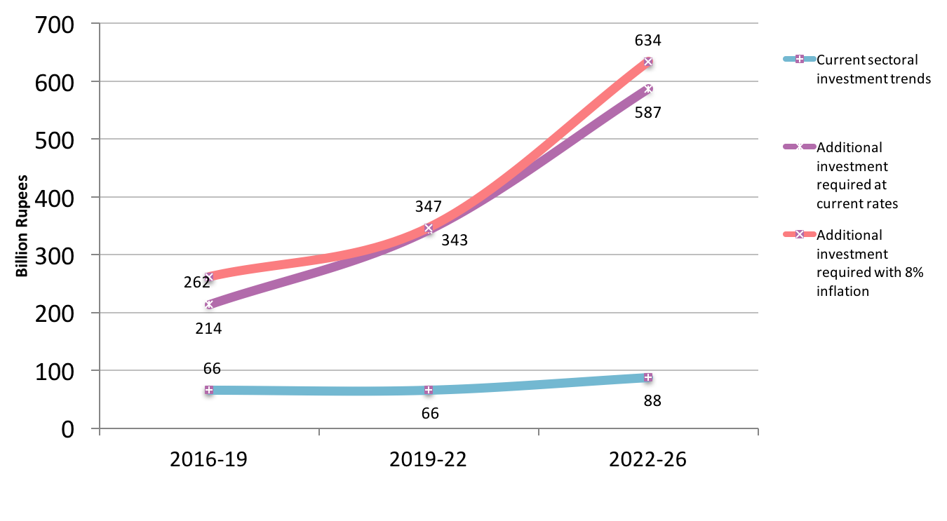

Figure 80– Sub-sector investment at current rates (safely managed water supply and sanitation)
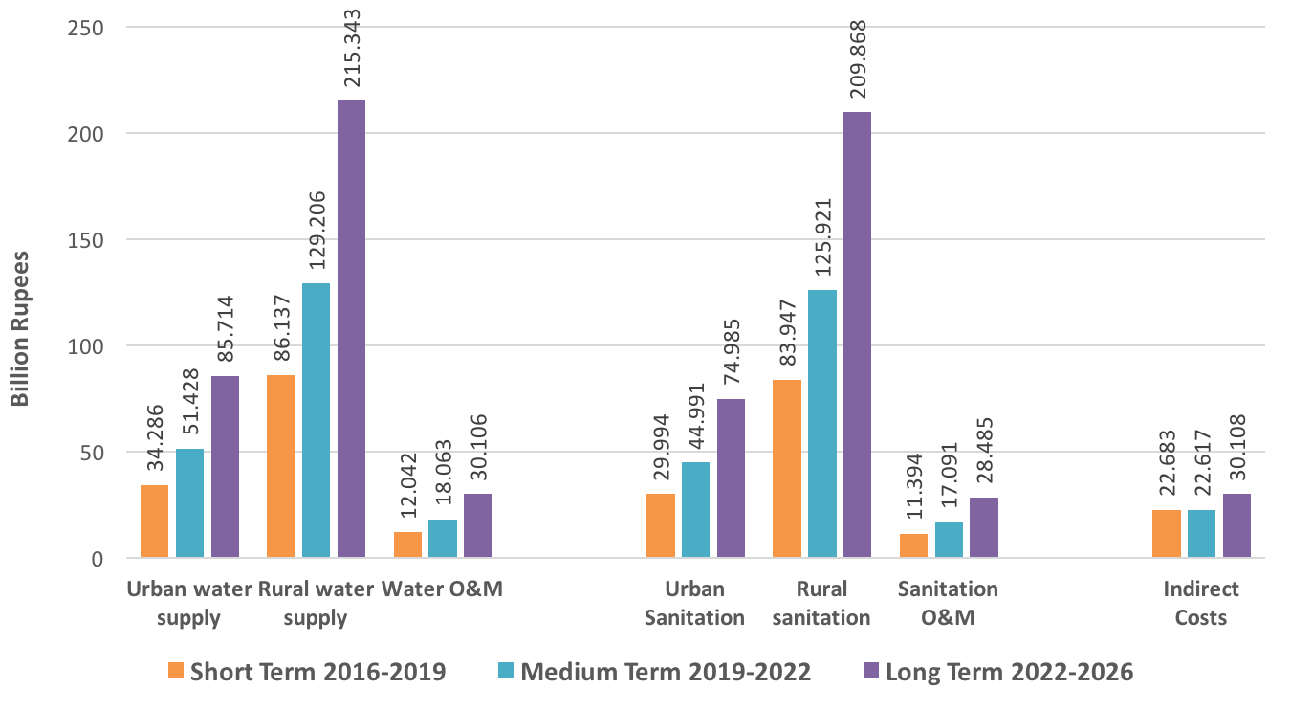

Figure 81 - Sector investment scenario at current rates and with 8% inflation (improved water supply and sanitation)
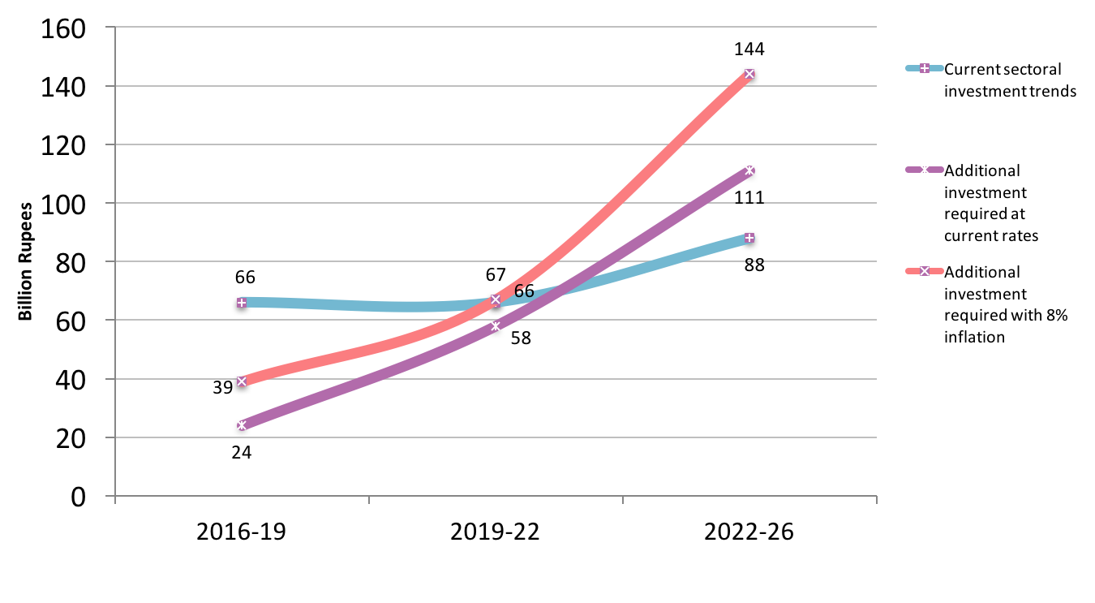

Figure 82– Sub-sector investment at current rates (improved water supply and sanitation)
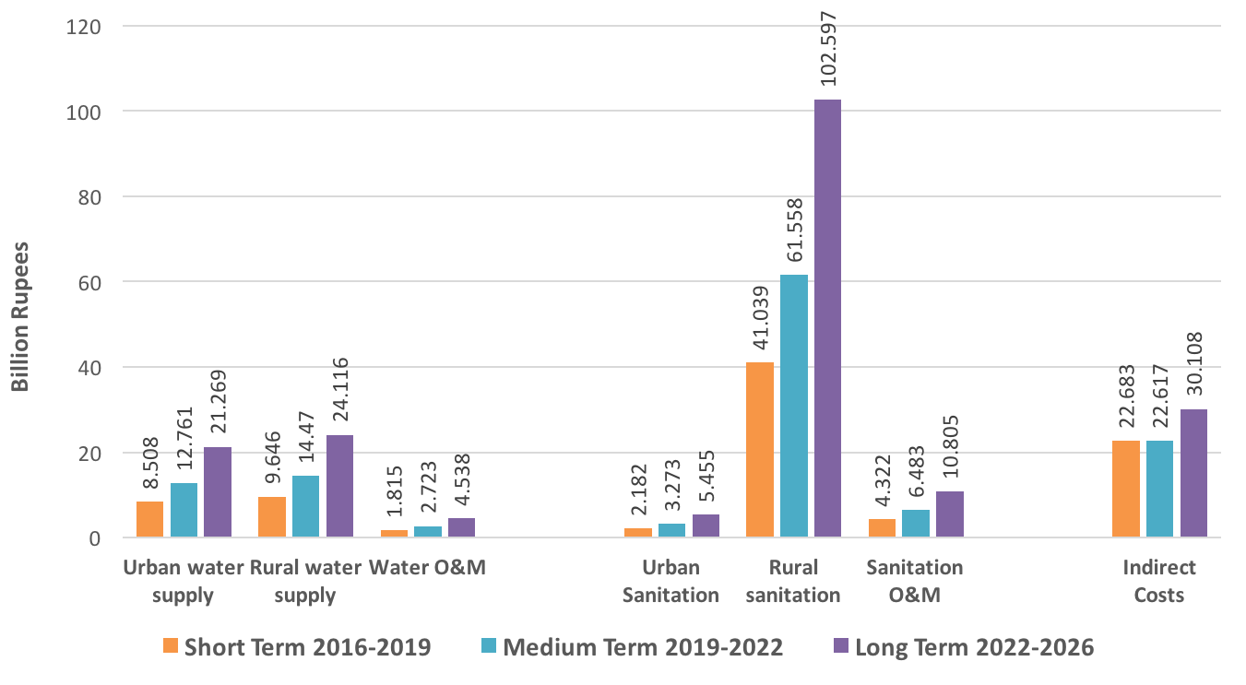

Resource Mobilisation

One of the critical areas for the sector development plan will be to mobilise sufficient resources to finance the ten year plan.

Various financing options exist and these would need to be explored and developed over time. Some of the potential areas include the following:

Own Source Revenue (OSR)

Under the SLGA, Local Governments can raise revenue through various bye-laws, schedules, taxation and tariffs for water and sanitation services. Presently, there is a very low tariff structure for services and revenue generated from water and sanitation is not necessarily used for sector and sub-sector services. This process needs to be streamlined and OSR increased incrementally at respective local government tiers.

Local Revenue Generation by Consumer Organisations

As part of planning, design and execution of schemes, CBO involvement is paramount. Where feasible, a CBO or similar community organisation should be empowered during the scheme development process to generate community resources through a community based system of billing and collection, especially to ensure O&M once the scheme is complete and handed over to the community.

Innovation

One of the major impediments in revenue generation is inefficient billing and collection for sub-sector services. The Government of Sindh may consider outsourcing functions like billing and collection to private sector companies to improve revenue generation.

Several corporates are already involved in promoting health and hygiene related to WASH through their Corporate Social Responsibility e.g. Reckitt and Coleman Company who advertise their soap brand ‘Safeguard’ and Unilever with their soap brand ‘Lifebuoy’. These companies can be engaged on a wider scale to health and hygiene promotion in WASH.

Strengthening Local Government

The WASH sector is fortunate that it is already devolved through the SLGA. At present, prioritisation and planning takes place at the provincial level. The SLGA can be used as an opportunity to strengthen local government tiers in prioritisation and planning of WASH services by allocating a proportion of development funding at their disposal. It would be mandatory to specify that this development funding be utilised for sector and sub-sector activities and for the local governments to develop their own priorities and plans for these.

Sub-National Governance Programme

The Department for International Development (DfID) has initiated a Sub-National Governance (SNG) programme in Punjab and Khyber Pakhtunkhwa. The Government of Sindh may approach DfID to support a similar programme in Sindh with specific emphasis on sector and sub-sector governance development.

USAID and Nutrition Support Initiative

USAID has developed a programme policy for support to nutrition specific programmes. These programmes may incorporate nutrition-sensitive components like water and sanitation that contribute towards improving nutritional status in affected communities. The Government of Sindh may enhance WASH programming as nutrition-sensitive components in nutrition-specific projects.

World Bank Drought Emergency Programme

For drought stricken areas of Sindh, the Government of Sindh may explore World Bank funding to set up an emergency programme that incorporates accelerated development of WASH services in affected communities.

Small Dams and Water Reservoirs

Funding from ADB may be explored for development of multiple small dams to act as water reservoirs with outlets to drinking water supply schemes. Such reservoirs would also benefit the irrigation sector.

Sustainable Development Goal for Water and Sanitation

The launch of the SDGs provides a unique opportunity to seek development financing from international partners as the SDG indicators require massive new investment to achieve the SDG targets. The Government of Sindh may use the sector plan to mobilise new investment from international development partners.

Climate change

Climate change is recognised to have a major impact on water and sanitation services, and therefore provides an opportunity to the Government of Sindh for high level engagement for developing pilot projects to mitigate risks of climate change on sector and sub-sector services before scaling up.

Achieving Equity and Universal Coverage

Government of Sindh may consider accessing concessional loans or other new resources or by improving value for money to support equitable and viable service delivery models for closing coverage gaps, and removing bottlenecks.

Sanitation Marketing

Government of Sindh may incentivise the private sector through rebate and subsidies for investment in the WASH sector especially provision of sanitation materials. The provincial government may also engage the private sector, international partners and NGOs in developing the capacities of local entrepreneurs, masons and suppliers in sanitation marketing and supply side interventions.

Strategy

Sector Financing
Strategic Objectives/Outcomes | Short Term Actions  1 - 3 years | Medium Term Actions  4 - 6 years | Long Term Actions  7 - 10 years
Sectoral budgeting and expenditure reporting stratified separately for each sub-sector (environment, water supply, sewerage and drainage) | Conduct a financial budgeting and expenditure review of sectoral budgets and expenditures and stratify actual sub-sector spends against sub-sector budgets for last five years  Introduce sub-sector expenditure reporting separately for environment, water supply, sewerage and drainage, and solid waste | At least 70% of districts and talukas report sub-sectoral spending by stratified reporting procedure | At least 90% of districts and talukas report sub-sectoral spending by stratified reporting procedure
Increased Own Source Revenue (OSR) in sub-sectors by Town Councils | Incentivise by providing matching grants to Town Councils related to sub-sector OSR  At least 30% of Town Councils increase their baseline sub-sector OSR by 100% or more | At least 60% of Town Councils increase their baseline sub-sector OSR by 200% or more | At least 75% of Town Councils increase their baseline sub-sector OSR by 300% or more
Increased regulated private sector participation in sub-sectors | Incentivise private sector with subsidies to provide water supply, filtration plants, O&M services, rehabilitation of dysfunctional schemes, solid waste management, wastewater treatment in selected areas and city and town zones  Determine type of contract arrangement and ensure regulatory mechanism in place | At least 30% or more of coverage of municipal services in mega cities provided by private sector  At least 20% or more of coverage of municipal services in intermediate cities provided by private sector  At least 10% or more of coverage of municipal services in Towns provided by private sector | At least 50% or more of coverage of municipal services in mega cities provided by private sector  At least 30% or more of coverage of municipal services in intermediate cities provided by private sector  At least 20% or more of coverage of municipal services in Towns provided by private sector
Increased development expenditure allocation to and spending by sub-sectors and prioritised by equity and need | Allocate 8% of ADP allocation to the sector and prioritise by equity and need  Increase proportionate ADP allocation for ongoing schemes from 69% to 75% and correspondingly reduce ADP allocation to new schemes from 31% to 25%  40% of sector development allocation requirement and release achieved | Allocate 9% of ADP allocation to the sector and prioritise by equity and need  Increase proportionate ADP allocation for ongoing schemes from 75% to 80% and correspondingly reduce ADP allocation to new schemes from 25% to 20%  50% of sector development allocation requirement and release achieved | Allocate 10% of ADP allocation to the sector and prioritise by equity and need  Maintain proportionate ADP allocation for ongoing schemes at 80% and corresponding ADP allocation to new schemes at 20%  60% of sector development allocation requirement and release achieved

SECTOR COORDINATION AND IMPLEMENTATION ARRANGEMENTS

Coordination

The subjects of drinking water supply, sanitation, and solid waste, rural and urban development have been designated to the provincial government under the Constitution of Pakistan. The Local Government Act 2001 created the structure of Tehsil Municipal Administration (TMA) with the responsibility of municipal services including water supply, sanitation and solid waste management. The Government of Sindh approved a new Local Government Act in 2014. The Sindh Local Government Act restored the formal mayoral system for towns/cities to serve the urban population with Chairman led district councils mainly responsible for the rural areas.

In rural areas, the union councils and zila (district) councils will be responsible for services, while in urban areas and the metropolis, Metropolitan Corporation, Municipal Corporation, Municipal and Town Committees will be restored. Presently, TMAs are functional under a transition period though local bodies election were held in 2015 at the community level and new mayors and chairmen have been elected in 2015. The new administrative structure is expected to be fully functional in 2016-2017 financial year. Urban water and sanitation authorities called KW&SB for Karachi, H-WASA for Hyderabad, and NSUSC are entrusted to deliver municipal services under supervision of the local governments. In addition, other agencies like Karachi Development Authority, Karachi Metropolitan Corporation, Hyderabad Development Authority, Cantonment Boards, Defence Housing Authorities, private housing companies, etc. are also implementing water supply and drainage schemes.

In Sindh, the provision of drinking water supply to the rural communities’ rests with PHE&RDDwhile in big and intermediate cities and towns, it rests withLG&HTPD, which is also responsible for sanitation and solid waste. Both provincial departments are responsible for planning, funding, regulation, monitoring and service delivery of water and sanitation respectively at the district and sub district levels. In addition to these two departments, there are other departments who are directly and indirectly involved in WASH like Urban Planning and Development, Health, Education and Planning and Development Departments with some special initiatives. For water supply in schools, PHE&RDD provides technical support in designing and implementing the scheme, the budget being catered from the Education Department. The Health department is responsible for creating awareness and sensitisation among the communities about hygiene behaviours and pre-cautions for water borne diseases.

Presently, there are two ways of managing the water supply schemes in Sindh. Generally, in urban areas, LG&HTPD manages the schemes through its staff but has poor revenue collection from the users or community based organisations (CBOs). Whereas in rural areas, the schemes are designed and executed by PHE&RDD, but on completion require to be handed over to LG&HTPD or entrusted to the local CBOs that includes operation and maintenance of the schemes. Nearly one-fifth of water supply schemes in the province are non-functional because of either lack of interest on the part of CBOs or poor money collection mechanisms. There is lack of appropriate legislation for handing over of the schemes to the communities and clarity about the expected role from the stakeholders in O&M of the schemes. PHE&RDD does not have sufficient community mobilisation capacity, and requires additional capacity development support followed by policy reforms for appropriate well-defined community sharing and mobilisation mechanisms, and for O&M.

The function of sanitation falls under the purview of LG&HTPD, which is also involvedin implementing the large drainage and sanitation schemes. It is also involved in street payment and road construction in the villages. LG&HTPD has just initiated the Saaf Suthro Sindh programme through which it shall implement the Pakistan Approaches to Total Sanitation (PATS) in selected districts in association with local community organisations in collaboration with national and international partners. It is noted that many initiatives/pilot taken by the civil society partner organisations for scaling up of PATS and WASH programmes are not well embedded within Government, LG&HTPD and PHE&RDD programmes and initiatives. Resultantly, these pilot initiatives are not scaled up, as there are gaps in the understanding of the stakeholders about government operational mechanisms.

It is also recognised that government priorities are often driven by the political party manifestos, and advocacy of the international and national partners based on research and evidence. There is lack of sufficient research and evidence on the local water and sanitation innovative and cost effective solutions in the province. There is a strong need for identifying a water and sanitation research agenda that feeds into the development of new programmes and initiatives of the government of Sindh.

There is lack of coordination mechanism between PHE&RDD and Local Government about handing over of water supply and sanitation schemes in addition to future O&M of WASH projects. Both departments are implementing the schemes on the will of elected representatives but a joined up approach is missing where resources should be shared from planning, execution and monitoring of the project. The new SLGA 2014 shifts the onus of water supply, sanitation and solid waste to the local councils. It indicates the formation of guidelines for management of water supply and sanitation schemes but presently these do not exist. A similar challenge of coordination exists among the multiple departments responsible for WASH directly or indirectly. There is no single coordinating focal point that holds different sub sector strands together.

Further, there is lack of clarity about the roles and responsibilities among the stakeholders that has emerged as a result of SLGA 2014 and 18th Constitutional Amendment. There is need for a formal coordination mechanism for WASH under Assistant Chief Secretary for Development at P&D by creating a Project Planning and Implementation Unit. This unit should be responsible for identifying the synergies or determine any overlapping.

Improving Sector Coordination

The following are the critical areas for improving sector coordination.

- There is need for a regulatory body especially for urban areas – an integrated approach should be adopted for metropolitan areas where the Mayor should provide leadership
- Cantonment Board – Station Command should also be involved in the regulatory body as they provide service especially for Karachi
- ACS Development can issue notification to set up a regulatory board – and have representation of Mayor, Operators and Cantonment Board
- PHE&RDD and Provincial Water Board will not approve any scheme without consent of the above body regulating water supply in cities and towns – every scheme would require a No Objection Certificate from the Mayor
- Establish a Project Planning and Implementation Unit for WASH under the governance of the Assistant Chief Secretary for Development at P&DD

Sector coordination with education for missing WASH facilities can be improved at three levels:

- Provincial level – quarterly review of data on missing WASH facilities by Directorate of Education Schools, Reform Support Unit, SEMIS and PHE&RDD to prioritise community water supply schemes and ensure these are also linked with local schools
- District Authority level – local PHE&RDD and LG&HTPD officials can be part of this to promote coordination
- District Education Group - local PHE&RDD and LG&HTPD officials can be part of this to promote coordination for WASH

Sector coordination with health can be improved at three levels:

- Provincial – joint meeting six monthly between PHE&RDD and PPHI and Health to ensure water supply to health facilities in all new schemes where feasible
- District Health – district-wise status of health facilities with regards to water and sanitation and joint planning with PHE&RDD to address the gaps. Health Department and PHE&RDD develop a Joint Action Plan (JAP) to address these
- District Education – district-wise planning with Education to incorporate health and hygiene in schools and local communities

Implementation Mechanism

Implementation Arrangements

This section provides the framework and guidelines for implementing the Sindh Sector Development Plan for WASH – to be implemented by governmental departments and agencies, rural and urban communities throughout province, and supported and facilitated by civil society organisations, the private sector and international donors.

The implementation framework is premised on harmonisation and integration and outlines how delivery of WASH would need to be structured and coordinated, proposes funding arrangements (covered in further detail under ‘Resource Mobilisation’), and provides a structural platform for NGOs to be integrated in planning and execution of the sector plan. It is expected that as the programme evolves, the framework would ned to be revised to address issues not apparent at this time.

A significant component of the proposed framework is a joint commitment by six leading departments (LG&HTPD, PHE&RDD, Health, Education, P&DD and Finance) through a Memorandum of Understandingto support and facilitate an integrated WASH programmein the province to address the needs of urban and rural communities more holistically and limit compartmentalisation that may impede progress towards the sector plan’s objectives.

The framework further seeks to provide coherence to sector and sub-sector planning, design and execution, and to harmonise donor inputs in terms of programming and financial assistance. This would facilitate donors to support components of the sector plan that contribute a unified whole rather than disparate projects in isolation of each other.

Foundation

The foundation of the new WASH sector development plan is a formal Memorandum of Understanding (MoU) between the following departments:

- LG&HTPD
- PHE&RDD
- Health
- Education
- P&DD
- Finance

The intent of the MoU would be to establish a harmonious working modality between the six departments, donors and other sector partners active in the implementation of WASH activities to realise the full benefits of the WASH sector plan.

Features of the Implementation Framework

Four of the significant features of the new WASH sector plan are:

- Integration
- Harmonisation
- Alignment
- Partnership

Integration

The sector plan is designed to integrate:

- Water Supply (urban and rural)
- Hygiene and Sanitation
- WASH in Schools and Health Facilities

The primary objective is to foster integrated behaviour among community members in which:

- safe use of water,
- healthy hygiene practices
- regular use of improved sanitation facilities

are naturally and instinctively combined into the pattern of daily living. Further, it seeks to provide an institutional arrangement that would achieve greater efficiency and effectiveness.

Integrating Structure

The structural arrangements recommended for WASH, shown in the matrix below, are designed to build synergy among the sectors through coordinated and collaborative planning, implementation, monitoring, reporting and evaluation of programme results.

The recommended WASH organisational structures are intended to provide for effective:

- Governance
- Management
- Implementation
- Coordination

It is recognised that the recommended structures may not be appropriate in all situations and local adaptations may be necessary.

The MoU presupposes:

- provincial WASH structures for policy guidance, technical overview and approval

- a structure for programme coordination to ensure intersectoral convergence

Implementation Matrix

Level | Governance and Guidance | Oversight and Management | Programme Implementation | Programme Coordination
Provincial | Provincial Nutrition and WASH Committee | Multi-sectoral steering committee under P&DD for policy guidance and sectoral collaboration | Higher level multi-sector planning | Higher level multi-sector coordination
Provincial | Technical Committee | Departmental level technical committee to review ongoing and new schemes for ADP | Technical overview and sector partner engagement | Coordination and alignment of sector schemes with department plans
Provincial | Steering WASH Technical Working Group | Departmental level structure with a focus on the sector plan | Multi-sector engagement at planning and execution levels | Multi-sector coordination for planning and execution
Provincial | Sector Coordination and Monitoring Unit (SCMU) | Provincial monitoring and evaluation structure as part ofNutrition Unit in P&DD | Monitoring frameworks, reporting to provincial and district structures | Inter-departmental liaison and coordination with donors for reporting requirements
District | District WASH Committee) under the DC Office | District level coordination | Multi-sector engagement at planning, coordination and execution at district level | Multi-sector coordination for planning and execution at district level
District | District Coordination and Monitoring Unit (DCMU) | District level monitoring and reporting | Monitoring information reporting to SCMU and district structures | Inter-departmental liaison and coordination at district level for reporting requirements
Union Council Committee | UC WASH Committee under the UC Secretary Office | UC level WASH programming | CBO/VDC engagement at planning and execution at UC level | CBO/VDC coordination for planning and execution at UC level

Harmonisation

The second feature of the sector plan is harmonisation.

Historically, much of the work in WASH in the province has been departmental led on the basis of discrete, time-framed projects that have been largely been financed by the Provincial and Federal governments, while some projects have been donor-designed and donor-driven.

While there have been certain advantages in pursuing this approach, it has worked against comprehensive and strategic planning and effective programme execution. It has made difficult:

- assembly and analysis of essential planning data
- definition of expected outcomes
- mobilisation and allocation of resources
- establishment of management systems
- coordinated capacity development
- measurement of progress and of results
- communication and accountability.

At the provincial and district level, the management of diverse projects has placed an inordinate burden on generally under-capacitated implementing agencies and, at the community level, it has resulted in segmentation, gaps and overlaps in service delivery.

There is therefore a pressing need to move from a fragmented project approach to a more coherent and integrated programme approach, so that there is one WASH programme in the province to which donors and NGOs can align and contribute to its overall achievement.

Alignment

The third new feature of the WASH sector plan, closely related to harmonisation, is alignment. It is imperative that the sector plan is aligned with

- the policies, priorities and strategies of the pertinent departments as outlined in their respective Sector Development Plans
- the administrative systems, standards and procedures of the Government of Sindh

This means that the goals, objectives and development indicators of WASH are directly linked and contribute to those of the partner departments. It also means that, to the extent possible, WASH management systems and procedures follow and tie into the established government systems, standards and procedures for:

- Planning
- Financial Management
- Procurement
- Reporting
- Monitoring & Evaluation
Other than conformity and efficiency, and internal vertical and horizontal alignment for complementarity and mutual reinforcement, the overall purpose is to ensure that WASH is recognised and affirmed as an integral, ongoing component of the provincial government’s broader developmental programme. WASH responsibilities are incorporated in the established process streams and the job descriptions of the four sector agencies’ staff at all levels. This signals to WASH implementers within the government structures that their WASH activities are not “added on” responsibility in support of donor projects - but a core responsibility in government service.

Partnership

The fourth feature of the sector plan is partnership. Partnership is not a new feature – but it is an evolving feature in terms of scope and level of commitment. The scope has been enlarged to include the six departments and the commitment has been increased to engage with Civil Society Organisations and the Private Sector as significant partners. The new sector plan recognizes that each of these partners has an essential part to play in successfully scaling-up WASH, improving performance and ensuring the sustainability of programme results.

Civil Society Organisations/NGOs are major WASH actors throughout the province. Furthermore, they have exceptional motivation, expertise and flexibility that enables them to effectively implement WASH in remote areas where governmental agencies may not have the required capacity. Not least, CSO/NGOs bring additional and alternative experience to WASH and can contribute substantially to lessons learned and the achievement of best practices.

The role of the CSO’s/NGOs as Partners in the sector plan focuses on common approaches to local capacity building, empowerment and planning, common standards relating to WASH infrastructure, the harmonisation of reporting results – not least in relation to the WASH Inventory- and ensuring that the financial contributions to the Programme are recognised and recorded in WASH financial reporting.

Private sector involvement in WASH is essential to the sustainability of the community-led and community-managed development that is promoted by WASH. When communities do not have ongoing access to reliable maintenance and capacity building services, their good initiatives frequently falter and fail. The new sector plan encourages the private sector to assume this role and offers opportunity for public-private partnerships in the delivery of goods and services and in the building of stakeholders’ capacity.

The proposed implementation mechanism is presented diagrammatically in Fig 83.

Figure 83 – Implementation Mechanism
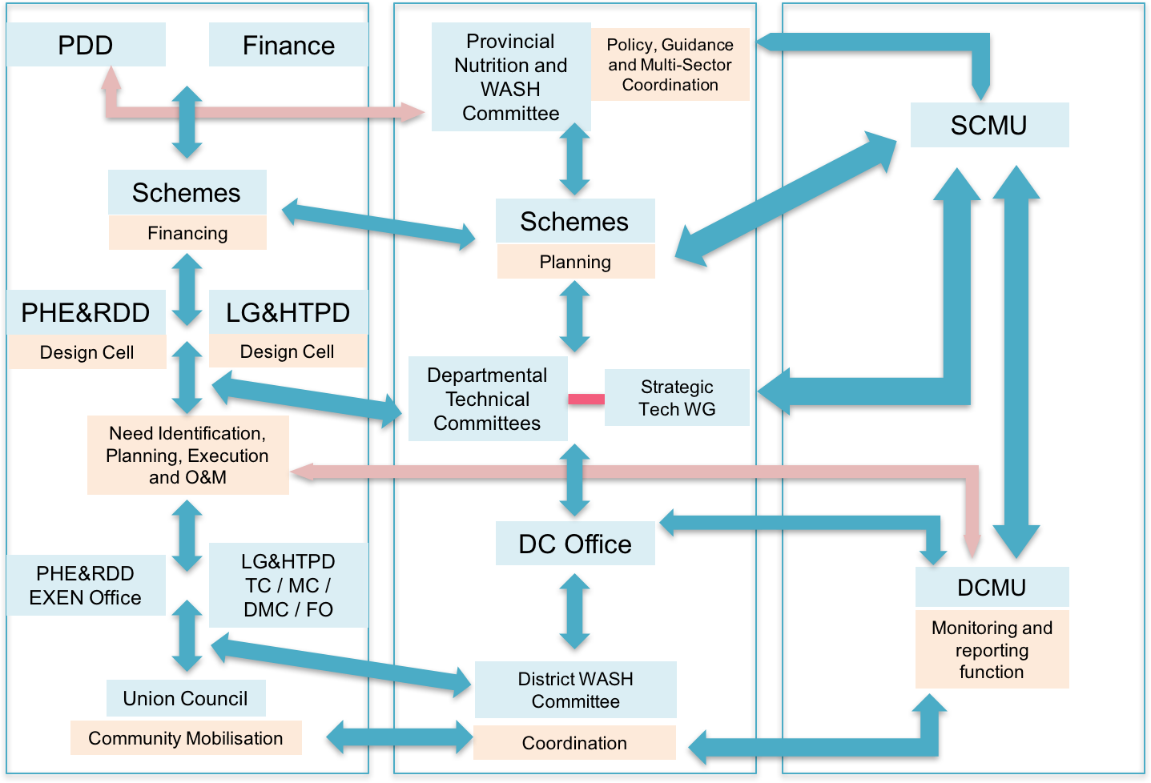

Need Identification and Scheme Design

The need identification process would commence at the UC level with community participation. Communities need to be involved at the outset to identify a suitable location, participate in the planning, design and execution of the scheme, and to ensure that the mobilisation process has obtained the necessary commitment by the local communities to bear the costs of operation and maintenance.

Design Cell

A Design cell would be established in LG&HTPD to assist Town Committees (TC), Municipal Committees/Municipal Corporations (MC), District Municipal Corporations (DMC) and Field Offices (FO), while the existing Design Cellin PHE&RDD would be strengthened to assist the EXEN Office in the designing of new schemes and review designs of existing schemes where required, and to ensure that all new schemes meet the technical and quality specifications.

Multi-Sectoral Nutrition Steering Committee

The P&DD has established a Multi-SectoralNutritionSteering Committee represented by most sectors. It is suggested that this committee incorporate WASH and be renamed Multi-Sectoral Nutrition and WASH Committee. For projects that require collaboration with other sectors, LG&HTPD and PHE&RDD can utilise the Steering Committee for improved coordination and high level planning. The Steering Committee provides policy guidance and coordination to the different sectors.

Departmental Technical Committees

The Departmental Technical Committees would be operationalised and review ongoing and proposed new schemes for technical and financial oversight and guidance in relation to the ADP.

Strategic WASH Technical Working Group

A Strategic WASH Technical Working Group would monitor overall progress and facilitate implementation of the Sector Development Plan, provide a forum for inter-departmental coordination for the implementation of the plan, promote alignment of sector partner projects with the Sector Plan, and facilitate donor engagement and reporting.

Sector Coordination and Monitoring Unit (SCMU)

Presently, there is no mechanism that can manage the implementation of sector development plan. Therefore, a SCMU would be established under the auspices of P&DDas part of the Nutrition Unit to facilitate implementation of the sector development plan. The SCMU shall liaise with the Multi-Sectoral Steering Committee,Departmental Technical Committees,Strategic WASH Technical Working Group, Monitoring and Evaluation cell in P&DD, and the District Coordination and Monitoring Unit (DCMU).

Aim
Monitor the progress and timely implementation of the Sindh Water, Sanitation and Hygiene Sector Plan 2016-2026

Key Objectives

- Report on progress and provide periodic updates to the Multi-Sectoral Steering Committee, Departmental Technical Committees,and Strategic WASH Technical Working Group
- Act as a mechanism for donor, NGOs and private sector coordination and reporting in Water, Sanitation and Hygiene - institutionalize the bottleneck analysis and joint sector review mechanism so that partners can see linkages between policy commitments and budgeting/ spending at all levels of government
- Develop and implement sectoral and sub-sectoral implementation and monitoring frameworks for the sector plan
- Liaise with the Monitoring and Evaluation Cell, P&DD, Government of Sindh
- Develop and maintain a Sanitation and Water Information System (SWIS) with District Scorecards
- Produce a Sindh Annual State of Water, Sanitation and Hygiene Report (SAWSH Report)
- Act as a provincial observatory for water, sanitation and hygiene, evidence generation and collation, and warehouse of sectoral and sub-sectoral information
- Monitor and report sectoral and sub-sectoral financing by state and non-state actors in Water, Sanitation and Hygiene – and generate Annual WASH budget briefs for better and more relevant budget and expenditure data information
- Maintain an updated database for Water, Sanitation and Hygiene for reporting to JMP and GLAAS

District WASH Committees

A District WASH Committee shall be set up and operationalised under the DC Office.

Representation of relevant district staff of LG&HTPD, PHE&RDD, Health and Education on to this committee would be required. Other sector representation can be co-opted as required. The District WASH Committee shall perform the role of sector coordination, planning, and multi-sectoral collaboration. An important role for the District WASH committee would be to improve budget transparency and accountability based on communities’ budget monitoring and feedback at the district level and ensuring that funds reach the intended programmes and beneficiaries.

District Coordination and Monitoring Unit

A District Coordination and Monitoring Unit (DCMU) shall be set up and operationalised under the DC Office. Each DCMU would be staffed by a District M&E Manager and supported by two Water and Sanitation Reporting Officers. The DCMU shallhave reporting arrangements to the SCMU and shall liaise with the EXEN Office and LG tiers for information regarding schemes, and also with other sectors like health and education for issues related to the sector. The DCMU shall compile physical and financial progress data on ongoing and completed schemes, make monitoring visits to scheme sites, determine the status of O&M of schemes visited, and provide monthly reporting to the SCMU. DCMU data shall be used to develop district scorecards for water, sanitation and hygiene. The organogram for DCMU is shown in Fig 84.

Figure 84 - Organogram for DCMU
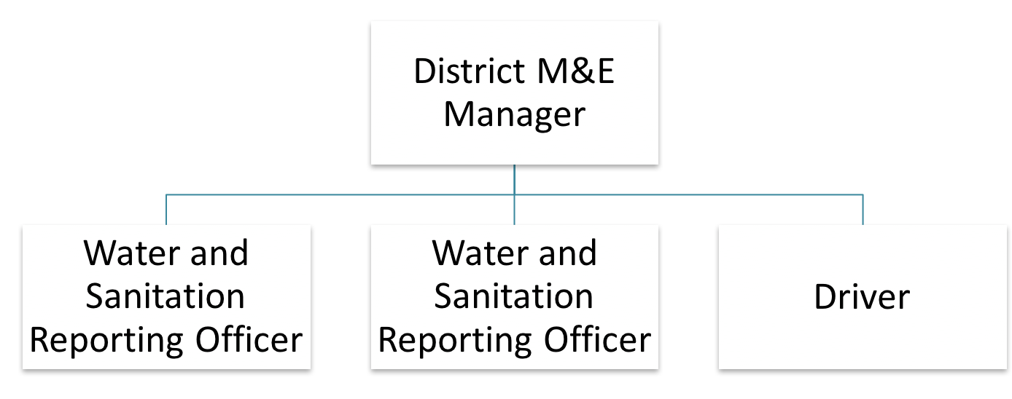

Rural Water Supply Schemes

For Rural Water Supply Schemes, the following implementation arrangements shall be adopted:

- The Drinking Water Policy goals and objectives can only be achieved through strong community mobilisation. It is envisaged that the Communities shall be involved in the planning, implementation, monitoring and O&M of the water supply schemes (WSS). The O&M of the schemes especially in the remote areas/villages shall be handed over to the Drinking Water User Associations (DWUAs), which can generate ample revenue by collection of water charges to maintain the water supply schemes. Local governments shall hold public consultations at the conceptual design of the development plan, schemes and projects, while PHE&RDD provides technical assistance to DWUAs. PHE&RDD shall not be involved in the collection of revenue. Modifications in the designs shall be carried out to accommodate the concerns of the stakeholders. The PC-1s shall be prepared only after such a process has been carried out. Local Council Monitoring Committees shall oversee the programme/project/scheme.

- For effective and sustainable rural water supply schemes (RWSS) management in Sindh:

- PHED shall appoint Social Mobilisation/Community Development Officers with proper qualifications to interact with communities
- Local government (LG) department in coordination with Social Mobilisation/Community Development Officers of PHED shall constitute the Local Council Monitoring Committee (LCMC) and hold public consultations at the conceptual design of the RWSS development plan, schemes and projects.
- The site selection of the RWSS shall require recommendation of the LCMC following which PHED will be responsible for Engineering Design, Procurement of Materials, Construction, Installation and Commissioning.
- Upon completion of the RWSS, the scheme shall be handed over to the respective Drinking Water User Association (DWUA) for operation and maintenance (O&M) of the RWSS. DWUAs shall be able to generate ample revenue by collection of water charges to maintain the water supply schemes. The water tariff shall be set as per recommendations of the DWUA in consultation with the community.
- The minor repair requirement of the RWSS shall be met within the revenue generated by the DWUA and major repairs of the RWSS shall be met from the budget of O&M Wing of the PHED. Moreover, technical support for minor/major repair shall also be provided by O&M Wing of PHED. O&M and minor repair manual shall be prepared by PHED and handed over to the DWUA for smooth functioning of the RWSS.
- DWUA shall sign a memorandum of agreement (MoA) with PHED to give their (DWUA) commitment to undertake regular monitoring and reporting to O&M Wing of PHED, and for carrying out O&M by the DWUA from the revenues generated from the scheme. The disbursement of revenues shall be the sole responsibility of the DWUA.
- Monitoring of RWSS shall be the sole responsibility of PHED and develop/maintain web based GIS/MIS of all RWSS and report the level of functionality of RWSS.
- PHED shall be designated as the lead agency for RWSS working in close coordination with LG department in Union and District Councils and its Rules of Business (ROB) shall be revised including design, construction, installation, commissioning, and monitoring (O&M, minor/major repair) of the rural water supply schemes).
- The Annual Development Plan (ADP) of PHED shall reflect the following:
  - New and ongoing rural WSS (RWSS)
  - Rehabilitation of non-functional RWSS
  - Upgrading/extension of existing RWSS
  - Major repair of existing RWSS
  - Behavioural Change Communication Campaigns/activities, IEC production and dissemination, trainings (PHED staff & DWUAs)

Strategy

Sector Coordination
Strategic Objectives/Outcomes | Short Term Actions  1 - 3 years | Medium Term Actions  4 - 6 years | Long Term Actions  7 - 10 years
Provincial level coordination and programme management for WASH streamlined and enhanced | ACS Development P&DD notifies broadened scope of Multi-Sectoral Nutrition Steering Committee to encompass WASH  ACS Development P&DD notifies Sector Coordination and Monitoring Unit for WASH as part of Nutrition Unit  Establish a Sector Coordination and Monitoring Unit in Nutrition Unit  Equip and furnish the SCMU  Quarterly review meetings of Multi-Sectoral Steering Committee, Departmental Technical Committee and WASH Steering Committee  Establish a Design Cell in LG&HTPD and PHE&RDD | Quarterly review meetings of Multi-Sectoral Steering Committee, Departmental Technical Committee and WASH Steering Committee | Quarterly review meetings of Multi-Sectoral Steering Committee, Departmental Technical Committee and WASH Steering Committee
District level coordination and programme management for WASH streamlined and enhanced | DC Offices notify District WASH Committees  Quarterly review of WASH schemes and activities in meetings of District WASH Committees  ACS Development P&DD notifies District Coordination and Monitoring Unit for WASH under DC Office  Establish and operationalise DCMU | Quarterly review of WASH schemes and activities in meetings of District WASH Committees | Quarterly review of WASH schemes and activities in meetings of District WASH Committees

SECTOR MONITORING

Monitoring and Evaluation

Monitoring and reporting activities in the sector and sub-sector take place at various levels but are fragmented.

At the federal level, the Poverty Reduction Strategy Paper (PRSP) progress report involves an annual review process led by the Ministry of Finance. Coverage is tracked through national household surveys and sector investments obtained through provincial submissions. Financial budget and expenditure data is fed into financial management systems at TMA, district and provincial levels using specific entry codes. The data available against these codes are then grouped for reporting and summarised in the PRSP Progress Reports. Data on water and sanitation coverage are usually obtained from PSLM surveys.

At the provincial level several mechanisms exist for providing overviews. For instance, the provincial PRSP Report, Medium Term Development Framework (MTDF), Medium Term Budgetary Framework (MTBF) and Public Sector Development Plans (PSDP). Generally, the PSDP provides the basis for planning, but current arrangements do not support a comprehensive assessment or access to capital expenditure on sanitation and hygiene. In absence of a template for a Sector/sub-sector Performance Report, it is difficult to consolidate the input and output data to have an overall picture of the sector i.e. investments, operational costs, output/outcome data, etc. While each project/scheme does in theory have a project cycle, based on a series of documents from PC-I to PC-V, the end of project evaluation stage (PC-V) is undertaken infrequently, bypassing yet another institutional monitoring mechanism.

Furthermore, there are challenges of coordination for monitoring and reporting due to complexities in the roles and responsibilities of different stakeholders in the government, cantonment boards and defence housing authorities, non-government and private sectors.

Presently, there are four reports/sources that provide information about access to water and improved sanitation. These are as follows:

Pakistan Poverty Reduction Strategy Paper Progress Report (PRSP)

The Ministry of Finance publishes periodic PRSP progress reports and budgetary expenditure reports that include sectoral pro-poor expenditure as part of Pakistan’s obligations to achieve the MDGs. These reports obtain data from the provincial finance departments and collate them to present a country and provincial progress report. Water and sanitation coverage statistics is usually obtained from the recent Pakistan Bureau of Statistics publications like PSLM. These reports provide useful information about trends in sectoral spending and projected planned expenditure.

Pakistan Social and Living Standards Measurement Survey (PSLM)

The PSLM is conducted annually by the Pakistan Bureau of Statistics. It provides disaggregated data by province and district, urban and rural, and by quintiles. While essential statistics are covered every year, additional data is obtained every 3-4 years together with a Household Integrated and Economic Survey (HIES) that is conducted with the same periodicity. Additionally, PSLM also collects data on sewerage systems and solid waste collection. However, it does not provide any significant information on hygiene. In addition, PSLM also has statistics on health (e.g. diarrhoea), education, housing etc. The type of WASH related indicators collected in PSLM are shown in Table 55.

Multiple Indicator Cluster Survey (MICS) Balochistan

The MICS is a province specific survey that is usually conducted every 5-6 years and it has a bias towards child, nutritional and reproductive health. It is conducted by the Provincial Bureau of Statistics in close collaboration with UNICEF. In Sindh, the two recent MICS were done in 2004 and 2014. MICS provides useful and more comprehensive data on sources of water and type of toilet. In addition, it is also rich in hygiene indicators. It disaggregates data by district, education profile and by quintiles. It does not collect any data on sewerage systems or solid waste. The type of WASH related indicators collected in MICS are shown in Table 55.

Pakistan Demographic and Health Survey (PDHS)

The PDHS is also a periodic survey conducted every 7-8 years and its main focus is on health and population. It is supported by USAID with contributions from UN agencies like UNICEF, UNFPA, WHO and UNAIDS. It is conducted by the National Institute of Population Studies in collaboration with international partners. It has close similarity to MICS. It does not collect any data on sewerage systems or solid waste. The type of WASH related indicators collected in PDHS are shown in Table 55.

Joint Monitoring Programme (JMP) of WHO and UNICEF

The JMP is an official UN mechanism to monitor the progress and achievement of the Millennium Development Goals on water and sanitation. It is conducted every two years and involves review of existing survey data usually about 2-3 years old. The surveys commonly referred to are PSLM and PDHS. JMP utilises regression analysis using population estimates obtained from United Nations Population Division (UNPD). This mechanism provides country trends and an overall picture in water and sanitation for urban and rural. It does not differentiate sub-nationally.

Figure 85 - Top 10 countries with the highest numbers of people (in millions) practicing open defecation
(Source: JMP Report 2014)

Figure 85 shows that Pakistan has the third highest number of people practicing open defecation in the world. Evidence shows that most of these reside in Punjab. This is further evident from Fig 86, which shows that 76% of the poorest quintile still lacks access to improved sanitation.

Figure 86 - Disparities in rural improved sanitation coverage

(Source: JMP Report 2014)

Disability

Figure 87 presents an interesting perspective of households that have a person with disability in the household. About two-thirds (65%) indicated that the population had access to improved sanitation, while over four-fifths (85%) said that the population had access to improved drinking water sources.

These trends are important as all countries that have ratified the UN Convention on Rights of Persons with Disabilities, of which Pakistan is one of them, are now obliged to ensure that the rights of persons with disability for access to improved and safe drinking water and improved sanitation are implemented in social sector and development initiatives. It also requires development of disability sensitive indicators for water and sanitation services.

Figure 87 - Access to improved drinking water sources and sanitation facilities – disability perspectives
(Source: JMP Report 2014)

Global Analysis and Assessment of Sanitation and Drinking-Water (GLAAS)

The GLAAS report is a biennial reporting mechanism implemented by WHO and supported by the World Bank. Every two years, a Sanitation and Water For All (SWA) High Level Meeting (HLM) is held in which countries present their progress and outline their commitments. The biennial meetings are jointly hosted by the World Bank and UNICEF at the World Bank/IMF spring meetings. The GLAAS report provides country level data on government investment in WASH; budgeting and expenditure in WASH; WASH coverage of schools and health facilities; the existence of policies and strategies for WASH; the effectiveness of planning, monitoring and evaluation mechanisms; participation and equity, sustainability of water and sanitation initiatives; human resources capacity for WASH; and hygiene promotion especially in schools and primary health care.

Completion of a GLAAS questionnaire is coordinated and facilitated by the Climate Change Division and receives inputs from all provinces. The last report was published in 2014.

Pakistan Water Operators Network

As part of a collaborative project with Water and Sanitation Program (World Bank), the Pakistan Water Operators Network (P-WON) was formed and consists of all the WASAs in Pakistan. P-WON monitoring reports provide information on service coverage, consumption and production, non revenue water, metering practices, network performance, cost and staffing, quality of service, billing and collection, and financial performance. These reports are available online. Some WASAs are particularly efficient and their quarterly reports are up to date, while some may lag behind in the quarterly reporting. Proposed monitoring indicators for WASA are shown in Table 56.

School Education Management Information System (SEMIS)

The SEMIS collects quarterly information regarding missing facilities (electricity, usable drinking water, usable latrine, school cleanliness, boundary wall etc.) in all government schools of Sindh. These are published in periodic progress reports (School Education Profile) of the Reform Support Unit, Education and Literacy department, Government of Sindh. They provide an invaluable update on the status of school WASH.

Annual State of Education Report (ASER)

The ASER report is published annually and is a survey of a representative sample of primary, middle and high schools in the government and private sectors. Apart from enrolment and school participation data, it also provides information on the status of school drinking water and sanitation facilities.

Pakistan Council of Research in Water Resources (PCRWR)

PCRWR monitor groundwater quality as part of the national water quality monitoring programme (NWQMP). It has surveyed 24 major cities and 23 surface water bodies in Pakistan. Its reports for Sindh have been alluded to earlier in the chapter on water quality.

PCRWR monitors the quality of bottled/mineral water regularly and publishes a quarterly report. The reports show that on average, 25%-30% brands are overall unsafe, 20% are chemically unsafe, 10% are microbiologically unsafe, 60% brands are consistent, 30%-80% brands disappear from the market, and 35%-40% new brands appear.

Public Health Engineering Water Testing Laboratories

PHED utilises PCRWR water testing laboratories at district headquarter level in Sindh. It is expected that these will provide monthly water quality monitoring data.

Monitoring and Evaluation Cell - Planning and Development Department

The P&DD is mandated to monitor identification of schemes, monitoring of schemes during implementation, and evaluation after completion of projects. It is mandated to conduct evaluations of projects that are completed as indicated in the PC-1. It is the responsibility of executing departments to complete the PC-IV and PC-V and ensure that evaluations are done. The P&DD has established a Monitoring and Evaluation Cell to monitor and evaluate development schemes.

Surveys and Evaluations by State and Non State Actors

Project surveys, research and evaluations are also undertaken by other councils (e.g. Pakistan Council for Scientific and Industrial Research), government departments (e.g. Irrigation, Agriculture, Fisheries etc.), university departments, bilateral and multi-lateral donors, UN agencies, national and international non-governmental organisations.

Collation, Synthesis and Dissemination

Despite the mass of information available from disparate sources, monitoring reports, evaluation studies, surveys, research studies etc., there is no mechanism to collate and synthesise this information and disseminate to policy, management and operational level stakeholders.

The development of a Management Information System (MIS) for Drinking Water and Sanitation has been started a few years back and is still in the piloting stage in different parts of the country. The new MIS shall be based on GPS data creating decision-making and analytical scenarios for the government to develop effective sanitation programmes.

Under public sector development programme financed by Government of Pakistan, the Climate Change Division has started development of a national MIS for WASH from July 2013 and this is likely to be completed over a period of three years.

Furthermore, there are efforts from various actors to set up different monitoring systems and reporting formats. While these may be useful for project specific interventions, they do not bear any semblance to existing institutional monitoring and reporting systems, with the result that monitoring and evaluation information flows remain fragmented, uptake by executing agencies and institutional partners is low, and the sector and sub-sectors remain under-reported. Synergies between government initiatives in the subsectors of water supply, sewerage and solid waste management and those of national and international non-governmental organisations are sometimes hard to achieve.

Presently, there is no systematic approach for the monitoring and evaluation of sanitation projects. The concept of PC-2 is even missing which provides the basis for need identification.

Sector tracking is mainly based on the data of MICS and PSLM conducted by provincial and federal Bureau of Statistics with the support of UN and other international development agencies.

There is need for developing a MIS for water and sanitation with defined capacity development of Local Government Units up to Union Council level to provide information on quarterly or six monthly basis to update the status about coverage, access and need of the respective areas.

During development of PC-1, data collection should also be included so that accurate data is used instead of inaccurate or anecdotal estimations. There is need to estimate population served by water supply pipe for drinking water, and take into consideration the population and resources available. It should be made mandatory for the Irrigation Department, LG&HTPD and PHE&RDD to upload GPS for every project.

For monitoring of drinking water and sanitation indicators to be institutionalised, it is essential that monitoring of the sector is contextualised within the broader monitoring framework of the province and that key stakeholders like the Bureau of Statistics, P&DD, and those involved with management information systems facilitate information management for drinking water and sanitation. At district level, the monitoring unit should be placed under the Deputy Commissioner.

Monitoring and Reporting Information Systems

The monitoring and reporting systems appear to cluster into three groups (Fig 88). The first group is where there are regular annual or more frequent reports. The second group includes those that have a periodicity of between 2-5 years, provide some mid-term trends, are isolated activities and may not be performance related. The third group provides a long term perspective and is useful to see broader societal impact of social sector investments and behaviour change.

Figure 88 - Existing monitoring and reporting systems

However, it is interesting to note that several institutional monitoring and reporting systems already exist, but the potential to distil information for policy, planning and execution has not been adequately harnessed.

Proposed monitoring indicators for district municipal services are shown in Table 57.

Performance Measurement Framework

The key performance indicators for the Sindh WASH sector plan are presented below.

Result Statements | Performance Indicators | Targets for 2026 | Collection Methods | Collection Frequency
Outcome Results
Access to improved water supply | Proportion of Population with Access to Improved Water Sources (%) that is:  - Accessible  - Available  - Safe | % Rural  % Urban | MICS  PDHS | 4 years
Access to improved sanitation | Proportion of latrines at Household/Population levels connected with sewerage and drainage (%) | % Rural  % Urban | MICS  PDHS  PSLM | 4 years
Access to improved sanitation | Proportion of households using improved sanitation (latrines) (%) that is:  - Not shared  - Disposed safely to a closed sewerage system | % Rural  % Urban | PSLM  MICS  PDHS | Annually  4 years
Reduced Child Mortality | Proportion of Children Under 5 Who Suffered from Diarrhoea in the last 15 days (MICS); last 30 days (PSLM) (%) | % | MICS  PSLM | 4 years  Annual
Reduced Child Mortality | Diarrhoea in those <5 years and >5 years – seen as outpatients at health facilities (%) | % | DHIS | Annual
Reduced Child Mortality | Diarrhoea in those <5 years and >5 years – admitted as inpatients at health facilities (%) | % | DHIS | Annual
Reduced Child Mortality | Children <5 years who are underweight (%)  - Moderate and severe  - Severe | % | MICS | 4 years
Reduced Child Mortality | Children <5 years who are stunted (%)  - Moderate and severe  - Severe | % | MICS | 4 years
Reduced Child Mortality | Children <5 years who are wasted (%)  - Moderate and severe  - Severe | % | MICS | 4 years
Outputs
Implementation of water supply schemes | Number of water supply schemes implemented |  | PHE&RDD  LG&HTPD | Quarterly
Implementation of water supply schemes | Rehabilitation of Dysfunctional schemes |  | PHE&RDD  LG&HTPD | Quarterly
Implementation of water supply schemes | Number of households having water supply connections |  | KW&SB  NSUSC  H-WASA  PHE&RDD  LG&HTPD | Annually
Water filtration Plants established | Number of filtration plants installed and operational |  | PHE&RDD | Monthly
Water filtration Plants established | Number of beneficiaries getting clean drinking water |  | PHE&RDD | Quarterly
Water quality | Number of water quality testing services in operation |  | PHE&RDD  PCRWR | Quarterly
Water quality | Number of water samples examined |  | PHE&RDD | Monthly
Water quality | Proportion of households practicing home water treatment (%) | % | MICS  PCRWR | 4 years  Annually
Water resources effectively managed | Number of locations with rain water harvesting schemes initiated |  | PHE&RDD  LG&HTPD | Annually
Implementation of sanitation schemes | Number of sanitation schemes implemented |  | LG&HTPD and PHE&RDD | Monthly
Implementation of ODF in villages | Number of villages ODF certified |  | LG&HTPD | Monthly
Environment friendly disposal of sewage water | Number of pilot decentralised sewage water treatment system constructed |  | LG&HTPD  PHE&RDD  H-WASA  NSUSC | Annually
Public Toilets for the communities | Number of the public toilets established |  | LG&HTPD | Quarterly
Solid Waste Management in Cities | Number and level of coverage of solid waste in towns/cities |  | LG&HTPD | Six monthly
Enhanced solid waste collection | Percentage of garbage/waste collected against the estimate/amount of garbage produced |  | LG&HTPD | Monthly
Enhanced solid waste collection | Number of cities where secondary collection points established for small and medium cities |  | LG&HTPD | Monthly
Enhanced solid waste collection | Number of approved/recognised slaughterhouses practicing hygienic disposal of slaughter waste as per guidelines |  | LG&HTPD | Monthly
Improved Hospital waste management | Health facilities whose staff have been trained in hospital waste management |  | Health Department | Annually
Improved Hospital waste management | Health facilities that have adopted and are practising hospital waste management guidelines |  | Health Department | Annually
Improved Hospital waste management | Health facilities (hospitals) that have an infection control committee |  | Health Department | Annually
School WASH | Number of schools with functional water supply at primary, middle and secondary levels |  | Education Department  SEMIS | Quarterly / Annually
School WASH | Number of schools with functional latrines at primary, middle and secondary levels |  | Education Department  SEMIS | Quarterly / Annually
School WASH | Number of water supply schemes with water supply extensions to local schools |  | Education Department  SEMIS  PHE&RDD | Annually
Health Surveillance for Water Borne Diseases | Pattern of Water borne diseases on district and sub district basis – No of health alerts issued |  | Health Department | Quarterly
Health Units with WASH | Health facilities with functional water supply |  | Health Department | Quarterly
Health Units with WASH | Health facilities with functional latrine facilities |  | Health Department | Quarterly
Improved sectoral governance | Multi-sectoral Steering Committee meetings for policy guidance, and improved planning and coordination |  | P&DD | Quarterly / Six monthly
Improved sectoral governance | Coordination Meeting of WASH partners in Technical Committee at Departmental level |  | LG&HTPD  PHE&RDD | Quarterly / Six monthly
Improved sectoral governance | Quarterly Progress Report of WASH Sector Plan |  | LG&HTPD  PHE&RDD  P&DD | Quarterly
Improved sectoral governance | Number of cities with Master Plans for water supply and sewerage and drainage up to 2026 |  | LG&HTPD  PHE&RDD  Urban Unit  P&DD | Annually
Improved sectoral governance | Consumer water meters installed for accurate billing for small and medium cities (water supplies) and big cities (through service connection fee/ government support) |  | KW&SB  H-WASA  NSUSC  LG&HTPD  PHE&RDD | Annually
Improved sectoral governance | Number of cities with Master plans for solid waste management |  | LG&HTPD | Annually
Improved sectoral governance | Joint Sector Reviews |  | LG&HTPD  PHE&RDD | Annually
Improved sectoral governance | Sector Expenditure Review |  | LG&HTPD  PHE&RDD | Annually

Table 55 - Comparative WASH indicators in PSLM, PDHS and MICS
PSLM | Indicators | PDHS | Indicators | MICS | Indicators
DRINKING WATER |  | DRINKING WATER |  | DRINKING WATER
Water delivery system | Urban, rural and overall  Tap Water  Hand Pump  Motor Pump  Dug Well  Others | Improved source of drinking water | Piped into dwelling/yard/plot  Public tap/standpipe  Tube well or borehole/hand pump  Protected well  Protected spring/rain water  Bottled water  Filtration plant | Main source of drinking water - improved | Piped into dwelling  Piped into compound, yard or plot  Pipe d to neighbour  Public tap / standpipe  Tube well  Hand pump (tap)  Motorised pump (donkey / turbine)  Protected well  Protected spring  Bottled water (mineral)
 |  | Unimproved source of drinking water | Unprotected well  Unprotected spring  Tanker truck/cart with drum  Surface water  Other source | Main source of drinking water - unimproved | Unprotected well  Unprotected spring  Tanker-truck  Cart with small tank / drum  Surface water (Toba, river, stream, dam, lake, pond, canal)  Bottled water (mineral)  Other/ Missing
Main source of drinking water by income group | 1st, 2nd, 3rd, 4th and 5th quintiles  Source of drinking water  Province, urban, rural and overall | Water treatment prior to drinking | Boiled  Bleach/chlorine added  Strained through cloth  Ceramic, sand, or other filter  Solar disinfection  Other  No treatment  Percentage using an appropriate treatment method | Water treatment method used in the household | Boil  Add bleach/chlorine  Strain through a cloth  Use water filter  Solar disinfection  Let it stand and settle  Other  None  Percentage of household members in households using unimproved drinking water sources and using an appropriate water treatment method using an appropriate treatment method

PSLM | Indicators | PDHS | Indicators | MICS | Indicators
DRINKING WATER |  | DRINKING WATER |  | DRINKING WATER
Percentage households paying for water by region and water source | Households getting water from source  Households paying for water  Average amount paid per month  Urban, rural and overall  Source of water – tap water, hand pump, motorised pump, dug well, river/canal/stream, other
Percentage of households paying for piped water by region and quintile | Urban, rural and overall  1st, 2nd, 3rd, 4th and 5th quintiles
Who installed the water delivery system by province | Water delivery system – piped water, hand pump, motor pump, open well, closed well  Local government  Non-government  Household itself  Don’t know  Total
Distance to water source by province | Water source – tap water, hand pump, motorised pump, dug well, river/canal/stream, other  Inside the house, 0-0.5 Km, 0.5-1 Km, 1-2 Km, 2-5 Km, Over 5 Km | Time to obtain drinking water (round trip) | Water on premises  Less than 30 minutes  30 minutes or longer  Don’t know/missing | Time to source of drinking water | Users of improved or unimproved drinking water sources  Water on premises  < 30 minutes  30 + minutes  Missing/Don’t know
 |  |  |  | Percentage of households without drinking water on premises  Person usually collecting water | Adult woman (age 15+ years)  Adults man (age 15+ years)  Female child (under 15 years)  Male child (under 15 years)  Don’t know or missing

PSLM | Indicators | PDHS | Indicators | MICS | Indicators
SANITATION |  | SANITATION |  | SANITATION
Type of toilet | Urban, rural and overall  Flush  Non-Flush  No Toilet | Improved, not shared facility | Flush/pour flush to piped sewer system  Flush/pour flush to septic tank  Flush/pour flush to pit latrine  Ventilated improved pit (VIP) latrine  Pit latrine with slab | Improved sanitation facility | Flush to piped sewer system  Flush to septic tank  Flush to pit latrine  Flush to unknown place/not sure/don’t know where  Ventilated improved pit (VIP) latrine  Pit latrine with slab  Composting toilet
Type of toilet used by the household by province | Flush, non-flush and no toilet  Province, urban, rural and overall | Non-improved facility | Flush/pour flush not to sewer/septic tank/pit latrine  Pit latrine without slab/open pit  Bucket  Hanging toilet/hanging latrine  No facility/bush/field  Other  Missing | Unimproved sanitation facility | Flush to somewhere else  Pit latrine without slab/open pit  Bucket  Other  Missing  Open defecation (no facility, bush, field)
Type of toilet used by the household by quintile | Flush, non-flush and no toilet  Urban, rural and overall  1st, 2nd, 3rd, 4th and 5th quintiles | Shared facility | Flush/pour flush to piped sewer system  Flush/pour flush to septic tank  Flush/pour flush to pit latrine  Ventilated improved pit (VIP) latrine  Pit latrine with slab | Users of improved or unimproved sanitation facilities | Not shared  Public facility  Shared by 5 households or less  Shared by more than 5 households  Missing/don’t know  Open defecation (no facility, bush, field)
Type of sanitation system used by province | Underground drains  Covered drains  Open drains  No system  Urban, rural and overall
Type of sanitation system used by quintiles | Underground drains  Covered drains  Open drains  No system  Urban, rural and overall  1st, 2nd, 3rd, 4th and 5th quintiles

PSLM | Indicators | PDHS | Indicators | MICS | Indicators
HYGIENE
 |  | Hand washing | Percentage of households where place for washing hands was observed  Soap and water  Water and cleansing agent other than soap only  Water only  Soap but no water  Cleansing agent other than soap only  No water, soap, or other cleansing agent | Hand washing | Water and soap are available  Water in available, soap is not available  Water is not available, soap is available  Water and soap are not available  Missing
 |  |  |  | Place of disposal of child’s faeces (children aged 0-2 years) | Child used toilet/latrine  Put/rinsed into toilet or latrine  Put/rinsed into drain or ditch  Thrown into garbage (solid waste)  Buried  Left in the open  Other, don’t know or missing  Percentage of children whose stools were disposed of safely

PSLM | Indicators | PDHS | Indicators | MICS | Indicators
SOLID WASTE |  | SOLID WASTE |  | SOLID WASTE
Garbage collection systems from the household by province | Province, urban, rural and overall  Municipality  Privately  No system

PSLM | Indicators | PDHS | Indicators | MICS | Indicators
HEALTH |  | HEALTH |  | HEALTH
Diarrhoea in children under 5 years in the past 30 days | Children under five (5) suffering from diarrhoea in past 30 days – by region and province  Diarrhoea cases: duration of episode  Diarrhoea cases: severity of illness  Diarrhoea cases in past 30 days - by province and quintiles  Treatment of diarrhoea in children under 5 years– by region and province | Diarrhoea in children under 5 years in the two weeks preceding the survey | All diarrhoea  Diarrhoea with blood  Also related with source of drinking water and type of toilet facility (improved, not improved etc.) | Percentage of children age 0-59 months with diarrhoea in the last two weeks, and treatment with oral rehydration solutions and recommended homemade fluids | Had diarrhoea in last two weeks  Children with diarrhoea who received:  ORS (Fluid from ORS packet or pre-packaged ORS fluid)  Any recommended homemade fluid (Boil water, Sugar, Salt etc.,)  ORS or any recommended homemade fluid

Table 56 - Proposed KW&SB, H-WASA and NSUSC Monitoring Indicators
Monitoring area | Indicators
Service Coverage | Water Coverage %  Sewerage Coverage %
Consumption and Production | Water Production L/capita/day  Water Consumption L/capita/day
Non Revenue Water | Non Revenue Water %  Unaccounted For Water %
Metering Practices | Metering Level %  Metered Water Sold %
Network Performance | Pipe Breaks-Burst/Km  Sewer System Blockages/Km  Pipe Leakages/Km  Replacement of Manhole Covers %  Cleaning/Desiltation of Manholes %  Cleaning/Desiltation of Sewers %  Storm Water Drain Used as Sullage Carrier %  Sewer Collapse/Crown Failure %
Cost and Staffing | Unit Operating Cost – Water Consumption Rs/m³ water consumed  Unit Operating Cost – Water Production Rs/m³ water produced  W&WW Staff Per 1000 W&WW Connections  Water Staff Per 1000 Water Connections  Waste Water Staff Per 1000 Waste Water Connection  Salary Cost as % of Total Operating Cost  Electricity Cost as % of Total Operating Cost  Maintenance Cost as % of Total Operating Cost  Contracted Out Cost as % of Total Operating Cost

Monitoring area | Indicators
Quality of Service | Continuity of Service per day  Chemical Unfit Source(s) %  Biologically Unfit Source(s) %  Chemically Unfit at Taps %  Biologically Unfit at Taps %  Water Quality – % of Required Residual Chlorine Test  Water Quality – Samples Passing On Residual Chlorine %  Complaints About W&WW Services % of total connections  Waste Water Treatment – Primary Level %  Waste Water Treatment – Secondary Level %
Billing and Collection | Average Revenue Water and Waste Water Rs/m³ water sold  Collection Period days  Billing Efficiency %  Collection Efficiency (Physical) %  Collection Efficiency (Financial) %
Financial Performance | Operational Cost Coverage (ratio)  Working Ratio  Debt Servicing %

Table 57 - Proposed Monitoring Indicators for District Municipal Services
Water Supply (six monthly) | Sewerage (annual) | Solid Waste (daily and monthly) | Slaughterhouse (annual)
Source of water supply  Water Taste  Ground water table depth in feet  Number of Tube wells  Number of Tube Wells with bad status  Overhead reservoir  Ground storage tanks  Coverage %  Consumer connections  Served Households  Water Tariff residential  Water Tariff commercial | Coverage %  Disposal station  Open drains | City coverage %  House to House primary collection  Number of collection points  Dumping  Average Solid Waste collection %  Average Solid Waste collection Tons/day | Number of slaughterhouses  Disposal of Slaughterhouse solid waste
Walled waste dumps
Metaled tray
Wheel barrows
Hand carts
Tractors
Steel containers open
Covered containers
Tractor trolleys
Tractor with blade
Tractor with bucket loader
Mechanised loader
Dumper trucks
Arm roll truck
Mechanical Sweeper
Container carrier
Water tanker
Rickshaws
Litter bins

Water Supply | Sewerage | Solid Waste | Slaughterhouse
Tehsil Officer TO (I&S)  Assistant Tehsil Officer ATO (I&S)  Supervisor  Sub-Engineer  Operators  Head tube well operator  Plumbers  Water Checker  Valve man  Beldar  Chowkidar |  | Chief Sanitary Officer  Supervisory Officers  Sanitation Inspector  Sanitary Inspectors  Supervisors  Sanitary Workers  Vehicle drivers  Water carriers  Sanitary Mate  Spray man  Auto mechanics  Auto electricians  Helpers | Veterinary doctor

Strategy

Sector Monitoring
Strategic Objectives/Outcomes | Short Term Actions  1 - 3 years | Medium Term Actions  4 - 6 years | Long Term Actions  7 - 10 years
Monitoring and reporting mechanism developed for water and sanitation schemes | Reporting templates for water supply and sanitation schemes developed and tested; Reporting pathway established from UC to district to provincial level  District LG&HTPD and PHE&RDD staff trained in its use | Annual WASH progress reports produced | Annual WASH progress reports produced
Improved infrastructure for monitoring and reporting established for water supply schemes | Establish 29 district monitoring units based at DC Office – 1 per district  Procure computers and accessories for MIS– 5 sets per district for water supply schemes  Develop computerised MIS for water supply schemes – 29 districts | Maintain district monitoring units  Data collection and reporting of water supply schemes done on real time through web-based application | Maintain district monitoring units  Data collection and reporting of water supply schemes done on real time through web-based application
Improved infrastructure for monitoring and reporting established for sanitation, sewerage and drainage schemes | Procure computers and accessories for MIS –5 sets per district for sanitation, sewerage and drainage schemes  Develop computerised MIS for sanitation, sewerage and drainage schemes – 29 districts | Data collection and reporting of sanitation, sewerage and drainage schemes done on real time through web-based application | Data collection and reporting of sanitation, sewerage and drainage schemes done on real time through web-based application
Monitoring and reporting capacity enhanced for water and sanitation | Recruit and deploy a 29 District M&E Managers based at DC Office – 1 District M&E Manager per district  Recruit and deploy 58 Water and Sanitation Reporting Officers – 2 per district based at DC Office  Recruit and deploy 29 drivers – 1 driver per district based at DC Office | Maintain District M&E Managers, Water and Sanitation Reporting Officers and Drivers | Maintain District M&E Managers, Water and Sanitation Reporting Officers and Drivers
Travel for monitoring and reporting facilitated | Procure 29 vehicles for monitoring and reporting – 1 vehicle per district based at DC Office | Maintain vehicles | Maintain vehicles

CONSOLIDATED SECTOR DEVELOPMENT PLAN

Vision and Strategic Priorities

Vision
A Clean and Healthy Sindh by 2026whose population enjoys good health as a result of a sustainable supply of safely managed clean drinking water, universal access to safe and improved sanitation, good nutrition and a safe and hygienic environment.

Strategic Priorities

Legislation
- Introduce legislative measures and regulations to create an enabling framework for nutrition-sensitive safely managed drinking water supply and sanitation and promote integrated water resource management

Water Resources
- Ensure that all drinking water resources and supply systems are safely managed and protected with community involvement
- Develop district level drinking water availability plans for urban and rural areas to ensure improved planning for equitable access

Drinking Water Supply
- Enhance the coverage of safely managed drinking water supply in the province to achieve the Sustainable Development Goals (SDGs) targets
- Develop criteria for installation of new nutrition-sensitive safely managed drinking water supply schemes and ensure that all new schemes are rationalised and constructed through need based criteria so that all areas and communities are served
- Develop standardised service delivery models for both nutrition-sensitive safely managed urban and rural drinking water supply schemes to improve efficiency, improve monitoring and sustainability
- Develop and promote cost effective and appropriate technological options for nutrition-sensitive safely managed drinking water supply systems
- Aim for a minimum per capita requirement of 50 litres (11 gallons) per day in urban and rural areas for domestic purposes, and 25 litres (5.5 gallons) per day for communal points in rural areas
- Develop mechanisms for reuse, recycle and recharge of wastewater for other municipal and productive uses

Drinking Water Quality
- Ensure that all drinking water supply systems are designed and constructed in line with the national drinking water quality standards
- Ensure compliance of all municipal discharges with National Environment Quality Standards (NEQS)
- Install water treatment plants at existing drinking water supply schemes where required and incorporate water treatment facilities in all new drinking water supply schemes
- Ensure development of water safety plans for all drinking water supply systems
- Develop and sustain regular drinking water quality monitoring and surveillance, and institute mechanisms for remedial action

Sanitation and Solid Waste
- Eradicate Open Defecation from Sindh Province
- Ensure that households in Sindh have access to and use safely managed nutrition-sensitive sanitation services and facilities
- Strengthen and implement liquid waste management with sewer lanes and covered/improved drains
- Create and develop safe wastewater treatment mechanisms
- Implement integrated solid waste management

Health and Hygiene
- Increase public awareness about water borne and water-related diseases and their implications to health and nutrition, and enhance the role of communities for household water treatment/storage, water safety and conservation, and safe hygiene and improved nutrition practices
- Institute behaviour change so that households wash hands with soap at critical times

Education
- Introduce curricular change to incorporate health, hygiene and nutrition-sensitive improved water and sanitation practices among school children

Sector Efficiency
- Update the status of non functional drinking water supply schemes and rehabilitate those that are ‘fit for repair’ and can be operationalised on priority basis
- Develop an inventory of ageing infrastructure and prioritise replacement of old and dilapidated drinking water supply systems in a phased manner
- Institute reforms in the drinking water supply sector to improve governance and accountability, enhance professional management, introduce performance measurement, and strengthen monitoring and cost recovery mechanisms

Sector Capacity
- Enhance capacities of line departments, NGOs and communities at all levels to improve planning, implementation and monitoring of drinking water supply projects and institute sustainable O&M of drinking water supply systems

Sector Financing
- Periodically revise the water tariff according to ground realities and ensure its timely collection
- Introduce mandatory water metering in all new schemes and upgrade water metering in existing schemes in a phased manner
- Promote public-private-partnerships to enhance access to safe drinking water and sanitation and sustainable operation & maintenance of water supply systems
- Allocate and utilise at least 10% of the ADP towards water and sanitation

Sector Coordination
- Conduct mapping and stakeholder analysis to determine the sector state and non-state actors, and formulate coordination and reporting mechanisms for drinking water at provincial, district, taluka and village level cognisant of urban and rural implications
- Pursue multi/inter-sectoral collaboration to maximise the impacts of drinking water supply interventions

Sector Monitoring
- Develop the modus operandi for monitoring and clarify information pathways for collection, reporting, synthesis and dissemination of drinking water supply and sanitation data for improved planning, monitoring and evaluation, and execution
- Develop and ensure a viable support mechanism for effective O&M of both urban and rural drinking water supply and sanitation schemes

Institutional Arrangements
- Clarify the roles and responsibilities of various government agencies and other stakeholders in the drinking water sector and reduce fragmentation of services
- Ensure involvement of communities in identifying, planning, designing, construction, monitoring and O&M of drinking water supply and sanitation schemes for sustainability
- Promote research and development in collaboration with academia to enhance the access, effectiveness and sustainability of drinking water supply and sanitation interventions

Climate Change and Disaster Risk Reduction
- Institute adaptation measures and disaster risk reduction and mitigation strategies to minimise the impact of climatic events and disasters on drinking water supply and sanitation systems

Strategic Objectives/Outcomes and Actions

Legislations, Regulations, Policies and Strategies
Strategic Objectives/Outcomes | Short Term Actions  1 - 3 years | Medium Term Actions  4 - 6 years | Long Term Actions  7 - 10 years
Finalisation of drafted policies and their implementation | Approval of Draft Drinking Water Policy, Revised Draft Sanitation Policy, and Draft Behaviour Change Communication Strategy and their implementation
Sindh Local Government Act 2013 provisions for WASH operationalised | Conduct a review of the SLGA and develop Rules of Business for LG&HTPD and PHE&RDD. Seek amendment in SLGA 2013 to clearly indicate role of PHE&RDD in rural water supply and sanitation, O&M, and provide administrative transfer of staff and funds
Municipal water governed by a legal framework | Enactment and promulgation of the Sindh Municipal Water Act (draft) | City and Town master plans developed and incorporate zone-wise development of water supply, sewerage and drainage, and solid waste management | Industrial wastewater management regulations put into effect in industrial zones and curbs to stop pollution enforced
Sindh Water Commission performs its functions as a regulatory body | Establishment of the Sindh Water Commission | Tariff structure revised  Minimum service delivery standards established for municipal services (water supply, sanitation, solid waste management)  Ensure that each local government has a master plan on water, sanitation and solid waste management for its area of jurisdiction  At least 25% local governments achieve minimum service delivery standards for municipal services (water, sanitation, solid waste management) | At least 50% local governments achieve minimum service delivery standards for municipal services (water supply, sanitation, solid waste management)
Legislative review to harmonise existing legislation, policies and rules | Legislative review of drinking water acts, policies, regulations and development of harmonised new acts, regulations and guidelines, including O&M  Introduce legislative change in SLGA 2014 for PHE&RDD to be responsible for O&M of water and sewerage and drainage schemes, and transfer resources and manpower to PHE&RDD for their proper maintenance  Legislative review of sanitation, sewerage and drainage acts, policies, regulations and development of harmonised new acts, regulations and guidelines, including O&M | Periodic review of new legislations, policies and regulations and their implications for WASH | Periodic review of new legislations, policies and regulations and their implications for WASH
Sectoral operating procedures (design guidelines) for planning and management developed | Development of Standard Operating Procedures (design guidelines) for water planning, management and O&M for PHE&RDD  Development of Standard Operating Procedures (design guidelines) for wastewater and solid waste planning, management and O&M for LG&HTPD
Operational guidelines for CBOs for water and sanitation developed | Development of guidelines for CBOs for project management and O&M of water supply schemes  Development of guidelines for CBOs for project management and O&M for sanitation, sewerage and drainage schemes
Municipal services duty bearers have necessary managerial and leadership skills for an integrated, safely managed and nutrition-sensitive water supply, sewerage and drainage, and solid waste management programme | Orientation and capacity building programme of 2 big cities, 119 town and 1297 union council officials on application of regulations, policies and strategies in planning, development and delivery of municipal services that are integrated, safely managed and nutrition-sensitive | At least 50% of 2 big cities, 119 town and 1297 union council officials have participated in a capacity building programme on planning for and implementing water supply, sewerage and drainage, and solid waste management that are integrated, safely managed and nutrition-sensitive | At least 90% of 2 big cities, 119 town and 1297 union council officials have participated in a capacity building programme on planning for and implementing water supply, sewerage and drainage, and solid waste management that are integrated, safely managed and nutrition-sensitive

Water Resources
Strategic Objectives/Outcomes | Short Term Actions  1 - 3 years | Medium Term Actions  4 - 6 years | Long Term Actions  7 - 10 years
Improved water resource utilisation through efficient project design and execution | P&DD to issue the following Advisories/Circulars:  All future reservoirs – basic design will have outlets for drinking water depending on storage capacity  Gravity flow lines are used where feasible  Every embankment must have provision for pipe outlet for drinking water  There must be water storage provision in design for outlet in times of calamity – all field engineers would need to comply and ensure that a drinking water supply component was part of their projects and ensure that a share for drinking water is allocated  It is mandatory to include GIS mapping for every drinking water supply project  Every new drinking water supply scheme must have an outlet for distribution to local schools and health facilities - All new PHE&RDD Water Supply schemes must ensure that they provide an extension water pipe to the nearby school with its water tank
District profiles developed for water resource management and development | Conduct a study on water resource management and development in each district and map available water resources with potential for domestic and municipal use (5 districts in short-term) and upgradation  Manchar Lake should be preserved  RBOD development should be completed on priority basis | Conduct a study on water resource management and development in each district and map available water resources with potential for domestic and municipal use (10 districts in medium-term) and upgradation | Conduct a study on water resource management and development in each district and map available water resources with potential for domestic and municipal use (14 districts in long-term) and upgradation  Develop an integrated water resources management policy and implementation framework
District level preparedness for safety of water and sanitation systems and disaster risk reduction enhanced | Map out all UCs with risk associated with disasters and safety of water and sanitation systems (5 districts)  Conduct planning for safety of water and sanitation systems and disaster risk reduction at district level (5 districts in short term) for duty bearers  Ensure water quality focus of embankments | Conduct planning for safety of water and sanitation systems and disaster risk reduction at district level (10 districts in medium term) for duty bearers  Build capacities at town and UC level for planning for safety of water and sanitation systems and disaster risk reduction at district level (60 towns and 500 UCs)  Ensure water quality focus of embankments | Conduct planning for safety of water and sanitation systems and disaster risk reduction at district level (14 districts in long term) for duty bearers  Build capacities at town and UC level planning for safety of water and sanitation systems and disaster risk reduction at district level (59 towns and 797 UCs)  Ensure water quality focus of embankments
Sectoral capacity for climate change adaptation and mitigation developed | Sub-sector climate change adaptation and mitigation strategies developed  Mapping of towns at risk of effects of climate change | Piloting of climate change adaptation and mitigation in selected towns (to be identified) | Climate change mitigation capacities developed in phased manner in towns located in zones vulnerable to climatic events (to be identified)
Municipal services duty bearers fully conversant with climate change and its mitigation strategies | Need assessment of sub-sector human resources for climate change adaptation and mitigation | Capacity building programme of city, town and union council officials in pilot areas on climate change mitigation strategies | Capacity building programme of city, town and union council officials on climate change mitigation strategies extended to other areas
Rainwater harvesting systems implemented in pilot areas | Rainwater harvesting pilot projects evaluated and plan to extend to other feasible cities developed | In participating pilot areas, rainwater harvesting provides at least 10% of water used for non-domestic municipal services and horticulture | In participating pilot areas, rainwater harvesting provides at least 30% of water used for non-domestic municipal services and horticulture

Water Supply
Strategic Objectives/Outcomes | Short Term Actions  1 - 3 years | Medium Term Actions  4 - 6 years | Long Term Actions  7 - 10 years
URBAN WATER SUPPLY
All cities, towns and UCs have surveys, strategies and action plans for integrated water supply, water safety, sewerage and drainage, storm water drainage and solid waste management  (common to water supply, sanitation and solid waste) | All cities have completed baseline surveys, GIS mapping and strategies, and start implementing action plans for integrated water supply, water safety, sewerage and drainage, storm water drainage and solid waste management on need basis  Develop integrated water supply, water safety, sanitation, storm water drainage and solid waste management action plans for all cities | At least 50% of UCs (500) have completed baseline surveys, GIS mapping and strategies, and start implementing action plans for integrated water supply, water safety, sewerage and drainage, storm water drainage and solid waste management on need basis  Develop integrated water supply, water safety, sanitation, storm water drainage and solid waste management action plans for 500 UCs | At least 100% UCs (797) have completed baseline surveys, GIS mapping and strategies, and start implementing action plans for integrated water supply, water safety, sewerage and drainage, storm water drainage and solid waste management on need basis  Develop integrated water supply, water safety, sanitation, storm water drainage and solid waste management action plans for 797 UCs
Improved and safely managed water supply coverage enhanced to meet access gap | Develop an SOP for all new and existing water supply schemes to provide improved and safely managed drinking water which is:  - Accessible: located on premises  - Available: available when needed  - Safe: free of faecal and priority chemical contamination  - Augmented by improved transmission and distribution networks and increased overhead reservoir capacity  Plan and implement safely managed water supply schemes to reduce access gap  - By 20% in short term  - improved availability from 4 hours to 6 hours daily  - piped drinking water that is ‘fit for drinking; in at least 25% of areas  Execution of schemes on cost sharing basis i.e. Community invests in maintenance and internal component, while Government invests for external component  Install water flow monitors at tube wells; also introduce flow monitors at valves | Plan and implement safely managed water supply schemes to reduce access gap  - By 50% in medium term  - improved availability from 6 hours to 8 hours daily  - piped drinking water that is ‘fit for drinking; in at least 50% of areas  Execution of schemes on cost sharing basis i.e. Community invests in maintenance and internal component, while Government invests for external component  Install water flow monitors at tube wells; also introduce flow monitors at valves | Plan and implement safely managed water supply schemes to reduce access gap  - By 100% in long term  - improved availability from 8 hours to 12 hours daily  - piped drinking water that is ‘fit for drinking; in at least 75% of areas  Execution of schemes on cost sharing basis i.e. Community invests in maintenance and internal component, while Government invests for external component  Install water flow monitors at tube wells; also introduce flow monitors at valves
Water supply schemes in 119 towns upgraded | Storage capacity needs of cities and towns determined  Upgrade water supply schemes in 30 towns including extra overhead storage capacity | Upgrade water supply schemes in 40 towns including extra overhead storage capacity | Upgrade water supply schemes in 49 towns including extra overhead storage capacity
RURAL WATER SUPPLY
Dysfunctional and non-functional schemes rehabilitated and maintained (538 schemes fit for repair plus 200 additional schemes) | Rehabilitate 260 dysfunctional and non-functional water supply schemes | Rehabilitate 278 dysfunctional and non-functional water supply schemes | Rehabilitate 200 newly dysfunctional and non-functional water supply schemes
Ageing water supply schemes infrastructure replaced (50 schemes per year) | Replace infrastructure of ageing water supply schemes (more than 20 years) – 150 schemes | Replace infrastructure of ageing water supply schemes (more than 20 years) – 150 schemes | Replace infrastructure of ageing water supply schemes (more than 20 years) – 200 schemes
Energy efficient water supply schemes (600) | Map areas that have persistent power shortage  Introduce solar energy supported water supply schemes  At least 180 water supply schemes converted to solar energy  All new water supply schemes are solar energy compliant where feasible | At least 180 water supply schemes converted to solar energy | At least 240 water supply schemes converted to solar energy
Community awareness about water use, safety, maintenance and preservation enhanced in all districts through an effective BCC strategy | Conduct community awareness sessions, including women and children, and disseminate key messages developed under BCC strategy by using billboards and leaflets in each district every year | Conduct community awareness sessions, including women and children, and disseminate key messages developed under BCC strategy by using billboards and leaflets in each district every year | Conduct community awareness sessions, including women and children, and disseminate key messages developed under BCC strategy by using billboards and leaflets in each district every year
Strengthen community development activities of PHE&RDD for social mobilisation and O&M (2594 social mobilisers) | Recruit 2 social mobilisers per UC and orient in water issues and maintenance | Maintain 2 social mobilisers per UC and orient in water issues and maintenance | Maintain 2 social mobilisers per UC and orient in water issues and maintenance

Water Quality
Strategic Objectives/Outcomes | Short Term Actions  1 - 3 years | Medium Term Actions  4 - 6 years | Long Term Actions  7 - 10 years
Quarterly water quality testing at water source | PHE&RDD conducts monthly water quality tests of town water supplies and filtration plants, and quarterly testing of at least 25% of tube wells (250) | PHE&RDD conducts monthly water quality tests of town water supplies and filtration plants, and quarterly testing of at least 50% of tube wells (500) | PHE&RDD conducts monthly water quality tests of town water supplies and filtration plants, and quarterly testing of at least 75% of tube wells (750)
Quarterly quality testing of distribution network | At least 25% coverage of distribution system every quarter (250 tube wells)  Annual monitoring of water quality in rivers and streams in collaboration with Irrigation department | At least 50% coverage of distribution system every quarter (500 tube wells)  Annual monitoring of water quality in rivers and streams in collaboration with Irrigation department | At least 75% coverage of distribution system every quarter (750 tube wells)  Annual monitoring of water quality in rivers and streams in collaboration with Irrigation department
District level water quality testing laboratories established (29 districts) | Establish water testing laboratory facilities in 5 districts | Establish water testing laboratory facilities in 10 districts | Establish water testing laboratory facilities in 14 districts
All ground and overhead reservoirs supplied with chlorination treatment | Conduct study to determine the status of ground and overhead reservoirs in cities and towns  Scheduled six monthly cleaning and maintenance of all reservoirs  Installation of chlorinators in 30% of reservoirs (or tube wells where storage capacity does not exist) and issue and orient users in standard operating procedure and safety for chlorination | Scheduled six monthly cleaning and maintenance of all reservoirs  Installation of chlorinators in 60% of reservoirs (or tube wells where storage capacity does not exist) and issue and orient users in standard operating procedure and safety for chlorination | Scheduled six monthly cleaning and maintenance of all reservoirs  Installation of chlorinators in 90% of reservoirs (or tube wells where storage capacity does not exist) and issue and orient users in standard operating procedure and safety for chlorination
Community awareness about water quality (including adoption of treatment of safe drinking water in the household) enhanced in all districts through an effective BCC strategy | Conduct community awareness sessions, including women and children, and disseminate key messages developed under BCC strategy for water quality by using billboards and leaflets in each UC every year (1297)  Promote use of low cost portable water quality testing and monitoring at village level | Conduct community awareness sessions, including women and children, and disseminate key messages developed under BCC strategy for water quality by using billboards and leaflets in each UC every year (1297)  Promote use of low cost portable water quality testing and monitoring at village level | Conduct community awareness sessions, including women and children, and disseminate key messages developed under BCC strategy for water quality by using billboards and leaflets in each UC every year (1297)  Promote use of low cost portable water quality testing and monitoring at village level

Sanitation (Sewerage and Drainage)
Strategic Objectives/Outcomes | Short Term Actions  1 - 3 years | Medium Term Actions  4 - 6 years | Long Term Actions  7 - 10 years
URBAN SANITATION
All cities, towns and UCs have surveys, strategies and action plans for integrated water supply, water safety, sewerage and drainage, storm water drainage and solid waste management  (common to water supply, sanitation and solid waste) | All cities have completed surveys, GIS mapping and strategies, and start implementing action plans for integrated water supply, water safety, sewerage and drainage, storm water drainage and solid waste management  Develop integrated water supply, water safety, sanitation, storm water drainage and solid waste management action plans for all cities | At least 50% of UCs (500) have completed surveys, GIS mapping and strategies, and start implementing action plans for integrated water supply, water safety, sewerage and drainage, storm water drainage and solid waste management  Develop integrated water supply, water safety, sanitation, storm water drainage and solid waste management action plans for 500 UCs | At least 100% UCs (608) have completed surveys, GIS mapping and strategies, and start implementing action plans for integrated water supply, water safety, sewerage and drainage, storm water drainage and solid waste management  Develop integrated water supply, water safety, sanitation, storm water drainage and solid waste management action plans for 608 UCs
Improved and safely managed sanitation services coverage enhanced to reduce access gap in urban areas and rural areas, especially in those that are also nutrition-sensitive | Develop an SOP for all new sanitation schemes to meet criteria for 'safely managed’ which include:  - not shared with other households  - excreta are safely disposed in situ or transported and treated off-site  - guidelines for integration in interventions in nutrition-sensitive areas  Plan and implement safely managed sanitation schemes to reduce access gap  - By 20% in short term  - reduce proportion of households connected to open drains from 27% to 24%  Execution of schemes on cost sharing basis i.e. Community invests in maintenance and internal component, while Government invests for external component | Plan and implement safely managed sanitation schemes to reduce access gap  - By 50% in medium term  - reduce proportion of households connected to open drains from 24% to 20%  Execution of schemes on cost sharing basis i.e. Community invests in maintenance and internal component, while Government invests for external component | Plan and implement safely managed sanitation schemes to reduce access gap  - By 100% in long term  - reduce proportion of households connected to open drains from 20% to 15%  Execution of schemes on cost sharing basis i.e. Community invests in maintenance and internal component, while Government invests for external component
Wastewater treatment plants established in 119 towns (12 per year) | Establish wastewater treatment plants in 36 towns | Establish wastewater treatment plants in 36 towns | Establish wastewater treatment plants in 47 towns
Water supply and sanitation schemes linked with wastewater treatment | At least 25% of new schemes have in-built wastewater treatment facility  Incorporate wastewater treatment options (like oxidation ponds, wetlands, sewerage treatment units, community septic tanks) in rural sanitation schemes | At least 50% of new schemes have in-built wastewater treatment facility  Incorporate wastewater treatment options (like oxidation ponds, wetlands, sewerage treatment units, community septic tanks) in rural sanitation schemes | At least 75% of new schemes have in-built wastewater treatment facility  Incorporate wastewater treatment options (like oxidation ponds, wetlands, sewerage treatment units, community septic tanks) in rural sanitation schemes
Monitor contamination levels of industrial effluent | LG&HTPD, PHE&RDD, Irrigation department, PCSIR and Sindh Environment Protection Agency map major industrial wastewater flows and conduct periodic wastewater testing and public reporting of industrial effluent quality  Environment protection regulations enforced | Hazard and risk GIS mapping of contaminated rivers and water bodies done  Conduct periodic wastewater testing and public reporting of industrial effluent quality  Environment protection regulations enforced | Conduct periodic wastewater testing and public reporting of industrial effluent quality  Environment protection regulations enforced
Increased proportion of treated industrial wastewater | Set up Combined Effluent Treatment Plant (CETP) for cluster of industries where feasible  Identify industries with high volume of untreated effluent and prioritise for enforcement of regulations | At least 5% of industrial wastewater treated | At least 10% of industrial wastewater treated
Optimal sewage flow capacity maintained | Sewage flows determined for all cities and towns, and six monthly de-silting and cleaning of 30% drains and sewers with safe sludge disposal in towns and zones in cities | Six monthly de-silting and cleaning of 60% drains and sewers with safe sludge disposal in towns and zones in cities | Six monthly de-silting and cleaning of 90% drains and sewers with safe sludge disposal in towns and zones in cities
Optimal status of sewer maintenance equipment (sucking machine, jetting machine, sucking/jetting machine) | Status of equipment availability and functionality determined for each town and city zone  At least 30% of towns and city zones equipped with sewer maintenance equipment | At least 60% of towns and city zones equipped with sewer maintenance equipment | At least 90% of towns and city zones equipped with sewer maintenance equipment
Adequate and functional collector and branch sewers | Status of collector and branch sewers in each city and town determined  Phased replacement or laying of new lines instituted | Phased replacement of 25% non-functional collector and branch sewers or laying of new lines instituted | Phased replacement of 50% non-functional collector and branch sewers or laying of new lines instituted
Optimal functionality of pumping stations | Status of pumping stations in each city and town determined  Phased rehabilitation plan instituted for at least 30% dysfunctional pumping stations | Phased rehabilitation plan instituted for at least 60% dysfunctional pumping stations | Phased rehabilitation plan instituted for at least 90% dysfunctional pumping stations
Systematic management of Operation and Maintenance of sewerage and drainage systems | Develop O&M manual for sewerage and drainage including sewer desilting safety measures  Train LG&HTPD and PHE&RDD staff in use of O&M manual | Refresher training to LG&HTPD and PHE&RDD staff on use of O&M manual | Refresher training to LG&HTPD and PHE&RDD staff on use of O&M manual
RURAL SANITATION
Implement rural sanitation scale-up strategy in nutrition and WASH programmes | Ensure provision of small water supply systems, implement PATS Plus Approach, disseminate health and hygiene related key messages on handwashing with soap during critical times and proper use of toilet and water safety practices through educating them on household water treatment options, establish WASH clubs in schools, promote handwashing through provision of handwashing stations, and establish WASH in Health Facilities (13 priority districts) | Ensure provision of small water supply systems, implement PATS Plus Approach, disseminate health and hygiene related key messages on handwashing with soap during critical times and proper use of toilet and water safety practices through educating them on household water treatment options, establish WASH clubs in schools, promote handwashing through provision of handwashing stations, and establish WASH in Health Facilities (13 ongoing + 6 other districts) | Ensure provision of small water supply systems, implement PATS Plus Approach, disseminate health and hygiene related key messages on handwashing with soap during critical times and proper use of toilet and water safety practices through educating them on household water treatment options, establish WASH clubs in schools, promote handwashing through provision of handwashing stations, and establish WASH in Health Facilities (19 ongoing + 10 other districts)
Community awareness and social mobilisation regarding sanitation, nutrition and hygiene enhanced in all UCs through effective implementation of BCC strategy | Conduct community awareness sessions, including women and children, and disseminate key messages developed under BCC strategy by using billboards and leaflets in each UC every year (1297 UCs) | Conduct community awareness sessions, including women and children, and disseminate key messages developed under BCC strategy by using billboards and leaflets in each UC every year (1297 UCs) | Conduct community awareness sessions, including women and children, and disseminate key messages developed under BCC strategy by using billboards and leaflets in each UC every year (1297 UCs)
2 Community Resource Persons (preferably one male and one female) deployed for BCC for each UC (2594 Community Resource Persons) | Deploy and orient 2594 Community Resource Persons in 1297 UCs | Maintain 2594 Community Resource Persons in 1297 UCs | Maintain 2594 Community Resource Persons in 1297 UCs
Safe sanitation practices promoted in high open defecation zones, nutrition-sensitive and polio priority areas | Develop provincial and district level road maps on PATS/ODF for identified villages in 13 priority districts  Incentivising the ODF villages by laying of water supply scheme, sewerage system, waste water treatment, etcin 13 priority districts  Execution of schemes on cost sharing basis i.e. Community invests in internal component, while Government invests for external componentin 13 priority districts  Collaborate with international partners and NGOs for integrating WASH component in interventions in nutrition-sensitive areas, and strengthening the supply side interventions especially sanitation marketing (training of masons, entrepreneurs and small businesses) in 13 priority districts | Develop provincial and district level road maps on PATS/ODF for identified villages in 6 additional districts  Incentivising the ODF villages by laying of water supply scheme, sewerage system, waste water treatment, etcin 6 additional districts  Execution of schemes on cost sharing basis i.e. Community invests in internal component, while Government invests for external componentin 6 additional districts  Collaborate with international partners and NGOs for integrating WASH component in interventions in nutrition-sensitive areas, and strengthening the supply side interventions especially sanitation marketing (training of masons, entrepreneurs and small businesses) in 6additional districts | Develop provincial and district level road maps on PATS/ODF for identified villages in 10 additional districts  Incentivising the ODF villages by laying of water supply scheme, sewerage system, waste water treatment, etcin 10 additional districts  Execution of schemes on cost sharing basis i.e. Community invests in internal component, while Government invests for external componentin 10 additional districts  Collaborate with international partners and NGOs for integrating WASH component in interventions in nutrition-sensitive areas, and strengthening the supply side interventions especially sanitation marketing (training of masons, entrepreneurs and small businesses) in 10 additional districts

Solid Waste
Strategic Objectives/Outcomes | Short Term Actions  1 - 3 years | Medium Term Actions  4 - 6 years | Long Term Actions  7 - 10 years
All cities, towns and UCs have surveys, strategies and action plans for integrated water supply, water safety, sewerage and drainage, storm water drainage and solid waste management  (common to water supply, sanitation and solid waste) | All cities have completed surveys, GIS mapping and strategies, and start implementing action plans for integrated water supply, water safety, sewerage and drainage, storm water drainage and solid waste management  Develop integrated water supply, water safety, sanitation, storm water drainage and solid waste management action plans for all cities  Conduct waste characterisation studies (including hospital waste) for mega cities | At least 50% of UCs (500) have completed surveys, GIS mapping and strategies, and start implementing action plans for integrated water supply, water safety, sewerage and drainage, storm water drainage and solid waste management  Develop integrated water supply, water safety, sanitation, storm water drainage and solid waste management action plans for 500 UCs  Conduct waste characterisation studies (including hospital waste) for intermediate cities | At least 100% UCs (797) have completed surveys, GIS mapping and strategies, and start implementing action plans for integrated water supply, water safety, sewerage and drainage, storm water drainage and solid waste management  Develop integrated water supply, water safety, sanitation, storm water drainage and solid waste management action plans for 797 UCs
Integrated solid waste management implemented in 29 districts (5 in short term, 10 in medium term, and 13 in long term) | Develop integrated solid waste management in 5 districts (Karachi, Hyderabad, Shaheed Benazirabad and Larkana) | Develop integrated solid waste management in 10 districts | Develop integrated solid waste management in 14 districts
Town and UC level profiles developed for wastewater and solid waste in 119 towns and 1297 UCs | Conduct a study on wastewater and solid waste in 119 towns to develop town  level profiles (including infrastructure, equipment and staffing) | Conduct a study on wastewater and solid waste in 1297 UCs to develop UC level profiles (including infrastructure, equipment and staffing)  Periodic updating of town and UC level profiles | Periodic updating of town and UC level profiles
Solid waste collection and disposal | At least 70% of solid waste generated is collected and disposed of per day  At least 30 town councils providing door to door collection service  Village based solid waste management piloted in selected villages | At least 80% of solid waste generated is collected and disposed of per day  At least 60 town councils providing door to door collection service  Village based solid waste management scaled up to 10% villages in Sindh | At least 90% of solid waste generated is collected and disposed of per day  At least 100 town councils providing door to door collection service  Village based solid waste management scaled up to 30% villages in Sindh
Effective solid waste management | Develop a minimum standards list of staffing, hardware and equipment for solid waste management and upgrade in 30 town councils (10 per year) | Upgrade the hardware and equipment for solid waste management in 30 town councils (10 per year) | Upgrade the hardware and equipment for solid waste management in 40 town councils (10 per year)
Efficient Solid waste disposal and recycling | At least 30% town councils have established transfer stations to reduce disposal time  Recycle at least 10% of solid waste by systematic separation  Sanitary landfill options identified for towns where feasible | At least 60% town councils have established transfer stations to reduce disposal time  Recycle at least 15% of solid waste by systematic separation  At least 20 towns served by sanitary landfill sites | At least 90% town councils have established transfer stations to reduce disposal time  Recycle at least 20% of solid waste by systematic separation  At least 40 towns served by sanitary landfill sites
Waste to Energy | Formalise contracts with companies for waste to energy options | At least each mega city has a WTE option in place | At least each intermediate city has a WTE in place
Safe hospital high risk waste disposal | Health department establishes hospital waste management committees in each hospital in line with the Environmental and Medical Waste Management Guidelines  Health department in collaboration with LG&HTPD orients each hospital waste management committee on Environmental and Medical Waste Management Guidelines, municipal solid waste and high risk waste and their separate disposal  Each mega city and intermediate city has a centralised and functional high risk hospital waste disposal facility  At least 50% of hospital high risk waste disposed of safely | Each town has a centralised and functional high risk hospital waste disposal facility  At least 60% of hospital high risk waste disposed of safely | At least 90% of hospital high risk waste disposed of safely
Safe and hygienic Slaughterhouses | Update status of all slaughterhouses (recognised and unrecognised) in each district and prioritise those for rehabilitation, solid waste and wastewater management  Develop slaughterhouse safety and hygiene practice guidelines and orient 100% slaughterhouse staff in recognised slaughterhouses in safe handling and disposal of carcass, entrails, hides, and wastewater  At least 30% of municipal services dispose of slaughterhouse solid waste safely | Provide refresher training on slaughterhouse safety and hygiene practice guidelines to 100% slaughterhouse staff in recognised slaughterhouses in safe handling and disposal of carcass, entrails, hides, and wastewater  At least 60% of municipal services dispose of slaughterhouse solid waste safely | Provide refresher training on slaughterhouse safety and hygiene practice guidelines to 100% slaughterhouse staff in recognised slaughterhouses in safe handling and disposal of carcass, entrails, hides, and wastewater  At least 90% of municipal services dispose of slaughterhouse solid waste safely
Efficient and effective management of Industrial Solid Waste | Determine the current status of industrial solid waste production and disposal | Develop strategies and actions for efficient and effective management of industrial solid waste

Health, Hygiene and Nutrition
Strategic Objectives/Outcomes | Short Term Actions  1 - 3 years | Medium Term Actions  4 - 6 years | Long Term Actions  7 - 10 years
Fully functional and safely managed water and sanitation services in health facilities DHQs, THQs/CHs, RHCs, CDs, MCHs at communal and facility level  For Basic Health Units with missing facilities for water and sanitation (about 20% of BHUs), provide extension of water distribution pipe from water supply scheme, water tank and 2 latrines per BHU | Health Department and PHE&RDD to jointly conduct a situation analysis and update the status of missing facilities for safely managed water and sanitation in all health facilities and develop a Joint Action Plan (JAP) to address these  Provision of missing WASH facilities (latrines, hand washing spots, filter tap for drinking water purposes, supply of soap and water treatment technology at health facility) in targeted health facilities based on Joint Action Plan (JAP)in 13 priority districts  Provide water distribution point to local health facility in all new water supply schemes in 13 priority districts | Provide water distribution point to local health facility in all new water supply schemes  Provision of missing WASH facilities (latrines, hand washing spots, filter tap for drinking water purposes, supply of soap and water treatment technology at health facility) in targeted health facilities based on Joint Action Plan (JAP) in 6 additional districts | Provide water distribution point to local health facility in all new water supply schemes  Provision of missing WASH facilities (latrines, hand washing spots, filter tap for drinking water purposes, supply of soap and water treatment technology at health facility) in targeted health facilities based on Joint Action Plan (JAP) in 10 additional districts
Hospital Waste Management Rules implemented in 88 hospitals as initial priority. | Implement Hospital Waste Management Rules in 27 hospitals | Implement Hospital Waste Management Rules in additional 27 hospitals | Implement Hospital Waste Management Rules in additional 34 hospitals  Hospital Waste Management Rules to be implemented in all health facilities.
Multi-sector nutrition-sensitive WASH programme implemented in nutritionally deficient districts | Multi-sector nutrition-sensitive WASH programme implemented in 3 nutritionally deficient districts | Multi-sector nutrition-sensitive WASH programme implemented in 10 nutritionally deficient districts | Surveillance and consolidation of multi-sector nutrition-sensitive WASH programme implemented in 13 nutritionally deficient districts
Nutrition-sensitive WASH integrated in health promotion in primary health care | Nutrition-sensitive WASH health education module added to curriculum of LHWs/CMWs/LHVs with supporting training material as part of multi-sector nutrition-sensitive WASH interventions  Master trainers, district trainers and facility trainers oriented in key nutrition-sensitive WASH messages and LHWs/CMWs/LHVs provided training on nutrition-sensitive WASH health promotion and hygiene as part of on-going training by health department  At least 100% of LHWs/CMWs/LHVs trained in nutrition-sensitive WASH health promotion and hygiene as part of on-going training by health department | At least 60% of LHWs/CMWs/LHVs receive refresher training in nutrition-sensitive WASH health promotion and hygiene as part of on-going training by health department | At least 100% of LHWs/CMWs/LHVs receive refresher training in nutrition-sensitive WASH health promotion and hygiene as part of on-going training by health department
Nutrition-sensitive WASH integrated in health advocacy and BCC campaigns and health weeks | Nutrition-sensitive WASH component of health promotion and hygiene integrated in mother and child health weeks as part of on-going campaign by health department across the province  Advocacy and BCC campaign held at health facility, district and provincial levels as part of on-going health campaigns  Key messages to advertised in electronic and print media as part of on-going health campaigns | Continue Nutrition-sensitive WASH component of health promotion and hygiene disseminated in mother and child health weeks as part of on-going campaign by health department across the province  Advocacy and BCC campaign held at health facility, district and provincial levels as part of on-going health campaigns  Key messages to advertised in electronic and print media as part of on-going health campaigns | Continue Nutrition-sensitive WASH component of health promotion and hygiene disseminated in mother and child health weeks as part of on-going campaign by health department  Advocacy and BCC campaign held at health facility, district and provincial levels as part of on-going health campaigns  Key messages to advertised in electronic and print media as part of on-going health campaigns
IEC materials with key nutrition-sensitive hygiene messages distributed at health facility level | Development of nutrition-sensitive IEC materials for primary, secondary and tertiary health facilities; CBOs and faith based facilities  Availability at and dissemination of IEC materials for 50% primary, secondary and tertiary health facilities; CBOs and faith based facilities | Availability at and dissemination of nutrition-sensitive IEC materials for 75% primary, secondary and tertiary health facilities; CBOs and faith based facilities | Availability at and dissemination of nutrition-sensitive IEC materials for 100% primary, secondary and tertiary health facilities; CBOs and faith based facilities
WASH services at health facilities monitored regularly by Health Department | Regular monitoring and supervision conducted by health facility in-charges, DHOs and respective stakeholders | Regular monitoring and supervision conducted by health facility in-charges, DHOs and respective stakeholders | Regular monitoring and supervision conducted by health facility in-charges, DHOs and respective stakeholders

Education
Strategic Objectives/Outcomes | Short Term Actions  1 - 3 years | Medium Term Actions  4 - 6 years | Long Term Actions  7 - 10 years
Nutrition-sensitive WASH integrated in teacher training programme | Collaborate with Sindh Teacher Education Development Authority, Board of Curriculum & Extension Wing, Provincial Institute of Teacher Education, Sindh Textbook Board and incorporate nutrition-sensitive WASH hygiene promotion in pre-service and in-service teacher training programme and CPD training of teacher educators  Nutrition-sensitive WASH hygiene promotion cascaded through Teacher Educators as part of on-going education programme | Nutrition-sensitive WASH hygiene promotion cascaded through Teacher Educators as part of on-going education programme | Nutrition-sensitive WASH hygiene promotion cascaded through Teacher Educators as part of on-going education programme
Nutrition-sensitive WASH integrated in schools’ curriculum | Collaborate with Sindh Teacher Education Development Authority, Board of Curriculum & Extension Wing, Provincial Institute of Teacher Education, Sindh Textbook Board for inclusion of topics on nutrition-sensitive water, sanitation and hygiene in curriculum for classes 1 to 12  WASH in Schools policy guidelines developed to ensure operation and maintenance of WASH infrastructure in schools  Implement WASH in Schools policy guidelines in 30% schools | Implement WASH in Schools policy guidelines in additional 30% schools | Implement WASH in Schools policy guidelines in 100% schools
Menstrual hygiene management integrated in health and hygiene for girls | Nutrition-sensitive WASH hygiene promotion module incorporates menstrual hygiene management for girls  Impart menstrual hygiene management education in nutrition-sensitive WASH hygiene promotion to at least 25% of girls middle and high schools as part of on-going school health education and WinS | Impart menstrual hygiene management education in nutrition-sensitive WASH hygiene promotion to at least 50% of girls middle and high schools as part of on-going school health education and WinS | Impart menstrual hygiene management education in nutrition-sensitive WASH hygiene promotion to at least 75% of girls middle and high schools as part of on-going school health education and WinS
100% of schools with missing facilities have safely managed drinking water and latrines (extension of water distribution pipe from water supply scheme, water tank and 2 latrines per school) in line with SESP and Sindh WinS strategic plan 2017-2022 | Water Supply  More than 68% of primary, 76% of middle and 91% of high schools with missing facilities have safely managed drinking water in line with SESP and Sindh WinS strategic plan 2017-2022  Create linkages with PCRWR and PHE&RDD for water quality testing and reporting in at least 10% schools  Sanitation  More than 71% of primary, 82% of middle and 97% of high schools with missing facilities have safely managed latrines and include proper design of wastewater in schools in line with SESP and Sindh WinS strategic plan 2017-2022 | Water Supply  More than 89% of primary, 92% of middle and 97% of high schools with missing facilities have safely managed drinking water in line with SESP and Sindh WinS strategic plan 2017-2022  Create linkages with PCRWR and PHE&RDD for water quality testing and reporting in 10% ongoing and 20% additional schools  Sanitation  More than 90% of primary, 94% of middle and 99% of high schools with missing facilities have safely managed latrines and include proper design of wastewater in schools in line with SESP and Sindh WinS strategic plan 2017-2022 | Water Supply  100% of primary, 100% of middle and 100% of high schools with missing facilities have safely managed drinking water in line with SESP and Sindh WinS strategic plan 2017-2022  Create linkages with PCRWR and PHE&RDD for water quality testing and reporting in 30% ongoing and 30% additional schools  Sanitation  100% of primary, 100% of middle and 100% of high schools with missing facilities have safely managed latrines and include proper design of wastewater in schools in line with SESP and Sindh WinS strategic plan 2017-2022

Sector Efficiency and Capacity
Strategic Objectives/Outcomes | Short Term Actions  1 - 3 years | Medium Term Actions  4 - 6 years | Long Term Actions  7 - 10 years
Reduced systems leakages of Non Revenue Water and Unaccounted for Water | Map out points of system leakages area by area and take remedial measures for Distribution Network Improvements (DNI)  Reduce NRW losses from 60% to 30% in Karachi  Reduce NRW and UAW to 20% or less  Outsource at least 25% of revenue collection | Reduce NRW and UAW to 20% or less in Karachi and other cities of Sindh | Reduce NRW and UAW to 10% or less in Karachi and other cities of Sindh
Increased household water metering | Introduce water metering in phases  All new connections to be metered  At least 100% of high income areas have metering in place  All commercial and business premises have water metering | At least 10% of medium income areas have metering in place | At least 20% of medium income areas have metering in place
Efficient Billing and Collection | Collection period reduced to less than 30 days  Billing efficiency increased to 50%  Financial collection efficiency increased to 50%  Outsource billing and collection | Collection period reduced to less than 15 days  Billing efficiency increased to 75%  Financial collection efficiency increased to 75% | Collection period maintained at less than 15 days  Billing efficiency increased to 90% and above  Financial collection efficiency increased to 90% and above
A functional Biometric tracking system in all cities and towns | All mega cities have an installed and functional biometric tracking system for staff, equipment/vehicles  At least 50% of intermediate cities have an installed and functional biometric tracking system for staff, equipment/vehicles  At least 30% of towns have an installed and functional biometric tracking system for staff, equipment/vehicles | At least 75% of intermediate cities have an installed and functional biometric tracking system for staff, equipment/vehicles  At least 60% of towns have an installed and functional biometric tracking system for staff, equipment/vehicles | At least 90% of towns have an installed and functional biometric tracking system for staff, equipment/vehicles
Human Resource Development for the sub-sectors | Conduct a human resource capacity, infrastructure and training capacity, and training needs assessment in the sub-sectors and develop a human resource development plan  Strengthen infrastructure and training capacities at Local Government Training Institutes
Technical training / workshops conducted for town level Local Government staff | Conduct 238 technical training / workshops per year for Local Government on SWM, DRR, Record Keeping, Management and Community Mobilisation – 2 training workshops per town per year | Conduct 238 technical training / workshops per year for Local Government on SWM, DRR, Record Keeping, Management and Community Mobilisation – 2 training workshops per town per year | Conduct 238 technical training / workshops per year for Local Government on SWM, DRR, Record Keeping, Management and Community Mobilisation – 2 training workshops per town per year
Capacities developed of CBOs and civil society in solid waste management (LG&HTPD) | Conduct 238 capacity development workshops per year of CBOs and civil society in solid waste management (LG&HTPD) (2 workshops per town per year) | Conduct 238 capacity development workshops per year of CBOs and civil society in solid waste management (LG&HTPD) (2 workshops per town per year) | Conduct 238 capacity development workshops per year of CBOs and civil society in solid waste management (LG&HTPD) (2 workshops per town per year)
Technical training / workshops conducted for district PHED staff | Conduct 145 technical training / workshops per year for district PHED staff on O&M, DRR, Record – 5 training workshops per district per year | Conduct 145 technical training / workshops per year for district PHED staff on O&M, DRR, Record – 5 training workshops per district per year | Conduct 145 technical training / workshops per year for district PHED staff on O&M, DRR, Record – 5 training workshops per district per year
Capacities developed of CBOs and civil society in O&M of water supply schemes (PHE&RDD) (5 workshops per district per year) | Conduct 145 capacity development workshops per year of CBOs and civil society in O&M of water supply and drainage schemes (PHE&RDD) (5 workshops per district per year) | Conduct 145 capacity development workshops per year of CBOs and civil society in O&M of water supply and drainage schemes (PHE&RDD) (5 workshops per district per year) | Conduct 145 capacity development workshops per year of CBOs and civil society in O&M of water supply and drainage schemes (PHE&RDD) (5 workshops per district per year)

Sector Financing
Strategic Objectives/Outcomes | Short Term Actions  1 - 3 years | Medium Term Actions  4 - 6 years | Long Term Actions  7 - 10 years
Sectoral budgeting and expenditure reporting stratified separately for each sub-sector (environment, water supply, sewerage and drainage) | Conduct a financial budgeting and expenditure review of sectoral budgets and expenditures and stratify actual sub-sector spends against sub-sector budgets for last five years  Introduce sub-sector expenditure reporting separately for environment, water supply, sewerage and drainage, and solid waste | At least 70% of districts and talukas report sub-sectoral spending by stratified reporting procedure | At least 90% of districts and talukas report sub-sectoral spending by stratified reporting procedure
Increased Own Source Revenue (OSR) in sub-sectors by Town Councils | Incentivise by providing matching grants to Town Councils related to sub-sector OSR  At least 30% of Town Councils increase their baseline sub-sector OSR by 100% or more | At least 60% of Town Councils increase their baseline sub-sector OSR by 200% or more | At least 75% of Town Councils increase their baseline sub-sector OSR by 300% or more
Increased regulated private sector participation in sub-sectors | Incentivise private sector with subsidies to provide water supply, filtration plants, O&M services, rehabilitation of dysfunctional schemes, solid waste management, wastewater treatment in selected areas and city and town zones  Determine type of contract arrangement and ensure regulatory mechanism in place | At least 30% or more of coverage of municipal services in mega cities provided by private sector  At least 20% or more of coverage of municipal services in intermediate cities provided by private sector  At least 10% or more of coverage of municipal services in Towns provided by private sector | At least 50% or more of coverage of municipal services in mega cities provided by private sector  At least 30% or more of coverage of municipal services in intermediate cities provided by private sector  At least 20% or more of coverage of municipal services in Towns provided by private sector
Increased development expenditure allocation to and spending by sub-sectors and prioritised by equity and need | Allocate 8% of ADP allocation to the sector and prioritise by equity and need  Increase proportionate ADP allocation for ongoing schemes from 69% to 75% and correspondingly reduce ADP allocation to new schemes from 31% to 25%  40% of sector development allocation requirement and release achieved | Allocate 9% of ADP allocation to the sector and prioritise by equity and need  Increase proportionate ADP allocation for ongoing schemes from 75% to 80% and correspondingly reduce ADP allocation to new schemes from 25% to 20%  50% of sector development allocation requirement and release achieved | Allocate 10% of ADP allocation to the sector and prioritise by equity and need  Maintain proportionate ADP allocation for ongoing schemes at 80% and corresponding ADP allocation to new schemes at 20%  60% of sector development allocation requirement and release achieved

Sector Coordination
Strategic Objectives/Outcomes | Short Term Actions  1 - 3 years | Medium Term Actions  4 - 6 years | Long Term Actions  7 - 10 years
Provincial level coordination and programme management for WASH streamlined and enhanced | ACS Development P&DD notifies broadened scope of Multi-Sectoral Nutrition Steering Committee to encompass WASH  ACS Development P&DD notifies Sector Coordination and Monitoring Unit for WASH as part of Nutrition Unit  Establish a Sector Coordination and Monitoring Unit in Nutrition Unit  Equip and furnish the SCMU  Quarterly review meetings of Multi-Sectoral Steering Committee, Departmental Technical Committee and WASH Steering Committee  Establish a Design Cell in LG&HTPD and PHE&RDD | Quarterly review meetings of Multi-Sectoral Steering Committee, Departmental Technical Committee and WASH Steering Committee | Quarterly review meetings of Multi-Sectoral Steering Committee, Departmental Technical Committee and WASH Steering Committee
District level coordination and programme management for WASH streamlined and enhanced | DC Offices notify District WASH Committees  Quarterly review of WASH schemes and activities in meetings of District WASH Committees  ACS Development P&DD notifies District Coordination and Monitoring Unit for WASH under DC Office  Establish and operationalise DCMU | Quarterly review of WASH schemes and activities in meetings of District WASH Committees | Quarterly review of WASH schemes and activities in meetings of District WASH Committees

Sector Monitoring
Strategic Objectives/Outcomes | Short Term Actions  1 - 3 years | Medium Term Actions  4 - 6 years | Long Term Actions  7 - 10 years
Monitoring and reporting mechanism developed for water and sanitation schemes | Reporting templates for water supply and sanitation schemes developed and tested; Reporting pathway established from UC to district to provincial level  District LG&HTPD and PHE&RDD staff trained in its use | Annual WASH progress reports produced | Annual WASH progress reports produced
Improved infrastructure for monitoring and reporting established for water supply schemes | Establish 29 district monitoring units based at DC Office – 1 per district  Procure computers and accessories for MIS – 5 sets per district for water supply schemes. Develop computerised MIS for water supply schemes – 29 districts | Maintain district monitoring units  Data collection and reporting of water supply schemes done on real time through web-based application | Maintain district monitoring units  Data collection and reporting of water supply schemes done on real time through web-based application
Improved infrastructure for monitoring and reporting established for sanitation, sewerage and drainage schemes | Procure computers and accessories for MIS – 5 sets per district for sanitation, sewerage and drainage schemes. Develop computerised MIS for sanitation, sewerage and drainage schemes – 29 districts | Data collection and reporting of sanitation, sewerage and drainage schemes done on real time through web-based application | Data collection and reporting of sanitation, sewerage and drainage schemes done on real time through web-based application
Monitoring and reporting capacity enhanced for water and sanitation | Recruit and deploy a 29 District M&E Managers based at DC Office – 1 District M&E Manager per district  Recruit and deploy 58 Water and Sanitation Reporting Officers – 2 per district based at DC Office  Recruit and deploy 29 drivers – 1 driver per district based at DC Office | Maintain District M&E Managers, Water and Sanitation Reporting Officers and Drivers | Maintain District M&E Managers, Water and Sanitation Reporting Officers and Drivers
Travel for monitoring and reporting facilitated | Procure 29 vehicles for monitoring and reporting – 1 vehicle per district based at DC Office | Maintain vehicles | Maintain vehicles

Implementation Plan

Short and Medium Term Implementation Plan up to 2022

Goal 1: Improved implementation of legislative and policy framework for water and sanitation
Strategic Outcome/Objective | Actions | Indicative costs – Short Term | Indicative costs – Medium Term | Lead Responsibility | Collaborating Agencies | Time Frame
Finalisation of drafted policies and their implementation | Approval of Draft Drinking Water Policy, Revised Draft Sanitation Policy | Non Cost Activity |  | LG&HTPD  PHE&RDD | P&DD | 2016-2019
Sindh Local Government Act 2013 provisions for WASH operationalised | Develop Rules of Business for SLGA for LG&HTPD and PHE&RDD | 5,000,000 |  | LG&HTPD  PHE&RDD | P&DD | 2016-2019
Municipal water governed by a legal framework | Enactment and promulgation of the Sindh Municipal Water Act | Non Cost Activity |  | LG&HTPD | P&DD | 2016-2019
Sindh Water Commission performs its functions as a regulatory body | Establishment of the Sindh Water Commission | Non Cost Activity |  | LG&HTPD  PHE&RDD | P&DD | 2016-2019
Legislative review to harmonise existing legislation, policies and rules | Legislative review of drinking water and sanitation acts, policies, regulations and development of harmonised new acts, regulations and guidelines, including O&M | 20,000,000 |  | LG&HTPD  PHE&RDD | P&DD | 2016-2019
Sectoral operating procedures (design guidelines) for planning and management developed | Development of Standard Operating Procedures (design guidelines) for planning, management and O&M | 10,000,000 |  | LG&HTPD  PHE&RDD | P&DD | 2016-2019
Operational guidelines for CBOs for water and sanitation developed | Development of guidelines for CBOs for project management and O&M of water supply and sanitation schemes | 2,000,000 |  | LG&HTPD  PHE&RDD | P&DD | 2016-2019
Municipal services duty bearers have necessary managerial and leadership skills for an integrated, safely managed and nutrition-sensitive water supply, sewerage and drainage, and solid waste management programme | Orientation and capacity building programme of 2 big cities, 119 town and 1297 union council officials on application of regulations, policies and strategies in planning, development and delivery of municipal services that are integrated, safely managed and nutrition-sensitive | 5,000,000 | 5,000,000 | LG&HTPD | Development Partners | 2016-2026

Goal 2: Improved and efficient use of water resources
Strategic Outcome/Objective | Actions | Indicative costs – Short Term | Indicative costs – Medium Term | Lead Responsibility | Collaborating Agencies | Time Frame
Improved water resource utilisation through efficient project design and execution | P&DD to issue Advisories/Circulars | Non Cost Activity |  | P&DD | LG&HTPD  PHE&RDD | 2016-2019
District profiles developed for water resource management and development | Conduct a study on water resource management and development in each district (5 districts in short term, 10 districts in medium term, and 14 districts in long term) | 25,000,000 | 50,000,000 | P&DD | LG&HTPD  PHE&RDD | 2016-2026
District level preparedness for water safety and disaster risk reduction enhanced | Water safety planning at district level including disaster risk reduction (5 districts in short term, 10 districts in medium term, and 14 districts in long term) | 10,000,000 | 20,000,000 | PHE&RDD | Development Partners | 2016-2026
Sectoral capacity for climate change adaptation and mitigation developed | Sub-sector climate change adaptation and mitigation strategies developed with piloting in selected districts | 10,000,000 | 15,000,000 | PHE&RDD  LG&HTPD | P&DD  Development Partners | 2016-2026
Municipal services duty bearers fully conversant with climate change and its mitigation strategies | Need assessment and capacity building programme of city, town and union council officials in pilot areas on climate change mitigation strategies | 5,000,000 | 5,000,000 | LG&HTPD  PHE&RDD | P&DD  Development Partners | 2016-2026
Pilot rainwater harvesting schemes | Evaluate existing rainwater schemes and scale up piloting to other areas | To be determined | To be determined | To be determined | To be determined | 2016-2026

Goal 3: Universal access to improved and safely managed drinking water supply
Strategic Outcome/Objective | Actions | Indicative costs – Short Term | Indicative costs – Medium Term | Lead Responsibility | Collaborating Agencies | Time Frame
All cities, towns and UCs have surveys, strategies and action plans for integrated water supply, water safety, sewerage and drainage, storm water drainage and solid waste management  (common to water supply, sanitation and solid waste) | All cities have completed surveys, GIS mapping and strategies, and start implementing action plans for integrated water supply, water safety, sewerage and drainage, storm water drainage and solid waste management  Develop integrated water supply, water safety, sanitation, storm water drainage and solid waste management action plans for all cities | To be determined | To be determined | LG&HTPD  PHE&RDD | P&DD  Urban Unit | 2016-2026
Improved and safely managed water supply coverage enhanced to meet access gap | Develop an SOP for all new and existing water supply schemes to provide improved and safely managed drinking water  Plan and implement safely managed water supply schemes to reduce access gap | 132,465,000,000 | 198,697,000,000 | PHE&RDD  LG&HTPD | Urban Unit | 2016-2026
Dysfunctional and non-functional schemes rehabilitated and maintained (538 schemes fit for repair plus 200 additional schemes) | Rehabilitate 74 non-functional water supply schemes per year (total 538 schemes plus additional 200 schemes in long term) | 222,000,000 | 222,000,000 | PHE&RDD  LG&HTPD | Development Partners | 2016-2026
Ageing water supply schemes infrastructure replaced (50 schemes per year) | Replace ageing water supply schemes (50 schemes per year) | 750,000,000 | 750,000,000 | PHE&RDD  LG&HTPD | Urban Unit | 2016-2026
Water supply schemes in 119 towns upgraded | Upgrade 119 township schemes (12 per year) including extra overhead storage capacity | 3,600,000,000 | 3,600,000,000 | PHE&RDD  LG&HTPD | Urban Unit | 2016-2026
Energy efficient water supply schemes (600) | Water supply schemes converted to solar energy (60 units per year) | 900,000,000 | 900,000,000 | PHE&RDD  LG&HTPD | Urban Unit | 2016-2026
Community awareness about water use, safety, maintenance and preservation enhanced in all districts through an effective BCC strategy | Community awareness, leaflets, billboards for water use | 87,000,000 | 87,000,000 | PHE&RDD  LG&HTPD | Development Partners | 2016-2026
Strengthen community development activities of PHE&RDD for social mobilisation and O&M (2594 social mobilisers) | Recruitment and deployment of 2594 Social Mobilisers – 2 per UC | 5,603,040,000 | 5,603,040,000 | PHE&RDD | Development Partners | 2016-2026

Goal 4: Availability of water safe for drinking
Strategic Outcome/Objective | Actions | Indicative costs – Short Term | Indicative costs – Medium Term | Lead Responsibility | Collaborating Agencies | Time Frame
Periodic water quality testing at water source | Conduct monthly water quality tests of town water supplies and filtration plants, and quarterly testing at tube wells | Non Cost Activity | Non Cost Activity | PHE&RDD | PCRWR | 2016-2026
Periodic water quality testing of distribution network | Periodic monitoring of water quality in rivers and streams in collaboration with Irrigation department | Non Cost Activity | Non Cost Activity | PHE&RDD | Irrigation Department | 2016-2026
District level water quality testing laboratories established (29 districts) | Establish water testing laboratory facilities in 29 districts | 100,000,000 | 200,000,000 | PHE&RDD | PCRWR | 2016-2026
All ground and overhead reservoirs supplied with chlorination treatment | Conduct study to determine the status of ground and overhead reservoirs in cities and towns  Scheduled six monthly cleaning and maintenance of all reservoirs  Installation of chlorinators in 30% of reservoirs (or tube wells where storage capacity does not exist) and issue and orient users in standard operating procedure and safety for chlorination | 10,000,000  Non Cost Activity  As part of O&M and include in new schemes | 10,000,000  Non Cost Activity  As part of O&M and include in new schemes | PHE&RDD  PHE&RDD  PHE&RDD | LG&HTPD | 2016-2022  2016-2026  2016-2026
Community awareness about water quality (including adoption of treatment of safe drinking water in the household) enhanced in all districts through an effective BCC strategy | Conduct community awareness sessions, including women and children, and disseminate key messages developed under BCC strategy for water quality by using billboards and leaflets in each UC every year (1297) | As part of overall BCC strategy | As part of overall BCC strategy | PHE&RDD |  | 2016-2026

Goal 5: Universal access to safely managed sanitation (sewerage and drainage) services
Strategic Outcome/Objective | Actions | Indicative costs – Short Term | Indicative costs – Medium Term | Lead Responsibility | Collaborating Agencies | Time Frame
All cities, towns and UCs have surveys, strategies and action plans for integrated water supply, water safety, sewerage and drainage, storm water drainage and solid waste management  (common to water supply, sanitation and solid waste) | All cities have completed surveys, GIS mapping and strategies, and start implementing action plans for integrated water supply, water safety, sewerage and drainage, storm water drainage and solid waste management  Develop integrated water supply, water safety, sanitation, storm water drainage and solid waste management action plans for all cities | To be determined | To be determined | LG&HTPD  PHE&RDD | P&DD  Urban Unit | 2016-2026
Improved and safely managed sanitation services coverage enhanced to reduce access gap in urban areas and rural areas, especially in those that are also nutrition-sensitive | Develop an SOP for all new and existing sanitation (sewerage and drainage) schemes to ensure that they are safely managed  Plan and implement safely managed sanitation (sewerage and drainage) schemes to reduce access gap | 125,336,000,000 | 188,004,000,000 | LG&HTPD  PHE&RDD | Urban Unit | 2016-2026
Wastewater treatment plants established in 119 towns (12 per year) | Establish wastewater treatment plants in 119 towns (12 per year) | 540,000,000 | 540,000,000 | LG&HTPD  PHE&RDD | P&DD  Urban Unit | 2016-2026
Water supply and sanitation schemes linked with wastewater treatment | New schemes have in-built wastewater treatment facility  Incorporate wastewater treatment options (like oxidation ponds, wetlands, sewerage treatment units, community septic tanks) in rural sanitation schemes | As part of new schemes | As part of new schemes | LG&HTPD  PHE&RDD | P&DD  Urban Unit | 2016-2026
Monitor contamination levels of industrial effluent | Map major industrial wastewater flows and conduct periodic wastewater testing and public reporting of industrial effluent quality  Conduct periodic wastewater testing and public reporting of industrial effluent quality | Non cost activity | Non cost activity | PCRWR  PCSIR  Sindh Environment Protection Agency | LG&HTPD  PHE&RDD  Irrigation Department  Industries | 2016-2026
Increased proportion of treated industrial wastewater | Set up Combined Effluent Treatment Plant (CETP) for cluster of industries where feasible | To be determined | To be determined | LG&HTPD  PHE&RDD | P&DD  Urban Unit  Industries  Sindh Environment Protection Agency | 2016-2026
Optimal sewage flow capacity maintained | Sewage flows determined for all cities and towns, and six monthly de-silting and cleaning of 30% drains and sewers with safe sludge disposal in towns and zones in cities | To be determined | To be determined | LG&HTPD | Sindh Environment Protection Agency | 2016-2026
Optimal status of sewer maintenance equipment (sucking machine, jetting machine, sucking/jetting machine) | Status of equipment availability and functionality determined for each town and city zone  Towns and city zones equipped with sewer maintenance equipment | To be determined | To be determined | LG&HTPD |  | 2016-2026
Adequate and functional collector and branch sewers | Status of collector and branch sewers in each city and town determined  Phased replacement or laying of new lines instituted | To be determined | To be determined | LG&HTPD |  | 2016-2026
Optimal functionality of pumping stations | Status of pumping stations in each city and town determined  Phased rehabilitation plan instituted for dysfunctional pumping stations | To be determined | To be determined | LG&HTPD |  | 2016-2026
Systematic management of Operation and Maintenance of sewerage and drainage systems | Develop O&M manual for sewerage and drainage including sewer desilting safety measures  Train LG&HTPD and PHE&RDD staff in use of O&M manual | As part of capacity building | As part of capacity building | LG&HTPD | Development Partners | 2016-2026
Community awareness and social mobilisation regarding sanitation, nutrition and hygiene enhanced in all UCs through effective implementation of BCC strategy | Community awareness, leaflets, billboards for safe sanitation and hygiene (1297 UCs in 29 districts) | 87,000,000 | 87,000,000 | LG&HTPD | Development Partners | 2016-2026
2 Community Resource Persons (preferably one male and one female) deployed for BCC for each UC (2594 Community Resource Persons) | Recruitment of 2594 Social Mobilisers – 2 per UC | 5,603,040 | 5,603,040 | LG&HTPD | Development Partners | 2016-2026
Safe sanitation practices promoted in high open defecation zones, nutrition-sensitive and polio priority areas | Develop provincial and district level road maps on PATS/ODF for identified villages in 13 priority districts  Incentivising the ODF villages by laying of water supply scheme, sewerage system, waste water treatment, etc  Execution of schemes on cost sharing basis i.e. Community invests in internal component, while Government invests for external component  Collaborate with international partners and NGOs for integrating WASH component in interventions in nutrition-sensitive areas | As part of ongoing and new schemes and Saaf Suthro Sindh | As part of ongoing and new schemes and Saaf Suthro Sindh | LG&HTPD | Development Partners | 2016-2026

Goal 6: Improved, efficient and safe management of solid waste
Strategic Outcome/Objective | Actions | Indicative costs – Short Term | Indicative costs – Medium Term | Lead Responsibility | Collaborating Agencies | Time Frame
All cities, towns and UCs have surveys, strategies and action plans for integrated water supply, water safety, sewerage and drainage, storm water drainage and solid waste management  (common to water supply, sanitation and solid waste) | All cities have completed surveys, GIS mapping and strategies, and start implementing action plans for integrated water supply, water safety, sewerage and drainage, storm water drainage and solid waste management  Develop integrated water supply, water safety, sanitation, storm water drainage and solid waste management action plans for all cities  Conduct waste characterisation studies (including hospital waste) for mega and intermediate cities | To be determined | To be determined | LG&HTPD  PHE&RDD | P&DD  Urban Unit | 2016-2026
Integrated solid waste management implemented in 29 districts (5 in short term, 10 in medium term, and 13 in long term) | Develop integrated solid waste management in 29 districts | To be determined | To be determined | LG&HTPD  PHE&RDD | P&DD  Urban Unit | 2016-2026
Town and UC level profiles developed for wastewater and solid waste in 119 towns and 1297 UCs | Study to develop profile on wastewater and solid waste in 119 towns and 1297 UCs (5 districts in short term, 10 districts in medium term, and 14 districts in long term) | 25,000,000 | 50,000,000 | LG&HTPD | Urban Unit | 2016-2026
Solid waste collection and disposal | At least 90% of solid waste generated is collected and disposed of per day  At least 100 town councils providing door to door collection service  Village based solid waste management scaled up to 30% villages in Sindh | As part of solid waste management programmes | As part of solid waste management programmes | LG&HTPD | Urban Unit | 2016-2026
Effective solid waste management | Develop a minimum standards list of staffing, hardware and equipment for solid waste management and upgrade in town councils | To be determined | To be determined | LG&HTPD | Urban Unit | 2016-2026
Efficient Solid waste disposal and recycling | Town councils establish transfer stations to reduce disposal time  Recycle proportion of solid waste by systematic separation  Sanitary landfill options identified for towns where feasible | To be determined | To be determined | LG&HTPD | Urban Unit | 2016-2026
Waste to Energy | Formalise contracts with companies for waste to energy options  At least each mega city has a WTE option in place  At least each intermediate city has a WTE in place | To be determined | To be determined | P&DD  LG&HTPD | Urban Unit | 2016-2026
Safe hospital high risk waste disposal | Health department establishes hospital waste management committees in each hospital in line with the Environmental and Medical Waste Management Guidelines  Health department in collaboration with LG&HTPD orients each hospital waste management committee on Environmental and Medical Waste Management Guidelines, municipal solid waste and high risk waste and their separate disposal  Each mega city and intermediate city has a centralised and functional high risk hospital waste disposal facility  Hospital high risk waste disposed of safely  Each town has a centralised and functional high risk hospital waste disposal facility | Non cost activity | Non cost activity | Health Department | LG&HTPD | 2016-2026
Safe and hygienic Slaughterhouses | Update status of all slaughterhouses (recognised and unrecognised) in each district and prioritise those for rehabilitation, solid waste and wastewater management  Develop slaughterhouse safety and hygiene practice guidelines and orient 100% slaughterhouse staff in recognised slaughterhouses in safe handling and disposal of carcass, entrails, hides, and wastewater  Provide refresher training on slaughterhouse safety and hygiene practice guidelines to 100% slaughterhouse staff in recognised slaughterhouses in safe handling and disposal of carcass, entrails, hides, and wastewater | 15,000,000 | 5,000,000 | LG&HTPD
Efficient and effective management of Industrial Solid Waste | Determine the current status of industrial solid waste production and disposal  Develop strategies and actions for efficient and effective management of industrial solid waste |  | 10,000,000 | LG&HTPD | Urban Unit  Industries | 2019-2022

Goal 7: Improved health, hygiene and nutrition
Strategic Outcome/Objective | Actions | Indicative costs – Short Term | Indicative costs – Medium Term | Lead Responsibility | Collaborating Agencies | Time Frame
Fully functional water and sanitation services in health facilities DHQs, THQs/CHs, RHCs, CDs, MCHs at communal and facility level  For Basic Health Units with missing facilities for water and sanitation (about 20% of BHUs), provide extension of water distribution pipe from water supply scheme, water tank and 2 latrines per BHU | Health Department and PHE&RDD to jointly conduct a situation analysis and update the status of missing facilities for water and sanitation in all health facilities and develop a Joint Action Plan (JAP) to address these  Provision of missing WASH facilities (latrines, hand washing spots, filter tap for drinking water purposes) in targeted health facilities based on Joint Action Plan (JAP)  Provide water distribution point to local health facility in all new water supply schemes | 57,100,000 |  | PHE&RDD  Health Department | LG&HTPD | 2016-2019
Hospital Waste Management Rules implemented in 88 hospitals as initial priority. | Implement Hospital Waste Management Rules in 88 hospitals | 540,000,000 | 540,000,000 | LG&HTPD  Health Department |  | 2016-2026
Multi-sector nutrition-sensitive WASH programme implemented in nutritionally deficient districts | Multi-sector nutrition-sensitive WASH programme implemented in nutritionally deficient districts | As part of Nutrition Support Programme and Saaf Suthro Sindh | As part of Nutrition Support Programme and Saaf Suthro Sindh | LG&HTPD  Health Department | Development Partners | 2016-2026
Nutrition-sensitive WASH integrated in health promotion in primary health care | Nutrition-sensitive WASH health education module added to curriculum of LHWs/CMWs/LHVs with supporting training material as part of multi-sector nutrition-sensitive WASH interventions  Master trainers, district trainers and facility trainers oriented in key nutrition-sensitive WASH messages and LHWs/CMWs/LHVs provided training on nutrition-sensitive WASH health promotion and hygiene as part of on-going training by health department  At least 100% of LHWs/CMWs/LHVs trained in nutrition-sensitive WASH health promotion and hygiene as part of on-going training by health department
Nutrition-sensitive WASH integrated in health advocacy and BCC campaigns and health weeks | Nutrition-sensitive WASH component of health promotion and hygiene integrated in mother and child health weeks as part of on-going campaign by health department  Advocacy and BCC campaign held at health facility, district and provincial levels as part of on-going health campaigns  Key messages to advertised in electronic and print media as part of on-going health campaigns | 2,000,000 |  | LG&HTPD  Health Department | Development Partners | 2016-2019
IEC materials with key nutrition-sensitive hygiene messages distributed at health facility level | Development of nutrition-sensitive IEC materials for primary, secondary and tertiary health facilities  Availability at and dissemination of IEC materials for primary, secondary and tertiary health facilities | 5,000,000 | 1,000,000 | LG&HTPD  Health Department | Development Partners | 2016-2026
WASH services at health facilities monitored regularly by Health Department | Regular monitoring and supervision conducted by health facility in-charges, DHOs and respective stakeholders | Non cost activity | Non cost activity | Health Department |  | 2016-2026

Goal 8: Improved school WASH
Strategic Outcome/Objective | Actions | Indicative costs – Short Term | Indicative costs – Medium Term | Lead Responsibility | Collaborating Agencies | Time Frame
Nutrition-sensitive WASH integrated in teacher training programme | Collaborate with Sindh Teacher Education Development Authority, Board of Curriculum & Extension Wing, Provincial Institute of Teacher Education, Sindh Textbook Board and incorporate nutrition-sensitive WASH hygiene promotion in pre-service and in-service teacher training programme and CPD training of teacher educators  Nutrition-sensitive WASH hygiene promotion cascaded through Teacher Educators as part of on-going education programme | Non cost activity | Non cost activity | LG&HTPD  Education and Literacy Department | PHE&RDD  Development Partners | 2016-2026
Nutrition-sensitive WASH integrated in schools curriculum | Collaborate with Sindh Teacher Education Development Authority, Board of Curriculum & Extension Wing, Provincial Institute of Teacher Education, Sindh Textbook Board for inclusion of topics on nutrition-sensitive water, sanitation and hygiene in curriculum for classes 1 to 12 | Non cost activity | Non cost activity | LG&HTPD  Education and Literacy Department | PHE&RDD  Development Partners | 2016-2026
Menstrual hygiene management integrated in health and hygiene for girls | Nutrition-sensitive WASH hygiene promotion module incorporates menstrual hygiene management for girls  Impart menstrual hygiene management education in nutrition-sensitive WASH hygiene promotion to girls middle and high schools as part of on-going school health education | Non cost activity | Non cost activity | LG&HTPD  Education and Literacy Department | PHE&RDD  Development Partners | 2016-2026
100% of schools with missing facilities have safely managed drinking water and latrines (30% in short term, 30% in medium term, 40% in long term) (extension of water distribution pipe from water supply scheme, water tank and 2 latrines per school) | Schools with missing facilities addressed and have safely managed drinking water and latrines | 1,948,455,000 | 1,948,455,000 | LG&HTPD  Education and Literacy Department | PHE&RDD  Development Partners | 2016-2026

Goal 9: Sectoral capacities enhanced for improved efficiency
Strategic Outcome/Objective | Actions | Indicative costs – Short Term | Indicative costs – Medium Term | Lead Responsibility | Collaborating Agencies | Time Frame
Reduced systems leakages of Non Revenue Water and Unaccounted for Water | Map out points of system leakages area by area and take remedial measures for Distribution Network Improvements (DNI)  Reduce NRW and UAW to 20% or less  Outsource at least 25% of revenue collection | To be determined | To be determined | LG&HTPD  PHE&RDD | Development Partners | 2016-2026
Increased household water metering | Introduce water metering in phases  All new connections to be metered  High and medium income areas have metering in place  All commercial and business premises have water metering | To be determined | To be determined | LG&HTPD  PHE&RDD | Development Partners | 2016-2026
Efficient Billing and Collection | Collection period reduced  Billing efficiency increased  Financial collection efficiency increased  Outsource billing and collection | To be determined | To be determined | LG&HTPD  PHE&RDD | Development Partners | 2016-2026
A functional Biometric tracking system in all cities and towns | All mega cities have an installed and functional biometric tracking system for staff, equipment/vehicles  Intermediate cities and towns have an installed and functional biometric tracking system for staff, equipment/vehicles in phases | To be determined | To be determined | LG&HTPD  PHE&RDD | Development Partners | 2016-2026
Human Resource Development for the sub-sectors | Conduct a human resource capacity, infrastructure and training capacity, and training needs assessment in the sub-sectors and develop a human resource development plan  Strengthen infrastructure and training capacities at Local Government Training Institutes | 10,000,000  To be determined |  | LG&HTPD  PHE&RDD | Development Partners | 2016-2019
Technical training / workshops conducted for town level Local Government staff | Conduct 238 technical training / workshops per year for Local Government on SWM, DRR, Record Keeping, Management and Community Mobilisation – 2 training workshops per town per year | 435,000,000 | 435,000,000 | LG&HTPD | Development Partners | 2016-2026
Capacities developed of CBOs and civil society in solid waste management (LG&HTPD) | Conduct 238 capacity development workshops per year of CBOs and civil society in solid waste management (LG&HTPD) (2 workshops per town per year) | 435,000,000 | 435,000,000 | LG&HTPD | Development Partners | 2016-2026
Technical training / workshops conducted for district PHED staff | Conduct 145 technical training / workshops per year for district PHED staff on O&M, DRR, Record – 5 training workshops per district per year | 435,000,000 | 435,000,000 | PHE&RDD | Development Partners | 2016-2026
Capacities developed of CBOs and civil society in O&M of water supply schemes (PHE&RDD) (5 workshops per district per year) | Conduct 145 capacity development workshops per year of CBOs and civil society in O&M of water supply and drainage schemes (PHE&RDD) (5 workshops per district per year) | 435,000,000 | 435,000,000 | PHE&RDD | Development Partners | 2016-2026

Goal 10: Improved sectoral financing
Strategic Outcome/Objective | Actions | Indicative costs – Short Term | Indicative costs – Medium Term | Lead Responsibility | Collaborating Agencies | Time Frame
Sectoral budgeting and expenditure reporting stratified separately for each sub-sector (environment, water supply, sewerage and drainage) | Conduct a financial budgeting and expenditure review of sectoral budgets and expenditures and stratify actual sub-sector spends against sub-sector budgets for last five years  Introduce sub-sector expenditure reporting separately for environment, water supply, sewerage and drainage, and solid waste | 10,000,000 |  | LG&HTPD  PHE&RDD | Development Partners | 2016-2019
Increased Own Source Revenue (OSR) in sub-sectors by Town Councils | Incentivise by providing matching grants to Town Councils related to sub-sector OSR  At least 30% of Town Councils increase their baseline sub-sector OSR by 100% or more | To be determined | To be determined | LG&HTPD  PHE&RDD | Development Partners | 2016-2026
Increased regulated private sector participation in sub-sectors | Incentivise private sector with subsidies to provide water supply, filtration plants, O&M services, rehabilitation of dysfunctional schemes, solid waste management, wastewater treatment in selected areas and city and town zones  Determine type of contract arrangement and ensure regulatory mechanism in place | To be determined | To be determined | LG&HTPD  PHE&RDD | Development Partners | 2016-2026
Increased development expenditure allocation to and spending by sub-sectors | Allocate 8% of ADP allocation to the sector  Increase proportionate ADP allocation for ongoing schemes from 69% to 75% and correspondingly reduce ADP allocation to new schemes from 31% to 25%  Increase sector development allocation requirement and release | To be determined | To be determined | LG&HTPD  PHE&RDD |  | 2016-2026

Goal 11: Improved sectoral coordination and planning
Strategic Outcome/Objective | Actions | Indicative costs – Short Term | Indicative costs – Medium Term | Lead Responsibility | Collaborating Agencies | Time Frame
Provincial level coordination and programme management for WASH streamlined and enhanced | ACS Development P&DD notifies Sector Coordination and Monitoring Unit for WASH  Establish, equip and maintain a Sector Coordination and Monitoring Unit in P&DD  Quarterly review meetings of Steering Committee and Departmental Technical Committees  Establish a Design Cell in LG&HTPD and PHE&RDD | Non cost activity  116,000,000  Non cost activity  To be determined | 114,000,000 | P&DD | LG&HTPD  PHE&RDD  Development Partners | 2016-2026
District level coordination and programme management for WASH streamlined and enhanced | DC Offices notify district WASH committees  Quarterly review of WASH schemes and activities in meetings of District WASH Committees  ACS Development P&DD notifies District Coordination and Monitoring Unit for WASH | Non cost activity | Non cost activity | LG&HTPD  PHE&RDD | Development Partners | 2016-2026

Goal 12: Improved sectoral monitoring
Strategic Outcome/Objective | Actions | Indicative costs – Short Term | Indicative costs – Medium Term | Lead Responsibility | Collaborating Agencies | Time Frame
Monitoring and reporting mechanism developed for water and sanitation schemes | Reporting templates for water supply and sanitation schemes developed and tested; Reporting pathway established from UC to district to provincial level  District LG&HTPD and PHE&RDD staff trained in its use  Establish 29 district coordination and monitoring units based at DC Office – 1 per district | 208,800,000 | 208,800,000 | P&DD | LG&HTPD  PHE&RDD  Development Partners | 2016-2026
Improved infrastructure for monitoring and reporting established for water supply schemes | Procure computers and accessories for MIS – 5 sets per district for water supply schemes. Develop computerised MIS for water supply schemes – 29 districts | 18,125,000 |  | PHE&RDD | Development Partners | 2016-2019
Improved infrastructure for monitoring and reporting established for sanitation, sewerage and drainage schemes | Procure computers and accessories for MIS – 5 sets per district for sanitation, sewerage and drainage schemes. Develop computerised MIS for sanitation, sewerage and drainage schemes – 29 districts | 18,125,000 |  | LG&HTPD | Development Partners | 2016-2019
Monitoring and reporting capacity enhanced for water and sanitation | Recruit and deploy a 29 District M&E Managers based at DC Office – 1 District M&E Manager per district  Recruit and deploy 58 Water and Sanitation Reporting Officers – 2 per district based at DC Office  Recruit and deploy 29 drivers – 1 driver per district based at DC Office | 250,560,000 | 250,560,000 | P&DD | LG&HTPD  PHE&RDD  Development Partners | 2016-2026
Travel for monitoring and reporting facilitated | Procure 29 vehicles for monitoring and reporting – 1 vehicle per district based at DC Office | 124,700,000 | 52,200,000 | P&DD | LG&HTPD  PHE&RDD  Development Partners | 2016-2026

Plan of Activities

Legislations, Regulations, Policies and Strategies

Strategic Objectives/Outcomes | Short Term Actions  1 - 3 years | Medium Term Actions  4 - 6 years | Activities | Time Frame
Finalisation of drafted policies and their implementation | Approval of Draft Drinking Water Policy, Revised Draft Sanitation Policy, and Draft Behaviour Change Communication Strategy and their implementation |  | Submitting the polices/strategy to cabinet  Approval of polices/strategy from cabinet  Implementation of polices/strategy | Feb 2017  June 2017  June 2017 and onward
Sindh Local Government Act 2013 provisions for WASH operationalised | Conduct a review of the SLGA and develop Rules of Business for LG&HTPD and PHE&RDD |  | Review of SLGA by technical experts  Stakeholder consultation Workshops  Draft Rules of Business for LG&HTPD and PHE&RDD  Final Rules with incorporating feedback on draft rules | March 2017  April-Sep 2017  Oct 2017  Dec 2017
Municipal water governed by a legal framework | Enactment and promulgation of the Sindh Municipal Water Act (draft) | City and Town master plans developed and incorporate zone-wise development of water supply, sewerage and drainage, and solid waste management | Engaging sector partners for preparation of Sindh Municipal Water Act  Drafting Sindh Municipal Water Act by LG&HTPD  Review of draft Act by Law Department  Enactment and promulgation of the Sindh Municipal Water Act | Jan-June 2017  June-Sep 2017  Oct 2017- March 2018  June 2018
Municipal water governed by a legal framework |  |  | Engaging donors and private sector support for development of City and Town master plans  Deploying technical experts  Stakeholder consultation at City and Town level  Drafting master plans incorporating zone-wise development of water supply, sewerage and drainage, and solid waste management  Review of draft master plans  Final master plans with incorporating feedback | Jan-June 2019  July 2019  Aug 2019-March 2020  April-June 2020  July-Sep 2020  Oct-Dec 2020
Sindh Water Commission performs its functions as a regulatory body | Establishment of the Sindh Water Commission | Tariff structure revised  Minimum service delivery standards established for municipal services (water supply, sanitation, solid waste management)  Ensure that each local government has a master plan on water, sanitation and solid waste management for its area of jurisdiction  At least 25% local governments achieve minimum service delivery standards for municipal services (water, sanitation, solid waste management) | Notification for establishment of Sindh Water Commission  Allocation of human and other resources for SWC  Establishment of the Sindh Water Commission (SWC) | Jan-Feb 2017  March-Aug 2017  Sep 2017
 | Establishment of the Sindh Water Commission |  | Revision of Tariff structure by SWC  Development of minimum service delivery standards by SWC  Collaborating with city/town governments for ensuring development of master plans  Monitoring of services of city/town governments against minimum service delivery standards | Oct-Dec 2017  Jan-June 2018  Jan 2019-Dec 2020  Jan 2021 to onward
Legislative review to harmonise existing legislation, policies and rules | Legislative review of drinking water acts, policies, regulations and development of harmonised new acts, regulations and guidelines, including O&M  Introduce legislative change in SLGA 2013 for PHE&RDD to be responsible for O&M of water and sewerage and drainage schemes  Legislative review of sanitation, sewerage and drainage acts, policies, regulations and development of harmonised new acts, regulations and guidelines, including O&M | Periodic review of new legislations, policies and regulations and their implications for WASH | Identification of technical experts  Review of drinking water acts, policies, regulations through consultation process  Development of harmonised new acts, regulations and guidelines, including O&M by consultant (draft)  Approval of new acts, regulations and guidelines, including O&M by cabinet  Revision of SLGA 2013 for PHE&RDD to be responsible for O&M of water and sewerage and drainage schemes | Jan-March 2017  April-June 2017  July-Dec 2017  Jan-June 2018  July-Dec 2018
 |  |  | Periodic review of new legislations, policies and regulations and their implications for WASH after every two years by technical experts and sector stakeholders | Dec 2020  Dec 2022
Sectoral operating procedures (design guidelines) for planning and management developed | Development of Standard Operating Procedures (design guidelines) for water planning, management and O&M for PHE&RDD  Development of Standard Operating Procedures (design guidelines) for wastewater and solid waste planning, management and O&M for LG&HTPD |  | Deployment of Team  Stakeholder consultation  Development of draft Standard Operating Procedures (design guidelines) for planning, management and O&M by consultant;  Review of developed SOPs by PHE&RDD , LG&HTPD and P&DD  Incorporating Feedback in final SOPs  Approval of SOPs by departments | Jan-March 2017  April-June 2017  July-Oct 2017  Nov-Dec 2017  Jan-March 2018  April-June 2018
Operational guidelines for CBOs for water and sanitation developed | Development of guidelines for CBOs for project management and O&M of water supply schemes  Development of guidelines for CBOs for project management and O&M for sanitation, sewerage and drainage schemes |  | Advertising Request for proposal  Selection of technical team  Development of draft guidelines for project management and O&M of water supply schemes, sanitation, sewerage and drainage schemes  Incorporating feedback in draft guidelines  Approval of guidelines | Jan 2017  Feb 2017  March-June 2017  Sep-Oct 2017  Dec 2017
Municipal services duty bearers have necessary managerial and leadership skills for an integrated, safely managed and nutrition-sensitive water supply, sewerage and drainage, and solid waste management programme | Orientation and capacity building programme of 2 big cities, 119 town and 1297 union council officials on application of regulations, policies and strategies in planning, development and delivery of municipal services that are integrated, safely managed and nutrition-sensitive | At least 50% of 2 big cities, 119 town and 1297 union council officials have participated in a capacity building programme on planning for and implementing water supply, sewerage and drainage, and solid waste management that are integrated, safely managed and nutrition-sensitive | Identification of technical team  Development of training modules on application of regulations, policies and strategies in planning, development and delivery of municipal services that are integrated, safely managed and nutrition-sensitive  Review of training modules  Finalization of training modules with incorporating feedback | Jan-Feb 2017  March-Dec 2017  Jan-June 2018  July-Dec 2018
 |  |  | Identification of Training Team  Training of Trainers  Conducting Trainings/ orientation workshops on regulations, policies and strategies in planning, development and delivery of municipal services that are integrated, safely managed and nutrition-sensitive by Master Trainers  Ensuring 50% of 2 big cities, 119 town and 1297 union council officials participate in training programme | Jan-March 2019  April-June 2020  June 2020-June 2021

Water Resources

Strategic Objectives/Outcomes | Short Term Actions  1 - 3 years | Medium Term Actions  4 - 6 years | Activities | Time Frame
Improved water resource utilisation through efficient project design and execution | P&DD to issue the following Advisories/Circulars:  All future reservoirs – basic design will have outlets for drinking water depending on storage capacity  Gravity flow lines are used where feasible  Every embankment must have provision for pipe outlet for drinking water  There must be water storage provision in design for outlet in times of calamity – all field engineers would need to comply and ensure that a drinking water supply component was part of their projects and ensure that a share for drinking water is allocated  It is mandatory to include GIS mapping for every drinking water supply project  Every new drinking water supply scheme must have an outlet for distribution to local schools and health facilities - All new PHE&RDD Water Supply schemes must ensure that they provide an extension water pipe to the nearby school with its water tank |  | Issuing of following advisories/circulars by P&DD;  All future reservoirs – basic design will have outlets for drinking water depending on storage capacity  Gravity flow lines are used where feasible  Every embankment must have provision for pipe outlet for drinking water  There must be water storage provision in design for outlet in times of calamity – all field engineers would need to comply and ensure that a drinking water supply component was part of their projects and ensure that a share for drinking water is allocated  It is mandatory to include GIS mapping for every drinking water supply project  Every new drinking water supply scheme must have an outlet for distribution to local schools and health facilities - All new PHE&RDD Water Supply schemes must ensure that they provide an extension water pipe to the nearby school with its water tank | Jan-March 2017
District profiles developed for water resource management and development | Conduct a study on water resource management and development in each district and map available water resources with potential for domestic and municipal use (5 districts in short-term) | Conduct a study on water resource management and development in each district and map available water resources with potential for domestic and municipal use (10 districts in medium-term) | Development of ToRs for Study  Reviewing the study design developed by technical team  Finalizing the study design  Data collection on water resource management and development in each district and mapping available water resources with potential for domestic and municipal use in 5 districts  Data analysis and report writing by technical team  Review of draft report  Final Report of 5 districts by incorporating feedback | March 2017  April 2017  May-June 2017  July-Sep 2017  Oct-Nov 2017  Dec 2017  Jan-Feb 2018
 |  |  | Replication of study in other 10 districts | Jan 2020-Feb 2021
District level preparedness for water safety and disaster risk reduction enhanced |  | Conduct water safety planning at district level including disaster risk reduction (10 districts in medium term) for duty bearers  Build capacities at town and UC level for water safety planning and disaster risk reduction (60 towns and 500 UCs) | Recruitment of technical experts  Development of study design  Data collection for mapping out UCs at risk of disaster and poor quality water;  Conducting water safety planning at district level including DRR in other 5 districts | Jan-March 2017  March-2017  April-June 2017  July-Sep 2017
 |  |  | Conducting water safety planning at district level including DRR in other 10 districts  Developing training material for Town and UC staff  Training of Trainers  Training of Town and UC staff on water safety planning and disaster risk reduction (60 towns and 500 UCs) by Master Trainers | Jan-June 2020  July-Sep 2020  Oct-Dec 2020  Jan-June 2021
Sectoral capacity for climate change adaptation and mitigation developed | Sub-sector climate change adaptation and mitigation strategies developed  Mapping of towns at risk of effects of climate change | Piloting of climate change adaptation and mitigation in selected towns (to be identified) | Developing ToRs for strategy  Stakeholder consultation  Draft climate change adaptation and mitigation strategies  Approval of climate change adaptation and mitigation strategies  Study on Mapping of towns at risk of effects of climate change by consultants | Jan-Feb 2017  March-Sep 2017  Oct-Dec 2017  Jan-March 2018  April-Dec 2018
 |  |  | Developing PC I for identified towns to pilot of climate change adaptation and mitigation projects  Implementation of project;  Review/Evaluation of project to assess lesson learnt/replication of project | April-June 2020  July 2020-June 2022  July 2022
Municipal services duty bearers fully conversant with climate change and its mitigation strategies | Need assessment of sub-sector human resources for climate change adaptation and mitigation | Capacity building programme of city, town and union council officials in pilot areas on climate change mitigation strategies | Developing ToRs for consultant;  Finalizing study tools and design  Training Need Assessment of sub-sector human resources for climate change adaptation and mitigation; | March-April 2019  May-June 2019  July-Dec 2019
 |  |  | Development of training module on climate change adaptation and mitigation  Training of Trainers  Conducting training of city, town and union council officials in pilot areas on climate change mitigation strategies by Master Trainers | Jan-March 2020  April-June 2020  July-Dec 2020
Rainwater harvesting systems implemented in pilot areas | Rainwater harvesting pilot projects evaluated and plan to extend to other feasible cities developed | In participating pilot areas, rainwater harvesting provides at least 10% of water used for non-domestic municipal services and horticulture | Third Party evaluation of rainwater harvest pilot projects for replication of these projects; | Jan-March 2019
Rainwater harvesting systems implemented in pilot areas |  |  | Developing proposal for rainwater harvesting projects based on recommendation of evaluation report  Mobilizing resources  Implementation of project in participating pilot areas, rainwater harvesting provides at least 10% of water used for non-domestic municipal services and horticulture | April-June 2019  July-Aug 2019  Sep 2019-June 2022

Water Supply

Strategic Objectives/Outcomes | Short Term Actions  1 - 3 years | Medium Term Actions  4 - 6 years | Activities | Time Frame
All cities, towns and UCs have surveys, strategies and action plans for integrated water supply, water safety, sewerage and drainage, storm water drainage and solid waste management  (common to water supply, sanitation and solid waste) | All cities have completed surveys, GIS mapping and strategies, and start implementing action plans for integrated water supply, water safety, sewerage and drainage, storm water drainage and solid waste management  Develop integrated water supply, water safety, sanitation, storm water drainage and solid waste management action plans for all cities | At least 50% of UCs (500) have completed surveys, GIS mapping and strategies, and start implementing action plans for integrated water supply, water safety, sewerage and drainage, storm water drainage and solid waste management  Develop integrated water supply, water safety, sanitation, storm water drainage and solid waste management action plans for 500 UCs | Deployment of Technical Experts;  Development of software by Technical Experts;  Survey for GIS mapping;  Developing GIS maps for integrated water supply, water safety, sewerage and drainage, storm water drainage and solid waste management;  Developing action plans for 500 UC on integrated water supply, water safety, sanitation, storm water drainage and solid waste management based on city GIS maps | Jan-March 2017  April-June 2017  July2017-June 2018  July 2018- June 2019  July 2020-June 2021
Improved and safely managed water supply coverage enhanced to meet access gap | Develop an SOP for all new and existing water supply schemes to provide improved and safely managed drinking water which is:  Accessible: located on premises  Available: available when needed  Safe: free of faecal and priority chemical contamination  Augmented by improved transmission and distribution networks and increased overhead reservoir capacity  Plan and implement safely managed water supply schemes to reduce access gap  By 20% in short term  improved availability from 4 hours to 6 hours daily  piped drinking water that is ‘fit for drinking; in at least 25% of areas  Execution of schemes on cost sharing basis i.e. Community invests in maintenance and internal component, while Government invests for external component  Install water flow monitors at tube wells; also introduce flow monitors at valves | Plan and implement safely managed water supply schemes to reduce access gap  By 50% in medium term  improved availability from 6 hours to 8 hours daily  piped drinking water that is ‘fit for drinking; in at least 50% of areas  Execution of schemes on cost sharing basis i.e. Community invests in maintenance and internal component, while Government invests for external component  Install water flow monitors at tube wells; also introduce flow monitors at valves | Developing SoPs for all new and existing water supply schemes to provide improved and safely managed drinking water;  Developing PC I of water supply schemes in 25% of areas for improved availability from 4 hours to 6 hours daily  Allocating resources for water supply schemes  Execution of water supply schemes project on component sharing basis i.e. Community invests in maintenance and internal component, while Government invests for external component  Installation of water flow monitors at tube wells and valves level | Jan-March 2017  April-June 2017  July-Aug 2017  Sep 2017-June 2019  Sep 2017-June 2019
 |  |  | Developing PC I of water supply schemes in other 50% of areas for improved availability from 6 hours to 8 hours daily  Allocation of resources  Execution of water supply schemes project on component sharing basis i.e. Community invests in maintenance and internal component, while Government invests for external component  Installation of water flow monitors at tube wells and valves level | April-June 2019  July-Aug 2019  Sep 2019-June 2022  Sep 2019-June 2022
Dysfunctional and non-functional schemes rehabilitated and maintained (538 schemes fit for repair plus 200 additional schemes) | Rehabilitate 260 dysfunctional and non-functional water supply schemes | Rehabilitate 278 dysfunctional and non-functional water supply schemes | Developing Proposal for rehabilitation of 260 dysfunctional and non-functional water supply schemes;  Mobilizing resources for rehabilitation of schemes  Rehabilitation of 260 dysfunctional and non-functional water supply schemes; | April-June 2017  July-Aug 2017  Sep 2017-June 2019
 |  |  | Developing proposal for rehabilitation of 278 dysfunctional and non-functional water supply schemes  Mobilizing resources for rehabilitation of schemes  Rehabilitation of 278 dysfunctional and non-functional water supply schemes; | April-June 2019  July-Aug 2019  Sep 2019-June 2022
Ageing water supply schemes infrastructure replaced (50 schemes per year) | Replace infrastructure of ageing water supply schemes (more than 20 years) – 150 schemes | Replace infrastructure of ageing water supply schemes (more than 20 years) – 150 schemes | Designing replacement of infrastructure of ageing water supply schemes (more than 20 years) – 150 schemes  Resource mobilization for replacement of infrastructure  Replacing infrastructure of ageing water supply schemes (more than 20 years) – 150 schemes | April-June 2017  July-Aug 2017  Sep 2017-June 2019
 |  |  | Reviewing the performance of short term action  Designing replacement of infrastructure of ageing water supply schemes (more than 20 years) – other 150 schemes  Resource mobilization for replacement of infrastructure  Replacing infrastructure of ageing water supply schemes (more than 20 years) – other 150 schemes | April-June 2019  April-June 2019  July-Aug 2019  Sep 2019-June 2022
Water supply schemes in 119 towns upgraded | Storage capacity needs of cities and towns determined  Upgrade water supply schemes in 30 towns including extra overhead storage capacity | Upgrade water supply schemes in 40 towns including extra overhead storage capacity | Storage capacity need assessment in all cities and towns;  Developing PC I for upgrading water supply schemes in 30 towns including extra overhead storage capacity  Allocating resources for work execution  Upgrading water supply schemes in 30 towns including extra overhead storage capacity | Jan-March 2017  April-June 2017  July-Aug 2017  Sep 2017-June 2019
Water supply schemes in 119 towns upgraded |  |  | Reviewing the performance of short term action  Developing PC I for upgrading water supply schemes in other 40 towns including extra overhead storage capacity  Allocating resources for work execution  Upgrading water supply schemes in other 40 towns including extra overhead storage capacity | April-June 2019  April-June 2019  July-Aug 2019  Sep 2019-June 2022
Energy efficient water supply schemes (600) | Map areas that have persistent power shortage  Introduce solar energy supported water supply schemes  At least 180 water supply schemes converted to solar energy  All new water supply schemes are solar energy compliant where feasible | At least 180 water supply schemes converted to solar energy | Map areas that have persistent power shortage  Developing designs and proposal for installation of solar energy panels for water supply schemes;  Converting 180 water supply schemes converted to solar energy in areas of persistent power shortage  Circulating guidelines for designing all new water supply schemes, solar energy compliant where feasible; | Jan-March 2017  April-June 2017  June 2017-June 2019  Jan-March 2017
Energy efficient water supply schemes (600) |  | At least 180 water supply schemes converted to solar energy | Reviewing the performance of short term action  Developing designs and proposal for installation of solar energy panels for water supply schemes;  Converting other 180 water supply schemes converted to solar energy in areas of persistent power shortage | April-June 2019  April-June 2019  Sep 2019-June 2022
Community awareness about water use, safety, maintenance and preservation enhanced in all districts through an effective BCC strategy | Conduct community awareness sessions, including women and children, and disseminate key messages developed under BCC strategy by using billboards and leaflets in each district every year | Conduct community awareness sessions, including women and children, and disseminate key messages developed under BCC strategy by using billboards and leaflets in each district every year | District WASH Ranking  Selection of Low ranked districts for community awareness programme  Developing PC I for community awareness programme on WASH;  Developing material for community awareness sessions, including women and children  Formulate key messages for community awareness programme  Designing billboards, leaflets and other IEC material for community awareness  Training of Trainers  Training of Social Mobilizers by Master Trainers  Conducting community awareness sessions, including women and children, and disseminate billboards, leaflets and other IEC material- in each district every year | Jan-Feb 2017  March 2017  April-June 2017  July-Sep 2017  July-Sep 2017  Oct-Dec 2017  Jan-March 2018  March-June 2018  July 2018-June 2019
Strengthen community development activities of PHE&RDD for social mobilisation and O&M (2594 social mobilisers) | Recruit 2 social mobilisers per UC and orient in water issues and maintenance | Maintain 2 social mobilisers per UC and orient in water issues and maintenance | Recruiting 2 social mobilisers per UC  Orientation of social mobilizers in water issues and maintenance;  Managing 2 social mobilisers per UC and orient in water issues and maintenance;  Monitoring and reporting of social mobilisers | Jan-March 2018  April-June 2018  July 2018-June 2019  July 2018-June 2019

Water Quality

Strategic Objectives/Outcomes | Short Term Actions  1 - 3 years | Medium Term Actions  4 - 6 years | Activities | Time Frame
Quarterly water quality testing at water source | PHE&RDD conducts monthly water quality tests of town water supplies and filtration plants, and quarterly testing of at least 25% of tube wells (250) | PHE&RDD conducts monthly water quality tests of town water supplies and filtration plants, and quarterly testing of at least 50% of tube wells (500) | Circulating guidelines for monthly water quality tests of town water supplies and filtration plants, and quarterly testing of tube wells to all district and sub-district offices of PHE&RDD  Conducting monthly water quality tests of town water supplies and filtration plants, and quarterly testing of by PHE&RDD  Central data management of water quality and ensuring that quarterly testing of at least 25% of tube wells (250) done regularly | Jan-March 2017  April 2017-Dec 2019  April 2017-Dec 2019
Quarterly water quality testing at water source |  |  | Conducting monthly water quality tests of town water supplies and filtration plants, and quarterly testing of by PHE&RDD  Central data management of water quality and ensuring that quarterly testing of at least 50% of tube wells (500) done regularly | Jan 2020-Dec 2022  Jan 2020-Dec 2022
Quarterly quality testing of distribution network | At least 25% coverage of distribution system every quarter (250 tube wells)  Annual monitoring of water quality in rivers and streams in collaboration with Irrigation department | At least 50% coverage of distribution system every quarter (500 tube wells)  Annual monitoring of water quality in rivers and streams in collaboration with Irrigation department | Circulating guidelines for Quarterly water testing of coverage of distribution system;  Quarterly water testing of 25% coverage of distribution system every quarter (250 tube wells);  Central database management and reporting  Annual monitoring of water quality in rivers and streams in collaboration with Irrigation department; | Jan-March 2017  April 2017-Dec 2019  April 2017-Dec 2019  2017, 2018, 2019
Quarterly quality testing of distribution network |  |  | Quarterly water testing of at least 50% coverage of distribution system every quarter (500 tube wells);  Central database management and reporting  Annual monitoring of water quality in rivers and streams in collaboration with Irrigation department; | Jan 2020-Dec 2022  Jan 2020-Dec 2022  2017, 2018, 2019
District level water quality testing laboratories established (29 districts) | Establish water testing laboratory facilities in 5 districts | Establish water testing laboratory facilities in 10 districts | Developing PCI for establishment of water testing laboratory facilities in 5 districts;  Resource mobilization  Recruitment of human resource and procurement of tools/equipment  Establishment of water testing laboratory in 5 districts | April-June 2017  July-Aug 2017  Sep 2017-April 2018  May-June 2018
 | Establish water testing laboratory facilities in 5 districts |  | Developing PCI for establishment of water testing laboratory facilities in other 10 districts;  Resource mobilization  Recruitment of human resource and procurement of tools/equipment  Establishment of water testing laboratory in other 10 districts | April-June 2019  July-Aug 2019  Sep 2019-April 2020  May-June 2020
All ground and overhead reservoirs supplied with chlorination treatment | Conduct study to determine the status of ground and overhead reservoirs in cities and towns  Scheduled six monthly cleaning and maintenance of all reservoirs  Installation of chlorinators in 30% of reservoirs (or tube wells where storage capacity does not exist) and issue and orient users in standard operating procedure and safety for chlorination | Scheduled six monthly cleaning and maintenance of all reservoirs  Installation of chlorinators in 60% of reservoirs (or tube wells where storage capacity does not exist) and issue and orient users in standard operating procedure and safety for chlorination | Developing ToRs for study to determine the status of ground and overhead reservoirs in cities and towns  Recruitment of Technical Experts;  Conducting study to determine the status of ground and overhead reservoirs in cities and towns  Schedule six monthly cleaning and maintenance of all reservoirs as per identified needs in study;  Developing proposal for Installation of chlorinators in 30% of reservoirs;  Installation of chlorinators in 30% of reservoirs (or tube wells where storage capacity does not exist) and issue and orient users in standard operating procedure and safety for chlorination | Jan-March 2017  April 2017  May-Sep 2017  Oct 2017 and onward  April-June 2017  July 2017-June 2019
 |  |  | Six monthly cleaning and maintenance of all reservoirs as per identified needs in study;  Developing PC I for Installation of chlorinators in 60% of reservoirs;  Installation of chlorinators in 60% of reservoirs (or tube wells where storage capacity does not exist) and issue and orient users in standard operating procedure and safety for chlorination | Jan 2020 and onward  April-June 2019  July 2019-June 2021
Community awareness about water quality (including adoption of treatment of safe drinking water in the household) enhanced in all districts through an effective BCC strategy | Conduct community awareness sessions, including women and children, and disseminate key messages developed under BCC strategy for water quality by using billboards and leaflets in each UC every year (1297)  Promote use of low cost portable water quality testing and monitoring at village level | Conduct community awareness sessions, including women and children, and disseminate key messages developed under BCC strategy for water quality by using billboards and leaflets in each UC every year (1297)  Promote use of low cost portable water quality testing and monitoring at village level | District WASH Ranking  Selection of Low ranked districts for community awareness programme  Developing PC I for community awareness programme on WASH;  Developing material for community awareness sessions, including women and children  Formulate key messages for community awareness programme  Designing billboards, leaflets and other IEC material for community awareness  Training of Trainers  Training of Social Mobilizers by Master Trainers  Conducting community awareness sessions, including women and children, and disseminate billboards, leaflets and other IEC material- in each district every year | Jan-Feb 2017  March 2017  April-June 2017  July-Sep 2017  July-Sep 2017  Oct-Dec 2017  Jan-March 2018  March-June 2018  July 2018 and onward

Sanitation (Sewerage and Drainage)

Strategic Objectives/Outcomes | Short Term Actions  1 - 3 years | Medium Term Actions  4 - 6 years | Activities | Time Frame
All cities, towns and UCs have surveys, strategies and action plans for integrated water supply, water safety, sewerage and drainage, storm water drainage and solid waste management  (common to water supply, sanitation and solid waste) | All cities have completed surveys, GIS mapping and strategies, and start implementing action plans for integrated water supply, water safety, sewerage and drainage, storm water drainage and solid waste management  Develop integrated water supply, water safety, sanitation, storm water drainage and solid waste management action plans for all cities | At least 50% of UCs (500) have completed surveys, GIS mapping and strategies, and start implementing action plans for integrated water supply, water safety, sewerage and drainage, storm water drainage and solid waste management  Develop integrated water supply, water safety, sanitation, storm water drainage and solid waste management action plans for 500 UCs | Deployment of Technical Experts;  Development of software by Technical Experts;  Survey for GIS mapping;  Developing GIS maps for integrated water supply, water safety, sewerage and drainage, storm water drainage and solid waste management;  Developing action plans for 500 UC on integrated water supply, water safety, sanitation, storm water drainage and solid waste management based on city GIS maps | Jan-March 2017  April-June 2017  July2017-June 2018  July 2018- June 2019  July 2020-June 2021
Improved and safely managed sanitation services coverage enhanced to reduce access gap in urban areas and rural areas, especially in those that are also nutrition-sensitive | Develop an SOP for all new sanitation schemes to meet criteria for 'safely managed’ which include:  not shared with other households  excreta are safely disposed in situ or transported and treated off-site  guidelines for integration in interventions in nutrition-sensitive areas  Plan and implement safely managed sanitation schemes to reduce access gap  By 20% in short term  reduce proportion of households connected to open drains from 27% to 24%  Execution of schemes on cost sharing basis i.e. Community invests in maintenance and internal component, while Government invests for external component | Plan and implement safely managed sanitation schemes to reduce access gap  By 50% in medium term  reduce proportion of households connected to open drains from 24% to 20%  Execution of schemes on cost sharing basis i.e. Community invests in maintenance and internal component, while Government invests for external component | Developing SOP for all new sanitation schemes to meet criteria for 'safely managed’ which include: not shared with other households excreta are safely disposed in situ or transported and treated off-site guidelines for integration in interventions in nutrition-sensitive areas  Disseminating the SoPs to all district and sub-district offices | Jan-March 2017  April-May 2017
 |  |  | Developing PC I for safely managed sanitation schemes to reduce access gap by 50% reduce proportion of households connected to open drains  Allocation of resources for safely managed sanitation schemes  Execution of sewerage schemes on component sharing basis i.e. Community invests in maintenance and internal component, while Government invests for external component | April-June 2019  July-Aug 2019  Sep 2019-April 2020
Wastewater treatment plants established in 119 towns (12 per year) | Establish wastewater treatment plants in 36 towns | Establish wastewater treatment plants in 36 towns | Designing wastewater treatment plant in 12 towns every year  Installation of wastewater treatment plant in 12 towns every year  O&M of installed wastewater treatment plant | April-June 2017  July 2017-June 2022  Jan 2018-Dec 2022
Water supply and sanitation schemes linked with wastewater treatment | At least 25% of new schemes have in-built wastewater treatment facility  Incorporate wastewater treatment options (like oxidation ponds, wetlands, sewerage treatment units, community septic tanks) in rural sanitation schemes | At least 50% of new schemes have in-built wastewater treatment facility  Incorporate wastewater treatment options (like oxidation ponds, wetlands, sewerage treatment units, community septic tanks) in rural sanitation schemes | Developing guidelines for new schemes have in-built wastewater treatment facility  Disseminating guidelines to all district and sub-district offices  Monitoring the execution of guidelines for new schemes and ensuring at least 25% of new schemes have in-built wastewater treatment facility  Introducing wastewater treatment options (like oxidation ponds, wetlands, sewerage treatment units, community septic tanks) in rural sanitation schemes | Jan-March 2017  April-May 2017  June 2017 and onward  July 2017-June 2019
 |  |  | Monitoring the execution of guidelines for new schemes and ensuring at least 50% of new schemes have in-built wastewater treatment facility  Incorporating wastewater treatment options (like oxidation ponds, wetlands, sewerage treatment units, community septic tanks) in rural sanitation schemes | Jan 2020 and onward  July 2019-June 2022
Monitor contamination levels of industrial effluent | LG&HTPD, PHE&RDD, Irrigation department, PCSIR and Sindh Environment Protection Agency map major industrial wastewater flows and conduct periodic wastewater testing and public reporting of industrial effluent quality  Environment protection regulations enforced | Hazard and risk GIS mapping of contaminated rivers and water bodies done  Conduct periodic wastewater testing and public reporting of industrial effluent quality  Environment protection regulations enforced | Devising a collaboration mechanism between LG&HTPD, PHE&RDD, Irrigation department, PCSIR and Sindh Environment Protection Agency for mapping major industrial effluent quality;  Mapping major industrial wastewater flows  Conducting periodic wastewater testing and public reporting of industrial effluent quality  Enforcement of Environment protection regulations | Jan-March 2017  April-June 2017  Quarterly June 2017 and onward  July 2017 and onward
Monitor contamination levels of industrial effluent |  |  | Hazard and risk GIS mapping of contaminated rivers and water bodies done  Conducting periodic wastewater testing and public reporting of industrial effluent quality  Enforcement of Environment protection regulations | Jan-Dec 2020  Quarterly  July 2017 and onward
Increased proportion of treated industrial wastewater | Set up Combined Effluent Treatment Plant (CETP) for cluster of industries where feasible  Identify industries with high volume of untreated effluent and prioritise for enforcement of regulations | At least 5% of industrial wastewater treated | Feasibility study of installation of Combined Effluent Treatment Plant (CETP) for cluster of industries  Installation of Combined Effluent Treatment Plant (CETP) for cluster of industries at feasible places  Identification of industries with high volume of untreated effluent and prioritise for enforcement of regulations | April-June 2017  July 2017-June 2019  June 2017 and onward
Increased proportion of treated industrial wastewater |  | At least 5% of industrial wastewater treated | Monitoring the enforcement of regulations and ensuring at least 5% of industrial wastewater treated | Jan 2017 and onward
Optimal sewage flow capacity maintained | Sewage flows determined for all cities and towns, and six monthly de-silting and cleaning of 30% drains and sewers with safe sludge disposal in towns and zones in cities | Six monthly de-silting and cleaning of 60% drains and sewers with safe sludge disposal in towns and zones in cities | Designing a study for determining sewage flow of all cities and towns  Data collection and identification of high flow towns and zones in cities  Review of draft report and finalizing report  six monthly de-silting and cleaning of 30% drains and sewers with safe sludge disposal in identified high flow towns and zones in cities, | April-June 2017  July-Sep 2017  Oct-Dec 2017  Jan 2018 and onward
Optimal sewage flow capacity maintained |  |  | Six monthly de-silting and cleaning of 60% drains and sewers with safe sludge disposal in identified high flow towns and zones in cities | Jan 2020 and onward
Optimal status of sewer maintenance equipment (sucking machine, jetting machine, sucking/jetting machine) | Status of equipment availability and functionality determined for each town and city zone  At least 30% of towns and city zones equipped with sewer maintenance equipment | At least 60% of towns and city zones equipped with sewer maintenance equipment | Development of questionnaire for mapping of sewer equipment  Data collection for status of equipment availability and functionality determined for each town and city zone  Identification of the needs of equipment  Allocation of resources for equipment support  Equipment support to at least 30% of towns and city zones for sewer maintenance equipment | Jan 2017  Feb-April 2017  May-June 2017  July-Aug 2017  Sep 2017-June 2018
 |  |  | Review the progress of short term action  Allocation of resources for equipment support to 60% of towns and city zones  Equipment support to at least 60% of towns and city zones for sewer maintenance equipment | April-May 2019  June-July 2019  Aug 2019-June 2020
Adequate and functional collector and branch sewers | Status of collector and branch sewers in each city and town determined  Phased replacement or laying of new lines instituted | Phased replacement of 25% non-functional collector and branch sewers or laying of new lines instituted | Map out status of collector and branch sewers in each city and town  Developing guidelines for phased replacement or laying of new lines  Disseminating guidelines phased replacement or laying of new lines adopted as SoPs for sewer designs | Jan-June 2017  June-July 2017  Aug-Sep 2017
Adequate and functional collector and branch sewers |  |  | Developing proposal and designing of phased replacement of non-functional collector and branch sewers  Resource allocation  Execution work for phased replacement of 25% non-functional collector and branch sewers or laying of new lines | April-June 2018  July-Aug 2018  Sep 2018 and onward
Optimal functionality of pumping stations | Status of pumping stations in each city and town determined  Phased rehabilitation plan instituted for at least 30% dysfunctional pumping stations | Phased rehabilitation plan instituted for at least 60% dysfunctional pumping stations | Designing templates for information collection on status of pumping stations in each city and town  Data collection and analysis  Status report furnishing all necessary information  Developing phased rehabilitation plan for at least 30% dysfunctional pumping stations  Rehabilitation plan of at least 30% dysfunctional pumping stations | Jan-March 2017  April-May 2017  June-Sep 2017  Sep 2017  July 2018-June 2019
Optimal functionality of pumping stations |  |  | Developing phased rehabilitation plan of other 60% dysfunctional pumping stations  Rehabilitation plan of other 60% dysfunctional pumping stations | April-June 2019  July 2019-June 2021
Systematic management of Operation and Maintenance of sewerage and drainage systems | Develop O&M manual for sewerage and drainage including sewer desilting safety measures  Train LG&HTPD and PHE&RDD staff in use of O&M manual | Refresher training to LG&HTPD and PHE&RDD staff on use of O&M manual | Identification of key challenges in O&M of sewerage and drainage  Developing O&M manual for sewerage and drainage including sewer desilting safety measures addressing the identified challenges  Pre-testing the manual in field  Training of LG&HTPD and PHE&RDD staff in use of O&M manual | July-Aug 2017  Sep-Dec 2017  Jan-Feb 2018  March-June 2018
 |  |  | Refresher training to LG&HTPD and PHE&RDD staff on use of O&M manual | Jan-March 2020
Community awareness and social mobilisation regarding sanitation, nutrition and hygiene enhanced in all UCs through effective implementation of BCC strategy | Conduct community awareness sessions, including women and children, and disseminate key messages developed under BCC strategy by using billboards and leaflets in each UC every year (1297 UCs) | Conduct community awareness sessions, including women and children, and disseminate key messages developed under BCC strategy by using billboards and leaflets in each UC every year (1297 UCs) | District WASH Ranking  Selection of Low ranked districts for community awareness programme  Developing PC I for community awareness programme on WASH;  Developing material for community awareness sessions, including women and children  Formulate key messages for community awareness programme  Designing billboards, leaflets and other IEC material for community awareness  Training of Trainers  Training of Community Resource Persons by Master Trainers  Conducting community awareness sessions, including women and children, and disseminate billboards, leaflets and other IEC material- in each district every year | Jan-Feb 2017  March 2017  April-June 2017  July-Sep 2017  July-Sep 2017  Oct-Dec 2017  Jan-March 2018  March-June 2018  July 2018 and onward
2 Community Resource Persons (preferably one male and one female) deployed for BCC for each UC (2594 Community Resource Persons) | Deploy and orient 2594 Community Resource Persons in 1297 UCs | Maintain 2594 Community Resource Persons in 1297 UCs | Training of 2594 Community Resource Persons in 1297 UCs on sanitation  Conducting community awareness session on sanitation by Resource Persons  Monitoring and supervision of Resource Persons | March-June 2018  July 2018 and onward  July 2018 and onward
Safe sanitation practices promoted in high open defecation zones, nutrition-sensitive and polio priority areas | Develop provincial and district level road maps on PATS/ODF for identified villages in 13 priority districts  Incentivising the ODF villages by laying of water supply scheme, sewerage system, waste water treatment, etc  Execution of schemes on cost sharing basis i.e. Community invests in internal component, while Government invests for external component  Collaborate with international partners and NGOs for integrating WASH component in interventions in nutrition-sensitive areas | Incentivising the ODF villages by laying of water supply scheme, sewerage system, waste water treatment, etc  Execution of schemes on cost sharing basis i.e. Community invests in internal component, while Government invests for external component  Collaborate with international partners and NGOs for integrating WASH component in interventions in nutrition-sensitive area | Circulating the notification for developing road maps on PATS/ODF for identified villages in 13 priority districts  Development of provincial and district level road maps on PATS/ODF for identified villages in 13 priority districts  Incentivising the ODF villages by laying of water supply scheme, sewerage system, waste water treatment, etc | Jan-Feb 2017  March-June 2017  July 2018 and onward
 |  |  | Incentivising the ODF villages by laying of water supply scheme, sewerage system, waste water treatment, etc  Execution of schemes on cost sharing basis i.e. Community invests in internal component, while Government invests for external component  Collaborate with international partners and NGOs for integrating WASH component in interventions in nutrition-sensitive areas | Jan 2020 and onward  Jan 2020 and onward

Solid Waste

Strategic Objectives/Outcomes | Short Term Actions  1 - 3 years | Medium Term Actions  4 - 6 years | Activities | Time Frame
All cities, towns and UCs have surveys, strategies and action plans for integrated water supply, water safety, sewerage and drainage, storm water drainage and solid waste management  (common to water supply, sanitation and solid waste) | All cities have completed surveys, GIS mapping and strategies, and start implementing action plans for integrated water supply, water safety, sewerage and drainage, storm water drainage and solid waste management  Develop integrated water supply, water safety, sanitation, storm water drainage and solid waste management action plans for all cities  Conduct waste characterisation studies (including hospital waste) for mega cities | At least 50% of UCs (500) have completed surveys, GIS mapping and strategies, and start implementing action plans for integrated water supply, water safety, sewerage and drainage, storm water drainage and solid waste management  Develop integrated water supply, water safety, sanitation, storm water drainage and solid waste management action plans for 500 UCs  Conduct waste characterisation studies (including hospital waste) for intermediate cities | Deployment of Technical Experts;  Development of software by Technical Experts;  Survey for GIS mapping;  Developing GIS maps for integrated water supply, water safety, sewerage and drainage, storm water drainage and solid waste management;  Developing action plans for 500 UC on integrated water supply, water safety, sanitation, storm water drainage and solid waste management based on city GIS maps | Jan-March 2017  April-June 2017  July2017-June 2018  July 2018- June 2019  July 2020-June 2021
 |  |  | Conduct waste characterisation studies (including hospital waste) for mega cities | July 2017-June 2018
Integrated solid waste management implemented in 29 districts (5 in short term, 10 in medium term, and 13 in long term) | Develop integrated solid waste management in 5 districts (Karachi, Hyderabad, Shaheed Benazirabad and Larkana) | Develop integrated solid waste management in 10 districts | Feasibility study for developing integrated solid waste management in 5 districts (Karachi, Hyderabad, Shaheed Benazirabad and Larkana)  Developing PC I for integrated solid waste management in 5 districts (Karachi, Hyderabad, Shaheed Benazirabad and Larkana)  Execution of integrated solid waste management in 5 districts (Karachi, Hyderabad, Shaheed Benazirabad and Larkana) | Jan-May 2017  June 2017  July 2017-June 2019
 |  | Develop integrated solid waste management in 10 districts | Feasibility study for developing integrated solid waste management in 10 districts  Developing PC I for integrated solid waste management in 10 districts  Execution of integrated solid waste management in 10 districts | Jan-May 2020  June 2020  July 2020-June 2022
Town and UC level profiles developed for wastewater and solid waste in 119 towns and 1297 UCs | Conduct a study on wastewater and solid waste in 119 towns to develop town  level profiles (including infrastructure, equipment and staffing) | Conduct a study on wastewater and solid waste in 1297 UCs to develop UC level profiles (including infrastructure, equipment and staffing)  Periodic updating of town and UC level profiles | Developing study guidelines  Identification of experts  Signing of contacts  Field research by experts  Draft report on wastewater and solid waste in 119 towns to develop town level profiles (including infrastructure, equipment and staffing)  Review of report  Final report with incorporating remarks of review | Jan 2017  Feb 2017  March 2017  April-Dec 2017  Jan-March 2018  April-May 2018  June 2018
 |  |  | Replicating the study in 1297 UCs to develop UC level profiles (including infrastructure, equipment and staffing)  Annual updates in town and UC level profiles | Jan 2020-June 2021  July 2018 and onward
Solid waste collection and disposal | At least 70% of solid waste generated is collected and disposed of per day  At least 30 town councils providing door to door collection service  Village based solid waste management piloted in selected villages | At least 80% of solid waste generated is collected and disposed of per day  At least 60 town councils providing door to door collection service  Village based solid waste management scaled up to 10% villages in Sindh | Information collection for current status of solid waste collection and disposal  Planning the resources to achieve, at least 70% of solid waste generated is collected and disposed of per day and at least 30 town councils providing door to door collection service  Designing models for solid waste management at village level  Piloting the model in selected villages | Jan-March 2017  April-May 2017  June-July 2017  Aug 2017-June 2019
Solid waste collection and disposal |  |  | Review the progress of short term actions  Extending the solid waste management services to 80% generated waste is collected and disposed of per day and at least 60 town councils providing door to door collection service  Extending village base solid waste management services up to 10% villages in Sindh | April-June 2019  July 2019-June 2022  July 2019-June 2022
Effective solid waste management | Develop a minimum standards list of staffing, hardware and equipment for solid waste management and upgrade in 30 town councils (10 per year) | Upgrade the hardware and equipment for solid waste management in 30 town councils (10 per year) | Develop a minimum standards list of staffing, hardware and equipment for solid waste management  Reviewing the existing resources of 30 town councils (10 per year) against minimum standard list and identification of gaps  Planning human, hardware and equipment resource to fill the gaps  Upgrading the resources in 30 town councils (10 per year) | Jan-March 2017  April-May 2017  Jun-July 2017  Aug 2017 –June 2019
Effective solid waste management |  |  | Replicating the exercise for other 30 town councils (10 per year) and upgrading the resources | July 2019-June 2021
Efficient Solid waste disposal and recycling | At least 30% town councils have established transfer stations to reduce disposal time  Recycle at least 10% of solid waste by systematic separation  Sanitary landfill options identified for towns where feasible | At least 60% town councils have established transfer stations to reduce disposal time  Recycle at least 15% of solid waste by systematic separation  At least 20 towns served by sanitary landfill sites | Mapping the status of transfer station in town councils  Designing transfer stations to reduce disposal time  Mobilizing resources  Execution work for establishing transfer stations in at least 30% town councils  Reviewing the progress and lesson learnt of short term action  Extending the transfer stations to 60% town councils | Jan-April 2017  May-June 2017  July-Aug 2017  Sep 2017-June 2019  April-June 2019  July 2019-June 2021
Efficient Solid waste disposal and recycling |  |  | Research on options systematic separation of solid waste  Identification of feasible options for systematic separation of solid waste  Introducing recycling of solid waste by systematic separation for at least 10% solid waste  Examining the achievement of short term action  Extending the recycling of solid waste by systematic separation for at least 15% solid waste | Jan-March 2017  April-June 2017  July 2017-June 2019  April-June 2019  July 2019-June 2021
Efficient Solid waste disposal and recycling |  |  | Designing feasibility study for identifying landfill options for towns  Deploying human resource for study  Feasibility study report finalized  Allocating resources for establishing land fill sites at feasible places in 20 towns  Establishment of land fill sites at feasible places in 20 towns | Jan-March 2017  April-June 2017  July-Sep 2017  June 2018  July 2018-June 2020
Waste to Energy | Formalise contracts with companies for waste to energy options | At least each mega city has a WTE option in place | Estimating solid waste supplies in mega cities  Designing terms of contract for contractors of WTE  Tender publication  Selection of contractors  Developing WTE option in each of mega cities by contractors  Monitoring and regulation of contractors | Jan-June 2017  July-Sep 2017  Oct 2017  Nov-Dec 2017  Jan-Dec 2018  Jan 2018 to onward
Safe hospital high risk waste disposal | Health department establishes hospital waste management committees in each hospital in line with the Environmental and Medical Waste Management Guidelines  Health department in collaboration with LG&HTPD orients each hospital waste management committee on Environmental and Medical Waste Management Guidelines, municipal solid waste and high risk waste and their separate disposal  Each mega city and intermediate city has a centralised and functional high risk hospital waste disposal facility  At least 50% of hospital high risk waste disposed of safely | Each town has a centralised and functional high risk hospital waste disposal facility  At least 60% of hospital high risk waste disposed of safely | Circulating letter to health department by LG&HTPD for formalizing hospital waste management committees in each hospital  Facilitating the process of formalizing hospital waste management committees in each hospital in line with the Environmental and Medical Waste Management Guidelines  Orientation of hospital waste management committees on Environmental and Medical Waste Management Guidelines, municipal solid waste and high risk waste and their separate disposal  Functioning of hospital waste management committees for safe disposal of hospital waste  Ensuring the centralised and functional high risk hospital waste disposal facility serving for at least 50% of hospital waste disposal in each mega city and intermediate city | Jan-March 2017  April-July 2017  Aug-Sep 2017  Oct 2017 and onward  Nov 2017 to onward
Safe hospital high risk waste disposal |  |  | Reviewing the progress of short term action  Extending the high risk hospital waste disposal facility to town level with at least 60% of hospital waste safely disposal | Jan-March 2020  April 2020 and onward
Safe and hygienic Slaughterhouses | Update status of all slaughterhouses (recognised and unrecognised) in each district and prioritise those for rehabilitation, solid waste and wastewater management  Develop slaughterhouse safety and hygiene practice guidelines and orient 100% slaughterhouse staff in recognised slaughterhouses in safe handling and disposal of carcass, entrails, hides, and wastewater  At least 30% of municipal services dispose of slaughterhouse solid waste safely | Provide refresher training on slaughterhouse safety and hygiene practice guidelines to 100% slaughterhouse staff in recognised slaughterhouses in safe handling and disposal of carcass, entrails, hides, and wastewater  At least 60% of municipal services dispose of slaughterhouse solid waste safely | Develop questionnaire for profiling of slaughterhouses  Circulating questionnaire to district governments for collecting profiles of each slaughterhouse (recognised and unrecognised)  Developing central database of slaughterhouses (recognised and unrecognised)  Data Analysis for identifying the need of rehabilitation, solid waste and wastewater management  Designing rehabilitation, solid waste and wastewater management of prioritized slaughterhouses during data analysis  Execution of rehabilitation, solid waste and wastewater management work  Developing slaughterhouse safety and hygiene practice guidelines  Deployment of human resource for orientation of slaughterhouses’ staff  Orientation of slaughterhouses’ staff slaughterhouse staff in recognised slaughterhouses in safe handling and disposal of carcass, entrails, hides, and wastewater  Reviewing the mechanism of slaughterhouse monitoring and ensuring at least 30% of municipal services dispose of slaughterhouse solid waste safely | Jan-Feb 2017  March-June 2017  July-Aug 2017  Sep-Oct 2017  Nov-Dec 2017  Jan-Dec 2018  Nov-Dec 2017  Jan-March 2018  April-June 2018  July 2018 to Dec 2019
Safe and hygienic Slaughterhouses |  |  | Refresher training of slaughterhouses’ staff slaughterhouse staff in recognised slaughterhouses in safe handling and disposal of carcass, entrails, hides, and wastewater  Extending the disposal of slaughterhouse solid waste safely to 60% | Jan-April 2019  July 2019-Dec 2022
Efficient and effective management of Industrial Solid Waste | Determine the current status of industrial solid waste production and disposal | Develop strategies and actions for efficient and effective management of industrial solid waste | Identification of various sources of information on industrial solid waste production and disposal  Information collection and data analysis  Recognizing the key issues in industrial solid waste production and disposal  Stakeholder consultation on key issues  Drafting strategies and actions for efficient and effective management of industrial solid waste  Implementation of strategies and actions for efficient and effective management of industrial solid waste  Monitoring progress on strategies and actions | Jan-March 2017  April-June 2017  July-Aug 2017  Sep-Dec 2017  Jan-June 2018  July 2018 to onward  June 2018 to onward

Health, Hygiene and Nutrition

Strategic Objectives/Outcomes | Short Term Actions  1 - 3 years | Medium Term Actions  4 - 6 years | Activities | Time Frame
Fully functional water and sanitation services in health facilities DHQs, THQs/CHs, RHCs, CDs, MCHs at communal and facility level  For Basic Health Units with missing facilities for water and sanitation (about 20% of BHUs), provide extension of water distribution pipe from water supply scheme, water tank and 2 latrines per BHU | Health Department and PHE&RDD to jointly conduct a situation analysis and update the status of missing facilities for water and sanitation in all health facilities and develop a Joint Action Plan (JAP) to address these  Provision of missing WASH facilities (latrines, hand washing spots, filter tap for drinking water purposes, supply of soap and water treatment technology at health facility) in targeted health facilities based on Joint Action Plan (JAP)  Provide water distribution point to local health facility in all new water supply schemes | Provide water distribution point to local health facility in all new water supply schemes  Provision of missing WASH facilities (latrines, hand washing spots, filter tap for drinking water purposes, supply of soap and water treatment technology at health facility) in targeted health facilities based on Joint Action Plan (JAP) | Devising mechanism for collaboration of Health Department and PHE&RDD  Designing study situation analysis study missing facilities for water and sanitation in health facilities  Deployment and training of data collection team  Data collection from all health facilities including DHQs, THQs/CHs, RHCs, CDs, MCHs  Data analysis and report writing  Develop Joint Action Plan (JAP) to address identified gaps in missing facilities for water and sanitation at health facilities  Mobilizing resources for implementation of JAP  Provision of missing WASH facilities (latrines, hand washing spots, filter tap for drinking water purposes, supply of soap and water treatment technology at health facility) in targeted health facilities based on Joint Action Plan (JAP)  Formulating guidelines by PHE&RDD for provision of water distribution point to local health facility in all new water supply schemes  Circulating guidelines to all district and sub-district offices | Jan-March 2017  April-June 2017  July-Aug 2017  Sep-Dec 2017  Jan-Feb 2018  March-April 2018  May-June 2018  July 2018-June 2019  May-June 2018  July 2018
Hospital Waste Management Rules implemented in 88 hospitals as initial priority. | Implement Hospital Waste Management Rules in 27 hospitals | Implement Hospital Waste Management Rules in 27 hospitals | Reviewing the status of Hospital Waste Management  Identifying the gaps in Hospital Waste Management  Provision of necessary resources for Hospital Waste Management  Enforcing Hospital Waste Management Rules in 27 hospitals  Formulating a monitoring team for Hospital Waste Management  Quarterly review of the progress and troubleshooting | April-May 2017  June 2017  July 2017-June 2018  July 2018 to onward  July 2018  Sep 2018 and onward
 | Implement Hospital Waste Management Rules in 27 hospitals | Implement Hospital Waste Management Rules in 27 hospitals | Replicating the model in other 27 hospitals  Plan for phased implementation of Hospital Waste Management Rules in all health facilities | Jan 2020-Dec 2022
Multi-sector nutrition-sensitive WASH programme implemented in nutritionally deficient districts | Multi-sector nutrition-sensitive WASH programme implemented in 3 nutritionally deficient districts | Multi-sector nutrition-sensitive WASH programme implemented in 10 nutritionally deficient districts | Analysing the available datasets i.e. PDHS, PSLM, MICS and DHIS etc. for identifying the needs of multi-sector nutrition-sensitive WASH programme  Designing the programme for multi-sector nutrition-sensitive WASH  Allocating resources for programme  Establishing PMU for programme implementation in 3 priority districts  Programme Implementation  Programme Review | Jan-March 2017  April-June 2017  July-Aug 2017  Sep-Dec 2017  Jan 2018 to Dec 2019  Dec 2019
 |  |  | Replicating the programme to other 10 districts | Jan 2020- Dec 2022
Nutrition-sensitive WASH integrated in health promotion in primary health care | Nutrition-sensitive WASH health education module added to curriculum of LHWs/CMWs/LHVs with supporting training material as part of multi-sector nutrition-sensitive WASH interventions  Master trainers, district trainers and facility trainers oriented in key nutrition-sensitive WASH messages and LHWs/CMWs/LHVs provided training on nutrition-sensitive WASH health promotion and hygiene as part of on-going training by health department  At least 100% of LHWs/CMWs/LHVs trained in nutrition-sensitive WASH health promotion and hygiene as part of on-going training by health department | At least 60% of LHWs/CMWs/LHVs receive refresher training in nutrition-sensitive WASH health promotion and hygiene as part of on-going training by health department | Review of current curriculum of LHWs/CMWs/LHVs  Identification of needs of adding education material on Nutrition-sensitive WASH  Engaging experts to develop Nutrition-sensitive WASH educational material  Material Development by experts  Integrating the developed material in curriculum of LHWs/CMWs/LHVs  Trainings of master trainers, district trainers and facility trainers on key nutrition-sensitive WASH messages  Training of LHWs/CMWs/LHVs on nutrition-sensitive WASH by master trainers, district trainers and facility trainers | Jan-March 2017  April 2017  March-April 2017  May-Sep 2017  Oct-Dec 2017  Jan-June 2018  July-Dec 2018
 |  |  | Refresher Training of LHWs/CMWs/LHVs on nutrition-sensitive WASH | Jan-June 2020
Nutrition-sensitive WASH integrated in health advocacy and BCC campaigns and health weeks | Nutrition-sensitive WASH component of health promotion and hygiene integrated in mother and child health weeks as part of on-going campaign by health department  Advocacy and BCC campaign held at health facility, district and provincial levels as part of on-going health campaigns  Key messages to advertised in electronic and print media as part of on-going health campaigns | Nutrition-sensitive WASH component of health promotion and hygiene disseminated in mother and child health weeks as part of on-going campaign by health department  Advocacy and BCC campaign held at health facility, district and provincial levels as part of on-going health campaigns  Key messages to advertised in electronic and print media as part of on-going health campaigns | Integration of Nutrition-sensitive WASH component of health promotion and hygiene in mother and child health weeks as part of on-going campaign by health department  Developing key messages for advocacy and BCC campaign of Nutrition-sensitive WASH component  Advertised key messages in electronic and print media as part of on-going health campaigns | Oct-Dec 2017  Jan-March 2017  April 2018 to onward
IEC materials with key nutrition-sensitive hygiene messages distributed at health facility level | Development of nutrition-sensitive IEC materials for primary, secondary and tertiary health facilities  Availability at and dissemination of IEC materials for 50% primary, secondary and tertiary health facilities | Availability at and dissemination of nutrition-sensitive IEC materials for 100% primary, secondary and tertiary health facilities | Identification of experts  Designing of IEC material on nutrition-sensitive WASH by experts  Printing of IEC Material  Dissemination of IEC material to 50% primary, secondary and tertiary health facilities | April 2017  Oct-Dec 2017  Jan-March 2018  April 2018 to onward
 |  |  | Reviewing the response of IEC material (change assessment)  Identifying necessary changes in IEC Material  Printing and dissemination of IEC material in 100% primary, secondary and tertiary health facilities | Jan-March 2020  April-June 2020  July 2020 to onward
WASH services at health facilities monitored regularly by Health Department | Regular monitoring and supervision conducted by health facility in-charges, DHOs and respective stakeholders | Regular monitoring and supervision conducted by health facility in-charges, DHOs and respective stakeholders | Designing questionnaire for WASH services monitoring at health facilities  Disseminating the questionnaire to all health facility in-charges, DHOs and respective stakeholders  Six monthly reporting by health facility in-charges, DHOs and respective stakeholders on WASH services in health facilities  Managing database on WASH services in health facilities | Jan-March 2017  April-May 2017  June 2017 to onward  July 2017 to onward

Education

Strategic Objectives/Outcomes | Short Term Actions  1 - 3 years | Medium Term Actions  4 - 6 years | Activities | Time Frame
Nutrition-sensitive WASH integrated in teacher training programme | Collaborate with Sindh Teacher Education Development Authority, Board of Curriculum & Extension Wing, Provincial Institute of Teacher Education, Sindh Textbook Board and incorporate nutrition-sensitive WASH hygiene promotion in pre-service and in-service teacher training programme and CPD training of teacher educators  Nutrition-sensitive WASH hygiene promotion cascaded through Teacher Educators as part of on-going education programme | Nutrition-sensitive WASH hygiene promotion cascaded through Teacher Educators as part of on-going education programme | Reviewing the current training material of teachers  Diagnosing the need of incorporating nutrition-sensitive WASH hygiene promotion material in pre-service and in-service teacher training programme and CPD training of teacher educators  Developing nutrition-sensitive WASH hygiene promotion material by experts  Collaborating with Sindh Teacher Education Development Authority, Board of Curriculum & Extension Wing, Provincial Institute of Teacher Education, Sindh Textbook Board and incorporate nutrition-sensitive WASH hygiene promotion in pre-service and in-service teacher training programme and CPD training of teacher educators  Designing cascade trainings of teachers through Teacher Educators as part of on-going education programme on Nutrition-sensitive WASH hygiene promotion  Conducting trainings of teachers through Teacher Educators as part of on-going education programme on Nutrition-sensitive WASH hygiene promotion  Monitoring the performance of trainings | March-April 2017  May-July 2017  Aug-Oct 2017  Nov-Dec 2017  Jan-March 2018  April-Aug 2018  April-Aug 2018
Nutrition-sensitive WASH integrated in schools curriculum | Collaborate with Sindh Teacher Education Development Authority, Board of Curriculum & Extension Wing, Provincial Institute of Teacher Education, Sindh Textbook Board for inclusion of topics on nutrition-sensitive water, sanitation and hygiene in curriculum for classes 1 to 12 |  | Reviewing the current curriculum for classes 1-12  Diagnosing the need of incorporating nutrition-sensitive WASH hygiene promotion material in curriculum  Developing nutrition-sensitive WASH hygiene promotion material by experts  Collaborate with Sindh Teacher Education Development Authority, Board of Curriculum & Extension Wing, Provincial Institute of Teacher Education, Sindh Textbook Board for inclusion of topics on nutrition-sensitive water, sanitation and hygiene in curriculum for classes 1 to 12 | Jan-March 2017  April-June 2017  July-Dec 2017  Jan-June 2018
Menstrual hygiene management integrated in health and hygiene for girls | Nutrition-sensitive WASH hygiene promotion module incorporates menstrual hygiene management for girls  Impart menstrual hygiene management education in nutrition-sensitive WASH hygiene promotion to at least 25% of girls middle and high schools as part of on-going school health education | Impart menstrual hygiene management education in nutrition-sensitive WASH hygiene promotion to at least 50% of girls middle and high schools as part of on-going school health education | Assessing the needs of school girls in menstrual hygiene education  Developing material for menstrual hygiene management  Incorporating menstrual hygiene management in Nutrition-sensitive WASH hygiene promotion module  Impart sessions on menstrual hygiene management to 25% of girls in middle and high schools  Reviewing the results of menstrual hygiene management sessions  Make necessary change in approach (if highlighted in review)  Impart sessions on menstrual hygiene management to 50% of girls in middle and high schools | April-May 2017  June-Sep 2017  Oct-Dec 2017  Jan-Dec 2018  Jan-May 2019  June-Aug 2019  Sep 2019-May 2020
100% of schools with missing facilities have safely managed drinking water and latrines (30% in short term, 30% in medium term, 40% in long term) (extension of water distribution pipe from water supply scheme, water tank and 2 latrines per school) | More than 30% of schools with missing facilities have safely managed drinking water and latrines and include proper design of wastewater in schools | More than 60% of schools with missing facilities have safely managed drinking water and latrines and include proper design of wastewater in schools | Develop policy guidelines for operational maintenance of WASH infrastructure in schools  Developing tools for information collection of schools with missing facilities of safely managed drinking water and latrines and proper design of wastewater in schools  Data collection and analysis  Developing proposal for provision of missing facilities in 30% schools  Mobilizing resources  Execution of construction work for missing facilities have safely managed drinking water and latrines and include proper design of wastewater in 30% of schools | Jan-Feb 2017  March-May 2017  March-May 2017  June 2017  July 2017  Aug 2017-June 2019
 |  |  | Examining the performance of short term action  Provision of missing facilities have safely managed drinking water and latrines and include proper design of wastewater in other 30% of schools | July 2019  Aug 2019-June 2021

Sector Efficiency and Capacity

Strategic Objectives/Outcomes | Short Term Actions  1 - 3 years | Medium Term Actions  4 - 6 years | Activities | Time Frame
Reduced systems leakages of Non Revenue Water and Unaccounted for Water | Map out points of system leakages area by area and take remedial measures for Distribution Network Improvements (DNI)  Reduce NRW and UAW to 20% or less  Outsource at least 25% of revenue collection | Reduce NRW and UAW to 20% or less | Developing guidelines for map out points of system leakages  Mapping of points of system leakages area by area  Taking remedial measures for Distribution Network Improvements (DNI)  Consultation with WASAs/TMAs to identify key issues in Non-Revenue Water (NRW) and Unaccounted for Water (UAW)  Devising mechanism to reduce NRW and UAW  Execution of devised mechanism to reduce NRW and UAW to 20% or less  Developing guidelines for out sourcing revenue collection  Publishing tender notice for outsourcing revenue collection  Awarding contracts to companies for at least 25% of revenue collection  Regulating the contractors | Jan-Feb 2017  April-June 2017  July 2017-June 2018  July-Sep 2017  Oct-Dec 2017  Jan 2017 to onward  Jan-March 2018  April 2018  May-June 2018  July 2018 to onward
Increased household water metering | Introduce water metering in phases  All new connections to be metered  At least 100% of high income areas have metering in place  All commercial and business premises have water metering | At least 10% of medium income areas have metering in place | Developing proposal for metering in high income and commercial areas  Installation of meters in all high income residential areas, all commercial and business premises  Regular billing to metered premises  Circulating letters to all WASAs/TMAs for meter installation in all new connections | June 2017  July 2017-June 2018  July 2017 to onward  June 2017
Increased household water metering |  | At least 10% of medium income areas have metering in place | Installation of meters in 10% of medium income areas  Regular billing to metered premises | July 2020-June 2021  July 2020 to onward
Efficient Billing and Collection | Collection period reduced to less than 30 days  Billing efficiency increased to 50%  Financial collection efficiency increased to 50%  Outsource billing and collection | Collection period reduced to less than 15 days  Billing efficiency increased to 75%  Financial collection efficiency increased to 75% | Reducing bill collection period to less than 30 days  Taking essential measures to increase billing and financial collection efficiency by 50% | July 2017  July 2017 to Dec 2019
Efficient Billing and Collection |  |  | Review the performance of short term actions  Reducing bill collection period to less than 15 days  Taking essential measures to increase billing and financial collection efficiency by 75% | Jan-March 2020  April 2020  April 2020 to onward
A functional Biometric tracking system in all cities and towns | All mega cities have an installed and functional biometric tracking system for staff, equipment/vehicles  At least 50% of intermediate cities have an installed and functional biometric tracking system for staff, equipment/vehicles  At least 30% of towns have an installed and functional biometric tracking system for staff, equipment/vehicles | At least 75% of intermediate cities have an installed and functional biometric tracking system for staff, equipment/vehicles  At least 60% of towns have an installed and functional biometric tracking system for staff, equipment/vehicles | Designing biometric tracking system for staff, equipment/vehicles  Developing PC I for installation of biometric tracking system in mega cities at first stage, 50% of intermediate cities at second stage, 30% of towns at third stage  Execution work for installation of biometric tracking system for staff, equipment/vehicles  Monitoring the biometric tracking system at central level | Jan-April 2017  May-June 2017  July 2017-June 2018  July 2018-Dec 2019
 |  |  | Developing PC I for installation of biometric tracking system in other 25% of intermediate cities and 30% of towns  Execution work for installation of biometric tracking system for staff, equipment/vehicles  Monitoring the biometric tracking system at central level | May-June 2020  July 2020-June 2020  July 2021-Dec 2022
Human Resource Development for the sub-sectors | Conduct a human resource capacity, infrastructure and training capacity, and training needs assessment in the sub-sectors and develop a human resource development plan  Strengthen infrastructure and training capacities at Local Government Training Institutes |  | Designing a study on human resource capacity, infrastructure and training capacity, and training needs assessment in the sub-sectors  Identification of experts  Deployment of Team for data collection  Data collection and analysis  Report writing by experts highlighting the key areas to strengthen infrastructure and training capacities at Local Government Training Institutes  Developing proposal for strengthening Local Government Training Institutes  Execution work for strengthening Local Government Training Institutes | Jan-March 2017  April 2017  May 2017  June-Dec 2017  Jan-March 2018  April-June 2018  July 2018-June 2019
Technical training / workshops conducted for town level Local Government staff | Conduct 238 technical training / workshops per year for Local Government on SWM, DRR, Record Keeping, Management and Community Mobilisation – 2 training workshops per town per year | Conduct 238 technical training / workshops per year for Local Government on SWM, DRR, Record Keeping, Management and Community Mobilisation – 2 training workshops per town per year | Identification of Technical Expert  Training Need Assessment by Technical Expert  Designing training module for Local Government staff on SWM, DRR, Record Keeping, Management and Community Mobilisation  Training of Master Trainers  Imparting training of Local Government staff on SWM, DRR, Record Keeping, Management and Community Mobilisation (2 training workshops per town per year) through cascade training model by master trainers  Monitoring training programme and ensuring 238 technical training / workshops conducted per year | Jan-March 2017  April-May 2017  June-Sep 2017  Oct-Dec 2017  Jan 2018-Dec 2022  Jan 2018-Dec 2022
Capacities developed of CBOs and civil society in solid waste management (LG&HTPD) | Conduct 238 capacity development workshops per year of CBOs and civil society in solid waste management (LG&HTPD) (2 workshops per town per year) | Conduct 238 capacity development workshops per year of CBOs and civil society in solid waste management (LG&HTPD) (2 workshops per town per year) | Conducting capacity development workshops per year of CBOs and civil society in solid waste management by LG&HTPD (2 workshops per town per year)  Monitoring training programme and ensuring 238 technical training / workshops conducted per year | June 2018-Dec 2022  June 2018-Dec 2022
Technical training / workshops conducted for district PHED staff | Conduct 145 technical training / workshops per year for district PHED staff on O&M, DRR, Record – 5 training workshops per district per year | Conduct 145 technical training / workshops per year for district PHED staff on O&M, DRR, Record – 5 training workshops per district per year | Identification of Technical Expert  Training Need Assessment by Technical Expert  Designing training module for PHED staff on O&M, DRR and Record  Training of Master Trainers  Imparting training of PHED staff on O&M, DRR, and Record (5 training workshops per district per year) through cascade training model  Monitoring training programme and ensuring 145 technical training / workshops conducted per year | Jan-March 2017  April-May 2017  June-Sep 2017  Oct-Dec 2017  Jan 2018-Dec 2022  Jan 2018-Dec 2022
Capacities developed of CBOs and civil society in O&M of water supply schemes (PHE&RDD) (5 workshops per district per year) | Conduct 145 capacity development workshops per year of CBOs and civil society in O&M of water supply and drainage schemes (PHE&RDD) (5 workshops per district per year) | Conduct 145 capacity development workshops per year of CBOs and civil society in O&M of water supply and drainage schemes (PHE&RDD) (5 workshops per district per year) | Conducting capacity development workshops per year of CBOs and civil society in in O&M of water supply and drainage schemes by PHE&RDD (5 workshops per district per year)  Monitoring training programme and ensuring 145 technical training / workshops conducted per year | June 2018-Dec 2022  June 2018-Dec 2022

Sector Financing

Strategic Objectives/Outcomes | Short Term Actions  1 - 3 years | Medium Term Actions  4 - 6 years | Activities | Time Frame
Sectoral budgeting and expenditure reporting stratified separately for each sub-sector (environment, water supply, sewerage and drainage) | Conduct a financial budgeting and expenditure review of sectoral budgets and expenditures and stratify actual sub-sector spends against sub-sector budgets for last five years  Introduce sub-sector expenditure reporting separately for environment, water supply, sewerage and drainage, and solid waste | At least 70% of districts and talukas report sub-sectoral spending by stratified reporting procedure | Recruitment of technical experts for financial budgeting and expenditure review of sectoral budgets and expenditures and stratify actual sub-sector spends against sub-sector budgets for last five years  Data collection by technical experts  Reviewing the report of technical experts  Finalizing the report by technical experts  Developing guidelines for sub-sector expenditure reporting separately for environment, water supply, sewerage and drainage, and solid waste  Circulating guidelines to all relevant departments and stakeholders  Monitoring the performance of sub-sector expenditure reporting and ensuring that at least 70% of districts and talukas report sub-sectoral spending by stratified reporting procedure | Jan-March 2017  April-July 2017  Aug-Sep 2017  Oct-Dec 2017Dec 2022  Jan-March 2018  April 2018  June 2018 to onward
Increased Own Source Revenue (OSR) in sub-sectors by Town Councils | Incentivise by providing matching grants to Town Councils related to sub-sector OSR  At least 30% of Town Councils increase their baseline sub-sector OSR by 100% or more | At least 60% of Town Councils increase their baseline sub-sector OSR by 200% or more | Formulating criteria for matching grants to Town Councils in sub-sectors having Increased Own Source Revenue (OSR)  Assessing Town Councils having increased OSR in sub-sectors  Awarding matching grants to town councils and ensuring that at least 30% of Town Councils increase their baseline sub-sector OSR by 100% or more | Jan-March 2017  April-June 2017  June 2018-Dec 2019
 |  |  | Reviewing the performance of short term action  Awarding matching grants to town councils and ensuring that at least 60% of Town Councils increase their baseline sub-sector OSR by 200% or more | Jan-March 2020  June 2020-Dec 2021
Increased regulated private sector participation in sub-sectors | Incentivise private sector with subsidies to provide water supply, filtration plants, O&M services, rehabilitation of dysfunctional schemes, solid waste management, wastewater treatment in selected areas and city and town zones  Determine type of contract arrangement and ensure regulatory mechanism in place | At least 30% or more of coverage of municipal services in mega cities provided by private sector  At least 20% or more of coverage of municipal services in intermediate cities provided by private sector  At least 10% or more of coverage of municipal services in Towns provided by private sector | Formulating rules for incentivising private sector with subsidies to provide water supply, filtration plants, O&M services, rehabilitation of dysfunctional schemes, solid waste management, wastewater treatment  Selection of areas , city and town zones for incentivizing private sector  Subsiding private sector for provision water supply, filtration plants, O&M services, rehabilitation of dysfunctional schemes, solid waste management, wastewater treatment in selected areas and city and town zones  Monitoring and regulating the contractors and ensuring that subsiding benefits results in 30% or more of coverage of municipal services in mega cities, 20% or more coverage in intermediate cities and 10% or more of coverage in Towns | Jan-March 2017  April-June 2017  July 2017-Dec 2022  July 2017-Dec 2022
Increased development expenditure allocation to and spending by sub-sectors | Allocate 8% of ADP allocation to the sector  Increase proportionate ADP allocation for ongoing schemes from 69% to 75% and correspondingly reduce ADP allocation to new schemes from 31% to 25%  40% of sector development allocation requirement and release achieved | Allocate 9% of ADP allocation to the sector  Increase proportionate ADP allocation for ongoing schemes from 75% to 80% and correspondingly reduce ADP allocation to new schemes from 25% to 20%  50% of sector development allocation requirement and release achieved | Organizing annual reviews on allocation of ADPs in WASH sector  Advocacy by Multi-Sectoral Steering Committee, Departmental Technical Committee, WASH Steering Committee and other sector partners on increasing proportion of WASH related budget in ADPs  Annual and periodical reviews of sector financing guarantees that 40% of sector financing requirements released by June 2019 and 50% by June 2022 | In July, every year  Aug 2017 to onward  In July, every year

Sector Coordination

Strategic Objectives/Outcomes | Short Term Actions  1 - 3 years | Medium Term Actions  4 - 6 years | Activities | Time Frame
Provincial level coordination and programme management for WASH streamlined and enhanced | ACS Development P&DD notifies broadened scope of Multi-Sectoral Nutrition Steering Committee to encompass WASH  ACS Development P&DD notifies Sector Coordination and Monitoring Unit for WASH as part of Nutrition Unit  Establish a Sector Coordination and Monitoring Unit in Nutrition Unit  Equip and furnish the SCMU  Quarterly review meetings of Multi-Sectoral Steering Committee, Departmental Technical Committee and WASH Steering Committee  Establish a Design Cell in LG&HTPD and PHE&RDD | Quarterly review meetings of Multi-Sectoral Steering Committee, Departmental Technical Committee and WASH Steering Committee | ACS Development P&DD notify broadened scope of Multi-Sectoral Nutrition Steering Committee to encompass WASH  ACS Development P&DD notify Sector Coordination and Monitoring Unit for WASH as part of Nutrition Unit  Establishing a Sector Coordination and Monitoring Unit in Nutrition Unit  Equipping and furnishing the SCMU  Quarterly review meetings of Multi-Sectoral Steering Committee, Departmental Technical Committee and WASH Steering Committee  Establishing a Design Cell in LG&HTPD and PHE&RDD | Jan-March 2017  Jan-March 2017  April May 2017  June-July 2017  June 2017 to Dec 2019  May 2017
 |  |  | Quarterly review meetings of Multi-Sectoral Steering Committee, Departmental Technical Committee and WASH Steering Committee | Jan 2019-Dec 2022
District level coordination and programme management for WASH streamlined and enhanced | DC Offices notify District WASH Committees  Quarterly review of WASH schemes and activities in meetings of District WASH Committees  ACS Development P&DD notifies District Coordination and Monitoring Unit for WASH under DC Office  Establish and operationalise DCMU | Quarterly review of WASH schemes and activities in meetings of District WASH Committees | Circulation notification to all DC and commissioner offices for formulation of District WASH Committees  Formulation of District WASH Committees with representation of all relevant departmental, communal and private sector representation  Notification of District WASH Committees by all DC offices  Quarterly review of WASH schemes and activities in meetings of District WASH Committees  ACS Development P&DD notifies District Coordination and Monitoring Unit for WASH under DC Office  Establish and operationalize DCMU | Jan-March 2017  March-June 2017  July 2017  Sep 2017 to onward  Aug 2017  Sep 2017
 |  |  | Quarterly review of WASH schemes and activities in meetings of District WASH Committees | Jan 2019-Dec 2022

Sector Monitoring

Strategic Objectives/Outcomes | Short Term Actions  1 - 3 years | Medium Term Actions  4 - 6 years | Activities | Time Frame
Monitoring and reporting mechanism developed for water and sanitation schemes | Reporting templates for water supply and sanitation schemes developed and tested; Reporting pathway established from UC to district to provincial level  District LG&HTPD and PHE&RDD staff trained in its use | Annual WASH progress reports produced | Publishing request for Expression of Interest for improving reporting mechanism of District LG&HTPD and PHE&RDD  Deployment of technical expert  Assessment of existing mechanism of reporting and identifying gaps  Developing templates for water supply and sanitation schemes  Field testing of templates  Revising template based on field test  LG&HTPD and PHE&RDD device mechanism of reporting on template from UC to district to provincial level  Training/orientation of staff in reporting template  Central information management | March 2017  April 2017  May-July 2017  July 2017  Aug 2017  Sep 2017  Aug 2017  Sep-Nov 2017  Dec 2017 to onward
 |  | Annual WASH progress reports produced | Developing annual WASH progress reports | Jan 2019 and onward annually
Improved infrastructure for monitoring and reporting established for water supply schemes | Establish 29 district monitoring units based at DC Office – 1 per district  Procure computers and accessories for MIS – 5 sets per district for water supply schemes. Develop computerised MIS for water supply schemes – 29 districts | Maintain district monitoring units  Data collection and reporting of water supply schemes done on real time through web-based application | Circulating notification for establish 29 district monitoring units based at DC Office – 1 per district  Establishing district monitoring units by allocating offices and human resource  Procure computers and accessories for MIS – 5 sets per district for water supply schemes  Develop computerised MIS for water supply schemes – 29 districts | May 2017  June-Sep 2017  Sep 2017  Oct-Dec 2017
 |  |  | Maintain district monitoring units  Data collection and reporting of water supply schemes done on real time through web-based application | Oct 2017 to onward  Jan 2018 and onward
Improved infrastructure for monitoring and reporting established for sanitation, sewerage and drainage schemes | Procure computers and accessories for MIS – 5 sets per district for sanitation, sewerage and drainage schemes. Develop computerised MIS for sanitation, sewerage and drainage schemes – 29 districts | Data collection and reporting of sanitation, sewerage and drainage schemes done on real time through web-based application | Procure computers and accessories for MIS – 5 sets per district for sanitation, sewerage and drainage schemes  Develop computerised MIS for sanitation, sewerage and drainage schemes – 29 districts | Sep 2017  Oct-Dec 2017
 |  |  | Data collection and reporting of sanitation, sewerage and drainage schemes done on real time through web-based application | Jan 2018 and onward
Monitoring and reporting capacity enhanced for water and sanitation | Recruit and deploy a 29 District M&E Managers based at DC Office – 1 District M&E Manager per district  Recruit and deploy 58 Water and Sanitation Reporting Officers – 2 per district based at DC Office  Recruit and deploy 29 drivers – 1 driver per district based at DC Office | Maintain District M&E Managers, Water and Sanitation Reporting Officers and Drivers | Recruitment of district monitoring teams including 29 District M&E Managers, 58 reporting officers (2 in each district) and 29 drivers  Training of District M&E managers and Reporting Officers on MIS and reporting templates  Deployment of monitoring teams at DC Office | June-Sep 2017  Oct-Dec 2017  Sep 2017
 |  |  | Management and supervision of district monitoring team | Sep 2017 and onward
Travel for monitoring and reporting facilitated | Procure 29 vehicles for monitoring and reporting – 1 vehicle per district based at DC Office | Maintain vehicles | Tender publication for procurement of vehicles  Selection of suitable tender for procurement of 29 vehicles  Placing 1 vehicle each district for monitoring and reporting support | Sep 2017  Oct 2017  Nov-Dec 2017
Travel for monitoring and reporting facilitated |  | Maintain vehicles | Management and maintenance of vehicles | Jan 2018 to onward

ACRONYMS

ACF Action against Hunger
ADB Asian Development Bank
AJK Azad Jammu and Kashmir
Al Aluminium
APHA American Public Health Association
As Arsenic
ASER Annual Status of Education Report
AWB Area Water Board
AZRI Arid Zone Research Institute
BCEW Bureau of Curriculum and Extension Wing
BHU Basic Health Unit
BISE Board of Intermediate and Secondary Education
BISP Benazir Income Support Programme
Ca Calcium
CAC Community Advisory Committees
CAEWRI Climate Change, Alternate Energy and Water Resources Institute
CBOs Community Based Organisations
CCT Conditional Cash Transfer
CDG City District Government
CDP Community Development Programme
CH Civil Hospital
CIF Curriculum Implementation Framework
Cl Chloride
CMWs Community Midwives
CPD Continuing Professional Development
CRI Climate Risk Index
CSUSC Central Sindh Urban Services Corporation
DBG Drainage Beneficiaries’ Group
DC District Commissioner
DCMU District Coordination and Monitoring Unit
DMC District Municipal Corporation
DNI Distribution Network Improvements
DOs Direct Outlets
DRIP Drainage and Reclamation Institute of Pakistan
DSE Directorate of School Education
DWUA Drinking Water User Associations
ECHO European Community Humanitarian aid Office
ELD Education and Literacy Department
ELDC Education Leadership Development Centre
EMIS Education Management Information System
EPI Expanded Programme for Immunisation
ETRC Education Technology Resource Centre
EU European Union
FANSA Fresh Water Action Network South Asia
FATA Federally Administered Tribal Areas
Fe Iron (Ferrous)
FLCF First Level Care Facility
FOs Farmer Organisations
FY Financial Year
GCA Gross Command Area
H-WASA Hyderabad Water and Sanitation Authority
HCU Health Care Unit
HDI Human Development Index
HRDC Human Resource Development Centre
HSR Higher Surface Reservoir
IBIS Indus Basin Irrigation System
ID&FCRC Irrigation, Drainage and Flood Control Research Council
IMNCI Integrated Management of Newborn and Childhood Illnesses
IPs Implementing Partners
IRSP Integrated Rural Support Programme
IRWR Internal Renewable Water Resources
ITE Initial Teacher Education
IYCF Infant and Young Child Feeding and care
K Potassium
KBCA Karachi Building Control Authority
KIA Korangi Industrial Area
KW&SB Karachi Water and Sewerage Board
LCMC Local Council Monitoring Committee
LG Local Government
LG&HTPD Local Government and Housing Town Planning Department
LHWs Lady Health Workers
LIA Landhi Industrial Area
MC Municipal Committee/Municipal Corporation/Metropolitan Corporation
MDGs Millennium Development Goals
Mg Magnesium
MGD Million gallons per day
MHA Million Hectares
MHM Menstrual Hygiene Management
MNA Member of National Assembly
MNCH Mother Newborn and Child Health
MoA Memorandum of Agreement
MoFEPT Ministry of Federal Education and Professional Training
MPA Member of Provincial Assembly
MPI Multi-dimensional Poverty Index
MTRI Municipal Training Research Institute
MUET Mehran University of Engineering and Technology
Na Sodium
NARC National Agricultural Research Centre
Ni Nickel
NRSP National Rural Support Programme
NSP Nutrition Support Programme
NSUSC Northern Sindh Urban Services Corporation
NWQL National Water Quality Laboratory
O&M Operation and Maintenance
OHR Overhead Reservoir
OPP-RTI Orangi Pilot Project Research and Training Institute
ORS Oral rehydration Solution/Salts
ORT Oral Rehydration Therapy
P&DD Planning and Development Department and Special Initiatives
PCAS-W Pakistan Centre for Advanced Studies in Water
PCRWR Pakistan Council of Research in Water Resources
PCSIR Pakistan Council for Scientific and Industrial Research
PDMA Provincial Disaster Management Authority
PEACe Provincial Education Assessment Centre
PEFSA Pakistan Emergency Food Security Alliance
PHE&RDD Public Health Engineering and Rural Development Department
PHED Public Health Engineering department
PITE Provincial Institute for Teacher Education
PKR Pakistani Rupees
ppb Parts Per Billion
PPHI People’s Primary Health Initiative
PPP Parity
PSQCA Pakistan Standards and Quality Control Authority
QASC Quality Assurance and Support Centre
R&D Research and Development
RBOD Right Bank Outfall Drain
RDD Rural Development Department
RO Reverse Osmosis
RoB Rules of Business
Rs Rupees
RSU Reform Support Unit
RWSS Rural Water Supply Schemes
SAP Social Action Programme
SARC Southern Zone Agricultural Research Centre
SCADA Supervisory Control And Data Acquisition
SCIP Sindh Cities Improvement Investment Programme
SCMU Sector Coordination and Monitoring Unit
SDGs Sustainable Development Goals
SEMIS Sindh Education Management Information System
SESP Sindh Education Sector Plan
SIDA Sindh Irrigation and Drainage Authority
SITE Sindh Industrial Estate
SLO Student Learning Outcomes
SMBBMU Shaheed Mohtarma Benazir Bhutto Medical University
SMSDP Sindh Municipal Services Delivery Programme
SO₄ Sulphate
SOP Standard Operating Procedure
SRSO Sindh Rural Support Organization
SSS Saaf Suthro Sindh
SSUSC Southern Sindh Urban Services Corporation
STBB Sindh Textbook Board
STEDA Sindh Teacher Education Development Authority
SWM Solid Waste Management
TARWR Total Actual Renewable Water Resources
TC Town Council
TDS Total Dissolved Solids
TEIs Teacher Education Institutes
TMA Tehsil Municipal Administration
TOTs Training of Trainers
TP Treatment Plant
UF Ultra Filtration
UNDP United Nations Development Programme
UNICEF United Nations Children’s Emergency Fund
UP&SP Urban Policy and Strategic Planning
US United States
USAID United States Agency for International Development
VDA Village Development Association
VDP Village Development Plan
WAC Water Allocation Committee
WAPDA Water and Power Development Authority
WCA Water Course Association
WFP World Food Programme
WHO World Health Organization
WINS Women’s and Infants Nutrition Programme
WinS WASH in Schools
WRRI Water Resources Research Institute
WSS Water Supply Schemes
WTP Water Treatment Plant

OPERATIONAL DEFINITIONS

Agency - means an Agency established under any of the laws for the time being enforced and includes any government department and any other local or international organisation
Agricultural Solid Waste- Solid waste that is generated by the rearing of animals, and producing and harvesting of crops or trees.
Aquifer - means a layer of water-bearing strata located underground that conveys water in sufficient quantity to supply pumping wells or natural springs
Arsenic Contamination- is the natural contamination of drinking water caused by application of insecticides, wood preservatives, mining activities and petroleum refining. The water quality guidelines mentioned by the NDWQS state that the level of arsenic contamination for safe drinking water should not exceed 0.05 mg/L (50 ppb).
Authority - means an Authority established under any law and includes any government, local or international authority
Bacterial contamination- is usually measured by the faecal coliform levels in the water. Faecal coliform is an indicator organism; it is easily measured and can signal the presence of other harmful bacteria in water.
Basic Sanitation - means provision of sewerage services to the inhabitants of any area using the lowest-cost technology ensuring hygienic excreta and sludge disposal and a clean healthy living environment
Basic Water Supply - means the supply of prescribed quantity and quality of water to households, including informal households, to support life and personal hygiene
Bulk Water Entitlement - means the volumetric authorisation given by the Commission to a bulk water supplier for a specific period of time as provided in the permit granting the entitlement
Bulk Water Supplier - means any person, who having procured a bulk water entitlement, treats it as per prescribed standards and then supplies it to service provider in an area or service providers in more than one area for retail distribution; and includes a supplier of wastewater treatment services
CBO - refers to Community Based Organisation; Organise and motivate community of the village(s) of WSS Scheme for ascertaining need for the scheme, Providing support to Public Health Engineering for planning, designing, estimation, execution and operation of the scheme and operate & maintain rural water supply schemes.
Chemical contamination- is measured by a test specific to a particular chemical. Chemicals contaminations can naturally occur or can be caused by anthropogenic activities entering from either point sources (such as a specific leak from a pipe or a dumping site) or from non-point sources (such as oil or other gasoline products from large-scale runoff from a highway or parking lot), and are considered to be very harmful.
Community Led Total Sanitation- is an “innovative methodology for mobilising communities to completely eliminate open defecation. Communities are facilitated to conduct their own appraisal and analysis of open defecation and take their own action to become open defecation free.”
Component Sharing- Approach by which responsibility for development of sanitation infrastructure is bifurcated between community and government. The community pays for and constructs internal infrastructure (household latrines, lane and small collector sewers) while the government agency construct external infrastructure (primary and trunk sewerage, disposal stations and treatment plants). The division of components is explained below.

a. Internal Development comprises of
- Inside the house-sanitary latrines,
- In the lane-underground sewerage line, and
- Small, secondary or collector sewers.
(Community is responsible for internal development)

b. External Development that constitutes
- Large secondary or collector sewerage,
- Trunk sewer/nullah development,
- Disposal station, and
- Treatment plant.
(Government is responsible for external development)

Conservancy - means the collection, treatment, removal and disposal of refuse
Consumer - means any end user who receives water supply or sanitation services from a service provider
Drain - includes a sewer, a house drain, a drain of any other description, a tunnel, a culvert, a ditch, a channel or any other device for carrying sullage or rain water
Drinking Water- means water used for municipal purposes including drinking, cooking, hygiene and other domestic uses
Effluent - means wastewater discharged from point sources which enters into a body of water or upon land, or wastewater arising as a by-product of any water use
EnvironmentalRemediation Use- means use of water for environmental remediation purposes
Groundwater - means subsurface water that occurs beneath a water table in soils and rocks, or in ecological formations
Groundwater Vulnerability - is defined as the tendency and likelihood for general contaminants to reach the water table after introduction at the ground surface
Hospital waste management- It means the management of waste produced by hospitals (during diagnosis, treatment or immunisation of human beings or animals or in research) using such techniques that will help to check the spread of diseases
Improved sanitation facilities- Facilities that ensure hygienic separation of human excreta from the human contact. They include pour-flush latrines/ toilets, linked to piped sewerage system septic tank, pit latrines, ventilated improved pit latrine, pit latrine with slab, composting toilets
Improved source of drinking water– refers to piped into dwelling; piped into compound, yard or plot; piped to neighbour; public tap or standpipe; tube well; hand pump with tap; motorised pump; protected well; protected spring; bottled mineral water
Industrial (Residual) Solid Waste - Solid waste generated by industrial processes and manufacturing
LG&HTPD- refers to the Local Government and Housing Town Planning Department and its attached and affiliated entities
Local Government - means a local government established under the Sindh Local Government Act, 2013, and includes a Union Council, a Municipal Committee, a Municipal Corporation, the Metropolitan Corporation, and a District Council
Metropolitan Corporation - means the Metropolitan Corporation Karachi
Municipal Committee - means a Municipal Committee constituted under the SLGA 2013
Municipal Corporation - means a Municipal Corporation constituted under the SBLGA 2013
Municipal Purpose - means use of water in an area for drinking, domestic and recreational use, horticultural, industrial or commercial use and includes such other purposes as may be prescribed but excludes water used solely for the purposes of irrigation
Municipal services - include intra-city network of water supply, sanitation, conservancy, removal and disposal of sullage, refuse, garbage, sewer or storm water, solid or liquid waste, drainage, public toilets, express ways bridges, flyovers, public roads, streets, foot paths, traffic signals, pavements and lighting thereof, public parks, gardens, graveyards, arboriculture, landscaping, billboards, hoardings, fire fighting, land use control, zoning, master planning, classification declassification or reclassification of commercial or residential areas, markets, housing, urban or rural infrastructure, environment and construction, maintenance or development of these services and enforcement of any law relating to municipal services
Municipal Water - means the total water required for municipal purposes in an area
National Drinking Water Quality Standards- means the standards approved the Pakistan Environmental Protection Council in March 2010
National Environmental Quality Standards- means the standards issued by the Pakistan Environmental Protection Agency established under the Pakistan Environmental Protection act, 1997
Open defecation - Defecation in fields, forests, bushes, bodies of water or other open spaces, or disposal of human faeces with solid waste
Operational Cost Coverage – This is the ratio of total annual operational revenue divided by total annual operating costs
Public sector- refers to all ministries, departments, entities, bodies and local governments at the provincial, federal and local levels
Refuse - includes rubbish, offal, night-soil, carcasses of animals, deposits of sewerage, waste and any other offensive matter
Rural Councils – these include the following:
- Union Council for each Union, comprising a village or a number of villages having, as far as possible, an aggregate population between 7000 and 15000, excluding its urban areas and the cantonment areas
- District Council for each District, comprising the area of a revenue district, excluding its urban areas and the cantonment areas
Safe Drinking Water- refers to the water complying with national/provincial drinking water quality standards
Sanitation- is defined as hygienic means of preventing human contact with the hazards of wastes. Wastes include human and animal faeces, solid wastes, domestic wastewater (sewage, sullage, and grey water), industrial wastes, and agricultural wastes, hygienic means of prevention by using engineering solutions (e.g. sewerage and wastewater treatment), simple technologies (e.g. latrines, septic tanks), or even by personal hygiene practices (e.g. simple hand washing with soap)
Service Providers- refer to local government institutions, WASA, CBOs responsible for the management, treatment and distribution of municipal water or collection, transport, treatment and disposal of wastewater
Sewage & wastewater treatment - Chemical, biological, and mechanical procedures applied to an industrial or municipal discharge or to any other sources of contaminated water to remove, reduce, or neutralise contaminants before discharging it into a water body
Sewerage - means a system of collection of wastewater from an area including its houses, institutions, industry and public places; the pumping, treatment and disposal of such wastewater, effluent, sludge, and other end products
Shared sanitation facilities - Sanitation facilities of an otherwise acceptable type shared between two or more households. Shared facilities include public toilets
Small Towns- Small towns are those having a population of less than hundred thousand, comprising of two to three union councils devoid of any municipal council
Solid Waste - means any garbage, refuse, sludge from a waste treatment plant, water supply treatment plant, or air pollution control facility and other discarded material, including solid, liquid, semisolid, or contained gaseous material resulting from industrial, commercial, mining, and agricultural operations, and from community activities, but does not include solid or dissolved material in domestic sewage, or solid or dissolved materials in irrigation return flows or industrial discharges
Sources of Drinking Water Supply – these include the following:
- Tap water is a delivery system where the water is delivered through a network of pipes and the water is treated before it is supplied. In urban areas generally, water comes in to house through pipes and is stored in tanks, built in the house. Then the water for the use of household is lifted to small tanks built at the top of the house
- Hand Pump is a pump operated manually to draw water from a bored hole. Sometimes hand pump and motor are operated at the same hole
- Dug well is of two types - opened and closed well. Closed well is a dug well with a covering and opened well is a dug well without covering
Surface Water - means water, which lies above the surface of the ground, is open to the atmosphere and is subject to surface runoff
Total Sanitation - Combination of four interventions that include; hygiene, foul water disposal/drainage, excreta disposal and solid waste management (sustaining ODF status and ensuring its sustainability)
Unimproved Sanitation facilities - Facilities that do not ensure hygienic separation of human excreta from human contact. Unimproved facilities include pit latrines without a slab or platform, hanging latrines and bucket latrines
Urban Councils – these include the following:
- Metropolitan Corporation for the Capital City comprising an urban area having population exceeding 500,000
- Municipal Corporation for each City comprising an urban area having a population exceeding 100,000 but not exceeding 500,000
- Municipal Committee for each Municipality, comprising an urban area having a population exceeding 15,000 but not exceeding 100,000
User of Water - means any natural or artificial person or persons, whether Government owned or controlled or not, who or which uses water for any municipal purpose
Village - means an integrated and contiguous human habitation commonly identified by a name and includes a dhok, gaown, killi or any other comparable habitation. There may be one or more Villages / Killies in a Mauza
Water and Sewerage Services Provider - means any Government or private body established under any law and operating as services providers
Water Body - means both natural and man-made bodies of fresh, brackish, and saline waters, and includes, but is not limited to, aquifers, groundwater, springs, creeks, streams, rivers, ponds, lagoons, water reservoirs and lakes but does not include bodies constructed, developed and used purposely as water treatment facilities, or water storage for recycling and re-use which are integral to process industry or manufacturing
Water Coverage- refers to the proportion of the population that has access to safe drinking water.
Water Pollution - means any alteration of the physical, chemical, biological, or radiological properties of a water body resulting in the impairment of its purity or quality
Water Quality - means the quality of water, which conforms to the national drinking water quality standards. It also means water the quality whereof is appropriate as per standards issued by a regulating authority for the purpose for which it is supplied or used
Water safety planning approach- is a plan to ensure the safety of drinking water through the use of a comprehensive risk assessment and risk management approach that encompasses all steps in water supply from catchment to consumer
Water Service - means in general water supply and sewerage services, unless otherwise specified
Water Supply Services- means the appropriation, conveyance, treatment and distribution of municipal water, or water (through withdrawal and abstraction of ground or surface water or harvesting of rainwater) intended to be converted to municipal water
Well- means a well sunk for the search or abstraction of water by a person or persons for carrying out scientific investigations, exploration, development or management work for the survey and assessment of water resources or for providing water and includes open well, dug well, bore-well, dug-cum-bore-well, tube well and collector well
Working Ratio – This is the ratio of total operating expenses divided by total operating revenues

Annex 1 – Bottleneck Analysis – Safely Managed Water Resources

 | Determinants | Bottlenecks Identified | Opportunities Description | Priority
ENABLING ENVIRONMENT | Social Norms | Water is generally considered a free and infinite source, and no voice and accountability mechanism in place for injudicious use of water. | The political leadership and media shaping the voices for depleting water resources, poor water quality, inapt water management and climate change impacting life. | High
ENABLING ENVIRONMENT | Legislation/ Policy | Lack of implementation arrangements/ structures for approved or draft drinking water policies in the provinces.  The legal framework, even under LGA, for drinking water is patchy, weak and fragmented especially around O&M, community participation, and resource allocations criterion. | Sindh policies are drafted.  The Ministry of Planning, Development and Reforms initiating to review existing policies to align with SDGs and national commitments  Legislative review for drinking water is needed. | High
ENABLING ENVIRONMENT | Budget/  Expenditure | Political interests of the government drive the budgetary allocations rather inequities /needs.  Lack of data in line with SDGs and appropriate planning tools. Need assessment, planning and budgeting is top down- wider community consultations rarely held for project proposals (PC-1)  Sectoral WASH expenditure data is not readily accessible and available- including funds spent by CSOs, LG and private sector | WASH budget especially for drinking water increasing mostly on water filtration - advocacy with elected representatives to address regional inequities.  Capacity development of provinces to refer SDGs in provincial budget- Extend support in preparing planning manuals to improve quality of government project proposals (PC1)  Advocacy with Finance/ P&DD to track WASH expenditures through their existing system, with bifurcation by sector and source of financing. | High+
ENABLING ENVIRONMENT | Management/  Coordination | No single regularity and monitoring authority exist for M&E and reporting of drinking water in the provinces.  Lack of clarity on roles and responsibilities- multiple institutions/ departments conduct need assessment and execution of drinking water projects with poor coordination and knowledge management | The development of guidelines for water supply initiatives under new LGA in the province.  Need for creation of Programme Management Unit or Steering Committee for WASH in the provinces for sector coordination, supervision and monitoring.  Joint sector reviews needed. | High
SUPPLY | Availability of essential commodities / inputs | Energy crisis: regular breakdown of power supplies and increasing costs limits efficiency of water supply schemes in rural and urban areas.  The communities are unable to pay the burgeoning cost of electricity in rural water supply  Lack of necessary equipment, tools and financing for O&M. | Develop provincial & district water supply plans validated by a wide range of stakeholders, defining clear targets, indicators, and budgeted activities.  Conduct joint sector reviews to track progress.  Assess and pilot new technological innovations like solar energy, water metering, O&M financing and sustainability- Learning should be documented. | Medium
SUPPLY | Access to adequately staffed services, facilities and information | Systematic professional capacity development is missing both for urban as well as rural WASH.  Lack of ageing and efficiency profiling of equipment/ tools and machinery  Lack of uniformity on WASH indicators under different HHs surveys and MIS of government and corporate bodies. | The capacity assessment of human resources for WASH in the provinces followed by capacity enhancement of training institutes with courses and infrastructure.  Provincial & district based aging profiling of equipment, tools and machinery.  Create consensus on WASH indicators to be covered in MICS/PSLM as well as MIS and proposed dashboards. | High+
DEMAND | Financial Access | Available funds are not distributed among the districts and tehsils on equity and need basis.  Lack of information about contributions and resources available from public and private sources. | Periodic mapping of inequities for safe water for advocacy with political leadership & donors for resource mobilization.  Budgetary analysis at the provincial/districts levels for advocacy through PMUs | High
DEMAND | Social and Cultural Practices and Beliefs | Beliefs that water is free and readily available and disempowerment of rights holders including women and children impedes their demand for accountability from WASH service providers | Adoption of bottom up sustainable behavioral approaches to generate demand for safely managed water services by ensuring that perspectives, concerns and voices of all, including marginalized groups, are reflected in upstream policy dialogue, decision making, and interventions | High+
DEMAND | Continuity of Use | The implementation arrangements are not backed with necessary legislation that defines roles and responsibilities of communities & stakeholders around O&M of water infrastructure | Strong social mobilization for ownership and accountability.  Conditional cash transfers for nutrition and health programmes be linked with O&M of drinking water and improved sanitation | Medium
QUALITY | Quality | Over 80% of drinking water being used is bacterially contaminated as per PCRWR. The NEQS include water & sanitation but not followed largely | Review and develop water quality standards in line with international and SDGs needs.  Work with PCRWR to capacitate stakeholders and local organizations on quality | High+

(Source: National Wash Data Diagnostic Study 2016. Ministry of Climate Change, Government of Pakistan)

Annex 2 – Bottleneck Analysis – Safely Managed Sanitation Services

 | Determinants | Bottlenecks Identified | Opportunities Description | Priority
ENABLING ENVIRONMENT | Social Norms | Sanitation is politically less attractive, and its responsibility is taken for granted with communities. | Increasing knowledge and information about burden of poor sanitation on health and economy. | High
ENABLING ENVIRONMENT | Legislation/ Policy | Lack of comprehensive sanitation frameworks for rural sanitation especially open defecation and hygienic latrines in the province  The LGA, entrusted sanitation responsibilities, have not fully operational. | The draft sanitation policyis awaiting approval..  The Ministry of Planning, Development and Reforms interested to review the existing policies for alignment with SDGs and national commitments  Legislative review for sanitation is needed | High
ENABLING ENVIRONMENT | Budget/  Expenditure | Need assessment, planning and budgeting is top down- wider community consultations rarely held for the preparation of project proposals (PC-1)  Less than 30% of total WASH budget is for sanitation, which is mainly for hardware and drainage.  The sanitation expenditures are difficult to track under current financial reporting. | The provincial governmentmade allocations under ADPs or partnerships with other agencies for PATS & hygiene.  Capacity development of provinces to refer SDGs in provincial budget- Extend support in preparing planning manuals to improve quality of government project proposals (PC1)  Advocacy with Finance/ P&DD/ PHE&RDD/LG&HTPD to track expenditures through their systems, with bifurcation by sector and source of financing. | High+
ENABLING ENVIRONMENT | Management/  Coordination | No single regularity and monitoring authority exist for M&E and reporting of sanitation in the province.  Lack of clarity on roles and responsibilities- multiple institutions/ departments conduct need assessment and execution of sanitation projects with poor coordination and knowledge management | The development of guidelines for sanitation interventions under new LGA in the province.  Need for creation of Programme Management Unit or Steering Committee for WASH in the province for sector coordination, supervision and monitoring.  Joint sector reviews needed. | High
SUPPLY | Availability of essential commodities / inputs | Less than 10% rural population has any drainage system outside their houses.  Lack of necessary machinery and techniques for disposal stations and appropriate wastewater treatments along with financing for O&M  Lack of access and availability of sanitation accessories especially to rural communities | Develop provincial & district sanitation plans validated by stakeholders, defining clear targets, indicators, and budgeted activities. Conduct joint sector reviews to track progress.  Pilot and scale up new technological innovations in sanitation marketing, improved sanitation, wastewater treatment, O&M financing and sustainability- Learning should be documented. | Medium
SUPPLY | Access to adequately staffed services, facilities and information | Systematic capacity development through professional training and mentoring is missing both for urban as well as rural WASH.  Lack of ageing and efficiency profiling of equipment/ tools and machinery  Lack of uniformity on WASH indicators under different HHs surveys and MIS of government and corporate bodies. | The capacity assessment of human resources for WASH in the provinces followed by capacity enhancement of training institutes with courses and infrastructure.  Provincial & district based ageing profiling of equipment, tools and machinery.  Create consensus on WASH indicators to be covered in MICS/PSLM as well as MIS and proposed dashboards. | High+
DEMAND | Financial Access | Available funds are not distributed among the districts and tehsils on equity and need basis.  Lack of information about contributions and resources available from public and private sources. | Periodic mapping of inequities for improved sanitation for advocacy with political leadership & donors for resource mobilization.  Budgetary analysis at the provincial/districts levels for advocacy through PMUs | High
DEMAND | Social and Cultural Practices and Beliefs | Open defecation in rural areas is part of their social behavior and cultural practices.  Even having knowledge, gap exists in hygiene practices.  Only 2/3rd of people WASH hands with soap and water. | Promote communication for social change initiatives that engage, motivate and empower communities and networks to influence or strengthen social norms and cultural practices that supports long-term sustainable social change for sanitation practices | High+
DEMAND | Continuity of Use | The implementation arrangements are not backed with necessary legislation that defines roles and responsibilities of communities around construction, operation and maintenance of sanitation infrastructure for sustainability. | Conditional cash transfers for nutrition and health programmes should be linked with sustainability of sanitation & hygiene.  Strong social mobilization for PATS plus should be integrated into local community programmes. | Medium
QUALITY | Quality | The quality standard of sanitation are not well defined and agreed. The NEQS include sanitation but not followed or practiced widely. | The PATS plus and community programmes should include quality standards linked with improved sanitation as integral component of programme delivery. | High+

(Source: National Wash Data Diagnostic Study 2016. Ministry of Climate Change, Government of Pakistan)

Annex 3 – Bottleneck Analysis – Institutional WASH

 | Determinants | Bottlenecks Identified | Opportunities Description | Priority
ENABLING ENVIRONMENT | Social Norms | The provision and maintenance of WASH in schools, health facilities and public buildings is considered the responsibilities s of state | The School Management Committees and Health Committees have representation of local communities whom are being capacited through training | High
ENABLING ENVIRONMENT | Legislation/ Policy | National Education policy 2009, a guiding document for the province, has not described specific interventions for WASH.  Draft National Policy 2009 and Provincial Health Sector Strategies did not reflect WASH component.  National housing policy 2001 out-dated, and did not talk about public and work place WASH. | Provincial Education Sector plan emphasized and defined activities for school WASH.  Engage local representative and communities for legislation/ enforcement of public latrines /WASH at work place. | High
ENABLING ENVIRONMENT | Budget/  Expenditure | Fragmented information about budget allocated and spent on WASH in schools- that is mostly with missing facilities.  No budgetary information about WASH in health facilities.  No budgetary information about public toilets. | Increase budget for missing facilities in the province – advocacy for WASH specific budget in education/schools.  Engage with PPHI and health department for reporting on WASH budget in health facilities  Advocate LG for specific budget on public toilets | High
ENABLING ENVIRONMENT | Management/  Coordination | Poor coordination mechanism between health, education, PHE&RDD and LG&HTPD around institutional WASH at the national, provincial and district levels. The district WASH committees have lack of necessary legislative backing and upward reporting to single body. | The programme management unit for WASH should be advocated for setting up at the provincial level with line reporting from education, health, LG&HTPD and PHE&RDD, P&DD and environment with reporting from districts and TMAs.  The provincial government advocated for endorsing ToRs of district WASH committees | High
SUPPLY | Availability of essential commodities / inputs | Lack of necessary data/ information from health facilities, school WASH and public toilets about availability of WASH including accessories like soap, detergent, etc.  Lack of accessibility in WinS- WASH in health and WASH in public and work place. | Create a database for availability of inputs/ commodities for monitoring by the SMCs/ health service providers and relevant department periodically.  Develop accessibility guidelines including designs, manuals and training for accessible WASH. | High
SUPPLY | Access to adequately staffed services, facilities and information | Ad-hoc training of schoolteachers and health facility staff around WASH.  The current SEMIS, DHIS and MIS provide insufficient information about WASH. No information about public toilets is available | Collaborate with education and health departments to integrate the capacity assessment of WASH under their staff appraisal and development.  Engagement with education, health and LG department to integrate WASH information in SEMIS, DHIS and MIS. Add public toilets in the LG surveys. | High+
DEMAND | Financial Access | Lack of necessary information at provincial and district levels about WASH expenditures at schools, BHUs and public places- community contributions under SMCs for WASH are not reported. | Engage with Education, Health and LG departments to compile and collate information about expenditures made on WASH either through public funds or community or private sources periodically. | High
DEMAND | Social and Cultural Practices and Beliefs | Cleanliness of WASH facilities is considered a delegated job to specific people.  Facility and Community based hygiene is rarely recognized as collective responsibility of people and service providers. | An innovative mix of communication tools, channels, and approaches to promote positive and measurable hygiene practices targeting schools & health facility workers should be employed | High+
DEMAND | Continuity of Use | The SMCs and School WASH clubs exist in majority of places but less confient about audit issues like procurement of soaps, acceesories, etc.  The health committees seek curative services with little emphasis on preventive and hygiene aspects.  Poor advocacy for public toilets by the local organizations. | Capacitate SMCs and WASH clubs for promotion of hygiene practices including accessories for hand washing and improved sanitation, etc.  Innovative approach of conditional cash transfers for nutrition and health programmes should be linked with improved sanitation and hygiene.  PATS plus approaches should be integrated into local development initiatives and scaling up of nutrition programme of Government. | Medium
QUALITY | Quality | Draft WinS quality standards in schools and minimum service delivery standards including WASH in health facilities exist but not being implemented and monitored. | Develop and finalize WinS quality standards with respective department of education and other stakeholders in the provinces.  Engage health departments to finalize and implement WASH related standard at PHC facility developed by Pakistan standards and quality control authority | High+

(Source: National Wash Data Diagnostic Study 2016. Ministry of Climate Change, Government of Pakistan)

Annex 4 – Access to Improved Water by Quintiles

 | Overall |  |  |  |  |  | Rural |  |  |  |  |  | Urban
 | Poorest | 2nd | Middle | 4th | Richest | Total | Poorest | 2nd | Middle | 4th | Richest | Total | Poorest | 2nd | Middle | 4th | Richest | Total
Pakistan | 81 | 87 | 89 | 89 | 86 | 86 | 78 | 86 | 88 | 90 | 92 | 87 | 90 | 86 | 88 | 86 | 81 | 86
Sindh | 74 | 87 | 87 | 89 | 94 | 86 | 63 | 82 | 87 | 89 | 94 | 83 | 88 | 81 | 89 | 93 | 94 | 89
Tharparkar | 9 | 8 | 33 | 19 | 38 | 18 | 8 | 8 | 27 | 16 | 20 | 12 | 30 | 0 | 100 | 65 | 90 | 79
Thatta | 37 | 47 | 63 | 73 | 82 | 60 | 37 | 45 | 62 | 70 | 84 | 57 | . | 100 | 100 | 100 | 79 | 84
Umerkot | 48 | 54 | 61 | 70 | 81 | 62 | 43 | 52 | 56 | 59 | 64 | 53 | 100 | 100 | 100 | 99 | 99 | 99
Sujawal | 47 | 55 | 65 | 78 | 71 | 63 | 47 | 55 | 64 | 75 | 66 | 60 | . | . | 100 | 100 | 75 | 80
Jacobabad | 92 | 95 | 82 | 72 | 32 | 74 | 94 | 99 | 97 | 97 | 81 | 95 | 37 | 15 | 19 | 16 | 5 | 12
Mirpur Kh | 63 | 70 | 75 | 86 | 89 | 76 | 63 | 68 | 71 | 77 | 75 | 69 | 78 | 86 | 96 | 98 | 96 | 96
Jamshoro | 54 | 77 | 89 | 86 | 92 | 80 | 52 | 74 | 87 | 85 | 92 | 75 | 100 | 94 | 95 | 87 | 92 | 92
Shahdadkot | 81 | 79 | 82 | 80 | 90 | 83 | 82 | 80 | 91 | 91 | 92 | 87 | 50 | 58 | 53 | 62 | 89 | 71
Karachi | 84 | 72 | 88 | 97 | 95 | 87 | 74 | 68 | 100 | 100 | . | 74 | 86 | 72 | 88 | 97 | 95 | 88
Dadu | 82 | 88 | 86 | 94 | 100 | 90 | 82 | 87 | 84 | 92 | 100 | 88 | 100 | 100 | 100 | 100 | 100 | 100
Hyderabad | 88 | 95 | 94 | 85 | 92 | 91 | 94 | 91 | 95 | 93 | 96 | 93 | 82 | 96 | 94 | 85 | 92 | 91
Badin | 89 | 94 | 90 | 94 | 91 | 91 | 89 | 93 | 89 | 95 | 89 | 91 | 93 | 100 | 97 | 89 | 92 | 93
Sukkur | 94 | 98 | 96 | 94 | 86 | 94 | 91 | 96 | 96 | 100 | 100 | 95 | 100 | 100 | 97 | 93 | 85 | 93
Sanghar | 97 | 95 | 97 | 97 | 95 | 96 | 97 | 95 | 96 | 98 | 93 | 95 | . | 100 | 99 | 97 | 98 | 98
Kashmore | 100 | 99 | 98 | 99 | 92 | 97 | 100 | 99 | 97 | 99 | 100 | 99 | 100 | 100 | 98 | 98 | 88 | 94
Khairpur | 90 | 98 | 99 | 98 | 99 | 97 | 88 | 98 | 99 | 97 | 99 | 96 | 100 | 100 | 100 | 100 | 100 | 100
TM Khan | 96 | 97 | 95 | 98 | 97 | 97 | 96 | 97 | 96 | 99 | 100 | 97 | . | 100 | 70 | 95 | 95 | 94
Shaheed B | 100 | 98 | 100 | 97 | 95 | 98 | 100 | 98 | 99 | 98 | 100 | 99 | 100 | 100 | 100 | 95 | 87 | 94
Tando All | 97 | 100 | 100 | 100 | 96 | 99 | 97 | 100 | 100 | 100 | 97 | 99 | 100 | 100 | 100 | 100 | 95 | 97
Matiari | 100 | 98 | 98 | 99 | 99 | 99 | 100 | 98 | 98 | 99 | 98 | 99 | 100 | 100 | 95 | 100 | 100 | 99
Shikarpur | 100 | 100 | 100 | 100 | 100 | 100 | 100 | 100 | 100 | 100 | 100 | 100 | 100 | 100 | 100 | 100 | 100 | 100
Larkana | 99 | 99 | 100 | 100 | 100 | 100 | 100 | 100 | 100 | 100 | 100 | 100 | 93 | 97 | 100 | 100 | 100 | 99
Ghotki | 100 | 98 | 100 | 100 | 99 | 100 | 100 | 100 | 100 | 100 | 100 | 100 | 100 | 87 | 100 | 100 | 99 | 98
Naushahro | 100 | 100 | 100 | 98 | 100 | 100 | 100 | 100 | 100 | 100 | 100 | 100 | 100 | 100 | 100 | 89 | 100 | 98

(Source: National Wash Data Diagnostic Study 2016. Ministry of Climate Change, Government of Pakistan)

Annex 5 – Access to Piped Water by Quintiles

Area | Poorest | Second | Middle | Fourth | Richest | Total
Pakistan | 9.9 | 21.0 | 24.9 | 36.4 | 32.5 | 25.2
Sindh | 6.0 | 19.0 | 37.6 | 59.1 | 58.0 | 35.6
Shikarpur | 2.7 | 1.8 | 0.5 | 0.0 | 0.0 | 0.9
Larkana | 0.0 | 1.2 | 0.0 | 0.5 | 2.3 | 0.9
Jacobabad | 0.9 | 0.9 | 2.1 | 0.8 | 2.3 | 1.4
Kashmore | 0.5 | 0.0 | 1.9 | 3.5 | 2.9 | 1.8
Khairpur | 2.4 | 1.7 | 0.0 | 2.6 | 8.6 | 3.2
Tando Allah Yar | 2.7 | 2.7 | 5.0 | 6.0 | 6.2 | 4.6
Matiari | 3.3 | 1.2 | 4.0 | 4.7 | 9.5 | 4.7
Ghotki | 2.6 | 2.8 | 4.6 | 4.5 | 11.4 | 5.1
Tharparkar | 1.1 | 0.4 | 2.2 | 1.9 | 21.1 | 5.4
Tando Mohammad Khan | 0.0 | 0.7 | 1.3 | 9.9 | 16.2 | 5.8
Shaheed Benazir Abad | 3.4 | 3.1 | 3.9 | 9.7 | 9.2 | 6.1
Sanghar | 0.0 | 0.0 | 10.9 | 14.0 | 6.1 | 6.6
Shahdadkot | 5.5 | 3.8 | 9.3 | 9.3 | 16.6 | 9.3
Sujawal | 0.7 | 1.9 | 0.8 | 9.9 | 32.0 | 10.0
Naushahro Feroze | 1.7 | 0.0 | 4.2 | 21.8 | 22.0 | 10.6
Badin | 3.2 | 5.5 | 6.5 | 12.7 | 27.1 | 11.5
Dadu | 5.7 | 4.0 | 12.7 | 19.6 | 31.7 | 15.6
Umerkot | 12.8 | 3.1 | 24.8 | 25.7 | 39.2 | 22.2
Thatta | 0.3 | 13.2 | 20.7 | 23.7 | 49.2 | 22.9
Sukkur | 11.5 | 20.9 | 21.7 | 28.2 | 39.1 | 24.1
Mirpur Khas | 2.6 | 6.7 | 19.4 | 39.2 | 61.9 | 27.0
Jamshoro | 21.6 | 37.4 | 53.0 | 53.7 | 58.3 | 45.6
Hyderabad | 27.0 | 69.0 | 70.2 | 64.3 | 71.7 | 60.3
Karachi | 79.2 | 64.8 | 84.3 | 94.8 | 87.8 | 81.9

(Source: National Wash Data Diagnostic Study 2016. Ministry of Climate Change, Government of Pakistan)

Annex 6 – Water Quality and SDG Target for Water

 | No Treatment for Drinking - PDHS 12-13 | Appropriate Treatment for Drinking - PDHS 12-13 | Improved Water | Water Accessible | Water Available in Premises | PCRWR |  | Safely Managed Water at HHs Level
 |  |  |  |  |  | Bacterial Contamination | Contamination factor (% Safe)(100-col-8)
Pakistan | 89.9 | 8.0 | 86 | 85.5 | 78.0 | 68 | 32 | 25.0
Sindh | 80.1 | 16.5 | 86 | 86.1 | 74.0 | 39.0 | 61 | 45.1
Badin | 93.2 | 4.4 | 91 | 90.9 | 32.1 | 19.0 | 81 | 26.0
Dadu | 83.2 | 0 | 90 | 91.5 | 44.6 | 32.0 | 68 | 30.3
Ghotki | 99.2 | 0.8 | 100 | 99.5 | 96.4 | 85.0 | 15 | 14.5
Hyderabad | 75.5 | 17.7 | 91 | 90.4 | 78.4 | 40.9 | 59 | 46.4
Jacobabad | 100 | 0 | 74 | 74.0 | 55.4 | 4.0 | 96 | 53.2
Jamshoro | 100 | 0 | 80 | 77.8 | 64.5 | 22.0 | 78 | 50.3
Karachi | 58.3 | 38.4 | 87 | 84.4 | 82.8 | 39.56 | 60 | 50.0
Kashmore | 100 | 0 | 97 | 97.9 | 84.9 | 100.0 | 0 | 0.0
Khairpur | 100 | 0 | 97 | 97.4 | 75.4 | 25.0 | 75 | 56.6
Larkana | 100 | 0 | 100 | 99.3 | 96 | 26.2 | 74 | 70.8
Matiari | 100 | 0 | 99 | 98.7 | 78 | 37.0 | 63 | 49.1
Mirpur Khas | 91.2 | 3.1 | 76 | 77.2 | 35 | 51.5 | 48 | 17.0
Naushahro Feroze | 100 | 0 | 100 | 98.6 | 97.7 | 56.0 | 44 | 43.0
Sanghar | 87.1 | 12.9 | 96 | 95.8 | 68.1 | 15.0 | 85 | 57.9
Shahdadkot | 100 | 0 | 83 | 83.5 | 22.6 | 7.0 | 93 | 21.0
Shaheed Benazir Abad | 99.1 | 0.9 | 98 | 97.6 | 89.2 | 10.0 | 90 | 80.3
Shikarpur | 100 | 0 | 100 | 100.0 | 98.6 | 67.0 | 33 | 32.5
Sukkur | 84.5 | 8 | 94 | 92.4 | 65.6 | 19.50 | 80.5 | 52.8
Tando Allah Yar | 100 | 0 | 99 | 98.3 | 58.3 | 0.0 | 100 | 58.3
Tando Mohammad Khan | 95.3 | 0 | 97 | 96.3 | 84.3 | 11.0 | 89 | 75.0
Tharparkar | 91.5 | 1.8 | 18 | 16.8 | 35 | 12.0 | 88 | 30.8
Thatta | 96.1 | 3 | 60 | 64.7 | 52.6 | 2.0 | 98 | 51.5
Umerkot | 97 | 0 | 62 | 62.5 | 42.8 | 12.0 | 88 | 37.7

(Source: National Wash Data Diagnostic Study 2016. Ministry of Climate Change, Government of Pakistan)

Annex 7 – Access to Improved Sanitation by Quintiles

 | Overall |  |  |  |  |  | Rural |  |  |  |  |  | Urban
District | Poorest | 2nd | Middle | 4th | Richest | Total | Poorest | 2nd | Middle | 4th | Richest | Total | Poorest | 2nd | Middle | 4th | Richest | Total
Pakistan | 20 | 45 | 63 | 77 | 82 | 57 | 15 | 29 | 47 | 63 | 77 | 46 | 58 | 75 | 82 | 85 | 84 | 77
Sindh | 11 | 20 | 48 | 68 | 65 | 42 | 8 | 11 | 8 | 12 | 9 | 9 | 44 | 70 | 81 | 83 | 72 | 70
Larkana | 1 | 0 | 0 | 3 | 2 | 1 | 1 | 0 | 0 | 2 | 3 | 1 | 0 | 0 | 0 | 5 | 2 | 2
Naushahro | 3 | 0 | 0 | 0 | 2 | 1 | 0 | 0 | 0 | 0 | 0 | 0 | 17 | 0 | 0 | 0 | 5 | 5
Dadu | 0 | 1 | 1 | 3 | 1 | 1 | 0 | 1 | 1 | 3 | 0 | 1 | 0 | 0 | 0 | 0 | 1 | 1
Shikarpur | 0 | 1 | 0 | 2 | 8 | 2 | 0 | 1 | 0 | 1 | 5 | 1 | 0 | 0 | 0 | 5 | 12 | 6
Matiari | 1 | 1 | 2 | 3 | 5 | 2 | 1 | 0 | 2 | 5 | 6 | 3 | 0 | 6 | 0 | 0 | 2 | 2
Sujawal | 0 | 0 | 0 | 2 | 6 | 2 | 0 | 0 | 0 | 1 | 3 | 0 | . | . | 0 | 10 | 9 | 9
Tharparka | 1 | 1 | 0 | 2 | 4 | 2 | 1 | 1 | 0 | 1 | 3 | 1 | 15 | 0 | 0 | 7 | 5 | 6
Tando All | 7 | 4 | 4 | 2 | 4 | 4 | 7 | 4 | 5 | 3 | 3 | 5 | 0 | 0 | 0 | 0 | 5 | 3
Umerkot | 6 | 1 | 6 | 5 | 4 | 5 | 4 | 1 | 4 | 5 | 1 | 3 | 31 | 0 | 22 | 5 | 8 | 11
Jacobabad | 2 | 5 | 6 | 5 | 12 | 6 | 1 | 5 | 6 | 6 | 20 | 6 | 9 | 0 | 9 | 2 | 8 | 7
Badin | 6 | 6 | 4 | 3 | 13 | 6 | 4 | 4 | 3 | 3 | 17 | 5 | 48 | 18 | 10 | 2 | 9 | 10
Shaheed B | 1 | 1 | 2 | 15 | 17 | 7 | 0 | 0 | 0 | 1 | 2 | 1 | 17 | 4 | 13 | 34 | 41 | 27
Jamshoro | 2 | 6 | 7 | 12 | 10 | 7 | 1 | 6 | 2 | 1 | 10 | 4 | 27 | 8 | 21 | 28 | 9 | 18
Thatta | 0 | 0 | 0 | 5 | 33 | 8 | 0 | 0 | 0 | 0 | 4 | 0 | . | 0 | 0 | 51 | 62 | 57
Khairpur | 5 | 7 | 11 | 4 | 16 | 9 | 5 | 9 | 9 | 7 | 10 | 8 | 6 | 0 | 16 | 0 | 22 | 10
Sanghar | 13 | 20 | 3 | 6 | 9 | 10 | 13 | 20 | 4 | 2 | 1 | 10 | . | 0 | 0 | 13 | 25 | 13
Shahdadko | 12 | 16 | 8 | 9 | 10 | 11 | 13 | 17 | 10 | 14 | 13 | 13 | 0 | 0 | 0 | 0 | 8 | 3
Sukkur | 14 | 9 | 8 | 5 | 19 | 11 | 19 | 14 | 19 | 23 | 14 | 17 | 5 | 2 | 2 | 1 | 19 | 7
Tando Moh | 18 | 17 | 13 | 8 | 15 | 14 | 18 | 18 | 14 | 10 | 13 | 15 | . | 0 | 0 | 0 | 16 | 11
Kashmore | 23 | 14 | 24 | 17 | 6 | 17 | 21 | 13 | 16 | 15 | 13 | 17 | 37 | 36 | 44 | 19 | 3 | 18
Ghotki | 25 | 19 | 17 | 9 | 17 | 17 | 26 | 19 | 17 | 8 | 19 | 18 | 0 | 20 | 15 | 10 | 15 | 14
Hyderabad | 17 | 21 | 20 | 26 | 21 | 21 | 23 | 23 | 0 | 7 | 6 | 19 | 9 | 21 | 22 | 26 | 21 | 21
Mirpur Kh | 33 | 30 | 25 | 25 | 31 | 29 | 33 | 27 | 20 | 12 | 0 | 22 | 41 | 61 | 49 | 44 | 48 | 48
Karachi | 91 | 97 | 98 | 100 | 100 | 97 | 56 | 58 | 67 | 61 | . | 57 | 99 | 100 | 99 | 100 | 100 | 99

(Source: National Wash Data Diagnostic Study 2016. Ministry of Climate Change, Government of Pakistan)

Annex 8 – No Toilet (Open Defecation) by Quintiles

Area | Poorest | Second | Middle | Fourth | Richest | Total | Literate | Illiterate
Pakistan | 39.8 | 17.7 | 6.7 | 2.2 | 0.9 | 13.0 | 6.2 | 20.9
Sindh | 24.7 | 9.5 | 1.8 | 0.4 | 0.6 | 7.5 | 3.0 | 12.7
Jacobabad | 22.7 | 7.3 | 4.7 | 1.1 | 0.8 | 7.6 | 2.9 | 9.5
Kashmore | 3.4 | 12.4 | 4.3 | 7.7 | 1.9 | 5.7 | 2.8 | 7.2
Shikarpur | 10.0 | 9.1 | 2.9 | 1.4 | 0.7 | 4.5 | 2.4 | 5.9
Larkana | 2.9 | 1.1 | 0.4 | 0.0 | 0.0 | 0.8 | 0.5 | 0.9
Shahdadkot | 1.4 | 0.3 | 0.6 | 1.9 | 0.8 | 1.1 | 0.7 | 1.5
Sukkur | 15.6 | 3.6 | 0.0 | 0.0 | 0.0 | 3.8 | 1.3 | 6.1
Ghotki | 7.0 | 4.5 | 1.2 | 0.8 | 0.0 | 2.6 | 1.6 | 3.5
Khairpur | 13.5 | 6.0 | 1.8 | 0.5 | 0.9 | 4.1 | 1.8 | 5.3
Naushahro Feroze | 21.3 | 3.4 | 1.4 | 0.0 | 0.0 | 4.6 | 2.0 | 9.6
Shaheed Benazir Abad | 10.3 | 3.8 | 2.9 | 1.6 | 0.0 | 3.3 | 1.9 | 4.7
Dadu | 28.9 | 6.6 | 0.6 | 0.0 | 8.1 | 8.4 | 6.0 | 15.2
Jamshoro | 50.8 | 24.5 | 8.5 | 4.9 | 0.7 | 16.8 | 6.4 | 24.8
Hyderabad | 24.3 | 0.4 | 0.7 | 0.0 | 0.0 | 5.3 | 1.1 | 10.0
Tando Allah Yar | 10.5 | 7.0 | 6.9 | 1.1 | 0.0 | 4.8 | 2.8 | 5.5
Tando Mohammad Khan | 11.8 | 15.8 | 6.1 | 4.2 | 1.2 | 7.7 | 3.2 | 8.4
Matiari | 43.2 | 31.5 | 15.9 | 12.1 | 9.5 | 22.2 | 12.9 | 28.3
Badin | 22.5 | 24.9 | 25.7 | 14.8 | 1.5 | 17.7 | 8.4 | 21.5
Thatta | 23.0 | 39.7 | 44.2 | 30.5 | 8.6 | 29.1 | 19.9 | 31.4
Sujawal | 32.2 | 34.0 | 55.0 | 54.8 | 25.1 | 40.8 | 22.2 | 46.4
Sanghar | 17.6 | 12.6 | 17.3 | 3.2 | 0.2 | 9.4 | 3.0 | 14.6
Mirpur Khas | 15.0 | 24.8 | 17.5 | 7.0 | 0.0 | 12.6 | 5.2 | 17.1
Umerkot | 62.0 | 57.4 | 45.9 | 28.5 | 7.3 | 39.5 | 23.9 | 46.7
Tharparkar | 42.8 | 57.5 | 32.6 | 47.3 | 19.6 | 43.8 | 34.9 | 48.5
Karachi | 0.9 | 0.7 | 0.4 | 0.0 | 0.0 | 0.4 | 0.3 | 0.8

(Source: National Wash Data Diagnostic Study 2016. Ministry of Climate Change, Government of Pakistan)

Annex 9 – Hand Washing and SDG Target for Sanitation

Districts /Regions | Improved Sanitation | % Pop Water and Soap for hand washing DHS | Safely Managed Sanitation At HHs after applying hand wash factor | %age from DHS Not Share toilet with other households | Safely Managed Sanitation After applying not shared factor
Pakistan | 56.2 | 63.8 | 35.9 | 87.3 | 31.3
Sindh | 36.7 | 50.9 | 18.7 | 92.5 | 17.3
Tando Mohammad Khan | 13.0 | 0.0 | 0.0 |  | 0.0
Sujawal | 1.3 |  | 0.0 |  | 0.0
Matiari | 2.4 | 6.3 | 0.1 | 100.0 | 0.1
Dadu | 1.0 | 44.1 | 0.4 | 74.2 | 0.3
Naushahro Feroze | 1.0 | 43.5 | 0.4 | 86.2 | 0.4
Jamshoro | 7.2 | 6.6 | 0.5 | 54.0 | 0.3
Umerkot | 5.1 | 10.5 | 0.5 | 23.8 | 0.1
Tharparkar | 1.6 | 35.7 | 0.6 | 77.1 | 0.4
Tando Allah Yar | 4.5 | 18.0 | 0.8 | 77.6 | 0.6
Larkana | 1.8 | 52.9 | 1.0 | 100.0 | 1.0
Badin | 5.8 | 20.8 | 1.2 | 79.6 | 1.0
Shikarpur | 2.8 | 43.1 | 1.2 | 89.5 | 1.1
Kashmore | 17.2 | 11.6 | 2.0 |  | 0.0
Jacobabad | 6.3 | 32.4 | 2.0 | 56.1 | 1.1
Shaheed Benazir Abad | 7.4 | 37.5 | 2.8 | 70.9 | 2.0
Khairpur | 9.0 | 33.5 | 3.0 | 93.2 | 2.8
Thatta | 8.0 | 38.4 | 3.1 | 80.8 | 2.5
Sanghar | 10.0 | 34.9 | 3.5 | 83.5 | 2.9
Shahdadkot | 11.0 | 43.1 | 4.8 | 73.9 | 3.5
Sukkur | 11.2 | 51.1 | 5.7 | 95.8 | 5.5
Ghotki | 16.0 | 42.8 | 6.8 | 79.8 | 5.5
Mirpur Khas | 29.2 | 28.1 | 8.2 | 81.9 | 6.7
Hyderabad | 21.3 | 61.6 | 13.1 | 94.6 | 12.4
Karachi | 96.7 | 94.0 | 90.9 | 98.7 | 89.7

(Source: National Wash Data Diagnostic Study 2016. Ministry of Climate Change, Government of Pakistan)

Annex 10 – Zones of Irrigation Development

(Source: FAO, AQUASTAT 2011)

Annex 11 – Zones of Salinity and Water Logging

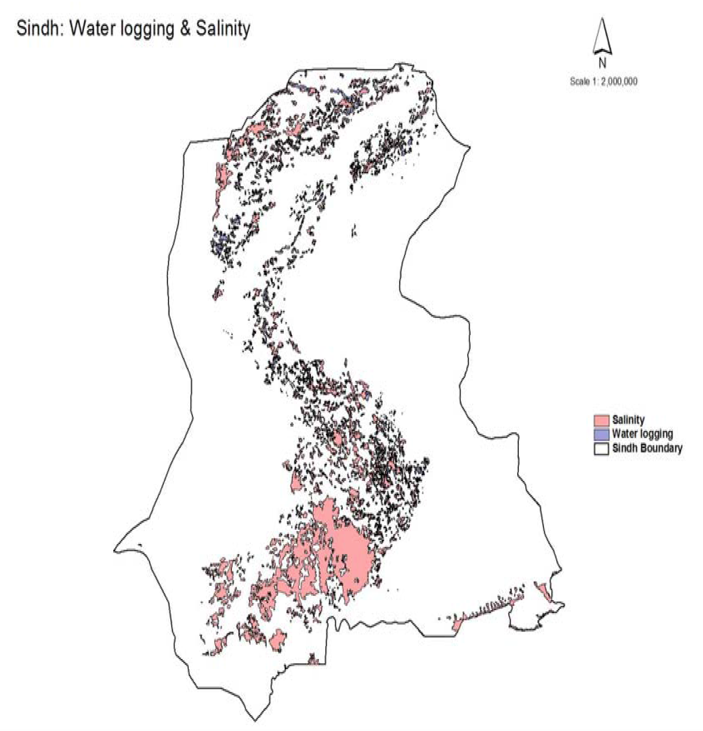

(Source: Land use Atlas of Pakistan, 2009. Ministry of Environment, Government of Pakistan)

Annex 12 – Proposed Water Reservoirs for Karachi

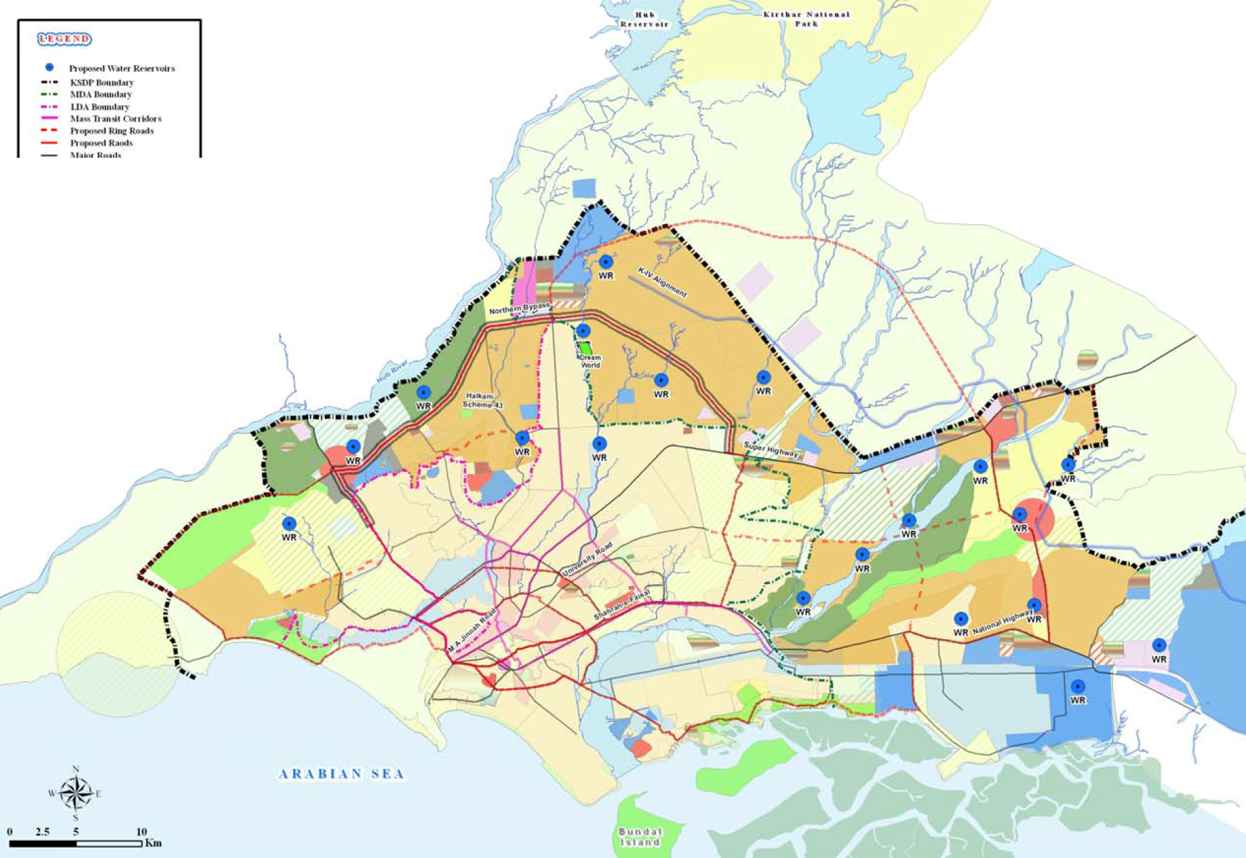
(Source: Karachi Strategic Development Plan 2020. Master Plan Group of Offices, City District Government Karachi)

Annex 13 – Proposed Sewage Treatment Plants in Karachi

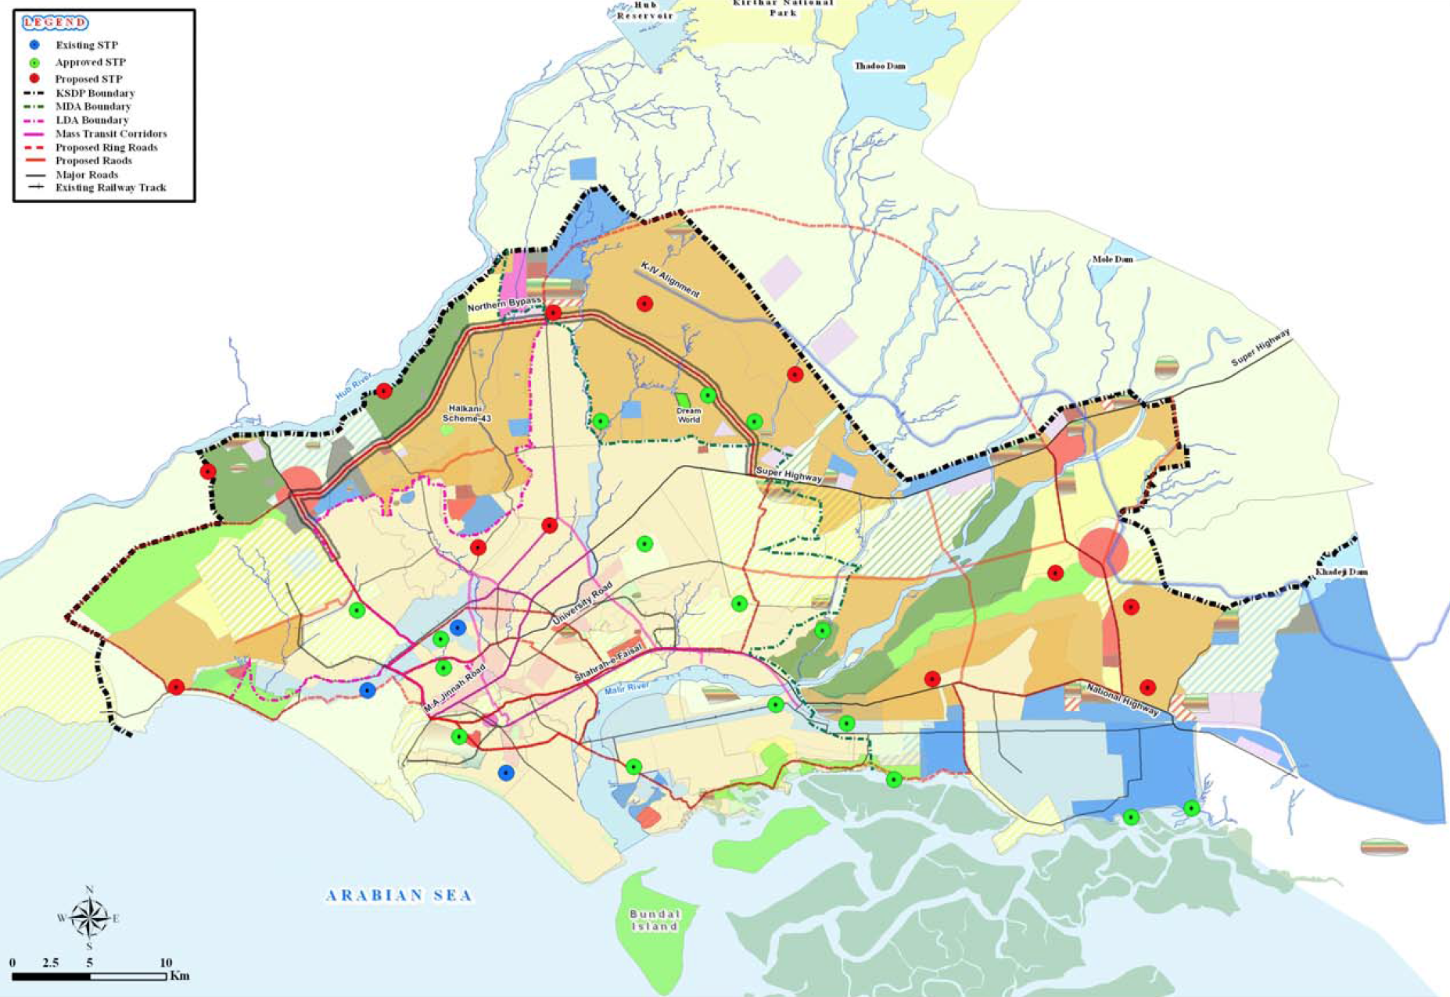
(Source: Karachi Strategic Development Plan 2020. Master Plan Group of Offices, City District Government Karachi)

Annex 14 – Proposed Garbage Transfer Stations for Karachi

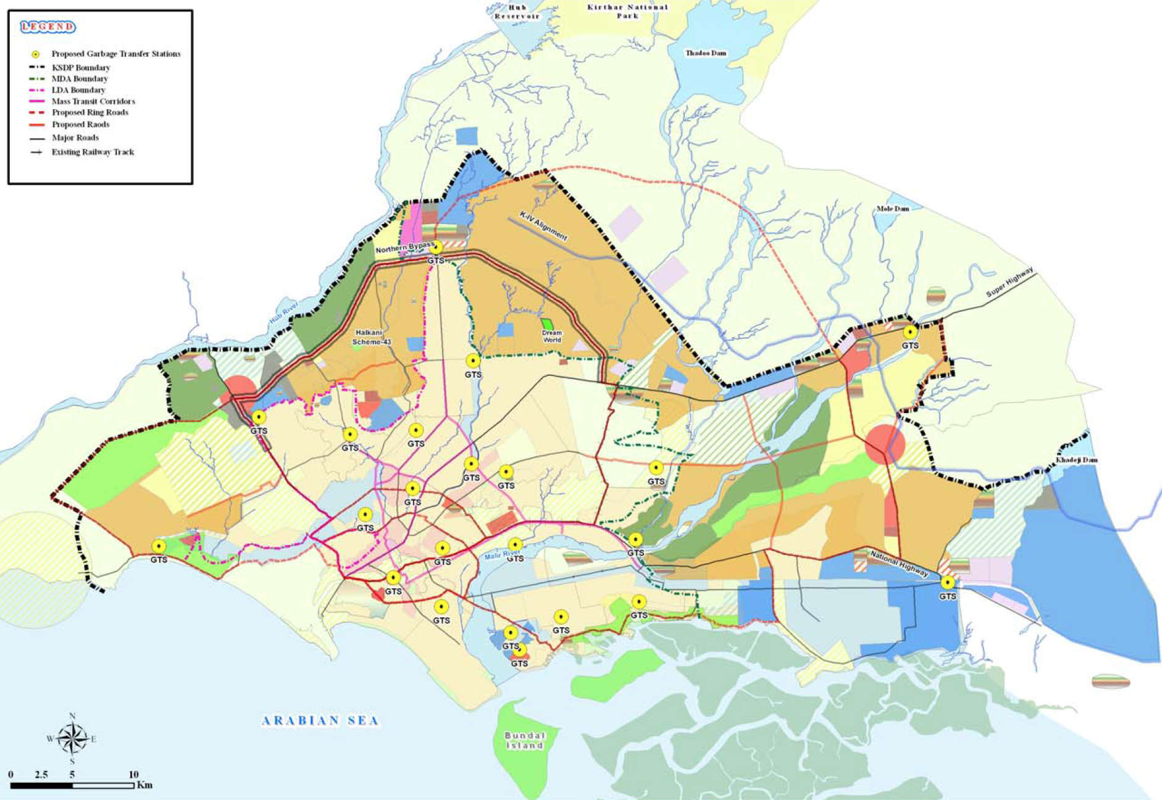
(Source: Karachi Strategic Development Plan 2020. Master Plan Group of Offices, City District Government Karachi)

Annex 15 – Stakeholder Analysis

Stakeholder Interviews

As part of the consultation process to develop the Sindh Sector Development Plan for WASH, several key stakeholders were consulted. The synthesis from this process is provided below.

Pakistan Council for Research in Water Resources

Pakistan Council of Research in Water Resources (PCRWR) is an apex autonomous research organisation established with the objective to conduct, organise, coordinate and promote research in all aspects of water resources. PCRWR was established in 1964, under a resolution and named as Irrigation, Drainage and Flood Control Research Council (IDFCRC) under the Ministry of Natural Resources. It was brought under the control of Ministry of Science and Technology in 1970. The Council was renamed as Pakistan Council of Research in Water Resources (PCRWR) in 1985. Since its inception, PCRWR has played its role as a national research organization by undertaking and promoting applied as well as basic research in various disciplines of water sector, more specifically, irrigation, drainage, surface and groundwater management, groundwater recharge, watershed management, desertification control, rainwater harvesting, , water quality assessment and monitoring, drinking water, industrial water, sewerage management and development of innovative water resource management, conservation and quality improvement technologies, etc.

The PCRWR is mandated to conduct, organise, co-ordinate and promote research in all fields of water resources engineering, planning and management, so as to optimally use the available land and water resources and to help achieve sustainability in the agricultural sector.

The following key challenges were identified and recommendations made during the consultation.

Challenges
- Inadequate water quality monitoring mechanism
- Poor dissemination of available knowledge (huge water quality data with PCRWR) among professionals for informed decision making
- Vast area of Sindh (about two-thirds) has brackish groundwater leading to no alternatives but costly surface water schemes
- Low priority of government on health and hygiene
- There is no check on effluent disposal into canals. The water in canals may be used for drinking and other household purposes in the downstream. This practice may have huge health impacts

Recommendations
- There is a need to take informed decisions in implementing water supply schemes while keeping water quality data in view
- Water conservation techniques should be promoted particularly rain water harvesting
- Low cost technological solutions need to be developed and adopted (indigenous bio-sand filters and arsenic removal filters) for rural areas
- Health and hygiene awareness should be made part of every scheme
- Untreated waste should not be disposed of into water bodies, particularly into canals which are the only sources of water supply in rural areas
- Irrigation department should make responsible for canal water quality

Sindh Environmental Protection Agency

Environmental and Alternate Energy Department was established in October 2002 through a cabinet order to supervise, administer and look after its subordinate directorates including Sindh Environmental Protection Agency and Alternative Energy Wing. The Sindh Environmental Protection Agency was established in July 1989 and has been working since then for the protection, rehabilitation, preservation and improvement of the environment It has two regional offices one each at Sukkur and Hyderabad while at Karachi it has a full-fledge analytical and testing laboratory.

The following key challenges were identified and recommendations made during the consultation.

Challenges
- Lack of financial and human resources in the sector
- Less sensitisation and lack of priority on wastewater treatment
- Inadequate capacity of EPA in monitoring and enforcing effluent standards
- Unplanned housing/industrial development making infrastructure planning more difficult and costly
- Burning of solid waste is on the increase by street sweepers
- Unplanned and uncontrolled cattle dens are making the sanitary conditions even worse

Recommendations
- An ecological study needs to be done for any significant change in cropping pattern (cotton reduced to 44% in Ghotki district) for better understanding of social and environmental impacts
- There should be separate policy for ground water abstraction/control
- Water logging should be addressed on priority to save/recover the most fertile lands
- Being a source of contamination; soakage pits should be banned in high water table areas
- Private sector should also be encouraged and sensitised to tackle environmental issues on priority
- The environmental mitigation measures should be properly estimated and anticipated costs should be reflected in every PC-I
- There is need to sensitise the policy makers on environmental related issues and hazards

Sindh Planning and Development and Special Initiatives Department

The P&DD is the main planning department for the Government of Sindh.

The following key challenges were identified and recommendations made during the consultation.

Challenges
- Capacity issue of professionals in the sector
- Inadequate sensitisation and lack of ownership in development works
- General tendency of over-design of schemes and thereby increasing costs
- Project management is a critical issue in designing and executing water and sanitation schemes
- Casual approach to project costing and planning as reflected through PC-1s (missing drawings, implementation plan and beneficiaries etc)

Recommendations
- Avoid duplication of efforts and resources by improving coordination among key players in the sector
- The schemes should be demand driven and should be well within the local context
- The schemes involving lower O&M costs should be preferred
- A workable implementation plan should be a part of every scheme design (PC-1) to adequately monitor progress
- Due to scarce financial resources; water and sanitation schemes need to design and implement wisely and optimally

Public Health Engineering and Rural Development Department

This is the main stakeholder responsible for execution of rural water supply and sanitation schemes.

The following key challenges were identified and recommendations made during the consultation.

Challenges
- Non-availability of potable ground water in most of Sindh
- Inadequate allocation of funds for O&M of completed schemes
- Inadequate capacity of local government department – both technical and financial- for taking over water supply and sanitation schemes completed and implemented by PHED
- Due to absence of electric connection, many completed water supply and sanitation schemes are non-functional

Recommendations
- There should be one organisation / department for both project execution and post completion O&M
- The schemes should be so designed that these could be completed in one year. The release of funds in subsequent years has always been a problem
- The funds allocated for a scheme should be made available (released) at the start of the fiscal year
- Electric connection for water supply and sanitation schemes should be given on priority basis. No scheme should be approved without approval of required electric connection
- There is need to establish a proper PHE wing in LG&RD having a pool of good engineers (transferred from PHED or newly recruited)
- Adequate funds should be allocated for O&M of the completed schemes

Directorate of Urban Policy and Strategic Planning

Government of Sindh has established the Directorate of Urban Policy and Strategic Planning (UP&SP) in the Planning and Development Department, with the mandate to plan for sustainable urban development in the province to realise the objectives of economic growth, planned infrastructure development - dictated by a strong policy and regulatory regime and to also address inequities caused by intra-urban and regional disparities. In order to achieve these objectives the Directorate has adopted a multi-pronged approach that includes preparation of policies, plans and projects - as well as discourse with the citizenry and the intellectuals.

The following key challenges were identified and recommendations made during the consultation.

Challenges
- Roles and responsibilities at various levels are vague and duplicating leading to diffused accountability
- The lack of capacity of public sector officials in taking right decisions and setting priorities for budget allocations
- Water and sanitation tariffs are too low to cover cost of service delivery that in turn leads to further deterioration of services

Recommendations
- In the Sindh context, untreated wastewater, currently being disposed of into sea, may also be looked into while developing WASH sector policies
- Instead of new schemes, budget allocation for on-goings schemes should be done on priority to ensure timely completion and to avoid cost over-run
- Water and sanitation sector policy should be synergetic with other related policies particular the health policies for having consolidated effects
- Sustainable Development Goals (SDGs) should be accounted for while developing Water and sanitation sector policies
- The O&M mechanism of Water and sanitation schemes need to be strengthened as brick and mortar type schemes are normally the priority of policy makers
- Emphasis should also be taken to complete PC-IV proforma which provides a sound basis to allocate proper O&M funds for a completed scheme
- No new scheme should be included in ADP for a particular area unless and until on-going schemes are completed
- Monitoring mechanism needs to be strengthened for effective development

Education Department – Reform Support Unit

The establishment of Reform Support Unit (RSU) was conceptualised as a means to build the institutional capability of the Department of Education. The very rationale of this programme is to streamline the existing edifice of education delivery and provide policy inputs for future advancement of education growth both in terms of access and quality. The institutional structure of RSU comprises of three wings: policy wing; monitoring and evaluation wing; and EMIS wing. The policy wing provides inputs for policy formulation and develops institutional memory of the department. The monitoring and evaluation wing develops reporting mechanisms as well as conducts evaluation of different interventions of Department of Education. The results of evaluations are ploughed back into policy. The existing structure of the Sindh Education Management System (SEMIS) has been made an integral part of the RSU as a first step to have a reliable and timely data for further policy formulation. The RSU is also envisioned as a forum to provide a platform for donor coordination as a measure to synchronise different donor's resources and efforts in a consolidated vision of educational excellence.

The following key challenges were identified and recommendations made during the consultation.

Challenges
- Inadequate funding resources for the sector
- A large majority of schools are without water and sanitation facilities
- Wrong priorities for allocation of development funds
- Capacity constraints in the water and sanitation sector

Recommendations
- Low cost technological models should be introduced, particularly for rural schools
- Aggressive awareness campaign should be launched regarding health impacts of poor sanitation and absence of proper hygiene practices
- Teaching curricula should be included in health and hygiene issues
- Water and sanitation sector should not go in isolation rather linkages should be developed with other sectors particularly health and education

Karachi Water Supply and Sewerage Board

The Karachi Water & Sewerage Board is a service based consumer oriented organisation responsible for production, transmission and distribution of potable water to the citizens of Karachi, managing sewerage systems within the city to ensure hygienic environment, development of scheme to cover short falls in services and collection of revenues for sustained economic viability.

The following key challenges were identified and recommendations made during the consultation.

Challenges
- Huge population influx in Karachi from all over Pakistan; putting more pressure on available water and sanitation services
- Ever widening demand and supply water gap in Karachi
- Water quality is a big issue in Sindh, as most of the available ground water is brackish

Recommendations
- Karachi should be given separate water quota other than for Sindh; as it is termed as mini Pakistan
- Climate change aspects need to be considered for all future developments in water and sanitation
- Water utilities need to adapt climate smart measures in their planning
- More storage reservoirs and dams are needed to capture increased water flows as a result of increased glacier melting
- Domestic and municipal water consumptions account for only 5% even then we are facing scarcity. There is need to prioritise competitive water uses
- More than 90% of available water is being used for agriculture (irrigation) with centuries old methods leading to huge losses. There is need to employ more water efficient irrigation methods and to conserve water for other uses
- Like water apportion award, we should have an interprovincial drinking water apportion award
- Wastewater recycling should be made on priority with needed treatment
- In rural areas we should introduce low cost wastewater solutions like floating gardens (constructed wetlands)
- There is need to sensitise policy makers (politicians) on water and sanitation issues and allocation of necessary funds and resources
- Water quality needs to be monitored on regular basis. Accordingly, a robust monitoring plan should be developed at provincial level

Sindh Solid Waste Management Board

The Sindh Solid Waste Management Board was established under the The Sindh Solid Waste Management Board Act, 2014 to provide for the establishment of a Board called as the “Sindh Solid Waste Management Board” for the collection and disposal of solid and other waste in the Province of Sindh.

The following key challenges were identified and recommendations made during the consultation.

Challenges
- Lack of will and dedication of public sector officials in efficient service delivery
- Wrong priority of funds allocation for development works
- Capacity constraints of water and sanitation professionals

Recommendations
- The overall goal should be to improve environment for uplifting quality of life
- Ideally solid waste management should be the purview of one entity dedicated for water and sanitation services. But solid waste should be handled by a separate entity other than water and sanitation service provider under the current circumstances
- There should be dedicated water and sewerage board at each Administrative Division level (similar to KW&SB). As water and sanitation services have upstream (if water source is in other district) and downstream (wastewater is disposed into a water body) effect, it needs macro level management
- The role of divisional boards would be to give policy and set directions. Whereas districts would be responsible for actual service delivery
- A separate section should be dedicated on solid waste in Sanitation Policy
- Adequate linkages should be suggested in policy with other areas (social, economic, health, environment etc.)

North Sindh Urban Services Corporation

The North Sindh Urban Services Corporation has been established under the Companies Ordinance 1984 for the secondary cities of the Northern cluster of Sindh Province. This Urban Services Corporation aims to aggregate participating Tehsil Municipal Administration’s (TMAs) water supply, waste water and solid waste management operation in a single institution to leverage economies of scale, introduce new skills and management, and increase focus on operations, maintenance and financial management. Presently, NSUSC is being implemented in 7 cities (Sukkur/New Sukkur, Rohri, Khairpur Mirs, Shikarpur, Larkana, Jacobabad and Ghotki).

The following key challenges were identified and recommendations made during the consultation.

Challenges
- Political Interference leading to compromised decision making
- Lack of capacity of sector officials
- Inadequate allocation of financial resources
- Insufficient machinery
- Water quality issue
- Lack of will among professionals and internal rift – impact negatively in achieving sector targets and objectives

Recommendations
- Mass awareness is needed particularly for effective water and sanitation services particularly for solid waste management
- Need to change the mind set of public – water and sanitation services are not free and need cost recovery for sustainability and further improvement
- Sensitisation and awareness campaigns should make use of schools, notables and public gatherings
- Improve water and sanitation tariff to cover at least operational costs
- Discourage free or even subsidised WSS services
- Seek customised technological solutions to meet local requirements
- Establish customers’ care centre for quickly addressing public complaints
- Develop and implement SOPs for each process/step in WSS service delivery
- Involve /engage press and media proactively for disseminating of development activities, constraints and seek public support

Cantonment Board Malir

Malir Cantonment is administratively governed through "Cantonment Board Malir", a Local Body by its charter, under the jurisdiction of Ministry of Defence, through the Military Lands and Cantonment Department, headed by a Director General. The governance of the Cantonment Board derives authority from the Cantonment Act, 1924 and rules and regulations made thereunder. The cantonment maintains its own infrastructure of water supply, electricity and is outside the jurisdiction of City District Government Karachi.

The following key challenges were identified and recommendations made during the consultation.

Challenges
- No water pricing mechanism
- Lack of solid waste dumping sites
- No or inadequate wastewater treatment

Recommendations
- Wastewater reuse needs to be encouraged after proper treatment
- Cost recovery of water and sanitation services should be ensured
- Close monitoring and keen follow up of development works should be made on priority
- Coordination mechanism among various water and sanitation sector stakeholders should be improved for expeditious outputs
- Dedicated dumping sites should be made available for solid waste disposal
- Water quality monitoring should be made a part of the overall development agenda
- Filter plants need to be installed in areas where normal water supply schemes are not economically feasible

Hyderabad Water and Sanitation Agency

Hyderabad WASA is the main utility for Hyderabad City.

The following key challenges were identified and recommendations made during the consultation.

Challenges
- Haphazard development in absence of any master plan at city level
- Low cost recovery leading towards ever deteriorating water and sanitation services
- Lack of awareness among consumers towards better use of water and sanitation services, (leakages, garbage dumping in sewers, illegal water connections and pumping through main lines etc.)
- The development projects are politically motivated thus jeopardise or at least compromise the true demand
- Change of government is detrimental to on-going schemes; as the new government has its own priorities. Resultantly the on-going schemes are inordinately delayed and in most cases are cost over-runs

Recommendations
- City wide master planning needs to done
- The funding once allocated for a scheme should be properly ensured
- The on-going schemes should have priority in receipt of development funds
- Adequate funds should be allocated for water treatment (chemicals) facilities to ensure supply of potable water to consumers
- Public awareness on water and sanitation services, cost recovery and other related issues should be aggressively followed
- Dignitaries should be involved for effective dissemination of key motivating messages
- At national level, the awareness campaign (like of polio) should be launched particularly for water conservation, health impacts and on cost recovery
- Water metering should be promoted as a critical demand management tool
- Water and sanitation sector should be reformed at city level by separating and designating responsibilities of Production, Distribution and Maintenance to three different entities
- Capacity building of water professionals should be made on regular basis
- Cash crunched water utilities should be given bailout package by government to make them financially self-sufficient
- Legal authority should be given to water utilities for enforcing its policy (illegal water and sewer connections) and boosting cost recovery
- Consumers’ survey should be conducted on regular intervals to gauge the utilities outreach and level of services
- Effluent should be treated on priority
- Water storage capacity should be increased
- Governance of water sector institutions should be improved for efficient services delivery

NED Engineering University of Engineering and Technology

The NED University of Engineering and Technology, was established in March 1977 under an Act of the Provincial Assembly of Sindh after upgrading of the former NED Government Engineering College, which was set up in 1922. The NED University is thus one of the oldest institutions in Pakistan for teaching and producing Engineering graduates.

The following key challenges were identified and recommendations made during the consultation.

Challenges
- Overexploitation of groundwater which is threatening the water balance
- Water scarcity forces migration to other places which are not yet water scarce areas but could lead to further water stress
- Most of the water and sanitation infrastructure is old and hampering effective service delivery
- Irrational water pricing causes poor level of service and enhance corruption
- Most of water supply schemes are politically motivated rather than cope with the actual needs
- Water availability and demand gap is widening day by day due to increased population and lack of proper planning

Recommendations
- Wastewater should be treated and managed at source for cost effectiveness
- Pipe leakages should be addressed on priority; as these not only lead to huge wastage of treated water but also a continuous source of pollutions in overall water supply network
- Groundwater abstraction needs to be controlled
- More storage reservoirs and dams need to be built to adequately cater for variations in water availability
- The water and sanitation management for urban and rural should be designed with respect to social, cultural and economic context
- There is need to define a clear ownership of various water bodies for better monitoring of water resources
- There should be a mechanism for regular technological updating and capacity building of sector professionals
- Accountability needs to be strengthened at all levels
- Reduce discretionary powers as a policy measure
- High moral values need to be inculcated among people from all walks of life through enhanced awareness and behavioural change campaigns
- There is need to raise awareness on current water challenges (scarcity, conservation and climate change effect etc.)
- Systems should be so designed that water theft (through pumps and illegal connections) is minimised
- Solid waste should be taken as a resource and accordingly be reused or recycled
- Introduce policy of award and penalty at all levels to promote accountability and efficient service delivery

Mehran University of Engineering Technology

The Pakistan Centre for Advanced Studies in Water (PCAS-W) has been established at the Mehran University of Engineering and Technology (MUET) Jamshoro under the Cooperative Agreement signed with USAID on Dec. 12, 2014 for five years. The USAID-funded Pakistan Centre for Advanced Studies MUET in water is a state of the art and modern applied research centre. PCAS-W is a world class education and applied research centre dedicated to resolving Pakistan’s water crises through applied research, developing specialist human resources and technologies; academia-industry collaboration; and policy formulation. The centres will generate cost-effective and sustainable solutions to Pakistan’s challenges related to water and educating the next generation of scientists, engineers, and policy makers through innovative academic programmes in water that are focused on applied research.

The following key challenges were identified and recommendations made during the consultation.

Challenges
- Water Quality is a serious issue and is being grossly neglected by concerned agencies.
- Water treatment measures are not adequate, particularly in water treatment plants, (case of H-WASA), treatment process is being compromised (lesser degree of sedimentation, inadequate flocculation – adding no coagulant- and inappropriate filtration and absence of chlorination). Such a situation is leading to serious health risks for the consumers
- The machinery is in dilapidated situation due to no or deferred O&M
- There is no robust mechanism of monitoring and oversight
- There is need to improve accountability with proper check and balance arrangements in place
- Insufficient cost recovery
- Embedded corruption in the system

Recommendations
- Rural urban migration – needs to be studied in context of push and pull factors as water is also a push factor. Urban areas are already water stressed and any additional population influx could further aggravate the situation
- Water mapping in terms of its availability / scarcity needs to be done
- Population settlements should be adoptive of water availability /scarcity context
- Water governance needs to be strengthened
- Availability of water should be taken as a right and access should accordingly be universal (for all)
- Increase water and sewerage tariff to cover operational expenditures
- Community Participation should be through the entire project cycle
- Raising awareness on water borne diseases and its linkage with provision of water and sanitation services
- Mechanism should be in place for wider dissemination of R&D findings in the sector
- Promote low cost technologies in the sector
- In the context of growing water scarcity, wastewater re-cycling should be an option

National Rural Support Programme

Established in 1991, National Rural Support Programme (NRSP) is the largest Rural Support Programme in the country in terms of outreach, staff and development activities. It is a not for profit organisation registered under Section 42 of Companies Ordinance 1984.

NRSP's mandate is to alleviate poverty by harnessing people's potential and undertake development activities in Pakistan. It has a presence in 61 Districts in all the four Provinces including Azad Jammu and Kashmir through Regional Offices and Field Offices. NRSP is currently working with more than 2.9 million poor households organised into a network of 185,766 Community Organisations. With sustained incremental growth, it is emerging as Pakistan's leading engine for poverty reduction and rural development.

The following key challenges were identified and recommendations made during the consultation.

Challenges
- Water quality is a major issue in Sindh context
- Lack of coordination among various actors in the sector; leading to overlapping and duplication of resources and efforts
- There is no mechanism to monitor the sector issues and progress in a coherent way
- Inadequate low cost solution in rural localities particularly in sparsely populated areas

Recommendations
- Health and Hygiene should be an integral part of all schemes
- Exclusive yet mandatory funds need to be allocated for health and hygiene (soft component) in water and sanitation schemes
- An integrated approach (water, sanitation, health and hygiene) should be adopted; as schemes meeting such criteria appeared to be more sustainable and long lasting
- IEC material needs to be developed for use of improved quality water
- Behaviour change is a key in sanitation and solid waste management
- ODF needs to be promoted by sensitising communities on related health issues
- At district level, a water and sanitation coordination committee should be formulated to assess the need, monitor progress in sector and liaise with/ among participating organisations
- There should be central database for the sector to know precisely who is doing what and where
- For civil society organisations working in the sector; increased level of government support is critical for efficient service delivery
- More effective tools (school teachers, LHVs) need to be developed for sensitising the communities on health and hygiene related issues
- Softer issues should be promoted through smart messages in the media

Sindh Rural Support Organisation

Established in 2003, the Sindh Rural Support Organisation (SRSO) is the major Rural Support Programme in Northern Sindh. It is a not-for-profit organisation registered under Section 42 of the Companies Ordinance 1984. SRSO is present in 10 districts, namely Sukkur, Khairpur, Ghotki, Nausharo Feroze, Shaheed Banazirabad, Shikarpur, Jacobabad, Larkana, Kashmore-Kandhkot, and Qambar-Shadadkot. The mandate of SRSO is to alleviate poverty by harnessing the people’s potential and to undertake development activities in Sindh.

The following key challenges were identified and recommendations made during the consultation.

Challenges
- Poor implementation of policy, developmental activities
- Lack of horizontal and vertical linkages in the water and sanitation sector
- Lack of consultation with key stakeholders in development planning
- Politically motivated schemes having lesser impact in overall service coverage
- Inadequate government writ in implementing its policy measures

Recommendations
- Community involvement and their active participation are critical for success of projects
- Communities’ voice could be integrated through community based organisations
- There is a need to formulate a rural development policy
- All developments in rural areas should broadly follow the principles and guidelines given in policy documents
- Village Development Plans (VDPs) should be prepared for each village and should adhere to the general guidelines given in the rural development policy
- Channel more financial resources in the water and sanitation sector
- Discourage/avoid construction of open drains as these are a source of pollution and contamination
- Government officers should be given a tenure posting to avoid political influence (no threat of transfer) and promote accountability (have to leave the job after certain time)
- Capacity building of professionals involved in the sector is of paramount importance and requires due attention
- Sector planning should be done at national/provincial level and all development should follow the macro level planning
- Hygiene is a critical issue and community should be sensitised in the context of health impacts
- Governance in the sector needs to be improved by giving civil society organisations a more proactive role in planning, monitoring and execution of public sector projects
- Access to information for public sector projects should be encouraged /promoted

Research and Development Foundation

The organisation was established and registered in the year 2002 at Hyderabad with the objective to innovate social solutions against long standing problems through action research and creating impacts on lives and livelihoods of the less privileged sections of the society. The organisation was established by young and energetic development professionals who believed in values of transparency, accountability and equality. The organisation started its operations as a volunteer effort in its formative phase but later on since 2008 it started implement development projects in collaboration with funding agencies and humanitarian organisations. Hence by 2008, a formal structure of the organisation evolved and professional staff were hired to carry out the projects. The organisation is being looked after by an elected Board of Directors.

The following key challenges were identified and recommendations made during the consultation.

Challenges
- Brackish ground water in almost two-thirds of the province makes water supply schemes costly
- Communities are forced to access brackish water in the absence of any water supply scheme
- Poor consultation with communities in case of public sector schemes
- Most of the sector schemes are not demand driven; as such more likely to fail when these are handed over to communities for post completion O&M

Recommendations
- Promote low cost technologies like bio-sand filters
- Solar based technologies should be introduced in rural areas to reduce operational cost and achieve sustainability of schemes
- ODF sanitation approach should be intensified
- CLTS may be strengthened and consolidated
- More resources should be injected in the sector

HANDS

Health and Nutrition Development Society (HANDS) was founded in 1979.HANDS has evolved since then as one of the largest Non-Profit Organisation of the country with an integrated development model. HANDS has a network of 30 offices across the country and has access to more than 16.2 million population in nearly 20,274 villages/settlements in 34 districts of Pakistan. HANDS strength is 18 volunteer Board Members, more than 1502 full time staff and nearly one million community based volunteers of 5205 medium and small size organisations.

The following key challenges were identified and recommendations made during the consultation.

Challenges
- In urban areas, slums and poor settlements are often neglected for water and sanitation services
- Very low coverage of sanitation in rural areas of Sindh has huge health implications
- Water utilities lack in needed policy and regulation with regards to cover slum areas

Recommendations
- Water and sanitation sector should also not only be capable of responding to disasters but should also get prepared for such events
- In rural areas CLTS model should be promoted
- Low cost sanitation models should be designed and implemented for universal sanitation coverage
- Every water utility should have an exclusive policy to expand its outreach in slums and katchi abadies
- Water and sanitation services should be provided in an integrated way (water, sanitation, solid waste and wastewater treatment) where possible
- The sector plans and policy should have a strong monitoring mechanism to gauge progress and to take corrective measures during course of implementation

WaterAid Pakistan

WaterAid launched its programme in Pakistan in 2006. It has helped marginalised communities establish sustainable water supplies and sanitation services. It has also influenced government policy-makers to serve the interests of vulnerable people. WaterAid's strategy in Pakistan is to work through local partners to improve hygiene behaviour and ensure people have access to water supply and sanitation services, with a special emphasis on innovative approaches, participatory methods, women and other vulnerable groups, hygiene promotion, monitoring and evaluation, and sustainability. WaterAid is working with seven partner organisations in seven districts of Sindh, Punjab and Khyber Pakhtunkhwa to bring change in the lives of those living without safe water and sanitation.

The following key challenges were identified and recommendations made during the consultation.

Challenges
- Monitoring of water quality is a critical issue and often neglected despite huge health impacts
- Health and hygiene do not get proper attention in water and sanitation sector
- Demand management by service provider does not get proper attention leading to water scarcity in already water stressed environment

Recommendations
- Water Security mapping needs to be done and updated periodically
- Water conservation technologies should be promoted (rainwater harvesting, ground water recharging etc.)
- Donors should build capacity of the government with particular focus on policy and reforming the sector
- An integrated approach needs to be followed in the water and sanitation sector. End of pipe solutions (effluent treatment) should also get priority in overall development agenda/ planning
- District level water and sanitation coordination mechanism needs to be developed for developing synergies and avoiding overlapping of resources and efforts
- Strengthen implementation monitoring mechanism for development effectiveness
- Central database for water and sanitation sector need to be maintained at district/provincial level for generating updated reports
- There should be time bound targets at all levels (policy, implementation, service providers, increasing access etc.)

Plan Pakistan

Plan is an International, Child Centred Community Development Organisation with no religious, political, or government affiliation. Plan Pakistan is a member of its global network of 66 Countries working with 10 million children, women and men. Plan Pakistan began its programmes in Pakistan in 1997 and its work covers around 150 communities, benefiting about 50,000 children under the areas of health, education, livelihood, child and gender rights, and disaster risk reduction and response. Plan implements its programmes and projects at the grassroots level in Health, Education, Water and Sanitation, Income Generation, and Building Relations.

The following key challenges were identified and recommendations made during the consultation.

Challenges
- Lack of capacity of services provider in synergetic planning and implementation
- Absence (or insufficient) of central database of the water and sanitation sector
- Negligible attention on wastewater treatment
- Lack of support funds (for logistics, travel, equipment, stationery etc.) in public sector entities, leading to inefficient services delivery
- Ambiguity and confusion in sector jargons (ODF, CLTS, PATS etc.)

Recommendations
- Need to develop workable coordination among sector actors particularly among donors
- CLTS approach should be effectively followed for expanding access to safe sanitation services
- The villages that have successfully achieved ODF status should be given water supply schemes on priority as an incentive
- There is a need to develop ground water monitoring to regulate abstraction of this scarce resource
- Water and sanitation sector should be viewed in totality (keeping in view, other developments, environment and social aspects) for sustainability of interventions
- Encourage re-use of water through treatment
- ODF campaign should be followed religiously
- Appropriate tools should be employed for awareness raising and behaviour change; these include use of LHWs, School teachers, UC Secretaries, and children. The capacity should accordingly be built for persons involved
- BHU doctors should also be involved in ODF campaign; as they can better highlight health impacts of poor sanitation conditions
- A dedicated unit should be established at provincial level to monitor progress of milestones identified in water and sanitation policy/strategy
- Uniformity and consistency – with clear definitions- should be made in sector Acronyms to avoid confusion
- Consistent approach (with similar incentives, subsidies etc.) should be followed, at least in the same district; in implementing various programmes in an area to avoid implementation confusion
- Academia should involve in the water and sanitation sector particularly for finding low cost solutions for water, sanitation and wastewater treatment

Asian Development Bank

The Asian Development Bank (ADB) was conceived in the early 1960s as a financial institution that would be Asian in character and foster economic growth and cooperation in one of the poorest regions in the world. ADB assists its members, and partners, by providing loans, technical assistance, grants, and equity investments to promote social and economic development.

The following key challenges were identified and recommendations made during the consultation.

Challenges
- Diffused responsibilities in the sector leading to inefficient services and lack of accountability
- Absence of any anchor/ focal department at district level (to whom interested parties/donors could directly interact)
- Lack of political will to implement the development agenda
- Wrong priorities in allocation of funds and resources
- Capacity building gaps among the policy makers, institutions and civil society organisations

Recommendations
- Overall management/ governance of water and sanitation sector needs to be strengthened
- In urban context, provision of water and sanitation services should be well integrated with the overall urban sector planning. Sector development in isolation would be bound to fail or ineffective
- Political leadership needs to be sensitised on water and sanitation sector’s needs and requirements through awareness raising, dialogue and exposure visits
- Need to find political champions among the policy makers and critical mass within the system to bring required change in a sustainable fashion
- Different governance/ management structure for rural and urban areas in water and sanitation sector should be kept in mind while doing development planning
- A synergetic approach should be followed in policy measures for water and sanitation sector (Considering urban planning, environment, education and other related sectors)
- Performance benchmarking in the sector needs to be introduced. Accordingly, the sector institutions should be rewarded/penalised
- Monitoring of sector should be strengthened by introducing crispy and measureable indicators
- An output based budgeting needs to be done
- Academia also be sensitised to play its active role in water and sanitation sector through R&D and technological innovations

Focus Group Discussions

Over 50 Focus Group Discussions (FGDs) were held with students, teachers, local councillors, community members, LHWs etc to gauge their views about water and sanitation in the province. These FGDs were undertaken in Hyderabad, Sanghar, Dadu and Gadap Town in Karachi.

The following key themes emerged from the FGDs.

Water
A mixed trend of piped water supply and ground water pumping has been observed. Cities i.e. Hyderabad, Karachi and some areas of Dadu have water supply connections. However, towns/small cities i.e. Mithi, Shahdad Pur (Sanghar) rely entirely on ground water. In rural areas, ground water is the major source, while dug wells (particularly in Tharparkar) and canal water are other sources. Complaints of old laid water supply lines; water contamination (bad smell, taste and colour) and brackish water are very common. Filtration plants have been installed in big cities and towns. However, timely maintenance (Cartridge replacement) of these filters remains a question mark. Furthermore, delay in construction of development projects has also observed i.e. water filtration plant in village Tando Fazal, Hyderabad is under construction since the last one and half year and, while a city level filtration plant in Shahdadpur Sanghar is under construction since the last two years. A trend of purchasing drinking water at the rate of PKR 20-30 per can (10-20 litres) has also been observed in urban areas. Hepatitis and jaundice diseases are found in all of the interviewed communities.

Sewerage/Drainage
Piped sewerage is available in most of the urban areas of Karachi, Hyderabad, Dadu and Shadadpur (Sanghar). However, there are common issues of overflowing of sewerage gutters. There are two major factors that lead to this situation 1) desilting of gutter/sewerage line has not been performed regularly; 2) natural gravity is not available for sewage flow and lines are connected with sewerage wells that throw water to the main trunk line by way of a motor pump - however, due to load-shedding or disconnection (because of over-dues) of electricity from motor-pumps, this system is not functional. Furthermore, open drains exist in some areas of Dadu, Shadadpur (Sanghar) and Mithi, and in entire rural areas. However, in urban areas drains are paved while in rural areas unpaved drains are common. It is generally observed that waste water flows directly to canals without any treatment in urban areas, while in rural areas it is flows to the streets (if drain system doesn’t exist) or to the fields (if drain system exists).

Toilets
Household toilets are available in almost all of the urban areas except urban slums (Bhagri Mohalla Dadu). Majority of these toilets are connected directly with sewerage lines or open drains. However, toilets connected with septic tanks also exist in urban areas. In larger villages, household level toilets exist above 50%, while in smaller villages/hamlets the concept of household toilet is not common or its need appreciated. The members of households without toilets defecate in the open. Furthermore, toilets in rural areas are mostly connected with unpaved pits and infrequently with septic tanks.

Solid Waste Management
Urban areas have been served with solid waste management services by the Government. However, non availability of street level dumping stations or trolleys are very common complaints. Generally, garbage is dumped in empty plots from where it is collected in a range of time between 2 days to a month. Furthermore, regular sweeping of streets is very uncommon in small cities/towns i.e. Dadu and Mithi. There are no solid waste services in rural areas. In larger villages, communities themselves allot a place for dumping solid waste and very occasionally burn it.

Hand Washing
Regular hand washing with soap before eating and after toilet is not above 50%. However, washing hands with water only or occasionally hand washing with soap is common. In FGDs with LHWs, it was revealed that hand washing before breastfeeding by lactating women is not common.

Governance
Generally, the community doesn’t show their satisfaction from WASH services by the government. However, the newly elected local government representatives prioritise WASH issues. But these elected representatives are not clear about their role as per the SLGA 2013.

NGOs Initiatives
A number of NGOs have been implementing WASH related projects i.e. HANDS and OPP in Karachi; Sukaar Foundation, Sami Foundation and NRSP in Mithi; RDF in Hyderabad; Oxfam in Dadu and; DevCon in Sanghar etc.

National Lady Health Workers Programme
National LHW programme is the largest programme in terms of outreach in which almost 90% or more areas are covered with this programme. WASH is part of the curriculum of LHWs i.e. use of boiled or filtered drinking water, keeping toilets clean and door closed, hand washing before eating/feeding and after toilet use. LHWs have also formed women groups to whom they deliver sessions for peer to peer learning. Furthermore, WASH mapping of respective areas i.e. type of water sources, toilet availability and drainage system is part of LHWs monthly reports. However, there is no centralised WASH database to capture information obtained from these monthly reports.

School WASH
Piped water in urban area schools and ground water in rural area schools are the main source of drinking water. However, bad taste, yellow colour, bad smell and brackish water have also been recorded regarding school water. Furthermore, except for some NGO initiatives, the water test has never been performed for school water.

School toilets exist in almost all of the schools. However, there are a considerable number of non-functional toilets due to inappropriate management. There are a number of factors that contribute to this situation e.g. unavailability of water or excess of water in toilets, not cleaning toilets regularly and choked toilets due to improper drainage. Furthermore, implementation of guidelines of Sindh Education Sector Plan 2014-18 for toilet facility i.e. one toilet per 25 girls and one toilet per 40 boys has not observed in the schools visited. In high schools, this ratio is above 100 students per toilet.

Soap availability at hand washing facilities of schools has not been seen in schools except those schools where an NGO or soap company provided soap. However, most of the students claim that they wash hands with soap after using toilet. This suggests that there is knowledge of critical times of hand washing and may even be practiced.

Except some NGO’s training of teachers and school level sessions, no WASH training of teachers has been conducted by the education department. However, school level sessions on hand washing by some soap companies in urban areas and by NGOs in rural areas has created awareness among students. A nutrition officer from the respective BHU also visits the school on monthly basis and he/she occasionally imparts a session on WASH practices. Teachers don’t consider that the existing curriculum addresses the WASH issues.

The themes that emerged from stakeholder consultation were used to develop strategic priorities for the sector development plan.



Bloom, David, Zeba A. Sathar, and Maqsood Sadiq. “Prospects for Economic Growth in Sindh under Alternative Demographic Scenarios: The Case for a Rapid Fertility Decline,” Policy Brief. Islamabad, Pakistan: Population Council, Evidence Project. 2015.
State of the Environment Report (draft) 2005. Government of Pakistan, Ministry of Environment
Improved sources of drinking water are those using any of the following types of supply: piped water (into dwelling, compound, yard or plot, to neighbor, public tap/standpipe), tube well/borehole, protected well, protected spring, and rainwatercollection. Bottled water is considered as an improved water source only if the household is using an improved water source for hand washing and cooking.
(Draft) Guideline for Solid Waste Management June 2005. Pakistan Environment Protection Agency
http://worldpopulationreview.com/world-cities/karachi-population/ accessed on 27 April 2016
Pakistan Social and Living Standards Measurement Survey, 2013-14
Menstrual Hygiene Management for Adolescent School Girls in KP and PAK, Pakistan, May 2013, UNICEF Pakistan
National Water Quality Monitoring Programme, Water Quality Status in Pakistan, Phase I-V, 2001-2006, Pakistan Council of Research in Water Resources
http://pwon.org.pk/ accessed on 31st March 2015
Investing Wisely - Sanitation and Water - Saving Lives. Pakistan Sector Status Report 2012, Government of Pakistan
UN-Water global annual assessment of sanitation and drinking-water (GLAAS) 2012 report: the challenge of extending and sustaining services. WHO 2012
Pakistan Water Supply and Sanitation Sector, Volume I. Urban Water Supply and Sanitation, 2012. The World Bank
Pakistan Water Supply and Sanitation Sector, Volume II. Rural Water Supply and Sanitation, 2012. The World Bank
Pakistan Sanitation Country Paper SACOSAN-V 2013. Government of Pakistan
UN Process Towards a Post-2015 Development Agenda. Report on Pakistan National Consultations February 2014. Global Water Partnership, 2014
https://sustainabledevelopment.un.org/sdgsproposal accessed on 31st March 2015
Pakistan Millennium Development Goals Report 2013. Planning Commission, Government of Pakistan
Multiple Indicator Cluster Survey 2014. Government of Sindh and UNICEF
Development Statistics of Sindh 2013. Sindh Bureau of Statistics, Government of Sindh
Development Statistics of Sindh 2013. Sindh Bureau of Statistics, Government of Sindh
Development Statistics of Sindh 2013. Sindh Bureau of Statistics, Government of Sindh
Human Development Report 2015. UNDP
http://unpo.org/article/10253 accessed on 21 May 2016
Sathar, Zeba A., Maqsood Sadiq, and Seemin Ashfaq. “Reducing maternal and child mortality in Sindh: The untapped potential of family planning,” Policy Brief. Islamabad, Pakistan: Population Council, Evidence Project 2015.
Multiple Indicator Cluster Survey (MICS) Sindh 2014. Government of Sindh
Annual PRSP Budgetary Expenditures for FY 2010-11, FY 2011-12, FY 2012-13, FY 2013-14, and FY 2014-15 (Provisional). Ministry of Finance, Government of Pakistan
Pakistan Social and Living Standards Measurement Survey 2013-14. Pakistan Bureau of Statistics
Sindh (Rural) Education Scorecard. ASER 2014
Pakistan Social and Living Standards Measurement Survey 2013-14. Pakistan Bureau of Statistics
Annual Status of Education Report – Pakistan 2014
Annual Status of Education Report – Pakistan National Report (Rural) 2015
Annual Status of Education Report – Pakistan National Report (Rural) 2015
Annual Status of Education Report – Pakistan National Report (Rural) 2015
Economic Survey of Pakistan 2014-15. Ministry of Finance, Government of Pakistan
Analytical Review of the PSDP portfolio, Planning Commission, Government of Pakistan, 2011
Economic Survey of Pakistan 2014-15. Ministry of Finance, Government of Pakistan
Khan A et al. Mapping and Measuring of Multidimensional Poverty in Pakistan: Empirical Investigations, 2011
Jamal H. Assessing Poverty with Non-Income Deprivation Indicators: Pakistan, 2008-09. The Pakistan Development Review 50:4 Part II (Winter 2011) pp.913–927
Household Integrated Economic Survey 2010-11. Pakistan Bureau of Statistics
Arif Naveed and Nazim Ali. Clustered Deprivation: District Profile of Poverty in Pakistan, 2012. Sustainable Development Policy Institute
Economic Survey of Pakistan 2014-15. Ministry of Finance, Government of Pakistan
Pakistan Social and Living Standards Measurement Survey 2013-14. Pakistan Bureau of Statistics
Pakistan Social and Living Standards Measurement Survey 2013-14. Pakistan Bureau of Statistics
Shahida Rasheed, Saira Iqbal, Lubna A. Baig, Kehkashan Mufti. Hospital Waste Management in theTeaching Hospitals of Karachi. JPMA 55:192;2005
Bloom, David, Zeba A. Sathar, and Maqsood Sadiq. “Prospects for Economic Growth in Sindh under Alternative Demographic Scenarios: The Case for a Rapid Fertility Decline,” Policy Brief. Islamabad, Pakistan: Population Council, Evidence Project. 2015.
Sindh Development Statistics 2013. Sindh Bureau of Statistics, Government of Sindh
“Other” includes public standpipe (supplied by tanker), water seller, canal, river, spring, stream, pond, mineral water, Filtration Plant and other
Pakistan Social and Living Standards Measurement survey 2012-2013 and 2013-14. Pakistan Bureau of Statistics, Government of Pakistan
Multiple Indicator Cluster Survey (MICS) Sindh 2014. Government of Sindh
Includespiped water (into dwelling, compound, yard or plot, to neighbor, public tap/standpipe), tube well/borehole, protected well, protected spring, and rainwatercollection. Bottled water is considered as an improved water source only if the household is using an improved water source for handwashing and cooking.
Pakistan Social and Living Standards Measurement survey 2013-2014. Pakistan Bureau of Statistics, Government of Pakistan
The Study on Water Supply and Sewerage System in Karachi in the Islamic Republic of Pakistan, 2008. Japan International Cooperation Agency (JICA), Karachi Water & Sewerage Board (KW&SB)
Water resource information by country/territory and MDG Water Indicator, FAO-AQUASTAT database, April 2016
1 Million Acre Foot (MAF) is equivalent to about 1.233 Km³
Overlap is water shared by both the surface water and groundwater systems
World Water Report 2013 – Data Table 2, Freshwater withdrawal by country and sector (2013 update)
Irrigation in Southern and Eastern Asia in Figures. Aquastat Survey 2011. FAO, Rome, 2012
Country Assistance Strategy, 2005. Pakistan’s economy running dry. World Bank, Pakistan Resident Mission, Islamabad.
State of the Environment Report (draft) 2005. Government of Pakistan, Ministry of Environment
Pakistan Water Sector Strategy. National Water Sector Profile, Vol 5, 2002. Ministry of Water and Power, Government of Pakistan
Mekonnen, M. M., and A. Y. Hoekstra. 2011. National Water Footprint Accounts: The Green, Blue and Grey Water Footprint of Production and Consumption. Value of Water Research Report Series No. 50. Delft, Netherlands: UNESCO-IHE Institute for Water Education.
World Water Development Report 2015. Water for a Sustainable World. UNESCO on behalf of UN-Water
Pakistan Economic Survey 2010-11. Special Section 2: Flood Impact Assessment. Islamabad, Ministryof Finance.
http://reliefweb.int/sites/reliefweb.int/files/resources/Climate_Change_2015_Press_Countries_V01.pdf
Climate Change, Food and Water Security in South Asia: Critical Issues and Cooperative Strategies in an Age of Increased Risk and Uncertainty. Global Water Partnership and International Water Management Institute, 2011
Sönke Kreft, David Eckstein, Lukas Dorsch & Livia Fischer. Global Climate Risk Index 2016. German Watch
Climate Change, Food and Water Security in South Asia: Critical Issues and Cooperative Strategies in an Age of Increased Risk and Uncertainty. Global Water Partnership and International Water Management Institute, 2011
Malik SM, Awan H, Khan N: Mapping vulnerability to climate change and its repercussions on human health in Pakistan. Globalisation and Health 8:31, 2012
Nazeer Essani, General Manager, SIDA (Sindh Irrigation & Drainage Authority). Water Sector Development in Sindh: A case of Irrigation Reforms, 2009
Sindh Water Resources Development and Management Investment Programme, 2010. Sindh Irrigation and Power Development and Asian Development Bank
Pakistan Social and Living Standards Measurement Survey 2014-15. Pakistan Bureau of Statistics
Multiple Indicator Cluster Survey 2014, Key Findings Report. Government of Sindh
Improved sources of drinking water are those using any of the following types of supply: piped water (into dwelling, compound, yard or plot, to neighbor, public tap/standpipe), tube well/borehole, protected well, protected spring, and rainwatercollection. Bottled water is considered as an improved water source only if the household is using an improved water source for hand washing and cooking.
Pakistan Social and Living Standards Measurement Survey 2014-15. Pakistan Bureau of Statistics
River, stream, dam, lake, pond, canal, irrigation scheme
Khalid M Siddiqui, DG UP&SP. State of Urban Water Supply & Sanitation Sector in Sindh. Pakistan Urban Forum Karachi 2014
Adapted from Karachi Strategic Development Plan 2020. Master Plan Group of Offices, City District Government Karachi
WWF 2011 Report
Technical Assessment Survey Report of Water Supply Schemes, Sindh 2010. Pakistan Council of Research in Water Resources
PCRWRAnnual Report2013–2014. Pakistan Council of Research in Water Resources
Technical Assessment Survey Report of Water Supply Schemes, Sindh 2010. Pakistan Council of Research in Water Resources
Budget 2015-16. Budget Speech, Minister for Finance, Finance Department, Government of Sindh
Adapted from Sindh Province Assessment of the Quality of Governance 2014-15. Pakistan Institute of Legislative Development and Transparency (PILDAT)
National Water Quality Monitoring Programme, Water Quality Status in Pakistan, Phase I-V, 2001-2006, Pakistan Council of Research in Water Resources
Water Supply Schemes (7), Tap (41), Hand Pump (7) (Total:55)
Muhammad Aslam Tahir, Hifza Rasheed and Saiqa Imran. Water Quality Status in Rural Areas of Pakistan, 2010. Pakistan Council of Research in Water Resources
Technical Assessment Survey Report of Water Supply Schemes, Sindh 2010. Pakistan Council of Research in Water Resources
Quarterly Report Bottled Water Quality (January - March, 2016). Pakistan Council of Research in Water Resources, Ministry of Science and Technology
Pakistan Council of Research in Water Resources Year Book 2013-14, Ministry of Science and Technology, Government of Pakistan
Pakistan Council of Research in Water Resources Year Book 2013-14, Ministry of Science and Technology, Government of Pakistan
http://www.pcsir.gov.pk/Karachi_lab_RD.html
http://www.parc.gov.pk/index.php/en/caewri-home
Adapted from http://pcrwr.gov.pk/regionaltandojam.aspx
Adapted from http://www.parc.gov.pk/index.php/en/azri-home
Provision of Safe Drinking Water (Revised PC-I), January 2014. Pakistan Council of Research in Water Resources, Ministry of Science and Technology
Pakistan Council of Research in Water Resources Year Book 2013-14, Ministry of Science and Technology, Government of Pakistan
Pakistan Council of Research in Water Resources Year Book 2013-14, Ministry of Science and Technology, Government of Pakistan
Pakistan Social and Living Standards Measurement Survey 2014-15. Pakistan Bureau of Statistics
The Study on Water Supply and Sewerage System in Karachi in the Islamic Republic of Pakistan, 2008. Japan International Cooperation Agency (JICA), Karachi Water & Sewerage Board (KW&SB)
Pakistan Social and Living Standards Measurement Survey, 2013-14
Mahmood Hussain. Competitive Performance Evaluation of Waste Water Treatment Plants of Karachi and Impact of Untreated Waste Water on Some Edible Fishes of Arabian Sea (Thesis, 2007). Department of Chemistry, University of Karachi
Rashid Ali Panhwer. Wastewater Problem and its Complications for “Karachi”. Journalist Blog 2011, Associated Press of Pakistan
Adapted from Karachi Strategic Development Plan 2020. Master Plan Group of Offices, City District Government Karachi
Provincial Assembly Sitting on 16th February 2016. http://www.pas.gov.pk/index.php/business/stn/en/31/927 accessed on 27 April 2016
Adapted from Karachi Strategic Development Plan 2020. Master Plan Group of Offices, City District Government Karachi
Greater Karachi Sewerage Plan S III 2007-11 PC-1. Government of Sindh
Budget 2015-16. Budget Speech, Minister for Finance, Finance Department, Government of Sindh
Pakistan Water Supplyand Sanitation Sector. Volume III Executive Summaries, April 2013. International Bank for Reconstruction and Development/The World Bank
(Draft) Guideline for Solid Waste Management June 2005. Pakistan Environment Protection Agency
http://worldpopulationreview.com/world-cities/karachi-population/ accessed on 27 April 2016
Pakistan Social and Living Standards Measurement Survey, 2013-14
Adapted from Karachi Strategic Development Plan 2020. Master Plan Group of Offices, City District Government Karachi
Solid waste management the most important elementconstituting theenvironmental health. UKessays, March 2015
Solid waste management the most important elementconstituting theenvironmental health. UKessays, March 2015
Shahida Rasheed, Saira Iqbal, Lubna A. Baig, Kehkashan Muft. Hospital Waste Management in theTeaching Hospitals of Karachi. JPMA 55:192;2005
Kishan Chand Mukwana, Kamran Ahmed Samo, Abdul Qayoom Jakhrani. Assessment of Hospital Waste Management System and Generation Rates at SMBBMU Hospital Larkana. Quaid-e-Awam University Research Journal of Engineering, Science & Technology, Volume 13, No. 2, Jul-Dec. 2014
Notices issued to 30 hospitals upon failure to submit waste management plan. Health Watch. http://healthwatch.pk/2015/12/1971 accessed on 27 April 2016
Pakistan Livestock Census 2006.Agricultural Census Organization, Statistics Division, Government of Pakistan
Pre-feasibility Study Modern Slaughter House (Abattoir)For Cattle only. Sindh Board of Investment, Government of Sindh, 2010
Budget 2015-16. Budget Speech, Minister for Finance, Finance Department, Government of Sindh
Jai Das and Zulfiqar Bhutta. Scale-up plan for essential medicines for child health – Diarrhoea, Pneumonia and Malaria. Aga Khan University, 2012
Pakistan Demographic and Health Survey 2012-13
Liu L, Johnson HL, Cousens S, et al. Child Health Epidemiology Reference Group of WHO and UNICEF. Global, regional, and national causes of child mortality: an updated systematic analysis for 2010 with time trends since 2000. Lancet. 2012;379(9832)
Pakistan Demographic and Health Survey 2006-07
Pakistan Strategic Country Environmental Assessment – World Bank 2006
Pakistan Strategic Country Environmental Assessment – World Bank 2006
Cost and impact analysis of water supply and environmental sanitation in Pakistan. Pakistan Institute of Development Economics, 2002
Pakistan Briefing: Economic impact of water and sanitation. Sanitation and Water for All, 2012
Water and sanitation to reduce child mortality, World Bank 2011
Economic and health effects of increasing coverage of low cost household drinking water supply and sanitation interventions to countries off-track to meet MDG target 10. World Health Organisation, 2007
Baseline survey of eight key family practices in Sindh, June 2010 –June 2011. A project funded by The Maternal and Newborn Health Programme-Research and Advocacy Fund (RAF). Implemented by Provincial Health Development Centre Sindh, Jamshoro and Department of Health, Government of Sindh
Steven Esrey. Water, waste and well being. Am J Epidemiol Vol 143 No 6:608-623, 1996
William Checkley et al. Multi-country analysis of the effects of diarrhoea on childhood stunting. Int J Epidemiol. Aug 2008; 37(4): 816–830
Zulfiqar Bhutta et al. What works? Interventions for maternal and child undernutrition and survival. Published Online January 17, 2008 DOI:10.1016/S0140-6736(07)61693-6
Prüss-Üstün A, Bos R, Gore F, Bartram J. Safer water, better health: costs, benefits and sustainability of interventions to protect and promote health. World Health Organisation, Geneva, 2008
WASH & Nutrition. Water and Development Strategy. Implementation Brief January 2015. USAID
National Integrated Feedback Report 2013. District Health Information System. NHIRC, Departments of Health and WHO
http://203.170.79.131/DHISReport/dhis_sindhwise.php accessed on 29 April 2016
Annual Plan 2015-16. Ministry of Planning, Development and Reform, Government of Pakistan
Sindh Education Sector Plan 2014-2018. Education and Literacy Department, Government of Sindh.
Education and Literacy Department, Government of Sindh
Pakistan Education Statistics 2014-15. National Education Management Information System, Academy of Educational Planning and Management, Ministry of Federal Education and Professional Training, Government of Pakistan, February 2016
Annual Status of Education Report. ASER-Pakistan 2014. Sindh (Rural) Scorecard
Pakistan Education Statistics 2014-15. National Education Management Information System, Academy of Educational Planning and Management, Ministry of Federal Education and Professional Training, Government of Pakistan, February 2016
Pakistan Education Atlas 2015. National Education Management Information System (NEMIS), Academy of Educational Planning and Management (AEPAM), Government of Pakistan and Vulnerability Analysis and Mapping (VAM) Unit, United Nations World Food Programme (WFP) Pakistan
Pakistan Education Statistics 2014-15. National Education Management Information System Academy of Educational Planning and Management, Ministry of Federal Education and Professional Training, Government of Pakistan, February 2016
Menstrual Hygiene Management for Adolescent School Girls in KP and PAK, Pakistan, May 2013, UNICEF Pakistan
Muhammad Masud Aslam. Menstrual Hygiene Management for Schoolgirls in Pakistan. Thematic Session: MHM During Emergencies, UNICEF Pakistan 2011
UNICEF Annual Report 2013 - Pakistan
Menstrual Hygiene Management – a neglected right of Pakistani women. IRSP-Pakistan, 2013
Ali TS, Karmaliani R. Hygiene practices during menstruation and its relationship with income and education ofwomen in Hyderabad, Pakistan. Pakistan Journal of Women’s Studies. Alam-e-Niswan. Vol 13, No. 2, 2006, pp 185-199
Ali TS, Rizvi SN. Menstrual knowledge and practices of female adolescents in urban Karachi, Pakistan. J Adolesc. 2010 Aug;33(4):531-41
http://www.data360.org/dsg.aspx?Data_Set_Group_Id=757 accessed on 22 May 2016
Adapted from Arlene B. Inocencio, Jose E. Padilla and Esmyra P. Javier. Determination of Basic Household Water Requirements. February 1999. Philippine Institute for Development Studies
Adapted from Social Audit of Local Governance and Delivery of Public Services 2011 – 2012. National Report, 2012. UNDP
Public Opinion on Quality of Governance in Pakistan. Second Year of the Federal and Provincial Governments June 2014 – May 2015. Pakistan Institute of Legislative Development And Transparency (PILDAT), October 2015
Assessment of the Quality of Governance in Sindh. Second Year of the Provincial Government May 2014 – May 2015. Pakistan Institute of Legislative Development And Transparency (PILDAT), March 2016
A Study on the Civil Service Structure, Civil Servants Training and an Overview of National Commission ofGovernment Reforms in Pakistan, 2013. Government of Khyber Pakhtunkhwa, German Federal Ministry of Economic Cooperation and Development (BMZ) and Deutsche Gesellschaft für Internationale Zusammenarbeit (GIZ) GmbH
A Study on the Civil Service Structure, Civil Servants Training and an Overview of National Commission ofGovernment Reforms in Pakistan, 2013. Government of Khyber Pakhtunkhwa, German Federal Ministry of Economic Cooperation and Development (BMZ) and Deutsche Gesellschaft für Internationale Zusammenarbeit (GIZ) GmbH
Update information provided by the Sindh Civil Services and Local Government Academy Tandojam
Pakistan Social and Living Standards Measurement Survey 2014-15. Pakistan Bureau of Statistics
Pakistan Social and Living Standards Measurement Survey 2014-15. Pakistan Bureau of Statistics

